Skidmore-Tynan Elementary School Bee County, TX

Skidmore-Tynan Elementary enrolls 314 students and is a part of a pre-kindergarten through grade 12 campus. The school’s population comprises 68% Hispanic, 29% white, and 3% African American students. Approximately 67% of Skidmore-Tynan’s students come from low income families. Strong family ties and a long history of school involvement give this school a unique standing in the community: with high expectations and strong support, the professional teaching staff has met the the challenges of this small, rural elementary school.

School setting

With Tynan, another small rural community seven miles to its west, the town of Skidmore forms the Skidmore-Tynan Independent School District in southern Bee County, Texas. According to the U.S. Census, Bee County had a population of 32,000 in 2000. Just under half—42%—of Bee County households speak English as a second language. While three out of four county residents graduated from high school, only about one in ten graduated from college. The median family household income is about $28,000.

The school is the “hub and the heart of this small, proud, rural community,” explained Patty Holubec, principal of Skidmore-Tynan. Despite a continually modest budget, the school has earned exemplary school ratings and accomplishments in student achievement. This achievement is the driving force in using state per pupil allocations and federal Title I allocations.


A collection of giraffes sit atop principal Patty Holubec’s bookshelves to remind the children and adults that “it is important to stick their necks out and hold their heads high.” She also likes to draw the analogy between the giraffes and children by telling them that when there is a drought, a giraffe’s neck will grow to reach the top of the trees—students will succeed by stretching their abilities.

Many teachers at Skidmore-Tynan Elementary School have two or more certifications, preparing them to work with diverse learners. In addition, all teachers are trained to address the needs of gifted and talented students using the HOTS (Higher Order Thinking Skills) program. A number of teachers are certified in ESL and in special education.

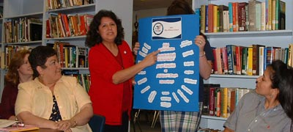
Professional development opportunities are varied and accessible through a regional education service center. Staff members typically participate in intensive training, rather than “one shot workshops.” Teachers cited the week-long Reading Academies as an example of a comprehensive approach to professional development. A teacher mentoring program, including grade level mentors, helps new teachers acclimate and understand the instructional expectations.

In another important professional development step, the teaching staff takes advantage of opportunities to teach others about the programs and practices that have made Skidmore-Tynan so successful. Visitors are always welcome to observe teachers and students and pose questions to the teaching staff. Skidmore-Tynan teachers also present information about their school at teaching conferences and other professional development opportunities. Such presentations deepen Skidmore-Tynan teachers’ understanding of the school’s programs and practices and at the same time offer other teachers usable information about a successful school.


It takes a county to raise a child

Asked to use non-print means to reflect on what makes their school so successful, staff members used a variety of media—photographs, drawings, poetry, and song—to convey, often in deeply emotional terms, the depth of their commitment to and ambition for Skidmore-Tynan students. Their evident commitment appears to have created a climate of respect and safety for all children and adults at Skidmore-Tynan.

One teacher captured this caring through the African proverb, “It takes a whole village to raise a child,” adding that Skidmore-Tynan staff members hold “common values, unity, share with each other, and are a true community.” Teachers strive, she said, to “leave no child behind.” A special education teacher pointed out, “We have never left a child behind at Skidmore-Tynan, well before the No Child Left Behind law.”
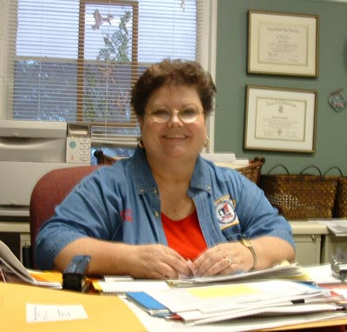
Patty Holubec, principal of Skidmore-Tynan leads through “encouragement, empowerment, and example.”
As the school’s instructional leader, the principal stated that she leads through “encouragement, empowerment, and example.” Strong leadership was a theme throughout the discussions. The principal leads a cadre of teachers dedicated to making a difference for all students. She stresses the need to be professional, not to personalize issues when they arise, she said, and to see conflicts as opportunities. She did not diminish the challenge, however, reflecting, “We have a job to do and we are professionals, as well as a family—it is complicated.”

“Patty [the principal] makes it work so well. We are all on the same page” another teacher said. The school secretary added, “Because of you [staff members] my children are very successful!”

Collaboration is a hallmark of Skidmore-Tynan’s operation. Through a campus-wide Site-Based Decision Making Team (SBDM), many stakeholders—parents, teachers, community members, and business leaders—meet four times a year to advise the school on student success. An active Parent Teachers Club (PTC) sponsors an annual fall festival for the school and the community. Recent PTC fund-raising efforts paid for improvements to the elementary school’s playground, which also serves as the community’s only playground and park.

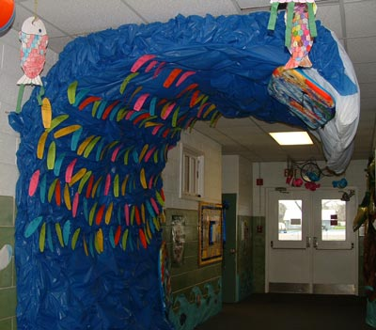
Surf the TAKS

Surfing to success

Principal Holubec believes that student success is non-negotiable and goal-setting by all is vital to success. Each year, teachers generate a theme and set classroom goals, incorporating opportunities for challenge and growth. The theme for 2003-04 is Surf the TAKS [Texas Assessment of Knowledge and Skills] Wave. (Last year, it was We’re Hot, Hot, Hot! Chile peppers were used as the theme.) Working with their teachers, students set personal goals, after which they attend individual goal setting meetings with the principal to record and sign statements of their personal goals. The principal cements each students’ written contract with a handshake. Statements of student goals hang in the hallway outside the principal’s office as part of a display about the yearly theme.

All staff members believe that successful students generate successful schools. The school’s mission states that all children can and will learn, given the time and resources to help them to succeed. Skidmore-Tynan has created a climate in which it is unacceptable for any child’s learning to become static. Celebrations, such as an honor roll breakfast for the 26 students who received straight As on their report cards, are important ways to reward success. At the breakfast, Skidmore-Tynan staff members served breakfast to the children and their family members.

Site-based leadership keeps the focus on students


Skidmore-Tynan Elementary School’s site-based leadership team (SBDM) understands the importance of taking responsibility and sharing leadership through experience. Although Skidmore-Tynan received an Excellence Award in 1990, without focused leadership the school entered a downward slide. One first grade teacher explained, “We fell fast without leadership prior to Patty.”

Now strong bonds promote a sense of respect and responsibility to support each other. Collaboration among the faculty for the purpose of planning, implementing, assessing, and evaluating is exceptional, reported a fourth grade teacher. Teachers pride themselves on pursuing excellence with a passion, never hesistating to go “the extra mile” for children who lack real world experiences and require extra instructional time.

Teachers appeared to have strong rapport with both students and parents. They are empowered to provide quality instructional delivery, explained a teacher. As a result, students are expected and encouraged to learn well beyond “the basics.” Teachers welcome support in whatever capacity parents are confident and comfortable in giving it. To encourage students’ success the school offers incentives such as field trips to larger cities so that the students with very limited experiences have the opportunity to expand their personal knowledge base.

Skidmore-Tynan is a learning community that promotes continuous learning. As one teacher said, “We are not where we want to be, yet. We are always talking about ways to improve as a campus. Right now we are talking about the need for more writing. We’ll keep growing.”

The district Superintendent recognizes the extraordinary leadership and high quality teaching prevalent at Skidmore-Tynan. Asked about his role and what he can do to support the efforts at Skidmore-Tynan Elementary School, he responded, “I can’t keep out the politics, but I can take the hits. My best move is to get out of their [educators] way and give them the support they need.”

A background in curriculum

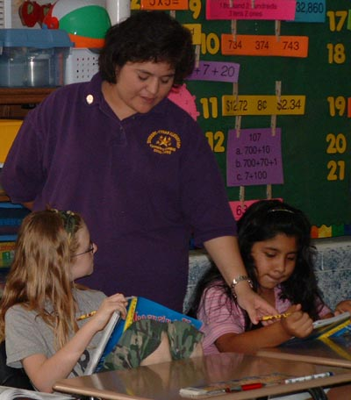
The principal’s strong background in curriculum development (she was a PK-12 Curriculum Director and Special Programs Director in other districts before her current position) has given her the expertise to guide and support staff members as they implement the curriculum with all students. The curriculum is strong and coherent. The core subject matter is aligned with the state standards, and instruction addresses the concepts assessed on the Texas Essential Knowledge and Skills (TEKS). Teachers and administrators review concepts they need to work on with their students. For example, the May 2003 results showed that fourth grade students were weak in vocabulary and prioritizing skills. Teachers designed instruction to teach these skills explicitly.

Kindergarten is “heavily phonics-based along with a myriad of strategies for phonemic awareness and pre-reading” a teacher explained. In grades 1-5 the High Expectations Reading Program is considered critical to students’ success. The principal explained that “reading for me is a passion…if you can’t read, you are dead in the water. It’s a gift we give our kids that takes them places they’ll never go. It did for this little girl [the principal].”]

Mathematics assessments, using the Texas Assessment of Knowledge and Skills, occur at regular intervals. This benchmarking identifies what areas of math factual knowledge and problem solving students at each grade level are expected to master.

Teachers construct the instructional timeline together over the summer. It includes a weekly map of priority and ongoing objectives, selected readings, vocabulary words, and assessments. Teachers develop the assessments in grade level teams, so that students at each grade level use the same assessment tools.

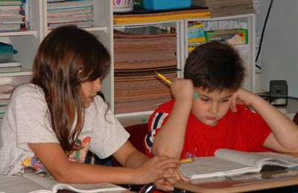
All teachers use a structured cycle of instruction. Based on the theories of Madelyn Hunter and Benjamin Bloom, teaching proceeds by stages. Initially, teachers focus students’ attention and clarify the purpose of the new learning. Direct teaching of content follows, and the teacher models the use of the new learning by teacher. The teacher checks for student understanding through a variety of means—choral responses, group discussion, individual responses, etc. Where necessary, the teacher re-teaches the material or offers guided practice in using it. At the same time, teachers also challenge students who mastered 85% of the objectives by offering enrichment activities. All students are expected to master the lesson objectives. A teacher explained that, “children don’t give up, because they know that they have a whole week in which to learn the materials.” The final phase involves independent student practice with immediate feedback and informal assessment. The lesson is considered complete when students can summarize and demonstrate their learning.


“There are very high expectations for all students. We gear to the mid and high level students rather than to the lower students—you are always going to have to pull up the low group,” remarked the principal. “All students receive the support they need to accomplish their goals,” she added.

Skidmore-Tynan staff members attribute their accomplishments to goal setting and grade level vertical planning. Grade level teams have 60 minutes of planning time together daily. They also work in the summer to develop the instructional pacing charts (timelines) and assessment tools for next school year. The instruction is so intense, and effective, the kindergarten teacher attested, “most students are reading when they leave kindergarten.”

Another teacher cited an example of the school’s high academic standards by noting that substitute teachers are expected to deliver appropriate instruction so students do not lose any instructional time. Parents and adults in the community also benefit from instructional programs and support such as ESL and GED classes; the school guidance counselor also offers parenting education programs.

The school made a “big change in the school to promote learning,” by emphasizing more time on task, a teacher stated. The school day starts at 8:00 and ends at 3:30 for all students, including the kindergarten students who attend a full day program. The day is designed to optimize instructional time and learning opportunities. Tutorials occur both during the school day and after school for an hour three days a week. Students who need extra academic support may attend a summer school program.

Teachers and administrators have developed extensive tools to track and document student learning. These tools allow everyone to use data systematically to ensure that every child makes progress. For example, teachers are required to note all special education modifications in their lesson plans, tagging their notes with the student’s initials and a code, such as AA for auditory aids.

Another document identifies students by their socio-economic status to track potentially at-risk children. In it, teachers record the instructional strategies they used, how long they used them (for example, three years from pre-kindergarten to 2nd grade), and what successes they achieved with these strategies.

Teachers clearly understand the importance of knowing the progress of each and every student. “We are measuring from day one and we’re confident that by the end of the year we’ve made the right decisions.” Another teacher always asks, “What am I going to do about it when one of my students doesn’t do well?” All students are assessed weekly at the end of the instructional cycle to prevent children from “slipping through the cracks.” Struggling students receive feedback and re-teaching to master the learning objectives.


