U.S. Department of Education Green Ribbon Schools

Fact Sheet
2023 – 2024

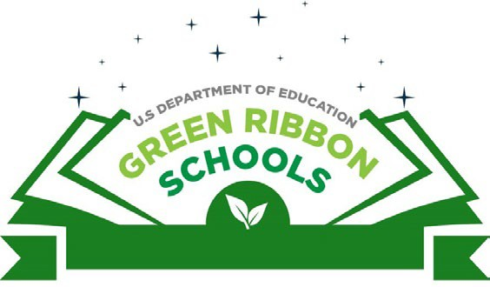
Overview
U.S. Department of Education Green Ribbon Schools (ED-GRS) is a public engagement initiative structured as a federal recognition award for whole school sustainability. ED-GRS honors schools, districts, and postsecondary institutions’ cost-saving, health promoting, and performance-enhancing sustainability practices, thereby celebrating these schools and bringing more attention to their work.

ED-GRS by the Numbers
As of 2023 ED has:
- Recognized 712 honorees: 542 schools, 108 districts, and 62 postsecondary institutions;
- Received participation from 46 state nominating authorities (number of participants varies annually).
- Honored over 40% of honorees serve disadvantaged communities, demonstrating how all schools can be “green.”

Award Criteria
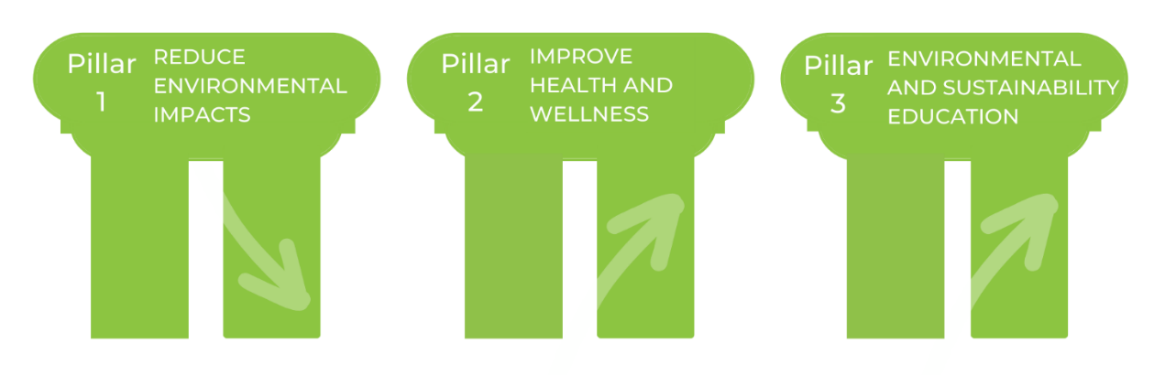
ED-GRS nominees must show progress in each of the following areas, known as the three Pillars: 1) reducing environmental impacts; 2) improving health and wellness; and 3) offering effective environmental and sustainability education. By taking a multi-pronged approach, ED-GRS nominees are demonstrating whole school sustainability practices.
“Your work shines a spotlight on the ways that modern, healthy, efficient school facilities; wellness practices; and learning about environmental sustainability can increase student achievement and educational equity.” – U.S. Secretary of Education Miguel Cardona

Program Structure
Schools, districts, and postsecondary institutions apply to their state education authority, who in turn submits nominations to ED. State participation in the award is voluntary and not all state education authorities choose to nominate annually. Participating states have considerable autonomy on how they select their nominees to ED, and support from ED in developing their application, review process, and program outreach. States submit their nominees to ED by February 9th, 2024.
ED announces national honorees in spring, normally on Earth Day, April 22. States are encouraged to offer additional state recognition and benefits that amplify the impact of their award implementation.
“All students thrive when they engage in hands-on learning that connects them to their community.” – Secretary Miguel Cardona

Benefits
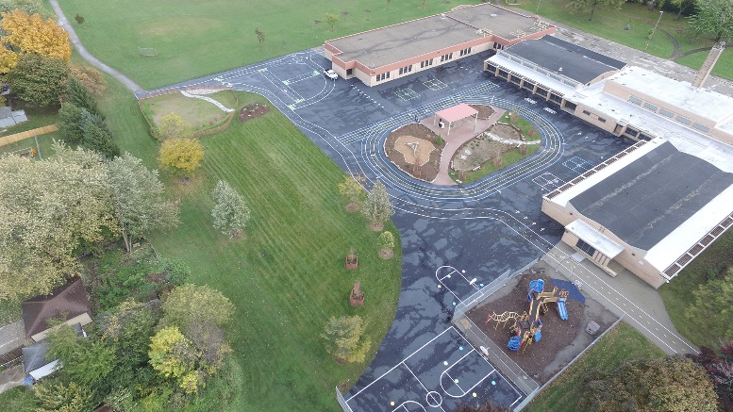
ED-GRS has defined what it means to be a “green school,” encompassing environmental impacts, health and wellness, and sustainability education. States and school programs that participate report an increase in collaboration, partnerships, and strengthening of their existing green school networks. Recognizing success is an important tool in building momentum, highlighting innovative practices, and communication. The schools are invited to a ceremony in Washington, D.C. where they receive a plaque; are the subject of media attention; and have their efforts celebrated. Other schools, in turn, learn about and may adopt their practices.
2021 ED-GRS Clement Avenue School in Milwaukee, Wisconsin features a renovated green schoolyard.

Contact:
Andrea Falken, andrea.falken@ed.gov for more information on ED-GRS 2023-2024.

Resources:
Visit https://www2.ed.gov/programs/green-ribbon-schools/index.html for a full program description and to learn about previous award cycles.
Stay up to date on national events, resources, webinars, and more by subscribing to ED Infrastructure and Sustainability News.
Access resources for whole school sustainability on the Green Strides School Resources Hub.

