This survey was conducted by three distance learning and education innovation organization (UPCEA, OLC, and WCET) during the week of February 4, 2019. Thank you to Julie Uranis, UPCEA, for spearheading the survey. Eighty-two responses from different types of institutions were received. Responses were made anonymous.
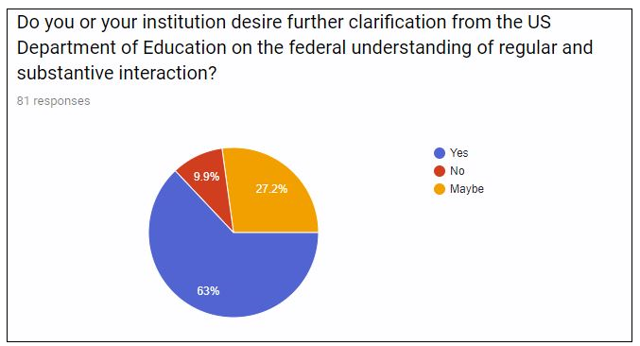

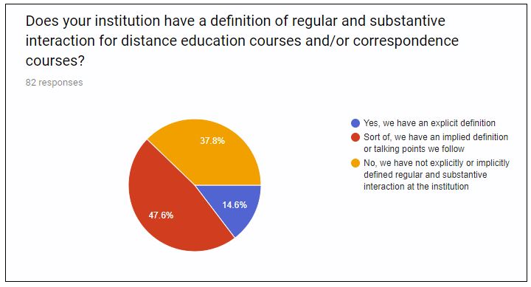

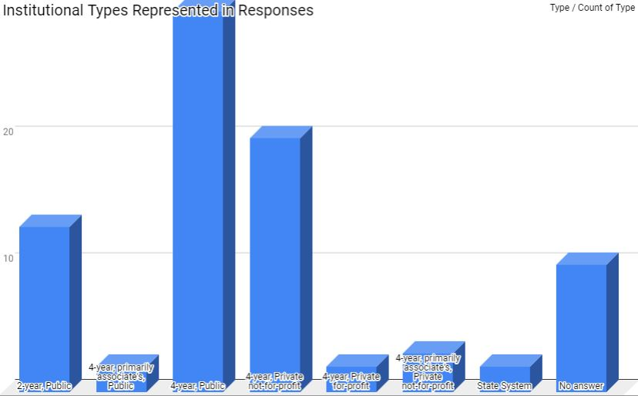

Key Takeaways
In reviewing the institutional “regular and substantive interaction” (RSI) language from the table below and the responses to the questions in the charts on the previous page, the following themes are noted:
- Even after decades of implementing this requirement there is still confusion over what constitutes “regular and substantive interaction.” This is despite on-going efforts by the three organizations conducting this survey to educate members about it.
- “Interaction” was often defined as going beyond instructor-initiated contacts to include student-initiated and student-to-student interaction. Presumably, this is based upon experience indicating the importance of these connections in educational quality.
- Who is counted in the “instructional team” for compliance purposes is unclear. One institution reported that G.A.s and T.A.s are included, while another reported that they are not.

Methodology and Assumptions
The following table lists the definitions and/or talking points used by institutions that responded to the survey (82) that was sent out generally to members of the three organizations. Please note:
- No verification or validation of responses was conducted to determine if the individual responding to the survey could speak with authority on the institution’s practices in regards to RSI.
- The absence or existence of a definition or talking points shared in this survey does not necessarily indicate that an institution does or does not adhere to federal financial aid guidelines and regulations.
- At some institutions, teaching and RSI may be a question of academic freedom and handled on a case by case (or course by course) basis.
- The absence of an institutional definition does not suggest that an institution is not focused on quality online experiences.

Does your institution have a definition of RSI…? | If you have a definition or talking points regarding regular and substantive interaction, please share that below (and include any citations or links that detail RSI). | Type | Carnegie Classification
Sort of. | These traits appear in our Classroom Observations form:  "Instructor provided ongoing opportunities for students to interact with peers and has created an online learning community through the use of socially engaging activities, such as discussions, group assignments and/or presentations." and "Instructor is responsive to learner questions or comments and communicates in a supportive and encouraging manner. The instructor regularly checks for student comprehension, and provides formative feedback." | 2-year, Public | Associate's Colleges: High Transfer-High Nontraditional
Yes. | <link to institutional web page> | 2-year, Public | Associate's Colleges: High Transfer-High Traditional
Sort of. | In our local distance education union contract, there is language that specifies three requirements related to teaching procedures and learning activities: 1. Create original learning activities to provide varied and ongoing opportunities that support learning; 2. Provide venues and activities for interaction; 3. Align activities with course objectives. Since we have collective bargaining, language has to be approved by a statewide group and each institution has its local DE contract. It would be very helpful to have an agreed-upon language to stay within compliance both at the state and federal level. | 2-year, Public | Associate's Colleges: High Transfer-High Traditional
Sort of. | RSI includes weekly interaction between the student and the instructor, and is instructor-initiated. Examples include but are not limited to feedback on assignments, emails, announcements, synchronous webinars, and discussion board posts. | 2-year, Public | Associate's Colleges: High Transfer-Mixed Traditional/Nontraditional
Sort of. | Minimum of instructor initiated action once per week, outcome-related, individualized feedback related to improvement | 2-year, Public | Associate's Colleges: High Vocational & Technical-High Nontraditional
Sort of. | Regular refers to interactions that are frequent and predictable and are part of the course design. Substantive refers to interactions that pertain to the academic subject matter of the course outcomes. Instructor Initiated interactions are those where the instructor is reaching out to the students. | 4-year, primarily associate's, Public | Associate's Colleges: High Vocational & Technical-Mixed Traditional/Nontraditional
Sort of. | Our substantive change request to HLC for CBE programs describes how regular and substantive interaction is designed into the curriculum and provides examples of how it occurs and is documented. We do not have an absolute, one-size-fits-all definition and are skeptical that one exists (hence, my "maybe" response in the next question). We do agree, however, that the regulation is outdated and requires review and revision. | 2-year, Public | Associate's Colleges: High Vocational & Technical-Mixed Traditional/Nontraditional
Yes. | This definition was applied for our CBE programs:  The Course Faculty will work with the students on all academic related matters of each competency in which students are enrolled. Instructional materials and course faculty are available to students every week of the term of enrollment. During this time the Course Faculty leads instruction in the competency, interacting with students on a continual basis with a minimum of one substantive faculty-initiated interaction each week. The following are examples of the contacts that Course Faculty will initiate with students:  • Approval for students to take assessments  • Provide feedback related to formative and summative assessments that students complete  • Provide individualized preparatory information to student related modules/projects  • Work with students who are having issues with various formative assessment activities  • Proactively contact students on a regular basis (weekly) to provide feedback on their activity level and address any academic concerns the students may have  • Observe and provide guidance during lab practice activities  • Interact with students on discussion questions  • Provide direct instruction during synchronous class sessions  • Provide regular office hours available every week the competency is in progress. | 2-year, Public | Associate's Colleges: High Vocational & Technical-Mixed Traditional/Nontraditional
Sort of. | We address this when developing our online master templates by requiring regular discussion boards and including expectations of substantive interaction. | 2-year, Public | Associate's Colleges: Mixed Transfer/Vocational & Technical-High Nontraditional
Yes. | 55204. Instructor Contact.  In addition to the requirements of section 55002 and any locally established requirements applicable to all courses, district governing boards shall ensure that:  (a) Any portion of a course conducted through distance education includes regular effective contact between instructor and students, through group or individual meetings,  orientation and review sessions, supplemental seminar or study sessions, field trips, library workshops, telephone contact, correspondence, voice mail, e-mail, or other  activities. Regular effective contact is an academic and professional matter pursuant to sections 53200 et seq.  (b) Any portion of a course provided through distance education is conducted consistent with guidelines issued by the Chancellor pursuant to section 409 of the Procedures and  Standing Orders of the Board of Governors.  NOTE: Authority cited: Sections 66700 and 70901, Education Code. Reference: Sections 70901 and 70902, Education Code. Guideline for Section 55204  This section defines what contact must be maintained between instructor and student. It is virtually identical to section 55211 which it replaces, except that language has been added to clarify that rules related to conduct of distance education and effective instructor contact apply to any portion of a course conducted through distance education. Subdivision (a) stresses the responsibility of the instructor in a DE course to initiate regular contact with enrolled students to verify their participation and performance status.  The use of the term “regular effective contact” in this context suggests that students should have frequent opportunities to ask questions and receive answers from the instructor of record.  The last published Distance Education Guidelines, March 2004, issued by the Chancellor pursuant to section 409 of the Procedures and Standing Orders of the Board of Governors, as referenced in subdivision (b), establishes the principle that for DE courses there are a number of acceptable interactions between instructor and student, not all of which may require in-person contact. Thus, districts and/or colleges will need to define “effective contact” including how often, and in what manner instructor-student interaction is achieved. It is important to document regular effective contact and how it is achieved.  Since regular effective contact was declared an academic and professional matter, this documentation must include demonstration of collegial consultation with the academic senate, for example through its delegation to the local curriculum committee. A natural place for this to occur is during the separate course approval process (see section 55206) as well as during faculty evaluations, student surveys, and program review. Documentation should consist of the inclusion of information in applicable outlines of record on the type and frequency of interaction appropriate to each DE course/section or session. Local policies should establish and monitor minimum standards of regular effective contact.  This section of Title 5 has been changed to include student to student contact. The changes have not taken effect yet. | 2-year, Public | Associate's Colleges: Mixed Transfer/Vocational & Technical-High Traditional
No. | We encourage each online instructor to use the following: office hours or other meetings with students via Zoom video conferencing; a welcome video in their course; weekly announcements; feedback to students; participation in discussion boards; and collaborative group work to some extent. | 4-year, Public | Baccalaureate Colleges: Arts & Sciences Focus
Sort of. | We indicate specific expectations regarding teaching presence, feedback and communication, and instruction in an online class. | 4-year, primarily associate's, Public | Baccalaureate/Associate's Colleges: Mixed Baccalaureate/Associate's
Sort of. | Our "talking points" equate to the Basic Online Course Check  A. A current syllabus is available in the course.  B. Instructor’s contact information and office hours are provided.  C. Textbook information (with ISBN) and/or other required materials are identified and included in the LMS.  D. Expected turn-­‐around time in responding to students’ emails is stated (e.g., within 24 hours or 24–48 hours).  E. Instructor is active in the course and communicating with students (e.g., logging in a minimum of once a week AND a minimum of 1 hour per week of activity, updates and changes via announcements or e-­‐mail, progress and feedback via Gradebook, etc.).  F. Assignments are scheduled and have due dates.  G. A variety of assessment methods and types are included.  H. Use of LMS tools to support course activities/assignments (e.g., announcements, assignments, discussions, conferences, quizzes, etc.  Citation, I kid you not, (Poulin, R. (2012, April 20). Is your distance education course actually a correspondence course? Retrieved from https://wcetblog.wordpress.com/2012/04/20/correspondence‐definition/) | 4-year, Public | Doctoral Universities: Higher Research Activity
Sort of. | Our Online Course Quality Rubric includes the following bullet points related to RSI - The course provides a concrete timeframe for responses to student inquiries (within 24 hours during the work week and 48 hours over weekends) and posting grades. The course contains activities that provide students with opportunities to receive feedback early and frequently. The course contains appropriate pacing mechanisms (due dates, reminders, follow-ups) which are used to ensure timely student completion and regular engagement. | 4-year, Public | Doctoral Universities: Higher Research Activity
Yes. | The academic week begins on Monday at 6:00 am MT and ends on Monday at 5:59 am MT. Students must actively participate in the course by turning in assignments and posting to discussion forums each week. Each week has new discussion questions.  Students must post at least one time in week one to be considered as an active student in the course. Failure to post in week one classifies a student as a "non-start". Students classified as non-starts who are receiving federal financial aid are automatically dropped from the course. Students who add a course on the last day of the add/drop period may extend the first week of the term (only) through the following Tuesday at 5:59am Mountain Time. | 4-year, Private for-profit | Doctoral Universities: Higher Research Activity
Yes. | • XXX Online courses have regular and substantive interaction between students and the instructor.  o We define “regular” as at least weekly.  o We define “substantive” as academically purposeful and relevant (interactions are related to the course learning outcomes and are not “busy work”).  • XXX Online courses should have interactions that are  o Instructor initiated interactions (instructor to student or peer to peer assigned and monitored by the instructor),  o Timely and dependable (students know when they will receive feedback from the instructor and the feedback helps them improve future performances), and  o Personalized and varied (the course is designed so instructors personally connect with students using a variety of methods). | 4-year, Private not-for-profit | Doctoral Universities: Higher Research Activity
No. | This is some language we are working on to help define this for XXX. Nothing is formal or available for other to see.  While the terms “regular”, “substantive”, and “limited” are not specifically defined, a combination of common-sense definitions and scheduling practices for face-to-face courses should be applied (number and length of class meetings with the instructor expected per semester). In distance education courses, reviewers have considered course materials that culminate in an interaction with an instructor as part of the “substantive” requirement. This also assists in meeting credit-hour requirements. | 4-year, Public | Doctoral Universities: Highest Research Activity
Sort of. | Regular and substantive interaction involves periodic feedback from the instructor and consistent communication between the instructor and student(s) throughout the course. This can be accomplished through activities such as synchronous meetings, course updates, discussion boards, clarification on topics, feedback on assignments, office hours, etc. | 4-year, Public | Doctoral Universities: Highest Research Activity
Sort of. | Course design standards specify that courses must be designed to include three forms of engagement, one of which is instructor/student, and provide guidance on feedback and learner support, including the expectation that questions be answered in 24 hours on business days. If course designs don't meet these standards, they are not funded or scheduled for offer. Instructional designers help faculty find some way to meet the standard that works for the course.  Additionally, our training materials (required for faculty developing an online course) include information about the DOE requirements for RSI.  Our talking points for our F2F trainings and meetings to onboard new programs explain the requirement as being threefold: Regular (throughout the term), substantive (relating to course content, not just "good job" on assignment feedback), and instructor-led (not just replying to questions that are student-led).  It would be helpful to provide more guidance regarding what is enough and what's not enough, but given the breadth of courses we offer in so many disciplines and at UG and grad levels, I would have difficulty defining a metric that would fit all courses. Some examples of what's sufficient and what's insufficient would be helpful.  Additionally, a definition of "instructor" would be helpful. In a large section where GTAs are helping to deliver the course, does interaction with the TA count? We have been asked this and do not know the answer. | 4-year, Public | Doctoral Universities: Highest Research Activity
Sort of. | (In the section on university requirements for distance education courses, from the online course quality standards offered by the Office of Distance Education and eLearning:)  Students will have opportunities for **regular and substantial academic interactions** with the course instructor.  This Department of Education requirement is based on the types of courses that XXX University can offer. A self-paced format is considered a correspondence course, which the university is not accredited to offer.  This type of interaction is defined by the following four elements, outlined in more depth in the article [Interpreting what is Required for Regular and Substantive Interaction](https://wcetfrontiers.org/2016/09/30/interpreting-regular-and-substantive-interaction/) .  * **Interaction initiated by instructor:**While in distance courses students have a heightened responsibility to take ownership of their learning, the faculty presence, guidance, and initiation of contact is critical. In distance courses, the flow, sequence, and deadlines of the course must be directed by the instructor and the timing of the course set through use of learning activities, online discussion, lectures, etc. In comparison, in correspondence courses students submit work when they finish it and initiate questions when they have them with little or no guidance from the instructor.  * **Initiation of interaction must be regular and pretty frequent:**This element is probably one of the least defined of the bunch. Essentially interaction with students should happen fairly frequently and regularly where students are likely to grow to expect it. A weekly interaction is a good baseline.  * **Interaction must be meaningful or of an academic nature:**Essentially, the interaction should lead toward increased learning and might consist of things like:  * Regularly scheduled synchronous activities. At XXX this might equate to regular use of XXX software.  * Facilitating a study group or online discussion forum.  * Facilitating faculty-guided independent study.  * Announcements, email, or social media check-ins initiated by the instructor about aspects of the course, additional guidance, etc.  * **Interaction must be initiated by academic personnel who meet accrediting body standards:** Essentially, interaction should be initiated by someone who is qualified to do so as it relates to the subject matter. At XXX, this would fall to qualified faculty or those who meet similar requirements of faculty, lecturers, instructors, etc. For competency-based programs this has been defined by the HLC as “appropriate academic credentials and experience in the applicable knowledge domain”. | 4-year, Public | Doctoral Universities: Highest Research Activity
Sort of. | We generally encourage some activity within the online class every week--a discussion, some kind of assignment, or a deliverable. We also talk about encouraging interaction through weekly announcements and emails on the faculty member's part to ensure that students feel faculty presence. | 4-year, Public | Doctoral Universities: Highest Research Activity
Yes. | Provided a link to a two-page guide. Here is an excerpt:  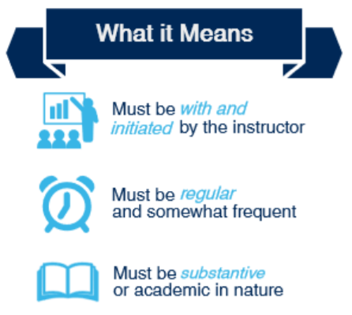 | 4-year, Public | Doctoral Universities: Moderate Research Activity
Sort of. | We refer to this link: https://wcetfrontiers.org/2016/09/30/interpreting-regular-and-substantive-interaction/ | 4-year, Public | Doctoral Universities: Moderate Research Activity
Sort of. | Excerpt from eCampus Center Administrative Orientation for faculty teaching online:  Online Education Characteristics  The Higher Education Opportunity Act (2008) provides further definition of online education.  It is education that “uses one or more” technologies—”(i) the Internet; (ii) one-way and two-way transmissions through open broadcast, closed circuit, cable, microwave, broadband lines, fiber optics, satellite, or wireless communications devices; (iii) audio conferencing; (iv) video cassettes, DVDs, and CD–ROMs, if the cassettes, DVDs, or CD– ROMs are used in a course in conjunction with any of the technologies listed in clauses (i) through (iii).”  It delivers “instruction to students who are separated from the instructor.”  It supports “regular and substantive interaction between the students and the instructor, synchronously or asynchronously” (Higher Education Opportunity Act, 2008, emphasis added). | 4-year, Public | Doctoral Universities: Moderate Research Activity
Sort of. | What is direct faculty instruction (interaction)? Interaction (direct faculty instruction) in an online course essentially includes all opportunities during which the student interacts with faculty, peer, and content. Examples of instructional activities that qualify as contact hours, listed below, can be used in several combinations to meet the “per week” credit requirements.  1. Listening to or reading course materials (e.g.: word documents, pdfs, audio recordings, video recordings, other webpages or resources)  2. Attending class lectures  3. Participating in discussion forums  4. Getting feedback from (or giving feedback to) peers and instructors on assignments, activities, and discussion forums  5. Presenting student reports and participating in group projects  6. Taking quizzes and exams  7. Communicating with faculty via email, phone, discussion forums, synchronous session, asynchronous and synchronous chat sessions or any other medium through which student has the opportunity to interact with their faculty and peers.  What is independent work? Independent work is work completed by students out of class such as completing assignments, working on projects, reading chapters, writing papers and other activities that the students work on in their own time (independent work) and in which their level of mastery of the subject matter is evaluated. E.g.: Reflection papers, preparing independent presentations, journal entries, assignments, projects, case studies, research papers, studying for exams and quizzes, article analysis, etc. | 4-year, Public | Master's Colleges & Universities: Larger Programs
Sort of. | We require our instructors to demonstrate their instructional contact hours with their students by completing an instructional contact hours form. We developed this form for the explicit purpose to demonstrate "Regular and Substantive" student-to-instructor interactions. It is also used to demonstrate institutional credit hour compliance and parity of instruction. The form provides a basic overview of what can and cannot be counted as instructional contact hours.  It also defines what should count as homework. When the instructor begins the form, they are asked to enter how many credits the course is worth. The form then calculates how many instructional hours the instructor needs to plan with their students. The form then directs them to list their instructional interactions for each week of the term along with time estimates for each interaction. The entire form has been automated. All time estimates are added together to show how many hours are planned. Upon completion of the form, the instructor and our online department receives a PDF of the completed form. Using this form has greatly helped our faculty plan their courses and ensure compliance with the "Regular and Substantive." | 4-year, Private not-for-profit | Master's Colleges & Universities: Larger Programs
Sort of. | instructor-initiated asynchronous or synchronous discussions | 4-year, Private not-for-profit | Master's Colleges & Universities: Medium Programs
Sort of. | Our online teaching readiness course, which is required for new online instructors, speaks to how to engage with students in the online platform. We also develop courses relative to the Quality Matters rubric/guidelines which helps to ensure the opportunity for RSI is embedded in the course design itself. | 4-year, Private not-for-profit | Master's Colleges & Universities: Medium Programs
Sort of. | Faculty are required to respond to all student inquiries within 2 working days | 4-year, Private not-for-profit | Special Focus Four-Year: Other Health Professions Schools
Yes. | We require once weekly live lecture, which are also recorded for students who can not make the live session. Depending on the program, there can be as many as three lectures per week. Instructors manual. | 4-year, primarily associate's, Private not-for-profit | Special Focus Four-Year: Other Health Professions Schools
Yes. | 1/3 of all initial posts must be responded to in each module. | 4-year, Private not-for-profit | Special Focus Four-Year: Other Technology-Related Schools
Sort of. | At the system level, we do not have a definition of RSI. We have three types of online course sections:  Asynchronous Online - 100% of the Direct instruction occurs under time delay; that is, direct instruction is recorded/stored and accessed later.  Synchronous Online - 100% of the Direct instruction occurs in real time without (time) delay.  Combined Online - 100% of the Direct instructed combines both Synchronous and Asynchronous type.  We also have best practices for course design outlined in a rubric designed by the System. | State System | State System
Yes. | The XXX Online Course Design Rubric, adopted by many colleges in the XXX system, defines it as: (B1) Instructor initiates contact prior to or at the beginning of course; (B2) The course design includes regular instructor-initiated contact with students using CMS communication tools; (B3) Students are encouraged to initiate contact with the instructor through easily accessed contact information that includes expected response times. (B4) Opportunities for student-initiated interaction with other students are available and encouraged; (B5) Regular effective contact among students is designed and facilitated to build a sense of community among learners; (B6) Guidelines explaining required levels of participation (i.e., quantity and quality of interactions) are consistently provided, | State System | State Virtual Campus
Sort of. | Students experience an engaging learning environment founded on extensive personal contact among faculty, staff and students in and out of the classroom.  The following is for all instruction at the University:  LEARNING objective A is about student ENGAGEMENT: Students experience an engaging learning environment founded on extensive personal contact among faculty, staff and students in and out of the classroom  - Achievement indicator: Students participate in learning experiences such as undergraduate research, service learning, involvement and other forms of experience-based learning and metrics for monitoring achievement are rates of student participation in engaged learning experiences.  - Achievement indicator: Students experience extensive contact with faculty, staff and other students and achievement metrics are student perceptions of contact with faculty and class size. | No answer | No answer

