Introduction

The U. S. Department of Education is conducting negotiated rulemaking on the topic of gainful employment. Gainful Employment (GE) programs are certificate programs at public, private, and proprietary institutions as well as degree programs at proprietary institutions. GE negotiators requested data that would show the impact of expanding debt to earnings computations to all schools and all programs, regardless of control or credential level.

Currently, the Department computes debt to earnings rates only for GE programs. Further, the Department only has income data at the program-level for cohorts in GE programs. Therefore, comparing debt to earnings at the program level across institutional type is not possible with existing Department data. The best data proxy currently available to the Department is College Scorecard data, which is at the institutional but not the programmatic level. It is important to note that the data generating process for College Scorecard debt and earnings values is substantially different than the GE data generating process. These differences are further explained in the Methods section (see Exhibit 1). Given the differences in the two processes for generating these data, findings derived from Scorecard data are limited in estimating how debt to earnings using the GE methodology compare across control categories.

Key findings
- In each of the three categories of bachelor’s, associate’s, and undergraduate certificate level institutions, proprietary institutions had the most variation (standard deviation) of debt to earnings rates followed by private institutions, followed by public institutions.
- Among bachelor’s level institutions, the median debt to earnings was lowest at public institutions, followed by proprietary and private institutions. However, the number of proprietary institutions was relatively small in this category.
- At associate’s level institutions, the middle half (25th through 75th percentiles) of the debt to earnings rates at public institutions was lower than private institutions, which in turn were lower than at proprietary institutions.
- At certificate level institutions, public institutions had relatively lower debt to earnings rates. As can be seen in the box and whisker plots, there was a large overlap between private and proprietary institutions. However, private institutions were relatively few in this category.
- Debt to earnings rates were not strongly correlated with repayment rates.

Methods

The U. S. Department of Education produces the College Scorecard debt and earnings values annually. The data underlying the September 2017 Scorecard release were used to produce the analyses in this report. The Institutions included in these data are limited to those with at least one currently operating location participating in Title IV programs. Debt to earnings measures were computed using the College Scorecard data and the formula below:

$$\text{annual earnings rate = }\frac{\text{annual loan payment}}{\text{annual earnings}}$$

It is important to note that College Scorecard data has important differences from the data currently being used to compute GE program debt to earnings measures (see Exhibit 1). For this reason, the Department expects that the results in this paper may differ from those publicly available for GE programs.

Exhibit 1: Data and methods differences
GE programs debt to earnings | College Scorecard debt to earnings
Calculated at program level | Calculated at institution level
Uses an exit cohort for both debt and earnings calculations | Uses an entry cohort for earnings calculations and an exit cohort for debt calculations
Excludes non-completers | Includes non-completers
Includes non-borrowers (e.g. Pell-only) in both median debt calculation and earnings calculation | Excludes non-borrowers in median debt calculation, but includes non-borrowers in the earnings calculation
Debt capped at tuition and fees | No cap on debt
Debt includes nonfederal debt | Debt excludes nonfederal debt
Earnings values are based on a cohort that includes zero dollar earners | Earnings values are based on a cohort that excludes zero dollar earners
Program level debt and earnings values are calculated for both undergraduate and graduate programs | Institution level debt and earnings values are calculated for only undergraduate students

Below are definitions for data used in this report:
- Predominant award: Scorecard classifies institutions by the most common undergraduate level the institution awards. For example, an institution that awards 40 percent bachelor’s degrees, 30 percent associate degrees, and 30 percent certificate programs is classified as predominantly bachelor’s degree awarding.
- Earnings: Calendar year 2013 and 2014 earnings (higher of mean and median earnings) for cohorts of students who entered the institution in:
  - Academic years 2004-05 and 2005-06 at predominantly bachelor’s degree awarding institutions (measuring earnings eight years after entry),
  - Academic years 2006-07 and 2007-08 at predominantly associate degree awarding institutions (measuring earnings six years after entry), and
  - Academic years 2006-07 and 2007-08 at predominantly certificate awarding institutions (measuring earnings six years after entry).
- Debt: Cumulative median debt was captured for students that exited (completed or withdrew) in fiscal years 2010 and 2011. Cohorts with fewer than 30 students were excluded.
- Debt to earnings: A three year lag between debt and earnings was used here to more closely match the GE debt to earnings calculation. Since the most recent earnings data in Scorecard is calendar years 2013 and 2014, implementing the 3 year lag means using debt values from the 2010 and 2011 award years. The cumulative debt values were converted to an annual loan payment with a 6.8 percent interest rate and a 15-year repayment plan for institutions predominantly awarding bachelor’s degrees and a 10-year repayment plan for institutions predominantly awarding associate’s degrees and certificates.
- Repayment Rate: The proportion of borrowers repaying at least one dollar on their initial balance after three years. Repayment rates used in this document reflect the combined FY2010 and FY2011 cohorts measured in FY2013 and FY2014. Scorecard provides more recent data, but these data were selected to match with the debt to earnings calculation.

Results

Debt to earnings rates were calculated for 3,542 institutions after exclusions for small cell sizes. The distribution of debt to earnings in these institutions is provided in Exhibits 2 and 3. Exhibit 2 displays descriptive statistics by control and predominant undergraduate award; Exhibit 3 provides box and whisker plots by control and predominant undergraduate award.

Exhibit 2. Descriptive Statistics for Debt to Earnings
Descriptive  Statistic | Bachelor |  |  | Associate |  |  | Certificate
 | Public | Private | Proprietary | Public | Private | Proprietary | Public | Private | Proprietary
Number | 531 | 1016 | 60 | 622 | 89 | 151 | 296 | 68 | 709
Mean | 2.7% | 3.5% | 3.1% | 2.2% | 4.0% | 5.4% | 2.5% | 4.4% | 4.9%
Standard Deviation | 0.8% | 1.1% | 1.7% | 0.5% | 1.3% | 1.8% | 1.0% | 2.0% | 1.7%
Minimum | 0.3% | 0.5% | 0.5% | 0.9% | 1.4% | 2.0% | 0.7% | 0.9% | 0.5%
Median | 2.6% | 3.5% | 2.8% | 2.1% | 4.0% | 5.4% | 2.3% | 3.9% | 4.8%
Maximum | 6.7% | 7.7% | 10.3% | 4.6% | 10.0% | 12.5% | 8.7% | 14.1% | 11.9%

The most substantive differences between types of institutions were at associate’s level institutions. The middle half (25th through 75th percentiles) of the debt to earnings rates at public institutions was lower than private institutions, which in turn were lower than at proprietary institutions. At certificate level institutions, public institutions continued to be lowest, and there was a large overlap between private and proprietary. Private institutions were relatively few in this category. Among bachelor’s level institutions, the median debt to earnings was lowest at public institutions, followed by proprietary and private institutions. There was more variation in rates (standard deviation) at proprietary institutions than public and private institutions. However, the number of proprietary institutions was relatively small.

Higher education institutions are diverse in the types of students they serve. For example, some institutions are more selective or enroll students with higher levels of prior academic achievement. To compare institutions with more similar characteristics, the universe of institutions was limited to open enrollment institutions only. Analysis on open enrollment institutions showed similar results to those presented for all institutions (results not shown).

Exhibit 3. Distribution of Debt to Earnings
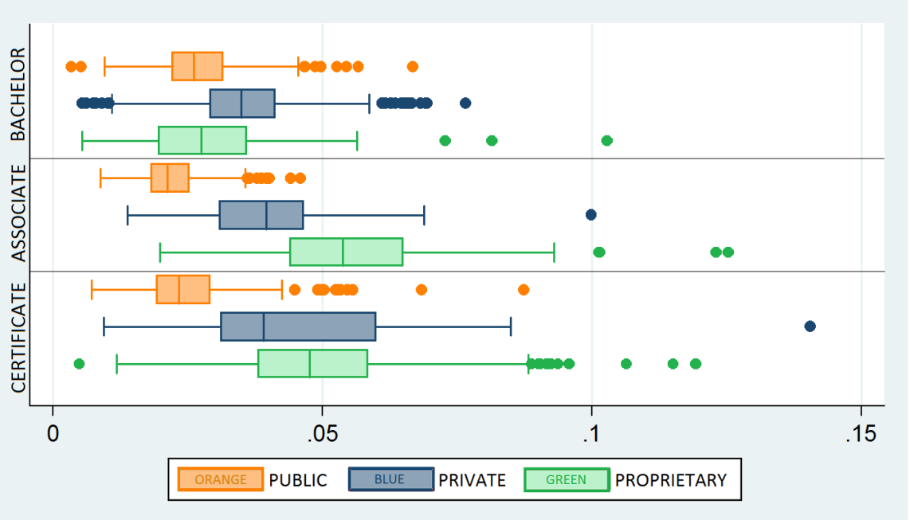

In box and whisker plots, the line inside the box is the median, and the box contains the middle 50% of the data. The dots past the ends of the whiskers are considered statistical outliers.

Exhibit 4 shows repayment rates (proportion of borrowers repaying at least one dollar on their initial balance after three years) for institutions that have debt to earnings rates. When comparing Exhibit 3 to 4, debt to earnings does not appear to be strongly correlated with repayment (correlation coefficient = -0.165). That is, it does not appear to be a reliable expectation that as repayment increases debt to earnings decreases.

Exhibit 4. Distribution of Repayment Rates
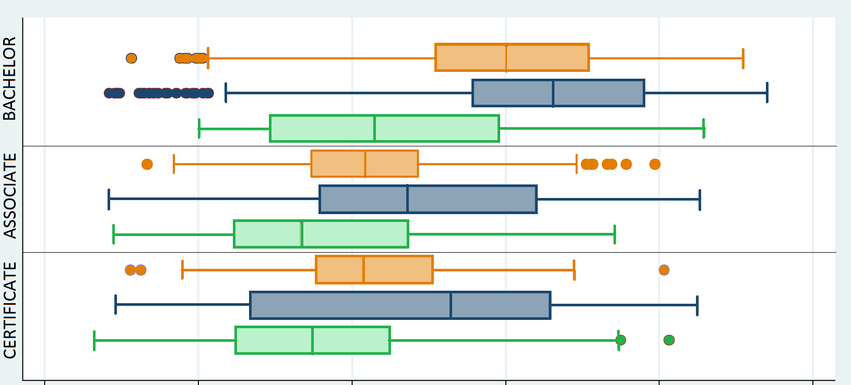

Conclusion

Comparisons of institution-level estimates of debt to earnings rates reveal variation in rates both across sectors and within sectors. While some groups of institutions may have higher or lower distributions of debt to earnings, there is enough overlap in distributions that an individual institution in any given group may have higher or lower debt to earnings than another institution in a different group. Given this overlap, prospective students may benefit from information related to as many institutions as possible. Further, because repayment rate did not appear to be highly correlated with debt to earnings, prospective students may benefit from multiple metrics when choosing an institution.

College Scorecard
College Scorecard Data
Because some metrics are calculated at the IPEDS reporting unit (UNITID) level and others are calculated at the institution (six-digit OPEID) level, when an institution met the criteria for inclusion, all associated locations included in the College Scorecard (regardless of their individual currently operating status) were included in these metrics to maintain consistency across metric sources.

