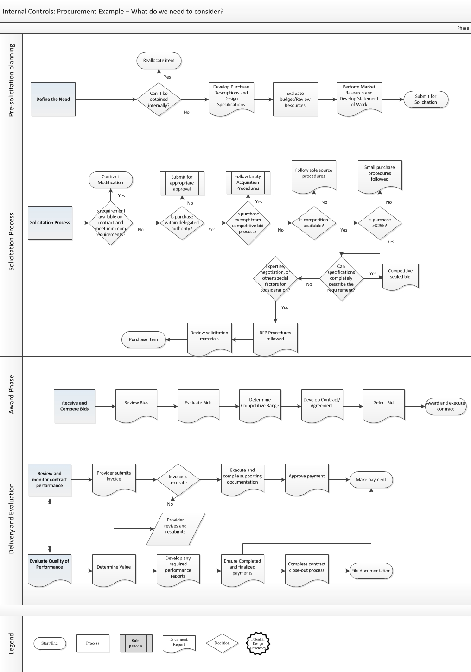

Internal Controls: Procurement Example

Control Environment

Has Leadership:
Demonstrated a commitment to integrity and ethical values
- Does the entity actively set an ethical tone around procurement procedures and expectations?
- Are there ethics requirements, certifications, etc.?
- Is there an established code of conduct for employees? Requirements for those making procurement requests and for those processing procurement requests?
Established structure, responsibility, and clear lines of authority
- Are there policies and procedures for the procurement processes and decision making?
- Are there clear lines of responsibility and authority?
Demonstrated commitment to competence
- Are there competency requirements?
- Are the competencies clearly communicated and is training toward those competencies provided?
Enforced accountability
- Does leadership take action to correct errors in decisions regarding the procurement process?
- Are staff held accountable for their actions?
- Are processes modified as needed to minimize and/or mitigate errors?

Internal Controls: Procurement Example

Risk Assessment
Has Leadership:
Defined process objectives and risk tolerances
- Has the entity assessed areas of vulnerabilities?
- Does the entity have data to inform the impact of vulnerabilities i.e. what is at stake should a control failure occur
- Are there articulated processes that utilize that likelihood and impact data to inform risk thresholds?
Strategically addressed known risks to minimize the impact on the stated objective
- Are there mitigating controls in place?
- Do processes have business rules to prevent or detect errors?
- Has the entity assessed the risk of procurers? e.g., LEAs

Internal Controls: Procurement Example

Control Activities
Has Leadership:
Developed specific control activities for the procurement process?
- Are there documentation requirements?
- Does the entity have sufficient staff to ensure segregation of duties?
- Is there a mechanism in place to inform staff if a step has been skipped?

Internal Controls: Procurement Example

Information and Communication
Has Leadership:
Demonstrated a Commitment to the use of data to inform decisions?
- Are there policies and practices in place to receive and communicate information in a timely manner?
- Are deficiencies identified in the procurement process communicated and remediation activities shared?
- Are there clearly stated lines of authority responsible for communication?
- Has management established formal mechanisms for communication regarding procurement processes up and down the hierarchy?
- Has management established clear lines of communication and technical support and assistance for procurers?
- Has management set clear expectations for procurers for procurement submissions?

Internal Controls: Procurement Example

Monitoring
Has Leadership:
Demonstrated a commitment to monitoring the efficacy of its procurement process
- Has management collected data to serve as a baseline of efficiency?
- Does the procurement process have periodic monitoring systems, continuous monitoring systems, and/or both?
- Are the data collected evaluated?
- Are there established lines of reporting and are results reported?
- Is there a mechanism in place to make sure that communicated procurement system corrections are implemented and effective?
- Is there any way to document procurement process efficiency and effectiveness and/or implementation of corrective actions?

