Department of Education



VETERANS’ EMPLOYMENT OPERATIONAL PLAN
FY 2010 - 2012

“VETERANS SUPPORTING EDUCATION EXCELLENCE FOR AMERICA”

Table of Contents
Foreword 4
Acronyms 5
Executive Summary 6
I. Introduction 8
II. Strategic Overview and Mission of the U.S. Department of Education 9
III. Veterans’ Employment Program 10
IV. Veterans Workforce Profile 11
V. Veteran Employment Strategies 14
Leadership Commitments in the First 30 Days 18
Strategy 1: 21
Foster Effective Leadership Commitment 21
VI. Develop Skills and Manage Veterans Employment 23
Strategy 2: 24
Develop Skills and Manage Veterans Employment 24
VII. Marketing and Outreach 28
Strategy 3: 29
Market and Outreach for Veterans Employment 29
Establish Success Indicatorses for Marketing and Outreach. 32
VIII. Build an Information Gateway 34
Strategy 4: 35
Build an Information Gateway 35
Appendices 37
Appendix A 38
Appendix B 39
Appendix C 40
Appendix D 41
Appendix E 42
Appendix F 43
Appendix G 44
Appendix H 45
Appendix I 46

Foreword
Executive Order 13518
Employment of Veterans in the Federal Government

Under Sec. 3. Veterans Employment Initiative, participating agencies shall, to the extent permitted by law:
(a) develop an agency-specific Operational Plan for promoting employment opportunities for Veterans, consistent with the Government-wide Veterans Recruitment and Employment Strategic Plan described in section 4 of this order, merit system principles, the agency's strategic human capital plan, and other applicable workforce planning strategies and initiatives;
(b) within 120 days of the date of this order, establish a Veterans Employment Program Office, or designate an agency officer or employee with full-time responsibility for its Veterans Employment Program, to be responsible for enhancing employment opportunities for Veterans within the agency, consistent with law and merit system principles, including developing and implementing the agency's Operational Plan, Veterans recruitment programs, and training programs for Veterans with disabilities, and for coordinating employment counseling to help match the career aspirations of Veterans to the needs of the agency;
(c) provide mandatory annual training to agency human resources personnel and hiring managers concerning Veterans' employment, including training on Veterans' preferences and special authorities for the hiring of Veterans;
(d) identify key occupations for which the agency will provide job counseling and training to better enable Veterans to meet agency staffing needs associated with those occupations; and
(e) coordinate with the Departments of Defense and Veterans Affairs to promote further development and application of technology designed to assist transitioning service members and Veterans with disabilities.

Acronyms
CHCO Chief Human Capital Officer
DEU Delegated Examining Unit
DHS Department of Homeland Security
DoL Department of Labor
DVA Department of Veterans Affairs
DOD Department of Defense
FPPS Federal Personnel/Payroll System
FSA Federal Student Aid
HCCS Human Capital and Client Services
HR Human Resources
HRO Human Resources Officers
LEAs Local Enforcement Agencies
MCEC Military Child Education Coalition
MCOs Mission Critical Occupations
MOS Military Occupational Specialty
MSOs Mission Support Occupations
OCO Office of Communications and Outreach
OPM Office of Personnel Management
PMF Presidential Management Fellows
POs Principal Offices
PMO Professional Military Organizations
TAP Transition Assistance Programs
ED U.S. Department of Education
USERRA Uniformed Services Employment and Reemployment Rights Act
VEOP Veterans Employment Operations Program
VEP Veterans Employment Program
VEPO Veterans Employment Program Office
VSO Veterans Service Organizations

Executive Summary
The U.S. Department of Education (ED) plans to leverage the extensive investment which our Government makes in the training and development of military service members and capitalize on the return on this investment. As such, ED will execute an aggressive three-pronged strategy to:
- Become more strategic in valuing and retaining the leadership, skills, dedication, and commitment to excellence which Veterans have honed as service men and women in the Army, Marines, Navy, Air Force, and Coast Guard and reserve components.
- Identify and dismantle potential barriers for Veterans seeking employment at ED.
- Create a culture which welcomes Veterans and identifies ED an “employer of choice” for Veterans.

ED’s Veterans Employment Operations Program (VEOP) is consistent and in alignment with the Government-wide Veterans’ Recruitment and Employment Strategic Plan for FY 2010 - FY 2012, and Executive Order for the Employment of Veterans in the Federal Government. ED’s VEOP builds on the four comprehensive areas of change identified in the Government-wide VEOP:
- Leadership Commitment;
- Skills Development and Employment;
- Marketing Veterans’ Employment; and
- Information Gateway.

Highlights of the ED VEOP actions include:
- Leveraging Executive Orders and Directives to increase accountability, improve agency operations, and enhance collaborative solutions to internal management and administrative policies.
- Developing specific and measurable Office of Management actions to increase the Veteran Applicant Pool and utilization of veteran hiring authorities and other hiring resources.
- Partnering with Department of Defense (DOD) organizations to transition service members and military spouses through the effective use of the EDVeterans Skills Catalog which describes ED professional, Mission Critical Occupations (MCOs) and skills and maps them to the skills-sets of similar military occupations.
- Establishing multi-faceted marketing strategies to reach both internal and external stakeholders, using creative and innovative techniques to encourage the employment of qualified Veterans.
- Utilizing web based portals and the information gateway to share information about ED’s programs for Veterans, with links to programs and services offered by other Federal agencies, Veterans Service Organizations, state agencies and other organizations.

Indicators of Progress

- Specific and measurable HCCS activities:
  - Establishing a human capital strategy for HR professionals to promote and increase use of Veteran hiring authorities by hiring managers.
  - Establishing an approved human capital plan for expanding the Veteran applicant pool for Delegated Examining Unit (DEU) for external hires and merit promotion vacancy announcements for internal recruitment.
  - Identifying specific training hiring managers will be required to take in order to increase Veteran hiring.
  - Developing and executing the OpenED Veterans Dashboard to be populated with output and outcome measures including:
    - Monthly meetings of the Principal Office (PO) HR Policy Group to discuss Dashboard updates.
    - Establishment of performance standards and objectives in the Performance Plans of Senior Human Capital and Client Services (HCCS) leaders and managers.
  - Establishment of PO Service Level Agreements.
  - Submitting the annual VEOP report to OPM September 1, 2011 and September 1, 2012 using performance indicators tracked in the Veterans Dashboard.

I. Introduction

In November 2009, the President stated, “It is the policy of my Administration to enhance recruitment of, and promote employment opportunities for, Veterans within the executive branch, consistent with merit system principles and Veterans preferences prescribed by law. The Federal Government will thereby help lead by example in promoting Veterans employment.” As an active member of the Interagency Council on Veterans Employment Initiative which was established by Executive Order 13518, the Secretary of Education is responsible along with other Council members for contributing advice and assistance and reporting to the President and the Director of the Office of Personnel Management (OPM), as well as reporting on the progress of the Department of Education (ED) in promoting the employment of Veterans.

In carrying out the Administration’s policy, ED’s executive leadership embraces its charge to join other Federal agencies in “establishing operational plans, training programs for disabled vets, and mandatory instruction for human resources personnel and hiring managers on veteran’s preference.” ED’s leadership is committed to the effort outlined by the President in his Executive Order and will actively reach out to engage all of the Department’s employees as participants in responding to the President’s call for action on behalf of Veterans.

The Department’s Veterans Employment Operational Plan (VEOP) focuses on “Veterans Supporting Education Excellence for America.” The plan sets forth effective human capital policies and practices for the employment of Veterans that are appropriately aligned with the mission and budget priorities of ED and are critical to ensure the Department’s success. We welcome this opportunity to expand our outreach to individuals who have already demonstrated a strong belief in public service as members of the Armed Forces and who can be expected to continue to serve throughout their Federal civilian careers with similar dedication.

As an initial step in this direction, ED has established the Veterans Employment Program Office (VEPO) to attract, hire and train Veterans who have served and sacrificed in defense of our country. A primary goal of VEPO is to increase the number of Veterans in ED by promoting employment opportunities to Veterans nationally.

The increased hiring of Veterans within ED will allow the Department to capitalize on their unique and varied backgrounds, and to benefit from the leadership and technical skills they learned or enhanced while serving on active duty. Our ED workforce will be strengthened through our increased employment of Veterans, who understand the critical importance of education and training as the basis for success in accomplishing tasks on a personal as well as on a national level.

II. Strategic Overview and Mission of the U.S. Department of Education

ED is recognized as a leader in improving the quality of education for children and adults in order to ensure that all Americans can use their knowledge and skills to lead productive lives and enhance our communities. This foundation of educational excellence is consistent with the Department’s primary mission, which centers on promoting student achievement, preparing for global competitiveness, fostering educational excellence and ensuring equal access to education. Veterans are a critical talent source for providing valuable candidates to assist in accomplishing this important mission. The executive leaders of ED have indicated aligning, integrating and executing the Veterans Employment Program (VEP) with other human capital governance, strategies, policies, and practices is a top priority.

The Department’s Strategic Plan for FYs 2007–12 spells out in detail the tasks to be accomplished as it pursues its mission, helping to define America's education agenda while working closely with state and local partners to achieve concrete results. With its partners, ED seeks to establish a world-class education system for all Americans, accessible to everyone regardless of achievement gaps or other barriers faced by low-income and minority students, students with disabilities, and those with limited English proficiency. Productive and responsible citizens who have acquired a quality education will be able to succeed in the global economy as productive and responsible citizens and leaders.

The Strategic Plan also sets “high expectations for the management of the Department by creating a crosscutting goal focused on excellent management practices, fiscal integrity, and a culture of high performance.” The establishment of VEPO to direct and coordinate ED’s Veterans’ employment initiative is consistent with these expectations. The Department anticipates that ED leaders and managers will not only look to VEPO for direction on this initiative, but will actively participate in reaching out to Veterans and seeking ways to integrate them into their organizations as they plan for meeting future workforce needs.

ED’s POs complete annual workforce plans using a strategic process to help ensure the Department has the right people in appropriate jobs to carry out critical functions. The POs analyze current and future needs, identify workforce and skills competency gaps, and develop action plans to fill identified gaps. As part of this annual planning process, the Department expects the active consideration of qualified Veterans. Additionally, the VEPO is identified as a resource to provide direction and assistance to the POs during the planning process.

Veterans committed to public service will enhance ED’s ability to accomplish its mission of ensuring a quality education for all citizens.
This plan leverages the strengths of ED’s veteran workforce, integrating with the HR practices identified in ED’s FY-2009-2012 Human Capital Management Plan. ED established a program that has leadership commitment, transparency and accountability at the forefront. While the VEP activities are aligned with, and responsive to, the barriers identified as part of the Government-wide focus to improve employment opportunities for Veterans, this plan is based on a strategic analysis of past recruitment activities of Veterans and disabled Veterans with respect to hiring trends, on-boarding activity, employee engagement, training, performance management and leadership development. The VEP addresses specific characteristics of the ED veteran demographic profile and articulates plans for obtaining required competencies and opportunities in mission-critical and mission-support occupations through targeted marketing, outreach and recruitment within various Veteran communities.

III. Veterans’ Employment Program

VISION

To promote meaningful employment opportunities for Veterans and encourage their integration into the ED workforce nationwide through effective training, career development and promotional opportunities.

MISSION
ED’s Veterans Employment Program Office (VEPO) is committed to attract and hire Veterans who have served and sacrificed in defense of our country, as well as trained to perform needed services in mission-critical and mission support occupations.

IV. Veterans Workforce Profile

The Federal government is the largest employer of Veterans. Of the 1,811,459 total employees, 25.5% or 462,744 are Veterans. Three agencies, the Department of Defense, the Department of Veterans Administration (DVA) and the Department of Homeland Security had the highest percentages of Veterans in the Federal workforce during fiscal years 2007 and 2008, at 40%, 26% and 25% respectively. Comparatively, during the same time period, ED employed 351 Veterans or 8.1%. ED’s employment rate for Veterans of 8.1% is more closely aligned with the 8.3% of Veterans in the civilian workforce, but more can be done to raise these percentages.

Type of Veterans | FY 2007 Federal Workforce | FY 2007 Civilian Workforce | FY 2007 Education | FY 2008 Federal Workforce | FY 2008 Civilian Workforce | FY 2008 Education
All Veterans | 25.5% | 8.3% | 8.1% | 25.5% | 8.3% | 8.1%
Disabled Veterans | 5.7% | 0.8% | 2.0% | 6.0% | 0.8% | 2.1%
30% or More Disabled Veterans | 3.1% | 0.3% | 1.1% | 3.4% | 0.3% | 1.1%
Note: Data derived from Employment of Veterans in the Federal Executive Branch Fiscal Year 2008, published November 2009.

An analysis of ED’s hiring records reveals that the POs with the most significant impact in Veteran hiring include the Office of Management (OM), Office of Federal Student Aid (FSA), and the Office of the Inspector General (OIG). Of the 120 ED employees hired overall since FY 2008, 24 hires were veterans, for a total 20%. Such significant outcomes highlight the concerted effort to make Veteran hiring a priority by these offices and are outstanding examples of what can be accomplished.

MOST HIRED BY OFFICE - HIRE DATA
HIRE DATE | TOTAL HIRED | VETERANS HIRED | % VETERANS HIRED | NON-VETERANS HIRED- | % NON-VETERANS HIRED
OM | 47 | 11 | 23% | 36 | 77%
FSA | 51 | 8 | 16% | 43 | 84%
OIG | 22 | 5 | 23% | 17 | 77%
TOTAL | 120 | 24 | 20% | 96 | 80%
Note: Data derived from Ed Hires Applications for Vacancies Opened Between 10/01/07 – 09/30/09 Report by Hire Date

Although ED’s Office of Communications and Outreach (OCO) did not add large hiring numbers to their overall roster, their commitment to hiring Veterans is apparent. Of the 4 staff members hired, 2 were Veterans, bringing the average number of Veterans hired in OCO to an impressive 50%.

In contrast, the ED Principal Offices which currently have minimal impact on Veteran hiring include the Office of Postsecondary Education (OPE), the Institute of Education Sciences (IES) and the Office of the Chief Financial Officer (OCFO). These offices encompass an average of 2% of Veteran hiring at ED with 1 Veteran hire out of 56 total hires. The OPE and IES have hired non-Veterans exclusively since FY 2008.

LEAST HIRED BY OFFICE - HIRE DATA
HIRE DATE | TOTAL HIRED | VETERANS HIRED | % VETERANS HIRED | NON-VETERANS HIRED | % NON-VETERANS HIRED
OPE | 10 | 0 | 0% | 10 | 100%
IES | 24 | 0 | 0% | 24 | 100%
OCFO | 22 | 1 | 5% | 21 | 95%
TOTAL | 56 | 1 | 2% | 55 | 98%
Note: Data derived from Ed Hires Applications for Vacancies Opened Between 10/01/07 – 09/30/09 Report by Hire Date

ED’s complete Principal Office hiring table can be found in the Appendix B.

Reviewing the current ED population, Veterans occupy every MCO, with the exception of series 1102, Contract Specialist. Of the 14 critical occupations identified in Appendix A, Veterans make up 9.6% of the total population hired. There are 255 Veterans currently on board out of 2,665 total staff members in MCOs at ED.

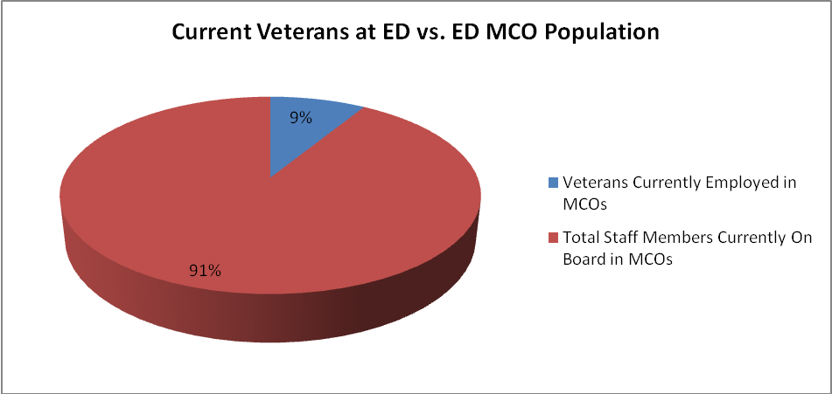
Note: Data derived from Veterans Employment Data as of 3-18-10 Report and U.S. Department of Education Human Capital Management Plan FY 2009–2012

A closer examination reveals that the highest number of Veterans employed fall within the areas of Series: 1811 Criminal Investigation at 20%; 2210 Information Technology (IT) Specialist at 15.5%; 1101 Loan Analyst/Institutional Review Specialist at 14.8%; and 0201 Human Resources Specialist at 14.3% (See Appendices B-I).

The areas that employ the lowest number of Veterans include Series: 1720 Education Program Specialist 4.7%, 1730 Education Research Analyst 3.1%, 0101 Vocational Rehabilitation Specialist 2.2%, and 1102 Contract Specialist with 0% employed.
Additional examination also reveals a decrease in the projected needs for several MCOs by FY 2011. Those MCOs include Series: 2210 IT Specialist, which projects a 9.2% decrease and where Veterans currently make up 15.5% of the total population; 0360 Equal Opportunity Specialist, which projects a 6% decrease and where Veterans make up 10.8% of the total population; and 0510 Accountant, which projects a 5.3% decrease and where Veterans make up 10.6% of the total population.

However, there are MCOs which project significant growth by FY 2011. Those MCOs include series 1730 Education Research Analyst, which projects a 28.1% increase in need for additional staff and where Veterans currently make up only 3.1% of the total population; and series 1511 Auditor, which projects a 21.8% increase in need for additional staff and where Veterans currently make up 12.7% of the total population. Overall, ED projects an approximate 9.2% increase in staffing needs for MCOs by 2011, even with the projected attrition rate of 8%.

Based on the analysis of ED’s current staffing by POs, the current and projected needs for MCOs and the commitment to increase Veteran hiring annually, there are opportunities for expansion in Veteran employment. Although these examples highlight the MCOs with the highest and lowest staff averages, there are opportunities for expansion at ED. The MCOs that project additional needs by FY 2011 include 1730 Education Research Analyst, 1511 Auditor, 1811 Criminal Investigator, 0905 Attorney, 1102 Contract Specialist, and 0501 Financial Management Specialist. Charts that illustrate these Workforce Profile examples can be found in the Appendices B-I.

V. Veteran Employment Strategies

The Government-wide Veterans’ Recruitment and Employment Strategic Plan for FY 2010-FY 2012 identifies a set of strategies to promote the increased employment of veterans. ED’s VEPO has already begun the process by meeting with executive leaders and analyzing workforce data to appropriately customize ED’s approach for implementing these strategies. The objective is to develop a set of planned activities and metrics that address the needs of the leaders, workforce, stakeholders and Veterans in focused areas of change:
  - Strategy 1: Foster Effective Leadership Commitment
  - Strategy 2: Develop Skills and Manage Veterans’ Employment
  - Strategy 3: Market and Outreach for Veterans’ Employment
  - Strategy 4: Build an Information Gateway

Foster Effective Leadership Commitment

The challenge to improve educational standards and practices across the nation to ensure global US competitiveness has reached critical proportions. The Secretary of Education and his leadership team are vigorous advocates of a Department which focuses on education excellence for all. With an unprecedented investment of over $4.35 billion dollar for school reforms, ED is relying on its workforce to assist in managing the American Reinvestment and Recovery Act (ARRA) funds for the Race to the Top and other education initiatives. Veterans can and will play an important role in this service delivery to the public.

ED’s leaders are fostering a vibrant culture which continues to welcome the leadership and technical competencies that Veterans bring to the ED community. Current Veteran programs are dispersed throughout ED’s principal offices and offer direct support to Veterans and to their families, and a recent department organizational realignment will bring these programs into a matrix structure to leverage visibility and information for Veterans. These programs include:

- Military Family Support

Educational Challenges Addressed at National Conference. On October 26, 2009, the ED Office of Parental Options and Information held a Project Director's Conference in Washington, DC which featured a session titled, Educational Support for Children and Youth of Military Families. This session offered successful options and best practices to address the issues of student mobility, frequent deployments, trauma and loss, and change within the military. It also focused on the unique challenges of military-connected students and current support to overcome these challenges which are provided by local, state and federal governments and organizations.

Military Child Education Coalition (MCEC) Briefed ED Senior Leader. On November 6, 2009, key MCEC leaders met with Scott Pearson, Associate Assistant Deputy Secretary of Education in the ED Office of Innovation and Improvement, in Washington, DC, to discuss the education of children and youth of military families. MCEC is a non-profit, world-wide organization focused on ensuring quality educational opportunities for all children of military families affected by mobility, family separation, and transition.

Secretary of Education and Retired Military Leaders Discuss Shared Goal. The Secretary demonstrated his strong support for veterans and military families on November 5, 2009, when he met with retired general and admirals at the National Press Club in Washington, DC. The Secretary and military leaders together called for greater investment in high-quality early learning programs to ensure that more young people graduate, obey the law, and have broader career options. These shared goals are especially critical for at-risk children, since quality early education has been proven to later result in higher graduation rates of young adults. The Secretary urged the Senate to pass the Early Learning Challenge Fund bill. The military leaders who met with the Secretary on November 5, 2009, were General Wesley K. Clark, U.S. Army, Former Supreme Allied Commander of NATO; Major General James A. Kelley, U.S. Army Former Deputy Assistant Secretary of Defense; Brigadier General John W. Douglass, U.S. Air Force; Former Assistant Secretary of the Navy; Rear Admiral James Barnett U.S. Navy, Chief, Public Safety and Homeland Security Bureau, Federal Communications Commission; Major General James W. Comstock, U.S. Army, Former Reserve Component Advisor, U.S. Central Command; and Former Under Secretary of the Army, Joe Reeder.
Education and Defense Meet in Arlington on Military Dependents' Issues. The Advisory Council on Dependents’ Education (ACDE) held its semi-annual meeting in Arlington on October 14, 2009, with ED represented by the Assistant Secretary for Elementary and Secondary Education and other key managers. ACDE is a 16-member team with representatives from ED and the Department of Defense (DoD), who together seek to develop and advocate the best means for reaching out to military families. At the October meeting, representatives developed recommendations to the Department of Defense Education Activity (DoDEA) Director concerning general policies for the operation of the Department of Defense Schools (DoDDS). ACDE also provided the Director with information about effective educational programs and practices that should be considered by DoDDS. Additional information about ACDE is available at:
http://www.pac.dodea.edu/AboutUs/advisorycouncil/ACDE_04.htm.

- Support to Veterans
Veterans Upward Bound Programs. ED has awarded seven colleges $250,000 each to develop and operate programs designed to help Veterans acquire the academic and other skills needed to succeed in postsecondary education. These programs provide academic guidance, personal counseling, mentoring and tutoring, and offer refresher courses for Veterans who did not complete high school or who may be high school graduates but delayed the start of their postsecondary education to serve in the military, and assist Veterans in obtaining support from sources such as VA, state agencies, Veterans’ associations and other organizations which aid Veterans.

Troops to Teachers Programs. ED and DoD are partners in the Troops to Teachers Program, which helps eligible military personnel begin new careers as teachers in public schools where their skills, knowledge and experience are greatly needed. This program also helps eligible individuals find employment in high-need local education agencies (LEAs) and charter schools. On July 9, 2009, ED employees attended an Education Policy Briefing which showcased this program and was an important step in assuring all ED staff members understand and share Veterans program information with the public.

Wounded Warriors Initiative. On July 25, 2008, the ED Assistant Secretary for Civil Rights announced the Wounded Warriors Initiative, calling for the Department’s full support of Veterans with disabilities as they pursue educational opportunities after military service. Most colleges and universities have not had much experience in accommodating students with the types of disabilities common among Wounded Warriors, including those with post trauma tic stress disorder (PTSD), trauma tic brain injury, late acquired blindness or deafness, significantly disfiguring burns, and multiple amputations, among others.

The Department is working closely with educational institutions and service providers to adopt innovative approaches to serve these Veterans. With full support from ED, many educational institutions are successfully conducting classes at VA facilities and developing cooperative efforts with VA rehabilitation services to help our nation’s Wounded Warriors transition smoothly to a college environment.

Leadership Commitments in the First 30 Days

In its commitment to leadership, ED has started establishing its governance structure for the Veterans Employment Program Office (VEPO) with the designation of the Deputy Principal Assistant Secretary for Management, Office of Management (OM) as the Veterans Interagency Council Representative and the designation of a full-time VEPO manager. Additionally, to enhance visibility and integration of the VEP, ED has realigned its Human Capital Management Staff, OM within the Human Capital and Client Services. All Veteran programs currently being implemented at the various POs will have a dotted line of reporting authority to the VEPO. This level of coordination will foster improved communications about Veteran focused activities, leverage resources and improve services to Veterans.

ED’s leadership team has also taken a number of additional steps to demonstrate its commitment to increasing Veteran employment. Department managers recently briefed OPM about the EdResume Pilot and are pleased that OPM is considering incorporating the Pilot program into its Veteran Employment Initiative as a part of the global strategies for all agencies. The Pilot concept has also been shared with outside organizations, and ED has established partnerships with key stakeholders interested in this outreach initiative, including Recruit Military, Corporate Gray, and the Wounded Warrior Project. These partnership organizations will work with ED in supporting Veteran recruitment, job fairs and resume services. For example, ED representatives are participating in a Corporate Gray Job Fair at the Convention Center in Washington, DC, on May 11, 2010.

With strong program support from ED’s CHCO, the Department continues to reflect improvements towards these efforts with OPM and the White House based on the Department’s published bi-weekly status updates. The CHCO directed that past practices relating to Veteran hiring practices be analyzed, to find key areas or issues that may need to be addressed to assure qualified Veterans receive full consideration for ED employment. The CHCO also endorsed marketing initiatives and training programs for all ED managers and employees to ensure they understand the contributions that qualified Veterans can make to the Department’s mission.

An early commitment by ED’s leadership focuses on training and support for its human resources practitioners who manage the day-to-day operations related to hiring qualified Veterans. Resources will be provided to assure that HR practitioners have the training and support they need to effectively carry out their duties, including USERRA training. Select staff members completed recent USERRA training on April 7, 2010, which assured that ED has the baseline compliance required on behalf of the Department. These HR practitioners should be able to share a high level of expertise with ED managers and offer guidance related to decisions on organizational and staffing needs.

ED leadership has reached out to both internal and external stakeholders, with the launch of early marketing and communication initiatives.

As ED has continued it stakeholder outreach, an ED Veterans Working Group was established, holding its first meeting on March 29, 2010, which included senior managers from the full range of ED program offices. Outside the Department, the ED Veterans Program will be profiled in GI Jobs and RecruitMilitary magazines, and the Department has partnered with the Graduate School Team (formerly USDA Grad School) to assure ED follows Best Practices guidelines in all its efforts related to hiring Veterans. The Department is also leveraging its use of the USAJOBS website with open continuous vacancy announcements as a vehicle for tracking veterans’ resumes. Initial use of this tool shows that ED will be able to obtain positive results as the Department seeks to identify qualified applicants and move them into appropriate available jobs.

Additionally, Michelle Draughn, Chief of Staff, of Federal Student Aid (FSA) Program is actively partnering on behalf of the Veterans’ employment initiative. This FSA partnership and collaboration offers a significant link to Veterans and military families, many of whom can only pursue career-related educational opportunities with financial assistance. Through the FSA Program, ED provides valuable financial aid and scholarship information to veterans and military families. At job fairs and other military events, FSA has been able to provide brochures and other relevant materials targeted to veterans, and to answer questions and educational and job opportunities. These efforts should ease and also encourage the transition of veterans into the Federal civilian workforce.

ED has incorporated ‘lessons learned’ from its ED Pathways to Leadership Program, and will apply these lessons in future educational offerings for its employees. The program will continue to be available to offer developmental opportunities to ED employees, including Veterans, throughout the Department, including the availability of independent study for employees through the centralized Information Gateway website, which is an important key to the program’s success.

The Department plans to conduct a Veterans Opportunity Day targeted for its own Veteran employees during the first quarter of 2011. This event will provide Veterans an opportunity to better understand the Department’s mission, its multitude of programs, and job opportunities and career prospects available to Veterans throughout the Department.

ED Department leaders have also reached out to Dennis May, Veterans Employment Coordination Service, Director for the Department of Veterans Affairs (DVA), for advice and guidance to assist in the development of ED’s Veterans employment initiative. The DVA’s program offers a model to ED leaders with ideas for best practices that can be incorporated in the Department’s own program, along with practical suggestions for ongoing program success. In addition, ED leadership contracted with STG International in the development of the Department’s operational plan based on input from internal and external stakeholders with an interest in the Veterans’ employment initiative. ED leaders and managers have established an ongoing relationship with DVA managers to assure the Department’s planned activities continue to move forward in the best possible manner.

Ongoing leadership objectives, milestones, and indicators of success are listed as follows:
Strategy 1: | Foster Effective Leadership Commitment | Milestones | Status
Goal 1: | Ensure Federal leaders advocate the value and importance of hiring Veterans in the federal government.
Objective 1.1: | Establish governance structure to provide program leadership and accountability.
Actions: | 1. Designate the Deputy Principal Assistant Secretary for Management as ED’s representative on the Government-wide Interagency Council.  2. Appoint dedicated Veterans Employment Program Manager.  3. Establish (Charter) a representative agency-wide Veterans Employment Steering Committee for plan implementation.  4. Establish agency-wide hiring strategy for Veterans.  5. Develop and disseminate via email the Veterans Employment Policy letter and post to the website. | 1. Q1 2010  2. Q2 2010  3. Q2 2010  4. Q2 2010  5. Q3 2010 | 1. Completed  2. Completed  3. Completed  4. Completed  5. In-progress
Objective 1.2: | Establish and implement targeted hiring strategies.
Actions: | 1. Increase all hires of Veterans yearly.  2. Identify number of projected positions open in the MCO professional and FSA positions available to Veterans.  3. Implement increased use of Veterans and student hiring authorities throughout ED and FSA.  4. Partner with the Office of Civil Rights to conduct the MD-715 Agency Self-Assessment to identify any potential barriers to employment for Veterans and implement corrective strategies. | 1. Q3 2010  2. Q3 2010  3. Q3 2010  4. Q1 2011 | 1.  2.  3.  4.

Objective 1.3: | Launch Organization-wide Flagship Initiatives.
Actions: | 1. Establish ED Veterans Employment and Hiring Solutions to  improve agency operations and provide oversight of ED  Veterans hiring processes and strategies.  2. Establish ED Veterans Dashboard to improve agency  transparency and collaboration, using input from EDHires  and FPSS to review monthly applicant and hiring data for  discussions at the HC Policy Steering Committee meeting. | 1. Q3 2010  2. Q3 2010 | 1. In-progress  2. In-progress
Objective 1.4: | Establish Success Indicators for Leadership Commitment.
Actions: | - Issue Veterans Employment Policy letter from the Secretary.  - Use data from EDHires to establish a baseline, track applicant flow data.  - Use FPPS to identify hires quarterly and establish the increase of Veterans hired.  - Baseline utilization of veteran hiring authorities.  - Use the Dashboard report to support the OPM annual report due Sept 1, 2010.  - Measure percentage of Veterans inquiring about jobs through email and phone contacts with the VEPO.  - Assess manager satisfaction with Veteran hires as a percentage of the applicant pool as measured by the Management Effectiveness Survey administered by the Office of Management.  - Develop and execute on schedule the OpenED Veterans Dashboard and post to the website. | 1. Q3 2010  2. Q3 2010  3. Q4 2010  4. Q4 2010  5. Q4 2010  6. Q4 2010  7. Q4 2010  8. Q3 2011 | 1. In-progress  2. In-progress  3.  4.  5.  6.  7.  8.

VI. Develop Skills and Manage Veterans Employment

Under the leadership of the CHCO, ED has identified 14 MCOs, as well as Mission Support Occupations (MSOs) within its department. Over the next 3 years, ED will conduct a series of competency assessments to ensure employees and managers possess the necessary knowledge, skills and abilities to accomplish the Department’s mission. Following the identification of competencies, ED will then conduct a gap analysis and develop effective strategies to close any detected gaps. ED has also identified four occupational series to focus initial outreach and hiring activities to increase veteran employment. These occupations are: Management and Program Analyst (series 343); Loan Analyst (series 1101); Education Program Specialist (series 1720); and Criminal Investigator (series 1811).

As ED pursues its MCO and MOS gap analysis and subsequent outreach, a key component will include targeted initiatives to hire qualified Veterans to fill these positions so critical to ED’s continuing success in helping America’s students achieve educational excellence. The Department seeks to employ qualified Veterans at all levels within the organization, bringing them in at the entry level and, as appropriate journeyman and management level positions. Skills development and promotional opportunities will be provided, with career ladders identified for Veterans and other employees in MCO and MOS categories. It is clearly in the Department’s best interest to invest in its employees as it seeks not just to hire, but also to retain a highly qualified and dedicated staff. Individual development plans will be encouraged to assist employees with the identification and pursuit of specific training and work experiences designed to encourage growth and the attainment of specific career objectives. ED will offer training courses, workshops and career counseling services, with particular attention to meeting identified needs of transitioning service members and their family members.
ED’s executive leadership will also take steps to assure employees throughout the Department are aware of Veterans’ contributions and potential as highly qualified staff members sharing in the development and operation of educational programs for American students. At the same time, the leadership and managers will make certain that appropriate resources are made available for Veterans’ training and talent development, reintegration, and support services. This approach implemented through the Strategy 2 goals, objectives and actions should help the Department achieve its strategies of increasing Veteran employment and retaining new employees as part of the Federal civilian workforce.

Strategy 2: | Develop Skills and Manage Veterans Employment | Milestones | Status
Goal 2: | Align Veteran’s and transitioning service members’ skills and career aspirations to Federal employment opportunities.
Objective 2.1: | Develop Systems that Prepare Veterans for High Demand/Mission Critical Positions (Skills Development).
Actions: | Strengthen Veterans on boarding, service member transition, marketing efforts through New Employee Orientation Program and HR Essentials.  - Develop EDVeterans Skills Catalog for transitioning service members and Military spouses which describes ED MCO’s and mission-support professional positions and maps skill sets to similar military occupation specialties (MOS).  - Launch VetsConnectED, a voluntary network of ED’s Veterans.  - Develop Interviewing Skills and Resume Writing workshops jointly with veteran service organizations.  - Coordinate strategy to deliver workshops and career counseling services for transitioning service members and Military spouses.  - Incorporate mentoring component of VetsConnectED into Mentoring at ED program for seamless integration to improve the retention of Veterans.  - Establish greater organizational-wide awareness and utilization of resources for Veteran’s training and talent development, reintegration, and support services.  - Measure and track Veterans retention annually. | 1. Q3 2010  2. Q3 2010  3. Q3 2010  4. Q4 2010  5. Q4 2010  6. Q4 2010  7. Q4 2010  - Q4 2010  8. Q4 2010 | 1.  2.  3.  4.  5.  6.  7.  8.
Objective 2.2: | Identify specific training and actions Hiring Officials will be required to take to expand the applicant pool of Veterans when partnering with other organizations. (Manage employment)
Actions: | - Schedule annual training for hiring managers on veteran’s special hiring authorities for veterans and reasonable accommodations.  - Identify partnership organizations for feeding the veteran pipeline and developing transition workshops.  - Share workforce planning data and map strategy to increase hiring in Principal Offices.  - Expand training for hiring managers to include Federal hiring authorities for Veterans, i.e. VRA, VEOA, 30% or more disabled Veterans and disabled veterans training programs. | 1. Q2 2010  2. Q2 2010  3. Q1 2011  4. Q2 2011 | 1. On going  2. In-progress  3. In-progress  4.
Objective 2.3: | Identify specific training and actions HR hiring specialists to expand applicant pool of Veterans when partnering with other organizations.
Actions: | - Schedule annual training for HR specialists on the veteran’s special hiring authorities.  - Create FAQs for hiring managers on Federal hiring authorities for Veterans, i.e. VRA, VEOA, 30% or more disabled Veterans and disabled veterans training programs.  - Identify partnership organizations for feeding the veteran pipeline and developing transition workshops.  - Analyze workforce planning data and map strategy for MCO and mission support occupations by Principal Offices. | 1. Q2 2010  2. Q2 2010  3. Q2 2010  4. Q3 2010 | 1. In-progress  2. Completed  3. In-progress  4. On going
Objective 2.4: | Establish Success Indicators for Skills Development and Employment Management.
Actions: | 1. No. of workshops developed jointly with  Steering Committee and delivered to  Veterans.  2. No. of training sessions held for HR  specialists and managers.  3. Level of satisfaction with the workshops  meeting stated objectives to increase skills  and knowledge of Veterans.  4. No. of executed Memoranda of Agreements  with partnering organizations. | 1. Q3 2010  2. Q3 2010  3. Q3 2010  4. Q4 2010 | 1. On going  2. On going  3. On going  4.

VII. Marketing and Outreach
Successful marketing to encourage the employment of qualified Veterans requires that ED leadership, along with VEPO and OCO, implement an effective communications plan with specific strategies targeted to managers and supervisors. Marketing strategies must also include other key stakeholders both inside and outside the Department. At all levels within the Department, employees should be familiar with, and encouraged to think about, the many ways that hiring qualified Veterans will enhance their own ability to carry out ED’s mission. It is vital that all employees understand the Department’s commitment related to increased Veteran employment and are able to respond to general questions.

All of ED’s executive leadership, along with ED’s managers, supervisors and hiring officials, share a key role in ensuring that increased numbers of qualified Veterans are hired to serve within the Department. The VEPO, HCCS, and OCO managers and staff are also key stakeholders in this shared initiative. In fact, all ED employees should be considered stakeholders who have an interest in the increased employment of qualified Veterans to help them carry out the day-to-day operations of the Department, and ED will implement a multi-faceted approach to communicate information about hiring qualified Veterans to all ED stakeholders. For published materials, it is critical that distribution is timely, not only within ED headquarters but also nationwide, to all ED employees and other stakeholders.

An additional key to the marketing campaign will be outreach to external stakeholders, including Veterans Service Organizations (VSOs), Military Installations and Transition Centers, Transition Assistance Programs (TAP), Professional Military Organizations, and to the extent possible, all Veterans. Of particular interest to ED will be outreach to educational institutions, focusing on colleges and universities where Veterans are studying to prepare themselves for employment in the civilian marketplace.
As with internal stakeholders, ED should use a multi-faceted approach to communicate information about the Department’s interest in hiring qualified Veterans. The marketing campaign should be well-coordinated, ongoing and should use a variety of tools and resources, some of which are detailed (on the next page), to reach as many Veterans and family members as possible.

Strategy 3: | Market and Outreach for Veterans Employment | Milestones | Status
Goal 3: | Develop and Execute a Marketing, Education and Communications Campaign to Promote Veteran’s Recruitment and Employment.
Objective 1: | Establish effective Internet outreach practices capitalizing on social media networks.
Actions: | 1. Social Media site: VEPO will join Facebook and connect with veteran communities. VEPO will establish a Facebook page that promotes ED’s available positions at the Department.  2. Produce an interactive and user friendly VEOP website/video targeted for the veteran professional population. When applicants visit the new VEPO website, applicants will have an active interface in which they can click on a map and see exact locations of job fairs ED/ Veterans Employment Program Operations will be attending, and preview a revised version of their recruitment video as seen on the VEPO website and YouTube.  3. Banner Ads: Develop, design and create ads for recruitment advertisement.  4. Link with State Employment Commission One –stop Centers; Veterans Service Organization (VSO); American Legion, GI Forum, Professional Military Organizations, etc.  5. ED “The Career Events Calendar”: A simple interactive guide to all ED Career Events throughout the United States, which will be a great user-friendly tool for managing events and promoting them to the public.  6. ED/Veteran’s Video: Create video by ED/Office of Communications & Outreach. Put on YouTube and VEPO website homepage.  7. Virtual Career Fair: VEPO will partner to offer an ED Virtual Career Fair website. Once developed this site can be used by various occupations to recruit for ED positions. Recruitment Fairs can be held periodically on the website. | 1. Q4 2010  2. Q4 2010  3. Q4 2010  4. Q4 2010  5. Q4 2010  6. Q1 2011  7. Q1 2011 | 1.  2.  3.  4. On going  5. On going  6.  7.
Objective 2: | Establish effective print media campaign.
Actions: | 1. Corporate Gray: An on-line and print company that provides employment information for transitioning military personnel.  2. Internal Communication: Write announcements and participate in HCCS Conference Calls that will highlight the promotion of Veterans by job fair attendance, college-Veteran highlights, etc.  3. Newsletters: Office of Communications and Outreach “Touching Base”, “ED Review”, etc., will solicit stories, promoting Veteran hires, from the VEPO, ED Recruiters, and HR Representatives.  4. Reflect ED transformation into the 21st century to include new layout, design colors, and information about the ED/VEPO mission and services.  5. VEPO Brochures: Develop and distribute nationwide VEPO brochures. | 1. Q2 2010  2. Q2 2010  3. Q3 2010  4. Q4 2010  5. Q4 2010 | 1. On going  2.  3.  4.  5.
Objective 3: | Execute effective on-site recruitment activities.
Actions: | 1. Presidential Management Fellows Program (PMF): VEPO/ED Recruiters will actively participate in the annual recruitment event. ED will target Mission Critical Positions.  2. Job fairs: Human Resources Officers (HRO) will be a liaison between VEPO, ED Recruiters, HR Technical Specialist and job-fair host, so that ED will continue to have a significant presence at job fairs promoting ED as the “Best Place to Work.”  3. Workshops and seminars: HRO will be a liaison between VEPO, ED Recruiters, HR Technical Specialist and job workshop promoters, so that ED can continue its mission of training potential employees in anticipation for working at ED. | 1. Q2 2010  2. Q2 2010  3. Q2 2010 | 1. Completed  2. On going  3. On going
Objective 4: | Establish Success Indicators for Marketing and Outreach.
Actions: | 1. Number of sign-in visitors at the job fairs.  2. The number of inquiries from OPM-PMF data base and follow-up emails.  3. Publish ED’s Veterans’ Employment Campaign materials using various media.  4. Use marketing materials developed by OPM as part of external outreach efforts by April 30, 2010.  5. Number of Veteran’s visitor clicks to the website.  6. Number of visitors who click on the VEPO internet banner.  7. Number of follow-up emails and visitor clicks to the VEPO website.  8. Number of visitors who click on VEPO YouTube internet link.  9. Results of external surveys posted on the website to evaluate offsite and onsite marketing of outreach and partnerships with DOD, VA and DOL. | - Q2 2010  - Q2 2010  - Q3 2010  - Q3 2010  - Q3 2010  - Q3 2010  - Q3 2010  - Q4 2010  - Q4 2010 | 1. On going  2. On going  3. On going  4. On going  5. On going  6. On going  7.  8.  9.

VIII. Build an Information Gateway

As part of building an information gateway, the development of a Department-wide Communication Plan will serve as the foundation for communicating information to internal and external stakeholders. This plan will include themes, a consistent message, and provide current and accurate information to employees, managers, Veterans and the public. It will include the specific items which need implementation and a timeline for Department-wide compliance. To operate effectively, the ED Communication Plan and the associated marketing campaign identified earlier will align with other Federal initiatives and Government-wide transition assistance programs, such as Higher Education Act (HEA), which authorizes the major federal student aid programs that are responsible for the majority of financial assistance to postsecondary students. Communication and marketing will also aligned with programs in the Department of Labor (DOL), Department of Veterans Affairs (DVA), and Veterans Service Organizations (VSOs). All marketing materials should feature branding unique to ED, with consistent information regarding Veterans’ employment on all internal and external websites, materials, and resources.

Several key actions have already been initiated as part of ED’s outreach efforts to reach external stakeholders, including Veterans.
The ED Veterans Program will be profiled in GI Jobs and Recruit Military magazines, publications known to be key resources for Veterans seeking information about benefits and career opportunities.

VEPO has also partnered with the Graduate School Team (formerly USDA Graduate School) to assure utilization of Best Practices in developing and implementing ED’s program.

ED staff recently developed the ED Resume Pilot, which OPM is now considering for incorporation as one its recommended Veteran Employment Initiatives, to be shared with other Federal agencies as they develop and implement their own plans for increasing Veteran employment. To further market the ED Resume Pilot concept and expand its scope, ED has developed partnerships with OPM, Recruit Military, Corporate Gray, and the USMC Wounded Warrior Program.

Strategy 4: | Build an Information Gateway | Milestones | Status
Goal 4: | Ensure Veterans, transitioning service members and their families, HR professionals, and hiring managers receive accurate and consistent information regarding Veteran’s employment.
Objective 1: | Develop an enterprise-wide communications strategy.
Actions: | 1. Assure that marketing materials include information on the Federal Student Aid (FSA) Veteran Education Benefits Program and related resources.  2. Align the Flagship OpenEd Veterans Plan with the overall ED’s Open Government Plan.  3. Disseminate marketing/information materials and an agency brand to ensure consistent information regarding Veterans’ employment on all internal and external websites, materials, and resources.  4. Incorporate the Communications Plan, reflecting ED’s unique marketing and branding, with the Flagship Initiative OpenEd Veterans Employment and Hiring Solutions. | 1. Q2 2010  2. Q3 2010  3. Q4 2010  4. Q 4 2010 | 1. On going  2.  3.  4.
Objective 2: | Develop communication and feedback systems to insure a smooth flow of information.
Actions: | 1. Determine information technology requirements that support the goals and objectives of an agency-wide Veterans Employment Program.  2. Establish and post FAQs.  3. Establish a link to OPM’s Veterans Employment website for all ED job announcements.  4. Create ED Veterans Employment Program web pages on ED.gov, ConnectED, OpenED, and other FSA Portal.  5. Leverage current ED learning technology and IT systems planning to maximum distribution of training and VEP information agency-wide. | 1. Q2 2010  2. Q3 2010  3. Q3 2010  4. Q3 2010  5. Q3 2010 | - Completed  2.  3.  4.  5.
Objective 3: | Establish Success Indicators for the Information Gateway.
Actions: | 1. Establish schedule for site development and monitor ED links.  2. Track distribution of materials. | 1. Q4 2010  2. Q2 2011 | 1.  2.

Appendices
Appendix A

MISSION CRITICAL OCCUPATIONS/MISSION SUPPORT OCCUPATIONS FORECASTED NEEDS

SERIES | OCCUPATION | PROJECTED NEED  FY 2011
0101 | Vocational Rehabilitation Specialist | 46
0201 | Human Resources Specialist | 57
0343 | Management and Program Analyst | 694
0360 | Equal Opportunity Specialist | 218
0501 | Financial Management Specialists/Audit Resolution Specialist | 60
0510 | Accountant | 125
0511 | Auditor | 134
0905 | Attorney | 397
1101 | Loan Analyst/Institutional Review Specialists, Case Management Specialists | 245
1102 | Contract Specialist | 68
1720 | Education Program Specialist | 338
1730 | Education Research analysts | 41
1811 | Criminal Investigators | 93
2210 | Information Technology Specialist | 187
 | Total | 2,703

Source: U.S. Department of Education Human Capital Management Plan Fiscal Years 2009–2012

Appendix B
TOTAL ED HIRES BASED ON AVAILABLE HIRE DATA *Source: Ed Hires Applications for Vacancies Opened Between 10/01/07 – 09/30/09 Report by Hire Date
Principal Office | 10-Point Compensable Disability Preference (CP) | 10-Point 30 Percent Compensable Disability Preference (CPS) | Non-Veteran (NV) | 5-Point Preference (TP) | 10-Point Disability Preference (XP) | Total Number of Hires by Principal Office
OCIO |  | 1 | 6 |  |  | 7
OCO-HQ |  |  | 2 |  |  | 2
OCR-HQ |  |  | 5 |  |  | 5
OLEA |  |  | 1 |  |  | 1
OESE |  | 1 | 24 | 2 |  | 27
OGC
OIG-HQ |  | 1 | 17 | 4 |  | 22
OII |  |  | 5 |  |  | 5
OLCA |  |  | 1 |  |  | 1
OM | 1 | 3 | 36 | 5 | 2 | 47
OPE |  |  | 10 |  |  | 10
OPEPD | 1 | 1 | 9 |  |  | 11
OS | 1 |  | 7 |  |  | 8
OSDFS |  |  | 5 |  |  | 5
OSERS |  |  | 15 | 2 |  | 17
OVAE |  |  | 11 |  |  | 11
SF-OCO
CHI-OCR
DAL-OIG | 1 |  |  |  |  | 1
DEN-OIG
FSA | 4 | 1 | 43 | 3 |  | 51
IES |  |  | 24 |  |  | 24
OCFO |  |  | 21 | 1 |  | 22
TOAL | 8 | 8 | 242 | 17 | 2 | 277

Appendix C

Current Veterans at ED compared with the Total MCO Population

Note: Data derived from Veterans Employment Data as of 3-18-10 Report and U.S. Department of Education Human Capital Management Plan FY 2009–2012

Appendix D

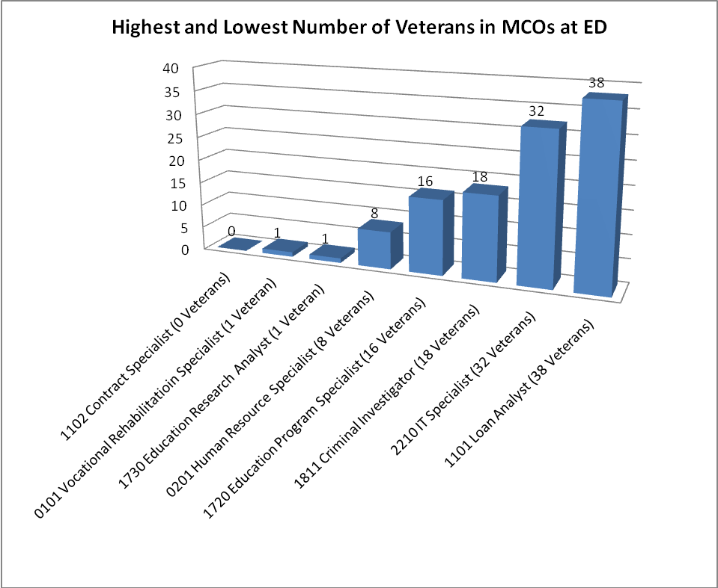

Note: Data derived from Veterans Employment Data as of 3-18-10 Report

Appendix E

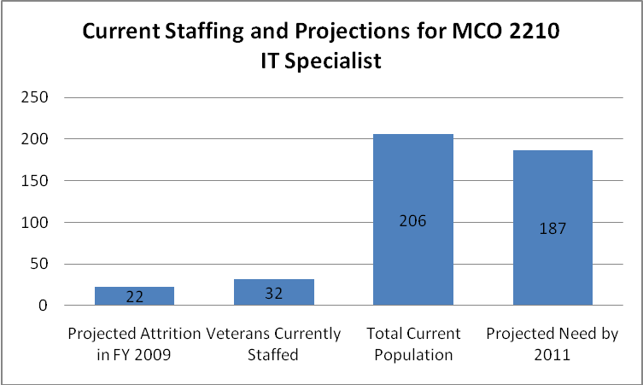

Note: Data derived from Veterans Employment Data as of 3-18-10 Report and U.S. Department of Education Human Capital Management Plan FY 2009–2012

Appendix F

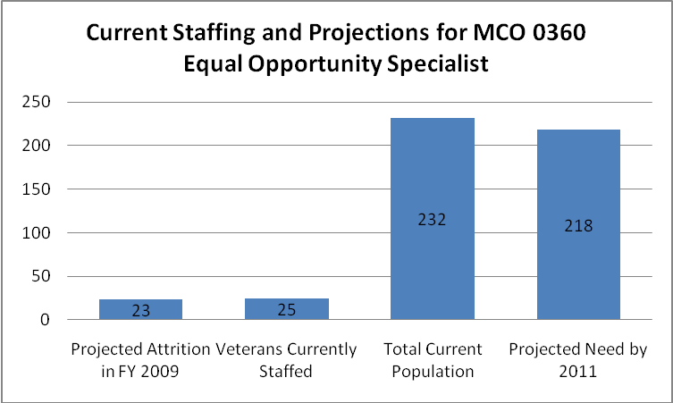

Note: Data derived from Veterans Employment Data as of 3-18-10 Report and U.S. Department of Education Human Capital Management Plan FY 2009–2012

Appendix G

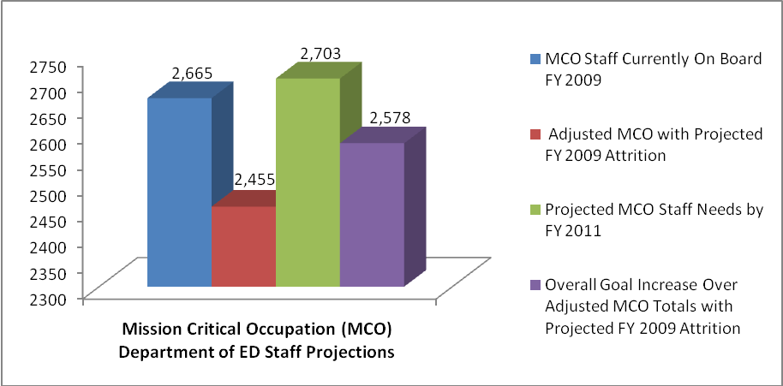

Note: Data derived from Veterans Employment Data as of 3-18-10 Report and U.S. Department of Education Human Capital Management Plan FY 2009–2012

Appendix H

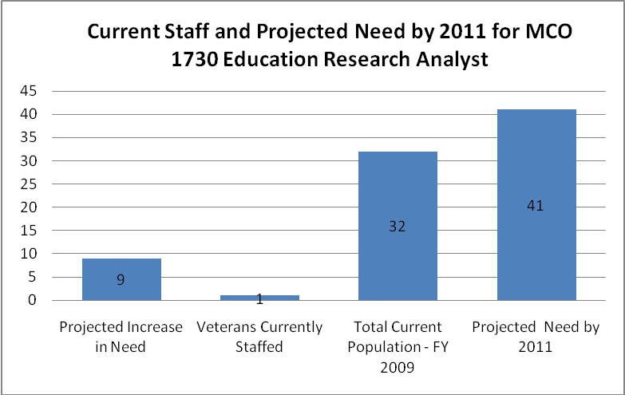

Note: Data derived from Veterans Employment Data as of 3-18-10 Report and U.S. Department of Education Human Capital Management Plan FY 2009–2012

Appendix I

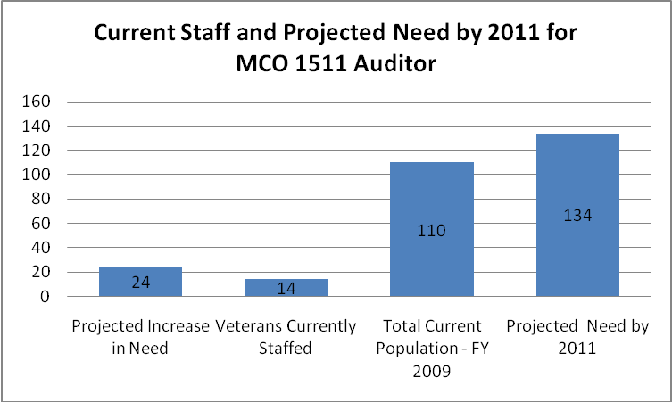

Note: Data derived from Veterans Employment Data as of 3-18-10 Report and U.S. Department of Education Human Capital Management Plan FY 2009–2012



U.S. Department of Education
400 Maryland Avenue, SW
Washington, D.C. 20202

