TO: Department of Education Grant Recipients

FROM: Phillip Juengst, Deputy Assistant Secretary
Office of Acquisition and Grants Administration

SUBJECT: Single Audit Submission: Reporting subprogram Assistance Listing Number (ALN) alphas in the Federal Audit Clearinghouse single audit submission form (Form SF-SAC)

DATE: August 4, 2021

The Department of Education (Department) is sending this e-mail notification and memo to inform Department grant recipients of guidelines for identifying subprogram ALNs in Form SF-SAC, the cover form completed as part of the submission of a single audit to the Federal Audit Clearinghouse (FAC).

Specifically, in order to more precisely identify grant program expenditures, the Department requests that grantees include on the Schedule of Expenditures of the Federal Awards (SEFA) page of Form SF-SAC, if applicable: (1) whether the program is novel coronavirus 2019 (COVID-19) relief assistance (see list below of COVID-19 programs); and (2) the subprogram ALN alpha.

Action Requested: On page 2 of the Form SF-SAC, under “Part II: FEDERAL AWARDS” in the chart labeled “Schedule of Expenditures of Federal Awards” under column c with the heading “Additional Award Identification” include the phrase “COVID-19” if the program is considered COVID-19 assistance). Then place a comma (,) after COVID-19 and include the full ALN number and alpha character (A, B, C, etc.) (see Example 1 below).

OMB’s instructions to auditees in the FY 2020 Compliance Supplement instructed auditees to include COVID-19 in Column c (see 2020 Compliance Supplement Appendix VII beginning on page 8-VII-2 at https://www.whitehouse.gov/wp-content/uploads/2020/08/2020-Compliance-Supplement_FINAL_08.06.20.pdf)

Additionally, if the program is not considered a “COVID-19” program, include the full ALN and alpha character in column c (see Example 2).
Figure: The box to include this information on the SEFA is circled in the figure below:

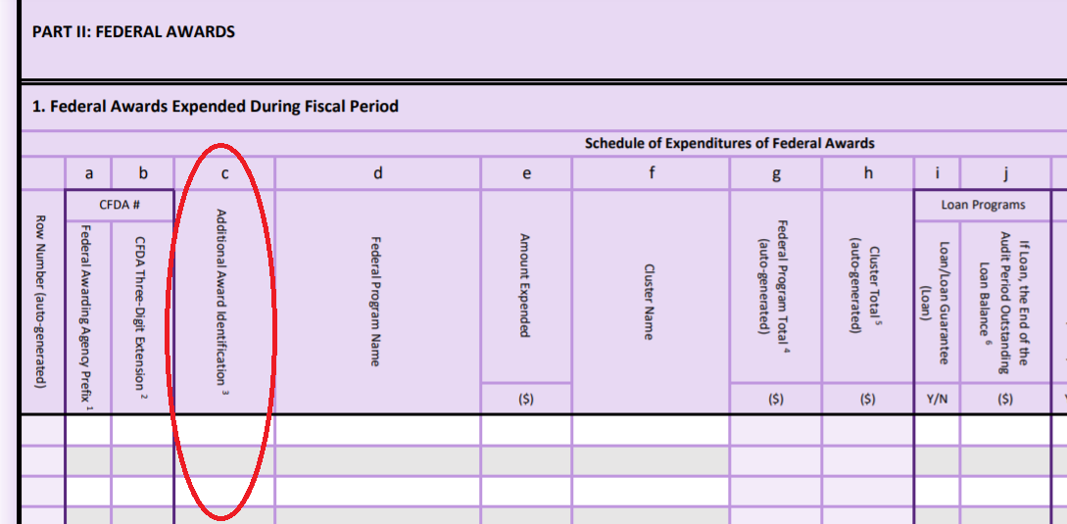

Example 1: A grantee listing the program “Higher Education Emergency Relief Fund – Student Aid Portion” (ALN 84.425E) on the SEFA would complete the SEFA in the following manner highlighted in yellow:

 | a | b | c | d
Row Number (auto generated) | Federal Awarding Agency Prefix | CFDA Three-Digit Extension | Additional Award Identification | Federal Program Identification
1 | 84 | 425 | COVID-19, 84.425E | Education Stabilization Fund

Note: Please note the inclusion of “COVID-19” in column c since the Higher Education Emergency Relief fund (HEERF) is considered a COVID-19 relief program.

Example 2: A grantee listing the program “Title I Grants to Local Educational Agencies” (ALN 84.010A) on the SEFA would complete the SEFA in the following manner highlighted in yellow:

 | a | b | c | d
Row Number (auto generated) | Federal Awarding Agency Prefix | CFDA Three-Digit Extension | Additional Award Identification | Federal Program Identification
1 | 84 | 010 | 84.010A | Title I Grants to Local Educational Agencies

Effective Date: This guidance is effective for all single audit submissions that include Department programs on or after Monday, August 9, 2021. The Department may ask grantees that submit Single Audits on or after this date that do not follow these guidelines to resubmit their Form SF-SAC so the Department might better identify grantee subprogram expenditures by ALN alpha.

Questions: Questions regarding implementation of this guidance should be emailed to Patrick Smith, Audit Liaison Officer, of the Office of Acquisitions and Grants Administration (OAGA) at patrick.smith@ed.gov.

DEPARTMENT OF EDUCATION COVID-19 PROGRAMS

Assistance Listing Number and Alphabetic Character | Name
84.425A | Education Stabilization Fund–State Educational Agency (Outlying Areas)
84.425B | Discretionary Grants: Rethink K–12 Education Models Grants
84.425C | Governor’s Emergency Education Relief Fund
84.425D | Elementary and Secondary School Emergency Relief Fund
84.425E | Higher Education Emergency Relief Fund–Student Aid Portion
84.425F | Higher Education Emergency Relief Fund–Institutional Portion
84.425G | Discretionary Grants: Reimagining Workforce Preparation Grants
84.425H | Education Stabilization Fund–Governors (Outlying Areas)
84.425J | Higher Education Emergency Relief Fund–Historically Black Colleges and Universities
84.425K | Higher Education Emergency Relief Fund–Tribally Controlled Colleges and Universities
84.425L | Higher Education Emergency Relief Fund–Minority Serving Institutions
84.425M | Higher Education Emergency Relief Fund–Strengthening Institutions Program
84.425N | Higher Education Emergency Relief Fund–Fund for the Improvement of Postsecondary Education Formula Grant
84.425P | Higher Education Emergency Relief Fund–Institutional Resilience and Expanded Postsecondary Opportunity
84.425Q | Higher Education Emergency Relief Fund–Proprietary Institutions Grant Funds for Students
84.425R | Emergency Assistance for Non-Public Schools

Previously known as Code of Federal Domestic Assistance (CFDA), e.g., 84.425E (Higher Education Emergency Relief Fund (HEERF)-Student Aid Portion).
This memo does not apply to Department for-profit grantees, foreign public grantees, or foreign organization grantees that do not submit single audits to the Federal Audit Clearinghouse (FAC).
An example Form SF-SAC is available here in the FAC instructions and the page referenced is PDF page 16.

