

U.S. Department of Education

Education Data Management and IT Services (EDMITS)

DMS State User Guide

Submitted by:

Applied Engineering Management Corporation

13880 Dulles Corner Lane, Suite 300

Herndon, VA 20171

Contract Number: 91990019A0008

Document Type: Contractual

Document Classification: For Official Use Only

January 2022

**DOCUMENT CONTROL**

DOCUMENT INFORMATION

| **Title:** | DMS State User Guide |
| --- | --- |
| **Revision:** |  |
| **Issue Date:** | December, 2021 |
| **Security Level:** | Unclassified – For Official Use Only |
| **Filename:** | dms-state-user-guide |

DOCUMENT HISTORY

| **Version Number** | **Date** | **Summary of Change** |
| --- | --- | --- |
| 1.0 - 4.0 |  | Versions 1.0 through 4.0 are for Data Management System prior to SY 2020-21 |
| 5.0 |  | Rolled over for SY 2020-21 |
| 5.1 | January 2022 | New! Section 7.0 - Notification Report |

**RELEASE AUTHORIZATION**

| **Role** | **Responsible Individual** |
| --- | --- |
| Author | Kara Osmonson |
| QA | Matt K. Boli |
| Release Authority | Steve Lenker |

Table of Contents

1.0 INTRODUCTION 1

1.1 Document Purpose 1

1.2 Data Management System (DMS) Overview 1

1.3 Document Organization 1

1.4 Related Documents 1

1.5 Other Resources 2

1.6 Minimum System Requirements to use the DMS 2

2.0 DMS Data Flow and Minimum System Requirements 3

2.1 DMS Data Flow 3

3.0 Account Administration 4

3.1 Establishing a DMS account 4

3.2 Logging into the DMS 4

3.3 Password Recovery 5

3.4 Administrative Functions (for State Administrators only) 6

3.4.1 Create New User 6

3.4.2 Manage User Settings 7

3.4.3 Delete Users 7

3.4.4 Quarterly User Reviews 7

4.0 Landing Page and Summary of DMS Functions 8

5.0 DMS Data Viewer 12

5.1 Sort 13

5.2 Show/Hide Columns 13

5.3 Search/Filter 13

5.4 Detailed entity information 14

6.0 Error Reports 15

6.1 View Error Reports 15

6.2 Resolving Errors 17

6.3 Repeat Errors Report 19

6.4 5-Year Edits Report – CCD only 22

6.5 Additional Questions 23

7.0 Notification Report 25

8.0 User Support 27

1. INTRODUCTION
   1. Document Purpose

The purpose of this guide is to provide state users with the information needed to use the Data Management System (DMS).

* 1. Data Management System (DMS) Overview

The DMS is an online system designed to manage the collection of ED*Facts* files pertaining to the Common Core of Data (CCD) and the Gun-Free Schools Act (GFSA). State education agencies (SEAs) submit all data through the ED*Facts* Submission System (ESS); final data processing takes place through the DMS. States use the DMS to review and respond to error reports, monitor data processing, and verify that resubmitted data files (resubmitted through ESS) resolve outstanding data issues.

One of the primary goals of the DMS is to increase the level of transparency in data processing. As soon as data are submitted through ESS and replicated to the DMS, SEA users can view error reports by logging into the system. The DMS includes a comment system that allows SEAs to provide responses and explanations for data anomalies identified in the error reports. DMS Data Analysts working with the U.S. Department of Education (ED) have access to the same error reports and can review state comments and explanations in real time. The DMS increases transparency and reduces the data collection burden on states by creating a smoother and quicker data edit process.

* 1. Document Organization

This document is organized as follows:

* Section 2 provides a high-level illustration of the data flow;
* Section 3 assists uses with logging into the DMS and assigning user permissions;
* Section 4 shows the landing page that SEA users are directed to after logging into the DMS;
* Section 5 details the Data Viewer functionality for users;
* Section 6 shows a summary by ESS file of possible errors;
* Section 7 is the description of the Notification Report; and
* Section 8 provides DMS Support contact information.
  1. Related Documents
* [**ESS User Guide**](https://www2.ed.gov/about/inits/ed/edfacts/index.html) – Provides assistance to users logging into and using the ESS.
* [**ED*Facts* Workbook**](http://www2.ed.gov/about/inits/ed/edfacts/eden-workbook.html) – Provides an overview of ESS data submissions as well as resources SEAs can use for support. This document includes a detailed crosswalk between the data fields in the CCD and the ED*Facts* data files SEAs submit.
* [**Business Rules Single Inventory**](https://www2.ed.gov/about/inits/ed/edfacts/business-rules-guide.html) (BRSI) – Provides a single inventory of all data quality business rules applied to ED*Facts* data files.
  1. Other Resources
* **CCD** –The official CCD data releases are available through the CCD website ([www.nces.ed.gov/ccd](http://www.nces.ed.gov/ccd)). This site includes data files as well as accompanying file documentation and release notes.
* **GFSA** – The official GFSA Initiative site (<https://www2.ed.gov/about/offices/list/osdfs/gfsa.html>) provides background information on the Gun-Free Schools Act as well as documentation and other supporting materials.
* **ED*Facts*** – The official ED*Facts* Initiative site ([www2.ed.gov/about/inits/ed/edfacts/index.html](http://www2.ed.gov/about/inits/ed/edfacts/index.html)) provides background information on the ED*Facts* Initiative as well as documentation and other supporting materials.
* **ED*Facts* Communities 360o** – An on-line clearinghouse maintained by Partner Support Center (PSC) for ED*Facts* data providers (https://edfacts.communities.ed.gov/#program). This site includes the ED*Facts* Data Submission Organizer, an archive of updates from PSC, a calendar of upcoming file submission deadlines, and links to other related sites.
  1. Minimum System Requirements to use the DMS

The DMS is compatible with all versions of Internet Explorer from version 9.0 and up. It is also compatible with all versions of Chrome, Firefox, and Safari. Cookies must be enabled, regardless of the browser in use.

1. DMS Data Flow and Minimum System Requirements
   1. DMS Data Flow

Figure 2.1 below provides a high-level illustration of the data flow from initial state submission through ESS and the DMS to publication.



**Figure 2.1:** DMS Data Flow

States submit all data files through ESS which are subjected to ESS format, validation, and submission edits. Each successful submission (and resubmission) is replicated nightly to the DMS. Following replication to DMS, the business rules run automatically to identify potential data errors.

The states and DMS Data Analysts work together to review error reports generated by the DMS. States are asked to resolve outstanding data questions through ESS resubmission, or provide responses explaining why the data questions raised are not errors.

Once all data questions are resolved or documented, the DMS Data Analysts move the data into publication, which freezes the data for release. Analysts conduct final data reviews on the data publication file. The CCD data may be subjected to data adjustments, including imputation at the state level and suppression of local education agency (LEA)- and school-level data flagged for 5-year edits.

1. Account Administration

The DMS provides automatic password resets for all users; state administrators can add new users and assign their roles.

* 1. Establishing a DMS account

The ED*Facts* Coordinator(s) in each state administer the DMS accounts for their state and can add users as needed. New ED*Facts* Coordinators can contact PSC to obtain DMS login credentials. Additional users within a state may include the CCD Non-Fiscal Coordinator as well as state staff in other program offices that the ED*Facts* Coordinator(s) would like to review and respond to data questions. The maximum number of users that can be assigned within a state is ten. If a state needs more than ten users, the ED*Facts* Coordinator may contact PSC.

The sequence of emails users receive to establish their DMS account is as follows:

* **Email #1:** This email, with the subject line “[ED*Facts* DMS] Account Created” provides a link to confirm the account email address.
* **Email #2:** This email, with the subject line “[ED*Facts* DMS] Temporary Account Password” provides a temporary account password. This password expires in 48 hours if no action is taken to set up the account. In the case of password timeout, contact the PSC to restart the process.
* **Email #3:** Users verify their email accounts, and receive a third email with the subject line “[ED*Facts* DMS] Email Account Verified”. Follow the steps in this email to log into the account. For the initial login, enter the temporary account password received in email #2, which can be changed after logging in for the first time. Passwords must be at least 6 characters long and cannot be the same as the current password or user email address.
  1. Logging into the DMS

SEA users access the system through the DMS using a secure login site:

[https://surveys.nces.ed.gov/CCDDMS/login/go](https://surveys.nces.ed.gov/CCDDMS/login/go" \o "DMS Login website)

After opening the DMS page, a notification appears requiring users to accept the terms of consent to monitoring before accessing the application.

After accepting the terms, log into the DMS using the following three steps:

1. Enter email address
2. Enter Password
3. Click the **Login** button

Screenshot from the DMS showing the spaces to enter registered e-mail address, password, and then click login.

**Figure 3.1:** DMSLogin screen

Contact PSC for assistance with difficulties logging into DMS.

* Toll Free: 877-457-3336
* Federal Relay Service: 800-877-0996 (Voice/TTY) / [federalrelay@sprint.com](mailto:federalrelay@sprint.com)
* Email: [ED*Facts*@ed.gov](mailto:edfacts@ed.gov)

PSC is available to answer questions from 8:00 a.m. to 6:00 p.m. ET, Monday through Friday, excluding federal holidays.

* 1. Password Recovery

The DMS includes an automated password recovery system for users who do not remember their password. To access this system, click the **Forgot Password?** link on the login screen.

DMS Login screen with "Forgot Password" link highlighted.

**Figure 3.2:** Login screen highlighting **Forgot Password?** link

On the second screen (Figure 3.3), enter the email address to receive a return email with a password change link.

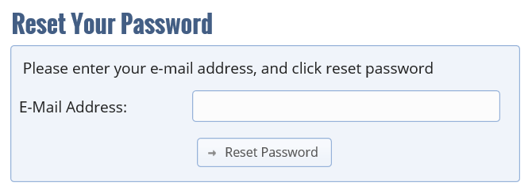

**Figure 3.3:** Reset password screen

* 1. Administrative Functions (for State Administrators only)

State Administrators (the ED*Facts* Coordinator(s) in each state) may manage user access and roles for users within their state. A state can have up to two administrator accounts. All ED*Facts* Coordinators are assigned administrative functions with their DMS account. For users with State Admin access, these functions are accessible at the top of the DMS page:

To access Admin functions, click **Admin**, followed by **Admin Main.**

State Admins can select: Create New User, Manage User Settings, and Delete Users.

* + 1. Create New User

An administrator can add new users, including the State CCD Non-Fiscal Coordinator (if different from the ED*Facts* Coordinator) and users who might review or respond to data error reports, to match the workflow in the state.

Steps to add new users:

1. Enter the email address of the new DMS user.

Add the email in the box and click **Register**. After clicking **Save**, the new user will be registered and receive an email with login information.

1. Assign a Role and Group to the user.

Rolesets the privileges a user has when using the DMS site. Users can either be an Analyst or an Administrator. An Analyst is a state user able to review data, respond to comments, and provide general support to DMS. An Administrator has the same privileges as an Analyst, and can also manage user accounts.

The ED*Facts* Coordinator assigns the user to the role for the data they need to review: CCD working group or the GFSA working group. A user can be assigned permission to view both data sets.

The Working Groupfor state users is the state name followed by the data set (i.e., <State> (CCD)). No action is needed on this item during registration.

1. Assign the User

The final step to add a new user is to make the assignment. Check the box next to the state name and select the **Make Assignments** button.

* + 1. Manage User Settings

Use the same approach to change a user role or group as described under user registration:

1. Type in the email address of the user.
2. Choose the role and work group for that user, as applicable.
3. Select **Save**.
   * 1. Delete Users

State Admins can delete a user or users by clicking on **Remove User from Group** and selecting which user(s) to delete.

* + 1. Quarterly User Reviews

The DMS team conducts a quarterly access check that reviews authorized DMS user accounts and account activity. DMS users who have not logged into DMS in the last 12 months are considered to be inactive. Accounts that are inactive are removed.

1. Landing Page and Summary of DMS Functions

The page SEA users are directed to after logging into DMS is the state landing page. This page serves as a central point for all features available through the DMS; the central feature is a matrix showing file submission status and errors for a state, grouped by ESS file specification. From this landing page, users can access drop-down menus for **Data**, **Admin,** **Errors**, and **Help** in the top bar as shown in Figure 4.1. Users can return to the state landing page by clicking the **Home** icon, located at the top left of every page in DMS.

***NOTE:*** Only those users who have Administrative permissions see the **Admin** tab displayed in DMS.

When a state first logs in, the state landing page will display the State Name and a drop-down listing school years (SYs). Selecting the SY generates the state landing page (Figure 4.1). For each ESS file in the working group selected, the table displays the File Specification, Error Type, Level, Latest File Submission Date, Latest Error Run Date, State Action, Analyst Action, and No Further Action columns. The columns are populated as follows:

* **File Specification:** contains links to the error reports and individual file submission history.
* **Error Type:** indicates the error type.
* **Level:** identifies the file level for the remaining columns information.
* **Latest File Submission Date:** identifies the last date the file was replicated from ESS to DMS.
* **Latest Error Run Date:** indentifies the most recent date the errors were run.
* **State Action:** indicates the number of errors (highlighted red) that require state review and either a comment or resubmission of data to correct the error. Statuses that populate this count include: Unresolved, Request State Resubmission, and Failed Not Explained.
* **Analyst Action:** indicates the number of errors (highlighted blue) currently being reviewed by an analyst. The status that populates this count is, In progress state comments received.
* **No Further Action:** indicates the number of errors (highlighted grey) that still exist in the system but no further action is required.Statuses that populate this count include: Not an error, Accept as is, Analyst researched and resolved, Failed Rejected, and Failed Accepted.

Cells that display “-” (dashes), rather than “0”s, indicate that an error report has not been run.

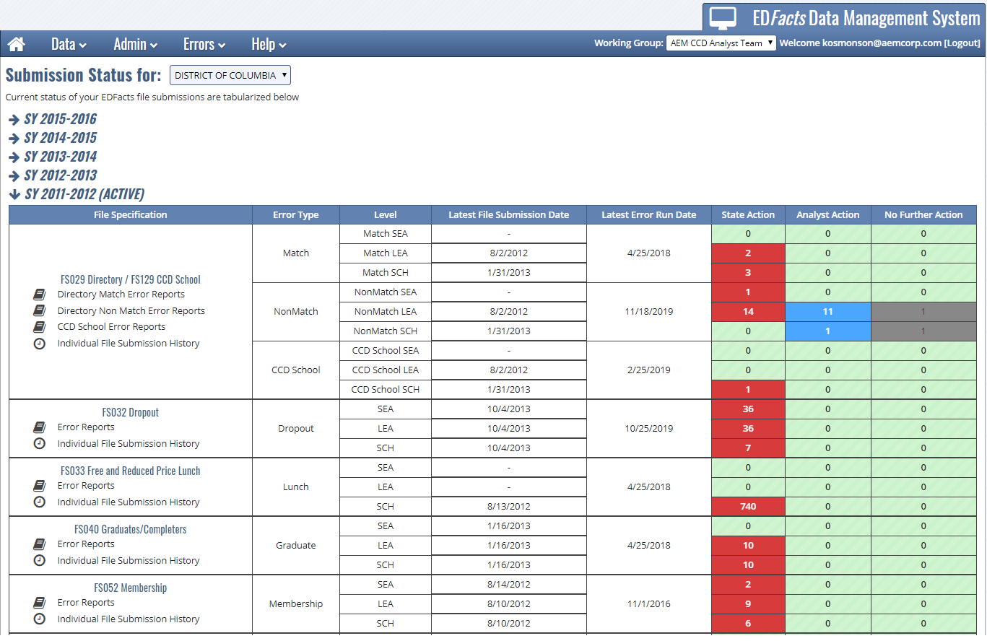

**Figure 4.1:** DMS State Landing Page

To view data specific to a working group, select the working group associated to the data set from the top right of the menu bar.

* + Users in the CCD working Group are able to respond to Error Reports for the following file specifications:
    - FS029 Directory
    - FS039 Grades Offered
    - FS052 Membership
    - FS032 Dropouts
    - FS033 Free and Reduced-Price Lunch
    - FS040 Graduates/Completers
    - FS059 Staff FTE
    - FS129 CCD School
    - 5-Year Edits
  + Users in the GFSA working Group are able to respond to Error Reports for the following file specifications:
    - FS086 Students Involved in Firearms
    - FS163 Discipline Data

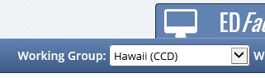

**Figure 4.2:** Working Group Selection

***NOTE:*** DMS optimizes the screen layout for smaller screens; on a laptop, the top bar shown in the figure above with drop-down menus for Data, Admin, Errors, and Help is collapsed to show a stacked menu that expands into the full menu as shown below in Figure 4.3.

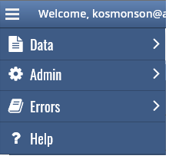

**Figure 4.3:** Drop-down menu optimized for a smaller screen

DMS displays data by school year. The school year selector is shown in the upper left corner of the landing page.

Active data submissions are those currently in the data processing stage and automatically display information when DMS is on the state landing page.

Use the landing screen to view the history of submissions by clicking on the field marked **Individual File Submission History**. This option brings up a pop-up screen that lists all files submitted for the state including the file level, submission dates, file name, and status. The submission date refers to the date that data was replicated to DMS from ESS.

**CCD Only** – The error reports for FS029 Directory file are different than other ESS data files that are part of the CCD. While the FS029 Directory file has the four options (Directory Match Error Reports, Directory Non-Match Error Reports, CCD Schools Error Reports, and Individual File Submission History), the other files only include two options (Error Reports and Individual File Submission History).

The following are functions available to SEA users through the menu bar at the top of the screen:

1. **DMS Data Viewer (View).** Allows users to view submitted data during different phases of processing.
   * All working groups are able to view the following only in the view data screen. Only the CCD group are able to view the following in the Error Reports tab:
     + FS029 - Directory
     + FS039 - Grades Offered
     + FS052 - Membership
   * Users in the CCD Group are additionally able to view:
     + FS032 - Dropouts
     + FS033 - Free and Reduced-Price Lunch
     + FS040 - Graduates/Completers
     + FS059 - Staff FTE
     + FS129 - CCD School
   * Users in the GFSA Group are additionally able to view:
     + FS086 - Students Involved in Firearms
     + FS163 - Discipline Data
2. **Account Administration (Admin).** Administrators can add new users, manage the settings for existing users, and remove users. This drop-down option is only visible for users with administrative rights.
3. **Error Reports (Errors).** A detailed view of data errors and the priority associated with each error.
   * Users in the CCD Group only see CCD related files.
   * Users in the GFSA Group only see GFSA related files.
4. **User Support (Help).** Provides contact information for any problems users encounter with the DMS.

1. DMS Data Viewer

The DMS Data Viewer allows SEA users to view data at the SEA, LEA, and school level. An SEA user might use this DMS function to review the data for a particular school or district.

To view data, click on the **Data** icon on the menu bar at the top of the screen and select **View Data** (Figure 5.1).

Refine the data view by selecting the appropriate view, schema, and data year using the drop-down boxes shown below.

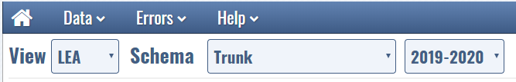

**Figure 5.1:** View data ribbon

The **View** box determines what level of data users wish to view. By default, the view is set to SEA, but can be changed to LEA or School.

The **Schema** box allows users to view database schemas. Database schemas describe the dataset during different steps in data processing. The trunk schema is the schema most state users use to view data. SEA users can toggle between school years by selecting the appropriate options from the drop-down menu.

From the **View** page, users can sort records, show/hide columns to create custom views, view detailed state information, and search fields (Figure 5.2).

The following sections describes tools available to users in the DMS. While described using the view data screens, these tools are available for use throughout the DMS, including on the error report screens.

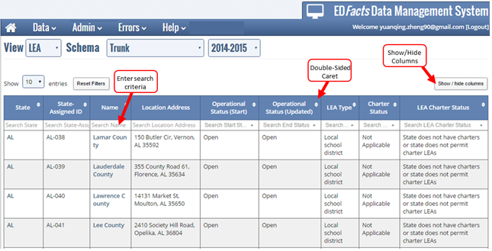

**Figure 5.2:** View data functionality

* 1. Sort

Click on the caret at the top of columns to sort data in ascending or descending order.

* 1. Show/Hide Columns

Click on the **Show/Hide Columns** button on the far-right side of the screen to choose the information to include in the display.

* 1. Search/Filter

The search function helps users filter data lists, and is available for use with any text field. The search field is in the grayed out box immediately above the data, as marked in Figure 5.2 that shows Lamar County. In this area, the LEA name is a grayed out area with the text “Search Name” in the **Name** column. When using searches, partial text may be typed in the field to initiate the search, as illustrated in Figure 5.3. By typing “Book” into the search box, the DMS automatically filters the list to only include names that contain that character string.

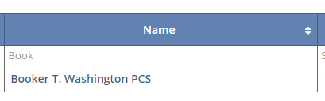

**Figure 5.3:** Search box with partial text search

* 1. Detailed entity information

View detailed data for a specific SEA, LEA, or school by clicking on the state abbreviation under the **State** column or the **Name** column (for LEAs and schools).

Figure 5.4 shows specific information about an entity: location, phone number, website, mailing addresses, etc.

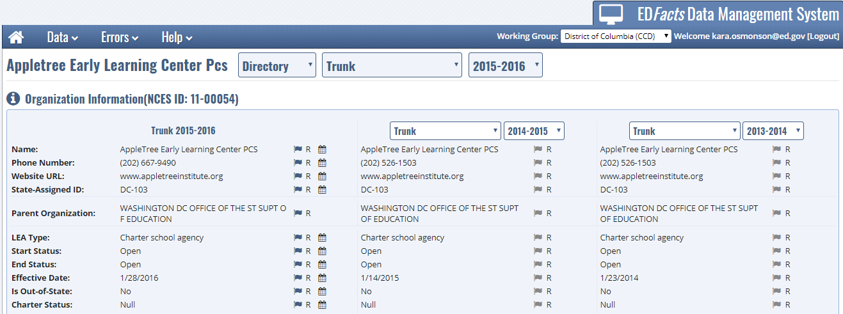

**Figure 5.4:** Detailed data view

Click on the drop-down menu next to the name of the entity to access additional CCD data elements including student membership, staffing, free and reduced-price lunch data for that entity.

***NOTE:*** The default flag “R” indicates the value remains unchanged from the original state submission. Scroll over any small FLAG icon to display the complete list of flag definitions.

1. Error Reports

The landing screen shows a summary by ESS file of possible errors identified after the DMS executes automatic data checks. These checks include validation edits, internal logic edits, and edits that compare current year and prior year data (including a small number of edits that look at five years of data). Data that fail a check are flagged and labeled with an error. Error reports are grouped by ED*Facts* file group (e.g., Directory Match, Staff FTE, Membership, Firearms).

SEAs can correct or address identified data issues by resubmitting data through ESS or by providing comments and explanations.

* 1. View Error Reports

There are two ways to access error reports in DMS:

1. Select error reports for ESS data files by selecting the **Errors** icon from the top of the DMS page. After clicking **Errors**, the following screen shows (Figure 6.1).

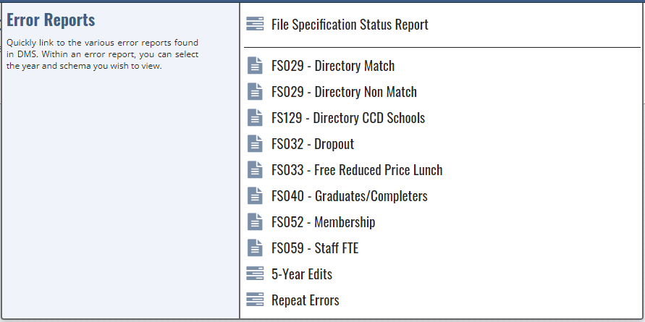

**Figure 6.1:** CCD UserError report menu

1. Or select the **Error Reports** link directly from the landing page for a specific data group (Figure 6.2).

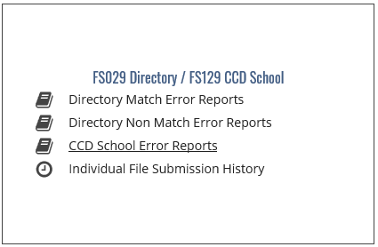

**Figure 6.2:** Error Reports link from landing page

Data are grouped by the type of error, in tabs at the top of the screen. Each tab shows the error, as well as the number of this type of error, in parentheses. The error reports include Entity Name and NCES ID columns by default. Click on the NCES ID hyperlink to obtain additional information on any educational entity in an error report.

The ED*Facts* Business Rules Single Inventory (BRSI) provides a complete listing of the ED*Facts* business rules, including DMS business rules and their error messages. The BRSI is available through the [ED*Facts* Initiative site](https://www2.ed.gov/about/inits/ed/edfacts/business-rules-guide.html); a guide explaining how to use the BRSI is on the same site.

***NOTE:*** The system default for the DMS is to show 50 entries per page (which can be modified to show 25, 50, 100 or all entries).The system directs users to additional pages at the bottom of each screen if there is more than one screen of errors.

Every error report includes an Error Levelcolumn indicating the following:

* **High**: Errors which need to be dealt with immediately;
* **Medium**: Errors in need of review but are not as important as high-level errors; and
* **Low**: Errors of least importance, review as time permits.

In some cases, a high number of errors may appear after initial checks are complete. Users searching for a specific error, or set of errors, can enter search terms in many of the columns (e.g., by clicking on **Medium** and exclude all other errors, or using key search terms like “Vocational” to filter for groups of schools or LEAs that may have similar errors). Users can sort data in ascending and descending order using the double-sided caret.

Errors can also be viewed by applied comments; filter the Comment column to “Yes” or “No”.

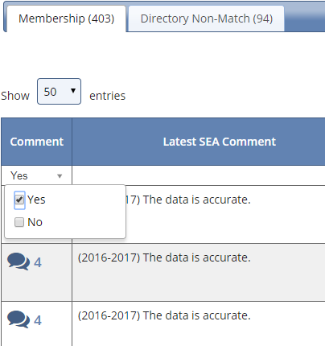

**Figure 6.3:** Filter to Yes for entities with comments

* 1. Resolving Errors

The goal is to resolve as many of the identified errors as possible. This may be accomplished by a combination of the following approaches:

* **Resubmission**. States are encouraged to resubmit data files through ESS to correct data issues, particularly if it appears there is a systematic problem with a data element. The new submission is copied from the ESS to the DMS; within 24 hours both the state and the DMS Data Analyst can re-examine the error reports to determine if the resubmission resolved the errors.
* **Comments**. The DMS might flag a data issue that, with additional information regarding the state context, is determined to be correct. In other cases, the state may provide an explanation that does not resolve the error. In either case, the DMS Data Analyst contacts the state (through PSC) to learn more about the error and determine the best course of action. In all cases, the explanations are noted in the DMS.

***NOTE:*** Data notes and comments provided by SEA users to explain data anomalies may be included in the state notes as part of the documentation that accompanies data file release.

* **Data edits directly in the DMS**. DMS Data Analysts have the ability to make minor changes to the data directly through the DMS. This option is rarely used and always noted in the comments field.

There are six status options in the Resolution column that change as the state and the DMS Data Analysts work together to resolve errors. The initial resolution status for all errors is “Unresolved”; all resolution status codes are shown in Table 6.1. This table also explains when errors are displayed on the state and DMS Data Analyst screens as resolution codes are changed. The DMS Data Analysts work with the states to understand errors identified by the DMS, and the DMS Data Analysts revise the resolution status field to reflect this input.

**Table 6.1:** Resolution status codes

| Resolution code | Description | SEA Summary screen | ED summary screen |
| --- | --- | --- | --- |
| 1. Unresolved | The default resolution code for all errors identified by the DMS business rules.  This is largely an intermediate code. All high- and medium-level errors must be resolved before data for a state is considered final. | Yes | Yes |
| 1. In progress, state comments received | When states add a comment to an error or group of errors, the DMS sets the resolution code to **In progress, state comments received**.  This is an intermediate code. The DMS Data Analyst reviews the error along with state comments and set the final resolution code. | No | Yes |
| 1. Request state resubmission | The DMS Data Analyst determines that the state must resubmit the relevant data files(s) through ESS to correct the identified data issue.  The data flagged with this code are presumed to be in error. | Yes | Yes |
| 1. Not an error | The DMS Data Analyst determines the data are correct as reported. This conclusion can be based on analyst research, SEA explanation, and other communication between the SEA and DMS Data Analysts. This code can be assigned by the DMS Data Analyst either with or without state input. | No | No |
| 1. Accept as is | The DMS Data Analyst believes the data are as accurate as the state can provide. This conclusion is based on communication between the SEA and DMS Data Analyst; this code is not assigned without state input. | No | No |
| 1. Analyst researched and resolved | After research into an issue, the DMS Data Analyst corrected the data. This code is reserved for edits made manually to the data and the change could be based on communication with the state or outside research. | No | No |

The **Comment** icon on the left side of reports is a common field used by both state data providers and DMS Data Analysts. Click on this icon to view or respond to comments from DMS Data Analysts, or to add new comments.

After writing a comment in the box provided, select the **Post** button to publish it. All comments are retained in sequence.

One comment may be applicable to multiple errors. Users can filter errors to show those with the common error, and click the **Add multiple comments and resolutions** box, located at the bottom of the DMS page. A comment box appears and applies one comment to all selected errors. Additionally, with the **Add multiple comments and resolutions** box selected, users can select a subset of the filtered errors by highlighting the rows and applying a comment to the highlighted rows.

***NOTE:*** Comments cannot be removed or edited once they are posted. If users want to amend a posted comment, they may post another comment that explains the situation.

To download an error report in Excel, click the **Create Excel Report** button located at the bottom of each error reports page. Larger reports may take longer to create. Only click the icon once.

* 1. Repeat Errors Report

The Repeat Errors report was developed to identify recurring DMS errors and allow SEAs to review those errors separately from non-recurring errors. If an entity within a current year error report has triggered the same error in prior year(s), this entity and error combination is displayed in the **Repeat Errors** report. Comments associated with the prior year errors are displayed in the comment section of the current year’s error report. SEAs can use the Repeat Errors report to confirm that the explanation from the prior year is still applicable and to apply the same comments to the current year’s submission.

To access the Repeat Errors report, click **Errors** in the blue drop-down bar; select **Repeat Errors** from the list (Figure 6.4).

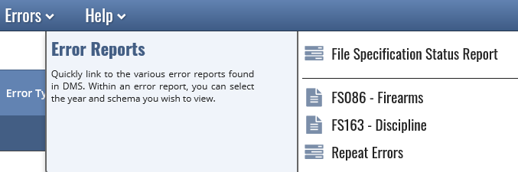

**Figure 6.4:** Accessing the Repeat Errors report (GFSA Error Report View)

All repeat errors are presented together in the Repeat Errors report, organized by tab per file specification. Similar to other error reports, an SEA user can change the school year and schema view by the drop-down menu at the top of the page.

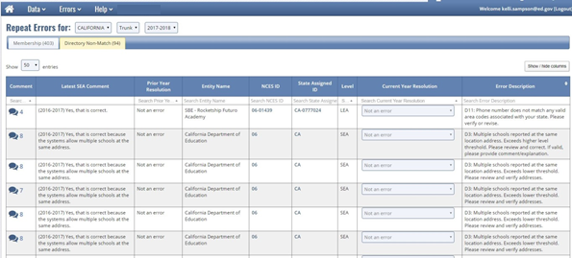

**Figure 6.5:** Repeat Errors report

The columns in the Repeat Errors report differ from other error reports. In addition to showing the current year resolution, the prior year resolution is also displayed. The latest SEA comment from the prior year is displayed to the right of the Comment icon. To determine which edit check is being referenced, the error description includes the number of the business rule.

To apply the prior year comment to a current year error, review the errors in the Repeat Errors report. To view all the prior year(s) comments for a particular error, click the **Comment icon** located in the far-left column. The window expands to show all prior comments. There are three ways to carry comments forward: (1) Individual comments; (2) Group – all entities; and (3) Group – specific entities.

**Individual**: Click the **Comment** icon located in the far-left column. Review the past comments in the expanded window; click **Apply** for the comment to be carried forward.

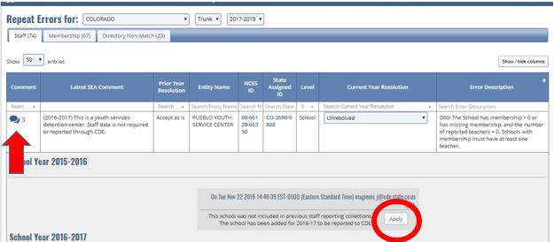

**Figure 6.6:** How to apply individual comments

**Group**: This method allows multiple Latest SEA comments to carryover.

1. Group – all entities: to carry forward all the latest SEA comments for all entities displayed in the Repeat Error report, check the **Carryover multiple Latest SEA Comments box;** select **Post All.**

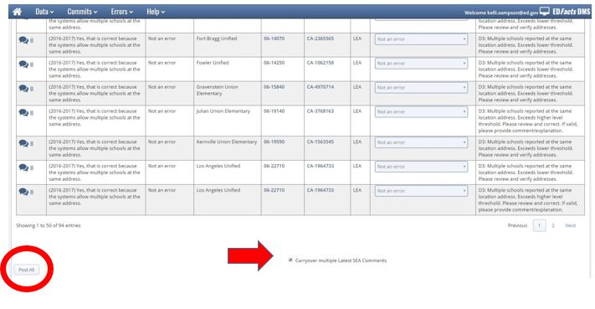

**Figure 6.7:** Carryover Latest SEA Comments

1. Group – specific entities: to carry forward comments for a subset of multiple entities at the same time, check the **Carryover multiple Latest SEA Comments box**;select the entities, and select **Post All.**

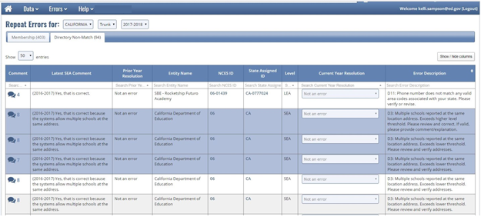

**Figure 6.8:** Carryover selected SEA Comments

* 1. 5-Year Edits Report – CCD only

The 5-year edits check for changes in variability of specific data fields in the current year as compared against a four-year baseline. Current year data flagged by the 5-year edits may be suppressed.

Each of the 5-year edit checks run against a pair of variables with a set of limits defined for each variable. A school or LEA is included in the error report and receives a warning message when both variables in each edit pair fail both of two distinct tests. The ED*Facts* BRSI provides more details about the limits and measures of variability for each 5-year edit check and is available through the [ED*Facts* Initiative site](https://www2.ed.gov/about/inits/ed/edfacts/business-rules-guide.html).

All 5-year edits are presented together, organized in tabs by business rule. Similar to other error reports, the tab identifies the error and shows the number of instances of this error in parentheses (Figure 6.9).

***NOTE:*** LEA- and school-level data flagged in the 5-year Edits Report are candidates for data suppression. State-provided data notes explaining the data anomalies are reviewed as ED and the CCD Data Analysts make final data suppression decisions.

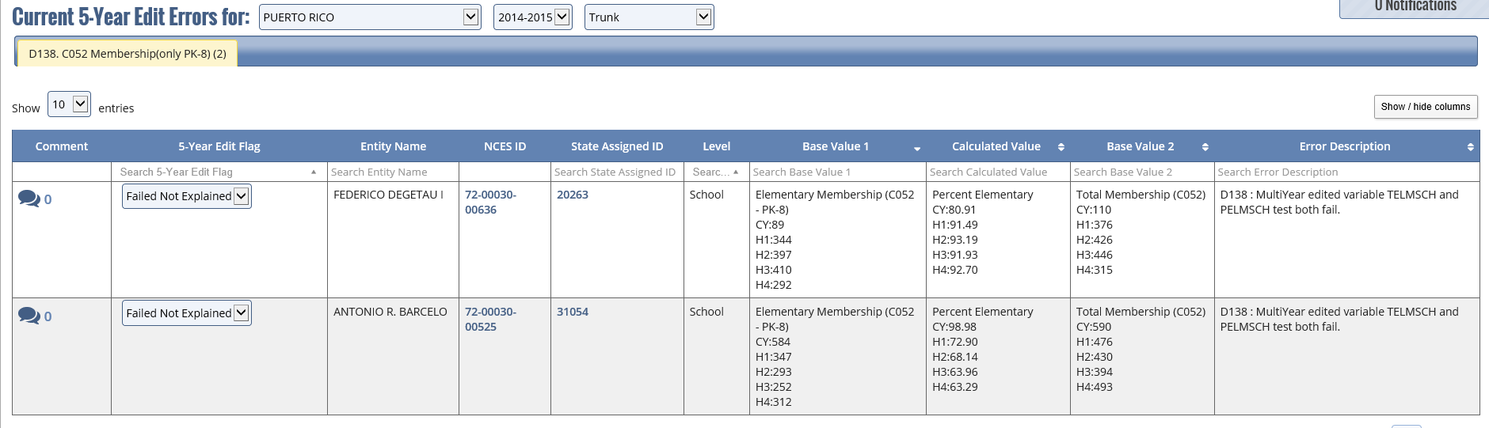

**Figure 6.9:** 5-year edit report example

View the data for education unit that triggered the 5-year edits by clicking on the **NCES ID** hyperlink. State users can provide comments by clicking on the **Comment** icon. The DMS FAQ document available on the [ED*Facts* Initiative site](http://www2.ed.gov/about/inits/ed/edfacts/index.html) provides tips for how to read and interpret the 5-year edit reports.

DMS Data Analysts and SEA users work together to resolve the data issues identified by the 5-year edit checks. As a result, DMS Data Analysts set the 5-year edit flag to one of four options outlined in Table 6.2.

**Table 6.2:** 5-year edit resolution status codes

| Resolution Code | Will data be Suppressed? | Explanation |
| --- | --- | --- |
| Failed - Not explained | Yes | Default value for all errors identified by the 5-year edits. This flag remains if SEA does not respond to follow up or if after the analyst reviewed and determined the data are not reasonable. |
| In progress, state comments received | No | When states add a comment to an error or group of errors, the DMS sets the resolution code to **In progress, state comments received**.  This is an intermediate code. The DMS Data Analyst reviews the error along with state comments and set the final resolution code. |
| Failed - Accepted | No | The entity failed the edit; either the DMS Data Analyst reviewed the data and determined reasonability, or the SEA provided an informative explanation. |
| Failed - Rejected | Yes | The entity failed the edit and the DMS Data Analyst determined the SEA response needs to provide more information to explain the data issue. |

* 1. Additional Questions

DMS Data Analysts reviewing the data may have questions about the data that are not covered by business rules in DMS. The additional questions can be viewed by the SEA users in one of two ways: from the main menu bar, or from any error report. The additional questions may include an attachment.

1. From the main menu bar:

To view the ad hoc questions, click on the **Data** icon on the menu bar at the top of the screen and select **Add A Question** (shown below in Figure 6.10).

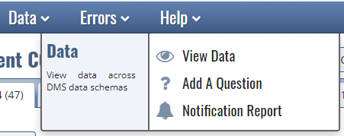

**Figure 6.10:** Accessing Add a Question from the menu bar

1. From any error report:

To view the ad hoc questions, click on **Additional Questions** at the top right of the screen.

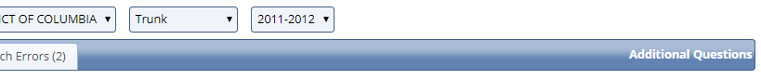

**Figure 6.11:** Accessing Additional Questions from an Error Report

Responses to these additional questions are important to ensure data quality and completeness of data notes. SEA users need to respond to the additional questions by providing a comment. When needed, SEA users may upload attachments as part of the response to the question.

To upload an attachment, select **Upload.** Once a file is selected, provide a comment and click **Post.**

1. *NEW!* Notification Report

The DMS Notifications Report aids analysts and states in seeing what has changed in DMS from day to day. The report is run at 5:00 am ET every morning.



**Figure 7.1: Accessing Notification Report**

Users can filter the report on almost every column in the table. There is also an option to export the table into an excel spreadsheet for reference.   
 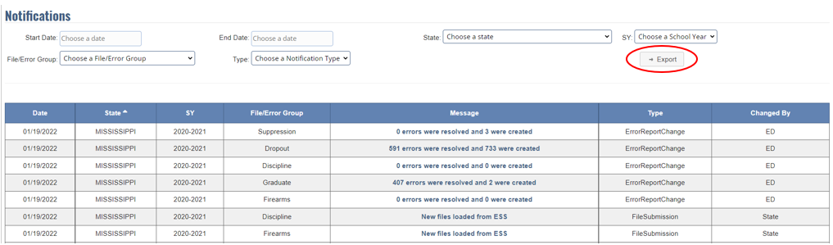

**Figure 7.2: Exporting Notification Report**

***NOTE:*** The system default will show 90 days worth of data in the report. ED may change the number of days showing at any time. Note once the designated time has lapsed, the notification will no longer show and cannot be recovered.

There are 5 notification types that will default to display chronological order in the report as outlined in tables 7.1.

**Table 7.1:** Notification Action and Message

| Action | Message | Message Type | Changed By |
| --- | --- | --- | --- |
| State submitted a file | New files loaded from ESS | File Submission | State |
| Analyst refreshed error report | # errors were resolved and # were created | Error Report Change | ED |
| State entered a comment in the error report | Added # comments | New Comments | State |
| Analyst entered a comment in the error report | Added # comments | New Comments | ED |
| Analyst asked a new question | File question asked | New Question | ED |
| State responded to a question with a comment or uploads an attachment | File question response | Question Response | State |
| Analyst responded to a question with a comment or uploads an attachment | File question response | Question Response | ED |

The Changed By column indicates the user type (state or ED) that initiated the change in the system to the data that triggered the notification type.

States should continue to review the Landing Page for the most updated status of their errors.

1. User Support

Contact PSC to resolve issues or questions regarding the DMS. The PSC contact information is available through the **Help** icon at the top of the DMS screen and shown below.

* Toll Free: 877-457-3336
* Federal Relay Service: 800-877-0996 (Voice/TTY) / federalrelay@sprint.com
* Email: [ED*Facts*@ed.gov](mailto:edfacts@ed.gov)

PSC is available to answer questions from 8:00 a.m. to 6:00 p.m. ET, Monday through Friday, excluding federal holidays.