United States Department of Education (ED)
Office of Postsecondary Education (OPE)
Federal TRIO Programs (TRIO)
User Guide for Talent Search Annual Performance Report
November 2023
Submitted by
The Tactile Group

2400 Market Street, No 200, Suite 217
Philadelphia, PA 19103

Table of Contents
Log In and Navigation 2
Login.gov 3
Successful Login to the APR 15
Contact TRIO Help Desk 16
Request Data Entry User Access 16
Forgot Password 17
Navigation 19
Section I: Project Identification, Certification, and Warning 20
Data entry person 21
Section II: Demographic Profile of Project Participants and Listing of Target Schools 23
Section III – Educational Status of Talent Search Participants (at the Time of the First Service in the Reporting Year) 29
Cohort Download 29
Section IV – Educational Status of Talent Search Participants (at End of Reporting Period or for Fall Term 2023) 30
Section IV – Establishing 2022-23 Cohort of Postsecondary Enrollees (Participant Data Upload) 35
Review and Submit 2022-23 Annual Performance Report (APR) 37
Review and Submit (with errors) 37
Review and Submit (no errors) 37
Review and Submit – APR Submitted 39
Upload Section I Signature Page 41
PE Points Report 41

Log In and Navigation
Please go to the URL: https://trio.ed.gov. A warning message regarding authorized use and privacy will display before you log in to the system. Click the button Click Here to Accept to move to the main page.

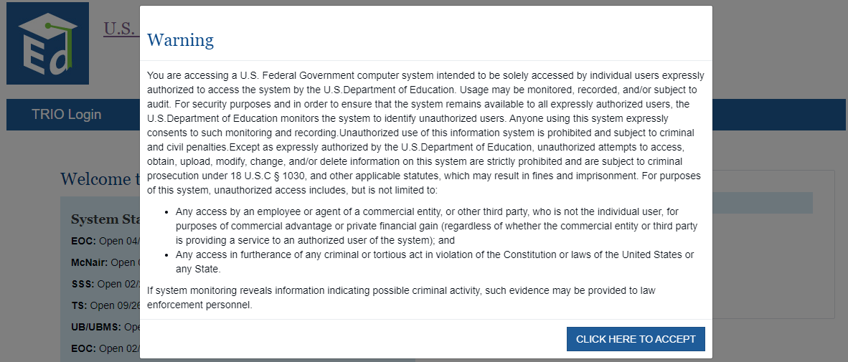

The main page of the TRIO APR website is shown below. You must create an account in Login.gov website before you login to the APR. An overview of the Login process follows.

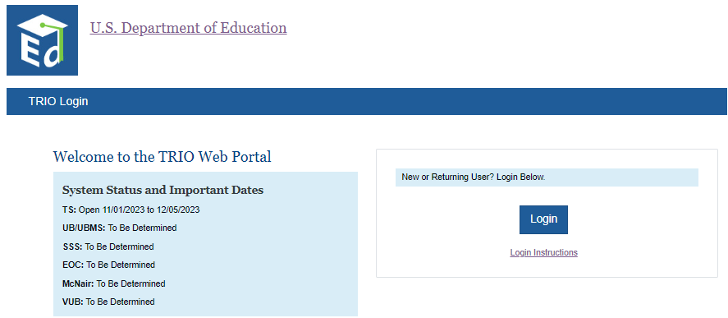

Login.gov
As the project director for your TRIO grant, the Federal Government now requires you have an account with Login.gov to access the TRIO APR Web Portal. This requirement follows new federal rules pertaining to federal IT system security. Below are instructions on how to access the TRIO APR Web Portal including registering with Login.gov.

What is Login.gov?
Login.gov securely verifies, stores, and manages user’s digital identity using verified credentials and multi-factor authentication. This means multiple layers to your identity are verified when you access the system to ensure the person logging into your account is indeed you! Several levels of security are needed to qualify as an official identity provider (IdP) for a government agency, and Login.gov meets these requirements.

How Does This Work?
Think of Login.gov as a directory where external users’ identities can all be housed and managed. The Department of Education allows transferring that identity (after being verified) from Login.gov to the Department’s network. There are two steps to the transfer:
1. External users set up and use their Login.gov account
2. Login.gov verifies a user’s identity through a vetted process

How do I access the TRIO APR Web Portal?
- If you have setup an account in Login.gov and used the email address as listed in G5 of your Grant Award Notification (GAN), please click here for further instructions.

- If you have not setup a Login.gov account, please click here for further instructions.

- If you have an account but the email address you used to create that account is different from the email address in G5 of your Grant Award Notification (GAN), please click here for further instructions.

What if I need additional assistance?
If you need assistance with Login.gov, please go to the Login.gov Help Center at https://login.gov/help/. If you need assistance with the TRIO APR Web Portal, please contact TRIO Help Desk at TRIO@helpdesk.thetactilegroup.com.

If you have setup an account in Login.gov and used the email address as listed in G5 of your Grant Award Notification (GAN), please follow the steps below.

- Go to https://trio.ed.gov/ and click the button “Click Here To Accept”.

- Click ”Login.”
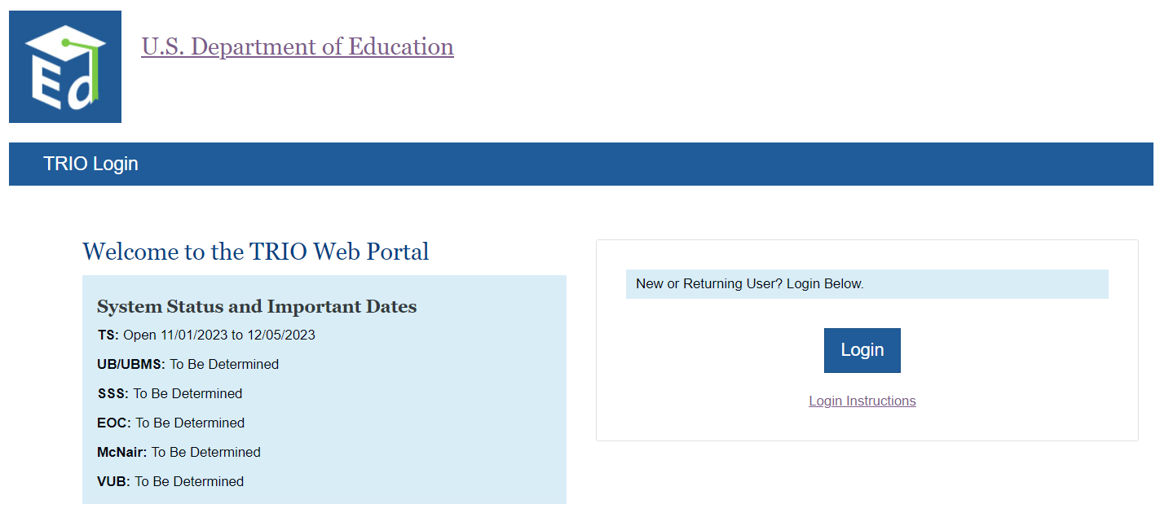

- Click “Sign in with Login.gov.”
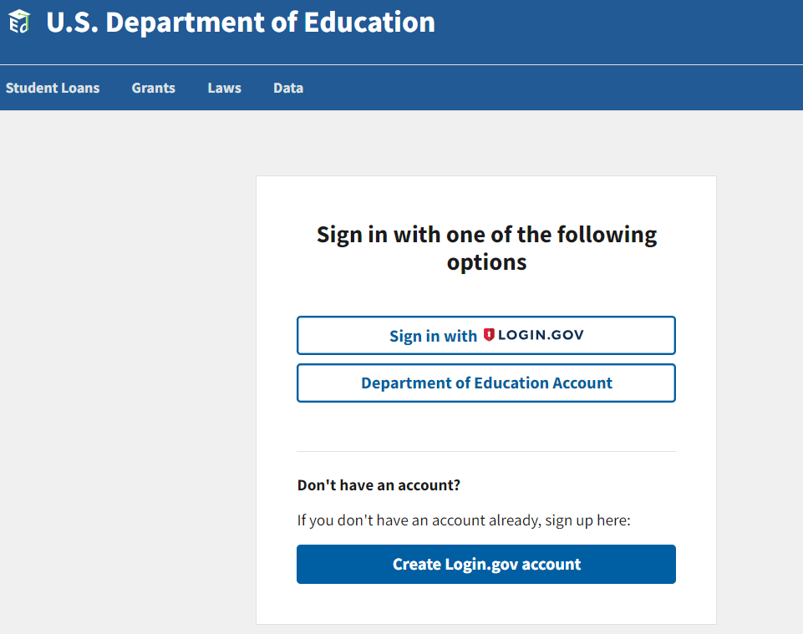

- Enter your email address and password and click “Sign In.”
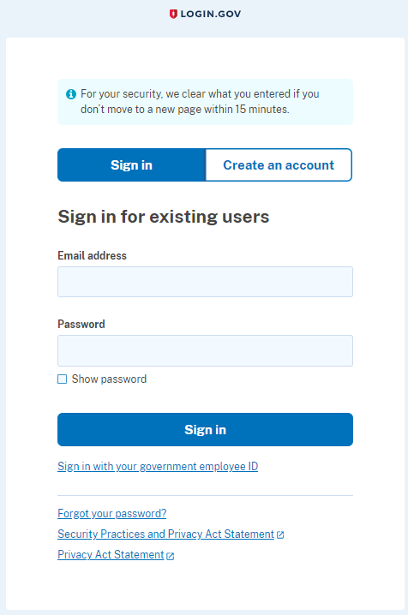

- Enter the one-time password code that is generated by the method you used to create Login.gov and click on Submit. Examples of methods you may have used are authenticator app, text message, email, etc.
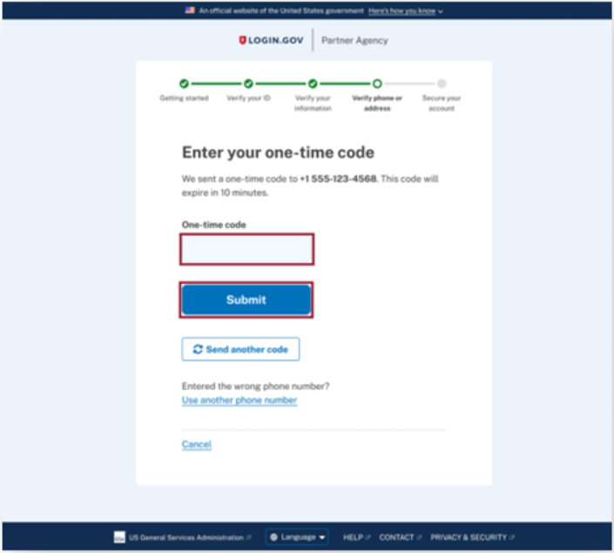

- You will be taken to the TRIO Web Portal page where you can begin your APR submission.
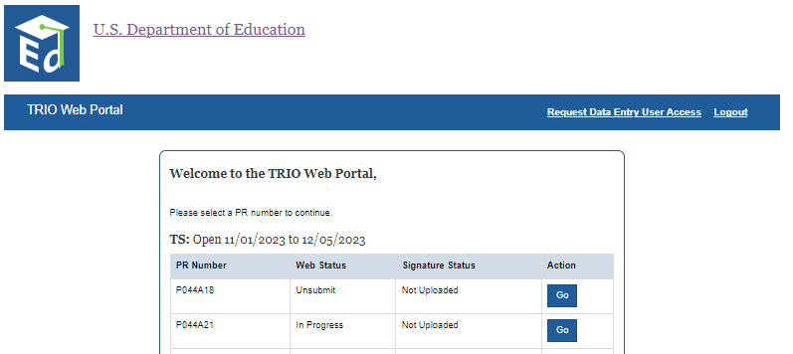

If you have not setup a Login.gov account, please follow the steps below.

- Go to https://trio.ed.gov/ and click the button “Click Here to Accept.”

- Click on “Login.”

- Click on “Create Login.gov account.”

- Enter your email address as it appears in G5 of your Grant Award Notification (GAN), check the box “I read and accept the Login.gov” Rules of Use and click “Submit.”
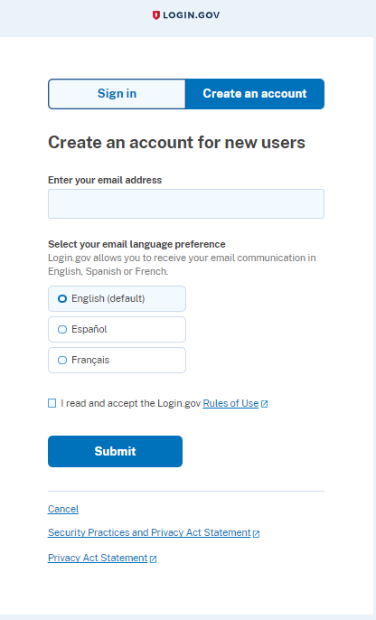

- Open the email that was sent to your email address, then click on the button “Confirm your email” or click on the link below the button. If you did not receive the email, please check your SPAM or Junk folders.
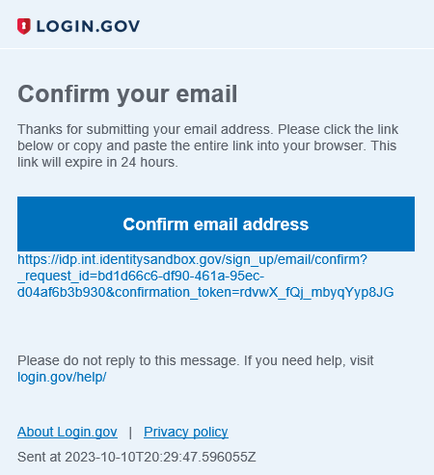

- Create a password.
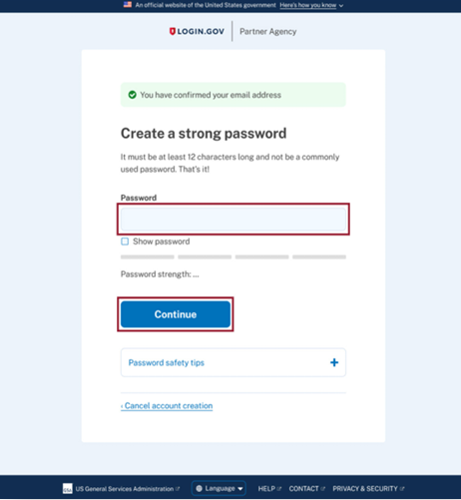

- Setup your multi-factor authentication method(s) by selecting at least one of the methods (e.g., authenticator application, text or voice message, etc.), then click “Continue.”
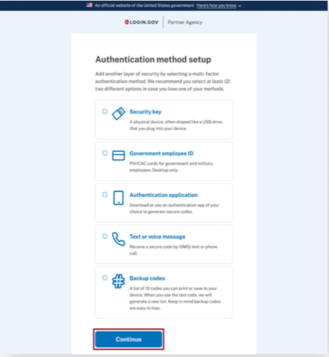

- You will be taken to the TRIO APR Web Portal page where you can begin your APR submission.

If you have an account but the email address you used to create that account is different from the email address in G5 of your Grant Award Notification (GAN), please follow the steps below.

- Go to https://trio.ed.gov/ and click the button “Click Here to Accept.”

- Click on “Login.”

- Click on “Sign in with Login.gov.”

- Enter your email address and password and click “Sign In.”
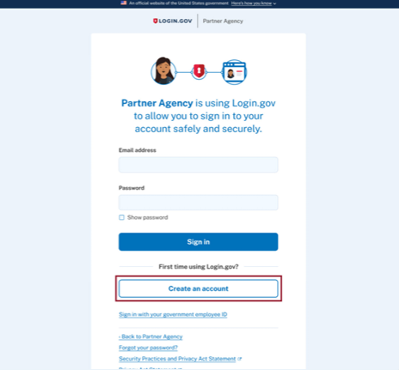

- Enter the one time password code that is generated by the method you used to create Login.gov, then click “Submit.” Examples of methods you may have used are authenticator app, text or voice message, backup codes, etc.

- The web page “Welcome to the TRIO APR Web Portal” will be displayed. Click on “Change Project Director Request.”

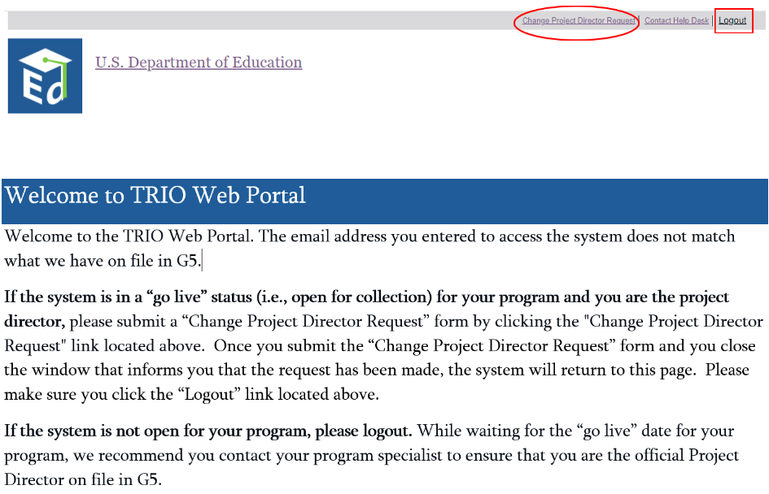

- Complete the information requested, then click “Submit.” If you need to cancel the request, click the “Close” button.
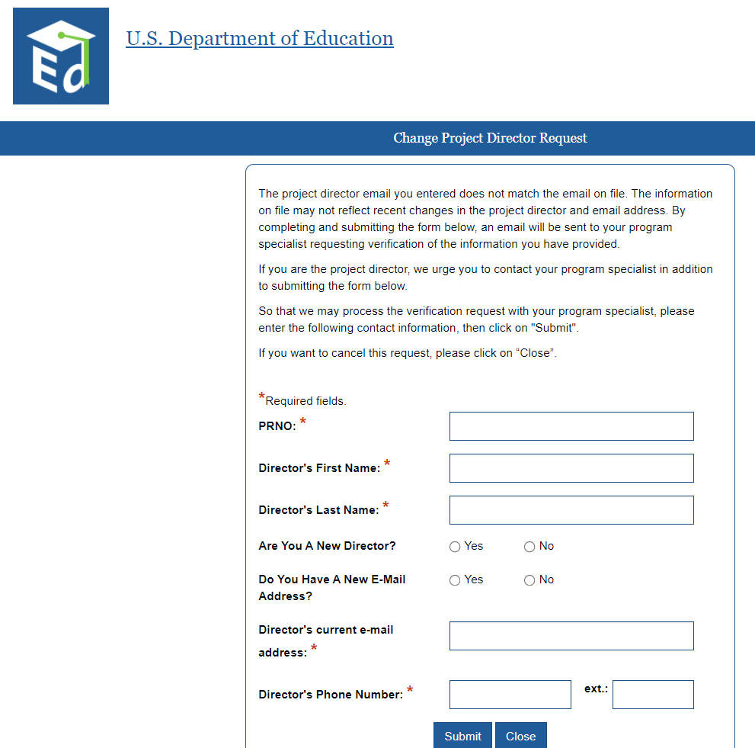

- The message below will display after you have submitted a “Change Project Director Request.” Close the window by clicking on the button “Close”. You will then see the previous window “Welcome to TRIO Web Portal”. Be sure to click the “Logout” link located at the top of the window.

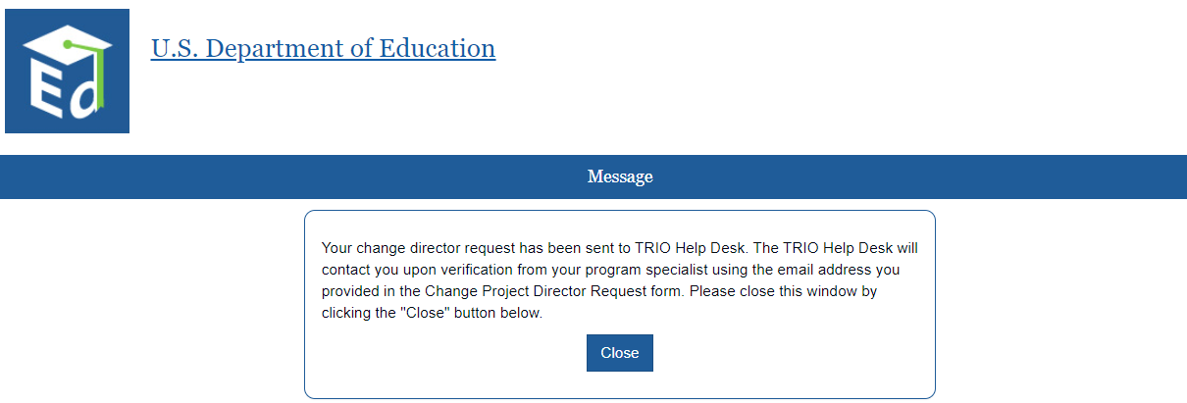

- Once you have been verified as the Project Director for your grant, please follow the instructions beginning on page 2—"A. If you have setup an account in Login.gov and used the email address as listed in G5 of your Grant Award Notification (GAN), please follow the steps below.”

Successful Login to the APR
Once an account is successfully created in Login.gov website and if your information is on file, you should be able to Login to the APR website. Further registration process is not required to login to the APR website as you always do in the past.
The returning users can use Sign in with LOGIN.GOV button, to sign in into their account. The page below is displayed.

After you sign in successfully, you will be taken to the TRIO Web Portal page as shown below. Please click on the ‘Go’ button which will take you straight to the Section I page.

Contact TRIO Help Desk
If you would like to submit a request to Help desk for any other issues, please fill out the form below and click the ‘Send’ button. A Help Desk representative will contact you within two business days. To cancel the request, please click the ‘Close’ button to close this window and continue your submission.
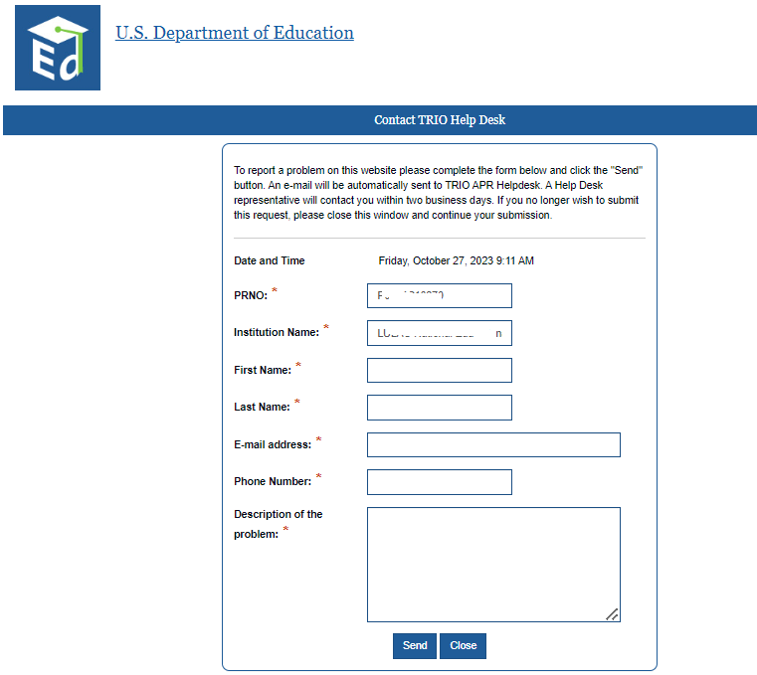

Request Data Entry User Access
Only the Project Directors have the permission to request access for new users (data entry person) in the system.
After you login to the APR, please click on the link ‘Request Data Entry User Access’ to add a data entry person. After you fill out the form (shown below), please click ‘Send’. The request will then be sent to the TRIO Help Desk. Once the user is added in the system, the Help desk will notify you within two business days.

If someone other than the Project Director tries to register a new user, the message below will be displayed.
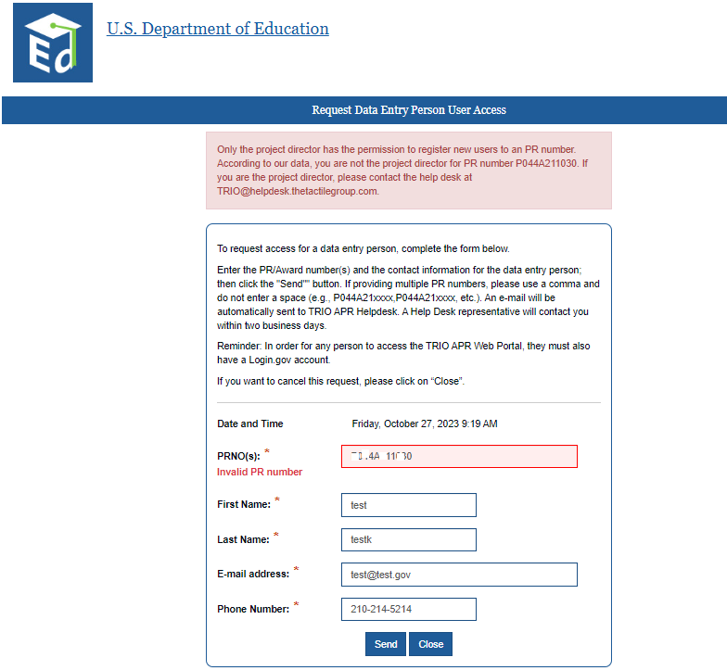

Forgot Password
The APR website or the TRIO Help Desk will no longer handle the user accounts. If you forget your password, please follow the instructions in Login.gov to reset your password.
Click the Login button and use the link ‘Forgot your password?’ as shown below.

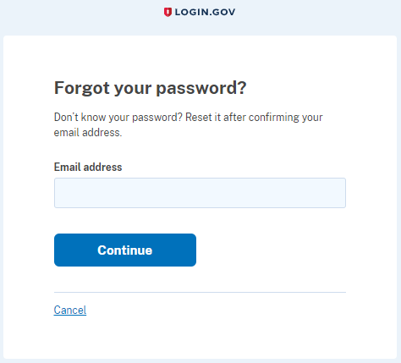

Navigation
The APR has seven sections. After initial login, the system displays the Section I page. To navigate between sections, click on the individual tabs at the top of the page, Section I, Section II, Section III, Cohort Download, Section IV, Section IV Upload, and Review & Submit. The current tab is highlighted in dark blue.
- The PR /Award Number and institution name are displayed at the upper left corner of each page.
- At the upper right corner, note that there are five hyperlinks:
- The Back to Portal link takes you back to the main page.
- The Contact Help Desk link allows you to report a problem with the site to the Help Desk.
- The TS Instructions link displays the Department of Education (ED) site’s TS APR page. From there, you can download the APR instructions and other documents. The Department strongly suggests that you review these documents before working with the Web application.
- The link for the User Guide connects users to this downloadable guide.
- The Log Out link logs you off the application and displays the main page.

Once you have completed Section I, click on the Save and go to next section button. You may tab from one section to another or log off and return at any time to complete a section. If you do, be sure to save the current page before exiting. The system will validate your entries and will not allow you to submit the APR if it detects errors or omissions.

Section I: Project Identification, Certification, and Warning
Section I will be partially pre-populated with information about your grantee institution. Please complete all of the non pre-populated data fields (e.g., 7, name of data entry person, etc.). Once you have entered the necessary information, please verify all the information by clicking the box “I have verified the information in this section” located at the bottom of Section 1, B. Certification.
The project director and certifying official for the institution must sign and date Section I of the 2022-23 APR to certify that the information reported and submitted electronically is readily verifiable, accurate, and complete. After you complete the APR online, you can download a copy of the completed signature page, print it, and obtain the required signatures. After both the director and the certifying official have signed the signature page, upload the signed Section I only of the APR on the website. We highly recommend you download a copy of the completed signature page to get the signatures instead of downloading the entire APR. By doing so will avert the issues when TRIO verifies the signature page.
Please do not upload the entire report. For your records, you should retain in your files Section I with the original signatures and a copy of the two parts of your APR submission: (1) the PDF version of Section I and the data validation reports, which you will be able to print at the end of your submission; and (2) the Excel file of your student cohort data. These items are discussed later in this user's guide.
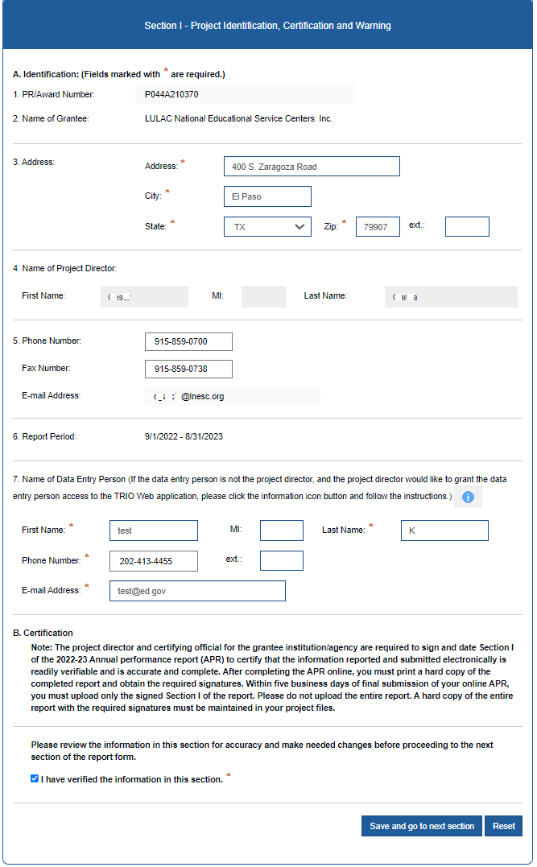

Data entry person
If the Project Director would like to grant access to the data entry person, please click on the “i” icon next to Name of Data Entry Person.
If the project director does not wish for the data entry person to have access to TRIO Web Portal, please close this window and continue the APR submission.

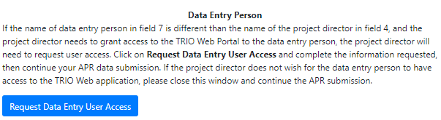

If the name of data entry person in field 7 is different than the name of the project director in field 4 and the project director needs to grant access to the TRIO Web Portal to the data entry person, the project director will need to request user access. Click on “Request Data Entry User Access” button and complete the information requested, then continue your APR data submission. The following window will be opened.
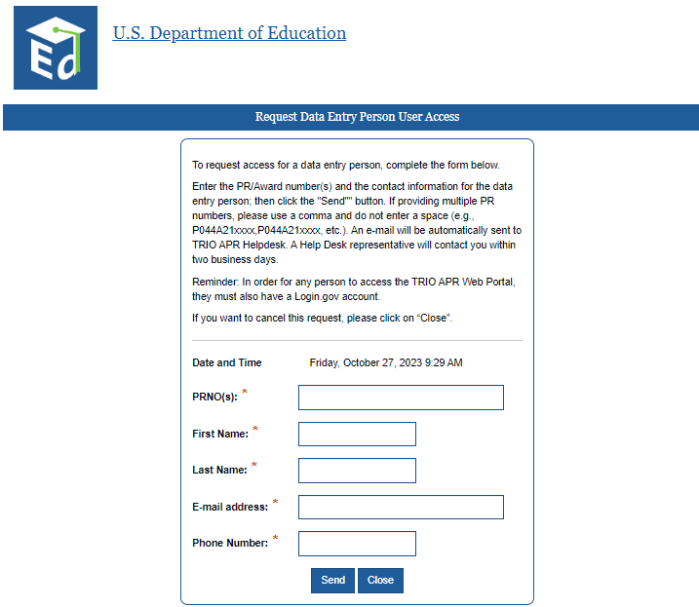

Section II: Demographic Profile of Project Participants and Listing of Target Schools
To access Section II, click the Section II tab at the top, or complete Section I and click on the Save and go to next section button.
This section will be pre-populated with participants funded to serve number and the list of target schools the grantee provided in the 2021-22 Talent Search Annual Performance Report (APR). Please note the Department verified certain information (e.g., NCES School ID), and if the information provided in the 2021-22 TS APR was incorrect, it was updated to the correct information. You need approval from your Program Specialist before you Add or Delete a target school, so please contact either the TRIO Helpdesk or your assigned program specialist. Unless you are certain the NCES School ID is incorrect (e.g., school merged with another school), please do not make any changes to the NCES School ID as this data has been verified.
For those grantees who were newly funded in FY 2022 or did not submit an APR in 2021-22, please provide the school’s NCES School ID, the name of the school and its city, state, and Zip code as listed in your grant application. Also provide the number of students served, whether the given target school had a dual enrollment program, and the number of participants enrolled in a dual enrollment program.
To save the progress you made in Section II and to update Target School information, please click the button Modify Target Schools. Once Section II is complete, you may click the Save and go to next section button to continue.

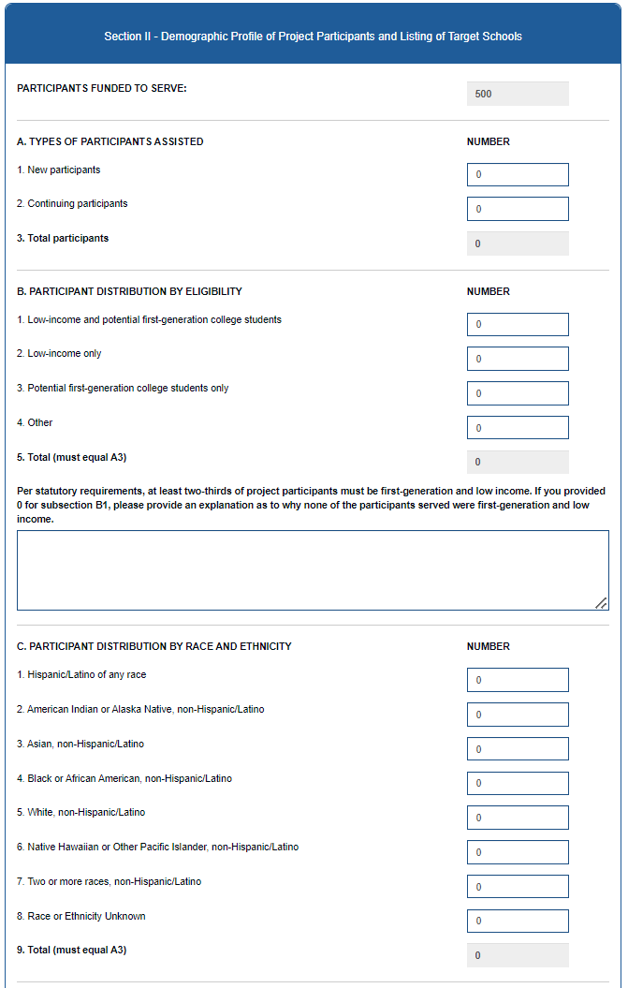
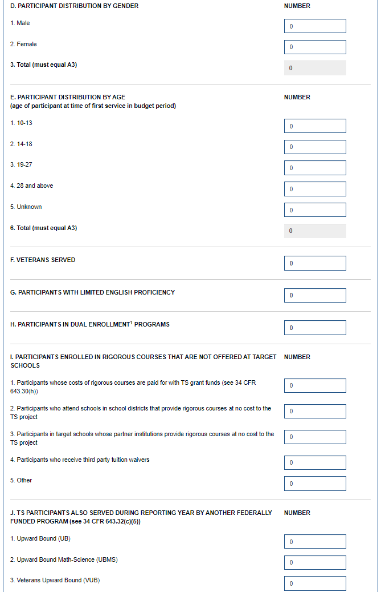
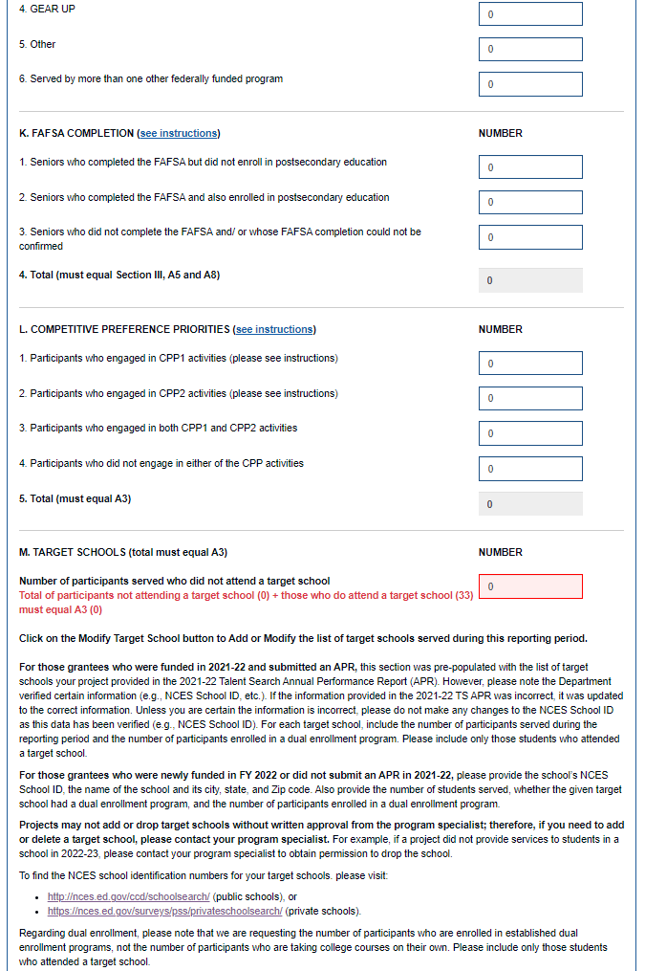
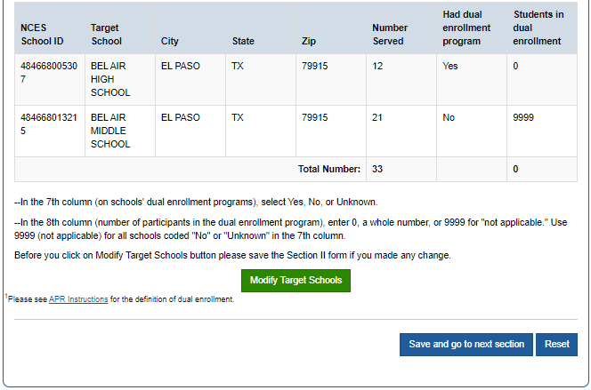

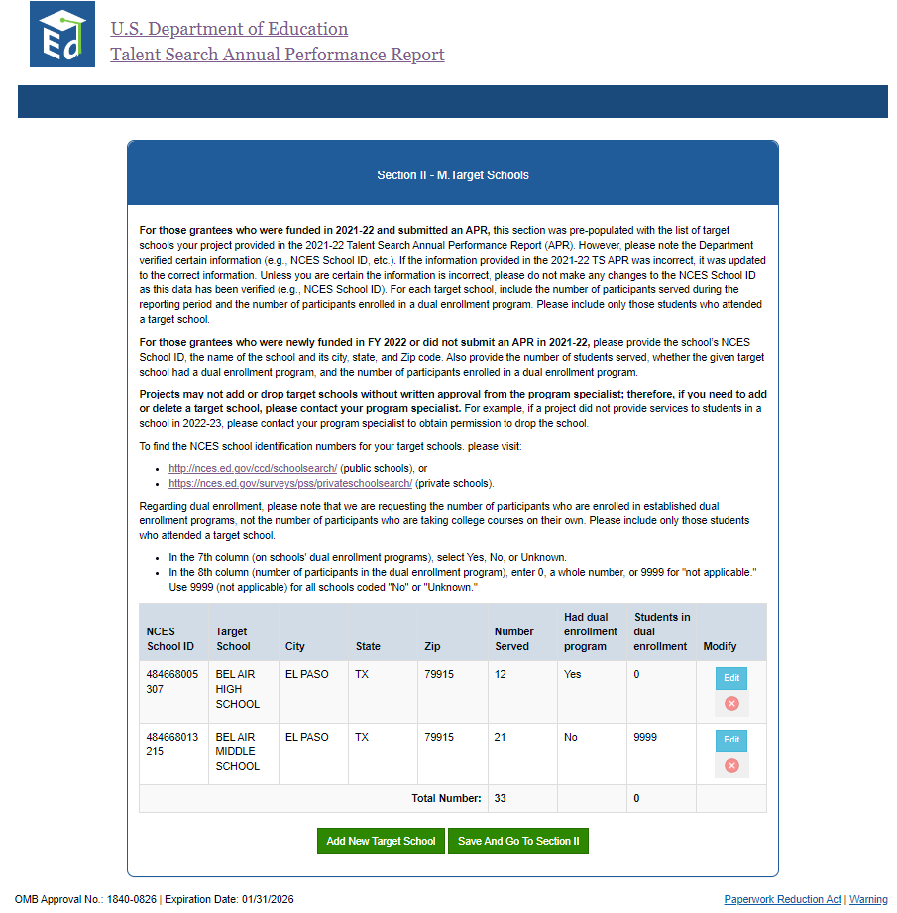

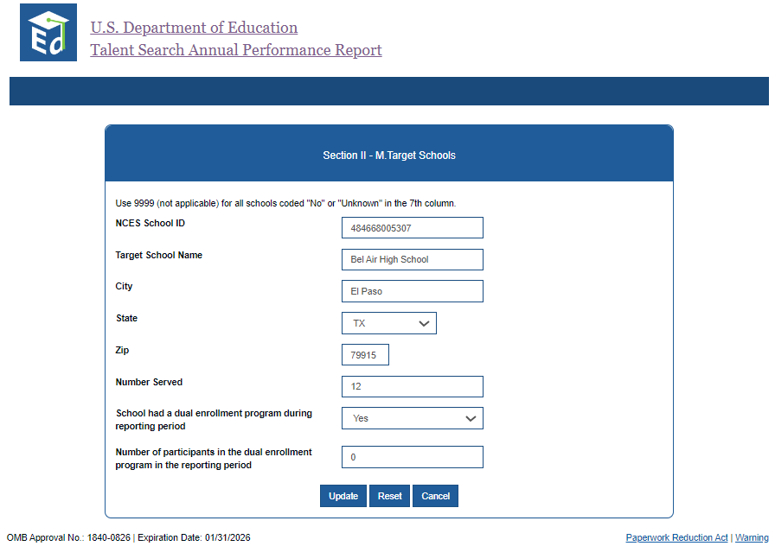

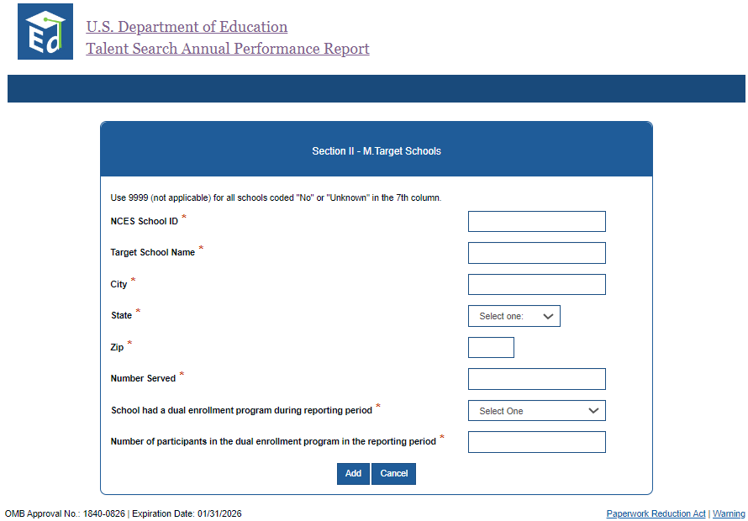

Section III – Educational Status of Talent Search Participants (at the Time of the First Service in the Reporting Year)
To access Section III, click the Section III tab at the top, or complete Section II and click on the Save and go to next section button.
Section III requests data on the educational status of participants at time of first service in the reporting period. For example, if a participant was a secondary school dropout when first served in October 2022, he or she should be counted in Section III as such, even if the participant reenrolled over the course of the reporting period.

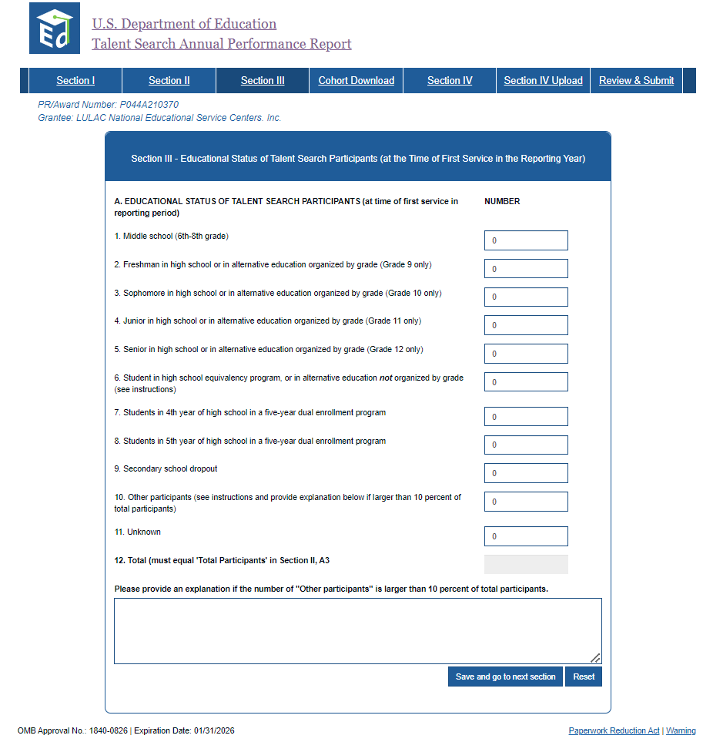

Cohort Download
To access Cohort Download, click the Cohort Download tab at the top, or complete Section III and click on the Save and go to next section button.
When completing the 2022-23 APR, in this section TS projects funded in the previous grant cycle will report on the participants in the 2016-17 cohort who did, or did not, attain at least one postsecondary credential within six years following graduation from high school.
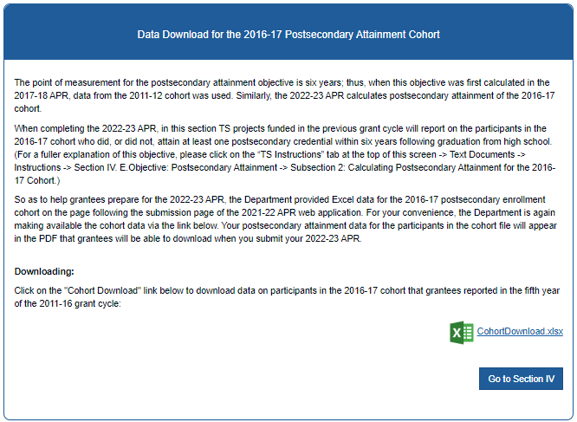

On the other hand, due to the six-year point of measurement for this objective, grantees first funded in the 2021-26 cycle will not be able to report on attainment during this period. The following screen is displayed for them.
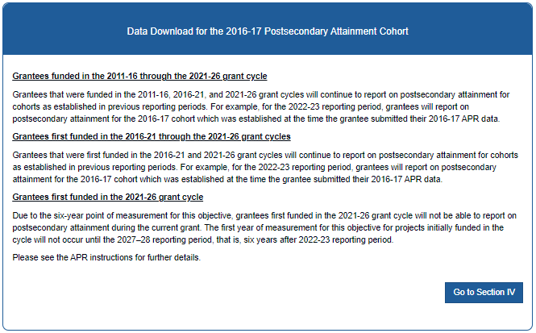

Section IV – Educational Status of Talent Search Participants (at End of Reporting Period or for Fall Term 2023)
To access Section IV, click the Section IV tab at the top, or complete Cohort Download and click on the Go to Section IV button.
In this section, all the standard objectives are listed for your Talent Search project. The percentage for each of these standard objectives will be pre-populated in the online Web application for all grantees. The pre-populated numbers are based on the information provided on the Program Profile sheet submitted with your approved fiscal year (FY) 2021 application. No changes may be made to these percentages on this form. However, if the pre-populated number appears to reflect a data entry error, you must contact your assigned program specialist to resolve the problem. To allow the Department to report aggregated data gathered in a uniform manner, all TS grantees must report outcomes based on the standard objectives identified in the FY 2021 application.

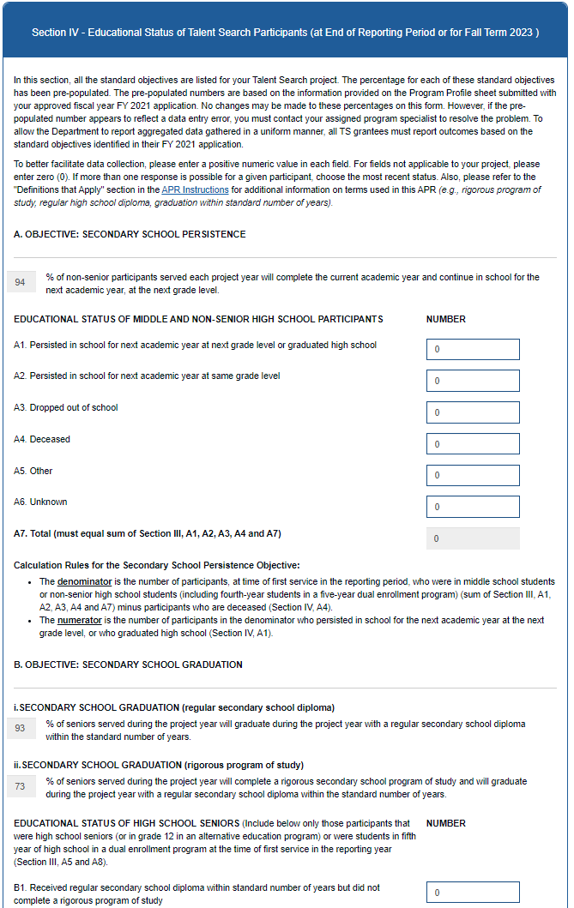
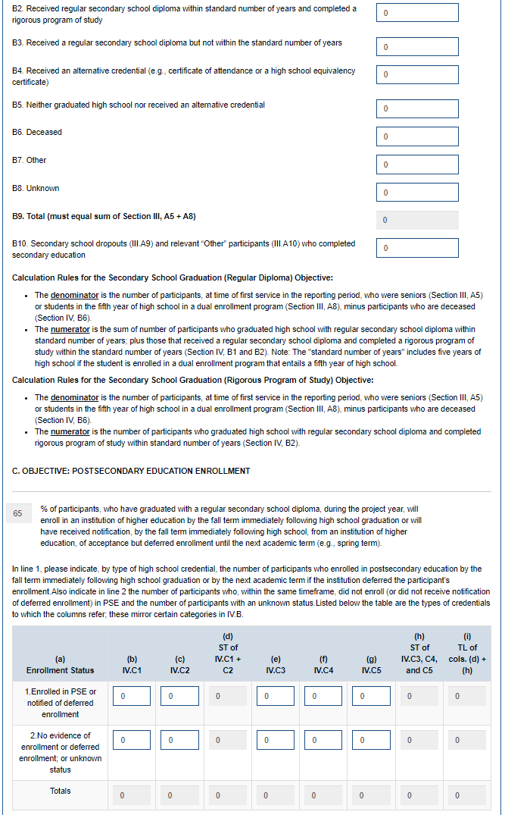
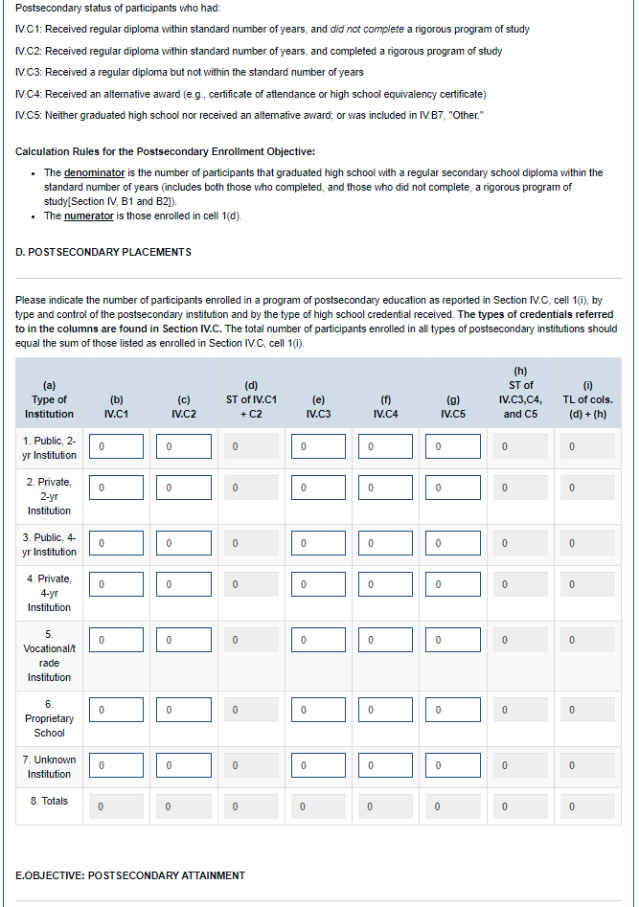
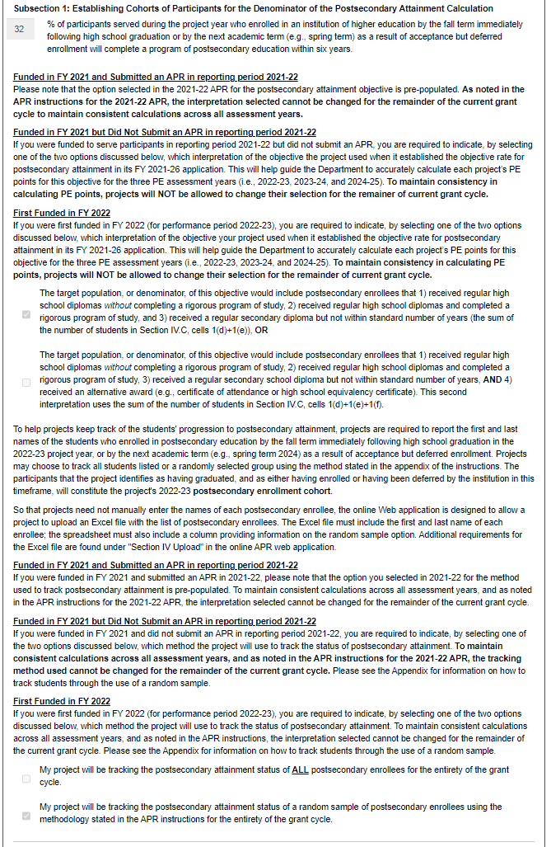
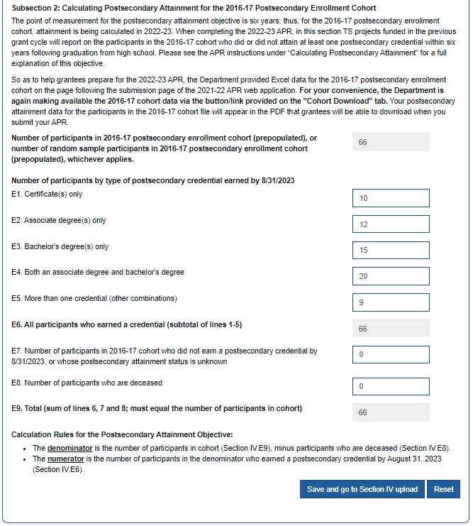

Section IV – Establishing 2022-23 Cohort of Postsecondary Enrollees (Participant Data Upload)
To access Section IV Upload, click the Section IV Upload tab at the top, or complete Section IV and click on Save and Go to Section IV Upload button.
For each reporting period, TS projects must report data in an Excel spreadsheet on students served during the reporting year who enrolled in postsecondary education by the fall term immediately following high school graduation (that is, fall term 2023) and those who received notification from the institution that enrollment had been deferred until the next academic term (for example, spring term 2024).

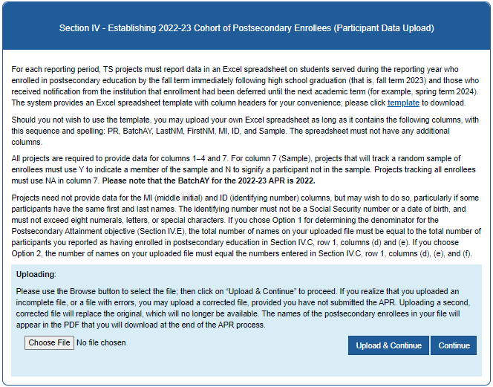
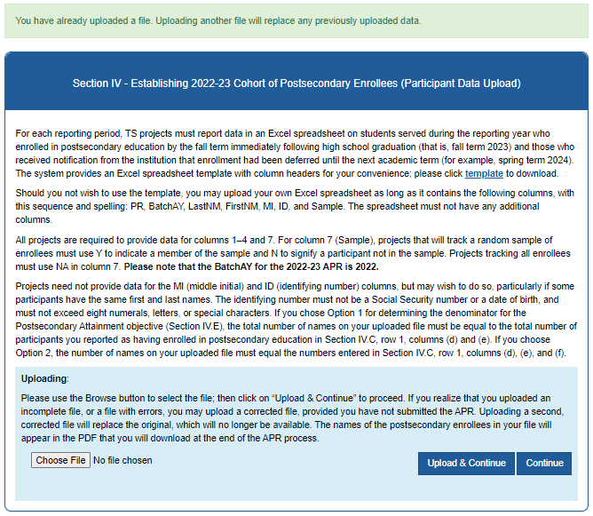

Review and Submit 2022-23 Annual Performance Report (APR)
- Access the Review and Submit page by clicking the Review & Submit tab on top.

Review and Submit (with errors)
If there are any sections of the APR that you have not completed, they will display with an “X” on this page. You must complete any section marked with an “X” before you continue.
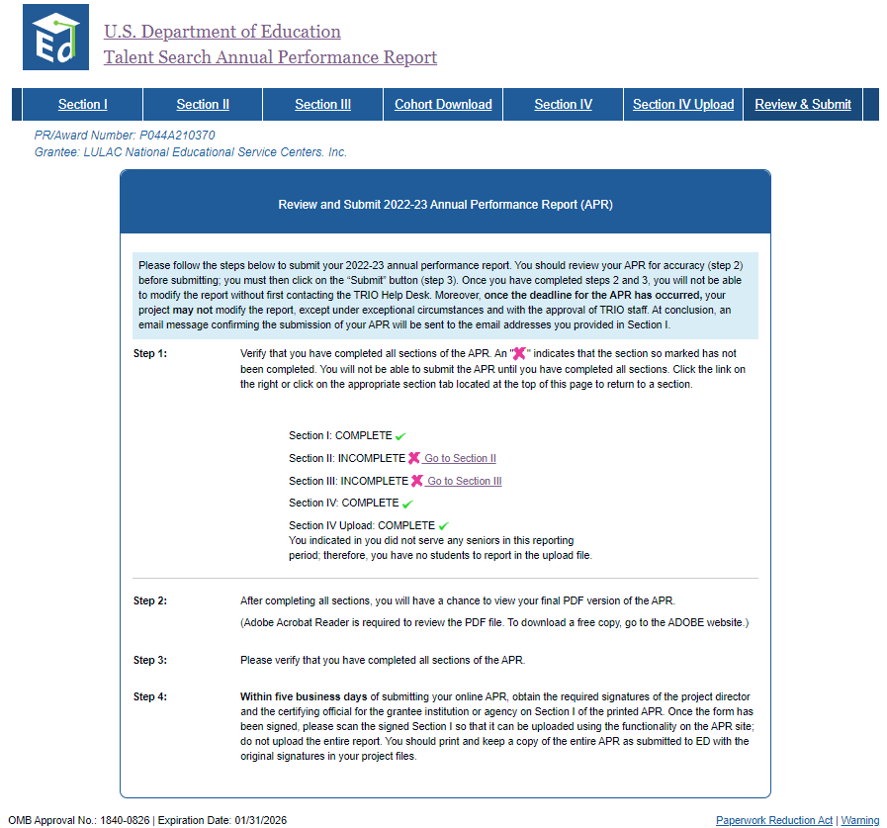

Review and Submit (no errors)
When you submit with all sections of the APR complete, the following page will display. Click on the Submit APR button.
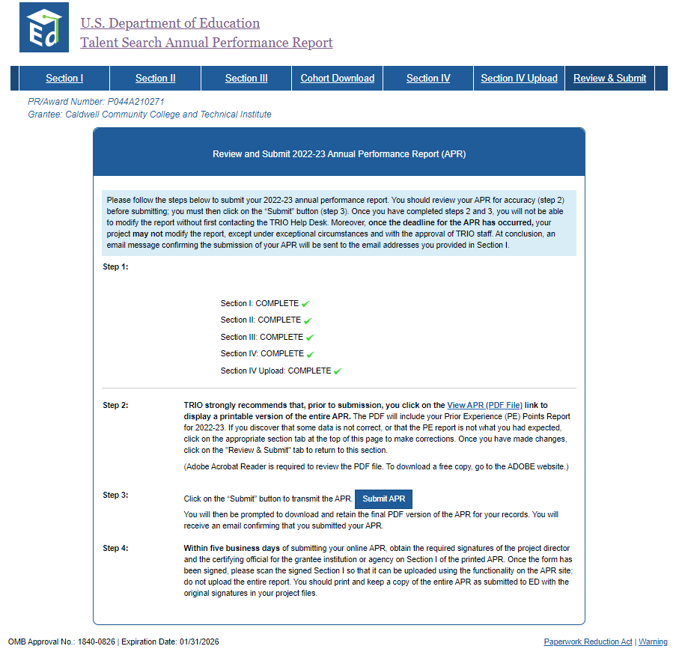

Review and Submit – APR Submitted
Once you have successfully made the corrections to clear the errors in all the sections, the following screen displays acknowledging your APR submission is complete:
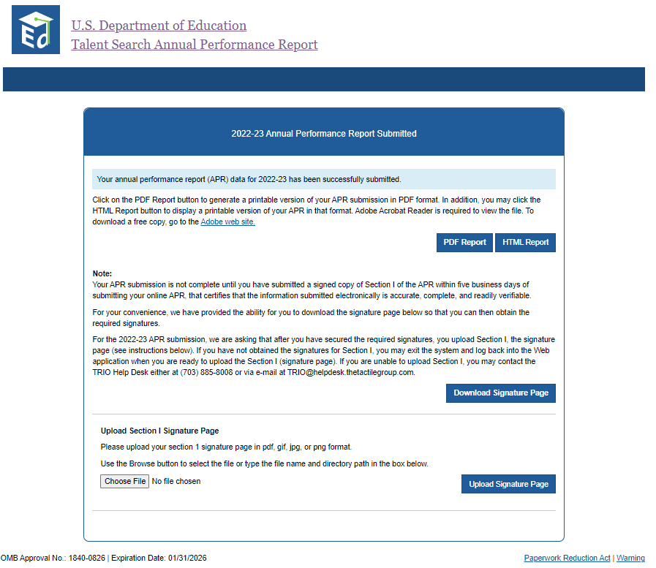

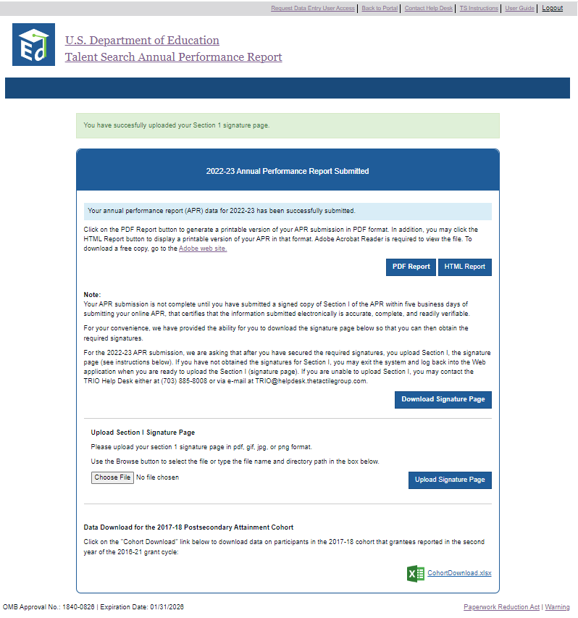

Once your APR has been successfully submitted, no additional revisions are needed. A confirmation email will be sent to the email address provided in Section I.
To print the Section I signature page, click on the PDF Report button. The APR will display as a PDF. Print the Section I page ONLY, collect the required signatures and scan and upload using this website.
To print a copy of the final APR in PDF, please click on the PDF Report button. For a HTML version of the report, please click on HTML Report button. We strongly urge you to download and save the PDF report for your records.
Adobe Acrobat Reader is required to view PDF files and can be downloaded from the Adobe site via the hyperlink on this page. Once the PDF is displayed, select File-Print from the menu or click on the printer image.
- To download an Excel version of the 2017-18 Postsecondary Attainment Cohort data file, click on the CohortDownload.xlsx link.
- To save the file to your desktop, use File Save As option. Select a location on your desktop (e.g., My Documents) to save the file.

Upload Section I Signature Page
Click on the Download Signature Page button. The Section I signature page will display as a PDF. Print this PDF. After you have obtained the signatures, please scan and upload this page in the APR site. The TRIO help desk will verify that the document you uploaded is a signed copy of Section I of your APR and will contact you via email if there are any problems with the document you uploaded.
Click on the Log Out link to end the session and return to the main portal. No further revisions to your file can be made.

PE Points Report
After you successfully submit your APR, the system will generate a report that shows the Prior Experience points earned for the 2022-23 reporting year. Your points are calculated using the data you submit via the online system for reporting period 2022-23 and are based on your project’s approved objectives. The Department will not accept any changes to the project’s 2022-23 data once the system has closed.

