2005-2006 No Child Left Behind - Blue Ribbon Schools Program
U.S. Department of Education Revised 3/23/06

Cover Sheet Type of School: (Check all that apply) __ Elementary __ Middle _x_ High __ K-12 __Charter

Name of Principal Mrs. Patricia Cosgrove
(Specify: Ms., Miss, Mrs., Dr., Mr., Other) (As it should appear in the official records)

Official School Name Bergen County Academies
(As it should appear in the official records)

School Mailing Address_____200 Hackensack Avenue_________________________________________

(If address is P.O. Box, also include street address)

_______Hackensack_______________________________________New Jersey________________07601-6110________

City State Zip Code+4 (9 digits total)

County _______Bergen____________________State School Code Number*__03-0290-020 ___________

Telephone ( 201 ) 343-6000 2279 Fax ( 201 ) 343-8884

Website/URL www.bergen.org E-mail patcos@bergen.org

I have reviewed the information in this application, including the eligibility requirements on page 2, and certify that to the best of my knowledge all information is accurate.

Date____________________________
(Principal’s Signature)

Name of Superintendent* Mr. Robert Aloia
(Specify: Ms., Miss, Mrs., Dr., Mr., Other)

District Name Bergen County Technical Schools Tel.(201)343-6000

I have reviewed the information in this application, including the eligibility requirements on page 2, and certify that to the best of my knowledge it is accurate.

Date____________________________ (Superintendent’s Signature)

Name of School Board Mr. Jack Drakeford
President/Chairperson
(Specify: Ms., Miss, Mrs., Dr., Mr., Other)

I have reviewed the information in this package, including the eligibility requirements on page 2, and certify that to the best of my knowledge it is accurate.

Date____________________________
(School Board President’s/Chairperson’s Signature)

PART I - ELIGIBILITY CERTIFICATION

The signatures on the first page of this application certify that each of the statements below concerning the school's eligibility and compliance with U.S. Department of Education, Office for Civil Rights (OCR) requirements is true and correct.

- The school has some configuration that includes grades K-12. (Schools with one principal, even K-12 schools, must apply as an entire school.)
- The school has not been in school improvement status or been identified by the state as "persistently dangerous" within the last two years. To meet final eligibility, the school must meet the state’s adequate yearly progress requirement in the 2005-2006 school year.
- If the school includes grades 7 or higher, it has foreign language as a part of its core curriculum.
- The school has been in existence for five full years, that is, from at least September 2000 and has not received the 2003, 2004, or 2005 No Child Left Behind – Blue Ribbon Schools Award.
- The nominated school or district is not refusing the OCR access to information necessary to investigate a civil rights complaint or to conduct a district-wide compliance review.
- The OCR has not issued a violation letter of findings to the school district concluding that the nominated school or the district as a whole has violated one or more of the civil rights statutes. A violation letter of findings will not be considered outstanding if the OCR has accepted a corrective action plan from the district to remedy the violation.
- The U.S. Department of Justice does not have a pending suit alleging that the nominated school, or the school district as a whole, has violated one or more of the civil rights statutes or the Constitution's equal protection clause.
- There are no findings of violations of the Individuals with Disabilities Education Act in a U.S. Department of Education monitoring report that apply to the school or school district in question; or if there are such findings, the state or district has corrected, or agreed to correct, the findings.
PART II - DEMOGRAPHIC DATA

All data are the most recent year available.

DISTRICT (Questions 1-2 not applicable to private schools)

1. Number of schools in the district: __0__ Elementary schools
__0___ Middle schools
__0___ Junior high schools
__4___ High schools
_____ Other

__4___ TOTAL

2. District Per Pupil Expenditure: __16,704_____

Average State Per Pupil Expenditure: __12,972_____

SCHOOL (To be completed by all schools)

3. Category that best describes the area where the school is located:

[ ] Urban or large central city
[ ] Suburban school with characteristics typical of an urban area
[ X] Suburban
[ ] Small city or town in a rural area
[ ] Rural

4. 4 Number of years the principal has been in her/his position at this school.

If fewer than three years, how long was the previous principal at this school?

5. Number of students as of October 1 enrolled at each grade level or its equivalent in applying school only:

Grade | # of Males | # of Females |  | Grade Total |  | Grade | # of Males | # of Females | Grade Total
PreK |  |  |  |  |  | 7
K |  |  |  |  |  | 8
1 |  |  |  |  |  | 9 | 140 | 111 | 251
2 |  |  |  |  |  | 10 | 149 | 151 | 300
3 |  |  |  |  |  | 11 | 149 | 145 | 294
4 |  |  |  |  |  | 12 | 118 | 142 | 260
5 |  |  |  |  |  | Other
6
 |  |  | TOTAL STUDENTS IN THE APPLYING SCHOOL → |  |  |  |  |  | 1,105
[Throughout the document, round numbers to avoid decimals.]

6. Racial/ethnic composition of 52 % White
the students in the school: 2 % Black or African American
5 % Hispanic or Latino
41 % Asian/Pacific Islander
% American Indian/Alaskan Native
100% Total

Use only the five standard categories in reporting the racial/ethnic composition of the school.

7. Student turnover, or mobility rate, during the past year: ___1_____%

[This rate should be calculated using the grid below. The answer to (6) is the mobility rate.]

(1) | Number of students who transferred to the school after October 1 until the end of the year. | 0
(2) | Number of students who transferred from the school after October 1 until the end of the year. | 6
(3) | Total of all transferred students [sum of rows (1) and (2)] | 6
(4) | Total number of students in the school as of October 1 | 1122
(5) | Total transferred students in row (3) divided by total students in row (4) | .0053
(6) | Amount in row (5) multiplied by 100 | 1

8. Limited English Proficient students in the school: ___0____%
____4___Total Number Limited English Proficient
Number of languages represented: __3______
Specify languages: Korean, Kannada, Cantonese

9. Students eligible for free/reduced-priced meals: __2_____%

Total number students who qualify: ____17____

If this method does not produce an accurate estimate of the percentage of students from low-income families or the school does not participate in the federally-supported lunch program, specify a more accurate estimate, tell why the school chose it, and explain how it arrived at this estimate.
10. Students receiving special education services: ___1____%
_____9___Total Number of Students Served

Indicate below the number of students with disabilities according to conditions designated in the Individuals with Disabilities Education Act. Do not add additional categories.

____Autism ____Orthopedic Impairment
____Deafness __1 Other Health Impaired
____Deaf-Blindness __4_Specific Learning Disability
__1_Emotional Disturbance __1_Speech or Language Impairment
____Hearing Impairment ____Traumatic Brain Injury
____Mental Retardation ____Visual Impairment Including Blindness
____Multiple Disabilities

- Indicate number of full-time and part-time staff members in each of the categories below:

Number of Staff

Full-time Part-Time

Administrator(s) ___2___ ________
Classroom teachers __95___ ____2___

Special resource teachers/specialists _______ ________

Paraprofessionals _______ ________
Support staff ___9___ ___ 1___

Total number 106____ ___3____

- Average school student-“classroom teacher” ratio, that is, the number of
students in the school divided by the FTE of classroom teachers: _12:1___

13. Show the attendance patterns of teachers and students as a percentage. The student dropout rate is defined by the state. The student drop-off rate is the difference between the number of entering students and the number of exiting students from the same cohort. (From the same cohort, subtract the number of exiting students from the number of entering students; divide that number by the number of entering students; multiply by 100 to get the percentage drop-off rate.) Briefly explain in 100 words or fewer any major discrepancy between the dropout rate and the drop-off rate. Only middle and high schools need to supply dropout rates and only high schools need to supply drop-off rates.

 | 2004-2005 | 2003-2004 | 2002-2003 | 2001-2002 | 2000-2001
Daily student attendance | 97% | 96% | 96% | 96% | 95%
Daily teacher attendance | 98% | 98% | 98% | 98% | 98%
Teacher turnover rate | 15% | 11% | % | % | %
Student dropout rate (middle/high) | 0% | 0% | 0% | 0% | 0%
Student drop-off rate (high school) | 1% | 1% | 2% | % | %
14. (High Schools Only) Show what the students who graduated in Spring 2004 are doing as of September 2004.

Graduating class size | __278___
Enrolled in a 4-year college or university | ___95%
Enrolled in a community college | ___1%
Enrolled in vocational training | ____%
Found employment | ___1%
Military service | ___1%
Other (travel, staying home, etc.) | ____%
Unknown | ___2%
Total | 100 %

PART III - SUMMARY

The Bergen County Academies, began in 1992 as the Academy for the Advancement of Science and Technology (AAST) and became the model for the six additional magnet high school programs as follows: Academy for Business and Finance (ABF), Academy for Culinary Arts & Hotel Administration (ACAHA), Academy for Engineering and Design Technology (AEDT), Academy for Medical Science Technology (AMST), Academy for Telecommunications & Computer Science (ATCS), and the Academy for Visual & Performing Arts (AVPA). The Academy mission is to serve as an educational model for innovation and reform in the 21st century. In summary, we are a learning community comprised of individual career-focused academies that provide a dynamic, specialized, student centered environment that embraces the whole person. We encourage independent learning and creative problem solving at every level. Teachers serve as mentors in the learning process.
The Academies have been accepted by the International Baccalaureate organization. This program, with its emphasis on recent trends in the business world, is a natural fit for our Academy for Business and Finance, where students take seven courses across all disciplines, each leading to an audit style assessment that consists of both internal and external evaluations.
In 2004, the district began a new initiative, Global Leadership Exchange (GLE), with a focus on biotechnology. This unique learning experience offers students cutting edge, web-based technology and connects them to the global community and the workplace of tomorrow. Program highlights include an accelerated curriculum, a virtual language immersion experience, courses in essential 21st century leadership skills, college study, and a new family hub curriculum enabling parents to communicate with teachers and students. Many of the exciting components of this program will be integrated into the Academies.
In June 2001, all seven BCA programs graduated their first class of 200 students and received acceptances into every school in the Ivy League. Last year’s graduating class, the Class of 2005 collectively received offers of over 14 million dollars in scholarships not related to financial aid. Since 1992, the 1507 Academy graduates have received 415 acceptances into the Ivy League.
Each Academy prepares its students to meet the academic rigor of college and the corporate world beyond, through a specialized blend of professional, technical, and academic courses. To further connect with the world of work, each senior is required to complete a career-focused internship one-day per week called Senior Experience.
Bergen County Academies has an extended school day that officially is in session from 8:00 a.m. until 4:10 p.m., but frequently extends beyond, for student projects and sports. The year is divided into trimesters of equal length. Courses are scheduled in blocks of up to 60 minutes and generally meet twice per week on a Monday – Thursday or Tuesday – Friday cycle. Wednesday afternoon is devoted to all-school transdisciplinary projects, research, clubs, and Senior Experience for twelfth graders.
Instructors hold Master Degrees or higher – 20% hold PhD’s. Teachers are selected to serve on the Faculty Advisory Team and to participate in the governance of the Academy. Each department has representation on the Advisory Team which meets with the administration to review curriculum, scheduling, teacher recruitment and professional development needs. The course of study for all students in the seven academies is rigorous, project-driven, non-traditional, and requires motivation and commitment. Over 15 information technology suites augment student learning. Each program has distinct requirements in science, but all require the following: four years English, mathematics, physical education; three years social studies, science and world language; two years technology and art/music. In addition, students take three years of formalized projects and clubs, which are part of the school day each Wednesday. Bergen County Academies offer over one hundred (100) electives, some of which are required pre-requisites for specialized programs; most, however, are open to all Academy students. A Senior Experience internship in 12th grade, HSPT pass, and 40 hours of community service are also required for graduation. BCA students share in a rich learning environment which offers each the chance to participate in independent study, technical, athletic and academic competitions, and summer research experiences. BCA’s innovative approach to learning and an enviable record of student success has set the standard for educational reform in our county and beyond.

PART IV – INDICATORS OF ACADEMIC SUCCESS

1. Assessment Results
SAT Scores
For the Class of 2005, the average SAT score was 1958.25 out of a possible 2400. The Mathematics average was 679.68, the Reading average was 638.58 and the Writing average was 639.99 each out of a possible 800. Our students scored a total of 8 perfect scores in Reading, 15 perfect scores in Mathematics, and 3 perfect scores in Writing.

The Class of 2004 posted an average Mathematics SAT score of 677 out of a possible 800 and an average Verbal score of 645, also out of a possible 800. The state average for Mathematics was 516, while the state Verbal average was 500.

The Class of 2003 results show an average Mathematics SAT score of 677 out of a possible 800 and an average Verbal score of 645 out of a possible 800. The state averages were 516 and 500 respectively.

PSAT Scores

For the 2005-2006 school year the average PSAT for 10th graders was 62.71 for Mathematics, 58.5 for Reading, and 62.58 for Writing , and the average for 11th graders was 67.54 for Mathematics , 63.47 for Reading and 66.57 for Writing.

For the 2004-2005 school year the average PSAT for 10th graders was 61.24 for Mathematics, 55.99 for Reading, and 62.63 for Writing. The average for 11th graders was 65.03 for Mathematics, 61.15 for Reading and 66.32 for Writing.

For the 2003-2004 school year the average PSAT for 10th graders was 60.1 for Mathematics, 57.2 for Reading and 59.95 for Writing, and the average for 11th graders was 65.2 for Mathematics, 60.85 for Reading and 63.35 for Writing.
2. Using Assessment Results
We use a multitude of assessments such as Advanced Placement tests, NOCTI, post secondary follow-ups as well as course related internal assessments, and college acceptances to determine student and school performance. Although our students are extremely successful and their test results reflect this, we are however, always reflecting on how to improve our programs. Based on our fact finding analysis, we are now in the process of offering International Baccalaureate electives to students from all academies, in English, History, and World Languages. Additionally, we offer support workshops for students who score below the approximate state average on the PSAT tests.

In the past, AP classes were not offered in the arts and humanities due to a lack of faculty support for the curricula constraints and lack of assessment authenticity. The International Baccalaureate offered our students accelerated classes in these areas while still providing our teachers with options in selecting topics that address the needs of our community. In addition, the inclusion of performance and product assessment in the IB evaluation will better prepare our students for the future.

Additionally, for the 2005-2006 school year, the English department, in conjunction with the Director of Curriculum, is in the process of developing a five year plan to enhance the writing, reading and speaking skills of our students. A rigorous academic literacy course will be integrated throughout the 9-12 English curriculum.

Finally, we continually educate our staff to provide our students with high level instruction. We promote and encourage our faculty to take advantage of continuing education opportunities as well as AP and IB training.

3. Communicating Assessment Results
The Academy believes in a triad comprised of students, parents and faculty. Communication is paramount and therefore, students and parents are notified via mail of PSAT, SAT, and HSPA test results. Guidance personnel are always available for parents and students to discuss these results.

In addition to the above, the community is notified of outstanding test scores through the Principal’s newsletter, Its and Bits, as well as through our Parent Partnership Organization’s monthly Connections publication. Students are recognized by the school community at various honors assemblies, breakfasts and meetings throughout the school year. Student success is celebrated with the inside as well as the outside communities.

Additionally, our assessment results are published in our literature for incoming students as well as in the local newspapers. Our successful assessments are recognized by outside agencies such as DECA, Skills USA, NCSSSMST, USA Physics and Biology Olympiads to name just a few.
We also believe in sharing our successful strategies with surrounding high schools by inviting them to visit, and meet with our administration.

4. Sharing Success
The Bergen County Academies shares its success with other schools and the community through participation in various organizations such as VICA, Skills USA, Physics Olympiad, Math Olympiad, Model United Nations, Mock Trial, National Honor Society, French Honor Society, Spanish Honor Society and Habitat for Humanity to name just a few. We also reach out to middle school students through our Academy After Hours program which incorporates fall, spring and summer activities for elementary and middle-school students. Additionally, we work with Tomorrows Childrens Fund, and a plethora of community service and philanthropic endeavors in an effort to build strong citizenship.

Open Houses, conducted each fall for prospective students provide an avenue for us to share our successful methodologies, activities and career-focused programs.

Faculty, as well as administration, shares in the students successes in many international forums. For example, during the summer of 2005, Principal Patricia Cosgrove presented at the Summer Oxford Roundtable. She highlighted a new initiative, the Global Leadership Exchange program, and how to implement it, with other educators.

PART V – CURRICULUM AND INSTRUCTION

1. Curriculum
There are many aspects of the Academy curriculum that distinguish us from a comprehensive high school. Our extended school day runs from 8:00 am – 4:10 pm and our curriculum reflects a university model which places students in a small school within a school, but gives them the choices and resources of a large school. Our student requirements surpass the state levels by one year in mathematics, world languages and science. Students complete honors level course work linked to their specific academies, studied simultaneously with a rigorous academic curriculum in mathematics, humanities, foreign languages and the arts. Students complement their studies with electives and clubs, which cross academy boundaries. Students participate in interdisciplinary and class-wide projects. Following are the distinguishing curriculum features per academy:

Academy for the Advancement of Science and Technology – The program of study includes a strong core curriculum that includes three sciences studied simultaneously with a rigorous academic program in mathematics, humanities, foreign language and the arts. Students in the science track take three years each of chemistry, biology and physics. There is an emphasis on research projects and science competitions.

Academy for Engineering and Design Technology – This curriculum offers a specific concentration in the engineering sciences including design technology, computer science, architecture, electronics and biomedical engineering. Projects include product development, civil or architectural designs and robotic competitions. Articulation agreements with universities enable AEDT students to receive college credit for some of the core courses taken in this program.

Academy for Business and Finance (International Baccalaureate) – Students learn basic business principles in multiple high-level core courses such as ethics, business law, finance, management, economics and marketing. Technologies from SAP and Oracle, leading providers of e-business solutions have been incorporated into the curriculum. Students in this IB academy are required to take seven courses across all disciplines each leading to an audit style assessment that consists of both internal and external evaluations. All ABF students are required to complete a senior thesis as well as requirements in the arts, community service and athletics.

Academy for Culinary Arts and Hotel Administration – Students in the ACAHA train in a sophisticated culinary facility that rivals many professional restaurant sites. The curriculum includes the study of entrepreneurship and business aspects of hotel and restaurant management. Electives in economics, culinary enterprises, and the hospitality industry are emphasized. Students are offered articulation agreements and participate in Skills USA where they are the current national champions in several categories.

Academy for Medical Science Technology – Students take four years of biology, two years of chemistry and physics as well as anatomy and physiology. Students are engaged in research projects that reflect and demonstrate an advanced level of knowledge in the medical field. Course highlights include the opportunities to perform medical diagnostic procedures for doing research in clinical laboratories, exploring legal and moral issues in bio-ethics, learning the theory and physical principles that govern diagnostic protocols in imaging science, and investigating the role of pharmaceuticals in clinical research through the study of pharmacology.

Academy for Telecommunications and Computer Science – This academy offers a curriculum centered on the technology that has driven us into the Information Age: computer architecture, computer programming, computer applications, and the networking that joins everyone into a global community. Partnerships include Cisco, Dell, Microsoft, Sun, Adobe and Hewlett Packard and universities such as NJIT. ACTS prepares students for certification in industry standards such as Cisco CCNA and Panduit Voice and Data Cabling.

Academy for Visual and Performing Arts – (visual arts, music or theatre arts)
Visual students study every essential aspect of the visual art field through immersion in a curriculum that embraces new technology while still emphasizing traditional skills and principals of art and design. Classes focus on integrating technology, art and printing.

Music students study in an academic, honors-level curriculum with a focus on music. They are offered AP level courses and participate in various academy wide ensembles.

Theatre Arts students study acting, theatre history, voice and speech, directing and writing. The program utilizes guest teachers in the study of dance, musical theatre, performance for the screen and the business of theatre. Students participate as either performers or technicians in our major Academy theatrical productions.

2. English Curriculum
The sequence for English curriculum at the Academy is as follows: 9th graders study American Literature I, 10th graders study American Literature II, 11th graders take World Literature I and 12th graders take World Literature II.

Collectively, the English department recommends augmenting the curriculum by enrollment in elective offerings. Some of our electives are Arthurian Literature, Classical Philosophy, Creative Writing, Early Modern Philosophy, Great Problems in Philosophy, Humanity and the Absurd, Medieval Philosophy, Non-musical Play Production, One Act Plays, Shakespeare through Film, Shakespeare’s Tragedies, Shakespeare’s Comedies, Shakespeare’s Sonnets, Short Stories, Women in Film, Women in Literature, Word Etymologies, and Writing Lab.

Several of our Wednesday projects (grades 9 -11) focus on English based courses such as The Shakespeare Project, The Harlem Renaissance, and a Poetry Workshop.

Presently, the English department is developing a five year plan which will reinforce reading strategies, writing for idea development, and persuasive speaking throughout the curriculum.

3. Mathematics, Science, Art, Etc.
Our mathematics curriculum is unique, rigorous and challenging to even the brightest students. With the exception of those students enrolled in The Academy of Business and Finance, which follows the International Baccalaureate program of study, students are recommended to a particular class through placement tests. The sequence begins with either Algebra 2 and Trigonometry, Analysis I or Advanced Analysis I and continues to Analysis II, or Advanced Analysis II, Calculus I, or AB or BC Calculus, or Analytical Calculus and concludes with Calculus II or Monovariate Calculus, Multivariate Calculus, Statistics or AP Statistics or Data Structures or Linear Alg/Diff Equations.

International Baccalaureate students start with integrated math, a two year sequence which prepares them to take International Baccalaureate Math HL (higher level) during their junior and senior years.

In addition to course work, students are encouraged to join our nationally recognized Math Team which sent a student to the US Team at the International Math Olympiad, and which has accumulated a plethora of accolades from a variety of international and national competitions.

These classes correspond to our mission that believes in offering demanding course work that addresses creative problem solving and independent learning. As stated in our Mission Statement, the Academy exists “as a unique opportunity for motivated learners to experience intellectual, social, ethical and emotional growth.

4. Instructional Methods
The Academy employs a variety of instructional methods all of which include a performance/product assessment. Each department’s goal is to create an assessment scheme that contains multiple evaluative instruments, each geared towards a different kind of learner. Instructional methods as well as assessments are traditional, collaborative and project based depending on the course.

As a member of the Coalition of Essential Schools, we embrace their principles to help students to learn to use their minds well, to personalize teaching and learning, embrace the metaphor of ‘student-as worker’ and to require students to demonstrate mastery through exhibition. These are the cornerstones of the Bergen County Academies.

Additionally, an important part of our program is for teachers to outreach to industry and post secondary institutions for the purpose of updating our curriculum and creating partnerships that assure our students are learning the most recent trends in curriculum areas.

5. Professional Development
The Bergen County Academies recognizes the importance of promoting staff development. We have made a commitment to initiate workshops and seminars to enhance the skills of our faculty. Therefore, in the past we have provided a variety of opportunities for teachers to update their technology skills. Currently we are in the process of developing a schedule that facilitates a common meeting time for each department to meet to address curriculum and student related issues.

Each year the school’s Professional Development Committee offers a variety of after school courses to teachers in an effort to enhance their skills in the classroom. The content of these courses is developed based on teacher input, as well as from data collected from classroom observations by administration. Courses include but are not limited to: Promoting Emotional Intelligence, Differentiating Instruction for all Students, Building a Teacher Web Page, etc. An evaluative instrument is provided to all participants at the conclusion of the course in an effort to improve the quality of professional development instruction provided.

As a vocational/technical high school our faculty meets with advisory board members twice a year. These professionals review curriculum and share future trends with staff. This in turn has a positive impact on what we teach our students. There is a direct and positive correlation between the world of work and classroom learning. For example, physicians from local hospitals are invited to collaborate with our faculty to create courses such as “Topics in Oncology”. In the performing arts, nationally recognized actors, dancers, set designers etc, partner with our teachers to provide professional level training for our students. Our Senior Experience Coordinator receives ongoing Professional Development from industry professional in addition to the state standards in work-place readiness skills. Again, there is a clear connection between staff development and student performance.
PART VII - ASSESSMENT RESULTS
HSPA Scores

For the 2004-2005 school year, on the HSPA Language Arts section, 25% of the Academy students were proficient while 75% were advanced. The necessary score to be designated advanced was 250 and our mean score was 255.2.
For the 2003-2004 school year, the Academy students scored 43.1% proficient and 56.9% advanced compared to only 17% advanced scoring for the state average.
All of our students passed the assessment.

In the Mathematics section, for 2004-2005, 7.7 % of the Academy students were proficient and 92.3% were advanced. The necessary score to be designated advanced was 250 and our mean score was 263.5. The highest possible score is 300 and we had 8 students attain a perfect score.
For the 2003-2004 school year, 7.5% scored proficient in Mathematics and 92.1% scored advanced compared to 24.5% advanced scoring for the state average.
All of our students passed the assessment.

The HSPA is a state test given to students in the eleventh grade to measure whether they have
gained the knowledge and skills identified in the Core Curriculum Content Standards. These standards, adopted by the State Board of Education, identify what students should know and be able to do at the end of various benchmark years. The HSPA replaces the Grade 11 High School Proficiency Test (HSPT11), which was administered from 1993 to 2001. The HSPA will help determine whether students are making satisfactory progress toward mastering the skills they will need to graduate from high school.
Students who enter the eleventh grade on or after September 1, 2001, must pass the HSPA as a graduation requirement. The HSPA measures eleventh-grade achievement of the Core Curriculum Content Standards. In March 2006, all first-time eleventh-grade students will take the HSPA and receive test scores in Mathematics and Language Arts Literacy.

More information on the HSPA is available at:
http://www.state.nj.us/njded/assessment/hs/hspa_guide_english.pdf

STATE CRITERION-REFERENCED TESTS

Subject___Language Arts____________ Grade___11___ Test__ HSPA _______________________

Edition/Publication Year________ Publisher__Measurement Inc._______________________________

 | 2004-2005 | 2003-2004 | 2002-2003 | 2001-2002 | 2000-2001
Testing month March
SCHOOL SCORES*
% At or Above Meets State Standards* | 100 | 100 | 100
% At Exceeds State Standards* | 75% | 57% | 57%
Number of students tested | 260 | 253 | 281
Percent of total students tested | 100% | 100% | 100%
Number of students alternatively assessed | 0 | 0 | 0
Percent of students alternatively assessed | 0 | 0 | 0

Subject___Math____________ Grade___11___ Test__ HSPA _______________________

Edition/Publication Year________ Publisher__Measurement Inc.__________________

 | 2004-2005 | 2003-2004 | 2002-2003 | 2001-2002 | 2000-2001
Testing month March
SCHOOL SCORES*
% At or Above Meets State Standards* | 100 | 100 | 99
% At Exceeds State Standards* | 93% | 92% | 76%
Number of students tested | 260 | 253 | 281
Percent of total students tested | 100 | 100 | 100
Number of students alternatively assessed | 0 | 0 | 0
Percent of students alternatively assessed | 0 | 0 | 0

ASSESSMENTS REFERENCED AGAINST NATIONAL NORMS

Provide the following information for all tests in reading (language arts or English) and mathematics. Show at least three years of data. Complete a separate table for each test and grade level, and place it on a separate page. Explain any alternative assessments.

Subject__Math___________ Grade__11____ Test__HSPA ______________________

Edition/Publication Year________ Publisher_____Measurement Inc_________________________

Scores are reported here as (check one): NCEs____ Scaled scores __x__ Percentiles____

 | 2004-2005 | 2003-2004 | 2002-2003 | 2001-2002 | 2000-2001
Testing month March
SCHOOL SCORES
Total Score | 264 | 264
Number of students tested | 260 | 253
Percent of total students tested | 100 | 100
Number of students alternatively assessed | 0 | 0
Percent of students alternatively assessed | 0 | 0
SUBGROUP SCORES
1.____Economic______(specify subgroup)
Number of students tested
2.___White_______(specify subgroup) | 263 | 263
Number of students tested | 129 | 128
3.___Asian_______(specify subgroup) | 266 | 268
Number of students tested | 105 | 105
4.__Hispanic_______(specify subgroup) | 258 | 254
Number of students tested | 18 | 14

If the reports use scaled scores, provide the national mean score and standard deviation for the test.

MATH

 | 2004-2005 | 2003-2004 | 2002-2003 | 2001-2002 | 2000-2001
NATIONAL MEAN SCORE | 224 | 218 | 215
NATIONAL STANDARD DEVIATION | 33 | 35 | 34

Subject___Language Arts___________ Grade__11____ Test__HSPA ______________________

Edition/Publication Year_______ Publisher_____Measurement Inc_________________________

Scores are reported here as (check one): NCEs____ Scaled scores __x__ Percentiles____

 | 2004-2005 | 2003-2004 | 2002-2003 | 2001-2002 | 2000-2001
Testing month March
SCHOOL SCORES
Total Score | 255 | 250
Number of students tested | 260 | 253
Percent of total students tested | 100 | 100
Number of students alternatively assessed | 0
Percent of students alternatively assessed | 0
SUBGROUP SCORES
1.____Economic______(specify subgroup)
Number of students tested
2.___White_______(specify subgroup) | 255 | 250
Number of students tested | 129 | 128
3.___Asian_______(specify subgroup) | 256 | 252
Number of students tested | 105 | 105
4.__Hispanic_______(specify subgroup) | 253 | 246
Number of students tested | 18 | 14

If the reports use scaled scores, provide the national mean score and standard deviation for the test.
Language Arts

 | 2004-2005 | 2003-2004 | 2002-2003 | 2001-2002 | 2000-2001
NATIONAL MEAN SCORE | 224 | 222 | 220
NATIONAL STANDARD DEVIATION | 31 | 32 | 34

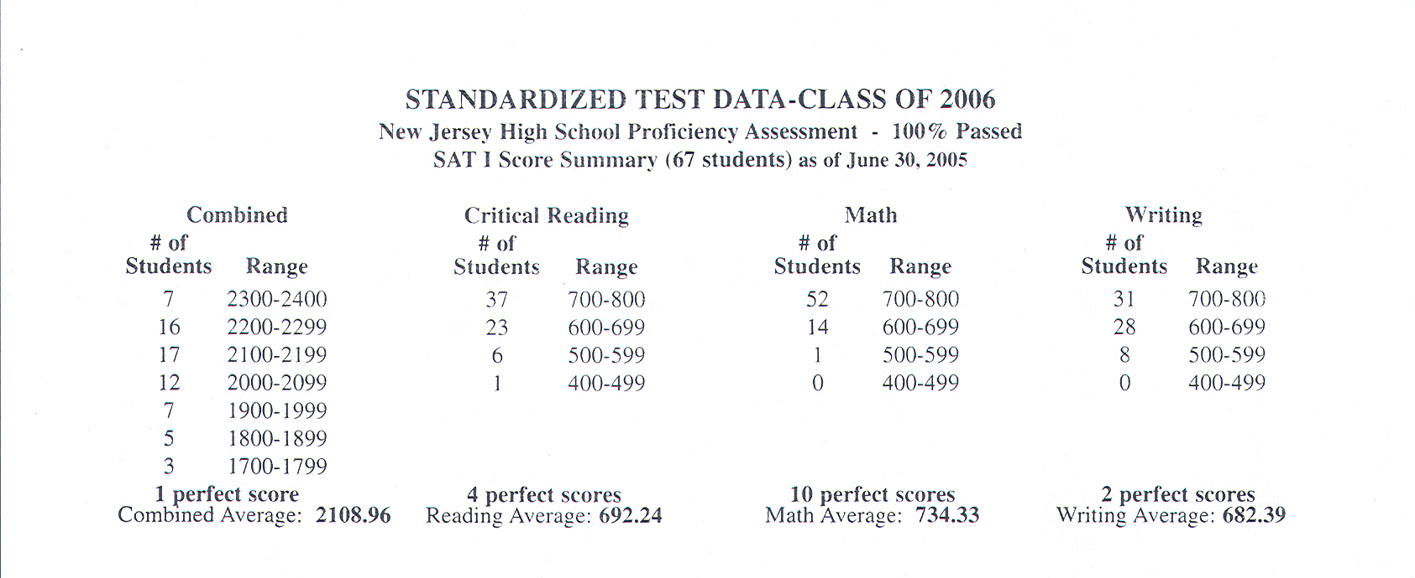
AAST

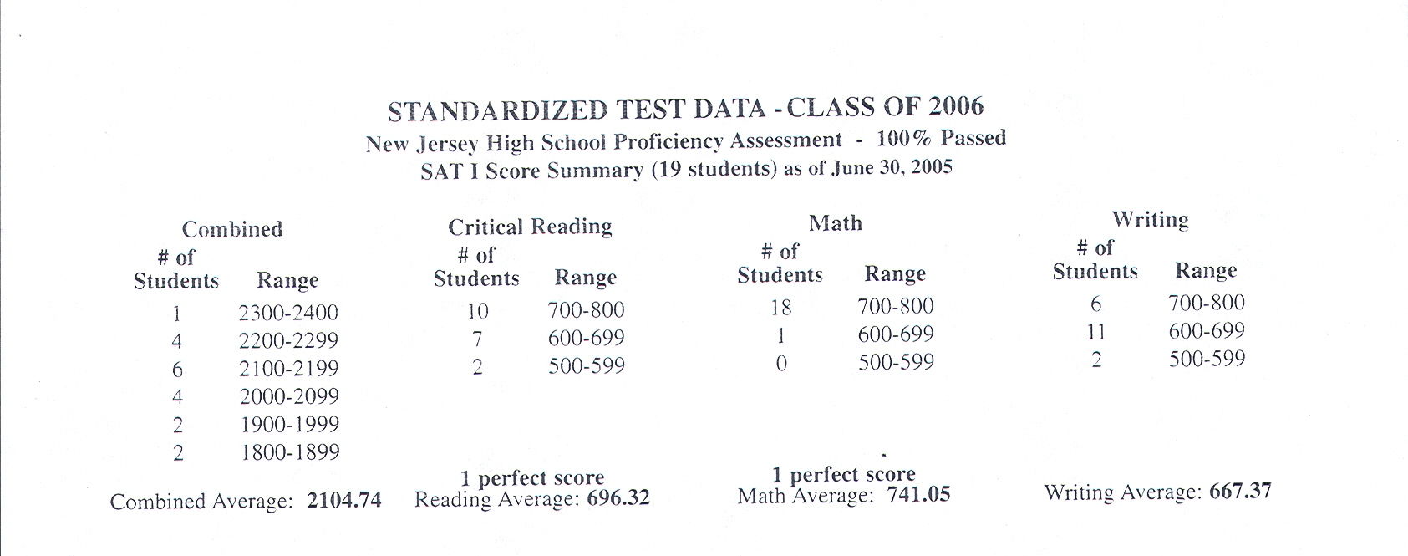
AEDT

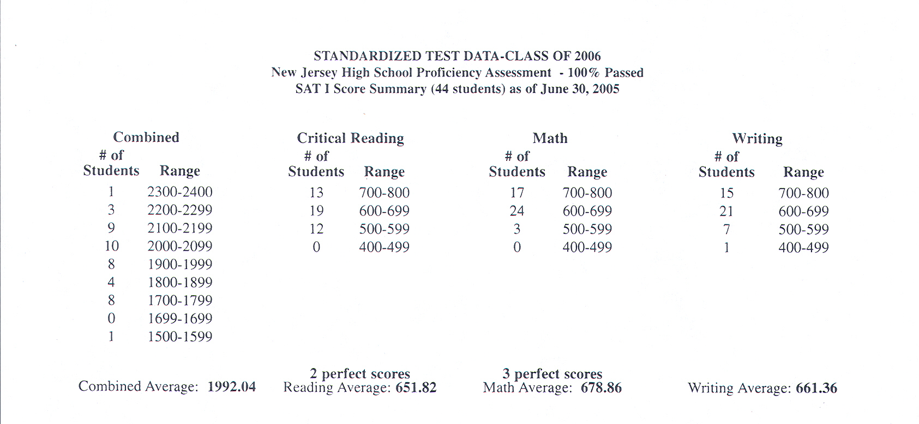
AMST

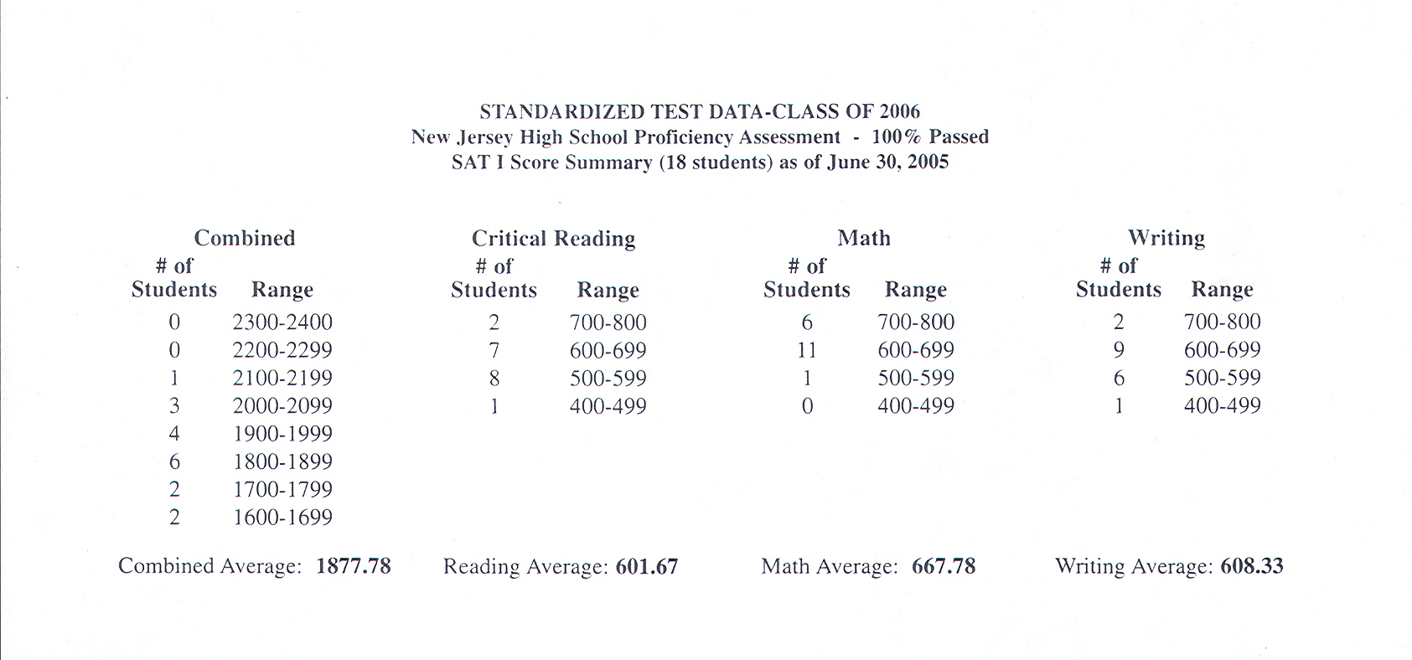
ABF
ABFIB
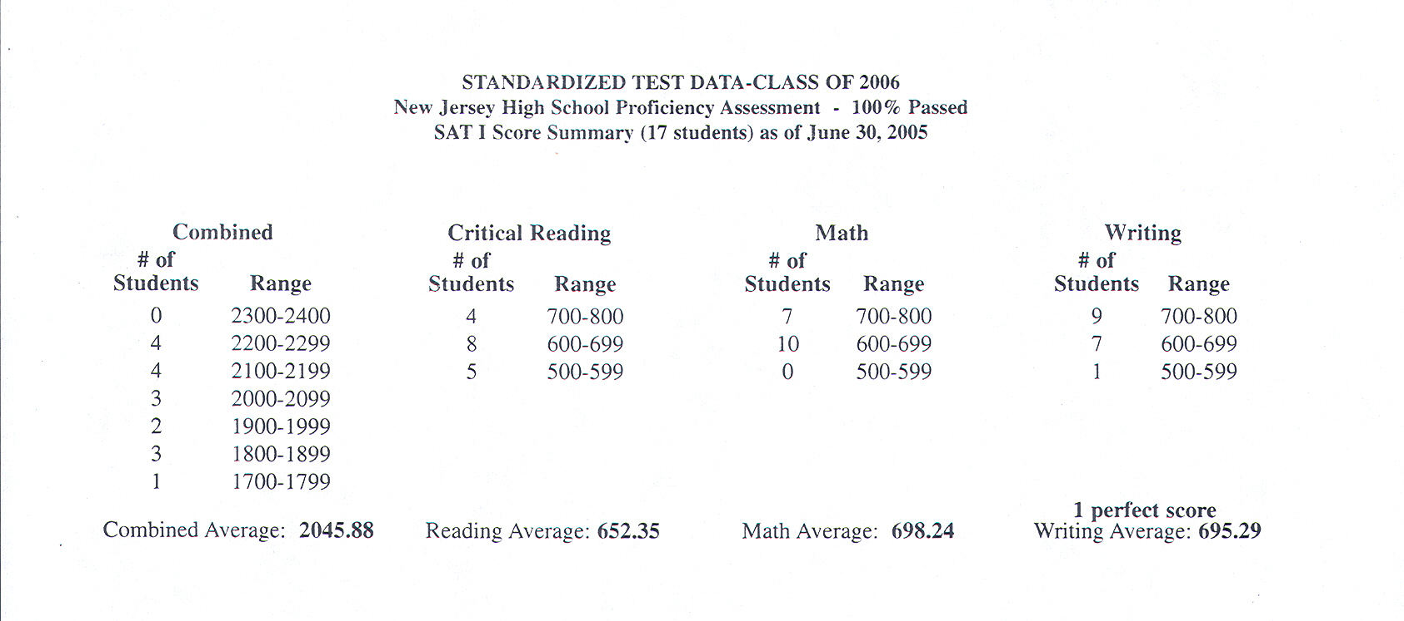
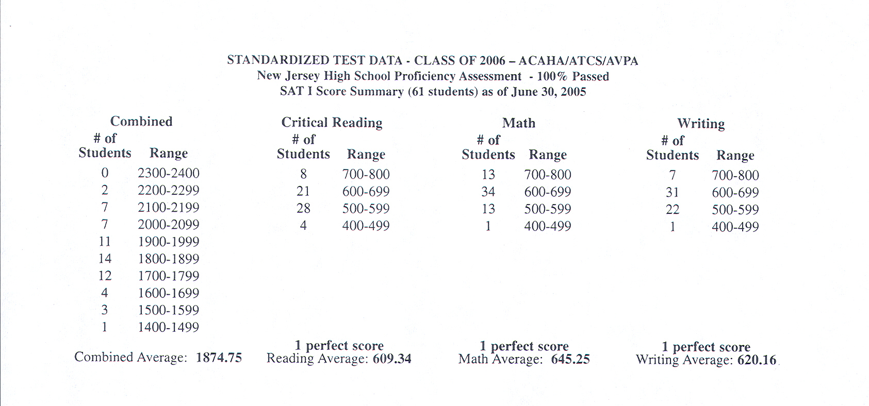

ACAHA/ATCS/AVPA

