Belle Isle Enterprise Middle School Oklahoma City, OK

Now completing its seventh year, Belle Isle Enterprise Middle School (Belle Isle) offers students a rigorous academic program in a highly supportive environment. Well ahead of most schools in its district, it is performing close to the state’s 2014 goals in both reading and math.
Belle Isle Enterprise Middle School
Oklahoma City, OK

412 students, grades 6—8

Students qualifying for free or reduced price lunch 59%
LEP students 19%

Student ethnicity:
White 46%
African American 23%
Hispanic 18%
Asian 9%
Native American 4%
A public school of choice in Oklahoma City, Belle Isle draws students from the greater Oklahoma City area, but gives preference to students in the immediate area, siblings, and other district students. Admission is by application; candidates must score above 60% in reading, language, and math and keep a B average in grades three through five.
A Strong School-Community Partnership
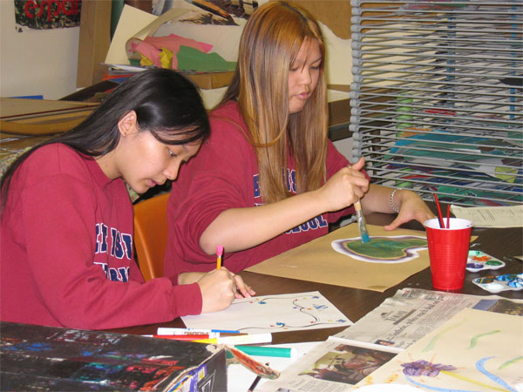
A grassroots group of parents and community members created Belle Isle in response to the Oklahoma City Public Schools (OCPS) enterprise policy (predating charter school policy), intended to increase school choice and education reform. Operating under contract with the Oklahoma City Public Schools, the school has authority over budgeting, recruitment and hiring, academic programs and staff development, and must meet state licensing requirements and use the same student assessments as other district schools. The district owns the school building—a former primary school in a residential neighborhood—and manages all purchasing.
Two bodies, a non-profit Board and the OCPS, govern the school. The principal, Lynn Kellert, answers to both, valuing the autonomy the OCPS offers and the support the Board provides. Teachers described the Board (13 of its 15 members are parents of current Belle Isle students) as supportive and generous. The Board makes grants to teachers for supplies and works to link the school to the neighborhood—most recently, by collaborating on a walking trail around the school that is open to neighborhood use.

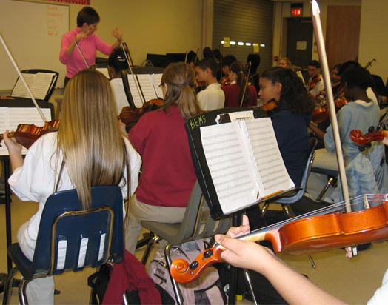
Principal Kellert sees site-based management as critical to Belle Isle’s success—particularly in hiring personnel, where she is careful to hire people committed to the model. Parents agree. Authority over finances lets the principal organize the budget to meet school-defined goals and priorities. Principal Kellert has been in her role for five years. Her staff includes an assistant principal, 22 FTE classroom teachers, 3.5 specialists, and 2.5 support staff members.
Core Knowledge Drives the Curriculum

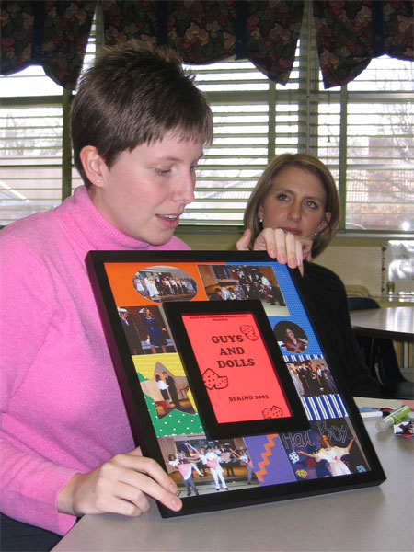
Belle Isle’s strong academic program is based on the Core Knowledge curriculum developed by the scholar E.D. Hirsch, Jr., with added emphasis on the fine and performing arts and foreign languages, including Spanish and Latin. Core Knowledge is a “solid, specific, shared core curriculum” designed to establish “strong foundations of knowledge, grade by grade.” Teachers explain that the Core Knowledge offers a spiraling approach to knowledge, allowing them to make connections across the disciplines. “[The] CK sequence reinforces from one classroom to another,” explained a 6th grade teacher. Teachers integrate student learning through both grade-level and subject-specific meetings. Each student’s social and academic progress is closely monitored and communicated to parents. Kellert keeps watch on student data, especially on students scoring below 50%—whom she calls “bubble kids”—and works to help them stay engaged and achieving.
Belle Isle’s fine and performing arts program includes orchestra, band, chorus, and fine arts classes. Performances punctuate the school year; during our visit, students produced a puppet show, rehearsed for a forthcoming string concert, and a practiced in a voice class. Students mount a major theatrical production, coordinated and facilitated by music and drama teachers. In 2003, for their production of Guys and Dolls, students came to school early for months.
The school relies on authentic materials rather than textbooks. A parent explained, “We are mostly project driven – focused on learning and achievement – not texts and tests.” Because using multiple sources presents challenges of its own, a school-created system of documenting lessons preserves syllabi and lesson plans for incoming teachers.
Each year, the school refines and develops a content area. For example, the school applied for and received a grant from the Southwest Educational Development Laboratory (SEDL) to use videotaping and conferencing to improve math instruction. Math teachers attended the National Council of Teachers of Math conference, and studied lessons with SEDL. “We got a better grasp on the math program,” a teacher said, “We are more reflective about how we teach.”
“Bell to Bell” Student Productivity
According to Principal Kellert, teachers are expected to engage students in learning productively “from bell to bell.” Teachers like the 90-minute block schedule because they can introduce a new concept in a lecture, and follow it up with active learning. The 90-minute instructional blocks permit more differentiated instructional practices and assessments. Students like the longer class periods and the A/B schedule: “If you don’t get something, you have a day to go ask for help before the next class,” a student explained.
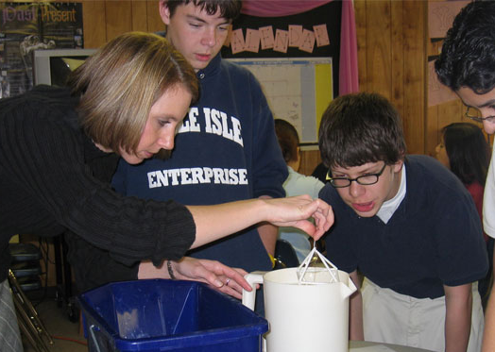
In a “Soapy Geometry” lesson, students in a 7th grade geometry class worked in small groups, building pyramids and prisms out of toothpicks and marshmallows. Each group created a triangle pyramid, square pyramid, triangle prism, and a cube, then recorded the numbers of faces, edges, and vertices, and calculated the areas of different shapes. Then they posed and tested hypotheses about how soap film would adhere to the shapes when dipped in soapy water.
Soapy Geometry
In another example of active learning, 8th grade language arts students explored the importance of communicating details. Working in pairs, one student described a black and white sketch of a street or other scene, while her partner drew the images described without looking at the picture he was attempting to replicate. Students interacted amiably, and focused on the task at hand.
An Atmosphere of Respect—and Achievement
Students are encouraged to feel positive about academic achievement. “It’s cool to be smart here, whereas in others schools, kids hid their books,” remarked one teacher. “Academic teams are given the same honor and prestige as athletic teams,” a student said, “the principal announces our successes – the whole school knows. They don’t announce when we do things wrong. Our classes have leadership teams – to help out. We don’t just sit and wait for the teacher.”
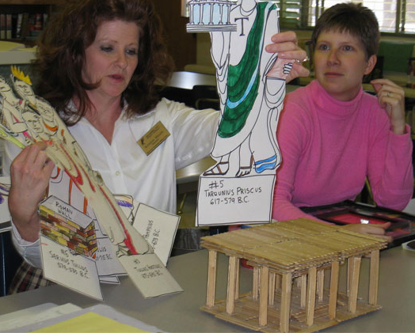
The sense of order and calm at Belle Isle is striking. Teachers agreed it was an unusual middle school environment, emphasizing respect, a positive attitude toward learning, and high expectations of achievement. A first year teacher noted, “This is like a family - everybody is so encouraging. They ask, ‘how can I help you?’” The positive relations begin with the administration and are carried through to the students. “We all talk the same language. We are all going in the same direction,” Kellert said, speaking of the unified vision that shapes the school community.
Students described teachers as “so nice, comforting. They make you feel welcome. Every teacher knows every student by name.” Others added, “If you go here, you have to want to be here.” Both teachers and students enthusiastically joked that the students at Belle Isle are nerds – that they want to learn. “We feel really well prepared here,” a student said, “We can get high school credit. We are exposed to a lot. French, Algebra, Fine Arts is great here. A lot of schools are losing the arts – we are active and involved! When we get into character (during grade-level Festival Days) it helps us remember history. It makes history fun.”
A teacher describes a student project on Roman Life
Meeting Great Expectations
Teachers and administrators credit the Great Expectations Teaching Model with creating this atmosphere. A state initiative, Great Expectations is bringing major changes and innovations to public school classrooms in Oklahoma. Founded in 1991 on the belief that education can solve social problems, that teachers want to become more skilled, and that students want to learn, its basic tenets are:

- All Children Can Learn
- Climate of Mutual Respect
- Building Self-Esteem
- Teacher Attitude and Responsibility
- High Expectations
- Teacher Knowledge and Skill

This model draws on a range of learning theories evident in classroom practices such as teacher modeling, critical thinking skills, emphasis on student responsibility, enriched vocabulary, and displays of student work. All Belle Isle’s teachers attend the Great Expectations professional development program; its ideals and practices permeate the school culture.
Teachers, students, parents and administrators see great value in modeling respect. One student said, “They want everyone to be proud of everyone.” Another added, “We’re all leaders. You want to be a model for the younger grades.” Teachers feel part of a professional learning community. A math teacher who received national teacher certification credited her peers: “Teachers helped me a lot. This is a professional community. I could not have done it without them.” Another teacher said, “I could not come here and coast. There are lots of expectations but there is lots of support. There is no acceptance of mediocrity.”
The tone is set by Principal Kellert: she is “beyond supportive,” explained a teacher, “She’s very fair, she has good advice.” Teachers feel trusted, not micromanaged, by the principal. “We just teach – she stays out of our way,” a teacher explained. “At other schools we were policed. . . . [Here] we are trusted. . . . People flock to her. I listen to here and learn from her – how she handles a parent conference. . . . She engages us in problem solving [and] does the same with students. Her expectations are 1) you are here first for the kids 2) you are a teacher of your subject area. . . . She is always trying to improve – reading, thinking, we are always working to get better.”
Making Character Count
Advisors plan morning “character meetings” around school principles like honor and integrity. “There is a focus on character here,” a teacher said, “We don’t try to hide it. We talk about life principles.” Stakeholders report a very strong sense of community. Belle Isle draws students from throughout Oklahoma City, including some of the wealthiest and poorest neighborhoods. Character meetings, the tone of respect, and the fact that all Belle Isle students wear uniforms help erase class- and race-based differences. “You don’t have concept of who is rich or poor. Don’t have clue about backgrounds,” explains one teacher. When school bus service was cut from twenty to four buses, some 20 students were no longer able to attend; in testament to the community’s spirit, parents were able to organize transit for most of the students.
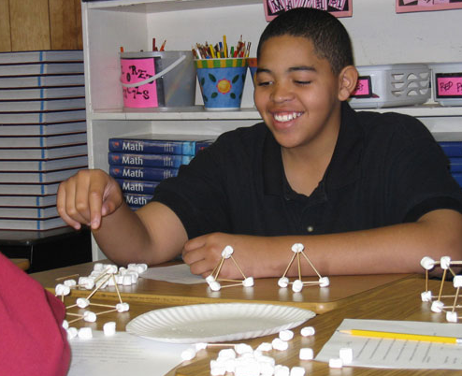
To ease students’ transition from elementary school, 6th graders stay together throughout the day. Team meetings for 6th grade look at how well a child fits with his or her classmates. In 7th and 8th grade team meetings, all teachers review students’ progress, working together to address individual needs. Teachers communicate frequently with parents, post grades weekly, and are available by email, phone, and for conferences. Regularly scheduled team meetings let parents see all of a child’s teachers in one visit. This access lets parents and students feel secure: Parents said that “it is like a family setting – they don’t let kids fall through the cracks.”
Students are encouraged to take responsibility in all parts of their life at Belle Isle, from behavior and academics to the student-run musical productions. They receive agenda books to plan their work, and can get extra help before or after classes. The honor code is posted in every classroom, and students are held accountable for their actions. If a student received marks for missing homework or behavioral problems, he or she can work them off after school or through extra work. A student described it as “well thought out. It is very fair and it gives us an opportunity to make mistakes and then to work to make up for them.”
One teacher saw the school’s success as a “positive self-fulfilling prophesy,” the result of holding students to high expectations for academic achievement, social development, and active citizenry. The school seeks to help every student find an area in which he or she can succeed. Students are expected to engage in a variety of activities, including music, arts, sports, and academics. Students said, “Teachers really care. They take the time to help you succeed” and, “They look at students’ individual talents and they will help you and find opportunities for you to develop those talents.”
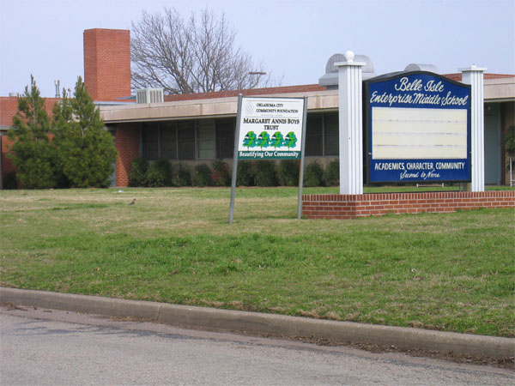

Core Knowledge website

