Individuals using assistive technology may not be able to fully access the information contained in this file.

For assistance, please send an e-mail to: NRC-FLAS@ed.gov and include “508 Accommodation” and the title of the document in the subject line of your e-mail.

Grant Application

NATIONAL RESOURCE CENTER
and
FOREIGN LANGUAGE AND AREA STUDIES FELLOWSHIP PROGRAMS

Funding Opportunity Number: ED-GRANTS-121621-001

Burdine Hall 452
2505 University Avenue F3600 Austin, Texas 78712
Phone: (512) 471-3607

Principal Investigator: Dr. Mary Neuburger
Director, Center for Russian, East European, and Eurasian Studies Chair, Department of Slavic and Eurasian Studies
Professor, Department of History

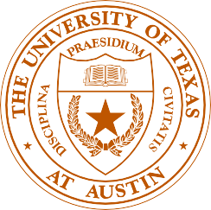

Table of Contents

PROJECT NARRATIVE Page

Introduction 1
Criterion A – Commitment to Subject Area 2
- Institutional Support for CREEES Operations 2
- Teaching Staff 3
- Library Resources 4
- Overseas Linkages 4
- Outreach 5
- Student Support 6
Criterion B – Quality of Language Instructional Program 6
1.-2. Language Instruction, Levels, Enrollments, and Courses 6
- Language Faculty and Pedagogical Training 7
- Performance-Based Instruction 7
- Resources for Language Teaching and Practice 8
- Language Proficiency Requirements 9
Criterion C – Quality of Non-Language Instructional Program 10
- Course Offerings in a Variety of Disciplines 10
2.-3. Non-Language Faculty and Depth of Specialized Courses 10
- Interdisciplinary Courses 11
Criterion D – Quality of Curriculum Design 12
- Undergraduate Training and Programs 12
- Depth and Breadth of Graduate Training 12
- Academic and Career Advising 14
- Overseas Opportunities 14
Criterion E – Quality of Staff Resources 17
1.-2. Faculty, Staff, and Administration Oversight 17
  - CREEES Director 17
  - CREEES Associate Director ………………………………………………... 18
  - CREEES Administrative and Library Staff 18
  - CREEES Faculty 19
  - Teaching, Supervision, and Advising of Students 19
  - Professional Development for Faculty and Staff 20
  - Governance Structure 21
- Equal Opportunity Employment, and Access 21
Criterion F – Strength of Library 21
- Library Holdings and Clientele 21
- Cooperative Arrangements and Open Access 23
Criterion G – Impact and Evaluation 24
- Impact of Training Programs and Outreach Activities 24
  - Enrollments and Training 24
  - Outreach Activities 25
- Post-Graduate Placements and Training 25
- National Needs and Public Information 27
- Evaluation Plan 28
  - Degree Program Evaluation 28
  - Language Program Evaluation 29
  - Alumni Tracking ……………………………………………………………. 29
  - Outreach Program Assessment ………………………………………..……. 30
  - Comprehensive Center Evaluation …………………………………………. 30
- Equal Access and Non-Discrimination 31
Criterion H – Outreach Activities 32
- K-12 Teacher Training and Outreach ………………………………………………… 32
- Post-Secondary Collaborations ………………………………………………………. 33
- Campus and Community Events ………………………………………………….….. 35
Criterion I – Program Planning and Budget + Priorities 36
- Development Plan 36
  - Area Studies Training and Professionalization 37
  - Language Training and Curriculum Innovation 40
  - K-16 Teacher Training and Outreach Initiatives 42
  - Campus and Community Events and Collaborations 43
  - Digital Initiatives, Media, and Library Development ………………………. 45
- Quality of Outcomes 46
- Cost Effectiveness 47
- Long Term Impact 47
Criterion J – FLAS Awardee Selection Procedures + Priorities 48
- Fellowship Selection Plan 48
- Institutional Support for FLAS 50
- FLAS Fellow Engagement 50

LIST OF FIGURES IN NARRATIVE Page
Figure 1: UT Institutional Support for CREEES (2020-21) 3
Figure 2: REEE Visiting Students & Scholars at UT (2020-21) 4
Figure 3: Non-NRC/FLAS Supplemental Funds (2018-22) 5
Figure 4: REEE Language Course Enrollments (2020-21) ……………………………………. 6
Figure 5: Enrollees in REEE Languages by College/School (2020-21) 24
Figure 6: Alumni Placements in Areas of National Need 26
Figure 7: NRC Outreach Activities and Priorities ……………………………………………... 47

List of Acronyms and Abbreviations

AATSEEL American Association of Teachers of Slavic and East European Languages
ACC Austin Community College
ACTFL American Council on the Teaching of Foreign Languages
AI Assistant Instructor
AP Absolute Priority
ASEEES Association for Slavic, East European, and Eurasian Studies
ASU Angelo State University
BCMS Bosnian-Croatian-Montenegrin-Serbian
Business McCombs School of Business
CIEE Council on International Educational Exchange
CP Competitive Priority
CoLA UT College of Liberal Arts
COERLL UT Center for Open Educational Resources and Language Learning
Communications UT Moody College of Communications
CREEES UT Center for Russian, East European, and Eurasian Studies
CRL Center for Research Libraries
CTL Center for Teaching and Learning
Dell Medical UT Dell Medical School
DoD US Department of Defense
DSES UT Department of Slavic and Eurasian Studies
EBC Extended Budget Council
ED US Department of Education Engineering Cockrell School of Engineering EU European Union
FAFSA Free Application for Federal Student Aid
FIC UT Faculty Innovation Center
FLAS Foreign Language Area Studies
FLC Faculty Learning Community
GDIL UT Global (Dis)Information Lab
GPA US Department of Education Fulbright-Hays Group Projects Abroad
GRA Graduate Research Assistant
HRC UT Harry Ransom Center
HSI Hispanic Serving Institution
HTU Huston-Tillotson University
IRG UT International Relations and Global Studies
iSchool UT School of Information

ISPRII UT Initiative for the Study of Politico-Religious Ideation and Influence
LBJ School UT Lyndon B. Johnson School of Public Affairs
LCTL Less Commonly Taught Language
MSI Minority Serving Institution(s)
NIS Newly Independent States
NRC National Resource Center
OCLC Online Computer Library Center
OER Open Educational Resources
OPI Oral Proficiency Interview
PAGL UT President’s Award for Global Learning
REEES Russian, Eastern European, & Eurasian Studies
REEE Russia(n), Eastern Europe(an), and Eurasia(n)
SEEMP Slavic and East European Material Project
SEU St. Edward’s University
SiberiaXSW Siberia by Southwest
SRAS School of Russian and Asian Studies
STAMP Standards-based Measurement of Proficiency (Avant Assessment)
STEM Science, Technology, Engineering, and Math
SXSW South by Southwest Music, Film, and Interactive Festivals
TA Teaching Assistant
TLC UT Texas Language Center
TREEES Texas Russian, East European, and Eurasian Studies
U University
UEX UT University Extension
UN United Nations
UT The University of Texas at Austin
UTeach The UTeach Institute
UTL UT Libraries/UT Library System

INTRODUCTION

Since 1988, the Center for Russian, East European, and Eurasian Studies (CREEES) at The University of Texas at Austin (UT) has provided a vital regional hub for area studies research and training, as well as K-16 and public outreach. We seek Title VI funding from the US Department of Education (ED) to build upon our achievements and momentum as a National Resource Center (NRC) and Foreign Language Area Studies (FLAS) institution with a focus on Russia, Eastern Europe, and Eurasia (REEE). Based in one of the fastest growing US cities in the second largest state by area and population, CREEES at UT is the only REEE NRC and FLAS institution serving the South and Southwest. Austin has an international reputation for innovative technology, entrepreneurship, education, and performing arts, providing a dynamic urban setting for UT and CREEES operations. UT is one of the largest and highest ranked public universities in the US, with a diverse student body of over 50,000 students. Since fall 2020, UT qualifies as a Hispanic Serving Institution (HSI), and CREEES actively embraces the challenge of diversifying the pool of students and scholars engaged in REEE study and research at UT and nationally.
In the next grant cycle, CREEES will build upon its proven record of achievement and

expand its impact on and beyond the UT campus. We will channel the energies and talents of UT faculty, students, and staff to advance new initiatives that encourage the integration of diverse perspectives into extracurricular events, area studies, advanced language training, and K-16 outreach that reaches a growing network of Minority Serving Institutions (MSI). CREEES will also continue to expand overseas and US partnerships as it works to build a more diverse, globally competent, and connected workforce in areas of national need. Finally, we will facilitate the generation and dissemination of scholarly research and debate on REEE through academic and public channels to better inform the general public in Texas, the US, and beyond.

UT provides a rich ecosystem for scholarly interaction and cross-campus partnerships that are vital to CREEES’ success. CREEES works closely on K-16 outreach, events, and curriculum development with other NRCs housed in UT’s College of Liberal Arts (CoLA), including the Centers for European Studies, Middle Eastern Studies, Latin American Studies, South Asian Studies. We also actively collaborate with an ED-funded Language Resource Center, the Center for Open Educational Resources and Language Learning (COERLL), as well as the policy-focused Strauss Center for International Security and Clements Center for National Security. We also partner with the UT’s Colleges of Natural Sciences, Education, and Fine Arts and its renowned professional schools: the LBJ School of Public Affairs (LBJ School), the Dell Medical School (Dell Medical), the McCombs School of Business (Business), the School of Information (iSchool), the Moody College of Communications (Communications), the Cockrell School of Engineering (Engineering), the Schools of Law and Architecture. In the 2022-26 grant cycle, CREEES will optimize resources and impact at UT and beyond, by co-sponsoring and
co-organizing activities with the exceptional faculty and staff from these units.

CRITERION A – COMMITMENT TO SUBJECT AREA

- Institutional Support for CREEES Operations: UT provides ample institutional support for Russian, East European, and Eurasian Studies (REEES) initiatives, totaling $7,511,162 in
2020-21. This total, even higher when international travel was unrestricted, includes a percentage of CREEES affiliate faculty and staff salaries; faculty research funds; programming; library acquisitions; digital project development; outreach; course development; maintenance and operations; and REEES student tuition, stipends, and scholarships (Figure 1). In terms of leadership support, CoLA provides the CREEES director with substantial course reductions, two months’ summer salary, supplemental research funds, and a semester research leave every four

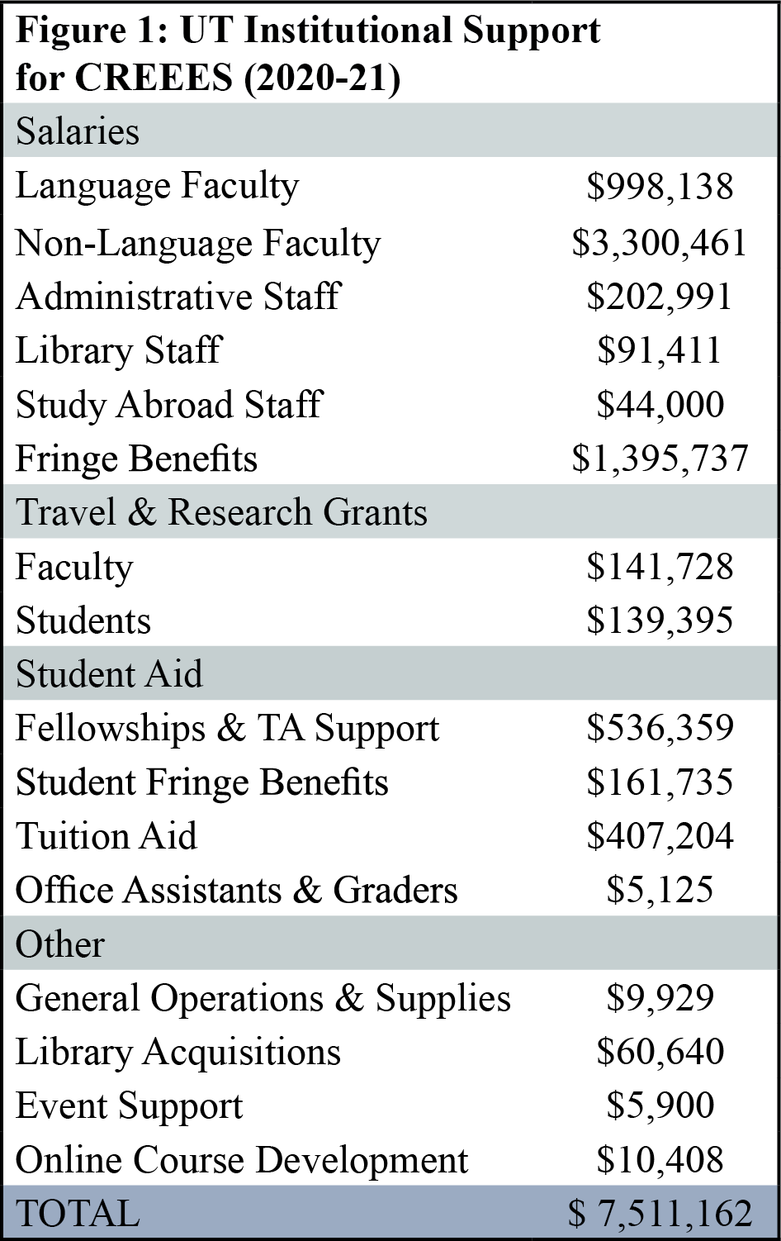
years. Teaching just one course a year, Dr. Mary Neuburger also serves as chair of the interdisciplinary Department of Slavic and Eurasian Studies (DSES), which administratively merged with CREEES in 2001. This dual appointment is facilitated by the active service of CREEES Associate Director Dr.
Craig Campbell and DSES Associate Chair Dr. Steven Seegel, who receives one course release per year. The CREEES/DSES merger makes it possible for Dr. Neuburger to focus hiring, development, and resource allocation on integrated center and department needs, including the incorporation of
technology tools into language and area studies teaching and research. For example, she initiated, secured funding, and hired appropriately trained faculty for the creation of new Open Educational Resources (OER) curricula in three Slavic languages (p. 24).
- Teaching Staff: UT continually supports the hiring and retention of top-notch CREEES faculty who are currently based in 11 schools and colleges, encompassing 29 departments. There have been eight faculty hires in REEES since 2018. This includes four tenure-track hires and one lecturer within DSES: anthropologists Dr. Chelsi West Ohueri (2018) and Dr. Maria Sidorkina (2018), political scientist Dr. Kiril Avramov (2020), historian Dr. Steven Seegel (2021), and applied linguist Frane Karabatić (2019). These hires bring new REEE research and teaching expertise while furthering CREEES connections to a variety of discipline-based departments.
A number of Provost-funded research and hiring initiatives have intensified CREEES

synergies with units across campus. Most notably, Dr. Neuburger’s global disinformation proposal was selected for funding in a 2019 cluster hire competition. As a result, DSES recruited Dr. Avramov in 2020, and disinformation-focused hires occurred in Middle East Studies, the iSchool, and Communications. Subsequently, Drs. Neuburger and Avramov co-founded the Global (Dis)Information Lab (GDIL), which received over $450,000 in Provost start-up funds to support interdisciplinary collaborative research projects, technology tools, and skills workshops for students related to global disinformation. The Provost also encouraged collaborations through the 2017 Bridging Barriers program, in which three teams of UT faculty are provided funds to generate research and possible solutions to urgent global issues. CREEES faculty are involved with two of these teams, “Whole Health-Whole Communities” (Dr. West-Ohueri) and “Good Systems: Ethics in Artificial Intelligence” (Drs. Avramov, Neuburger, and Roberts).
- Library Resources: UT Libraries generously funds REEES acquisitions (p. 21) and library staff, including REEES and Digital Projects Librarian Ian Goodale, Jewish Studies Librarian Uri Kolodney, and Middle Eastern (and Central Asian) Studies Librarian Dr. Dale Correa. Library staff work directly with REEES faculty and students to support research needs. They are responsible for REEES collection development, cataloging, digital projects coordination, and skills workshops. Full-time bibliographers in history, anthropology, and other disciplines also coordinate acquisitions for CREEES affiliates out of generous discipline-specific budgets.
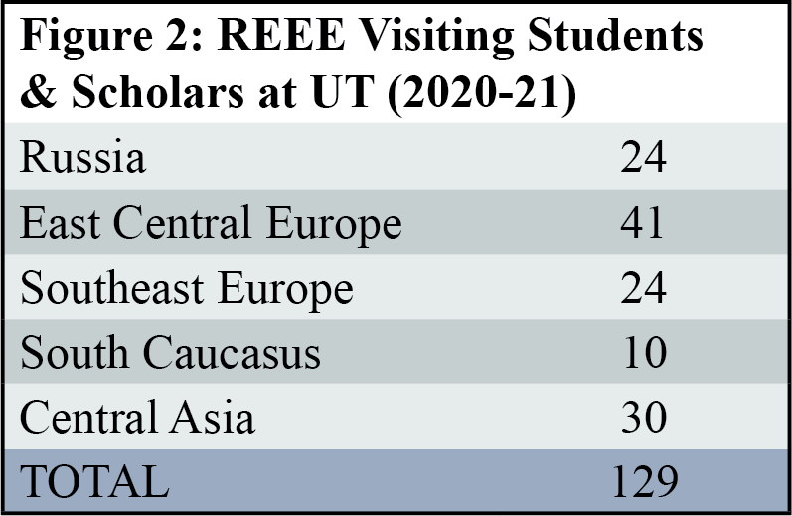
- Overseas Linkages: With UT support, CREEES has developed extensive linkages in the REEE region. UT hosted 129 international students and scholars from 29 REEE countries in 2020-21 alone (Figure 2). Since 2018, CREEES has provided office space, library

access, logistical support, and an intellectual community for 11 visiting scholars from REEE, including Fulbright fellows from Russia, Azerbaijan, Bulgaria, and Romania. These linkages, sustained by UT’s ample funding for faculty and student travel to REEE, are foundational to CREEES partnerships in the region. For example, CREEES and U Zagreb began a long-term collaboration after hosting award-winning Croatian author Dr. Maša Kolanović as a Fulbright scholar in 2015. This resulted in Drs. Neuburger and Kolanović co-chairing the summer 2019 Association for Slavic, East European, and Eurasian Studies (ASEEES) convention in Croatia.
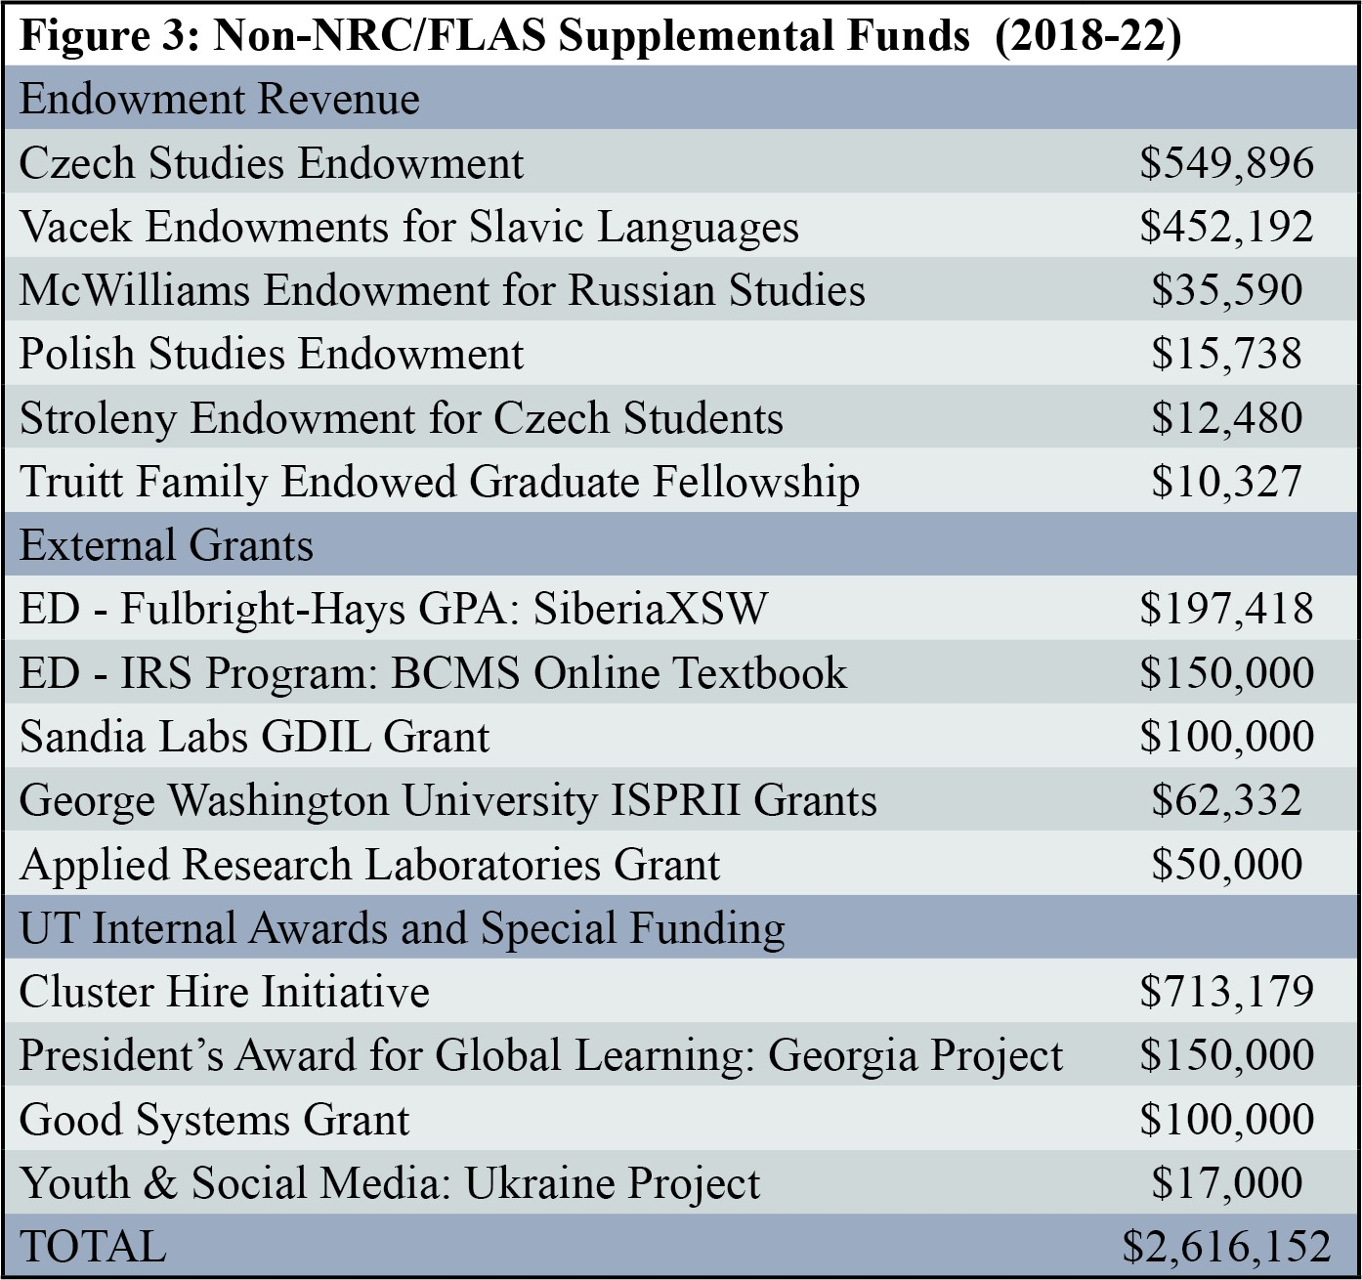
In addition, UT’s international office, Texas Global, has created a plethora of new global engagement opportunities that have benefited REEES faculty and students. These range from student scholarships and small grants for global classroom projects (p. 7) to the competitive President’s Award for Global Learning (PAGL) which CREEES faculty Dr. Amy Liu received in 2019. With over $150,000 in PAGL funds, Dr. Liu worked with a team of five students who spent ten weeks in Georgia working with the Georgian National Center for Disease Control, Tbilisi State University, and UN
Women. They conducted interviews and launched a nationwide survey, examining the ways Georgia reduced its maternal mortality rate by half in just two years.
- Outreach: CREEES draws upon numerous donor gifts, endowments, UT internal funding streams (Figure 3), and co-sponsorships with other

units from across the university for on and off campus events. UT also provides office space and salary support for key staff and faculty who coordinate, organize, and provide expertise for all outreach activities. Finally, CREEES has access to ample cost-free or low-cost conference facilities, computer labs, and three CREEES exclusive wired conference rooms.
- Student Support: In 2020-21, UT offered approximately $284,391 in REEES student scholarships, professional internships, research fellowships, and study abroad support. A significant proportion of CREEES MA students (80% in 2020-21) are funded through TA positions, fellowships, and research assistantships. CREEES also offers a number of graduate and undergraduate students part-time work on curricular, research, or administrative projects.
CREEES faculty and staff also regularly assist REEES students in securing outside funding. We host grant workshops and mentor students on individual grant proposals. Since 2018, REEES students have received the following prestigious awards to study REEE languages and conduct research in the region: the Critical Languages Scholarship, Boren Scholarship, Fulbright Fellowship, Fulbright-Hays Fellowship, ASEEES Cohen-Tucker Dissertation Fellowship, and National Council for Eurasian and East European Research Fellowship.

CRITERION B – QUALITY OF LANGUAGE INSTRUCTIONAL PROGRAM

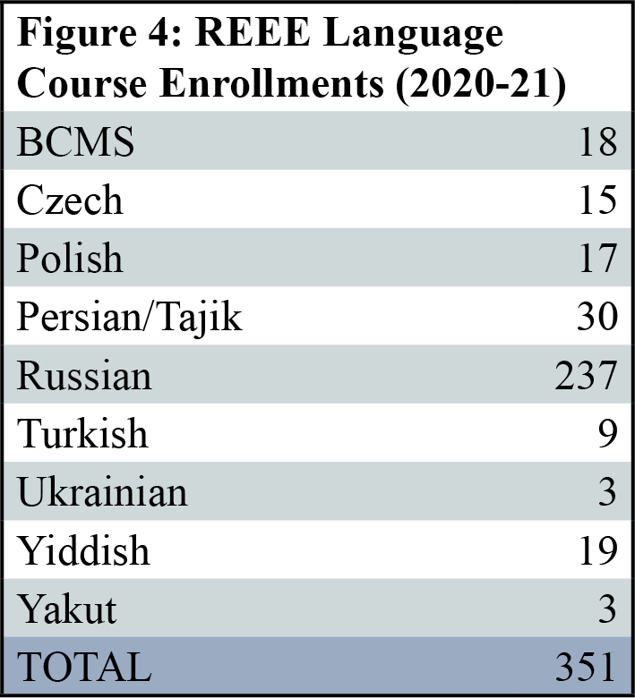
1.-2. Language Instruction, Levels, Enrollments, and Courses: UT faculty regularly teach Russian, Czech, Polish, Ukrainian, Romanian, Yiddish, Bosnian-Croatian- Montenegrin-Serbian (BCMS), Turkish, and Persian/Tajik through the advanced level. Bulgarian, Yakut, and Tuvan are also available for individual instruction at all levels based on student demand. Enrollments in REEE languages are robust,

totaling 351 students in 46 language sections in 2020-21 (Figure 4). In addition to traditional language courses, DSES offers Russian language content courses on topics like “Russian Politics and Media,” “Cultural Geography of Russia,” “Russian Through Drama,” “Mastering Russian Through Global Debate,” “Vysotsky: His Life and Works,” and “Russian for Business/Policy.”
- Language Faculty and Pedagogical Training: UT has 18 instructors that teach REEE languages. Our primary strength is in Slavic languages, including Russian (Garza, Livers, Bychkova-Jordan, Alexandrova, Lutsyshyna, Rice, Wilkins, Karabatić, Greff), Polish (Petrov, Kaminska), BCMS (Beronja, Karabatić), Bulgarian (Petrov), Ukrainian (Lutsyshyna), and Czech (Hilchey). We also offer Yakut and Tuvan (Bychkova-Jordan), Romanian (Roberts), Persian/Tajik (Aghaie, Shirazi), Turkish (Okur), and Yiddish (Gottesman, Roberts). Russian,
Persian/Tajik, Yiddish, and Turkish courses employ the accelerated, intensive method with a six-credit per semester sequence that covers two levels of instruction in one academic year.
REEES faculty regularly participate in pedagogical workshops and trainings at universities across the US, or sponsored by organizations such as American Association of Teachers of Slavic and East European Languages, the American Council on the Teaching of Foreign Languages (ACTFL), and the Southwest Conference on Language Teaching. In addition, the UT Texas Language Center (TLC), directed by Dr. Thomas Garza (DSES), supports foreign language acquisition research, training, and course development and provides a forum for all UT language instructors, TAs, and AIs to share best practices in language pedagogy. The TLC offers frequent seminars and workshops that encourage faculty to use proficiency-oriented scenarios, culturally authentic materials, and project-based learning. Lastly, All REEE language AIs are required to take a pedagogy and practicum course prior to teaching their own language course.
- Performance-Based Instruction: CREEES encourages language faculty to employ

innovative models for language teaching with an emphasis on performance-based competencies. REEE language courses routinely integrate experiential and project-based learning. Since 2018, Drs. Garza, Rice, Alexandrova, and Wilkins have been awarded grants from Texas Global to integrate the global classroom model into their curricula. Dr. Garza’s new “Mastering Russian Through Global Debate,” for example, connects students to Russian counterparts for lively debates on contemporary issues. Dr. Alexandrova created Telemosty.org, an OER website to facilitate Russian/English conversation exchange, using materials aligned with all ACTFL proficiency levels. Many REEE language classes integrate the use of social media and online portfolios to promote digital literacy in the language of instruction. Faculty-led conversation hours and film nights in Russian, Czech, Polish, and BCMS, as well as student-centered Slavic Fall and Spring Fests, contribute to a more immersive language learning experience.
Performance-based learning is also employed in overseas programs. In 2018, CREEES was awarded a Fulbright-Hays Group Projects Abroad award to run SiberiaXSW, a 10-week intensive Russian language program based in Irkutsk. Twenty program participants from across the Southwest engaged in intensive classroom learning in addition to active-learning, team-based research projects. Students were provided with local Russian peer mentors, who accompanied them in exploring the city of Irkutsk and its environs, gathering primary and secondary source materials, and conducting interviews with locals on topics ranging from the Decembrists in Irkutsk to Buryat cultural practices. Finally, teams were required to present their work in Russian to their Irkutsk instructors and student mentors and create a Russian/English project website.
- Resources for Language Teaching and Practice: CREEES is highly committed to advancing REEE language training through technology-based tools. A number of REEE language faculty have collaborated with COERLL in the development of new OER Slavic curricula. Dr. Christian

Hilchey worked with COERLL on his pioneering Reality Czech textbook, which uses hundreds of authentic Czech-language videos and other materials to foster a stimulating learning environment. In addition, Frane Karabatić is consulting with COERLL and Hilchey on a groundbreaking new OER web-based curriculum for first year BCMS called Tako Lako (Piece of Cake) funded by a 2020-23 ED International Research and Studies grant, CREEES, DSES, and UT’s Center for European Studies. Finally, in 2018, Dr. Heather Rice (DSES) completed an interactive multimedia platform Russian textbook Budem na Svyazi, working with Liberal Arts Instructional Technology Services. Funded by a $300,000 UT system grant, Budem na Svyazi utilizes an interactive multimedia platform, online conversation groups, and instant feedback, quizzes, and assignments. Since 2020, this innovative curriculum has been used free of charge by all DSES sections of online and in-person first-second year Russian. With CREEES and COERLL support, Rice will transition the materials to an OER beginning summer 2022.
In addition, CREEES actively supports UT’s Linguistics Research Center whose website features online OER materials for linguistic analysis and language-learning for Albanian, Armenian, the Baltic languages, and Old Church Slavonic. During the pandemic, there was a huge spike in the use of these materials, which registered between 1,200-3,000 views a month per REEE language and collectively over 60,000 views from September 2020-21.
- Language Proficiency Requirements: ACTFL proficiency guidelines are the foundation of language instruction in DSES, which has several faculty who are trained in Oral Proficiency Interview (OPI) methods. CREEES undergraduate majors and graduate portfolio students are required to reach a minimum of third-year equivalency in one REEE language through the completion of intermediate level coursework or a language proficiency exam rating of Intermediate Mid or higher on the ACTFL scale. CREEES MA students are required to reach a

proficiency of Intermediate Mid in at least one REEE language but are encouraged to achieve the highest possible proficiency, with most graduate students reaching Advanced level or above.

CRITERION C – QUALITY OF NON-LANGUAGE INSTRUCTIONAL PROGRAM

- Course Offerings in a Variety of Disciplines: CREEES faculty teach a wide array of discipline-specific and interdisciplinary courses. In 2020-21 UT offered a total of 107 REEES content courses taught by 96 faculty, with undergraduate enrollments of 6,262 and graduate enrollments of 428. For a list of REEES courses and enrollments see Appendix 1. REEES undergraduate courses appeal to students from across the university and fulfill requirements in and beyond the CREEES major, including interdisciplinary degree programs such as international relations and global studies (IRG), health and society, and sustainability studies. REEES graduate courses are offered not only in history, political science, geography, anthropology, and comparative literature, but also in professional school disciplines, including global policy, architecture, global health, and international business and law. UT has particular strengths in US-REEE foreign policy, with courses such as “The Long Cold War and Global Diplomacy” (Suri), “US Promotion of Democracy Abroad” and “Government and Global Broadcasting” (Pomar), and “Ethnic Conflict and Humanitarian Intervention” (Kuperman).
2.-3. Non-Language Faculty and Depth of Specialized Courses: CREEES affiliate faculty

span the university and teach courses on REEE history, culture, policy, and contemporary issues. Our core faculty offer considerable expertise on Russia and the former Soviet Union in the following disciplines: history (Neuberger, Wynn), political science (Avramov, Moser, Barany, Wellhausen), global policy (Suri, Inboden, Avramov), architecture (Udovicki-Selb), and Russian language and literature (Livers, Garza, Alexandrova, Petrov, Lutsyshyna). Within the Russian field, Siberia is an area of particular interest and expertise, with faculty in anthropology

(Campbell, Sidorkina), geography (Bychkova-Jordan), and religious studies (Roberts).

CREEES also has core faculty expertise in Southeastern Europe in history (Neuburger), global policy (Kuperman, Avramov), cultural/religious studies (Beronja, Roberts), anthropology (West Ohueri), ethnomusicology (Seeman), political science (Liu, Wellhausen), and classics (Rabinowitz). In East Central Europe, we have core faculty who specialize in history (Seegel, Lichtenstein, Crew), global policy (Redei, Eaton), architecture (Long), language and literature (Hilchey, Kaminska, Roberts, Lutsyshyna), and political science (Barany).
Every department, college, or school at UT provides hands-on TA and AI training and faculty mentorship, with AIs required to take a semester-long practicum course in their home units. In addition, UT’s Center for Teaching and Learning (CTL) has a Graduate Student Development Program that advances graduate students’ pedagogical training through a series of sessions on learning theory, syllabus design, inclusive teaching, and effective assessment.
4. Interdisciplinary Courses: CREEES offers required interdisciplinary, team-taught gateway courses for its undergraduate major “Introduction to REEES” (p. 12) and its MA program “Seminar in REEES” (p. 12). These introductory courses are open to and draw students from across UT who are interested in interdisciplinary approaches to REEES. CREEES area studies faculty also teach or co-teach a number of courses that cross disciplinary boundaries, including
(1) Drs. Roberts and Campbell, “Shamanism and the Primitive” (religious studies, anthropology); (2) Drs. Neuburger and Lutsyshyna, “Youth and Social Media in Ukraine” (history, cultural studies); (3) Drs. Roberts and Avramov, “Political Ideologies and Manifestos” (religious studies, political science); (4) Dr. Seegel, “East European Transnational Worlds to 1914” and “Geography and Geo-fantasy in Eastern Europe” (history, geography); and (5) Drs. Neuberger and Sidorkina, “Socialism’s Past and Futures” (history, anthropology).

CRITERION D – QUALITY OF CURRICULUM DESIGN

With flexible and rigorous interdisciplinary BA, MA, and Graduate Portfolio programs, CREEES has successfully trained students in area studies since 1988. In 2019-20, we had 33 undergraduate CREEES majors and 28 MA program students. UT’s IRG major, which requires an area studies concentration, had over 90 of its 787 majors declare a REEES focus in 2021.
- Undergraduate Training and Programs: CREEES BA students receive broad interdisciplinary training beginning with the foundational “Introduction to REEES.” This course incorporates best practices in project and team-based learning, and students benefit from frequent guest instructors who introduce thought-provoking, cross-disciplinary approaches. The CREEES BA program also requires “Introduction to Russian Literature,” which exposes students to the canon of Russian authors and literary works. Additionally, as of fall 2021, students must take a capstone course which offers in-depth training in research methods in a small seminar setting and requires the completion of independent research projects. CREEES honors students will expand upon their capstone work with another semester of faculty-mentored research and will engage primary and secondary sources in an REEE language to write an original thesis.
- Depth and Breadth of Graduate Training: Since 1994, CREEES has administered an MA program with advanced interdisciplinary training in REEES. CREEES also offers dual MA programs with Global Policy Studies, Public Affairs, Business, Law, and Communications and a graduate portfolio program open to all UT graduate students. All MA and portfolio students are required to enroll in the gateway “Seminar in REEES,” a team-taught course featuring CREEES affiliates who lead weekly sessions that expose students to interdisciplinary approaches to REEES. The course’s lead instructor guides students as they choose the appropriate methods for their MA thesis, undertake preliminary research design, and refine their academic writing and

presentation skills. Instructors often integrate team-based assignments into the course, such as a fall 2021 Diplomacy Lab project in collaboration with the US State Department. For this project students conducted research and interviewed UT faculty and specialists from the region to understand the history and policy implications of contemporary disputes over North Macedonian accession to the European Union (EU). By the end of the semester, students produced a 10-page brief for the US embassy in Macedonia and a podcast episode for The Slavic Connexion.
In addition to “Seminar in REEES,” MA students complete another 28-31 semester hours of coursework, with at least one course in each of the following fields: (1) literature or culture;
(2) economics, history, or politics; (3) sociology, geography, or anthropology; and (4) a research methodology course. They are also required to reach Intermediate Mid on the ACTFL scale in at least one REEE language. Coursework, supplemented by overseas experiences and a new
one-credit writing colloquium, prepares students for independent research and completion of an MA thesis or report that includes at least 25% of source materials in one or more REEE languages. All MA students are required to present their research in a formal Graduate Research Seminar in their final semester at UT. About half of CREEES MA students enroll in one of our five established dual-degree programs, with about 20% going on to pursue a PhD or JD.
CREEES faculty offer rigorous mentorship to MA students and also teach and supervise REEES-focused PhD students from units across campus. CREEES identifies and provides a network of information about funding and other opportunities to all UT REEES graduate students, who are invited to network with visiting speakers and scholars-in-residence. The REEES graduate portfolio program established in 2015 is open to all UT graduate students with the following requirements: “Seminar in REEES,” 12 semester hours of REEES graduate coursework, and an Intermediate Mid rating on the ACTFL scale in any REEE language. This

transcriptable portfolio allows students to deepen and credential REEES expertise, supplementing their discipline-specific or professional school degree programs.
- Academic and Career Advising: CREEES has dedicated faculty and staff advisors for both its graduate and undergraduate programs. Dr. Vlad Beronja and Agnes Sekowski advise CREEES MA and graduate portfolio students while Dr. Marina Alexandrova and CoLA advisor Stephanie Quinn work with undergraduates. With similar structures for REEES students in other departments, UT faculty also act as mentors and advisors to students who work as teaching or research assistants, on thesis projects, and in assorted extracurricular capacities.
UT devotes considerable resources to academic and career advising for REEES students across campus. UT’s new Texas Career Engagement office provides support to students for professionalization opportunities on and off campus, with dedicated staff advisors who meet with students to discuss career options. The Liberal Arts Career Services Center also has dedicated staff who offer career assessments, internship planning, mock interviews, graduate program planning, and resume or personal statement reviews for undergraduate and graduate students.
CREEES is particularly proactive in preparing our students for their future careers in the REEES field. We regularly host study abroad and funding information sessions and offer a steady stream of information on internships, job openings, grants, academic conferences, publishing opportunities, internships, and skills workshops via the CREEES undergraduate and graduate listservs and Professional Resources Forum. To build upon our already exemplary job placement record, CREEES has hosted yearly panels since 2018 in which successful alumni talk about their career trajectories and network with current students. In 2021, we also hosted our first annual “Women of CREEES” alumna event to celebrate International Women’s Day.
- Overseas Opportunities: Study, research, and other overseas experiences are a critical

component of CREEES graduate and undergraduate programs. REEE study abroad opportunities are available through Texas Global, CoLA, LBJ School, Business, Engineering, and Geosciences. In spite of the pandemic, UT managed to send 32 students abroad to 6 REEE countries in 2020-21. UT has affiliation agreements with Academic Programs International, the School of Russian and Asian Studies (SRAS), and the Council on International Educational Exchange (CIEE), with a wide range of REEE language, area studies, internship, and experiential-learning options. CREEES has an active presence at the bi-annual Education Abroad Fair, which is campus-wide and attended by over 1,000 students each semester. Information sessions are also held several times a year for all REEE study abroad programs, such as the Moscow Plus summer Russian language program, which has had over 170 participants since 2002. SRAS also holds information sessions and conducts classroom visits each semester to field questions about its complete menu of study abroad and internship options.
Ongoing UT faculty-led REEE content-based programs include (1) the Department of History’s “Normandy Scholar Program,” with 713 students since 1990, that includes travel to Poland and two pre-departure courses on WWII in Russia and Eastern Europe; (2) Engineering’s Maymester in Croatia, with 80 engineering students since 2016; (3) the Business School’s exchange program at the University of Economics in Prague, with 76 students on semester programs and 337 students in faculty-led summer sessions since 2014, as well as a new Budapest program with 65 students; (4) CREEES’ “Security and Society in Central Europe,” held in Warsaw, Poland, with 31 students since 2018 and over 24 registered for the 2022 program; and
(5) a new Maymester in St. Petersburg, “Russian Spiritual Traditions Past and Present,” with 15 registered for 2022. Participants in these programs are students from across the university, who routinely develop an interest in REEES as a result of their in-country experiences.

Students also have a wide variety of options for overseas language programs. CREEES supports as many students as possible on such programs through FLAS fellowships and other funding opportunities. For example, the following CREEES initiatives, paired with grant and endowment funding, have encouraged increased student travel to REEE for language training:
(1) The Moscow Texas Connections program, which sent 87 students from 10 Texas institutions to 10-week summer immersion programs at Moscow’s Higher School of Economics (2013-16);
(2) Project GO summer language programs in Russia (2014), Georgia (2015), and Kazakhstan (2016); (3) The SiberiaXSW program that sent one K-12 teacher and 19 university students from 11 institutions across the Southwest on a 10-week summer language immersion program in Irkutsk (2018); and (4) CREEES scholarships for study, research, and professional activities abroad from our Czech, Russian, and Polish endowments, totaling $63,650 since 2018. In addition, CREEES has regularly promoted and placed students in prestigious and well-funded summer language programs, such as US Department of State’s Critical Language Scholarship (Russian), Arizona State U’s Critical Languages Program (Albanian), U of Pittsburgh’s Summer Language Institute (Russian, Czech, Polish, BCMS), U of Wisconsin’s Central Eurasian Studies Summer Institute (Uyghur), and Indiana U’s Summer Language Workshop (Russian).
CREEES has also supported a significant number of faculty-led group projects in REEE that fall outside the parameters of standard study abroad programs. For example, Drs. Neuburger and Lutsyshyna accompanied six students to Ukraine in summer 2019 to conduct research, including interviews and focus groups, with students at universities in Lviv, Ivano-Frankivsk, Odessa, and Kyiv. This was a follow-up to a spring global classroom course on “Youth, Social Media, and Political Engagement in Ukraine,” which included online meetings with students from across Ukraine in the lead up to their 2019 presidential election. In addition, Dr. Adam

Rabinowitz (Classics) has accompanied groups of CREEES-funded students on archeological digs to the ancient site of Histria in Romania, in cooperation with the Institute of Archaeology at the Romanian Academy of Sciences. This project followed on the heels of Dr. Rabinowitz’s successful project in Crimea from 1994-2008, which resulted in a UNESCO World Heritage Site designation for Chersonesos in 2013. Another example is the NSF funded summer International Research Experience in Slovakia (2017-20) run by Dr. Elizabeth Carlos (Geosciences) as part of a collaboration with the Earth Science Institute of the Slovak Academy of Sciences. CREEES also supported the innovative and important work of Dr. Katie Dawson (Theatre and Dance), who has partnered with the US Embassy in Sarajevo since 2018 to connect language and literature educators from Bosnia’s three ethnic communities in secondary and university contexts. Dr. Dawson continues to organize trainings on using the arts in foreign language pedagogy and offers workshops on the use of critical and creative thinking in teaching conflict resolution. Dr. Dawson also worked with the US Embassy in Warsaw and a local partner organization of secondary educators in 2021 to run 5 workshops, training 25 Polish teachers in active/creative teaching strategies for English language learning and dialogue around sensitive issues like the Holocaust. Finally, the Business School’s Global Connections Program sent executive MBA students from across the state to REEE: 35 to Russia in 2014, 20 to Moldova and Romania in 2015, 20 to Lithuania and Latvia in 2016, 20 to Croatia and Serbia in 2018, and 20 to Bulgarian and Romania in 2019. As part of this program, UT faculty and students explored the lively ecosystem of incubators, start-ups, and venture capitalists in these emerging economies.

CRITERION E – QUALITY OF STAFF RESOURCES

1.-2. Faculty, Staff, and Administrative Oversight:

- CREEES Director: Dr. Mary Neuburger has overseen CREEES and DSES operations since

2010 and NRC and FLAS programs since 2014. She has secured and implemented an array of other federal grants, such as an International Research and Studies grant (2020), two ED
long-term Fulbright-Hays Group Project Abroad (GPA) programs (2012-16, 2018), one short-term Fulbright-Hays GPA (2013), and the DoD Project Global Officer grant (2013-16).
With a specialty in Southeastern Europe, Dr. Neuburger is a professor of history with three books published by Cornell U Press (2004, 2012, 2022) and one by Oxford U Press (2013). Dr.
Neuburger has been awarded research grants from the American Council of Learned Societies, the International Research and Exchanges Board, the Fulbright Commission, and the National Council for Eurasian and East European Research. She has served on the Executive Committee of ASEEES and the board of the American Institute for Southeast European Studies. She is the co-editor of the Journal of Contemporary History and the associate director of GDIL.
- CREEES Associate Director: Dr. Craig Campbell will continue to act as associate director in the coming grant cycle. Dr. Campbell is an associate professor of anthropology with a research focus on Siberia and, in particular, industrialism, indigenous peoples, ecological catastrophe, and visual anthropology. Dr. Campbell is co-director of UT’s Bureau for Experimental Ethnography and has numerous publications in Russian and English, including a book published by University of Minnesota Press (2014) and by the Canadian Circumpolar Institute (2005). He is affiliated with Novosibirsk State University where he maintains ongoing collaborations, including a new project beginning in spring of 2022 called “Siberia on Fire” that draws together Indigenous activists and anthropologists to explore local responses to global warming in the Russian north.
- CREEES Administrative and Library Staff: CREEES has a highly trained team of staff in the following roles: (1) Assistant Director Agnes Sekowski supervises all NRC/FLAS-related staff and activities, as well as coordinating the CREEES MA and FLAS programs. She has eight

years’ experience in administering federal grants, scholarships, and overseas programs; (2) Department Manager Roy Flores is in charge of financial oversight, budgeting, and contracts. He has six years of experience in grant finances, university accounting systems, and outreach project management; (3) Outreach Coordinator Molly Adler acts as liaison to Hemispheres and implements all outreach activities, including community events, teacher trainings, and K-16 collaborations. She has seven years’ experience in events coordination and project management;
(4) Communications Coordinator Cara Keirstead develops and maintains CREEES social media, websites, and the alumni and donor databases. Ms. Keirstead has ten years’ experience in web and media management, content creation, and public relations; (5) Media Producer Michelle Daniel creates and distributes podcast content to a global audience. She has three years of podcasting experience and twenty years experience as a performing musician, writer, and screenwriter; (6) REEES Librarian Ian Goodale serves as the CREEES liaison to the libraries and is in charge of acquisitions and digital projects coordination. Mr. Goodale has six years experience in UTL in REEE-librarianship and information management. Appendix 2 provides further details on staff within our unit and across UT who support CREEES Title VI activities.
- CREEES Faculty: UT is a top-10 ranked university, based on the teaching and research excellence of its faculty. Recruited in competitive national searches, CREEES faculty teach over 120 courses a year; conduct groundbreaking, university-supported research; receive prestigious grants and awards; and hold key administrative positions. CREEES currently has 75 faculty members across 8 professional schools and 29 departments, 16 of whom teach REEE languages. CREEES faculty are well-distributed by rank, with 28 full professors, 23 associate professors, 7 assistant professors, and 17 adjunct instructors. For detailed faculty profiles see Appendix 3.
- Teaching, Supervision, and Advising of Students: Tenured and tenure-track faculty have a

maximum teaching load of two courses per semester, with less teaching required by STEM, as well as select professional schools and departments within CoLA. Faculty who serve as chairs or directors, or occupy major administrative roles, receive reduced teaching loads in order to maintain active research profiles. All faculty members hold regular office hours and serve as formal and informal advisors to graduate and undergraduate students, supervising undergraduate theses, MA theses and reports, and PhD dissertations. Numerous REEES faculty are
award-winning teachers as a result of their innovative pedagogies and commitment to teaching. In addition to other awards, CREEES affiliates have been chosen for the past four years by UT’s alumni organization for the “Texas 10” award (top 10 professors at UT): Dr. Garza (2018), Dr. Alexandrova (2019), Dr. Lichtenstein (2020), and Dr. Mosser (2021).
- Professional Development for Faculty and Staff: UT devotes ample resources to funding professional development opportunities for faculty and staff. CoLA faculty receive $1,200 annually for conference travel in addition to home department funds, which are often substantial. In the history department, for example, CREEES affiliates receive up to $6,000 a year for research and conference travel. Additionally, CoLA’s Humanities Research Award Program provides $15,000 three-year research grants for 10 tenure-track and tenured faculty every year, and the new Littlefield and Ransom research grants award up to $40,000 per project. The CTL supports faculty teaching innovation through workshops and grants for course development and the integration of technology into the classroom. For staff development, UT offers courses in
job-related skills and management through the Human Resource Services’ Learning and Development Program, the Center for Professional Education, and training in college-specific human resources and finance topics. Staff also have unlimited access to LinkedIn Learning and can apply for professional development funding from various UT employee organizations.

- Governance Structure: CREEES is governed by an Extended Budget Council (EBC), which consists of 13 tenure-track faculty and tenured affiliates. This interdisciplinary body is made up of core faculty who represent departments from across UT. While all affiliates are asked for input on CREEES decisions and programming, the core faculty members on the EBC consult on efficient and equitable allocations of grant funds for awards, programming, and projects.
3. Equal Opportunity, Employment, and Access: As an equal opportunity employer, UT complies with all applicable federal and state laws regarding nondiscrimination and affirmative action. The university is committed to a policy of equal opportunity for all persons and does not discriminate on the basis of race, color, national origin, age, marital status, sex, sexual orientation, gender identity, gender expression, disability, religion, or veteran status in recruitment, employment, promotion, benefits, training, educational programs, activities, and admissions. CREEES has a diverse program environment, with women and minorities well represented among core faculty, students, and staff. We will continue to foster increased diversity and inclusion in our program and the REEES field through a series of new initiatives (p. 40).

CRITERION F – STRENGTH OF LIBRARY

- Library Holdings and Clientele: Harnessing over a century of institutional commitment, the University of Texas Libraries (UTL) system has one of the largest and most vibrant collections in the country. The combined campus libraries hold over 11.8 million volumes ranking UTL 14th in North America, with over 1.6 million e-books, 967,192 e-journals, and 970 e-databases and over 32% of UTLs collections in foreign languages. In Fiscal Year 2019-20, UTL materials expenditures reached almost $22 million, with over $2 million in global studies acquisitions.
UTL amply supports REEES collections and library staff, including Ian Goodale, Uri Kolodney, and Dale Correa (Appendix 2). Library staff coordinate acquisitions, catering to the

needs of CREEES faculty and students from all fields and levels of study. REEES acquisitions are supported by one-time, ongoing, grant, and endowment funds in addition to UTL allocations of over $110,000 a year. UTL has over 114,000 volumes related to REEES, with 2,763 print serial titles and 198 microform titles, as well as access to databases such as Russia/NIS Statistical Publications, the Current Digest of the Soviet/Russian Press, and digital archives for Sovetskaia Kul’tura, Literaturnaia Gazeta, and Pravda. Of the total number of volumes for all REEES subjects in every major REEE language, about 74% are in Russian, with significant collections in Czech, Polish, BCMS, and Bulgarian. Major strengths of the REEES collections include the Soviet Cinema Online collection from Brill Publishers as well as a plethora of rare books, journals, and zines and the digitized Elias Tobenkin collection of Soviet pamphlets.
UTL also manages relevant special collections and archival repositories in satellite libraries across campus. The Tarlton Law Library and the Architecture and Fine Arts libraries have thousands of books, journals, films, audio, and other materials related to REEE. UT’s renowned Harry Ransom Center (HRC) houses notable REEE-related collections, including the papers of Vladimir Nabokov, Alexander Kerensky, Isaac Bashevis Singer, Bolesław Leśmian, Henryk Sienkiewicz, and Martha Bibescu; the David Douglas Duncan Russian photographic collection; and the Magnum Photos collection with prints from the Cold War era Eastern Bloc.
Finally, UT is home to the Lyndon B. Johnson Presidential Library, directed by CREEES affiliate Dr. Mark Lawrence. Its 35 million pages of state documents include materials on Cold War diplomatic history and intelligence related to REEE. CREEES is currently creating a web portal for our larger “Documenting the Cold War” OER project that will eventually include the digitized and curated complete LBJ Library Country Files for all of REEE. We have thus far digitized and embedded metadata for the Czechoslovak, Yugoslav, Romanian, Polish, and

Albanian Country Files, with our Prague Spring Archive as the current centerpiece of the project. These open source materials serve as both a large-scale, evolving digital archive for scholarly research and a pedagogical tool available for use in courses at UT and elsewhere. In addition, CREEES often directs our students and faculty to visit the nearby George Bush Presidential Library at Texas A&M U and the George W. Bush Presidential Library at Southern Methodist U, both of which feature enormous archival collections with foreign policy relevance for REEES.
- Cooperative Arrangements and Open Access: UTL has an abundance of cooperative arrangements and memberships, including the Texas Digital Library, the Texas Library Coalition for United Action, the Greater Western Library Alliance, and the Center for Research Libraries (CRL). UTL is also part of the TexShare Library Card Program, the UTL Reciprocal Borrowing Program for all UT system institutions, and the Research Library Cooperative Program. UTL is also active in the Slavic and East European Materials Project (SEEMP), which acquires, preserves, and maintains microform and digital collections of rare research materials in REEES. Ian Goodale is the UTL representative for SEEMP and was recently elected to its Executive Board. SEEMP is part of the Global Press Archive Charter Alliance, which will make available to all CRL members 4.5 million pages of international newspaper content.
UTL is committed to developing new models of resource sharing that are freely accessible. Beyond creating its own digital collections, UTL is a founding member in initiatives such as the Luminos Open Access monograph publishing program and the Global Press Archive. Locally, it has developed robust institutional repositories for open access text, data, and geospatial data (Texas ScholarWorks, Texas Data Repository, and Texas Geodata Portal) and is committed to helping develop OER for global free use and re-use. In addition, UT’s interlibrary loan service has a budget of $120,000 for lending and borrowing and an additional on-demand

purchasing budget of $40,000. In 2019-2020, UTL was the ninth highest independent OCLC lender in the country, filling over 21,717 loan requests from its collections, with 86% of UTL’s lending activity serving smaller, less-resourced academic institutions.

CRITERION G – IMPACT AND EVALUATION

- Impact of Training Programs and Outreach Activities: Over the past four years, CREEES has efficiently managed Title VI grant funds, along with other internal and external funding streams (Figure 3, p. 5), to have a measurable impact across UT, the Southwest, and the nation.
  - Enrollments and Training: CREEES is constantly improving the UT campus educational experience through advancing teaching innovation, extracurricular programming, and on-campus professional development. Our language courses serve students throughout UT, from a multitude of departments in CoLA and the College of Natural Sciences departments, as well as from UT’s professional schools (Figure 5). In addition, since 2017, an online Russian section has been
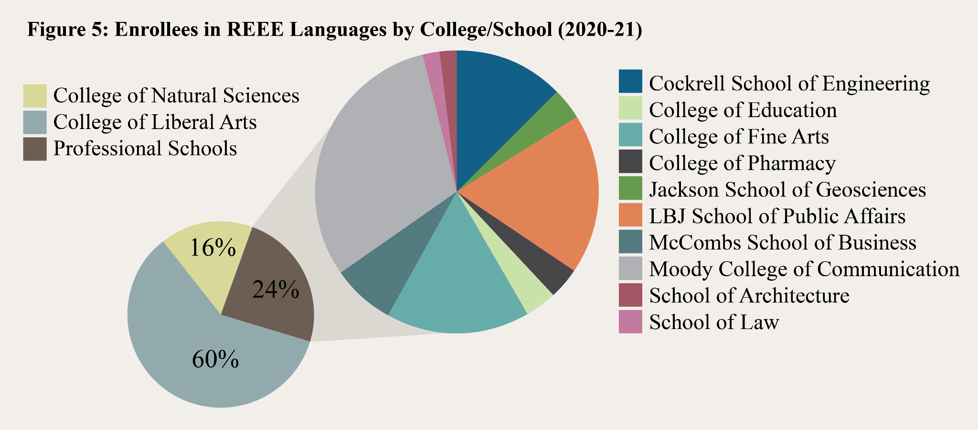
available nationally through University Extension (UEX). Enrollments in REEES courses are robust and rising (Appendix 1), with 6,690 students enrolled in 2020-21 alone. We diligently promote and fund domestic and overseas professional opportunities, with a priority for professional trajectories that meet national needs in education, global policy, business, and

STEM. Since 2014, we have funded 62 students taking advantage of overseas professional development opportunities and 56 students participating in relevant US-based activities.
  - Outreach Activities: The approximately 10,000 attendees at our combined campus and community events attest to the strength and reach of our programming. From 2018-22, CREEES had over 1,200 K-16 teacher participants from across the Southwest at its teacher trainings and workshops. A large percentage of these participants are from rural parts of the state or are instructors at regional MSIs. Additionally, from 2018-21, CREEES organized or co-sponsored 250 conferences, academic talks, film screenings, performances, and other events. Beginning in 2020, in light of the pandemic, CREEES shifted many of its events to a virtual format. While several events were canceled that spring, our shift to the virtual format ultimately allowed for an even wider reach in terms of national and international audiences and participation.
- Post-Graduate Placements and Training: CREEES is a vital resource center for training specialists in REEES in areas of national need, including business, education, global policy, and state security. CREEES has successfully trained undergraduate and graduate students in these fields, placing them in a variety of advanced degree programs and careers. Alumni placement and career trajectories are tracked through an alumni listserv, annual surveys, recent graduate placement reports, and established networks on LinkedIn and other social media platforms. Alumni surveys have documented the workplace applicability of the following professional skills, developed while in the CREEES program: advanced language training, research design, data analysis, problem solving, teaching, critical thinking, various formats of writing and presentation, the use of digital tools and resources, interdisciplinary collaboration, and
team-based project implementation. Since 2018, an impressive 80% of CREEES alumni survey respondents reported using REEE languages in their current professional position.

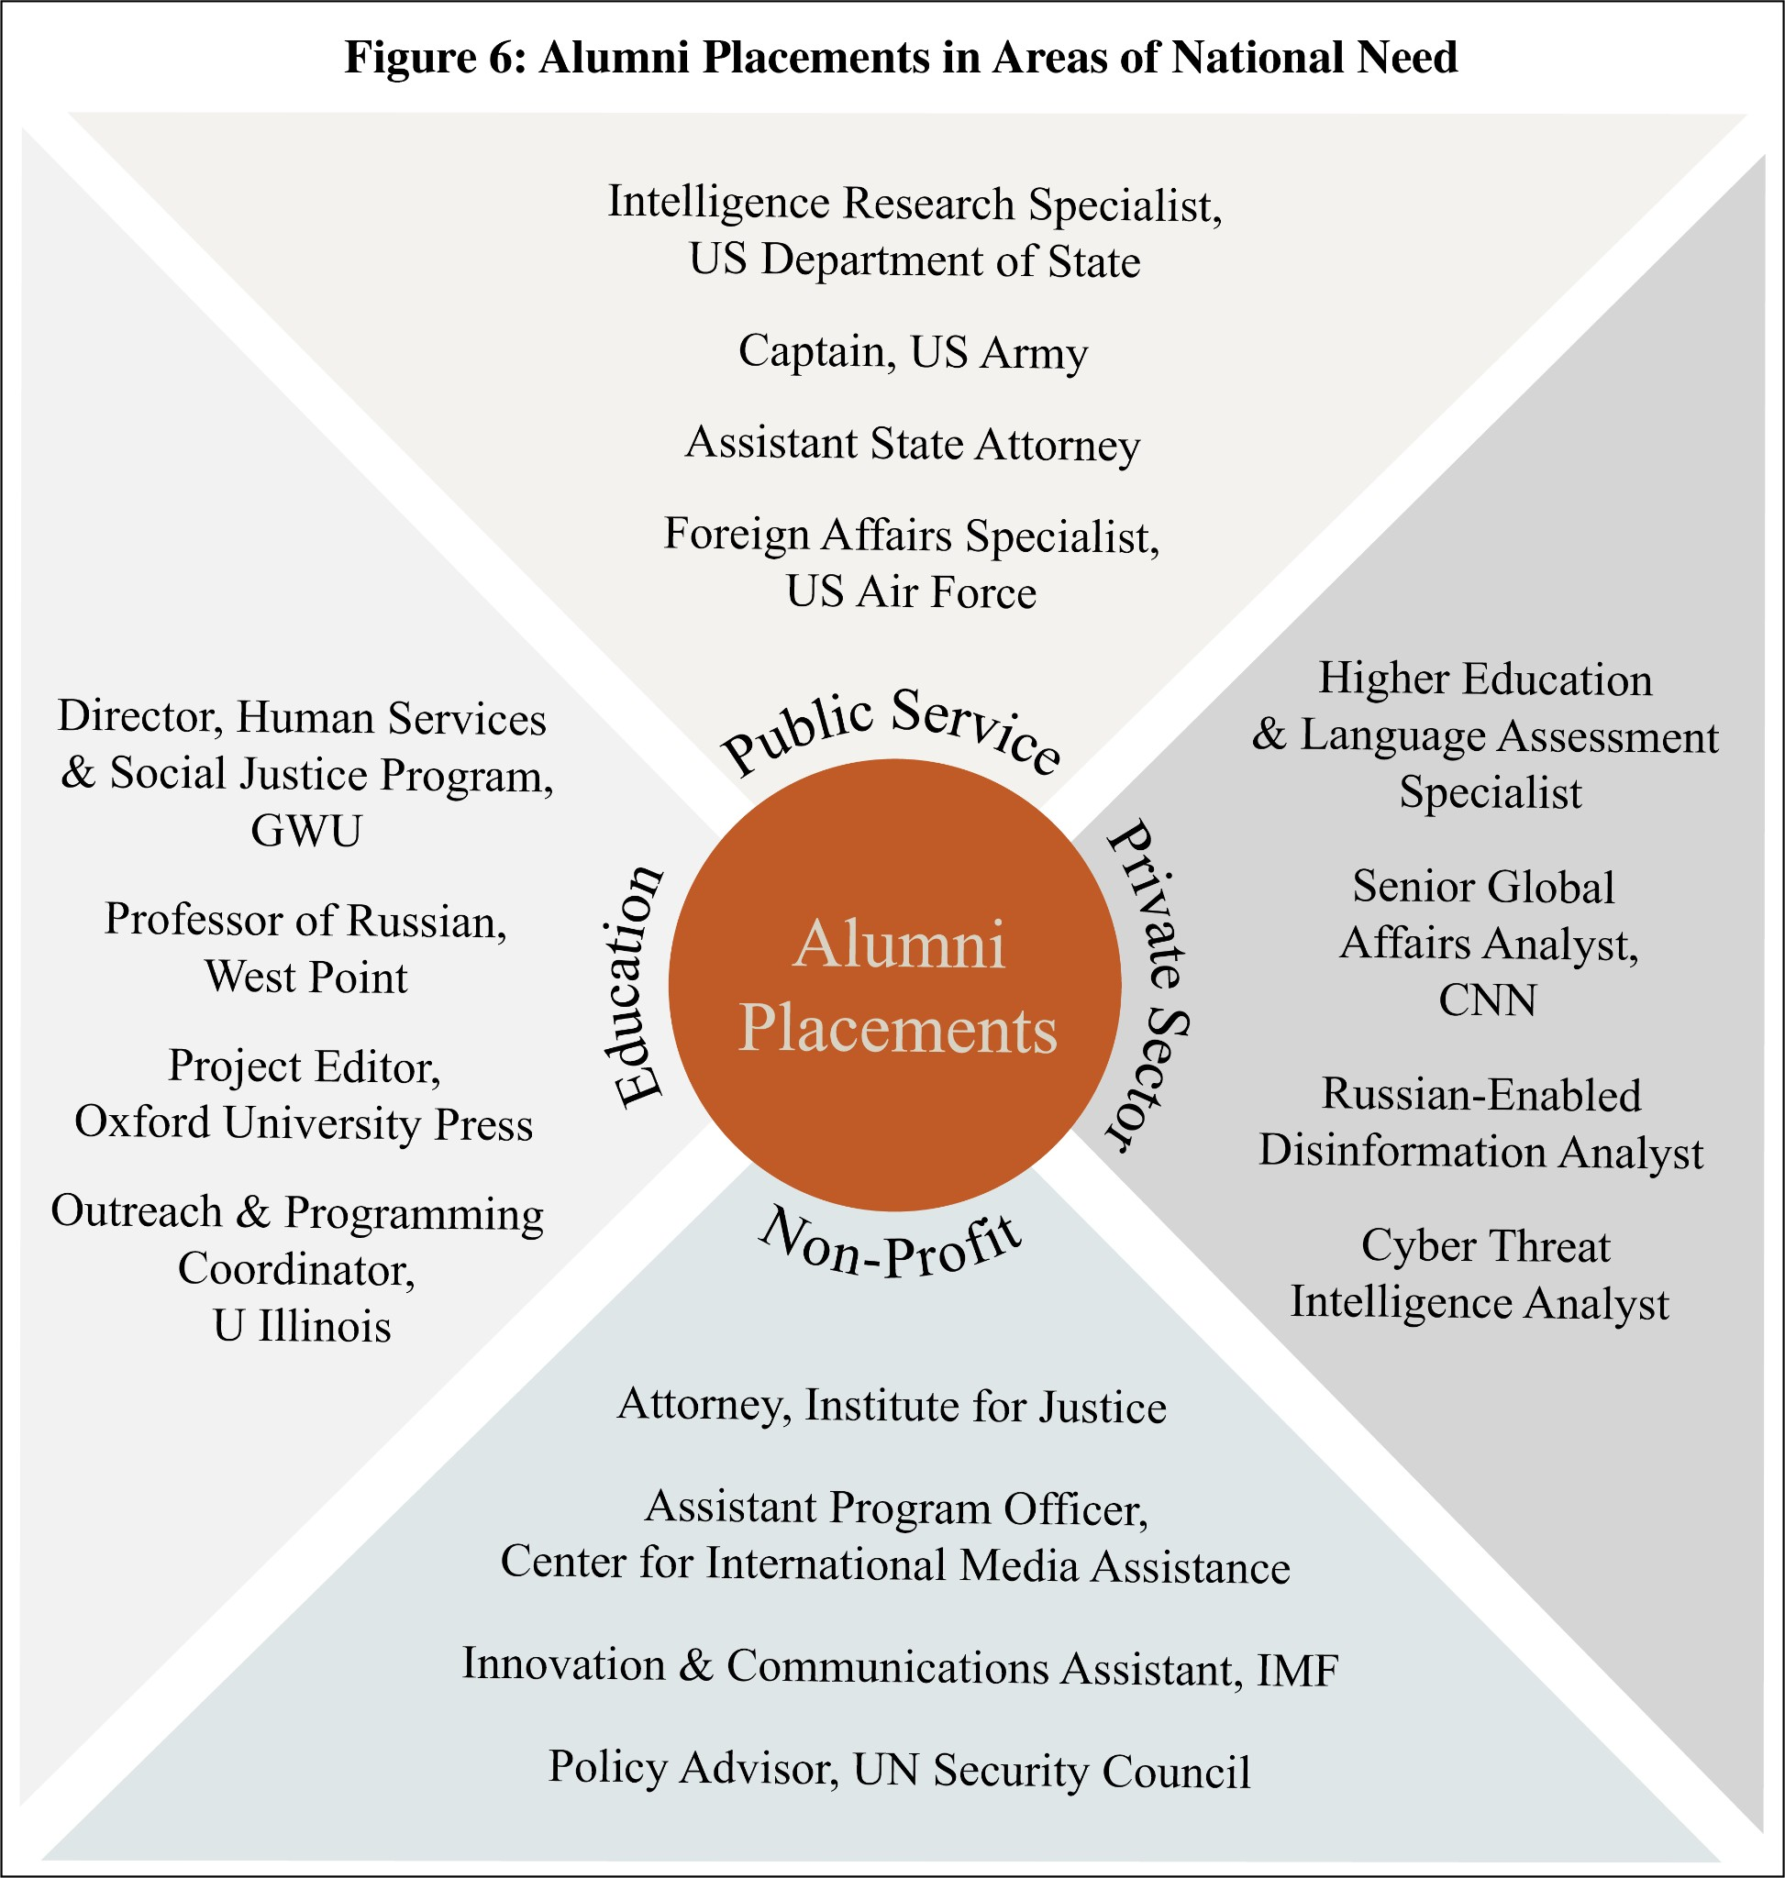
CREEES has an excellent record of placing students in careers of national need (Figure 6). We have an exemplary placement record in professions related to policy and state security, with CREEES alumni and recent FLAS recipients employed in federal agencies such as the
Departments of State, Defense, Energy, and Health and Human Services and the National Institute for Health. Others have gone on to work for state and local governments, district attorney offices, circuit courts, legislative commissions, and education agencies. Additionally, FLAS recipients and REEES alumni have been hired into the private sector, with positions at Deloitte
Consulting, RANE Network, Goldman Sachs, Lockheed Martin, Amazon, CNN News, and PricewaterhouseCoopers. A good portion of alumni have been employed in non-governmental organizations such as Freedom House, the International Monetary Fund, the Organization for Security and Cooperation in Europe, and the EastWest Institute. In terms of academic pursuits, during the past four years alone, CREEES BA and MA graduates have gone on to study in advanced degree programs at U of Virginia, UW Madison, U Michigan, Syracuse U, Georgetown U, Harvard U, Columbia U, Vanderbilt Law School, UCLA Law School, UT Dallas, UT Medical Branch Galveston, and the LBJ School. UT REEES PhD graduates have been placed nationally

in tenure-track academic jobs at U North Carolina at Chapel Hill, Syracuse U, Baylor U, U of Richmond, U of Alabama, and U Wisconsin, and Columbia U.
- National Needs and Public Information: CREEES activities address national needs through the training and placement of specialists, as described above, but also through working with MSIs and K-16 institutions across the US to internationalize education and expose teachers and students to REEES. Through K-16 outreach, we create a pipeline to advanced training in the field and the foundation for a globally attuned and connected US workforce and citizenry.
CREEES also marshals the expertise of its faculty and students to inform the public on REEE issues and generate potential student interest through online media. We have an
ever-broadening media footprint, with social media followers growing to 2,466 on Twitter, 985 on Facebook, and 699 on Instagram in the past three years. Since 2019 our LinkedIn page has grown from 283 to 441 followers, and our Center’s Professional Resources Forum boasts nearly 20,000 views each year. Since spring 2020, the pandemic has pushed CREEES to significantly amplify its online presence. By taking our popular new Balkan Circle speaker series online, for example, we’ve been able to reach international audiences and attract speakers from academic institutions across the US, REEE, and Western Europe. In 2020-21, we hosted 25 live-streamed Balkan Circle talks with 393 participants and a thousand views of recordings on the CREEES YouTube channel. In addition, since its 2019 launch, The Slavic Connexion podcast has produced 144 episodes with over 67,000 downloads and a growing global following of both academics and an REEE-curious public. In addition, REEE-related episodes of UT’s 15 Minute History podcast have been downloaded and streamed over 115,000 times since going live in 2013.
CREEES media efforts not only inform audiences, they cultivate student professional development and bolster a range of collaborative efforts. The Slavic Connexion podcast engages

and trains students in an experiential manner that directly complements and enhances their research, program of study, and career trajectories. Previous graduate student hosts have gone on to appear as pundits on BBC World Service, CNN, Fox News, and Voice of America. While still in the CREEES MA program, Michelle Daniel was the founding executive producer of the podcast, which has garnered international attention. In 2020, the BBC Russian Service invited Ms. Daniel to participate as an expert panelist for the first Russia-wide podcast conference live streamed via YouTube. Soon after, the American Center in Moscow sought assistance in the creation of two podcasts, a series on media literacy Stuck in the Media with You and an American culture podcast in Russian Blizhye chem kazhetsya (Closer than it looks), both launched in 2021. Ms. Daniel was hired in 2021 as CREEES’ new Media producer, and was instrumental in proposing and developing the official UT-wide Texas Podcast Network, which went live in 2021.
- Evaluation Plan: CREEES faculty and staff recognize the value of qualitative and quantitative evaluation and measurable outcomes for the future of our program. We are committed to tracking our programmatic successes as well as documenting areas for improvement across our degree programs, languages, graduate placements, and outreach efforts.
  - Degree Program Evaluation: CREEES degree programs are thoroughly assessed each year through a university-wide assessment tracking system. A faculty assessment committee regularly collects, inputs, and analyzes outcomes-based data, which we use to inform and catalyze needed programmatic, operational, curricular, and extracurricular enhancements. In addition, UT mandates that we routinely carry out comprehensive assessments of our programs, faculty, and staff, including (1) a periodic external evaluation of our graduate program by the Texas Coordinating Board for Higher Education, which last took place in 2018 (with updates and responses issued in 2019 and 2021) and is next scheduled for 2024; (2) annual activity reports

and performance evaluations of all UT faculty and staff, which are used by supervisors and the college to inform merit decisions and promotions; and (3) university-wide course instructor surveys, administered at the end of every term for all classes, in which students evaluate the course structure, design, learning outcomes, and instructor performance.
  - Language Program Evaluation: Utilizing the ACTFL-aligned Standards-based Measurement of Proficiency (STAMP) test from Avant Assessment, CREEES will launch a new annual assessment of students at all levels of Russian, Polish, and Czech. The STAMP test, used by dozens of institutions and certified by the American Council on Education, will provide an unbiased, external evaluation of student proficiency. With plans for a benchmark round of testing in spring 2022, CREEES will solidify language program goals and assess these three languages annually through 2026. In 2023 and 2025, data scientists from Avant will guide CREEES administrators and faculty through a statistical analysis of test data by language, level, and section, using data from other institutions as a guide for measuring program performance against national trends. This language program evaluation will be used to assess instructor efficacy, track student proficiency growth over time, and assist in identifying both strengths and weaknesses in our program. Results will be conveyed to the DSES language coordinator and REEE language instructors who will make needed programmatic adjustments based on results.
  - Alumni Tracking: CREEES maintains a robust alumni network and tracks placement of

recent graduates via an annual survey, which gathers data on career placements, exemplary achievements, and the career relevance of language and area studies skills. Beginning in 2022, the graduate coordinator will also provide CREEES MA program alumni status updates to UT’s Graduate Student Information System in an effort to compare data to other MA programs at UT. CREEES will also expand engagement on LinkedIn in the coming cycle to increase participation

in alumni surveys and to allow us to better track and assess the long-term impact of our MA program on career success, especially in areas of national need.
  - Outreach Program Assessment: CREEES tracks outreach efforts with an eye to expanding breadth and depth of coverage. By retooling performance measure forms created in 2018, CREEES leadership and staff will continue to track and evaluate international engagement, student professional development, the creation and utilization of K-16 resources, and digital media engagement. UT’s Hemispheres also regularly solicits feedback from program participants of its workshops, educator trainings, and summer institutes, incorporating suggestions into future program planning. In 2021, the Hemispheres consortium was evaluated by Dr. Sarah Santillanes (HTU) in an effort to assess its objectives and reach. In response to her recommendations, Hemispheres plans to expand digital offerings by developing a new web presence with more multimedia resources and dynamic content for K-16 teacher curriculum development.
  - Comprehensive Center Evaluation: The CREEES director and a faculty assessment committee will work with a senior assessment specialist and educational consultant at the CTL to design a new comprehensive plan to measure the efficacy of 2022-26 grant activities and track quantifiable outcomes in relation to our four stated objectives in program planning (p. 36). Starting in 2022, CoLA’s recently hired data analyst will work with CREEES and all UT Title VI centers to systematically gather and analyze language and area studies program data from across campus. CREEES leadership, staff, and the faculty assessment committee will annually review the provided data and analysis, which will inform decisions on programmatic improvement.
In terms of external evaluation, Dr. Patrick Patterson (UC San Diego) conducted a comprehensive assessment of our program in November 2021. Dr. Patterson reviewed all provided materials, including program information, grant reports, and assessment materials. He

conducted 15 hours of interviews with CREEES leadership as well as language and area studies faculty, students, and staff and produced a detailed, overwhelmingly positive report with the following constructive suggestions: (1) boost language enrollments at all levels and expand online offerings to non-UT students; (2) expand CREEES web presence, digital publications, and educational materials; and (3) develop more research, writing, and skills workshops for MA students. In planning our 2022-26 grant and activities, we diligently integrated these suggestions that promise to help us achieve our programmatic goals in alignment with ED priorities.
In fall 2025, a new external evaluator will be identified and invited to UT campus to conduct a round of interviews, review materials, and produce a comprehensive assessment report. The evaluator will have access to the same types of materials and meetings as Dr.
Patterson, along with new data analytics from our 2022-26 evaluation plan. Through all of these forms of evaluation, CREEES programs and activities will be continually and thoroughly evaluated and improved, with ongoing feedback from students, faculty, program participants, and assessment specialists. Over the course of the grant cycle, CREEES leadership and staff will pursue the necessary program enhancements for continual and quantifiable improvement.
- Equal Access and Non-Discrimination: UT offers automatic admission to the top 6% of students from every high school in Texas, allowing for a greater number of attendees from rural, minority, low-income, and first-generation backgrounds. The university also recently announced a diversity action plan to assist minority and first-generation students, offering an additional $15 million a year in financial aid to students in these categories. In 2019, UT was named a First-Gen Forward institution for its commitment to supporting first-generation students who make up 20% of the student body. As part of such efforts, UT’s Texas Global is committed to reducing financial barriers for study abroad through the First Abroad Initiative, offering special workshops

and targeted scholarships that support over 3,000 first-generation college students annually.

CREEES is dedicated to ensuring broad access to its programs and projects by recruiting and supporting minority faculty and students and networking with diverse alumni. CREEES core faculty participate in UT Graduate School’s diversity mentorship program, which offers a
$28,000 stipend and tuition to a first-year CREEES MA student under faculty guidance. Furthermore, CREEES and Hemispheres outreach programs target under-resourced and regional minority-serving K-16 institutions, bringing REEES content and opportunities to their students and faculty and creating a potential pipeline for a more diverse REEES field.

CRITERION H – OUTREACH ACTIVITIES

CREEES advances REEES-related global competency on and off UT campus, reaching thousands of K-16 educators, students, and the general public each year. CREEES-sponsored outreach events and activities draw large audiences, with over 10,000 attendees from 2019-21.
- K-12 Teacher Training and Outreach: Teacher training for pre- and in-service K-16 educators is central to CREEES’ outreach program. Over the past four years, CREEES has organized over 24 workshops, mostly in conjunction with UT’s Hemispheres, focused on global studies and interdisciplinary education. The first Hemispheres Summer Institute was organized in 2008 with the aim of increasing global content in K-12 secondary education through teacher engagement and the creation of OER curricular materials. Its success led to annual Summer Institutes on revolving themes, as well as to the recent creation of the following specialized institutes that run each year: (1) “Teaching from the Archives,” which trains educators on how to use archival sources in the classroom and is co-organized with UTeach-Liberal Arts, a professional middle and high school teacher preparation program within CoLA, and (2) “Critical Literacy” that exposes K-12 teachers to international children’s literature, in cooperation with

UT’s College of Education. In summer 2021, Hemispheres ran its three annual summer institutes virtually, with 100 educator participants from institutions across the Southwest. Through these and other teacher training events, CREEES faculty expertise reached over 1,200 teachers since 2018, facilitating the incorporation of REEES materials into their curricula. CREEES also shares resources and information via a website that features REEE-relevant downloadable curriculum modules, taped webinars, podcasts, and the Hemispheres e-bulletin, a weekly event newsletter that reaches 1,230 educators from 11 US states. Since 2005, CREEES has also hosted 20-50
K-12 students annually at the Texas Olympiada of Spoken Russian, part of the national ACTFL Russian language competition. Finally, CREEES participates in Explore UT, a university-wide annual open house during which 500+ K-12 students participate in REEES educational activities.
- Post-Secondary Collaborations: We are particularly proactive in building and joining national post-secondary networks. In 2019, Hemispheres brought together 56 NRC outreach coordinators from across the US to discuss best practices of K-16 outreach. The workshop preceded the annual conference for the National Council for Social Studies, the largest association in the country devoted to social studies education. In 2020-21, CREEES also supported a virtual “Race in Focus” lecture series in partnership with ASEEES and 10 REEES NRC programs. This was expanded into the “Intersectionality in Focus” series, which has reached over 7,600 scholars, educators, and members of the public. Such collaborations have contributed to a reinvigorated national REEES ecosystem, forging new academic pathways and professional development opportunities for a diverse pool of faculty and students.
Our collaborations with local and regional MSIs augment such efforts by exposing faculty and students at other institutions to REEES. Since 2014, CREEES has supported faculty at Huston-Tillotson U (HTU), Austin’s only historically black university (Title III), with

curriculum development, instructional funds, and textbooks for REEES content courses. In tandem with other Hemispheres initiatives, HTU has made significant progress towards its long-term goal of institutionalizing a new global studies major. In addition, in 2016.
Hemispheres created a Faculty Learning Community (FLC) with Austin Community College (ACC), a Title V school with 11 campuses across Central Texas and annual enrollments of over 70,000. In 2020, as a result of the FLC’s successes, Hemispheres expanded the program to a second cohort of ACC faculty with a global perspective on women and gender studies. Since 2016, 80 ACC faculty have worked with 60 UT faculty in the Hemispheres-run FLCs. CREEES also collaborates with a number of other MSIs in Texas, such as UT Arlington (Title III and V), St. Edward’s U (SEU), ACC, UT El Paso, and Angelo State U (ASU) (all Title V). As of 2015, CREEES has coordinated an annual Russian Enrichment public speaker at ASU, with audiences of over 100, and sponsored SEU’s Transatlantic Security Conference with 50-150+ participants.
CREEES has also utilized its networks to offer opportunities to students and educators from across the Southwest. The 2018 Fulbright-Hays GPA “SiberiaXSW” included 20 participants from 5 states, with a K-12 educator and students from 12 schools. Upon their return, CREEES hosted SiberiaXSW participants at the first annual Texas Russian, East European, and Eurasian Studies (TREEES) conference to present their digital projects to post-secondary educators from across the state. The TREEES network currently includes faculty from 12 institutions, 6 of which are MSIs, with whom we collaborate and share information about REEE speakers, research and study opportunities abroad, and relevant conferences. For example, we are co-sponsoring a symposium at U of Houston in spring 2021 on “Scientific Citizenship,” where several CREEES and other TREEES faculty will present their research.
- Campus and Community Events: CREEES sponsors on-campus talks, panels, conferences,

and other events throughout the academic year. Advertised on CREEES’ listservs, website, social media, and local media, these events are free, open to the public, and widely attended.
We organize at least one major academic conference or symposium annually; for example, “Information Wars: Social Media and Politics in Russia and Eastern Europe” (2019), “African-Soviet Encounters: New Histories of Russian Racism & Anti-Racism” (2021), and “Siberia on Fire” (2022). In addition, CREEES co-sponsors up to six REEE relevant symposia and a stream of visiting speakers and panels from across disciplines each year with campus partners and co-sponsors. Events are frequently organized in response to contemporary events, such as a recent panel entitled “Russia, Ukraine, and the West: Context for Standoff and Prospects for Peace,” which drew over 100 participants. The Balkan Circle series, which went virtual in 2020, features 10-12 outside speakers per semester, including prominent scholars like Drs. Dimitar Bechev, Theodora Dragostinova, and Emily Greble. In spite of the pandemic, we have also hosted in-person events, including high-profile visiting speakers of relevance to REEES such as Emily Harding, deputy staff director of the Select Committee on Intelligence, who led the investigation into Russian interference in the 2016 elections (2021), and Vladimir Kara-Murza, Russian opposition leader, author, and historian (2022). In 2019 alone, CREEES hosted on-campus talks with Alexander Genis, Francine Hirsch, Peter Pomerantsev, Ilya Yablokov, Olga Onuch, and Agnieszka Holland. Recently formed REEE-focused UT student organizations have also hosted events with CREEES logistical support. For example the Students for Central and Eastern Europe coordinated a panel on the work of LGBTQIA+ NGOs across Central and Eastern Europe (2021), and The Polish Club has scheduled talks by historian Norman Davies and former President of Poland Aleksander Kwaśniewski (2022).
CREEES also supports events that tap into the vibrant Central Texas film, music, and

business scene, drawing audiences from across the region and the nation. We run regular film series and screenings with director Q&A sessions and co-sponsor the annual Austin Polish Film Festival and the state-wide Russian Documentary Showcase. We support local and touring REEE bands that play on UT campus, at community events, and at SXSW, which draws over 280,000 annually. For example, CREEES sponsored SXSW appearances of Azeri Qarabagh Ensemble and Natiq Rhythm Group (2016), with 500 attendees, and Ukrainian SpivOberta (2017 and 2018) and Antytila (2018), with 250 attendees combined. Working with UT’s Center for European Studies, the Austin Chamber of Commerce, and the World Affairs Council of Austin, CREEES also co-sponsors the annual Texas EU Business Summit, which boasts a total of 407 attendees since 2015 and features speakers from East European EU members and candidates.

CRITERION I – PROGRAM PLANNING AND BUDGET + PRIORITIES

- Development Plan: Over the next grant cycle, CREEES will build upon its excellence in research, teaching, and outreach through activities outlined in this program plan. All activities will contribute to the following CREEES objectives that align with ED absolute and competitive priorities (AP and CP): (1) Integrate diverse perspectives into all CREEES activities. (AP-1a) CREEES will continue to encourage critical thinking and cross-pollination of ideas to foster debate on global issues of REEE importance. We will include faculty, students, staff, and members of the general public from a broad range of ethnic, social, and political milieus and will implement a new diversity, equity, and inclusion strategic plan; (2) Facilitate effective
college-to-career pipelines in areas of national need through advanced language and area studies training as well as professionalization opportunities. (AP-1b) CREEES activities will support curriculum development, scholarly activities and events, and faculty and student language and professional skills attainment, including data and digital dexterities; (3) Enhance

REEE language and area studies competency among K-16 teachers across the state and the nation, with a focus on MSI collaborations. (AP-1a, AP-2, CP) In cooperation with UT NRCs, we will conduct K-16 activities via Hemispheres and our center’s own community, statewide, and national networks. This work also aligns with our first objective as CREEES aims to boost REEE studies at local and regional MSIs; and (4) Build upon our media and communication networks to promote CREEES activities and disseminate diverse perspectives on REEE to the general public. (AP-1a) CREEES will significantly increase its media footprint and output in the next grant cycle, with a host of new digital deliverables. This includes new episodes for The Slavic Connexion and 15 Minute History podcasts, as well as additional YouTube channel videos, social media posts, and other website content.

Area Studies Training and Professionalization:

  - Course Development: REEE cross-disciplinary courses are the building blocks of CREEES undergraduate and graduate degree programs. Grant funds will support the development of up to two new (or redesigned) courses each year, with a preference for curricula that (1) utilize technology-based methods, such as data visualization, mapping, and/or virtual connections to scholars and institutions in REEE, (2) assign team-based or experiential learning projects, brings research methods into the classroom, and/or requires digital deliverables, (3) are based in or cross-listed with UT professional schools or STEM departments, and/or (4) involve innovative digital or interdisciplinary methods. We anticipate particularly robust developments in disinformation, health and society, critical race/ethnicity studies, and digital humanities, given recent and anticipated upcoming hires in these fields. (AP-1b)
  - REEE Overseas Study and Research: CREEES will advance research, language training, and professional skills acquisition by promoting and funding faculty, student, and staff overseas

research, conference travel, and professional workshops. We will continue to build upon our breadth of study and research abroad opportunities, catering to student interests while deepening partnerships in the region. Over the next four years, CREEES will sponsor faculty-led Maymester programs in Warsaw, “Security and Society in Central Europe” (Dr. Mosser), and St. Petersburg, “Russian Spiritual Traditions: Past and Present” (Dr. Alexandrova). CREEES will also develop three new Maymester programs: “Empire and Borderlands in Ukraine” (Dr. Seegel), “History and Memory in the Former Yugoslavia” (Dr. Neuburger), and “Religion and Politics in Romania and Bulgaria” (Dr. Roberts). In addition, we will support Dr. Liu’s 2023 “Ethnic Politics and Roma in Eastern Europe” course that includes a mid-semester week-long trip to Romania, Hungary, and Slovakia, where students will conduct interviews with officials and Roma organizations to complement data-driven research initiated on UT campus. (AP-1b)
We are especially committed to faculty-led overseas projects that engage student teams in on-site REEE research collaborations. Examples include the following ongoing overseas projects and REEE partners: (1) Dr. Campbell’s (Anthropology) “In the Shadow of a Dam” project with Novosibirsk State U, (2) Dr. Dawson’s (Theater and Dance) arts-based pedagogy projects in Bosnia at U Sarajevo and U Banja Luka and in Poland with secondary school educators, (3) Dr. Rabinowitz’s (Classics) archeological dig on the ancient site of Histria in Romania with the Romanian Academy of Sciences, (4) Dr. Catlos’ (Geosciences) geological studies of the Tatra mountains with the Slovak Academy of Sciences, and (5) Dr. Prodanović’s (Engineering) study of Croatian karst formations and gas exploration facilities in the Adriatic. (AP-1b)
  - Faculty, Staff, and Student Professionalization: Investment in faculty, student, and staff professional training is critical to the future of REEES. CREEES invites faculty to apply for professionalization funding to help with research costs, conference travel, site visits, and skills

workshops. Staff can request funds for conference attendance or building partnerships in REEE as well as training related to leadership, project management, data analytics, communication technologies, or other pertinent skills. NRC funds will also support annual competitive awards for graduate and undergraduate students who pursue REEE-relevant internships, research projects, digital skills workshops, or attend conferences. We will circulate information on these awards and other opportunities for students through weekly Professional Resources Forum digest emails and our social media platforms. Additionally, we will host information sessions for FLAS fellows and area studies majors and minors on Critical Language Scholarships, Boren awards, Fulbright and Title VIII grants, and the Alfa Fellowship program. We will also continue to promote internships and host recruitment events, for example, with the Foreign Service and the National Security Administration. Finally, we plan to put increased effort into spotlighting notable alumni placements on our website and through the UT Graduate School’s new Alumni@Work videos initiative, and host annual networking events where exemplary CREEES alumni discuss how they use REEE languages and program skills in a variety of careers. (AP-1b)
  - Research Labs: In the coming grant cycle, CREEES will support visiting speakers, research assistants, symposia, and the public circulation of information for three new faculty-led research labs. We have the most direct involvement with GDIL (p. 4) founded in 2020 and directed by Dr. Avramov (DSES). This lab boasts an interdisciplinary network of faculty and students who utilize their advanced language skills and area studies training, along with data-driven approaches, to explore the global generation and circulation of disinformation. With the majority of current projects focusing on Russia, the lab has budding partnerships with Voice of America, Sandia Labs, the National Geospatial-Intelligence Agency, the Atlantic Council of Montenegro’s Digital Forensic Center, and the Army Cyber institute. CREEES will promote GDIL’s new

digital skills workshops, for example, on Python, R, Tableau, network analysis, and web scraping, as well as meetings with professionals in relevant careers. CREEES will also nurture Dr. Liu’s new Politics of Race and Ethnicity Lab, where she mentors student teams to gather and compare data on minority politics in REEE and the US. Finally, we will support Dr. Roberts’ new Initiative for the Study of Politico-Religious Ideation and Influence that engages student teams to study the potent intersection of politics and religion in REEE. These new CREEES faculty-led labs bring faculty and student efforts to bear on some of the most timely issues that face REEE, the US, and the globe, with results circulated to the wider public. (AP-1b)
  - CREEES Diversity Strategic Plan: CREEES has formulated a new plan to foster REEES diversity and inclusion on and beyond campus. UT is now a qualified HSI with Title V certification pending while CREEES is a nationally recognized leader in advancing diversity in the field, as evidenced by a host of past campus and national co-sponsored events. We plan to deepen our commitment to diversity over the next four years through the following activities: (1) Collaborate with the University of Pittsburgh and other NRCs on the “Intersectionality in Focus” series, foregrounding critical pedagogies and continued disparities in the field (p. 33); (2) Integrate critical race, ethnicity, and gender studies into more CREEES events; (3) Co-sponsor the REEES Think Tank initiative (p. 43); (4) Collaborate with MSIs in Texas and beyond (p. 43); and (4) Recruit more students, through targeted program promotion, from a variety of backgrounds, social groups, and diverse racial and/or gender identities into our program, and secure UT’s Diversity Mentoring Fellowships or other earmarked funding. (AP-1a, AP-1b, CP)

Language Training and Curriculum Innovation:

  - Expansion of Less Commonly Taught Language (LCTL) Offerings: In the coming cycle, grant funds will support Ukrainian language instruction through the advanced level, taught by

Dr. Oksana Lutsyshyna, an internationally acclaimed author, who won Ukraine’s highest literary award, the Taras Shevchenko National Prize in Literature, in 2020 and was the American Association of Teachers of Slavic and East European Languages (AATSEEL) featured poet in 2022. CREEES will also use grant-funded LCTL stipends to supplement independent instruction and tutoring for advanced language instruction in REEE languages. Additionally, UT funds will be used to offer a full sequence of Romanian for the first time beginning in 2023-24. Finally, in addition to Russian, CREEES will now offer online Ukrainian, Czech, and BCMS nationally through UEX at less than in-state tuition prices to non-UT students. Through UEX, we hope to expand enrollments and serve as a language training resource to students across the US. (AP-1b)
  - OER Language Curriculum Development: Working with COERLL, CREEES will support the creation of new interactive, multimedia, OER language curricula in the following languages:
(1) Karabatić will complete his first-year OER textbook for BCMS entitled Tako Lako (It’s a Piece of Cake) by year two; (2) Dr. Rice will convert her new online Russian first and second year textbook Budem na Svyazi (We’ll be in Touch) from a UT-only curriculum into OER by year three, (3) Dr. Hilchey will develop a second-year Czech language textbook as a web-based OER follow up to his Reality Czech project by year four (see p. 9 for more details on these projects). Hilchey, Rice, and Karabatić will also spearhead a new series of OER Slavic curriculum development virtual workshops with COERLL and the TLC and will develop “Open Slavic,” a new website forum and resource hub for OER Slavic curricula. (AP-1b)
  - Language Pedagogy and Performance Assessment: In the next grant cycle, CREEES will support TLC workshops that encourage best practices in performance-based instruction in REEE languages and the use of innovative assessment tools. CREEES’ OPI-trained faculty members perform regular language proficiency assessments for CREEES MA students, graduate portfolio

program participants, FLAS fellowship recipients, and students in intensive Russian sections. As of 2022, DSES will pilot a comprehensive language program evaluation across Russian, Polish and Czech with Avant Assessment to fill gaps in standard OPI testing (p. 29). (AP-1b)

K-16 Teacher Training and Outreach Initiatives:

  - K-12 Teacher Training: Over the next four years CREEES and Hemispheres will coordinate four annual summer institutes open to K-12 educators with the following foci: (1) “Teaching from the Archives,” in collaboration with UTeach (p. 32); (2) “Critical Literacy and Language,” with UT’s College of Education (p. 32); (3) a globally relevant topic, selected each year in response to teacher demand and current events, and (4) “World Language Instruction & Cultural Competency,” a new partnership with the TLC and UTeach. Hemispheres will also run two workshops each academic year on a variety of topics, as well as develop and circulate new digital resources, including videos and curriculum units for K-12 teachers. CREEES will also partner with other REEE NRCs nationally on initiatives such as the two-year AATSEEL
Pre-college Teaching Excellence Program to foster excellence in the teaching of Russian. (AP-2)

  - MSI Collaborations: With UT as a recently qualified HSI, CREEES will solidify its MSI partnerships through continued and new initiatives in the coming grant cycle. We will continue to collaborate with MSIs across Texas to coordinate annual events, such as the ASU Russian Enrichment speaker series, the Transatlantic Security Forum at SEU, and the TREEES conference for REEE scholars in Texas. Working with Hemispheres, we will also facilitate two cohorts in the popular, ongoing FLC initiative with ACC (p. 34). In addition, CREEES will continue to provide instructional funds and textbooks for one REEES content course at HTU, in an effort to help develop their global studies program. In terms of new initiatives, CREEES will provide REEE speakers and coordination for Hemispheres and U of Florida’s Center for

European Studies nationally advertised, globally themed workshop for community college and MSI educators. CREEES will also partner with Howard U and other NRCs nationally to support the REEES Think Tank program, in which student-driven research teams of underrepresented and underserved populations in the field of REEES are assigned faculty mentors from higher-ed institutions across the US. Participants will present their research at the national ASEEES convention and publish their final projects digitally. CREEES will use grant funds to support faculty and graduate student mentors as well as staffing for program administration. In addition, each year CREEES will fund a UEX online REEE language class for a Think Tank fellow who lacks access to training in that language at their home institution. Finally, CREEES and Indiana U will tap into our institutions’ faculty expertise and respective MSI networks to co-organize a workshop on integrating Siberian and Central Asian content into post-secondary curricula in year two of the grant cycle. (AP-1a, AP-2, CP)
  - K-12 Student Recruitment: CREEES will also devote time and resources to K-12 student oriented events, such as Explore UT (a community-wide open house), and the Texas Olympiada of Spoken Russian, for which CREEES’s Dr. Rice will become the national organizing chair as of 2023. We also plan to launch a new initiative, requiring student FLAS and other award recipients to create short videos or deliver talks at K-12 schools based on research and study abroad or other academic experiences. We hope that such near peer speakers can inspire and promote REEE area studies and language study among Texas high schools students. (AP-1b)

Campus and Community Events and Collaborations:

  - UT Professional Schools: Over the next cycle, CREEES will build upon existing partnerships with UT’s professional schools, with whom we regularly co-organize talks, conferences, and other activities. For example, CREEES, GDIL, the LBJ School, and Law will co-host a

symposium on global disinformation in fall 2022. Dr. Avramov will also teach a year-long CREEES-LBJ “Policy Research Project” course on this theme in 2022-23, in which graduate students will conduct team-based research and present their findings and recommendations to policy makers in Washington, DC. In addition, CREEES will continue to provide pre-departure consultations for professional school overseas programs such as the McCombs School of Business’ Global Connections Program, which sends 20 executive MBA students from UT Austin and satellite campuses in Dallas and Houston to participate in a faculty-led business networking program each year. A Croatia trip planned for 2022 will supplement robust Business School exchange programs in Prague and Budapest, and an Engineering summer program in Croatia. Finally, CREEES will solidify its growing association with UT’s Dell Medical by participating in cross-campus global health initiatives. CREEES will support course development for a new MA program in “Humanities, Health and Medicine,” and REEE speakers for a new “Humanities Health Research” seminar, both organized by CoLA’s Humanities Institute in collaboration with Dell Medical, Nursing, Pharmacy, Communications, the iSchool, and Social Work. CREEES efforts will be facilitated by faculty like Dr. West Ohueri (DSES), who specializes in race, global health disparities, and Roma in Albania and brings REEE expertise to the cross-campus “Whole Health-Whole Communities” research cluster. (AP-1b)
  - Conferences and Visiting Speakers: CREEES cooperates with UT NRCs, departments, and professional schools to organize public conferences, symposia, and visiting speakers in areas of faculty expertise and/or contemporary relevance. In addition to the planned 2022 disinformation symposium, EU Business Summit, and Balkan Circle with a line-up of 12 interdisciplinary speakers per semester, we will launch a new monthly “REEE in the News” panel. Each year CREEES will also solicit ideas for conferences and speakers from affiliates as a basis for

organizing future events. Requests will be reviewed for feasibility by CREEES leadership and staff and implemented with appropriate partners and co-sponsorships. (AP-1a, AP-1b)
  - Cultural Programming and Community Outreach: Community organizations rely on CREEES support for popular events related to REEE. Examples include the annual Austin Polish Film Festival, the Texas Russian Documentary Showcase, and various cultural events of community-wide interest. Drawing on Austin’s reputation as the live music capital of the world and home of SXSW, CREEES will continue to support concerts from local REEE bands as well as touring musicians from the region, such as Alash (Tuvan throat singers), who draw audiences of 100+ with their performances. CREEES will also co-sponsor frequent performers in residence, in conjunction with Dr. Seeman’s (Music) work on ethnomusicology from the region. (AP-1a)

Digital Initiatives, Media, and Library Development:

  - Wired Spaces: With a 2017 grant from the UT Provost’s office, CREEES set up its own interdisciplinary learning lab or Fusion Room–a hub for the integration of emerging technologies into collaborative faculty and student research, active-learning pedagogies, wired classroom experiences, and digital delivery of public scholarship. In the coming grant cycle, GDIL will use the Fusion Room space for data management and visualization workshops, student research team meetings, and brainstorm sessions. CREEES also has a newly dedicated and wired language lab space that allows us to teach our less commonly taught languages virtually. This room also hosts tutoring sessions, conversation hours, and OER curriculum development workshops. Finally, CREEES recently upgraded its main conference room to feature hybrid-friendly video and audio streaming capabilities with a new Meeting Owl system to broadcast meetings and events. With a planned hire in digital humanities, CREEES will use grant funds to upgrade and maintain technology tools in these spaces to support faculty and student interdisciplinary research projects

and public-facing digital deliverables, such as podcasts or new websites. (AP-1a, AP-1b)

  - Media, Public Scholarship, and Curricular Resources: CREEES is constantly redesigning and implementing a more robust communications strategy in response to a rapidly changing digital media environment. Each year of the next grant cycle, we will produce a host of new digital deliverables, including at least 20 new episodes of our popular The Slavic Connexion podcast, 20 YouTube video recordings of Balkan Circle talks, 4 REEE content videos for K-16 outreach, and 1 issue of a newly spawned digital magazine targeting high school students. This is an addition to our weekly professional development and event newsletters (with over 1,000 combined subscribers), social media outreach (with over 3,000 subscribers), and ongoing technical support for faculty and students. Given our growing digital needs, our full-time communications coordinator has been joined by a new part-time media producer, who will work closely with graduate students and faculty on podcast production and digital projects. (AP-1a)
  - Open Access Library Resources: NRC funds will support the enhancement of REEES materials in the UT Libraries through funds for physical and digital acquisitions and repositories. REEES Librarian Ian Goodale will use travel and procurement funds to obtain special collections from REEE in alignment with the research needs of CREEES faculty and students. CREEES will also work with Goodale to create a website called “Documenting the Cold War,” a new portal for an open-source digital archive of digitized documents from the LBJ Presidential Archive. Over the next four years, Goodale and a graduate research assistant will scan and process a new cache of documents from the Country Files for Bulgaria, Hungary, and the Soviet Union, embedding searchable metadata and creating user guides for researchers and K-16 teachers. (AP-1a, AP-1b)
- Quality of Outcomes: As a Tier One university, UT upholds the highest possible standards for faculty and staff hiring and student recruitment. All of our planned activities are implemented

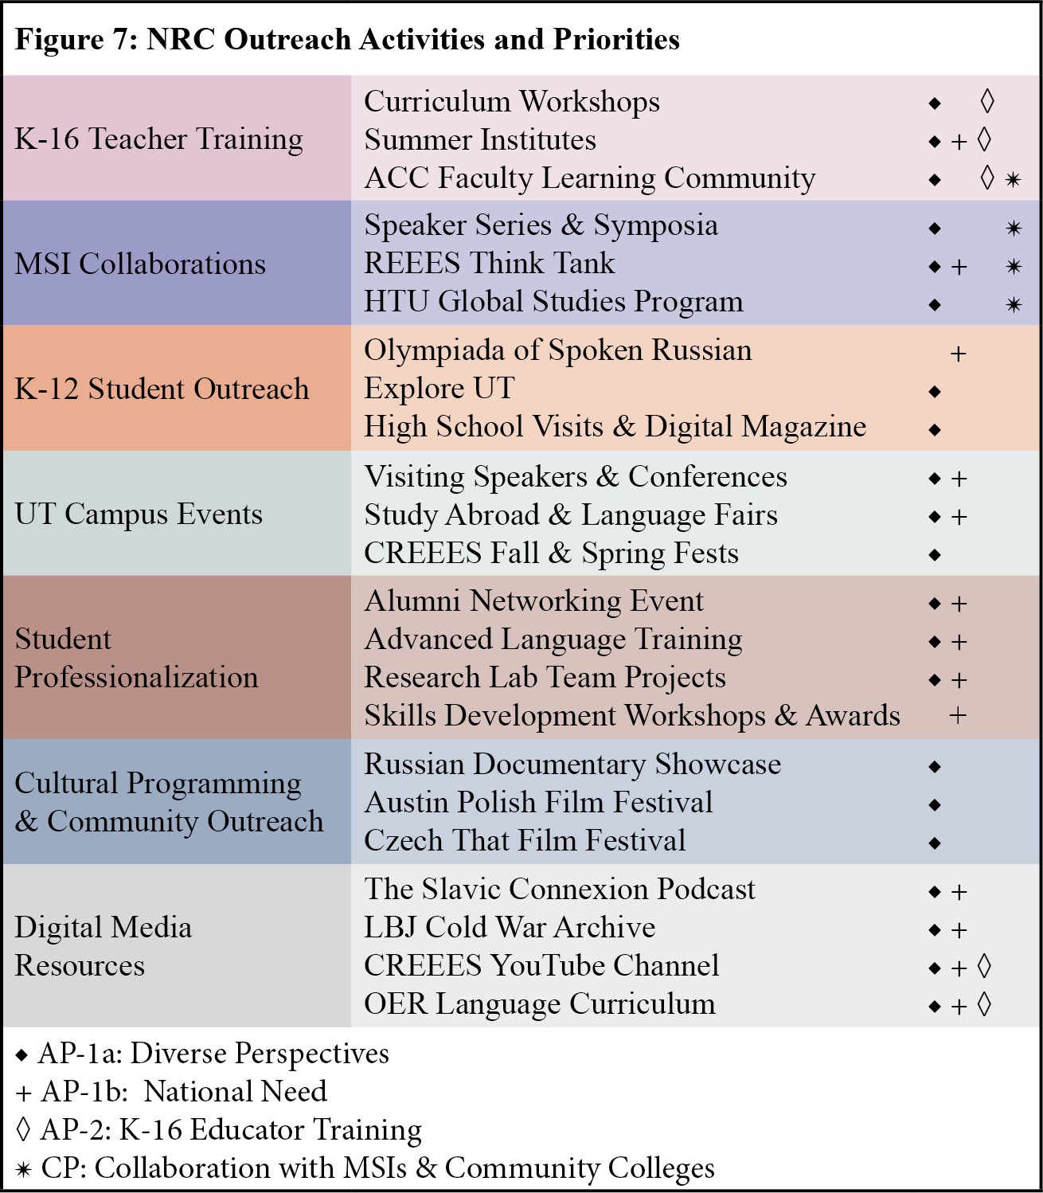
by highly-trained and experienced personnel and internationally renowned scholars. This ensures the quality of the wide range of activities, events, and outcomes generated by our program, all of which fulfill one or more ED program priorities (Figure 7). We also continuously enrich our program by actively building new
partnerships on and off campus, across the US and in REEE, with participants and audiences whose varied backgrounds and orientations bring diverse perspectives into all of our activities.
- Cost Effectiveness: Since 2014 CREEES Director, Dr. Mary Neuburger, has successfully optimized NRC and FLAS funds by
(1) seeking co-sponsorships for events and programs from units
across campus; (2) leveraging grant funds to seek CoLA support for CREEES leadership, staff, faculty, and students to carry out grant activities; (3) utilizing existing UT endowments to support grant related activities; and (4) securing new external and internal grants, endowments, and individual donor gifts to support REEES on UT’s campus. Utilizing these various sources of supplemental funds (p. 5) keeps project costs reasonable and creates buy-in from stakeholders.
- Long Term Impact: With Title VI funds CREEES will make a substantial long-term impact on the REEES field. We will solidify UT’s institutional commitment to and capacity for REEES

by supporting relevant library collections, cross-campus faculty hires, teaching, and research. We will continue to train career-prepared graduates who pursue impactful careers in the public, private, and educational sectors. CREEES will also have a lasting legacy in terms of OER digital resources, such as Slavic language curricula in Czech, Russian, and BCMS, and our “Documenting the Cold War” collection of LBJ documents. This is in addition to the plethora of podcast episodes and YouTube channel videos that showcase UT faculty and external speaker REEE expertise and offer a long-term resource for a better informed public. Finally, by integrating REEES into regional and national K-16 outreach and MSI collaborations, we will foster academic and career pipelines and permanently diversify the field.

CRITERION J – FLAS AWARDEE SELECTION PROCEDURES + PRIORITIES

CREEES is well poised to expand upon its excellent track record in FLAS fellowship administration by building a financial need index into our FLAS fellow selection ranking system (FLAS CP1), exclusively offering fellowships in LCTLs (FLAS CP2) and developing
career-oriented events specifically geared towards streamlining job placement for FLAS fellows.

- Fellowship Selection Plan: CREEES regularly recruits top students from across UT to apply for its FLAS fellowships. Each November, CREEES announces its FLAS competition for the upcoming summer and following academic year (AY) and holds a series of joint information sessions with all FLAS granting NRCs at UT. The award opportunity is promoted via the CREEES website, newsletter, social media outlets, and listservs to all faculty affiliates, CREEES majors, REEES graduate students, and all UT undergraduate advisors and graduate coordinators. The competition is open to current as well as prospective undergraduate and graduate students, resulting in over 50 applications received each year from students in CoLA, the LBJ School, Fine Arts, Communications, Architecture, Engineering, and Natural Sciences. Applications for

both the coming summer and following AY are due in early February . Students are required to complete a secure online application and upload supporting documents including a resume, college transcripts, and a statement of purpose. In this statement, students explain how their academic and career goals are tied to advanced language acquisition in one of the many REEE LCTLs offered on campus, or through quality summer programs. Students are also required to provide the names of two faculty references, including a language instructor, who are prompted to submit letters of recommendation into an automated online portal. (FLAS CP2)
Fellowship selection committee members are chosen from a rotating list of affiliate faculty representing a broad distribution of disciplines, with at least one REEE language faculty member per committee. At selection committee meetings, participating faculty rank all applicants, based on the applicants’ language acquisition, commitment to area studies, academic merit, and professional trajectory with regard to areas of national need. The CREEES assistant director acts as FLAS coordinator, vetting applications for compliance with federal regulations. UT’s Office of Scholarships and Financial Aid provides a financial aid index rating based on the applicant’s most recent Free Application for Federal Student Aid (FAFSA), which comprises 25% of a potential fellow’s final rank score. (FLAS CP1) CREEES leadership reviews final rankings to ensure that fellowships are awarded to the most deserving graduate and undergraduate students in a variety of disciplines across the humanities, social sciences, and professional fields. The first round of award notifications is in March, with a mid-April due date for acceptance letters, in which fellows commit to adhere to all FLAS requirements. A list of qualified alternates is kept on hand in case of unanticipated changes in student plans, and remaining funds are allocated to alternates based on rankings.
- Institutional Support for FLAS: Since 2020, CREEES’ FLAS coordinator has worked with

UT graduate administrators to secure Graduate School Dean’s Prestigious Awards of $1,000 for each FLAS fellow and non-resident tuition exemption waivers for all out-of-state AY graduate fellows. In addition, doctoral FLAS recipients often receive substantial top-off stipend support from their home departments. Tuition assistance received from various UT entities allows CREEES to allocate additional FLAS fellowships each year. CREEES has regularly exceeded the number of FLAS awards in our initial allocation by an average of 3.5 Summer FLAS and
1-1.5 AY FLAS annually and has secured commitments from UT leadership to cover insurance costs for graduate AY FLAS fellows in the coming grant cycle. CREEES also provides area studies courses in a wide range of disciplines and has qualified instructors in FLAS eligible languages through advanced levels, all of which are LCTLs. (FLAS CP2)
- FLAS Fellow Engagement: FLAS awardees are required to attend an orientation before their award period begins, during which ED regulations are discussed in detail. Fellows are assigned to CREEES or external faculty, who conduct language evaluations before and after the award period, which are recorded in the IRIS grant reporting system. CREEES adds all FLAS recipients to a “CREEES Careers” list, where subscribers receive a weekly digest email of professional resources related to the REEE region, including job postings, internships, research and study abroad opportunities, grants, fellowships, and graduate program solicitations. CREEES and other UT FLAS centers will also host at least one career-focused event per year for current, past, and potential fellows. For example, an information session on the 24 foreign service career tracks is planned for 2022 with the Texas Diplomat in Residence. Through these efforts, the FLAS coordinator will marshal FLAS funds to ensure that advanced language training in REEE LCTLs translates into productive careers in areas of national need for the most promising students at UT.

