Individuals using assistive technology may not be able to fully access the information contained in this file.
For assistance, please send an e-mail to: NRC-FLAS@ed.gov and include “508 Accommodation” and the title of the document in the subject line of your e-mail.

GRANT APPLICATION

for the FY2022
Latin America National Resource Center
and
Foreign Language and Area Studies Fellowships
Programs

CFDA No. 84.015A & 84.015B

ED-GRANTS-121621-001 & 121621-002

submitted by the
Center for Latin American Studies
on behalf of
The Board of Trustees of the Leland Stanford Junior University
February 14, 2022

Stanford University FY2022 NRC & FLAS Grants Proposal
Latin American Studies
TABLE OF CONTENTS
ITEM |  | PAGE
I LIST OF ACRONYMS |  | 00
II PROJECT NARRATIVE  - Commitment to the Subject Area | 01 | 01
B. Quality of Language Instructional Program | 07
C. Quality of Non-Language Instructional Program | 14
D. Quality of Curriculum Design | 17
E. Quality of Staff Resources | 21
F. Strength of Library | 24
G. Impact and Evaluation | 28
H. NRC: Outreach Activities | 34
I. NRC: Program Planning and Budget | 38
J. NRC: Competitive Preference Priority | 46
H. FLAS: FLAS Awardee Selection Procedures | 47
I. FLAS: Competitive Preference Priority | 49
III APPENDICES |  | 50
Appendix 1 – List of Courses Appendix 2 – Position Descriptions Appendix 3 – Curriculum Vitae Appendix 4 – Letters of Support

COMMON ACRONYMS AT STANFORD UNIVERSITY

ACTFL American Council on the Teaching of Foreign Languages
BEAM Bridging Education, Ambition & Meaningful Work - Career Education
BOSP Bing Overseas Studies Program
CCSRE Center for Comparative Studies in Race & Ethnicity CDDRL Center on Democracy, Development and the Rule of Law CLAS Center for Latin American Studies
CLASP Consortium of Latin American Studies Programs
CSET Center to Support Excellence in Teaching (Graduate School of Education)
EPIC Education Partnership for Internationalizing Curriculum
FSI Freeman Spogli Institute for International Studies
GEN Global Educators Network
GSB Graduate School of Business
GSE Graduate School of Education
H&S Humanities and Sciences
IDIEZ Instituto de Docencia e Investigación Etnológica de Zacatecas
ILAC Iberian and Latin American Cultures
IR Program in International Relations
LAC Language Across the Curriculum
LAISA Latin American Indigenous Studies Alliance
LCTL Less Commonly Taught Languages MOPI Modified Oral Proficiency Interview OPI Oral Proficiency Interview
SGS Stanford Global Studies
SHEG Stanford History Education Group
SLC Stanford Language Center
SLS Stanford Law School
SOPI Simulated Oral Proficiency Interviews
SPICE Stanford Program on International and Cross-Cultural Education
SUL Stanford University Libraries
SWLP Stanford World Language Project (Graduate School of Education)

A. COMMITMENT TO THE SUBJECT AREA

Stanford University is deeply aware of the importance of training the next generation of globally and culturally competent individuals, able to operate professionally in an increasingly complex intercultural and international context. The University Long-Range Vision is designed to enhance global citizenship in its student body, so students can have a “purposeful engagement with the world.” Over the past three decades, Stanford has placed considerable emphasis on interdisciplinary and comparative international research and teaching, including in Latin America, in an effort to address several of the world’s most complex problems (e.g., poverty alleviation, global environmental change), and to educate leaders with the knowledge and expertise to make an impact on a global level. Latin American area and language studies are essential to broadening the perspectives of U.S. students who may join public service or pursue international careers in education, private, or non-profit sectors.
The future priorities in Latin America for the United States, outlined on November 16, 2021, by Assistant Secretary for Western Hemisphere Affairs in the U.S. State Department Brian
A. Nichols, included addressing the ongoing crisis in Haiti and the root causes of irregular migration, promoting inclusive democracy in the region (and a continued engagement with Venezuela, Nicaragua, and Cuba), prioritizing public health and economic recovery in the aftermath of COVID-19, and supporting the G7 Build Back Better World (B3W) International Initiative. The Stanford Center for Latin American Studies (CLAS), with the support of the University Long-Range Vision to enhance global citizenship and the resources detailed below, is uniquely positioned to meet the challenge of deepening our understanding of a region that is critical to the global strategic interests of the United States. Furthermore, Stanford is committed in its vision to creating opportunities for local, regional, and national engagement for community

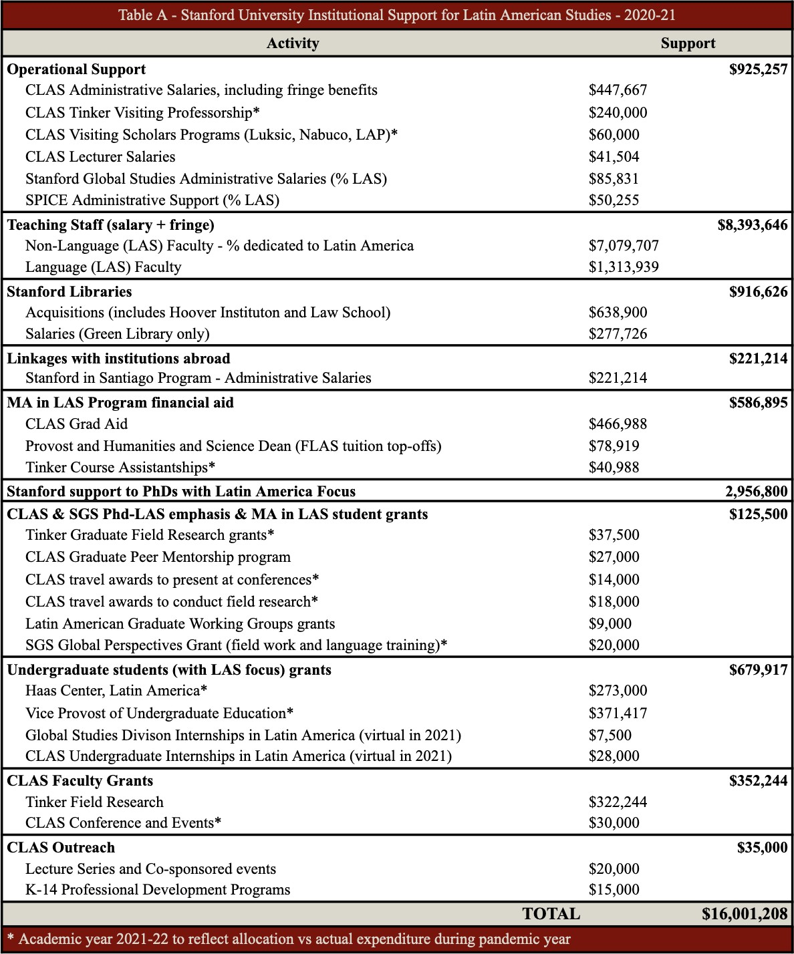
service and the advancement of knowledge to advance this work by connecting Stanford resources with neighboring partner institutions.

CLAS actively collaborates and engages with key partners within the university. The Freeman Spogli Institute for International Studies (FSI) is a critical resource for scholars interested in Latin America, most prominently through its Center on Democracy, Development and the Rule of Law (CDDRL), the Center for International Security and Cooperation (CISAC), the Program on Food Security and the Environment (FSE), and the Center for Health Policy.
Latin American scholars are affiliated to virtually all the Centers at FSI. The Lemann Center for Educational Entrepreneurship and Innovation in Brazil (part of the Graduate School of Education (GSE)), aims to enhance educational opportunities and policy in Brazil through professional training, policy research, and innovative projects. The Lemman Center provides graduate students fellowships, hosts Brazilian visiting scholars and visiting student researchers, and offers research opportunities to Stanford affiliates, including graduate students, faculty, and educational entrepreneurs. The King Center on Global Development is a university-wide initiative, founded by CLAS faculty affiliate Grant Miller to tackle the most pressing social challenges of our time; the Center on Poverty and Inequality, co-directed by CLAS affiliate, David Grusky, complements the King Center with programs that offer some of the most innovative research leveraging social scientific knowledge to alleviate poverty and enhance social mobility around the world.
Stanford’s Bing Overseas Studies Program (BOSP) with centers in 13 countries, has a Center in Santiago, Chile. BOSP-Santiago incorporates 13 local faculty, in addition to a quarterly Stanford faculty-in-residence, offering around 20 courses every year (apart from Spanish language instruction) for Stanford students. Additional study abroad opportunities are available through BOSP’s Overseas Seminars and Faculty-Initiated Programs including sites in Argentina, Brazil, Chile, Colombia, Costa Rica, Ecuador (Galapagos), and Mexico. The two Mexico

programs have been led by CLAS affiliated faculty with particular emphasis on community health and biodiversity in Oaxaca, Mexico (Section D3).
Furthermore, CLAS works closely with the Stanford Language Center (SLC) to coordinate the teaching of Less Commonly Taught Languages (LCTLs) and Language Across the Curriculum (LAC) courses (in Portuguese and Spanish). In addition to Spanish, SLC currently offers
three-year levels of Nahuatl and Quechua; and four year-levels of Portuguese. SLC started offering Haitian Creole in the 2021-2022 due to strong student demand. Command of Spanish or Portuguese allows for engaging in business with dozens of countries in Latin America, where the
U.S. concentrates a fifth of its international trade. Beyond Spanish and Portuguese, Latin America also has 45 million indigenous speakers, who communicate in hundreds of languages, including Nahuatl and Quechua.
Stanford’s strategic plan envisages an education that seeks to reimagine learning, pursuing promising new areas of research and developing innovative and flexible ways of addressing problems in the world. Research at Stanford aims to educate the next generation of intellectual pioneers while contributing to the betterment of society and enhancing our understanding of the world. Such is the international scope and ambition of the current university leadership. Two specific new initiatives are relevant for Latin American Studies in this respect.
The Stanford Impact Labs seek to transform teaching, training, and investment in the social sciences, in order to increase public impact. Several CLAS faculty are spearheading the seminal projects in this new initiative. A new Stanford School focused on Climate and Sustainability will open in 2022, where at least two of the departments will be focused on the human dimensions of climate and sustainability (including environmental justice, integrated socio-ecological systems, sustainable business, and environmental policy analysis). The new School will make cluster hires

that will enhance Black Studies and scholarship related to indigenous knowledges, expanding opportunities for learning and researching environmental issues in Latin America, particularly as they affect indigenous and afro communities.
CLAS is a national resource and a focal point within the University, providing a diversity of perspectives (ethnic, linguistic, cultural, historical) that enhance teaching and learning about Latin America at the national and campus levels alike. In addition to offering content and languages of the region courses, an MA program, and an LAS-emphasis minor, each year CLAS hosts 7 to 10 visiting professors and scholars from Latin America, invites over 100 guest speakers (including former presidents of Latin America, public officials, ambassadors, judges, scholars, journalists, artists, writers, musicians, and human rights activists) to participate in seminars, conferences, and workshops, and, since 2014, organizes a summer course for indigenous college students from Mexico. CLAS provides financial aid to approximately 95% of its LAS MA students; funds graduate student working groups, summer undergraduate internship opportunities, graduate fieldwork, and conference participation; and leads multiple sets of public engagement activities. (Section H)
CLAS is an integral part of the School of Humanities and Sciences (H&S) and the Stanford Global Studies (SGS) Division and actively collaborates with other Area Studies centers in several initiatives including academic conferences, annual career development panels for undergraduate and graduate students, and an annual international film festival open to the public. Furthermore, H&S provides funding for multi-disciplinary faculty hires and the Global Perspective Fund, which awards language study and research abroad fellowships specifically for area studies MA students.

Financial and Other. The Center for Latin American Studies. CLAS is housed in a 5,000 sq. ft. historic home (Casa Bolívar/Bolivar House) built in the 1890s and equipped with a seminar room with A/V projection, conferencing, and streaming capabilities for hosting lectures and courses; office space for staff, the faculty director, and visiting professors and scholars; and a lawn for outdoor events. CLAS is fortunate to have endowments that cover the entirety of its annual operating expenses (equipment purchases and supplies, CLAS staff salaries, visiting professors salaries, visiting scholars stipends, public programs, student financial aid, and faculty and student grants) with total annual payouts above $1,500,000. In addition, CLAS receives support from the Office of the Provost and the H&S Dean’s Office for supplemental FLAS fellowships funding (averaging $75,000 per year) as well as from SGS student summer internships and research funding ($25,000). Teaching Staff. The University provides $8,393,646 for the salaries of faculty who teach Latin America or the languages thereof. In the past decade, Stanford has ensured a continued robust presence on campus of tenure-track faculty with strong teaching and research commitments to Latin America. As some retirements happen, renewed commitments to the area are made through the hiring of new tenure track assistant professors. Nearly all the Latin Americanist tenure-track faculty appointed at Stanford in the early 2010s have been promoted. In addition, several Latinamericanists have recently been distinguished with endowed chairs, adding to the CLAS affiliated faculty who already enjoy such recognitions. A substantial number of CLAS affiliates have become members of the National and the American Academies of Sciences, and continue to serve as prominent members of their respective professional associations (Appendix 3). Library Support. Last year, Stanford spent $1,194,350 for the Stanford University Libraries’ (SUL) Latin America & Iberian Collections, which includes
$555,450 staff support. Herbert S. Klein, Professor of History and former CLAS Director, serves

as the curator of the Latin America collection in the Hoover Institution Library and Archives. (Section F) Linkages with Institutions Abroad. The University allocates an average of $981,000 annually for the operation of the Stanford Overseas Center in Santiago, Chile (Section D3).
Stanford also has formal agreements with universities across the world. Outreach Support. Title VI funding has been instrumental in developing additional linkages with K-12, MSI and community colleges. Targeted Financial Support to LAS Students. Stanford provides an average of $2.9 million annually in fellowship support to PhD students in fields involving Latin America. Last year, CLAS and the university expended $446,988 in financial aid for its MA students. In addition, CLAS and SGS provided $35,500 in undergraduate internship and graduate research and working group grants. Undergraduate Advising and Research, the Haas Center for Public Service, and the Vice Provost for Undergraduate Education award an average of $644,000 per year to students carrying out research or internships in Latin America. Financial Support for FLAS Fellows. Stanford CLAS grants around $157,000 per year to cover the difference between Stanford tuition and the amount allotted for FLAS awards. The Provost and the Dean of H&S provide funds to “top-off” one FLAS fellow from a professional school and one enrolled in the CLAS MA program. CLAS uses its own endowed funds to partially or fully “top-off” the remaining FLAS awards granted. (Table A)

B. QUALITY OF THE LANGUAGE INSTRUCTIONAL PROGRAM

B1. Languages of the Subject Area. Stanford offers language courses in Spanish, Portuguese, Quechua, and Nahuatl (Appendix 1) and in AY2021-22, started offering Haitian Creole.
Additional less commonly taught languages are offered in response to demand. All foreign language instruction is coordinated by the SLC, which requires language programs to adopt standards-based curricula with clearly articulated proficiency goals. Every year the SLC,

Stanford Law School (SLS), the School of Medicine, and Stanford in Santiago and Stanford in Madrid programs offer over 35 Spanish-language courses and at least eight Portuguese-language courses. The Special Language (LCTL) Program offers three levels of Quechua and Nahuatl in year-long sequences. (third-year level by demand). In 2020-21, Stanford had a combined 1,185 enrollments in Spanish, Portuguese, Quechua, and Nahuatl courses (Table B).
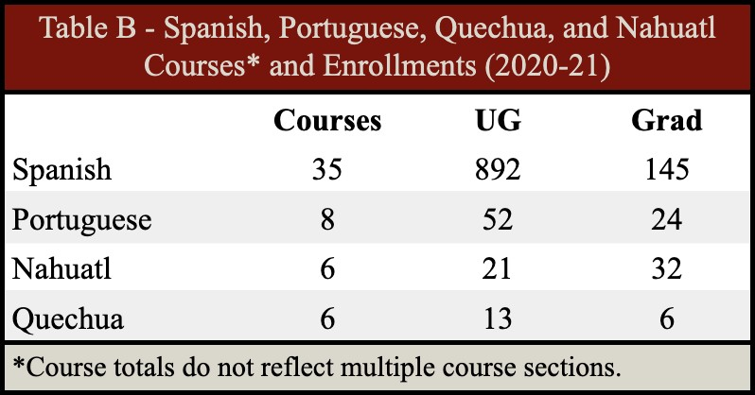
Stanford undergraduates must qualify in a foreign language at the Intermediate Mid level in the English-cognate languages (e.g., Spanish, Portuguese) or Novice High in the non-English-cognate languages (e.g., Quechua, Nahuatl). Some
majors require higher proficiency, such as CLAS, Iberian and Latin American Cultures (ILAC), and the Program in International Relations (IR) (Section D). Spanish is the most popular foreign language among Stanford undergraduates; every year close to 50% of the incoming students plan to study Spanish to meet the undergraduate language requirement during their freshman year. A high percentage of Stanford students enroll in language courses even when they have already fulfilled the requirement, including CLAS MA students. CLAS MA students with third-year college-level Spanish enroll in accelerated Nahuatl, Quechua, or Portuguese for Spanish Speakers courses; many graduate with a full year of accelerated Portuguese language classes (the equivalent of two college years of study) at the Advanced Low and Advanced Mid levels in speaking and writing proficiencies, having pursued proficiency beyond the minimum required by the MA program (Section D). Students may elect to have proficiency notations appear on their transcripts. Quechua and Nahuatl courses have a combined average annual enrollment of 72.

Nahuatl courses are offered in partnership with the University of California, Los Angeles (UCLA). Students from California’s MSI and community colleges enroll and receive credit through their home institution. We have had enrollments from the University of California, Davis (UC Davis) and De Anza Community College.
B2. Levels of Language Training. Stanford regularly offers four levels of Spanish and three levels of Portuguese, Nahuatl, and Quechua. In AY 2021-22, the SLC started offering the introductory-level course sequence of Haitian Creole. In the Spanish Language Program, there is a first-year sequence of three courses for beginners, and a two-quarter accelerated sequence for those with some knowledge of Spanish or another Romance language. Second-year courses prepare students for study abroad at Spanish-speaking universities and are available in three tracks: Cultural Emphasis; International Relations; and Spanish for Home Background Speakers. Each track has a series of three courses. Third-year courses focus on Spanish structure and writing and composition, with an optional community engagement component. All levels of conversational courses are also offered. Several course offerings are tailored to the needs of professional school students. Spanish for Medical Students is offered as a three-course sequence plus an advanced oral communications class. The Portuguese Language Program offers a beginning, three-quarter sequence for those without prior knowledge of Portuguese or another Romance language. First- and second-year accelerated Portuguese courses are offered each year and recommended for students with at least two years of formal study of a Romance language.
Advanced third-year courses include Reading Brazil; Brazil in Text: Advanced Grammar and Composition; and Advanced Conversation: Brazil Today. An introductory culture seminar,
Spaces and Voices of Brazil, is offered to sophomores each fall. Advanced (fourth- and fifth-year) literature and culture courses are taught in Spanish and Portuguese each year by

tenure-line ILAC faculty. The Quechua language program concentrates on the

Ayacucho-Chanka dialect and the cultural and ecological background of the language. Levels are structured as three-quarter sequences (4 units per quarter) starting each fall. Students who complete the first-year sequence test at the Novice High to Intermediate Low level of proficiency. Students achieve Intermediate High proficiency level after the second year and Advance Low after the third year. The Title VI-seeded Latin American Indigenous Studies Alliance (LAISA), a collaboration between Stanford, UCLA, the University of California, Berkeley (UC Berkeley), and the University of Utah, coordinated the development of a Nahuatl language program, consisting of course levels 1, 2, and 3. Stanford and UCLA jointly offer Distance Learning Nahuatl courses taught by instructors from the Instituto de Docencia e Investigación Etnológica de Zacatecas (IDIEZ) of Mexico. The first of three three-quarter sequence levels (4-units per quarter), the Nahuatl year-one course brings students to a Novice High to Intermediate Low level of proficiency. Students achieve Intermediate High proficiency level after the second year, and Advance Low proficiency by the third year. Haitian Creole language program. There is currently student critical mass for Haitian Creole language training at Stanford. We expect to reach demand to offer three levels of Haitian Creole by 2023-24. We elaborate on this point in the Program Planning and Budget (Section I).
The Stanford Bing Overseas Studies Program in Santiago, Chile, (Section D3) offers Stanford undergraduate students coursework in anthropology, biological sciences, ecology, earth systems, history, language and literature, economics, international relations, political science, and public policy, all taught in Spanish (Appendix 1).
Language Across the Curriculum (LAC). On the main campus, foreign language opportunities also exist in non-language-specific courses, including alternative sections in Spanish of

Introduction to Humanities; Freshman and Sophomore Seminars in Latin American literature or film; and optional readings and lectures in Spanish or Portuguese in various political science, history, anthropology, and linguistics courses. The Title VI-seeded LAC course, Racial and Gender Inequalities in Latin America, was developed in the 2014 grant cycle and incorporated into the School of H&S in 2018. Another Title VI-seeded course, Spanish in Science/Science in Spanish, was developed during the 2014 cycle and continues to attract science students with emphasis on enhancing science students’ ability to read scientific literature and on the development of science in Spanish-speaking countries or regions, particularly in the disciplines of ecology, environmental science, and sustainability. Spanish Language and Cross-Culture Theme Housing. Yost House promotes Spanish language, culture, and global issues while Casa Zapata focuses on Chicanx/Latinx history and culture. Theme programs include campus-wide events, in-house classes, film and lecture series, group discussions, drama productions, music recitals, and readings by noted authors. With guidance from faculty affiliates, student Academic Theme Associates teach courses at these houses each year, including Latin American Telenovelas and Spanish Intermediate Conversation. The Cafecito Quechua and the Encuentro Nahuatl are two student-led working groups supported by CLAS. These programs hold weekly informal conversation meetings throughout the academic year (virtually during the pandemic) and are open to Stanford students as well as the wider community. Quechua language faculty Marisol Necochea herself participates regularly as an outreach measure to foster and advance interest in Nahuatl and Spanish languages and cultures.
B3. Language Faculty and Pedagogy. At Stanford, the equivalent to a Department of Spanish and Portuguese in other institutions can be found in two units: ILAC, which offers courses on literature and content taught by tenured and tenured-track faculty, and SLC, which offers

language acquisition courses, taught by academic staff lecturers, who hold permanent positions at Stanford. With Spanish, Portuguese, Quechua, and Nahuatl language enrollments totaling over 1,100 annually, these SLC programs employ a teaching staff of 20 academic staff, 12 of whom are Latin Americanists and 18 advanced degrees (10 hold a PhD); 9 are native speakers. Class sizes remain small with maximum enrollment restricted to 15 students per class. The SLC oversees foreign language instruction, sets and maintains language standards, and conducts research on language pedagogy. The SLC requires all language programs to adopt
standards-based curricula with clearly articulated proficiency goals in each area: reading, writing, listening, and speaking. Currently, 10 of the 13 Spanish and Portuguese lecturers are American Council on the Teaching of Foreign Languages (ACTFL) certified Oral Proficiency Interview (OPI) raters, and 9 of them are ACTFL-certified raters in Writing Proficiency.
SLC and CLAS provide funding and pedagogical support to Quechua and Nahuatl instructors. Quechua instructor Marisol Necochea’s ACTFL OPI Tester Certification is currently in progress. Furthermore, as part of LAISA, since 2017, Stanford CLAS has held semi-annual pedagogy workshops for instructors of Indigenous language of Latin America from institutions across the U.S and cosponsored UCLA’s Annual Nahuatl Conference.
Graduate TAs receive appropriate training for performance-based teaching in Latin American languages. The departments in the Division of Literatures, Cultures, and Languages require that graduate students take the course Applied Linguistics 301, The Learning and Teaching of Second Languages, taught by the Director of the Language Center. The course provides students with an overview of second language acquisition research; practice in assessing undergraduate language development; practicum experience; and a Modified Oral Proficiency Interview (MOPI workshop.

B4. Quality of the Language Program. Language instruction at Stanford is performance-based, with a regularized process of assessment and evaluation and an integrated language-culture focus. Assessment of language competency is systematic. When entering and exiting courses, students are tested in proficiency and compile portfolios of their progress. SLC sponsors frequent ACTFL professional development workshops and has developed extensive materials for Simulated Oral Proficiency Interviews (SOPIs), including online assessment tools.
The SLC features classrooms equipped with current video and audio equipment as well as cable and internet connections, computer workstations for faculty and students, a soundproof room for recording student oral interviews and live foreign language broadcasts, and equipment for the production of student language portfolios. Students use the Digital Language Lab’s
state-of-the-art teaching spaces, enterprise level software resources, and expert support personnel. This lab offers reliable audio and video recording capability, foreign language digital media content, and software images to support computing in multiple foreign character sets. The lab also serves as a physical and virtual cross-cultural encounter environment. For Spanish and Portuguese, the goals for first-year instruction are an Intermediate Mid level of oral proficiency. For Quechua and Nahuatl, the first-year proficiency goal is Novice High/Intermediate Low.
Similar standards are set for reading and writing. These proficiency levels are based on the national Foreign Service Institute/ACTFL scale. In spring quarter each year, the SLC initiates a self-study of language programs to document whether third-quarter students (those completing one year of language study) meet the articulated standards. Oral proficiency data in Spanish and Portuguese are collected via a SOPI administered through Stanford’s online course management tool. Results from the Spring 2021 assessment indicate that the majority of students were in or beyond expected ranges. All data indicated that Stanford programs are significantly ahead of the

pace projected by the Foreign Service Institute. Substantial advancement was detected from first to second year. Portuguese students in particular seem to make remarkable strides. Writing Proficiency Test results for first- and second-year students of Spanish and Portuguese indicate that the writing measure outcomes are consistent with oral proficiency ratings across both years of instruction.

C. QUALITY OF THE NON-LANGUAGE INSTRUCTIONAL PROGRAM

C1. Non-language Course Coverage and Availability. In 2020-21, Stanford offered 206

non-language Latin American Studies (LAS) content courses across 40 departments, programs, and professional schools. Of those courses, 85 had 100% LAS content and 121 had 25% or more LAS content. Many of these courses were cross-listed in two or more departments and had a total of 1,960 enrollments, 1,351 undergraduate and 609 graduate students. Courses with Latin America content are offered in the professional schools, with 8 CLAS faculty in Education, 4 in Medicine, 3 in Earth, Energy & Environmental Sciences, 3 in Law, 2 in Business, and 1 in Engineering. In 2020-21, CLAS affiliated faculty in the professional schools taught courses with LAS content to 427 students. (Table C.1 and Appendix 1) As per the University Long-Range Vision, all schools have re-committed to internationalizing their curriculum as demonstrated in recent hires, among them professor Diego Zambrano, who teaches courses such as LAW 807E: Redesigning the Venezuelan Judiciary: The Venezuelan Constitutional Crisis. Also, SLS regularly invites Professor Rogelio Pérez-Perdomo of Universidad Metropolitana in Caracas, Venezuela, to teach Latin American Law. Likewise, participation in a global experience is a requirement for the Graduate School of Business (GSB) students, which has just hired two new Chilean tenured-track professors. Study sites include Argentina, Brazil, Chile, Guatemala, Mexico, and Peru. Stanford graduate students, including LAS students, participate in Stanford’s

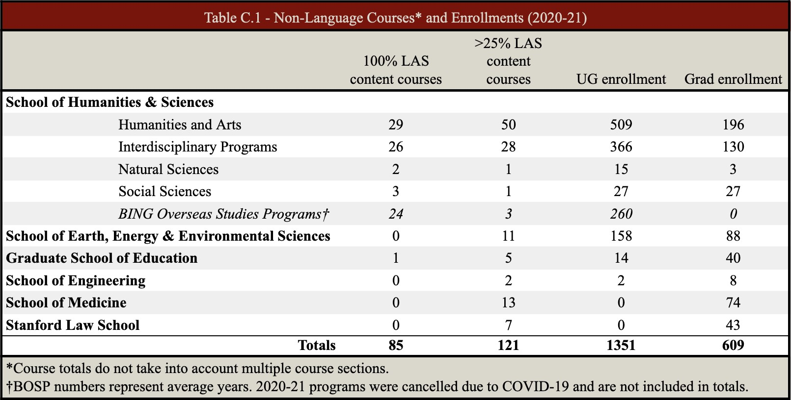
exchange-out program with UC Berkeley and the University of California, San Francisco, which allows them to enroll in courses at those institutions and earn the course credit at Stanford, and vice versa.

C2. Depth of Specialized Course Coverage. Course offerings in the School of H&S are especially complete with respect to Brazil, Chile, Colombia, Mexico, and Peru, and, in terms of disciplinary depth, in anthropology, ecology, history, literature, political science, and sociology, all of which offer Latin America as a special field in their PhD programs. The GSE has also continued with its long tradition of training doctoral students with a focus in Latin America (Table C.2).

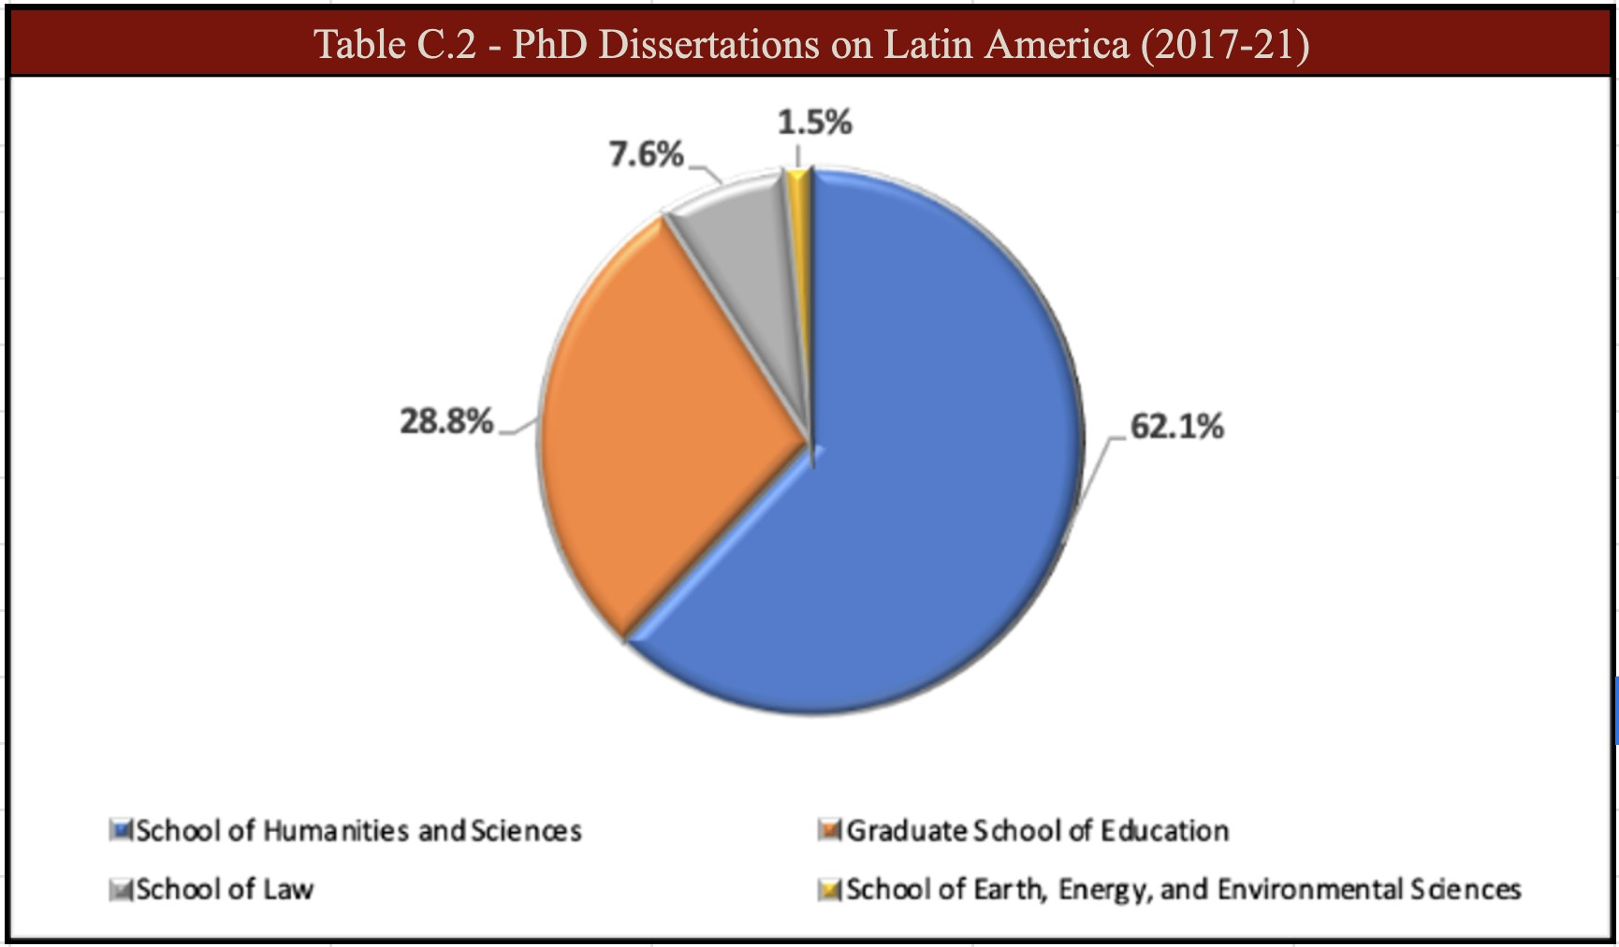

C3. Numbers of Non-language Faculty. CLAS has 19 core affiliated faculty, who devote 100% of their time to Latin American teaching and research, and an expanded core of 54 who devote 25% or more of their time (Appendix 3). Training of Instructional Assistants. Pedagogical training for faculty and TAs is a high priority at Stanford. All Stanford PhD students are required to fulfill teaching assistantships, for which both departmental and university training is required. Each department provides formalized and mandatory pedagogical workshops for TAs. The Center for Teaching and Learning offers excellent resources, pedagogy workshops, and individual consultations on teaching for faculty and graduate TAs.
C4. Interdisciplinary Courses. Stanford supports and encourages interdisciplinary courses, which are the core of the LAS academic programs (Section D2). There are 25 interdisciplinary programs in H&S and 23 departments. Many of the courses taught in the departments, programs, or schools listed in Table C.1 are interdisciplinary, including courses taught by CLAS Tinker Visiting Professors. Several courses are listed across two or more departments, and Stanford faculty are highly engaged in interdisciplinary research across campus (Section A). CLAS programs greatly benefit from this interdisciplinarity “culture” at Stanford as it enriches its academic programs and yields to research and events collaborations among its affiliated faculty.

D. QUALITY OF CURRICULUM DESIGN

CLAS undergraduate minor and graduate degree programs are structured to meet the needs of students with little academic background in Latin America. Courses provide students with a foundation in the region and draw on the strengths of Latin Americanist faculty in three main areas: (1) culture and society, (2) environment, ecology, and sustainability, and (3) political economy. The rigor and requirements of the program ensure that our graduates leave Stanford with knowledge, expertise, and language skills at levels sought after by employers in many fields (see Table G.3 for placements).
D1. Undergraduate programs. CLAS offers an undergraduate minor in Global Studies with a specialization in Latin American Studies and works with departments and programs to support LAS teaching in schools across campus and abroad. The minor requires 28 units, including a Global Studies survey course and an LAS introductory course, and advanced proficiency in Spanish or Portuguese. Furthermore, students in the minor are urged to pursue field experience or study abroad in Latin America. Opportunities to study and do research in Latin America abound at Stanford (Section D3). All Stanford students are required to complete a minimum of one year of college-level study in a foreign language. In addition, the Latin American track in the interdisciplinary IR major requires two years of language training, relevant overseas study, and five courses in LAS in addition to IR’s core of political science and economics courses.
Students majoring in ILAC are required to attain at least third-year Portuguese or Spanish. D2. Graduate Programs. CLAS offers a one-year Master of Arts program, which can be completed as a dual degree in any of the following combinations: JD/MA, MBA/MA, and MD/MA. The LAS MA is designed for qualified college graduates with some previous
experience working, living, or studying in Latin America. The Faculty Senate has just reviewed

and renewed the MA in LAS degree granting authority noting its excellence. Students benefit from the interdisciplinary curriculum consisting of a core set of courses surveying the culture and society, political economy, and environment, ecology, and sustainability of the region, along with advanced language training and in-depth courses tailored to their academic and career interests. Upon matriculation, each student is assigned a faculty advisor to plan a customized program of study. The MA program requires completion of 45 graduate units. In addition to the three core courses, students must complete three related courses (with a minimum of 25% LAS content), and the remaining units are selected with their advisors and approved by CLAS. Fluency in Spanish or Portuguese being an admission requirement, students meet the language requirement upon completion of at least three units of coursework in a second Latin American language, fulfilled through accelerated Portuguese, Spanish, Nahuatl, or Quechua, leaving Stanford with at least two Latin American languages. MA students enroll each quarter in the one-unit Contemporary Issues in Latin American Studies Seminar, during which they attend presentations by invited scholars on major Latin American themes and topics. The MA program requires students to write a thesis or capstone research paper and to present their findings in the LAS MA public symposium. MA students are required to enroll in the Graduate Writing Seminar for Latin American Studies, which is designed to aid students in fulfilling their MA in Latin American Studies capstone research paper or thesis requirement, and to participate in workshops, organized by CLAS, on a variety of topics from public speaking to GIS, big data, and visualization. MA theses and capstone papers are uploaded to SUL’s digital repository and are available to the public for research purposes. CLAS also supports other MA and doctoral students across the university with research projects in Latin America and provides funding and meeting space to two graduate student-led Latin American Research Groups, CLAS grants 12-14

awards per year to MA and PhD students to conduct field research in Latin America or present in conferences.
D3. Advising and Study Abroad. CLAS places great importance on academic and career advising to students in our degree programs as well as to those from other departments with an interest in doing research or internships in Latin America. Advising for MA students is provided by the CLAS director, affiliated faculty, associate director, and student services officer. Incoming graduate students are paired with faculty advisors prior to their campus arrival and meet at least quarterly to discuss selected courses and academic interests and progress. The associate director serves as the general academic advisor and meets with students throughout the year. The CLAS student services officer (SSO) tracks graduate and undergraduate student progress and informs students of academic and funding deadlines. The SSO also provides guidance to students from throughout the university interested in our degree programs or funding opportunities. In addition, the CLAS Peer Mentorship program brings PhD peer mentors together with CLAS MA students to provide them with academic and career guidance. Currently in its second year, this mentorship program, which was applauded by the Faculty Senate review, has been well received by the MA students and is proving to be a strong addition to the MA currriculum. CLAS also provides career advising to the LAS students, as well as to students from across the university with an interest in working in Latin America. Each fall quarter, CLAS and two other SGS area studies centers hold a reception at Casa Bolívar for faculty and students to begin networking.
Throughout the year, CLAS organizes a series of alumni career panels tailored to the MA cohort’s career interests. Other career development opportunities CLAS organizes with the support of the Bridging Education, Ambition & Meaningful Work (BEAM) Career Center and the Hume Center for Writing and Speaking include workshops on public speaking, resume and

cover letter developing, policy paper writing, career panels, LinkedIn, and other topics of student interest. Starting in winter quarter, the associate director meets individually with students to identify their interests and match and connect them with CLAS alumni in their areas of interest. CLAS has a fantastic pool of LAS MA alumni ready to speak with current students and support their “asynchronous peers” in getting ready to enter the labor market, careers in public service, or continue their graduate studies. CLAS actively stays in contact with its alumni and current students through weekly calendars of events and social media such as LinkedIn, Facebook, and Twitter to disseminate career fairs, jobs, study abroad, language programs, and other relevant opportunities.
Research and Study Abroad. Stanford offers more than 600 overseas opportunities to undergraduate and graduate students to study, intern, and undertake research and public service in 125 countries, roughly 25% of which are in Latin American, Caribbean, and Iberian countries, and strongly encourages undergraduate students to study abroad at some point during their four years of study. Over 50% of Stanford undergraduates participate in Stanford’s BOSP, another 3% study abroad with other programs, and an additional 12% participate in non-credit activities overseas such as internships, public service, and independent projects and research. Stanford’s BOSP runs a center in Santiago, Chile, and as well as multiple seminars in Latin America, including Brazil, Guatemala, Ecuador, Costa Rica, and Mexico.
The Overseas Resource Center (ORC) at Stanford’s Bechtel International Center helps Stanford students earn international scholarships, administering the campus process for over a dozen awards and promoting more than 50 international opportunities. ORC offers guidance to students through one-on-one advising, information sessions, application workshops, interview preparation, and other resources. An average of four students per year are awarded the Fulbright

Scholarship to carry out research or teach English in Latin America countries. CLAS alumni provide about $20,000 for undergraduate summer internships in Latin America. In 2020-21, from this funding, four undergraduate students received grants to carry out remote internships in organizations in Brazil, Costa Rica, Mexico, and Peru. The Center for Innovation in Global Health, King Center on Global Development, and Haas Center for Public Service are some of the units at Stanford that also provide funding opportunities abroad.
E. QUALITY OF STAFF RESOURCES .

E1. Teaching Faculty. Qualifications. As demonstrated in Appendix 3, all our affiliated tenure-line faculty hold PhDs and have extensive field experience, many engaged in research
work in Latin America. Collectively, these faculty members serve on the editorial boards of over 50 scholarly journals; approximately 50% hold or have held endowed chairs and have received prestigious teaching awards. Many have received grants from Fulbright, SSRC, NIH, NSF, State Department, Rockefeller, Guggenheim, the Mellon Foundation, and the MacArthur Foundation. Professional Development Opportunities. Stanford offers CLAS faculty and staff ample resources for professional development. The Stanford Center for Teaching and Learning supports faculty teaching and students’ learning. They offer assistance, consultation, and resources to help faculty advance pedagogy, student engagement, and learning outcomes in their classrooms. Staff receive annual funds to pursue work-related training or coursework. Assistant-level professors receive a guaranteed year of sabbatical before coming up for tenure, and all faculty receive annual conference travel and research funds, and a sabbatical program. Internal research fellowships are available competitively from the Dean of Research, the Stanford Humanities Center, the Clayman Institute for Gender Research, and other campus programs, such as the Stanford Institute for Innovation in Developing Economies (SEED) and the Woods Institute for

the Environment, and CLAS itself funds 7 to 8 faculty research grants and provides funding for 4 to 7 faculty-led conferences and events each year.
Teaching, supervision and advising of students. CLAS academic programs are successful due to the engagement of CLAS-affiliated faculty from departments and professional schools across campus, and the Latin American collections curators. Full-time non-language lecturers teach six courses per year and advise students, and some teach a quarter at Stanford’s overseas campuses in Santiago and Madrid. When not on leave or sabbatical, faculty are on duty as teachers, scholars, advisors and committee members (Appendix 3). Boasting a 1:7 faculty-undergraduate student ratio, Stanford does not pursue appointments or promotions without affirmation of excellence in teaching. CLAS faculty advisory board members and affiliates are committed to serve as advisors to our master’s and undergraduate minor students in addition to advising undergraduate and graduate students in their respective departments. CLAS’ Associate Director offers academic, career, and fellowship advising to students across campus interested in LAS. Faculty outreach involvement. CLAS outreach efforts have full LAS-affiliated faculty involvement from conception to implementation. Faculty actively participate in the community college fellowship program by presenting their research and meeting with fellows throughout the development of their projects, often forming long-lasting academic relationships. Faculty also lead content sessions in our teacher-training institutes and invite colleagues from other institutions to participate when the theme of the institute requires tapping into outside expertise. E2. Oversight/Center Staff. Direct oversight of NRC activities rests with the Project Director Alberto Díaz-Cayeros, Senior Fellow at the CDDRL and Professor (by courtesy) of Political Science. He received his PhD from Duke University in 1997, and joined Stanford in 2013. He has written and taught numerous undergraduate and graduate courses including Mapping

Poverty, Colonialism and Nation Building in Latin America; Latin American Politics; and Riesgos Globales. He is supported by Associate Director Elizabeth Sáenz-Ackermann who provides day-to-day administration of grant activities. She holds an M.A. from San Diego State University (SDSU) in Latin American Studies and a B.A. from Universidad Autónoma de Ciudad Juárez in Business Administration, and joined Stanford in 2012. Before coming to Stanford, she served nine years as Program Director at the SDSU’ CLAS, where she taught the Introduction to Latin American Studies course to undergraduate students. CLAS Public Engagement Coordinator Molly Aufdermauer assists with the implementation and reporting of Title VI National Resource Center K-14 outreach activities and Foreign Language and Area Studies (FLAS) fellowships. She is an ex-officio member of the CLASP Executive Committee and chairs its Outreach Committee. Molly holds a BA in Spanish from BYU and an MA in Teaching English as a Second Language from San José State University. CLAS Event and Communications Officer Sara Clemente Vásquez provides technical and logistical support for events and outreach activities, and assists with data collection for reporting purposes. She holds an MA in Latin American Studies from Stanford University. CLAS Academic and Student Services Officer Megan Bonilla organizes information sessions of CLAS grants, including FLAS fellowship and award disbursements. Megan received her BA in Chicano Studies from UC-Irvine and her MA in Public Policy from the University of Southern California.
Additional administrative support to conduct the NRC outreach activities outlined in Section I is provided by SGS, SPICE, and SUL staff (Appendix 2, Position Descriptions).
E3. Nondiscriminatory Employment. Stanford University is strongly committed to

non-discriminatory practices in the hiring and promotion of faculty and staff. The University leaders recognize the importance of diversity (broadly defined) in higher education and are

committed to increasing the number of women and persons who are members of traditionally underrepresented groups. The Office of Accessible Education ensures that all university units and facilities comply with federal and state law as well as university standards of equal, fair access. The office of the Vice Provost for Faculty Development and Diversity (FDD) assists deans and search committees in developing diverse faculty applicant pools, serves as a resource for recruits and newly hired faculty in their transition to Stanford, and promotes retention efforts to ensure continued faculty diversity. There are several initiatives at Stanford aiming to increase diversity at Stanford: the President’s Awards for Excellence through Diversity Program (est. 2009) recognizes individuals and programs that make exceptional contributions to enhancing and supporting diversity; the Diversity and Inclusion Innovation Fund (2013) supports faculty, student, and staff initiatives that advance diversity across the campus; and most recently the Presidential Initiative IDEAL – Inclusion, Diversity, Equity, and Access in a Learning Environment (2019-20), established to advance the university’s commitment to the values of diversity and inclusion, a key component of Stanford’s long-range vision, works across the entire campus community, focusing on the areas of recruitment, research, education and engagement.
Stanford is in the process of hiring a tenure-track LAS faculty under the IDEAL initiative.
F. STRENGTH OF THE LIBRARY .

F1. Relative Strength of Holdings. SUL, with an annual budget of $77.7 million (acquisitions and salaries) and over 9.1 million volumes, is one of the largest academic and research libraries in North America. The Latin American collection is one of the most comprehensive in the country. SUL holds over 540,000 print monographs, 50,000 digital items, and several thousand periodicals on Latin America, principally devoted to the humanities and social sciences. The collection is especially strong on Brazil, Chile, Mexico, and the US-Mexico Border. The Hoover

Institution Archives, one of the largest specialized archives in the world, contains unique primary collections of Latin America-related documents (Table F.1). Additional specialized resources are located in the Art, Business, Education, Medicine, Law, and Music Libraries as well as the Special Collections and Government Documents Unit of the main research library.
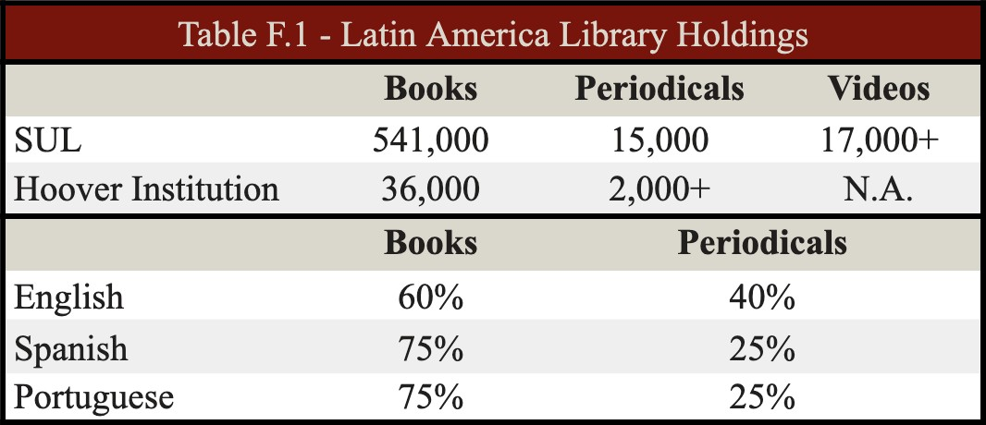
Support for Acquisitions and Staff. For 2020-21 SUL’s budgeted $370,500 for materials related directly to Latin America ($59,500 from endowed funds). An additional
$129,000 was budgeted for Spanish and Portuguese (Iberian) materials and $44,000 for Mexican-American collections. Each year the Latin America office of the library receives about
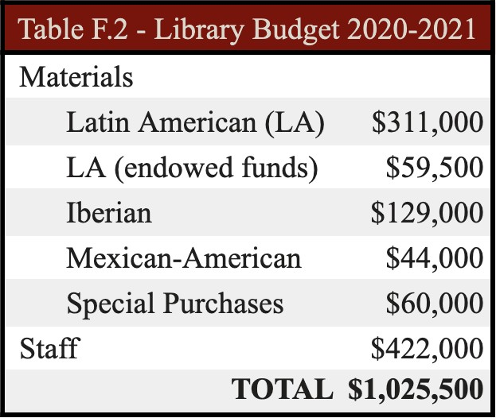
$60,000 from other funds to purchase unusually expensive collections (both print and non-print). Working with over a dozen separate dealers in Latin America, SUL acquires between 9,500 and 10,000 current titles annually. Full-time Senior Librarian-Curators Robert Trujillo and Adan Griego are in charge of Latin American materials
acquisitions and Adan oversees this Latin American Special Collection, assisted by a .25FTE Senior Library Specialist and a number of student assistants. SUL staff costs directly related to the Latin America office are in excess of $555,000 annually. (Table F.2)
F2. Availability of Research Materials. Stanford has

formal agreements with UC Berkeley and the University of Texas at Austin through the Research

Library Cooperative Program (RLCP), which affords reciprocal on-site and interlibrary borrowing privileges for faculty, academic staff, and graduate students. Especially advantageous is the access to the extensive Latin American collections at Berkeley (over 700,000 volumes) due to geographic proximity. Moreover, the respective online catalogs are linked for accessing bibliographic content, and the curatorial offices on the campuses provide consulting to faculty and students from each institution. This reciprocal borrowing agreement also includes a framework for materials acquisition through which each institution assumes extensive collecting responsibility for specific regions of Latin America for less frequently used materials that are unusually difficult to obtain. Division of labor is by country and encompasses such material as publications of non-major universities, annual reports of small financial institutions, dissertations from Latin America, and publications from non-governmental organizations. Analogous agreements exist with respect to Latin American government documents and map collections between Stanford and several University of California libraries. Nationally, Stanford contributes data to the Online Computer Library Center, the bibliographic utility that represents holdings of the major research libraries in North America. As members of the Center for Research Libraries (CRL), Stanford scholars have access to a vast collection of over 700,000 items in Latin America, including the Latin American Materials Project, a cooperative preservation project.
Membership in the Borrow Direct program of the Ivy League Plus gives campus researchers access to the Latinamericana holding of more than 3,000,000 volumes. As a member of the HathiTrust digital repository, Stanford also has access to several thousand public domain materials from/about Latin America.The Law Library acquires research material to support the Policy Lab on reforming the judiciary in Venezuela and Human Rights Clinic cases involving victims of torture in El Salvador and transitional justice inititives in Colombia. Library access.

SUL’s materials are widely accessible beyond the Stanford community. Through SUL’s Interlibrary Lending (ILL) Service, people not affiliated with Stanford may borrow materials from SUL’s collections as long as the requests for lending are submitted through their home organization. This includes requests by academic, public, corporate, law, and specialized libraries; U.S. government agencies; non-profit organizations; and public libraries (independent researchers). Each year, SUL lends out an average of over 300 books and 300 articles through the ILL program and an average of over 800 books and 50 articles through the RLCP agreement with UC Berkeley and UT Austin. Furthermore, members of the public are granted free in-person access to SUL seven days per calendar year, beyond which direct access and borrowing privileges are available through subscription plans according to the individual’s needs. SUL welcomes over 17,000 members of the public into its libraries every year. Many on-campus departments, including CLAS, sponsor local and visiting researchers’ library access. Since 2011, with Title VI support, SUL has worked closely with the CLAS’ outreach programs to provide 119 MSI and community college faculty to date with access to the Stanford collections – including online databases, in-person collections, and borrowing privileges – to further their research and strengthen the quality and depth of their course curricula (see Section H2). SUL has also engaged in extensive outreach to first-generation students from local high schools, and has worked with the schools’ instructors and librarians during the student visits. In addition, full-time Senior Librarian-Curator Adán Griego provides special sessions in various CLAS K-12 educator workshops to orient participants to SUL resources relevant to their course curricula and accessible to them as members of the public.

IMPACT AND EVALUATION

G1. Impact on the University, Community, Region, and Nation. CLAS rigorous academic curriculum, which includes advanced foreign language, and its remarkable placement record in areas of national need, makes Stanford CLAS one of the strongest Latin American training programs in the country. In addition, CLAS offers a range of research funding opportunities and quality teacher training and professional development programs, aiming to strengthen knowledge of the region and language training, thus contributing to build capacity in areas of national need. G1a. University Impact. Locally, CLAS impact is attested by course enrollments in language and non-language courses and event attendance. In AY 2020-21, Stanford offered 55 Spanish, Portuguese, Quechua, and Nahuatl courses (multiple sections) with a total enrollment of 1,185, and 206 courses with Latin American content in 40 different disciplines with an enrollment of 1,960. In addition to students enrolled in formal LAS degree programs, 167 undergraduate and
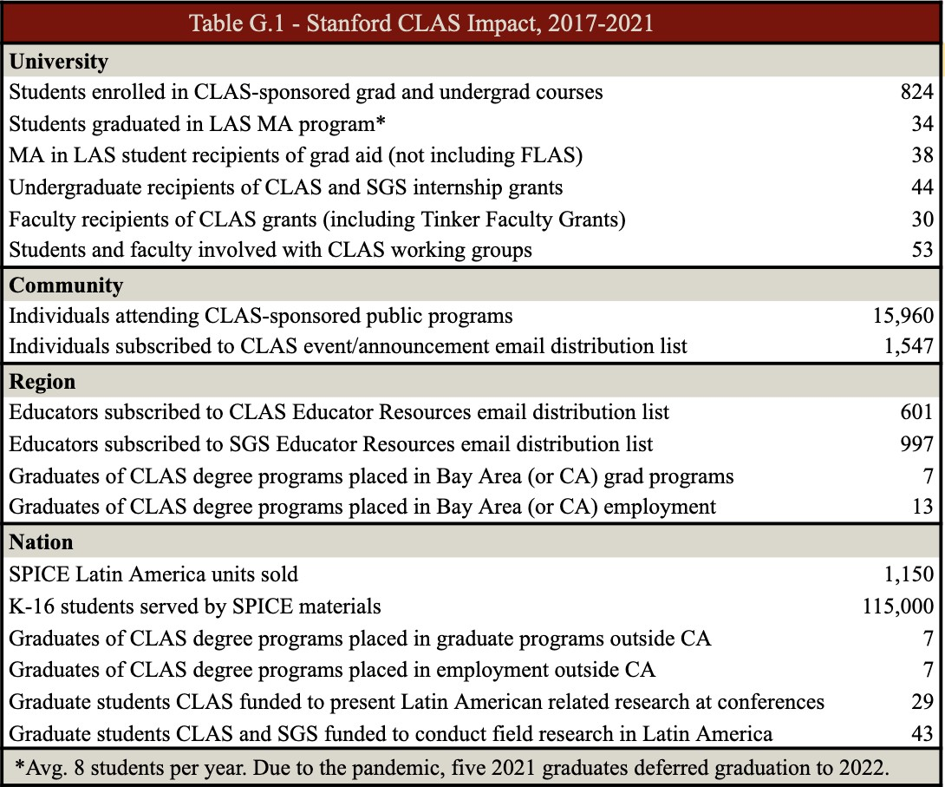

347 graduate students graduated with 22 or more units in LAS courses. This includes H&S (152 UG, 251 grad), Education (20 grad), Engineering (15 UG, 28 grad), Law (3 grad), Medicine (39 grad), and Business (6 grads). Most of Stanford’s graduating PhD’s in Latin American fields find jobs in academia, government, or business. Our MA alumni (2017-2021) received foreign language training during their MA program – 88% in languages of national need and 73% at intermediate-high proficiency or above and they have gone into a variety of careers that reflect the interdisciplinarity nature and strength of our academic program (Table G.2).
G1b. Community Audiences. Community events provide a platform to disseminate knowledge about Latin America. Since the pandemic started in March 2020, we moved all our programs and events from in-person to remote, exponentially expanding the number and geographies of our attendees and participants. Livestream changed our definition of community from local to global. CLAS organizes an average of 80 public lectures, conferences, and symposia with an average attendance of 2,000 persons per year, and recorded an attendance of over 3,300 in 2020-21 (remote) . In addition, CLAS cosponsors about 15 events per year with other Stanford departments and programs and is a major sponsor of the SGS Film Festival, which takes place on campus and is free and open to the public, and the renown United Nations Association International Documentary Film Festival (UNAFF), which attracts more than 10,000 persons and offers free admission to all K-16 students and instructors.
G1c. Region and Nation. CLAS core faculty and affiliates are leaders in their fields, producing an estimated 15 books and 200 academic articles in any given year. They share their expertise by lecturing in the U.S. and around the world, appearing in radio and TV interviews, writing editorial pieces in major publications, and serving on advisory boards and in other policy-making capacities. 44% of CLAS' MA graduates in the last five years are employed in areas of national

need or in doctoral degree programs outside California (Table G.1). CLAS' outreach activities (Section H) and academic programming result in significant impact at the K-12, community college, and university levels as well as in the private and public sector regionally and nationally. CLAS and its Stanford partners SPICE, SWLP, and GSE’s CSET provide direct professional development to an average of 320 K-12, community college, and MSI educators each year through its educational professional development programs of regional and national impact (Section H) .
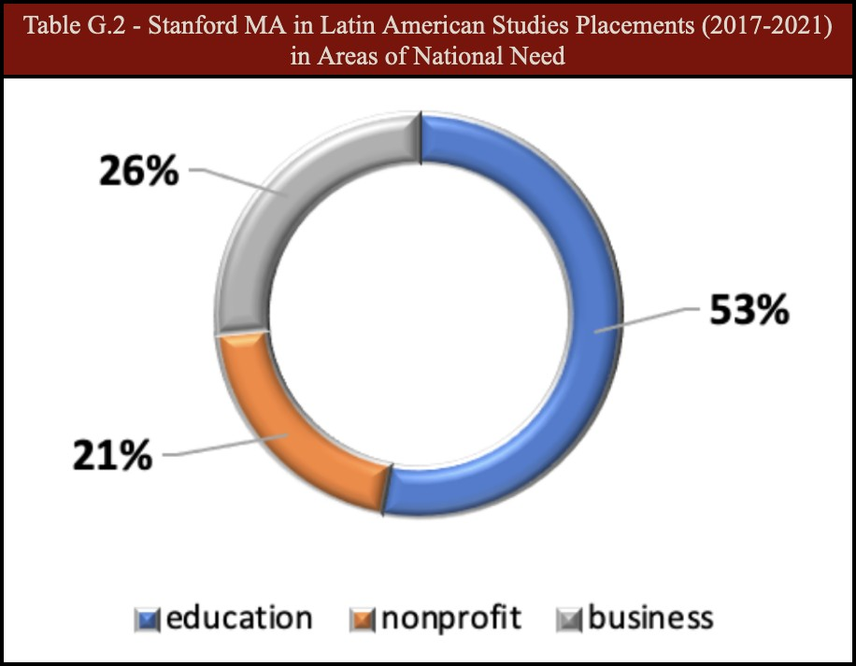
G2. Placement Data. By graduation, 9 out 10 MA in LAS students typically embark on one of two pathways: employment or a doctoral program. Stanford's career services program BEAM, the Alumni Association, and the Hume Center for Writing and Speaking are great resources that provide aid to our students as they plan for life after graduate school. CLAS also provides a robust wrap-around career advising program, from faculty advising to PhD peer mentors to alumni connections and alumni career panels. LAS MA students undertake a rigorous curriculum that includes basic training in systems and tools such as visualization, big data analysis, and GIS to help students be current and effective in their career of choice. Upon leaving Stanford, LAS alumni use their regional and
linguistic expertise to secure positions in areas of national need. CLAS has a strong record of placing students into post-graduate employment or training in areas of national need (Tables G.2, G.3).

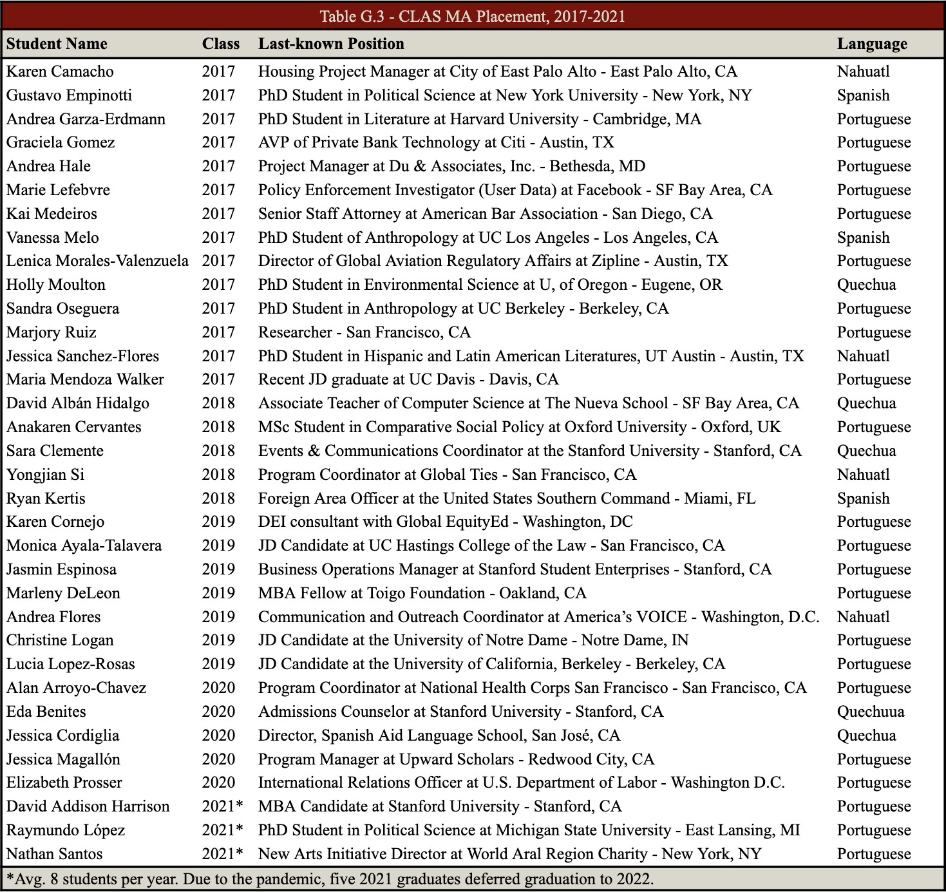

G3. National Needs and Information Dissemination.

Stanford addresses national needs in Latin American studies by supporting high quality LCTL and area studies instruction. 100% of Latin American language offerings are in designated languages of national need, with enrollments at roughly 1,700 annually. Our faculty’s numerous lectures, books, articles, white papers, and online resources inform debates in foreign policy, health care, engineering, and business. In the last four years, CLAS affiliates have produced an estimated 80 books and over 700 articles available to the general public. Stanford’s

Communications Office provides assistance to reporters, disseminates university’s news, and help to publicize and handle media relations for major events, provide media training for key faculty and administrators and serve as a liaison between scholars and media outlets.
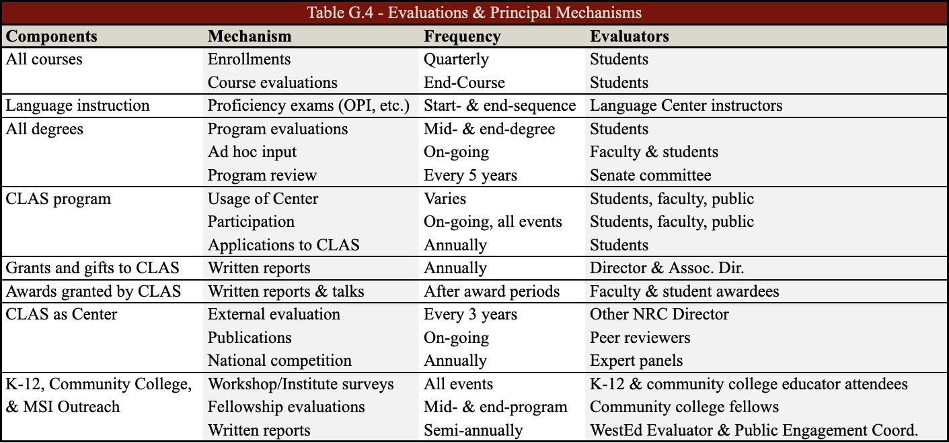
G4. Evaluation Plan. CLAS maintains a rigorous, on-going evaluation of its courses, programs, and activities through a variety of measures that target both quality and impact. Table G.4 summarizes these processes. Planning and design of performance measures are carried out in consultation with two independent, external evaluators from WestEd with extensive experience evaluating the impact of innovative education and professional development programs. (Budget 8N) Evaluation efforts by WestEd in the current grant cycle have informed iterative program changes and adjustments, and feedback from current partners and participants has been incorporated into the design of new programs proposed here. Evaluation of future programs will similarly allow for agile and ongoing project adjustments.

G5. Provisions for Equal Access and Treatment. Stanford University is committed to the expansion of the diversity of the student body and to equitable access and treatment for students. Undergraduate admission is “needs blind” and financial aid is widely available and need-based,

meaning that all aid eligibility is determined by the family’s financial circumstances. Students whose parents make less than $75,000 a year are not expected to pay tuition or contribute to the cost of room and board and other expenses. Those whose families with an income below
$150,000 a year do not pay tuition. For 2020-21, approximately 70% of students received some form of aid to attend Stanford, and approximately 47% received need-based aid. In addition, to encourage diversity, the University provides funds to departments for recruitment and a variety of fellowships, mentoring programs, support services, and cultural centers for diversity candidates. CLAS degree programs are made accessible to students of all economic backgrounds. About 95% of each incoming class is offered some form of financial aid ranging from full fellowships to half-tuition scholarships to partial course assistantships. CLAS places much importance on the diversity of the class to ensure varied perspectives will be brought to light in small seminar-style classes. MA in LAS admissions are in alignment with Stanford’s commitment to diversity, which includes, but is not limited to, underrepresented racial and ethnic minorities, gender, first-generation college students, and students with disabilities.
CLAS abides by non-discriminatory principles when offering teacher-training and other K-14 outreach programming. At least 75% of teachers who participate in our GSE-CLAS programs work in schools where more than 50% of the students receive free or reduced fee lunch (FRL). FRL is considered a proxy measure for Supplemental Educational Services (SES). Title VI funding has been instrumental in allowing CLAS to provide K-14 programming free or at an affordable cost for teachers. CLAS has offered Professional Development Awards of up to $500 per teacher to assist teachers in attending CLAS teacher professional-development programs.
Furthermore, for several years CLAS has ensured gender parity in all public events. All the speakers invited to the CLAS Lecture Series of 2020-21 were women.

NRC: OUTREACH ACTIVITIES

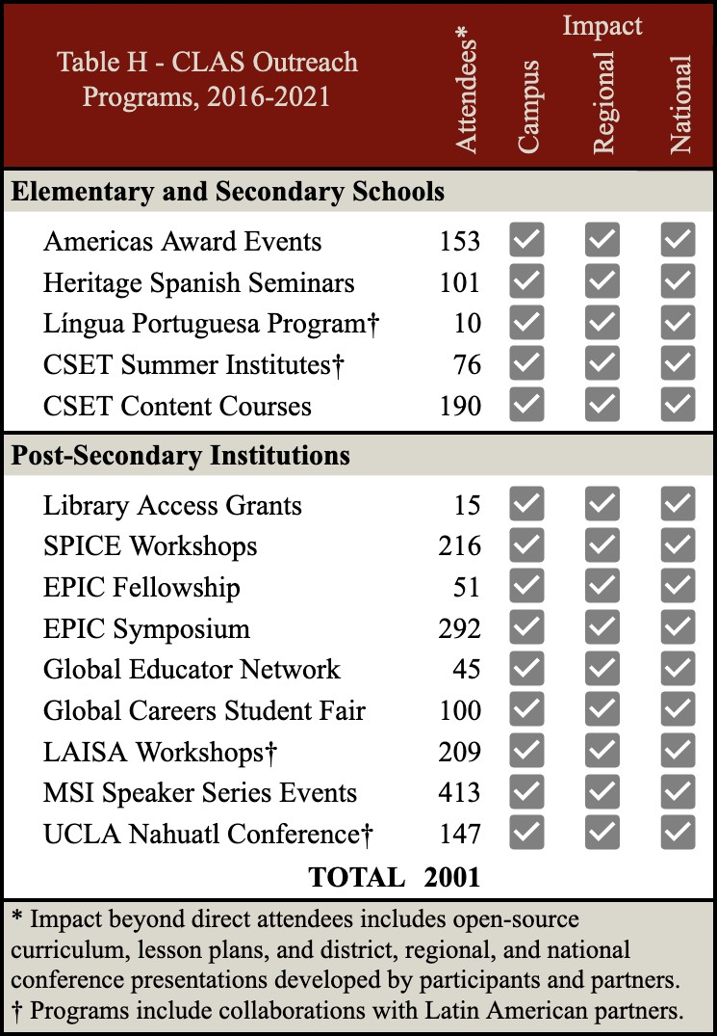
Stanford University is committed to public outreach and to the strengthening of K-12 and postsecondary education. Stanford provides grants to faculty members with an interest in strengthening elementary and secondary education and provides curricular units and professional development for K-16 educators through various departments and centers, including the GSE's CSET and Stanford World Language Project (SWLP) and the FSI's SPICE. CLAS provides significant and measurable outreach with national and regional impact (Table G.1). CLAS’ outreach programs are made possible with institutional support and Title VI funding, and with thriving on-campus, regional, national, and international partnerships formed over the last ten years. CLAS’ Public Engagement Coordinator has built valuable relationships with local, regional, and national K-12 and community college educators during this time, ensuring significant impact, sustainability, and caliber
within each outreach program. See Table H.

H1. Elementary and Secondary Schools. Many of the outreach efforts by Stanford University to improve K-12 education have benefited students in underrepresented communities and MSIs in the Bay Area. The GSE has numerous community partnerships that connect Stanford to a broad community of local educators and community leaders and support teachers, students, policy makers, and other professionals, including a fellowship for

early-career principals and a program with the San Francisco Unified School district that helps San Francisco acquire, interpret, and use Stanford research to benefit student learning. Likewise, CLAS has spent the last decade building a strong outreach program for K-12 educators. These programs include offerings for language teachers – including a year-long Portuguese language course for Spanish teachers looking to expanding Portuguese language programs in their secondary schools and community colleges – as well as content workshops and institutes geared toward history and social science educators – including week-long summer institutes on topics relating to Latin America, led by Stanford scholars and GSE pedagogy experts, held on Stanford campus as well as in Latin America. CLAS’ educator programs are designed to provide teachers with the opportunity to design resources to take back to their schools and districts and further the reach of our programs.
H2. Post-secondary Institutions. Stanford University has a long history of working with colleges and universities in the Bay Area and across California. Each year, the SLC holds an ACTFL MOPI workshop for its new lecturers and graduate TAs and invites instructors from local universities such as SJSU, Santa Clara, UC Berkeley, and UC Santa Cruz. In addition, and with Title VI funding, CLAS hosts semi-annual workshops for instructors of Indigenous languages of Latin America from universities across the U.S. and Latin America to discuss curriculum design, pedagogy, and the use of technology in the Indigenous language classroom. CLAS has also worked with local community colleges and MSIs to offer Nahuatl courses to their students.
Through its work with three Stanford NRCs and other SGS area studies units in the Education Partnership for Internationalizing Curriculum (EPIC), CLAS offers regular workshops, trainings, and symposia to regional and national community college educators. Since the start of EPIC in 2014, the partnership has reached over 1,000 community college educators

from over 30 colleges across California. Likewise, CLAS encourages the research and teaching of Latin American studies in community colleges and MSIs by offering SUL Travel Access Grants, which provide, with Title VI funding, community college and MSI faculty access to the SUL collections to further their research and strengthen the quality and depth of their course curricula. SUL has acquired copies of grantees’ books published with archival research completed during their grant period, including "Migrant Conversions" by anthropologist Erica Vogel, Saddleback College, and “Rio de Janeiro in the Global Meat Market, c. 1850 to c. 1930” by historian Maria-Aparecida Lopes, Fresno State University.
H3. Business, Media, and the General Public. LAS affiliated faculty are actively engaged in the realms of policy, journalism, and business through outreach events organized by our many research centers and programs. In 2020-21, the CLAS hosted 60 events with a total attendance of over 1,590. During the same time period, CLAS co-hosted 16 additional Latin American-related events and major conferences organized by other departments on campus, with an estimated attendance of nearly 1,600. CLAS maintains an electronic calendar, distributed to over 1,500 people each week and actively promotes its events and programs through social media outlets (Twitter, close to 5,000 followers as per Feb. 2021) CLAS' annual newsletter highlights alumni updates and CLAS activities and is made available on the CLAS website in PDF format and distributed widely via email. Public Events: Each year, CLAS sponsors or co-sponsors, on average, 80 public events, free and open to the public, many of which are live streamed to ensure accessibility and future access. Synchronous attendance varies from 30-50 at weekly lectures and about 250 at major conferences and talks. The Stanford CLAS YouTube Channel allows us to reach hundreds and sometimes thousands of asynchronous additional viewers. CLAS collaborates with departments, centers, faculty, students, and programs across campus as well as

regionally, nationally, and internationally. CLAS and the other area centers and programs host an International Film Festival each summer, which is widely attended by community members and draws over 200 weekly attendees. Visitors: CLAS hosts a range of visits, scholarly conferences, and workshops representing varied perspectives and disciplines open to the public. In the last five years, CLAS has hosted visits from two former Latin American Presidents, Vicente Fox and Dilma Rousseff; a joint visit with former U.S. Ambassador to Mexico Carlos Pascual and former Mexican Ambassador to the U.S. Arturo Sarukhan discussing NAFTA and the Future of
U.S.-Mexico Relations; a keynote address by Brazilian Supreme Court Justice Luís Roberto Barroso at the Rule of Law in Latin America Conference with SLS; a conference on Venezuela at a Crossroads, held in response to Venezuela's current socio-economic and institutional crisis; a keynote address by K'iche' Guatemalan Nobel Peace Prize laureate Rigoberta Menchú Tum; visits by Mexican award-winning authors Juan Villoro and Cristina Rivera Garza; a conference with Iván Velásquez Gómez Former Deputy Secretary General of the International Commission Against Impunity in Guatemala (CICIG); and visits by human rights activist Alejandro Solalinde and the relatives of missing Ayotzinapa students. Media: CLAS frequently connects journalists, seeking content expertise, to faculty for interviews. In addition, CLAS works with the Stanford John S. Knight Fellowships for Professional Journalists Program, which brings at least three journalists from Latin America or from Spanish news services in the U.S. to Stanford each year. Many of which give lectures at Bolivar House and become involved in CLAS activities.
Likewise, weekly lectures are often led by current and retired journalists who focus on Latin American topics, such as Juanita Darling, journalist, academic, and Los Angeles Times foreign correspondent. CLAS-sponsored working groups also bring a plethora of journalism and media specialists throughout the year, such as Roberto Lovato, educator, journalist and writer, who

presented his recent memoir, Unforgetting: A Memoir of Family, Migration, Gangs, and Revolution in the Americas (2022). CLAS’ MA program often attracts professional journalists, with three over the last four years. In April 2018, CLAS, in collaboration with Stanford John S. Knight Fellowship program and the CDDRL hosted a 3-day meeting of Mexican and U.S. journalists and Stanford scholars to discuss and empower journalism in Mexico.
I. NRC: PROGRAM PLANNING AND BUDGET .

Programs Quality and Timeline. Stanford CLAS’ programs proposed herein are designed to offer training and professional development for K-16 educators across the U.S. to support their teaching of Latin America and the languages of the region. All thirteen programs directly address FY 2022 NRC Absolute Priorities 1 and 2 and eight of them meet the Competitive Preference Priority and have been carefully designed in consultation with faculty and input from our partners and the educators we serve to ensure relevance and purpose. The programs are collaborative with units on campus and/or MSI and Community Colleges. CLAS is particularly excited about a new partnership with SJSU’s Lurie College of Education, an MSI that serves Hispanic and Asian American and Native American Pacific Islander student populations (Ig), which will strengthen our existing summer teacher institute while continuing collaborating with GSE’ CSET. Resources and personnel and reasonableness of cost. In addition to the efforts of CLAS staff, projects will be coordinated with other Stanford NRCs and area studies departments to maximize measurable results over the life of the grant and minimize costs. All projects will involve significant Stanford contributions, often with multiple supporting units, and are designed to provide benefits at multiple levels: on campus; in the community; regionally; nationally; and globally. We seek to leverage Title VI funding with dean’s support, grants, and gifts and request funding for 13 programs and projects (Budget 8) as well as administrative, teaching, outreach,

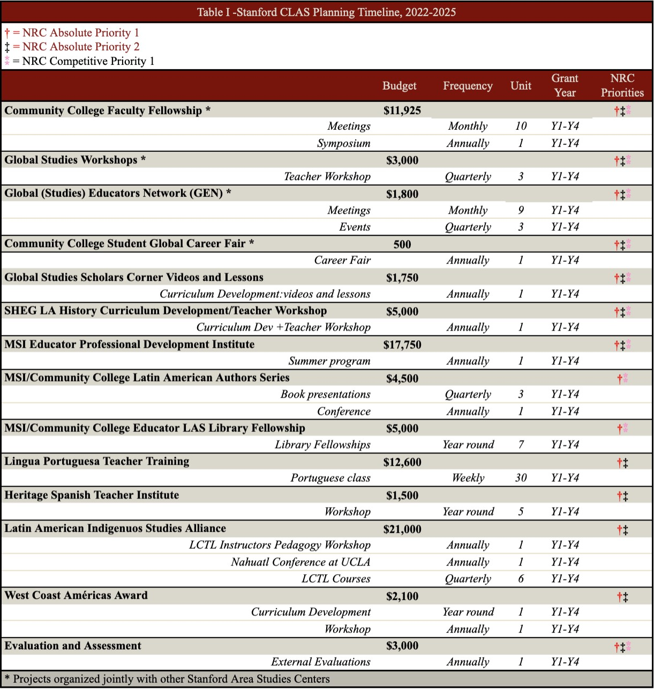
and evaluation support to implement them and to ensure quality outcomes (Budget 1Ai, 1Aii, 1Bii, Ci). Long term impact. Stanford faculty involvement and institutional support for Latin American Studies, as well as collaborations across campus and established external partnerships allow us to project positive outcomes of sustainable and long-term quality professional development programs and further strengthen capacity in areas of national need.

Ia. Community College Faculty Fellowship Program. (Absolute Priority [AP]1, AP 2, Competitive Preference Priority [CPP]) Each year a selected cohort of up to ten community college faculty will work throughout the year with Stanford faculty and academic staff in designing and implementing projects that internationalize core curricula and develop students’ global competencies based on the specific needs of their institutions. The selected Fellows will explore cutting-edge research with Stanford scholars, develop innovative curricular and digital learning materials and extra-academic programs, and explore issues related to global teaching and learning in workshops that promote the sharing of diverse perspectives. The Fellows will work collaboratively in consultation with curriculum design experts from SPICE and researchers from the Center for Spatial and Textual Analysis (CESTA) to leverage Stanford’s innovative digital platforms to implement their project objectives. SUL Curators will be available to offer guidance to the Fellows in navigating the vast digital holdings of SUL to support their final projects, which will be featured during the EPIC Annual Symposium. The EPIC symposium brings together about 70 faculty and administrators from two- and four-year academic institutions who are committed to fostering global studies on their campuses. Using conservative instructor-provided estimates for the number of students taught per year (200), and assuming a three-year lifespan for newly implemented courses, we estimate that each fellowship cohort impacts roughly 6,000 students. Budget 8A: $11,925
Ib. Global Studies Workshops. (AP 1, AP 2, CPP) To provide greater access to cutting edge research on issues of current relevance, such as migration, global health, and nuclear security, and to further enhance the Community College Faculty Fellowship Program experience, CLAS, in collaboration with other Area Studies Centers and SPICE, will offer quarterly workshops that will feature a presentation by faculty and research fellows, followed by a workshop on

pedagogical materials developed by SPICE curriculum specialists, which aim to enhance transferability to the classroom setting. Workshop registration will be open to K-14 faculty and the topics will vary in response to current affairs and input from current EPIC fellows and workshop participants. Additionally, and in response to the K-14 educator community we serve, we will conduct remote, off-site workshops at institutions outside of Stanford’s immediate geographic region, to broaden impact. Workshops can serve up to 30 participants per session for a total of 90 attendees annually. Budget 8B: $3,000
Ic. Global Educators Network (GEN). (AP 1, AP 2, CPP) Central to the success of our work with community college educators has been the professional community that has emerged, as they share institutional knowledge and best practices and bring diverse perspectives to the fellowship, symposia, and workshops. We are requesting funding to support the activities of the GEN, a thriving association of educators from community colleges and MSIs, which was established in 2020 by three former EPIC alumni, and has grown to include more than 40 active members from institutions across California. Network members will expand outreach by hosting workshops and colloquia at remote institutions, presenting at national conferences, creating a GEN YouTube channel, and developing open-source online resources, including best practices on how to institutionalize global studies at their own institutions. Current members will serve as liaisons to new institutions seeking to expand their international course offerings, or to individual instructors wishing to incorporate global materials. Budget 8C: $1,800
Id. Global Careers Fair for Community College Students. (AP 1, AP 2, CPP) This initiative is in response to input by community college/MSI faculty to directly engage students. CLAS will host an annual online community college career fair, where community college students will engage in Stanford-innovated design thinking methodology, learn from Stanford faculty about

career pathways outside of academia utilizing area studies and language training, hear from transfer students currently enrolled at Stanford and other 4-year institutions in California about their academic trajectories, and culminate with a “Design your Global Career” workshop led by Stanford career specialists. We will have participation from faculty, scholars and practitioners from SLS, GSB, FSI, and Stanford’s new School for climate and sustainability (opening fall 2022). We anticipate 100 students per year will participate in the Fair, and we will conduct active outreach to draw students from an ever-increasing number of community colleges/MSIs in the state and beyond. Budget 8D: $500
Ie. Global Topics Scholar Videos and Lessons (AP 1, AP 2, CPP) In collaboration with the SPICE and CLAS affiliated faculty, CLAS will produce a video aiming to inform and generate debate on relevant topics related to Latin American and an accompanying teaching aid (lesson plan) per grant year. These open-access, online short-form videos and guides will be crafted by curriculum design experts at SPICE and accompanied by free teaching and discussion guides, making current and cutting-edge scholarly research accessible to teachers nationwide. The SPICE website receives about 130,000 visits per year and over 5,000 downloads of curricular materials. Budget 8E: $1,750
If. Stanford History Education Group (SHEG) Workshops (AP 1, AP 2, CPP) Partnering with the GSE’s Stanford History Education Group (SHEG) we will underwrite teacher training registration fees for fifteen K-12 educators to attend workshops dedicated to Latin America themed topics. Workshops will be designed from the ground up around area-specific themes, leveraging the expertise of faculty affiliated with CLAS and other area studies centers and utilizing SHEG’s nationally recognized pedagogical methodologies. Series topics will align with national curriculum standards and will adapt relevant open-access and downloadable lessons to

classroom teaching, to broaden training and resources on historical topics of global importance. Building on SHEG’s existing record of more than 1 million website visitors and 2 million curricular downloads per year, we anticipate these new area-specific lessons will serve thousands of teachers by the end of the grant cycle. Budget 8F, $5,000
Ig. MSI Educator Professional Development Institute. (AP 1, AP 2, CPP) CLAS has formed a partnership with Connie L. Lurie College of Education at SJSU, an MSI serving Hispanic and Asian American and Native American Pacific Islander student populations to organize an annual summer teacher training program aiming to (1) examine rich content knowledge and diverse perspectives with renowned scholars on topics relating to various regions of Latin America (2) engage in transnational conversations through which teachers learn from each other about diverse pedagogical approaches addressing issues of inequity in education, and (3) provide a space for transnational networking of teachers and educators engaged in social justice teaching. This is particularly relevant as an increasing number of school districts, charter school networks, and teacher education programs across the U.S. continue to develop and strengthen their commitment to social justice and address related themes highlighted in the recently adopted California History-Social Science Framework (2016). This institute will weave together content knowledge, pedagogy training, and curriculum building, a unique aspect of our established CLAS-CSET teacher training structure, and aims to support pre-service and in-service educators developing curriculum around these important themes. Institutes will take place abroad in Y1 and Y3 and at SJSU and Stanford in Y2 and Y4. Stanford and SJSU faculty will design the content component of these courses and will engage with faculty from partner overseas institutions of higher education. CSET instructional coaches and overseas experts will provide the pedagogy skills component. Budget 8G: $17,750

Ih. MSI/Community College Latin American Authors Series and Conference (AP 1, CPP) CLAS seeks funding to strengthen programming with its recently formed partnership with MSIs SJSU and UC Davis. We will hold quarterly online “Conversations with Latin American Authors” book talks, highlighting recently published scholarly work of Latin American authors. A fourth event will be an in person “Conversations with Latin American Authors” conference, which will rotate locations among our three institutions. Based on similar online events, we anticipate 100 attendees from institutions across the region and the general public and about the same number for the in person conference. Budget 8H: $4,500
Ii. MSI/Community College Educator LAS Library Fellowships. (AP 1, CPP) In partnership with the SUL we will offer year-round Latin America Library Fellowships to eligible faculty from MSIs and/or community colleges that propose research projects that will benefit from remote access to SUL’s electronic resources, personalized guidance and support from SUL Latin American Collections Curator, remote or in person meeting with CLAS director and/or LAS affiliated faculty whose research aligns with the theirs to discuss and share project and ideas.
Applicants may indicate in their application if they plan to incorporate an in-person campus visit of up to one week during the period of the grant. Non-local Fellows will receive a travel stipend of up to $1,000. We anticipate granting 5-7 fellowships per year of the grant cycle. Using conservative instructor-provided estimates for the number of students taught per year (200), we anticipate up to 1,400 students impacted in the first year of this program, compounded to 5,600 by the end of Y4. Budget 8I: $5,000
Ij. Lingua Portuguesa Teacher Training (AP 1, AP 2) This intense remote teacher training program aims to increase the teaching of Portuguese in high school and community colleges. It aims to serve secondary and community college Spanish language instructors who are interested

in Portuguese language training with the goal of expanding Portuguese language programs in secondary and community college institutions. The course, that meets once a week during three quarters, is partially based on SLC pedagogical methodology and includes lessons and dedicated conversation practice sessions with trained language instructors from Brazil and the opportunity to develop curricular materials through the GSE’s SWLP seminars. At the end of the program, participants will be encouraged to take the California Subject Examination for Teachers (CSET) and language assessment for Portuguese. We expect to train 4-6 participants each year. Budget 8J: $12,600
Ik. Heritage Spanish Teacher Institute. (AP 1, AP 2) CLAS will collaborate with the GES’s SWLP to include Latin American content to their existing Heritage Spanish Pedagogy Seminars course designed for pre-service and in-service K-12 Spanish and Heritage-Spanish language teachers of Heritage Spanish language learners
This course is designed to provide educators with presentations and resources on integrating language into their classroom. CLAS contribution will afford participants the critical opportunity to discuss and interact with faculty speakers. Budget 8K: $1,500
Il. Latin American Indigenous Studies Alliance (LAISA). (AP 1, AP 2) LAISA members include the University of Utah, UCLA, and UC Berkeley. For this cycle we seek funding for LCTL instruction, teacher training, and professional development for LCLT instructors. LAISA members are committed to: 1) organize two pedagogy workshops per year for instructors of indigenous languages of Latin America in U.S.academic institutions - focusing on methods and materials in the indigenous language classroom, including the development of curricula and the standardization of student learning objectives; 2) support the annual Nahuatl conference at UCLA - where international scholars will present research on Nahuatl language and culture and

engage with local Nahuatl-speaking populations; 3) provide funding for LCTL instructors professional development opportunities, including but not limited to MOPI certification; 4) offer three-levels of Nahuatl language instruction in the four LAISA institutions and an intensive summer Nahuatl language and culture program at University of Utah; 5) facilitate the enrollment of MSI and Community Colleges matriculated students in our Nahuatl courses and obtain credit through their home institution. Budget 8L: $21,000
Im. West Coast Américas Award Curriculum & Teacher Workshops. (AP 1, AP 2) CLAS seeks funding to continue to support CLASP Américas Award programming: Library of Congress award ceremony, annual CLASP educator workshop at a D.C. bookstore, global read webinar series highlighting winning authors of the World Area Book Awards , conference representation, and a new national book club in collaboration with multiple world regions focused on teacher discussions & curriculum development. Based on feedback from a national educator survey conducted by the CLASP Outreach Committee in summer 2020, K-12 educators indicated a need for training and resources on using children’s literature in the Spanish-language classroom. In 2021, CLAS worked with CLASP and local teachers to develop a conference presentation on using Spanish-language Américas Award books in the classroom and presented the AATSP, COLT, and CLTA teacher conferences. CLAS seeks funding to continue supporting CLASP Américas Award programming and to develop one CLAS West Coast Américas Award Workshop per year of the cycle with a focus on using children’s literature in the
Spanish-language classroom and across the curriculum. Budget 8M: $2,100

NRC: COMPETITIVE PREFERENCE PRIORITY

All thirteen programs proposed directly address FY 2022 NRC Absolute Priorities 1 and 2 and eight of the programs meet the Competitive Preference Priority (CCP). CLAS has formed

partnerships with two Minority Serving Institutions: SJSU and UC Davis and several community colleges, including Las Positas, which is also a Hispanic Serving Institution.
  - CLAS is particularly excited about its partnership with SJSU’s Lurie College of Education to jointly organize a summer teacher training program (see letter of support from SJSU College of Education Dean and Associate Dean in Appendix 4)
  - CLAS’ partnership with UC Davis’ Global Studies, UC Davis’ Hemispheric Institute on the Americas, and SJSU's Department of World Languages and Literatures to enhance the study of Latin America in our three campuses by organizing events that expose our communities to current and relevant scholarship from Latin American academics and intellectuals.
  - CLAS and other Stanford National Resource Areas Studies Centers have long-term partnerships with community colleges throughout California, including Las Positas, whose strong institutional commitment to collaborate on the community college projects proposed for this grant cycle is evident in their letter of support (Appendix 4).
H. FLAS: AWARD SELECTION PROCEDURES .

H. Foreign Language and Area Studies (FLAS) Fellowship. (FLAS CPP 1, CPP 2) We are requesting $318,500 per year in FLAS Fellowship funding for 7 AY graduate awards, 1 AY undergraduate award, and 5 summer awards. FLAS competitions will be publicly announced in September, with an application deadline in early February.
FLAS Award Advertisement. CLAS directly administers the Latin America FLAS Fellowship competition. We will advertise the award through: 1) CLAS and SGS Division websites and weekly e-bulletins; 2) paid ads in the Stanford Daily (circulation: 13,500); 3) dissemination of the call to departmental administrators, faculty, and financial aid officers who in turn notify their current and incoming students; 4) Stanford student organizations mailing lists; and 5)

administrators in the professional schools. CLAS will also conduct intense advertising of the award through the First-Gen and/or Low Income (FLI) Office and the 10 centers and offices that comprise Stanford's Centers for Equity, Community and Leadership, including the Centro Chicano y Latino, to reach a wider pool of eligible first generation and low income students.
FLAS Award Information Session. CLAS organizes a FLAS Fellowship Information Session for prospective of both Summer and AY FLAS Fellowship applicants in December. FLAS Award Timeline. Summer and AY FLAS (February: submission; March: committee review; April: notifications). FLAS Application. Applicants for both academic-year and summer awards complete an online application specifying their current and intended language levels, program location and cost, and budget needs, and submit a statement of purpose, transcripts, and letters of recommendation from language instructors or other faculty. Applicants without internet access may request paper application forms directly from CLAS. Applicants must include their Free Application for Federal Student Aid (FAFSA) report, which serves as an indicator of financial need. FLAS Selection Committee. CLAS invites faculty members of the advisory board and affiliated faculty from across disciplines to be part of the FLAS Selection Committee, which is usually composed of at least five faculty and language academic staff. The FLAS Selection Committee meets within 30 days of the submission deadline and notifications are sent immediately after decisions are made. FLAS Selection Criteria. Applications are ranked by five
criteria: 1) overall academic achievement; 2) past performance in language courses; 3) strength of recommendations; 4) clarity and feasibility of stated study/career goals; and 5) financial need.
FLAS Award Notifications: Students will be notified in mid April of their award and required to meet or speak on the telephone with the Associate Director before signing their acceptance form, which is due on April 31. FLAS Disbursements. Summer awards are paid out as soon as study

plans have been approved by the USDE Program Officer. AY awards are paid out quarterly beginning in September of the award year.

I. FLAS: COMPETITIVE PREFERENCE PRIORITIES

FLAS Competitive Preference Priority 1. All FLAS awards will be reviewed for financial need. Final award preference for all FLAS recipients will be given to those students who demonstrate financial need in addition to demonstrated academic merit, as noted in section H- FLAS. CLAS will continue to offer tuition top-offs to eligible FLAS awardees with demonstrated financial need.
FLAS Competitive Preference Priority 2. 100% of CLAS Academic Year FLAS fellowships will be awarded for language training in Haitian Creole, Nahuatl, Portuguese, and Quechua.

