
FLAS Tracking Survey
Results
2010-2012 Cohort
International and Foreign Language Education
U.S. Department of Education
The views expressed herein do not necessarily represent the positions or policies of the U.S. Department of Education. No official endorsement by the U.S. Department of Education of any product, commodity, service, or enterprise mentioned in this publication is intended or should be inferred. Further, the inclusion of information or URLs does not reflect the importance of the organization, nor is it intended to endorse any views expressed.
U.S. Department of Education
Arne Duncan
Secretary of Education
Office of Postsecondary Education
Jamienne Studley
Deputy Under Secretary Delegated Duties of Assistant Secretary
December 2015
This report is in the public domain. Authorization to reproduce it in whole or in part is granted. While permission to reprint this publication is not necessary, the citation should be U.S. Department of Education, Office of Postsecondary Education, FLAS Tracking Survey Results: 2010 – 12 Cohort International and Foreign Language Education, Washington, DC, 2015.
This report is available on the Department’s website at: http://www2.ed.gov/programs/iegpsflasf/performance.html
Availability of Alternate Formats
On request, this publication is available in alternative formats, such as Braille, large print or CD. For more information, please contact the Department’s Alternate Format Center at 202-260-0852 or the 504 coordinator via e-mail at om_eeos@ed.gov.
Notice to Limited English Proficient Persons
If you have difficulty understanding English, you may request language assistance services for Department information that is available to the public. These services are available free of charge. If you need more information about interpretation or translation services, please call 1-800-USA-LEARN (1-800-872- 5327) (TTY: 1-800-437-0833), e-mail us at ED.Language.Assistance@ed.gov, or write to U.S. Department of Education, Information Resource Center, 400 Maryland Ave. SW, Washington, DC 20202.

Contents
Executive Summary iv
Introduction 1
Survey Design and Administration 2
Survey Results 3
Number of Responses 3
Number of Awards per Fellow 3
Languages 4
Location of Study 6
Language Proficiency 7
Degrees and Disciplines 8
Employment Outcomes 9
Conclusions 14
Methodological Issues and Recommendations for Future Surveys 14
Appendix 1 15
Priority Language of First Time FLAS Awardees 15
Non-Priority Language of First Time FLAS Awardees 17
Appendix 2 18
Survey Instrument 18

Executive Summary
The Foreign Language and Area Studies (FLAS) fellowship program provides academic year and summer fellowships to institutions of higher education. These fellowships assist meritorious undergraduate and graduate students undergoing training in modern foreign languages and related area/international studies.
When Congress reauthorized the Higher Education Act of 1965 (HEA), by way of the Higher Education Opportunity Act of 2008 (HEOA), it directed the U.S. Department of Education (ED) to assist grantees in developing a survey to administer to students who have completed programs authorized by Title VI of the HEA to determine postgraduate employment, education, or training. The survey on which this report is based tracks the post-graduation career trajectory of FLAS fellowship recipients from 2010 to 2012. Subsequent surveys will continue to track this cohort in addition to new FLAS graduates.
This report is not an evaluation of the FLAS program or its outcomes. Rather, it is a summary of the survey responses of the 2010-12 FLAS fellows.
According to the survey results, FLAS fellows received support to study 67 languages (50 priority languages and 17 non-priority languages as defined by ED) during their first FLAS fellowship. Arabic (18 percent), Portuguese (11 percent), Russian (9 percent), Japanese (7 percent), and Chinese (Mandarin) (7 percent) were the most frequently studied languages for the respondents’ first FLAS. These languages are considered to be essential for economic and strategic purposes.
Respondents overwhelmingly reported that FLAS fellowships have been an asset in their career trajectories. Fifty-nine percent indicated that knowledge of a foreign language is a requirement or considered a key asset for their current job, and 62 percent reported that knowledge of area/international studies is a requirement or a key asset for their current job. Approximately 50 percent of respondents reported that they use their foreign language knowledge at least monthly in their current job, and 22 percent use it daily. More than 60 percent reported using their area/international studies training in their current work on a regular basis, and 36 percent reported at least daily use. Furthermore, more than 70 percent reported that their foreign language and area/international studies’ training directly impacted their career path, insofar as they reported that such training was very beneficial or beneficial to their marketability and their professional development/promotion potential. Employers that have hired FLAS fellows include Boston Consulting Group, Brookings Institution, Citigroup, Google, JPMorgan Chase, McKinsey and Company, Oliver Wyman, Teach for America, the U.S. Department of Defense, and the U.S. Department of State, among others.
Regarding the relationship between the FLAS fellowship and fellows’ academic and career goals, 68 percent of fellows reported that they were “unlikely to [have achieved] advanced language proficiency,” and almost 50 percent reported that they were “unlikely” to [have traveled] overseas for a language immersion/study abroad experience had they not received a FLAS fellowship.
The report also suggests modifications to the survey methodology that will be implemented in its next iteration.

Introduction
The Foreign Language and Area Studies fellowship program (FLAS), which is authorized under section 602(b) of the Higher Education Act of 1965 (HEA), as amended, and administered by the U.S. Department of Education (ED), supports the development of expertise in world languages and area or international studies. Through the FLAS program, ED allocates fellowships to postsecondary institutions for this purpose, aiming to increase the numbers of trained world language and area/international studies experts in American institutions of learning, government agencies, and businesses by broadening and deepening knowledge and skill in these areas. Fellowships can last an entire academic year or a summer session. Acquiring advanced proficiency in a foreign world language takes many years; it is not unusual for one student to complete more than one FLAS fellowship during her or his course of study.
Every four years, ED, through the International Foreign Language and Education office (IFLE), conducts a competition for the allocation of these fellowships. Institutions of higher education (IHEs) apply under one or more of a number of world areas (e.g., Southeast Asia, Africa, etc.). Once awarded an allocation, IHEs must conduct competitions each year on their campuses to award academic year and summer fellowships to meritorious eligible students. FLAS coordinators on each campus administer the fellowships. FLAS fellows carry out their foreign language and area/international studies education both in domestic and in overseas institutions. In recent years, IFLE has funded approximately 1,800 academic year and summer FLAS fellowships per year.
When Congress reauthorized the HEA in 2008, it required grantee institutions to track the post- graduation career trajectory of FLAS fellows. Section 601 of the HEA states that the “Secretary shall assist grantees in developing a survey to administer to students who have completed programs under this title to determine postgraduate employment, education, or training. All grantees, where applicable, shall administer such survey once every two years and report survey results to the Secretary.”
The survey on which this report is based tracks FLAS fellowship recipients from 2010 to 2012 who have graduated. Subsequent surveys will continue to track this cohort in addition to new FLAS graduates.
This report is not an evaluation of the FLAS program or its outcomes. Rather, it is a summary of the survey responses of the 2010 – 12 FLAS fellows. Although the survey instrument contains nearly 40 items, it seeks primarily to address the following questions:
- What languages do FLAS fellows study? Do they study them domestically or overseas? How proficient do fellows perceive themselves to have become in their chosen language at the conclusion of their fellowship?
- What degrees did the fellows pursue and in what academic disciplines? Were these degrees completed?
- What are fellows doing now? Are they pursuing further study, or are they employed? Are they using their FLAS education, including their language skills, in their current pursuits? Have the language proficiency and area studies training the fellows gained as a part of the fellowship affected their career paths?

Survey Design and Administration
IFLE staff members worked together with IHEs in the field that have received FLAS allocations to develop the FLAS tracking survey. In cooperation with the field, IFLE staff members devised an initial set of questions to collect data that meet the purposes of the study as discussed above. A technical assistance group (TAG), composed of prominent practitioners who have worked or currently work with the FLAS program and IFLE staff members, settled on a total of 31 questions along with the standard demographic questions. The survey questions, cleared by ED and the Office of Management and Budget (OMB), appear in Appendix 2.
The HEA provides that the secretary of Education shall help grantee institutions collect data from FLAS recipients. IFLE staff members entered the survey into the Qualtrics survey platform.
Using the Qualtrics software, a link containing the survey was emailed to the FLAS coordinators (99 in total) at grantee institutions on Feb. 4, 2013, with a request that they forward the link to FLAS fellows who had graduated in the spring of 2010 and later. Consequently, the cohort for this iteration of the study comprises FLAS fellows who graduated from 2010 to 2012. The survey remained open through March 31, 2013.
Because this report is based on a survey of fellows who participated in the FLAS program, the conclusions are based on self-reported data. It would not have been possible within existing methodological and budgetary constraints to proceed otherwise; nonetheless it is important to remember that the study did not seek to measure variables independently of the fellows’ own views.

Survey Results

Number of Responses
This analysis is based on 735 completed surveys (a total of 772 surveys were started and 735 were finished).
In recent years, ED has funded institutional grants providing for approximately 1,800 FLAS fellowships each year. Because that number includes academic year and summer fellowships, and students sometimes receive more than one fellowship (which may include an academic and a summer fellowship in the same year; see also next section), determining the precise number of potential respondents is difficult. This challenge is compounded by the fact that the survey is directed only at the individuals who graduated in the specified years, and it is up to the FLAS coordinators at each of the 99 institutions to determine graduation status and then to send the survey link only to those individuals who graduated. In addition, some institutions supplement federal funds in order to expand the number of student fellowships. Consequently, the total number of FLAS fellowships (1,800) is inclusive of fellowships that institutions fund themselves. Given these challenges, it was decided that a response rate for this iteration of the study could not be accurately determined.
It is worth noting that in future iterations of this report a more accurate response rate is expected since FLAS coordinators will be asked to report the number of survey links sent to graduates who are potential respondents immediately following survey administration.

Number of Awards per Fellow
IFLE asked respondents report how many FLAS fellowships they received. Thirty-eight percent (n=279) of the 735 respondents received more than one FLAS; 64 percent (n=179) of those received two fellowships and 25 percent (n=70) received three (see Figures 2 and 3). Approximately 82 percent (n=237) of the fellows were working on a graduate degree for their second FLAS, and about 85 percent (n=60) were working on a graduate degree for their third FLAS.
We also asked whether respondents received additional fellowships or awards after participating in FLAS. For those who did receive additional fellowships, 19 percent reported receiving university department/division grants and 5 percent received Fulbright-related fellowships (Fulbright-Hays Doctoral Dissertation Research Abroad fellowship, Fulbright-Hays Faculty Research Abroad fellowship, and Fulbright fellowships). Other outside scholarships and awards received by the fellows included but are not limited to the Critical Language Scholarship, German Academic Exchange Service Student Fellowship, Truman Scholarship, Fulbright Scholarship, Rhodes Scholarship, and Presidential Management Fellowship (See Figure 1).
Byron Gray received a FLAS fellowship in 2012 to study Hindi at the University of Washington. His FLAS experience was “top-notch and well- integrated in the existing curriculum and coursework.” By taking advanced Hindi courses and India area studies courses, Gray acquired the language proficiency in Hindi and knowledge of India to become a specialist in this area. He was subsequently awarded both Beinecke and Rhodes scholarships. | Sarah Shihadah received a FLAS fellowship to study Hebrew in 2012 at the University of Pennsylvania. Sarah stated that “the quality of language courses was very satisfactory and facilitated language learning. Area studies course offerings were even richer and more diverse.” She applied those skills during her year as a Fulbright fellow teaching English in Jordan.
Figure 1
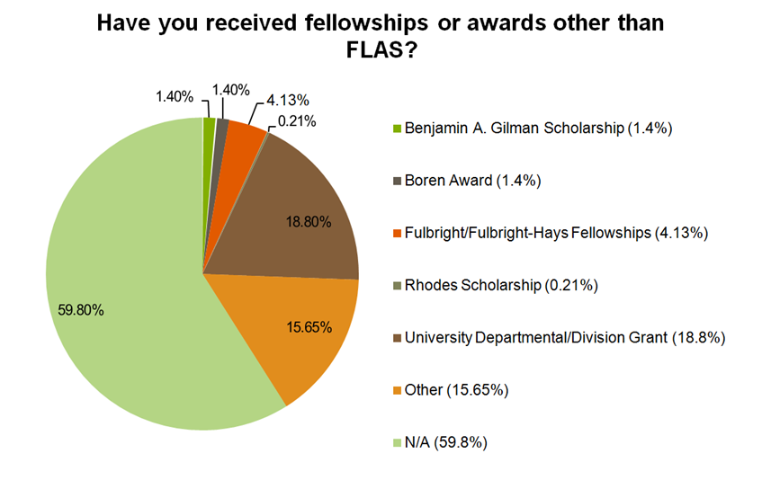

Languages
For the cohort covered in this study, fellows received support to study 67 languages. For the cohort surveyed, FLAS fellows received support to study 50 “priority languages” and 17 non- priority languages during their first FLAS fellowship. Sixty-two percent received one FLAS fellowship, and 38 percent received more than one FLAS fellowship. Twenty-four percent received two FLAS fellowships, and 13 percent received three or more FLAS fellowships (see Figures 2 and 3).
Arabic (18 percent), Portuguese (11 percent), Russian (9 percent), Japanese (7 percent), and Chinese (Mandarin) (7 percent) were the most frequently studied languages for the respondents’ first FLAS. The top five for the respondents’ second FLAS were Arabic (21 percent), Portuguese (8 percent), Hindi (7 percent), Russian (6 percent), and Chinese (Mandarin) (5 percent). Arabic (16 percent), Vietnamese (11 percent), Quechua (10 percent), Somali (7 percent), and Romanian (7 percent) were the top five languages studied by fellows who received three FLAS fellowships. These languages are all priority languages and are considered to be essential for economic and strategic purposes.
IFLE was also interested in finding out whether linguistic background influenced what languages fellows chose to study. Approximately 22 percent (132) of the fellows spoke a language other than English at home when they were growing up. Of those, Spanish (20 percent), Russian (7 percent), French (7 percent), Korean (5 percent), and Japanese (4.5 percent) were the five most commonly spoken languages. Of the 132 fellows who were heritage learners (i.e., spoke another language at home), 21 percent (28) studied the language that they spoke at home during their fellowships. Heritage language learners were more likely to study the language that they spoke at home than they were to study any other language. Moreover, heritage learners reported a high level of proficiency after they completed their first FLAS fellowship. Sixty-eight percent of heritage learners who studied the language they spoke at home while growing up reported having advanced proficiency after the completion of the FLAS.
Figure 2
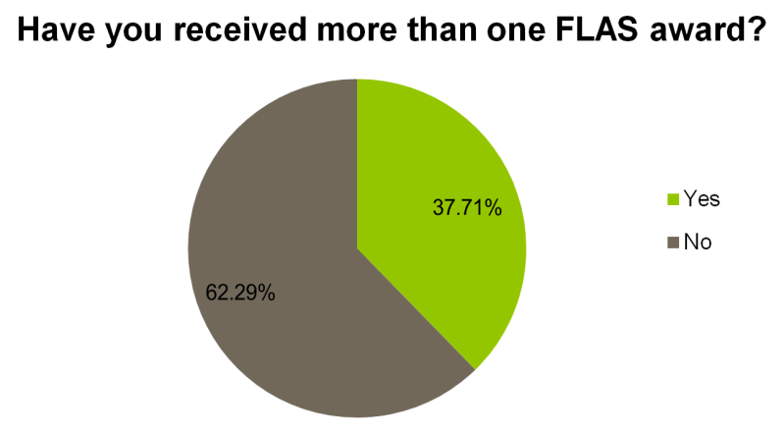
Figure 3
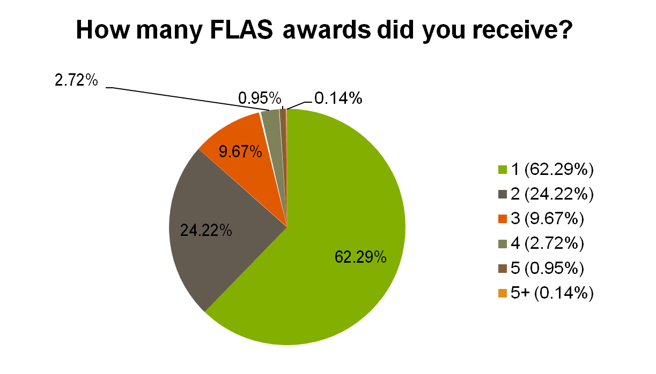

Location of Study
FLAS fellowships provide opportunities for American students to study abroad as a way to immerse themselves in their language and area studies. Nonetheless, no matter the number of FLAS fellowships received, most FLAS students have historically carried out their fellowships at domestic institutions. This remained true for this study cohort with 72 percent doing their first- year FLAS fellowships at a domestic institution, 24 percent doing so at an overseas institution, and 4 percent doing fellowships at both overseas and domestic institutions (see Figures 4 and 5).
Figure 4
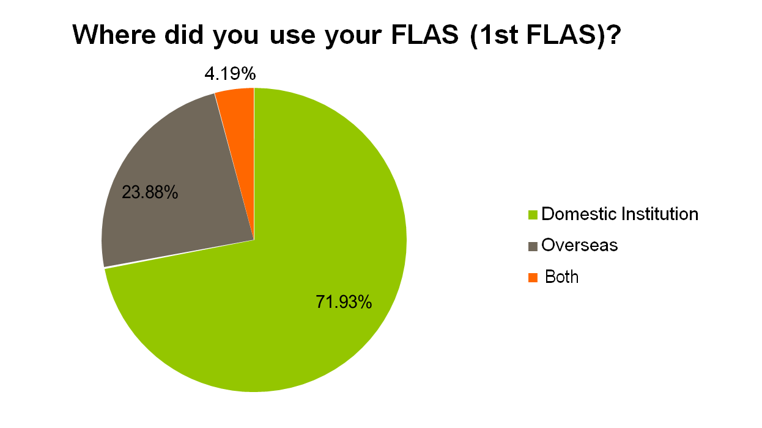
Figure 5
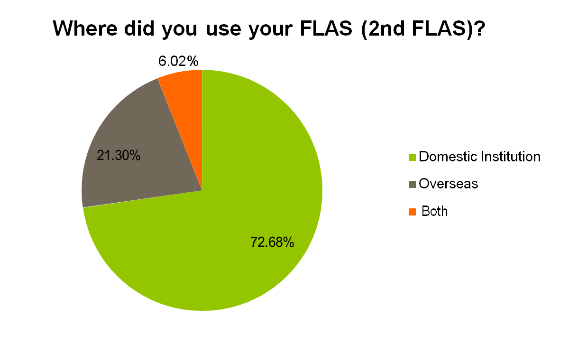

IFLE wanted to find out whether the location of study (domestic vs. overseas) influenced perceived language proficiency. As noted above, among first-time FLAS fellows, 72 percent (465) completed their study in domestic institutions and 24 percent (154) completed their study in overseas institutions, while 4 percent (27) reported studying in both overseas and domestic locations. Fellows were asked to rate their language proficiency level at the completion of their fellowship using the Interagency Language Roundtable scale.For fellows who studied entirely in domestic institutions, 15 percent indicated their language proficiency as “1” (elementary proficiency), 43 percent reported “2” (limited working proficiency), and 41 percent reported “3” (general professional proficiency). For fellows who went abroad to complete their studies, 6 percent reported their proficiency level as “1,” 53 percent reported “2,” and 41 percent reported “3.” Results from a t-test, after comparing the mean proficiency levels of the overseas group and the domestic group, revealed no statistically significant difference in self-reported language proficiency between those who studied abroad and those who studied domestically.
IFLE conducted t-tests for second-time and third-time fellows as well. Again, no statistically significant differences were found between the mean reported proficiency level of those who studied overseas and those who studied in domestic institutions during their FLAS fellowship. The reader is cautioned about drawing conclusions, however, since in addition to being based on self-reports, no distinction can be made in this analysis between academic-year fellows and summer fellows, whose opportunity to increase proficiency would have differed from one another

Language Proficiency
IFLE asked respondents to indicate their level of proficiency in the language they studied at the completion of their fellowship. Forty-six percent of respondents reported intermediate language proficiency, and 41 percent reported advanced proficiency. Of those who completed two FLAS fellowships, 43 percent reported intermediate proficiency and 48 percent reported advanced proficiency. And of those who completed three fellowships, 40 percent reported intermediate proficiency and 53 percent reported advanced proficiency. Twenty percent of those who completed four fellowships reported intermediate proficiency, and 40 percent reported advanced proficiency, though it should be kept in mind that many of the fellows in this category might have been studying a new foreign language (i.e., a language different from the one they studied in their previous FLAS fellowships). Finally, the two fellows who received five fellowship awards both reported advanced proficiency (see Figure 6).
The difference in reported language proficiency between first-FLAS heritage learners and non- heritage learners was statistically insignificant. The difference in reported language proficiency level between second-year FLAS heritage and non-heritage learners also was not statistically significant. The comparison of reported proficiency between heritage learners who studied the languages they spoke at home and non-heritage learners seems to indicate that being a heritage learner had little impact on perceived language proficiency.
Some languages tend to be more difficult to learn for native English speakers than others, which is a factor that the study methodology did not take into account. For instance, for native English speakers, languages with different writing systems (i.e., the Chinese logogram writing system) or languages with different alphabets present challenges in learning. Languages with grammar structures different from English are challenging as well. For example, Russian, which requires a consideration of grammatical cases and gender, can be challenging for English speakers.
Figure 6
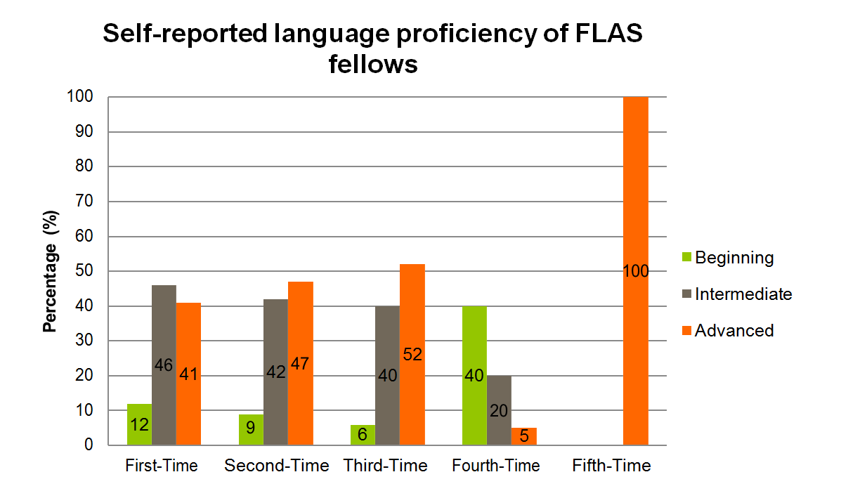

Degrees and Disciplines
According to respondents, more FLAS fellowships were awarded to graduate students than to undergraduate students. This is not surprising given that the FLAS program only opened to undergraduate students for the first time in 2010 (the first cohort to be affected by the 2008 reauthorization of the HEA). For those reporting on their first (or only) FLAS fellowship, 55 percent were master’s degree students, 24 percent were bachelor’s degree students, 16 percent were doctoral students, and 5 percent were in another advanced professional degree or certificate program. The percentage of graduate students increases for the subsequent FLAS fellowship awards. Of those reporting on their second FLAS fellowship, 82 percent were graduate students and 85 percent of those reporting on their third fellowship were graduate students.
With regard to discipline of study, most FLAS fellows majored in the humanities, social studies, and international studies (See Figure 7). More than 80 percent of those reporting on their first, second, or third fellowship majored in one of these disciplines.
Figure 7
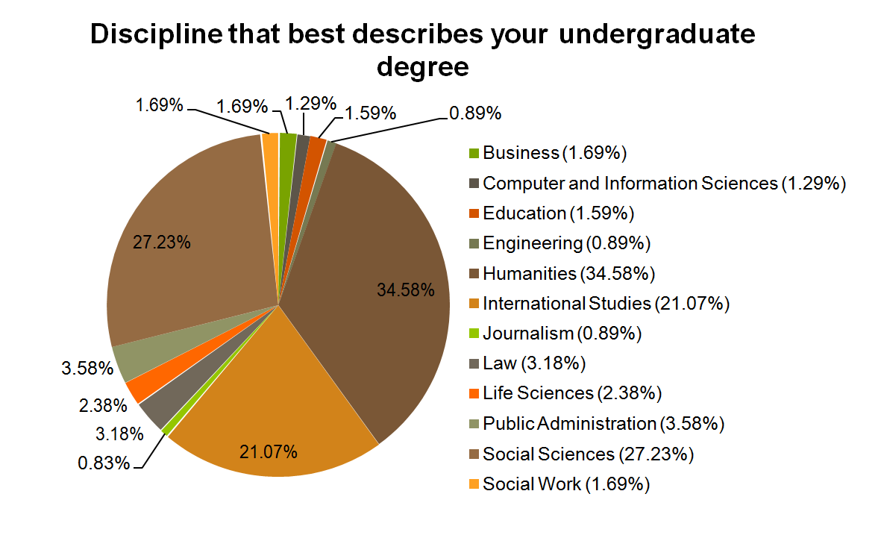

Employment Outcomes
When asked to what extent the fellows’ current primary employment related to the fields in which they received their degrees. Seventy-seven percent of respondents reported that their principal jobs were “closely related” (46 percent) or “somewhat related” (31 percent) to the fields in which they received their degrees. Five percent of fellows were unemployed. The 23 percent who responded that their principal jobs were “not related” to the fields in which they received their degrees were asked to select the factors that influenced their decisions to w outside of their degree fields. “Job location,” appeared to be the most important factor. “Job in field not available,” “pay, promotion opportunities,” and “working conditions” were the next most-cited reasons.
“My selection as a FLAS fellow in Russia was critical to my professional development. The language skills earned from the FLAS were critical in my ability to understand events surrounding the Russia-Georgia War, as I was the Georgia Country Director at the Pentagon in the Office of the Secretary of Defense from 2007 to 2011.”
-Mark Simakovsky
FLAS Fellow, 2004
The survey aims to track FLAS fellows after they graduate. In particular, we are interested in finding out not only what graduated FLAS fellows are doing in the 8-year period following graduation, but also whether or not they are using their language and/or area studies training in their current pursuits.
Respondents overwhelmingly reported that the FLAS fellowships have been an asset in their career trajectories. Fifty-nine percent indicated that knowledge of a foreign language is a requirement or a key asset to their current job, and 62 percent reported that knowledge of area/international studies is a requirement or a key asset to their current job. Approximately 50 percent reported that they use their foreign language knowledge at least monthly in their current job, and 22 percent reported using it daily. More than 60 percent reported using their area/international studies training in their current work on a regular basis, while 36 percent reported daily use. Furthermore, more than 70 percent reported that their foreign language and area/international studies’ training directly impacted their career path, insofar as they reported that such training was very beneficial or beneficial to their marketability and their professional development/promotion potential (See Figures 8 and 9).

Figure 8
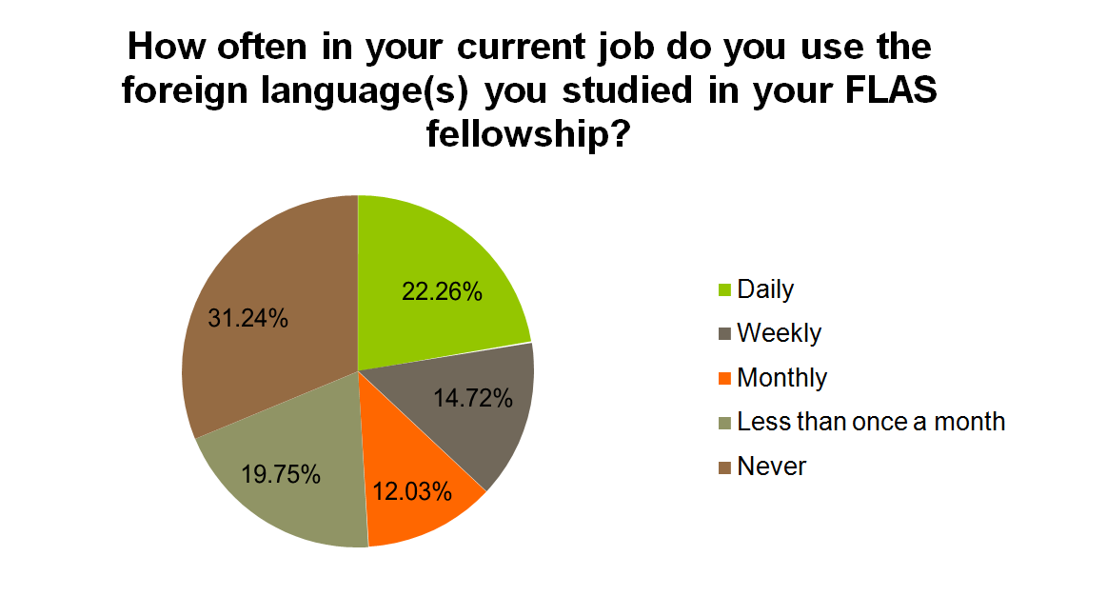
Figure 9
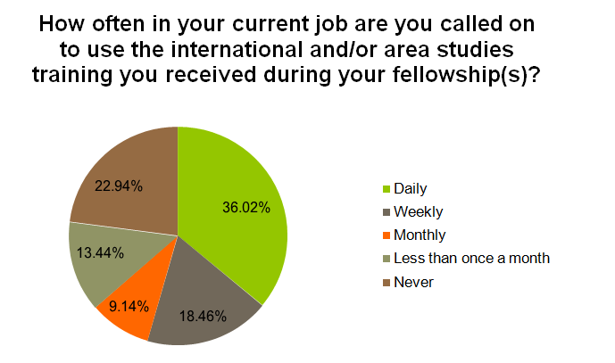

We also examined what sectors fellows worked for after their FLAS experience. Approximately 47 percent of the respondents reported working in the private sector. Twenty-one percent reported working for a public educational institution (see Figure 10).
Figure 10
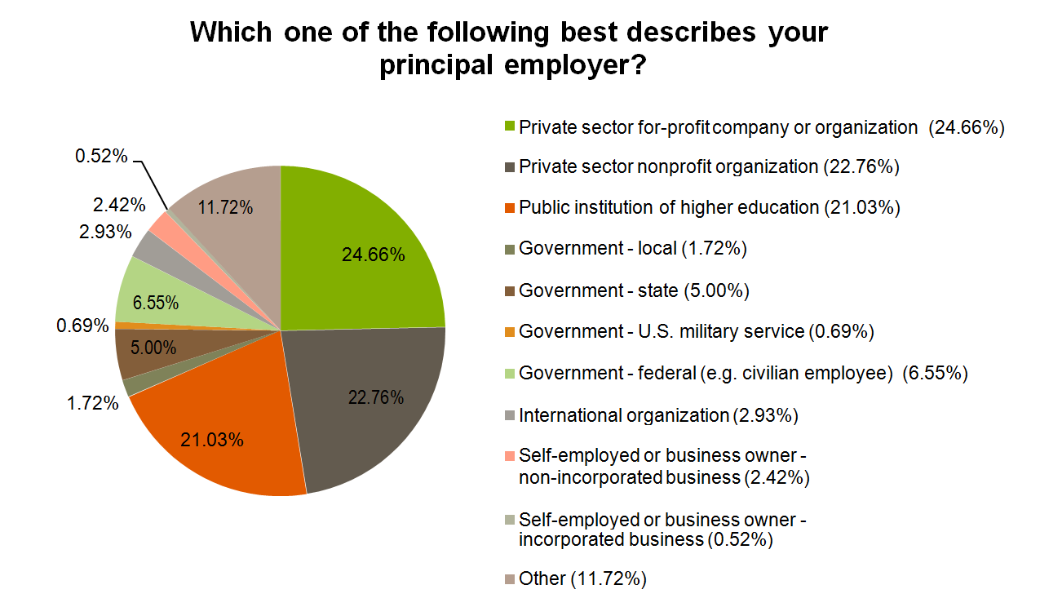
Employers that have hired FLAS fellows include Boston Consulting Group, Brookings Institution, Citigroup, Google, JPMorgan Chase, McKinsey and Company, Oliver Wyman, Teach for America, the U.S. Department of Defense, and the U.S. Department of State.
After inquiring how likely it was that fellows would have achieved their academic and career goals without a FLAS fellowship, 68 percent reported that they were “unlikely to achieve advanced language proficiency” and almost 50 percent reported that they were “unlikely” to travel overseas for a language immersion/study abroad experience had they not received a FLAS fellowship. Thus, respondents believed that their FLAS fellowship(s) were especially important in helping improve their language proficiency and in giving them greater opportunities to study abroad or to travel overseas for language immersion (See Figure 11).

Figure 11
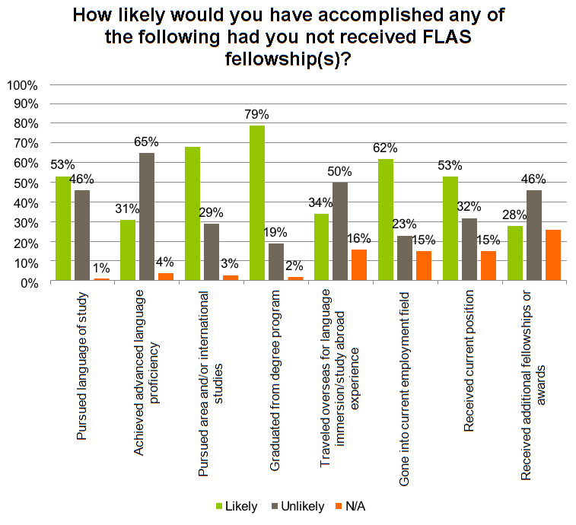

Conclusions
This study is the first step in meeting the statutory requirement that the post-graduation career trajectory of FLAS fellows be tracked. The survey data for this cohort demonstrate that graduated FLAS fellows tend to use their training in their jobs. The survey will be repeated for the 2013 – 14 cohort and revised and administered for the 2015 – 16 cohort, with a view toward both generating longitudinal data and improving on survey design and administration.
Key findings of this study were as follows:
- FLAS fellows studied 67 languages during their first fellowship; 75 percent of the languages studied were considered priority languages.
- Slightly over one-quarter of fellows used their fellowship to study at overseas institutions.
- More than three-quarters of respondents are working in fields that are related to the area of study during their fellowship.
- Fifty-nine percent indicated that knowledge of a foreign language is a requirement or a key asset to their current job, and 62 percent reported that knowledge of area/international studies is a requirement or a key asset to their current job.
- More than 60 percent reported using their area/international studies training in their current work on a regular basis with 36 percent reporting daily use.
- Sixty-eight percent reported that they were “unlikely to achieve advanced language proficiency” without the FLAS fellowship.

Methodological Issues and Recommendations for Future Surveys
For the next iteration of this study, certain aspects of the survey methodology will be adjusted. Many respondents in this cohort noted there were aspects of the survey that were not “respondent-friendly,” including not being able to return to the previous question if necessary; and requiring an answer to a question before they could proceed to the next question. The second iteration of the study will attend to these issues by making sure that respondents can go back to the previous question, and not requiring them to answer a question before they are allowed to proceed to the next one. Errors in the FLAS coordinator email distribution list will also be eliminated. In a small number of cases IFLE had to forward the survey link after being notified that the person who initially received the survey was not the intended recipient FLAS coordinator. This issue will be addressed by making sure the list of FLAS coordinators is up-to- date before sending out the survey. To address the challenge of estimating a response rate, FLAS coordinators will be asked to report to IFLE the number of survey links sent to graduates who are potential respondents immediately following survey administration. Furthermore, the addition to and/or modification of some questions on future iterations of the survey will be considered to allow the tracking of longitudinal results and also to better assess the results of the FLAS program moving forward.

Appendix 1

Priority Language of First Time FLAS Awardees, by Number and Percentage of Awards
Priority Language | Number of FLAS Awards | Percentage of All Grantees
TOTAL | 627 | —
Akan (Twi-Fante) | 2 | 0.31%
Albanian | — | —
Amharic | 1 | 0.16%
Arabic (All Dialects) | 113 | 17.55%
Armenian | — | —
Azeri (Azerbaijani) | — | —
Balochi | — | —
Bamanakan (Bamana, Bambara, Mandikan, Mandingo, Maninka, Dyula) | 1 | 0.16%
Belarusian | — | —
Bengali (Bangla) | 5 | 0.78%
Berber (All Languages) | — | —
Bosnian | 3 | 0.47%
Bulgarian | 1 | 0.16%
Burmese | 2 | 0.31%
Cebuano (Visayan) | — | —
Chechen | — | —
Chinese (Cantonese) | — | —
Chinese (Gan) | — | —
Chinese (Mandarin) | 42 | 6.52%
Chinese (Min) | -- | —
Chinese (Wu) | -- | —
Croatian | 3 | 0.47%
Dari | — | —
Dinka | — | —
Georgian | 1 | 0.16%
Gujarati | 1 | 0.16%
Hausa | 2 | 0.31%
Hebrew (Modern) | 9 | 1.40%
Hindi | 31 | 4.81%
Igbo | — | --
Indonesian | 6 | 0.93%
Japanese | 41 | 6.37%
Javanese | — | —
Kannada | — | —
Kashmiri | — | —
Kazakh | 1 | 0.16%
Khmer (Cambodian) | 1 | 0.16%
Kirghiz | — | —
Korean | 13 | 2.02%
Kurdish (Kurmanji) | — | —
Kurdish (Sorani) | — | —
Lao | — | —
Malay (Bahasa Melayu or Malaysian) | — | —
Malayalam | — | —
Marathi | 1 | 0.16%
Mongolian | 1 | 0.16%
Nepali | 2 | 0.31%
Oromo | — | —
Panjabi | 1 | 0.16%
Pashto | 1 | 0.16%
Persian (Farsi) | 21 | 3.26%
Polish | 11 | 1.71%
Portuguese (All Varieties) | 69 | 10.71%
Quechua | 15 | 2.33%
Romanian | 1 | 0.16%
Russian | 58 | 9.01%
Serbian | 10 | 1.55%
Sinhala (Sinhalese) | 1 | 0.16%
Somali | — | —
Swahili | 29 | 4.50%
Tagalog | 5 | 0.78%
Tajik | 1 | 0.16%
Tamil | — | —
Telugu | — | —
Thai | 7 | 1.09%
Tibetan | 5 | 0.78%
Tigrigna | — | —
Turkish | 20 | 3.11%
Turkmen | — | —
Ukrainian | 4 | 0.62%
Urdu | 16 | 2.48%
Uyghur/Uigur | 1 | 0.16%
Uzbek | 6 | 0.93%
Vietnamese | 9 | 1.40%
Wolof | 7 | 1.09%
Xhosa Yoruba | — | —
Yoruba | 1 | 0.16%
Zulu | 2 | 0.31%

Non-Priority Language of First Time FLAS Awardees, by Number and Percentage of Award
Non-Priority Language | Number of FLAS Awards | Percentage of All Grantees
TOTAL | 58
Aymara | 1 | 0.16%
Czech | 2 | 0.31%
Danish | 1 | 0.16%
Estonian | 1 | 0.16%
French | 19 | 2.95%
German | 3 | 0.47%
Greek | 3 | 0.47%
Haitian Creole | 8 | 1.24%
Hungarian | 2 | 0.31%
Italian | 3 | 0.47%
Kaqchikel Maya | 3 | 0.47%
K’iche Maya | 1 | 0.16%
Mixtec | 1 | 0.16%
Q’eqchi’ Maya | 1 | 0.16%
Sanskrit | 2 | 0.31%
Slovak | 2 | 0.31%
Spanish | 3 | 0.47%
Swedish | 2 | 0.31%
Yiddish | 1 | 0.16%
Yucatec Maya | 1 | 0.16%

Appendix 2

Survey Instrument
Survey of Post-Graduates for International Education Fellowship Recipients
According to the Paperwork Reduction Act of 1995, no persons are required to respond to a collection of information unless such collection displays a valid OMB control number, 1840- 0829. Public reporting burden for this collection of information is estimated to average 15 minutes per response, including time for reviewing instructions, searching existing data sources, gathering and maintaining the data needed, and completing and reviewing the collection of information. The obligation to respond to this collection is voluntary. Send comments regarding the burden estimate or any other aspect of this collection of information, including suggestions for reducing the burden to Amy Wilson. U.S. Department of Education, International and Foreign Language Education, 1990 K Street NW, Washington, DC 20006-8521 or email amy.wilson@ed.gov and reference the OMB Control Number 1840-0829. Note: Please do not return the completed FLAS Tracking Survey to this address. Introduction This survey asks about your employment and education after the completion of the Foreign Language and Area Studies (FLAS) fellowship program. The purpose of this survey is to report to U.S. Department of Education on the impact of this taxpayer-funded program, which will help ensure future students can also benefit from the fellowships. The survey is a legislative requirement of the Higher Education Opportunity Act of 2008. Your answers will be provided to the university that awarded your fellowship. Your university will report fellow responses in the aggregate to U.S. Department of Education. The survey is voluntary and should take approximately 15 minutes to complete. Thank you for your time.
Q1 In what year did you graduate from the degree program in which you received your fellowship?
- 2010 (1)
- 2011 (2)
- 2012 (3)
Q2 Have you received more than one FLAS fellowship award?
- Yes (1)
- No (2)
Q3 How many FLAS fellowship awards did you receive?
- 2 (1)
- 3 (2)
- 4 (3)
- 5 (4)
- More than five (5) __________
Q4 Enter the total number of FLAS fellowships you received.
Q4 For each of your FLAS awards, please answer the following questions:
  - What year did you receive the FLAS?
  - For which language did you receive the FLAS?
  - Where did you use the FLAS?
  - After the completion of the FLAS what was your level of language proficiency?
  - What degree were you working towards when you received the FLAS?
  - In which discipline was the degree? (Select more than one only if you were enrolled in a dual-Master’s program.)
If you received a FLAS award for a language other than the ones listed above, please specify the language(s) here:
Q4 If you were working toward a degree not listed above, please specify the degree here:
Q5 Select the discipline that best describes your undergraduate degree.
- Business management/administration (accounting, finance, etc.) (1)
- Communications (2)
- Computer and information sciences (3)
- Education (4)
- Engineering (5)
- Humanities (including history, foreign languages and literature, art, film, music, philosophy, and religion) (6)
- International Studies (7)
- Journalism (8)
- Law (9)
- Life sciences (including health sciences) (10)
- Mathematics (11)
- Physical sciences (12)
- Psychology (13)
- Public administration (14)
- Social sciences (including anthropology, area studies, cultural studies, economics, geography, international affairs, linguistics, political science and government, public policy, sociology, urban affairs, and urban planning) (15)
- Social work (16)
Q6 In addition to the degree you pursued during your fellowship, are you enrolled in or have you completed another degree?
- Yes (1)
- No (2)
Q7 What types of additional degrees or certificates are you working towards or have you completed? If you are working towards or have completed more than one degree, mark the level for the highest degree.
- Bachelor's degree (1)
- Terminal Master's degree, including dual Master's degree (2)
- Doctorate (3)
- Other advanced professional degree (e.g., MBA, MPA, JD) (4)
- Certificate (5)
- Other (please specify) (6) __________
Q8 What is the primary field of study for this additional degree or certificate?
- Business management/administration (accounting, finance, etc.) (1)
- Communication (2)
- Computer and information sciences (3)
- Education (4)
- Engineering (5)
- Humanities (including history, foreign languages and literature, art, film, music, philosophy, and religion (6)
- International Studies (7)
- Journalism (8)
- Law (9)
- Life Sciences (including health sciences) (10)
- Mathematics (11)
- Physical sciences (12)
- Psychology (13)
- Public administration (14)
- Social sciences (including anthropology, area studies, cultural studies, economics, geography, international affairs, linguistics, political science and government, public policy, sociology, urban affairs, and urban planning (15)
- Social work (16)
Q9 Does this additional degree or certificate have a foreign language component?
- Yes (1)
- No (2)
Q10 Does this additional degree or certificate have an international and/or area studies component?
- Yes (1)
- No (2)
Q11 What is your current employment status?
- Employed for pay, full-time (1)
- Employed for pay, part-time (2)
- Full-time student, not employed (3)
- Full-time student, employed in academic work (e.g., research assistant, teaching assistant) (4)
- Full-time student, employed part-time outside of academic work (5)
- Postdoctoral fellow (6)
- Unpaid intern (7)
- Stay-at-home parent (8)
- Unemployed (9)
- Other--please specify (10) __________
Q12 How many years have you been employed since the completion of your highest degree?
- Years (1) __________
- Months (2) __________
Q13 Using the job categories listed below, choose the one that best describes your current position. (Note: if you are a Consultant or Researcher, please select the area most relevant to your consulting or research expertise)
- Biological/Life Scientist (1)
- Clerical/Administrative Support (2)
- Clergy and Other Religious Worker (3)
- Computer-Related Occupation (4)
- Counselors (5)
- Engineer/Architects (6)
- Engineering Technologists/Technicians/Surveyors (7)
- Farmer/Forester/Fisherman (8)
- Health Occupation (9)
- International Occupation (10)
- Lawyer/Judge (11)
- Librarian/Archivist/Curator (12)
- Managers, Top-level Executives/Administrators (13)
- Other Occupation (please specify) (25) __________
Q14 Which one of the following best describes your principal employer?
- Private sector--for-profit company or organization (1)
- Private sector--in a non-profit organization (including private colleges and universities, and tax-exempt and charitable organizations) (2)
- Public institution of higher education (3)
- Government--local government (e.g., city, county, school district) (4)
- Government--state government (including state colleges and universities) (5)
- Government--U.S. military service, active duty and Commissioned Corps (6)
- Government--U.S. federal government (e.g., civilian employee) (7)
- International organization (8)
- Self-employed or a business owner--non-incorporated business, professional practice, or farm (9)
- Self-employed or a business owner--incorporated business, professional practice, or farm (10)
- Other (please specify) (11) __________
Q15 If you work for the U.S. federal government, for which agency do you work?
- Agriculture Department (1)
- Commerce Department (2)
- Congressional Branch (U.S. Congress, Congressional Research Service, Library of Congress (3)
- Defense Department (4)
- Education Department (5)
- Energy Department (6)
- Environmental Protection Agency (7)
- Health and Human Services Department (excluding NIH) (8)
- Homeland Security (9)
- Housing and Urban Development Department (10)
- Interior Department (11)
- Justice Department (12)
- Labor Department (13)
- National Aeronautics and Space Administration (14)
- National Institutes of Health (NIH) (15)
- National Science Foundation (16)
- State Department (17)
- Transportation Department (18)
- Treasury Department (19)
- Veterans Affairs (20)
- White House (21)
- Other national security agency (22)
- Other federal agency (please specify) (23) __________
- I prefer not to disclose (24)
Q16 Is your current employer an educational institution?
- Yes (1)
- No (2)
Q17 Is the educational institution where you work a...(mark one answer)
- Preschool, elementary, middle, or secondary school or system (1)
- Two-year college, community college, or technical institute (2)
- Four-year college or university, other than a medical school (3)
- Medical school (including university-affiliated hospital or medical center) (4)
- University-affiliated research institute (5)
- Other (please specify) (6) __________
Q18 If you are working in higher education, please indicate if it is one of these institutions that has a Title VI center funded by the Department of Education (e.g., National Resource Center, Language Resource Center, or Center for International Business Education). If your institution is not included below, please provide the name in the space provided below.
- Boston University (1)
- Brigham Young University (2)
- Columbia University (3)
- Cornell University (4)
- Duke University (5)
- Florida International University (6)
- George Washington University (7)
- Georgetown University (8)
- Georgia Institute of Technology (9)
- Georgia State University (10)
- Harvard University (11)
- Indiana University-Bloomington (12)
- Michigan State University (13)
- New York University (14)
- Northern Illinois University (15)
- Ohio State University (16)
- Ohio University (17)
- Pennsylvania State University (18)
- Portland State University (19)
- Princeton University (20)
- Purdue University (21)
- Saint Mary's University of Minnesota (22)
- San Diego State University (23)
- Stanford University (24)
- Temple University (25)
- Texas A&M University (26)
- Tulane University of Louisiana (27)
- University of Arizona (28)
- University of California-Berkeley (29)
- University of California-Los Angeles (30)
- University of Chicago (31)
- University of Colorado-Denver (32)
- University of Connecticut (33)
- University of Florida (34)
- University of Hawaii-Manoa (35)
- University of Illinois-Urbana-Champaign (36)
- University of Kansas (37)
- University of Maine (38)
- University of Maryland-College Park (39)
- University of Memphis (40)
- University of Miami (41)
- University of Michigan-Ann Arbor (42)
- University of Minnesota-Twin Cities (43)
- University of New Mexico (44)
- University of North Carolina at Chapel Hill (45)
- University of Oregon (46)
- University of Pennsylvania (47)
- University of Pittsburgh (48)
- University of South Carolina-Columbia (49)
- University of Southern California (50)
- University of Texas-Austin (51)
- University of Utah (52)
- University of Virginia (53)
- University of Washington (54)
- University of Wisconsin-Madison (55)
- Vanderbilt University (56)
- Yale University (57)
- Other (please specify) (58) __________
Q19 To what extent is your work in your principal job related to the field in which you received your degree (the one(s) you were working on during your FLAS fellowship(s))? Is it...(mark one answer)
- Closely related (1)
- Somewhat related (2)
- Not related (3)
Q20 Did the following factors influence your decision to work in an area outside the field of your degree (the one you were working on during your FLAS fellowship(s))? (Mark yes or no for each item)
 | Yes (1) | No (2)
Pay, promotion opportunities (1) | ❍ | ❍
Working conditions (e.g., hours, equipment, working environment) (2) | ❍ | ❍
Job location (3) | ❍ | ❍
Change in career or professional interests (4) | ❍ | ❍
Family-related reasons (e.g., children, spouse's job moved) (5) | ❍ | ❍
Job in field not available (6) | ❍ | ❍
Other (please specify) (7) | ❍ | ❍
Q21 Is knowledge of a foreign language a requirement or considered a key asset for your current job?
- Yes (1)
- No (2)
Q22 Is your international and/or area studies training a requirement or considered a key asset for your current job?
- Yes (1)
- No (2)
Q23 How often in your current job are you called on to use the foreign language(s) you studied in your fellowship(s)?
- Daily (1)
- Weekly (2)
- Monthly (3)
- Less than once a month (4)
- Never (5)
Q24 How often in your current job are you called on to use the international and/or area studies training you received during your fellowship(s)?
- Daily (1)
- Weekly (2)
- Monthly (3)
- Less than once a month (4)
- Never (5)
Q25 Please rate, in your own estimation, how the language proficiency and area studies training you gained as a part of the fellowship has affected your career path in the following ways:
 | Very beneficial (1) | Beneficial (2) | Somewhat beneficial (3) | Not beneficial at all (4) | N/A (5)
In your initial marketability on the job market (1) | ❍ | ❍ | ❍ | ❍ | ❍
In your professional development/promotion (2) | ❍ | ❍ | ❍ | ❍ | ❍
Q26 Please indicate how likely it is you would have accomplished any of the following if you had not received fellowship support. Without the support of this fellowship, I still would have:
 | Very Likely (1) | Likely (2) | Unlikely (3) | Very unlikely (4) | N/A (5)
Pursued my language of study (1) | ❍ | ❍ | ❍ | ❍ | ❍
Achieved advanced language proficiency (2) | ❍ | ❍ | ❍ | ❍ | ❍
Pursued area and/or international studies (3) | ❍ | ❍ | ❍ | ❍ | ❍
Graduated from my degree program (4) | ❍ | ❍ | ❍ | ❍ | ❍
Traveled overseas for a language immersion/study abroad experience (5) | ❍ | ❍ | ❍ | ❍ | ❍
Gone into the field in which I am currently employed (6) | ❍ | ❍ | ❍ | ❍ | ❍
Received my current position (7) | ❍ | ❍ | ❍ | ❍ | ❍
Received additional fellowships or awards (8) | ❍ | ❍ | ❍ | ❍ | ❍
Q27 If you received additional fellowships or awards after participating in the fellowship program, please check which of the following you received:
- Benjamin A. Gilman scholarship (1)
- Boren award (2)
- Charles B. Rangel International Affairs fellowship (3)
- Freeman award (4)
- Fulbright-Hays Doctoral Dissertation Research Abroad fellowship (5)
- Fulbright-Hays Faculty Research Abroad fellowship (6)
- Fulbright fellowship (7)
- Graduate Assistance in Areas of National Need (GAANN) (8)
- International Research & Exchanges Board (IREX) award (9)
- Jacob K. Javits award (10)
- National Security Language Initiative for Youth Award (11)
- National Science Foundation fellowship or grant (12)
- Social Science Research Council fellowship or award (13)
- Thomas R. Pickering Foreign Affairs fellowship (14)
- Mellon fellowship (15)
- University departmental/division grant (16)
- Other (please specify) (17) __________
- Not applicable (N/A) (18)
Q28 Have you ever made use of your foreign language and/or area studies training by consulting or volunteering for any of the following? (check all that apply)
- College or university (1)
- Community college (2)
- Domestic nonprofit organization (3)
- For-profit organization (4)
- International non-governmental organization (5)
- Media (6)
- Minority-serving institution (7)
- Multi-lateral agency (8)
- U.S. federal government agency (9)
- U.S. state government agency (10)
- U.S. local government agency (11)
- Peace Corps service, indicate years of service (12) __________
- Other (list) (13) __________
- Not applicable (N/A) (14)
- If applicable, please describe how you used your foreign language and/or area studies training as a consultant or volunteer: (15) __________
If applicable, please describe how you used your foreign language and/or area studies training as a consultant or volunteer:
Q29 If you have consulted for the U.S. federal government, with which agency or agencies did you work? Select all that apply.
- Agriculture Department (1)
- Commerce Department (2)
- Congressional Branch (US Congress, Congressional Research Service, Library of Congress) (3)
- Defense Department (4)
- Education Department (5)
- Energy Department (6)
- Environmental Protection Agency (7)
- Health and Human Services Department (excluding NIH) (8)
- Homeland Security (9)
- Housing and Urban Development Department (10)
- Interior Department (11)
- Justice Department (12)
- Labor Department (13)
- National Aeronautics and Space Administration (14)
- National Institutes of Health (NIH) (15)
- National Science Foundation (16)
- State Department (17)
- Transportation Department (18)
- Treasury Department (19)
- Veterans Affairs (20)
- White House (21)
- Other national security agency (22)
- Other federal agency (please specify) (23) __________
- I prefer not to disclose (24)
Optional: Please provide details on your work with this federal agency or agencies
Q30 What is your sex?
- Male (1)
- Female (2)
Q31 In what year were you born? (enter 4-digit birth year; for example: 1976)
Q32 Are you Hispanic or Latino?
- Yes (1)
- No (2)
Q33 What is your racial background? (check all that apply)
- American Indian or Alaska Native (1)
- Asian (2)
- Black or African American (3)
- Native Hawaiian or Other Pacific Islander (4)
- White (5)
Q34 Did you speak a language other than English at home when you were growing up?
- Yes (1)
- No (2)
Q35 If yes, what language did you speak at home (if more than one, select the primary language)
- Akan (Twi-Fante) (1)
- Albanian (2)
- Amharic (3)
- Arabic (all dialects) (4)
- Armenian (5)
- Azeri (Azerbaijani) (6)
- Balochi (7)
- Bamanakan (Bamana, Bambara, Mandikan, Mandingo, Maninka, Dyula) (8)
- Belarusian (9)
- Bengali (Bangla) (10)
- Berber (all languages) (11)
- Bosnian (12)
- Bulgarian (13)
- Burmese (14)
- Cebuano (Visayan) (15)
- Chechen (16)
- Chinese (Cantonese) (17)
- Chinese (Gan) (18)
- Chinese (Mandarin) (19)
- Chinese (Min) (20)
- Chinese (Wu) (21)
- Croatian (22)
- Dari (23)
- Dinka (24)
- French (25)
- Georgian (26)
- German (27)
- Gujarati (28)
- Hausa (29)
- Hebrew (Modern) (30)
- Hindi (31)
- Igbo (32)
- Indonesian (33)
- Japanese (34)
- Javanese (35)
- Kannada (36)
- Kashmiri (37)
- Kazakh (38)
- Khmer (Cambodian) (39)
- Kirghiz (40)
- Korean (41)
- Kurdish (Kurmanji) (42)
- Kurdish (Sorani) (43)
- Lao (44)
- Malay (Bahasa Melayu or Malaysian) (45)
- Malayalam (46)
- Marathi (47)
- Mongolian (48)
- Nepali (49)
- Oromo (50)
- Panjabi (51)
- Pashto (52)
- Persian (Farsi) (53)
- Polish (54)
- Portuguese (all varieties) (55)
- Quechua (56)
- Romanian (57)
- Russian (58)
- Serbian (59)
- Sinhala (Sinhalese) (60)
- Somali (61)
- Spanish (62)
- Swahili (63)
- Tagalog (64)
- Tajik (65)
- Tamil (66)
- Telugu (67)
- Thai (68)
- Tibetan (69)
- Tigrigna (70)
- Turkish (71)
- Turkmen (72)
- Ukrainian (73)
- Urdu (74)
- Uyghur/Uigur (75)
- Uzbek (76)
- Vietnamese (77)
- Wolof (78)
- Xhosa (79)
- Yoruba (80)
- Zulu (81)
- Other (please specify) (82)
Q36 Is the language you spoke at home the same language that you studied during your fellowship(s)?
- Yes (1)
- No (2)
Q37 Optional: If your experience with the fellowship program has been beneficial to your career, please explain why and provide specific examples.
Q38 Optional: Is there anything else you would like to tell us?
Q39 Optional: Please name the organization and geographic location where you currently work or study.
- Organization (1) __________
- State or territory (if U.S.) (2) __________
- Country (if not U.S.) (3) __________

See pages 16-18
The secretary creates a list of priority languages each year taking into account input from other federal agencies (e.g., Department of Defense and Department of State). See Appendix 1 for a list of priority languages and non-priority languages in which fellowships were awarded.
Using the chi-squared test, we found that being heritage language learners had an impact on the languages that the fellows chose to study during their FLAS fellowships. The chi-squared test revealed statistical significance, with one degree of freedom and a p-value of 9.89988E-25.
The Interagency Language Roundtable (ILR) provides rating scales from 0 to 5 for reading, speaking, listening, writing and other areas.
The t-test was used to test whether the mean proficiency level of the two groups differed significantly from each other. The two-tailed P value of the domestic group (mean: 2.26, SD: 0.7) and the overseas group (mean: 2.35, SD: 0.59) was 0.1517.
The two-tailed P value of second-time FLAS fellows was 0.2213. The mean proficiency level of the domestic group was 2.35, with a SD of 0.69. The mean proficiency level of the “abroad group” was 2.45, with a SD of 0.58. The two-tailed P value of third-time FLAS fellows was 0.2971. The mean proficiency level of the domestic group was 2.44, with a SD of 0.62 while the “abroad group” had a mean proficiency level of 2.66 and a SD of 0.47.
Because the FLAS program is meritocratic and encourages developing advanced proficiency, receiving five fellowships to achieve this level is not unfavorable.
The two-tailed P value is 0.8182. The mean proficiency level for heritage learners is 2.64, with SD of 0.55. The mean proficiency for non-heritage learners is 2.67 and the SD is 0.68.
The two-tailed P value is 0.5236. The mean proficiency level for heritage learners is 2.2, with SD of 0.98. The mean proficiency for non-heritage learners is 2.39 and the SD is 0.65.

