U.S. DEPARTMENT OF EDUCATION

The Strengthening Institutions Program:
Grantee Performance Assessment for Fiscal Years 2004 and 2005

The Strengthening Institutions Program:
Grantee Performance Assessment for Fiscal Years 2004 and 2005

U.S. Department of Education
Office of Postsecondary Education
2007
U.S. Department of Education
Margaret Spellings
Secretary

Office of Postsecondary Education
James F. Manning
Acting Assistant Secretary

Strategic Planning Staff
Dorothy Kingsley
Director

April 2007

This report is in the public domain. Authorization to reproduce it in whole or in part is granted. While permission to reprint this publication is not necessary, the citation should be: U.S. Department of Education, Office of Postsecondary Education, The Strengthening Institutions Program: Grantee Performance Assessment for Fiscal Years 2004 and 2005, Washington, D.C., 2007.

This report is available on the Department’s Web site at: http://www.ed.gov/programs/iduestitle3a/performance.html.

On request, this publication is available in alternate formats, such as Braille, large print or computer diskette. For more information, please contact the Department’s Alternate Format Center at 202-260-0852 or 202-260-0818.

Contents

Figures iv
Tables v
Executive Summary 1
Introduction 3
Program Funding 6
Program Performance Measures and Target Values 7
Participants and Demographics 10
Evaluation of Program Performance for Individual Development Continuation Grants 15
Change in Program Performance, Between FY 2004 and FY 2005 23
Conclusion 27

Figures

- Type and control of individual development continuation grant recipients: FY 2003 and FY 2004 11
- Enrollment size of individual development continuation grant recipients, by type of school: FY 2003 and FY 2004 12
- Geographical distribution of individual development continuation grant recipients: FY 2003 and FY 2004 13
- Percentage distribution of degree of urbanization for individual development continuation grant recipients: FY 2003 and FY 2004 14
- Median persistence in continuation grant SIP institutions, by enrollment size and type of school: FY 2005 18
- Median persistence in continuation grant SIP institutions, by degree of urbanization and type of school: FY 2005 18
- Federal cost per degree awarded, by enrollment size and type of school: FY 2004 and FY 2005 22
- Type and control of individual development continuation grant recipients funded in both FY 2003 and FY 2004 23
- Percentage change in enrollment, by enrollment size and type of school funded in both FY 2004 and FY 2005 24
- Graduation rate for institutions funded in both years, by institution type and control: FY 2004 and FY 2005 25
- Percentage-point change in graduation rate for institutions funded in both years, by enrollment size and type of school: FY 2004 and FY 2005 26
- Federal cost per degree awarded for institutions funded in both FY 2004 and FY 2005, by institutional type and control 27

Tables

1. Federally appropriated funding and the number of grants awarded for SIP, by fiscal year: 2003–06 6
2. Target values for SIP performance measures: FY 2006 and FY 2009 9
3. Number of schools, enrollment and change in enrollment for continuation grant SIP institutions, by type of school: FY 2004 and FY 2005 16
4. Median persistence in continuation grant SIP institutions, by type of school: FY 2004 and FY 2005 17
5. Number of schools and average graduation rate in two-year continuation grant SIP institutions and national graduation rate: FY 2004 and FY 2005 20
6. Number of schools and average graduation rate in four-year continuation grant SIP institutions: FY 2004 and FY 2005 21
7. Federal cost per degree awarded in continuation grant SIP institutions, by type of school: FY 2004 and FY 2005 22

Executive Summary
The Strengthening Institutions Program (SIP) provides grants to eligible institutions of higher education to facilitate their becoming self-sufficient by improving and strengthening their academic quality, institutional management, and fiscal stability. Potential grant activities include, but are not limited to, renovation, faculty exchanges, academic program development, counseling and endowment improvements. Eligible institutions have high percentages of low-income students and lower than average per-pupil expenditures. There are three types of SIP grants: planning, cooperative development and individual development.

This report presents analyses of data provided to the U.S. Department of Education’s Integrated Postsecondary Education Data System by 218 individual development SIP continuation grantees that received an award in either fiscal year (FY) 2003 or FY 2004. The average award amount was $340,303 in FY 2003 and $346,830 in FY 2004. Almost two-thirds of the grantees, 62 percent, were public two-year institutions, and over half, 56 percent, of the grantees enroll fewer than 5,000 students. Most of the grantees were in the eastern half of the United States.

The performance measures used to evaluate the effectiveness of the SIP program are:

- student enrollment,
- persistence,
- graduation and
- cost per degree awarded.

For those institutions that received continuation awards in both FY 2003 and FY 2004, three of the four program performance measures showed improvement. The improvements in enrollment and graduation rates were greater at four-year institutions than at two-year institutions, on average. From FY 2004 to FY 2005, enrollment increased 1 percent and 3 percent at two- and four-year institutions, respectively. The graduation rate increased 0.3 percentage points and 0.9 percentage points at two- and four-year institutions, respectively. Demonstrating improved cost efficiencies, the cost per degree awarded decreased 7 percent and 3 percent at two- and four-year institutions, respectively. Due to reporting requirements, too few institutions reported persistence in FY 2004 to validly evaluate a change in performance.

Despite improved performance for the subgroup of grantees receiving awards in both FY 2003 and FY 2004, overall, the data show that the total performance is unlikely to meet established annual program targets in FY 2006 for persistence and graduation. The programwide persistence rate decreased 2 percentage points, from 63 percent in FY 2004 to 61 percent in FY 2005. The graduation rate did not change from 31 percent. However, overall enrollment increased 11 percent, from 382,890 in FY 2004 to 426,485 in FY 2005. As the methodology for calculating the enrollment measure has changed since the long-term target for enrollment was established, actual enrollment cannot be compared to the target. Finally, federal cost per degree awarded decreased, as desired, from $470 to $447.

Introduction
The U.S. Department of Education (Department) strives to ensure American taxpayers receive better value for their money by improving federal program performance and increasing efficiency, while reducing waste. These goals go hand-in-hand with promoting increased program flexibility and innovation. The performance of every federal program is assessed to make sure it achieves its legislative intent. To assess performance in the Strengthening Institutions Program (SIP) program, the Department has established both outcome (impact) and efficiency measures. The assessment is used to inform program improvement opportunities and measure improvements in program outcomes over time. The results then are made available to the public in a transparent and meaningful manner.

This report describes the institutions that received Strengthening Institutions Program (SIP) continuation funding for individual development (up to five years) grants in fiscal years (FY) 2003 and FY 2004 and presents their performance results as reported to the Department. Institutions complete an annual series of surveys describing the condition of postsecondary education in the Integrated Postsecondary Education Data System (IPEDS), which is administered by the Department’s National Center for Education Statistics. The Higher Education Act of 1965 (HEA), as amended (20 U.S.C. 1094(a)(17)) mandates the completion of IPEDS surveys according to the Department’s schedule and in an accurate manner for all institutions that participate, or are applicants for participation, in any federal student financial assistance program authorized by Title IV of HEA.

The performance measures that are used to evaluate the overall effectiveness of the SIP program are:

- Student enrollment: The number of full-time, degree-seeking undergraduates enrolling at SIP institutions.
- Persistence: The percentage of full-time undergraduates who were in their first year of postsecondary enrollment in the previous year and are enrolled in the current year at the same SIP institution.
- Graduation: The percentage of students enrolled at four-year SIP institutions graduating within six years of enrollment and the percentage of students enrolled at two-year SIP institutions graduating within three years of enrollment.
- Federal cost per degree awarded: Federal cost per undergraduate and graduate degree awarded at SIP institutions.

The analyses that follow focus on the composition of the SIP grantee community and on program and grantee performance improvements for FY 2004 and FY 2005. FY 2004 performance measures capture the results of grantees receiving continuation funding in FY 2003, and FY 2005 performance measures capture the results of grantees receiving continuation funding in FY 2004.

Program Background

Title III, Part A, of HEA authorizes the SIP program, designed to provide assistance to “… institutions of higher education serving high percentages of minority students and students from low-income backgrounds … [to] enable them to become viable, fiscally stable and independent, thriving institutions of higher education.” The program helps eligible institutions of higher education (IHEs) become self-sufficient and expand their capacity to serve low-income students by providing funds to improve and strengthen academic quality, institutional management and fiscal stability.

There are two application processes for this program—one for determining institutional eligibility and one to compete for SIP funding. Each IHE must apply for, and receive, designation as an eligible institution before applying for funding under the SIP program. Competitions are held annually.

IHEs must meet both basic and specific eligibility requirements. One basic requirement is that an institution must be legally authorized, by the state in which it is located, to be a junior college or to provide an educational program for which it awards a bachelor's degree. Another is that the institution be either accredited or pre-accredited by a nationally recognized accrediting agency or organization.

Under the specific eligibility requirements described in the SIP regulations (Code of Federal Regulations, Title 34, Part 607), an institution must have at least 50 percent of its degree-seeking students receiving need-based student financial assistance from the Department or have a higher percentage of students receiving Pell Grants than the median percentage at comparable institutions that offer similar instruction, and have low education and general expenditures below the average of comparable institutions that offer similar instruction. The secretary may waive the eligibility requirements under certain conditions, which are defined in program regulations.

There are three types of SIP grants: planning, individual development and cooperative development. Planning grants are awarded for one year and allow institutions to prepare a development grant application. Development grants are awarded for a period of up to five years to promote self-sufficiency and to improve and strengthen the academic quality, institutional management, and fiscal stability of eligible institutions. Eligible institutions are awarded individual development grants, while cooperative development grants are awarded to eligible institutions that have made cooperative agreements with ineligible institutions to share resources and avoid duplication of efforts.

SIP funds may be used for the following:

- Purchase, rental, or lease of scientific or laboratory equipment for educational purposes, including instructional and research purposes.
- Construction, maintenance, renovation, and improvement in classrooms, libraries, laboratories, and other instructional facilities, including the integration of computer technology into institutional facilities to create smart buildings.
- Support of faculty exchanges, faculty development, and faculty fellowships to assist in attaining advanced degrees in the field of instruction of the faculty.
- Development and improvement of academic programs.
- Purchase of library books, periodicals, and other educational materials, including telecommunications program material.
- Tutoring, counseling, and student service programs designed to improve academic success.
- Funds management, administrative management, and acquisition of equipment for use in strengthening funds management.
- Joint use of facilities, such as laboratories and libraries.
- Establishing or improving a development office to strengthen or improve contributions from alumni and the private sector.
- Establishing or improving an endowment fund. Federal funds used to establish or build an endowment fund must be matched at least 100 percent with funds derived from non-federal sources, unless the requirement is waived. This matching requirement is only required of funds used for the institution’s endowment.
- Creating or improving facilities for Internet or other distance learning academic instruction capabilities, including purchase or rental of telecommunications technology equipment or services.
- And other activities.

Program Funding
Table 1 shows the federally appropriated funding levels for the SIP program for FY 2003–06. The table also shows the numbers of awards funded. For FY 2003, appropriated funding for SIP was over $81 million. This funding supported 257 grants. Funding decreased 2 percent ($81.32 million to almost $79.54 million) from FY 2003 through FY 2006, while the number of grants awarded decreased 13 percent (from 257 to 224) over the same period.

Table 1. Federally appropriated funding and the number of grants awarded for SIP, by fiscal year: 2003–06

 | Appropriated funding (thousands of dollars) | Number of  grants awarded
Fiscal year
2006 | $79,536 | 224
2005 | $80,338 | 227
2004 | $80,832 | 254
2003 | $81,320 | 257
Source: The U.S. Department of Education Grant Award Database (accessed at http://wdcrobcolp01.ed.gov/CFAPPS/grantaward/start.cfm on Nov. 17, 2006).

Grantees receiving individual development SIP continuation grants in either FY 2003 or FY 2004 serve as the basis for the subsequent analyses. Grants that received their first year of the multiyear grant in FY 2003 were excluded from the FY 2003 basis, and grants that received their first year of the multiyear grant in FY 2004 were excluded from the FY 2004 basis because there is insufficient time to affect institutional change and realize academic improvement within the first year. Cooperative development grants were excluded because their impact could not be isolated to a single institution. Branch campuses that do not report to IPEDS separately from their main campuses are not included in the analysis since specific outcome data are not available. This report analyzes 149 individual development continuation grants in FY 2003 and 164 in FY 2004. The analyses represent 58 percent (149 of 257) of FY 2003 grantees and 65 percent (164 of 254) of FY 2004 grantees. The grants in these analyses received $50,705,204 in FY 2003 (62 percent of the FY 2003 appropriation) and $56,880,103 in FY 2004 (70 percent of the FY 2004 appropriation).

Program Performance Measures and Target Values

Performance Measures

The Department’s Fiscal Year (FY) 2007 Program Performance Plan (2007 Performance Plan) states the goal of the SIP program:

To improve the capacity of minority-serving institutions, which traditionally have limited resources and serve large numbers of low-income and minority students, to improve student success and to provide high-quality educational opportunities for their students.

To help measure program effectiveness based on this goal, in February 2005, the Department’s Office of Postsecondary Education (OPE) developed performance measures that assess the program’s success in meeting program outcomes. Previous SIP performance measures, which were developed with substantial input from the grantee community, tracked the percentage of institutional project goals that were successfully completed in the areas of academic quality, institutional management and fiscal stability, and student services and student outcomes. However, the previous measures did not meet the current performance measurement requirements established by the federal government as part of an ongoing Budget and Performance Integration initiative. While the earlier measures captured grantees’ success in completing project goals, the new measures take the assessment a step further by assessing important student outcomes.

In addition, OPE has developed a measurement of program efficiency. The Office of Management and Budget has required that each program assessed by its Program Assessment Rating Tool have at least one efficiency measure. This measure should generally relate to a cost per unit of outcome.

These new measures provide the Department with a consistent approach for assessing key student outcomes for different programs serving large underrepresented populations. The measures are calculated using the rigorously reviewed and adjudicated data in IPEDS.

Specifically, these outcome measures are:

- Student enrollment: The number of full-time, degree-seeking undergraduates enrolling at SIP institutions.

- Persistence: The percentage of full-time undergraduates who were in their first year of postsecondary enrollment in the previous year and are enrolled in the current year at the same SIP institution.

- Graduation: The percentage of students enrolled at four-year SIP institutions graduating within six years of enrollment and the percentage of students enrolled at two-year SIP institutions graduating within three years of enrollment.

The OPE-developed SIP efficiency measure is:

- Federal cost per degree awarded: Federal cost per undergraduate and graduate degree awarded at SIP institutions.

Target Values for the Performance Measures

The Department establishes goals, or targets, for increasing program performance based on ambitious, yet achievable, improvements in historical performance. Targets have been set for the first three performance measures: enrollment, persistence and graduation. Currently, no target has been established for the cost per degree awarded measure. Table 2 provides the performance targets for the first three performance measures.

Table 2. Target values for SIP performance measures: FY 2006 and FY 2009

 | Target FY | Target value
Performance measures
 |  | Number
Enrollment in 4-year schools | 2009ª | 253,500
 |  | Percent
Persistence | 2006 | 68
Graduation
4-year degree within 6 years | 2006 | 47
2-year degree within 3 years | 2006 | 25
Source: U.S. Department of Education, FY 2007 Performance Plan, Section 5 (Goal 5: Enhance the Quality of and Access to Postsecondary and Adult Education), subsection HEA: AID Strengthening Institutions – FY 2007, available at http://www.ed.gov/about/reports/annual/2007plan/edlite-g5heaaidinstitutions.html (accessed Oct. 17, 2006).
ª Since enrollment in four-year schools is a long-term performance measure, there was no target for FY 2006 through FY 2008. The target was established for FY 2009.

This report presents descriptive data from the individual development continuation grants regarding: FY 2004 performance measure results for grantees receiving continuation funding in FY 2003, FY 2005 performance measure results for grantees receiving continuation funding in FY 2004, and the change in performance for grantees receiving continuation funding in both FY 2003 and FY 2004.

Participants and Demographics
Descriptive Statistics of Participating Postsecondary Institutions

Because two- and four-year postsecondary institutions tend to operate differently, accept different student populations, and have different student outcomes, most statistics throughout this report are shown for two- and four-year institutions separately, as appropriate.

As described earlier, this report evaluates 149 institutions that received individual development continuation grants in FY 2003. In FY 2004, 95 of the 149 grantees that received individual development continuation awards in FY 2003 received another continuation award. Also in FY 2004, 69 additional institutions that received new awards in FY 2003 received continuation funding. Therefore in FY 2004, there were a total of 164 (95+69) individual development continuation awards. This report will present data for 149 individual development continuation grants in FY 2003, 164 individual development continuation grants in FY 2004, and the 95 individual development continuation grants that received continuation awards in both FY 2003 and FY 2004.

Award sizes for all institutions are very similar. In FY 2003, the average award size is $340,303, regardless of institution type. The average award size increased to $346,830 in FY 2004. Most (90 percent) of the awards are within $35,023 of the average.

With regard to type of institution, almost two-thirds, 64 percent, of SIP individual development continuation grantees are two-year schools in FY 2003 and FY 2004. Of the two classifications of institutional control, more than three-quarters of the grantees, 78 percent, are public institutions; while the remaining are private institutions. Public two-year schools are in the majority, representing 62 percent of the total. Four-year schools are split between public and private not-for-profit institutions, 14 and 21 percent, respectively (fig. 1).

Figure 1. Type and controlª of individual development continuation grant recipients: FY 2003 and FY 2004

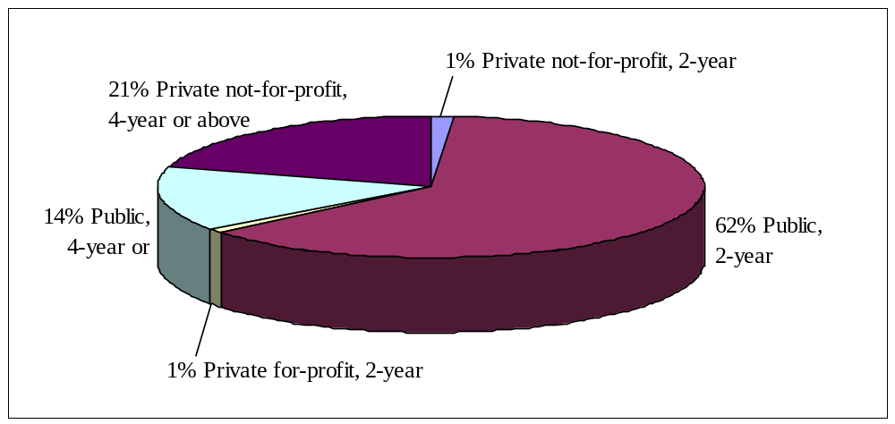
N = 218
Source: SIP data and Integrated Postsecondary Education and Data System (IPEDS), 2003 and 2004 data years.
ª Type is an IPEDS classification indicating whether an institution’s programs are four-year or higher (four-year), two-but-less-than four-year (two-year), or less than two-year. Control is an IPEDS classification indicating whether an institution is operated by publicly elected or appointed officials (public control) or by privately elected or appointed officials and derives its major source of funds from private sources (private control).

Most, 56 percent, of the SIP institutions are “very small” or “small” schools (using IPEDS size categories) with total enrollments of fewer than 5,000 students. Almost half, 49 percent, of two-year schools are very small or small. By contrast, over two-thirds, 68 percent, of four-year schools are very small or small. The ratio of medium, large and very large schools is approximately 14:8:3 for both two-year and four-year schools (fig. 2).

Figure 2. Enrollment sizeª of individual development continuation grant recipients,^{b} by type of school: FY 2003 and FY 2004
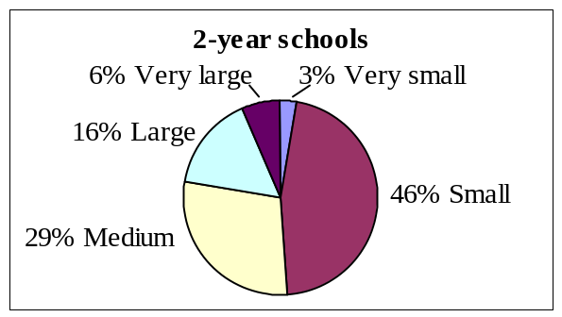
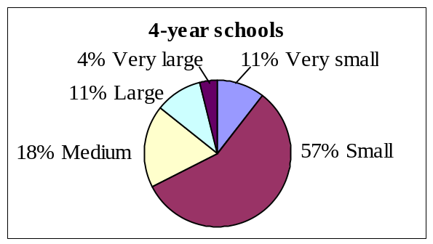
N = 142
N = 76
Source: SIP data and Integrated Postsecondary Education and Data System (IPEDS), 2003 and 2004 data years.
ª Enrollment size is an IPEDS classification indicating whether the institution is very large—more than 20,000 students, large—between 10,000 and 20,000, medium—between 5,000 and 10,000, small—between 1,000 and 5,000, or very small—less than 1,000.
^{b} Individual development continuation grant recipients are single institutions of higher education that have been awarded SIP grants and have completed the initial year of the award period, which may be set for as long as five years.

Of the nine geographic regions defined by IPEDS, schools in the eastern half of the United States, in the northeast, mid-east, southeast and Great Lakes regions, receive 60 percent of the awards. Further, schools in the southeast (Alabama, Arkansas, Florida, Georgia, Kentucky, Louisiana, Mississippi, North Carolina, South Carolina, Tennessee, Virginia, and West Virginia) have the greatest representation of SIP grantees, 27 percent. The other geographic regions receive 40 percent of the awards (fig. 3).

Figure 3. Geographical distributionª of individual development continuation grant recipients:^{b} FY 2003 and FY 2004

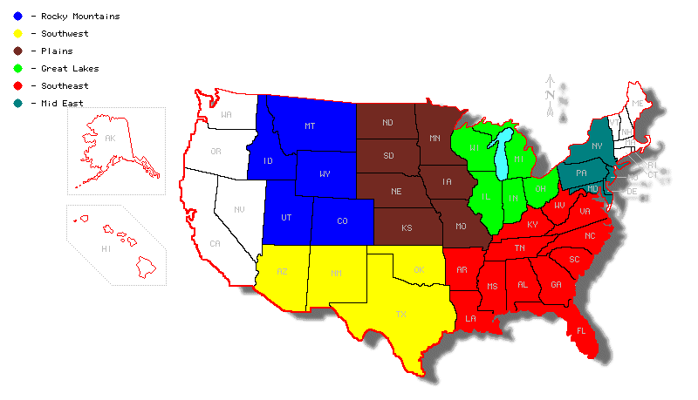
10%
0.5%
13%
0.5% in the outlying areas
5%
11%
18%
16%
27%
N = 218

Figure 3 above provides a map of the United States broken down into eight geographical areas providing the geographical distribution of individual development continuation grant recipients in FY 2003 and FY 2004 as follows: New England – 5 %; Mid East – 11%; Southeast – 27%; Great Lakes – 18%; Plains – 13%; Southwest – 10%; Rocky Mountains - .5%; West – 16%; and outlying areas - .5%.
Source: SIP data and Integrated Postsecondary Education and Data System (IPEDS), 2003 and 2004 data years and Texas Cooperative Extension, "Do It Yourself" Color-Coded State Maps, http://monarch.tamu.edu/~maps2 (accessed Oct. 18, 2006).
ª Geographic region is an IPEDS classification indicating the state or territory in which an institution is located.
^{b} Individual development continuation grant recipients are single institutions of higher education that have been awarded SIP grants and have completed the initial year of the award period, which may be set for as long as five years.

SIP individual development continuation grant recipients can also be described in terms of the degree of urbanization of the institutions’ surrounding community. Currently, institutions in small towns, urban fringes of large cities and mid-size cities are well represented, each comprising about one-quarter of the grants. Institutions in mid-size cities and small towns comprise nearly 50 percent of all institutions (fig. 4).

Figure 4. Percentage distribution of degree of urbanizationª for individual development continuation grant recipients^{b}: FY 2003 and FY 2004

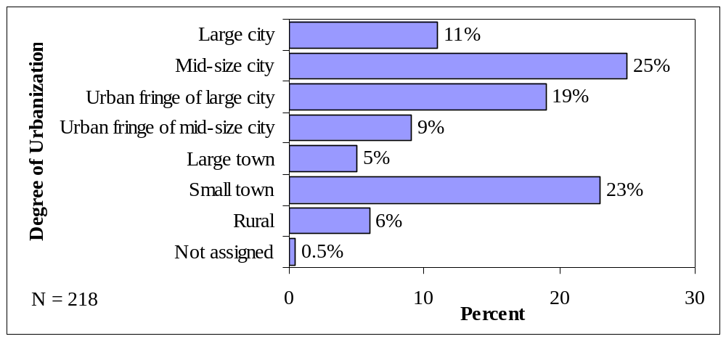
N = 218

Source: SIP data and Integrated Postsecondary Education and Data System (IPEDS), 2003 and 2004 data years.
ª Degree of urbanization is an IPEDS classification indicating the institution's locale: large city—a central city of a consolidated metropolitan statistical area (CMSA) or metropolitan statistical area (MSA) with the city having a population greater than or equal to 250,000; mid-size city—a central city of a CMSA or MSA, with the city having a population less than 250,000; urban fringe of large city—any incorporated place, census-designated place (CDP), or non-place territory within a CMSA or MSA of a large city and defined as urban by the Census Bureau; urban fringe of mid-size city—any incorporated place, CDP, or
non-place territory within a CMSA or MSA of a large city of a mid-size city and defined as urban by the Census Bureau; large town—an incorporated place or CDP with a population greater than or equal to 25,000 and located outside a CMSA or MSA; small town—an incorporated place or CDP with a population less than 25,000 and greater than or equal to 2,500 and located outside a CMSA or MSA; or rural—any incorporated place, CDP, or non-place territory designated as rural by the Census Bureau.
^{b} Individual development continuation grant recipients are single institutions of higher education that have been awarded SIP grants and have completed the initial year of the award period, which may be set for as long as five years.

Evaluation of Program Performance for Individual Development Continuation Grants
The analyses of program performance outcome measures for the 149 individual continuation grants awarded in FY 2003 and 164 awarded in FY 2004 present grantee performance for the year following their continuation grants. FY 2003 continuation grants fund academic year (AY) 2003–04 so that AY 2003–04 performance data are reported as FY 2004 program data (the last year of the academic year). Specifically, the FY 2004 outcome measures use:
- Enrollment data for fall 2003;
- Persistence rate data for first-time, full-time degree- or certificate-seeking students in summer or fall 2002 who persist to fall 2003 as full- or part-time degree- or certificate-seeking students;
- Graduation rate data for full-time degree- or certificate-seeking undergraduate students who began in fall 1997 (four-year institutions) or fall 2000 (less-than-four-year institutions) and graduated by summer 2003; and
- Cost per degree awarded based on the FY 2003 appropriation and all degrees awarded in AY 2003–04.

There are a few words of caution about the results.

- Because results reflect only the performance of each year’s continuation grantees, excluding new grantees, cooperative grantees and branch campuses, the results do not reflect the program’s total impact. Enrollment data are understated since some grantees are excluded. Actual persistence, graduation and cost per degree awarded for all of the grantees may be higher or lower than the numbers reported here.
- Some grantees did not report every performance measure each year. For instance, institutions were not required to report persistence in FY 2004.
- The slate of individual development continuation grantees changes each year as new grantees receive continuation awards and other continuation grants complete or close. Thus, changes in SIP continuation grantee performance from year to year reflect differences in the institutions receiving awards, as well as program-driven outcomes. For this reason, only grantees receiving continuation grants for both years are used for estimation of year-to-year change, and thus more accurately reflecting the program’s impact from one year to the next.

Undergraduate Student Enrollment

The enrollment performance measure simply counts the number of full-time degree- or certificate-seeking undergraduate students at SIP individual development continuation grantee institutions. Therefore, enrollment in fall 2003 for AY 2003–04 is used for FY 2003 SIP continuation grantees, and enrollment in fall 2004 for AY 2004–05 is used for FY 2004 continuation grantees.

Student enrollment for SIP continuation grantees increased from 382,890 to 426,485, or about 11 percent from AY 2003–04 to AY 2004–05 (table 3).

Table 3. Number of schools, enrollment and change in enrollment for continuation grant SIP institutions, by type of school: FY 2004 and FY 2005

 | Number of schools in FY 2004 | FY 2004 enrollment | Number of schools in FY 2005 | FY 2005 enrollment | Change from FY 2004 to FY 2005
 |  |  |  |  | Percent
Type of school
2-year schools | 96 | 230,512 | 104 | 244,549 | 6
4-year schools | 53 | 152,378 | 60 | 181,936 | 19
Total | 149 | 382,890 | 164 | 426,485 | 11
Source: SIP data and Integrated Postsecondary Education and Data System, 2003 and 2004 data years.

While a long-term target was established for the enrollment measure, the methodology used to calculate that target was later determined to be flawed. New targets based on an improved methodology will be established. For this reason, actual data will not be compared to the current target.

Undergraduate Student Persistence Rate

The persistence measure assesses the rate at which students continue in their studies at an institution. For four-year institutions, this is the percentage of first-time bachelor’s (or equivalent) degree-seeking undergraduates from the previous fall who are again enrolled in the current fall. For two-year institutions, this is the percentage of first-time degree- or certificate-seeking students from the previous fall who either re-enrolled or successfully completed their program by the current fall.

Median persistence did not increase from year to year, as desired, between FY 2004 and FY 2005; it decreased 2 percentage points from 63 to 61 percent. Since the FY 2006 performance measure target is 68 percent, it is unlikely persistence will meet the target. Targets were not established for FY 2004 and FY 2005 because reporting persistence in IPEDS first became mandatory for FY 2005. However, the two-year school rate increased by 3 percentage points between FY 2004 and FY 2005. Further, the national median for all Title IV-eligible institutions, which includes schools with more resources and fewer low-income students, is less than 10 percentage points higher. The median persistence rates for those students enrolled in either the summer or fall of 2003 that returned in fall 2004 are 59 and 69 percent for students enrolled at two- and four-year SIP continuation grantees, respectively. Overall persistence is lower at two-year SIP institutions than at four-year institutions (table 4).

Table 4. Median persistenceª in continuation grant SIP institutions, by type of school: FY 2004 and FY 2005

 | Number of schools in FY 2004 | FY 2004 median persistence | Number of schools in FY 2005 | FY 2005 median persistence
 |  | Percent |  | Percent
Type of school
2-year schools | 96 | 56.0 | 104 | 59.0
4-year schools | 53 | 70.5 | 60 | 69.0
Total | 149 | 63.0 | 164 | 61.0
All Title IV-eligible institutions^{b} |  | 71.0 |  | 71.0
Source: SIP data and Integrated Postsecondary Education and Data System, 2003 and 2004 data years.
ª Persistence is the percentage of first-time bachelor’s (or equivalent) degree-seeking undergraduates at four-year institutions from the previous fall who are again enrolled in the current fall. For two-year institutions, persistence is the percentage of first-time degree- or certificate-seeking students from the previous fall who either re-enrolled or successfully completed their program by the current fall.
^{b} All Title IV-eligible institutions are all of the institutions of higher education that the U.S. Department of Education has determined to meet basic legislative and regulatory standards for participating in federal financial aid programs (34 Code of Federal Regulations (CFR) 600 and 34 CFR 668, Subparts A and B).

The FY 2004 two- and four-year school persistence rate of 56 and 71 percent, respectively, for students progressing from either the summer or fall of 2002 to fall 2003 may not accurately reflect performance of all SIP continuation grantees (or the national median, for that matter). This initial year of persistence data collection was voluntary in IPEDS and less than half of SIP continuation grantees (69 of 149) provided data to the Department. However, there is little change from FY 2004 to FY 2005, when data submission was mandatory.

For SIP grantees, the persistence rates generally increase as the enrollment size of the institution increases (fig. 5). Similarly, the persistence rates show a slight upward trend as the institution’s surrounding degree of urbanization increases (fig. 6).

Figure 5. Median persistenceª in continuation grant SIP institutions, by enrollment size^{b} and type of school: FY 2005

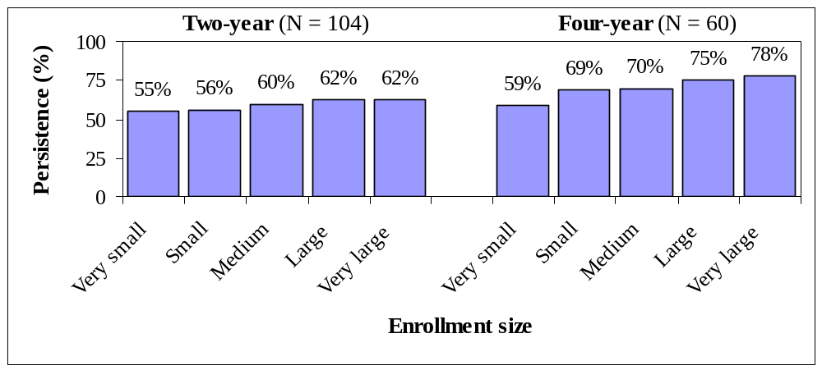
Source: SIP data and Integrated Postsecondary Education and Data System, 2003 and 2004 data years.
ª See table 4 for more on persistence.
^{b} See figure 2 for more on enrollment size.

Figure 6. Median persistenceª in continuation grant SIP institutions, by degree of urbanization^{b} and type of school: FY 2005

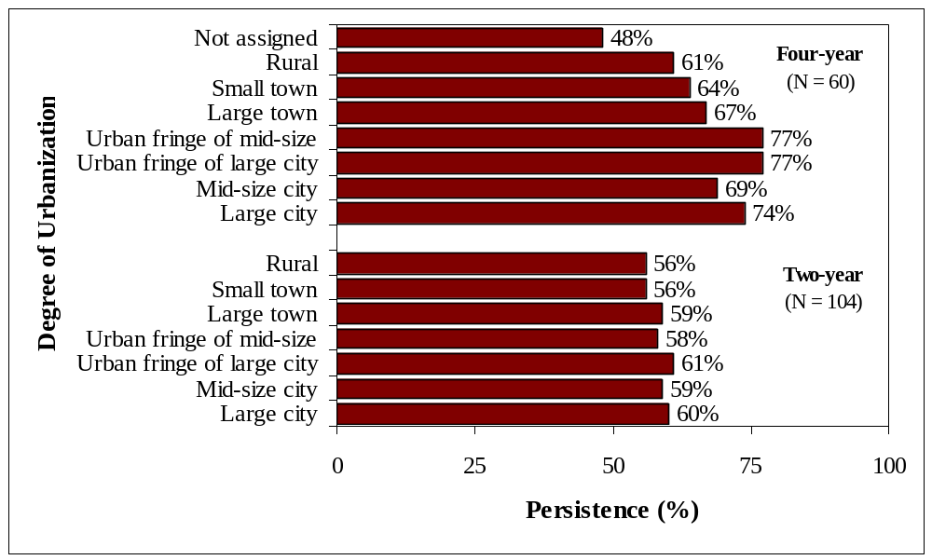
Source: SIP data and Integrated Postsecondary Education and Data System, 2003 and 2004 data years.
ª See table 4 for more on persistence.
^{b} See figure 4 for more on degree of urbanization.
College Graduation Rate

Graduation from college is an important SIP outcome measure. Evidence indicating significant increased earnings for those attending or completing college is compelling. For example, in 1980 males with a bachelor’s degree or higher earned 19 percent more than male high school completers, while in 2004, they earned 67 percent more. In 1980 males who completed some college earned only 5 percent more than males who only completed high school; in 2004, they earned 20 percent more.

Overall, the average graduation rate at all SIP individual development continuation grantee institutions was 31 percent for both FY 2003 and FY 2004.

Two-year college graduation rate

The graduation rate for two-year institutions is measured by calculating the percentage of degree- or certificate-seeking students who enrolled three years prior and graduated within three years. The graduation rate for two-year SIP continuation grantee institutions is 23.8 and 24.3 percent in FY 2004 and FY 2005, respectively. The FY 2006 target for two-year schools is 25 percent, requiring the actual value to increase by a factor of 1.03 from the FY 2005 actual value. Targets were not established for FY 2004 and FY 2005 because the graduation rate performance measure was developed in February 2005 (table 5).

Table 5. Number of schools and average graduation rate in two-year continuation grant SIP institutions and national graduation rate: FY 2004 and FY 2005

 | Number of schools in FY 2004 | FY 2004  average graduation rate | Number of schools in FY 2005 | FY 2005  average graduation rate
 |  | Percent |  | Percent
Type of school
2-year continuation grant schools | 96 | 23.8 | 104 | 24.3
National average of all 2-year schools |  | 29.3 |  | 32.6
Source: SIP data; Integrated Postsecondary Education and Data System (IPEDS), 2003 and 2004 data years; and IPEDS, 2003, table 24a, Average graduation and transfer-out rates for full-time, first-time students in Title IV institutions in 2000, initially enrolled in less than four-year institutions, by sector and state: 2003—Continued (Public two-year); and IPEDS, spring 2005, table 26, Graduation rates at Title IV institutions, by race/ethnicity, level and control of institution, and gender: United States, cohort years 1998 and 2001.
Note: The FY 2004 national average represents only public two-year institutions, but public two-year institutions are 96 percent of the two-year SIP institutions.

To provide additional context, the graduation rate also can be compared to the national average. However, since SIP institutions are generally smaller, enroll more low-income students, and have lower per-student expenditures, it is expected that their rates will be lower. The FY 2005 graduation rate for two-year schools of 24.3 percent compares to the national average of 32.6 percent for all first-time, full-time degree- or certificate-seeking undergraduates in the 2001 cohort year. The FY 2004 national average of 29.3 percent includes transfer students and students that completed a degree or certificate; thus, it will be higher than the FY 2004 SIP value of 23.8 percent, which only counts students that completed a degree or certificate (table 5).

Four-year college graduation rate

For four-year institutions, the calculation for graduation rate is the percentage of students who enrolled six years earlier and graduated within six years. For all the four-year SIP schools the rate is 44.4 and 43.4 percent in FY 2004 and FY 2005, respectively. The graduation rate at four-year schools will have to increase by 8 percent to meet the FY 2006 performance target of 47 percent. Targets were not established for FY 2004 and FY 2005 because the graduation rate performance measure was developed in February 2005 (table 6).

Table 6. Number of schools and average graduation rate in four-year continuation grant SIP institutions: FY 2004 and FY 2005

 | Number of schools in FY 2004 | FY 2004  average graduation rate | Number of schools in FY 2004 | FY 2005  average graduation rate
 |  | Percent |  | Percent
Type of school
Four-year continuation grant schools | 53 | 44.4 | 60 | 43.4
National average of all 4-year schools |  | 50.9 |  | 55.3
Source: SIP data; Integrated Postsecondary Education and Data System (IPEDS), 2003 and 2004 data years; and IPEDS, spring 2005, table 26, Graduation rates at Title IV institutions, by race/ethnicity, level and control of institution, and gender: United States, cohort years 1998 and 2001, http://nces.ed.gov/das/library/tables_listings/Spring2005.asp.

The 43.4 percent graduation rate in FY 2005 compares to a national average of 55.3 percent for all full-time, first-time degree- or certificate-seeking undergraduates enrolled in the 1998 cohort year at four-year Title IV postsecondary institutions and graduated within six years (table 6). As mentioned earlier, the characteristics of the SIP grantees, which make them eligible for a SIP award, also tend to decrease their graduation rates below the national average.

Federal Cost per Degree Awarded

The federal cost per degree awarded outcome measure is defined for SIP as the federal cost for all undergraduate and graduate degrees awarded at SIP institutions. The federal cost per degree awarded is calculated by dividing a given year’s continuation funding by the number of degrees awarded during the following year. For instance, the measure for FY 2005 is determined by dividing the FY 2004 appropriation for SIP continuation grantees ($56,880,204) by the number of students (127,304) receiving degrees during AY 2004–05 at these institutions. This calculation results in a federal cost per successful outcome of $447. The cost declined nearly 5 percent from $470 in FY 2004 to $447 in FY 2005 (table 7).

Table 7. Federal cost per degree awarded in continuation grant SIP institutions, by type of school: FY 2004 and FY 2005

 | Number of schools in FY 2004 | FY 2004 federal cost per degree awarded | Number of schools in FY 2004 | FY 2005 federal cost per degree awarded
 |  | $ |  | $
Type of school
2-year schools | 96 | 584 | 104 | 568
4-year schools | 53 | 346 | 60 | 326
All continuation grant schools | 149 | 470 | 164 | 447
Source: SIP data and Integrated Postsecondary Education and Data System, 2003 and 2004 data years.

Private not-for-profit, two-year institutions have the highest average federal cost per degree awarded at $4,915 in FY 2005, and public four-year institutions have the lowest at $202 in FY 2005. Federal cost per degree awarded increases as the institution’s enrollment size decreases (fig. 7).

Figure 7. Federal cost per degree awarded,ª by enrollment size^{b} and type of school: FY 2004 and FY 2005

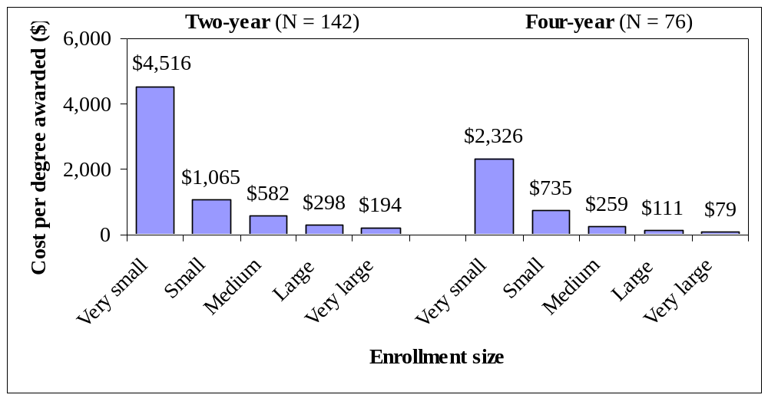
Source: SIP data and Integrated Postsecondary Education and Data System, 2003 and 2004 data years.
ª The federal cost per degree awarded is calculated by dividing a given year’s continuation funding by the number of degrees awarded during the following year.
^{b} Enrollment size is an IPEDS classification indicating whether the institution is very large—more than 20,000 students, large—between 10,000 and 20,000, medium—between 5,000 and 10,000, small—between 1,000 and 5,000, or very small—less than 1,000.

Change in Program Performance, Between FY 2004 and FY 2005
This section details the investigation of the change in performance between FY 2004 and FY 2005 for only those institutions that received individual development continuation awards in both FY 2003 and FY 2004. Ninety-five of the institutions discussed in the previous sections received individual development continuation funds in both FY 2003 and FY 2004. The majority of grantee institutions are public two-year schools (57 percent); there are 54 public two-year institutions. Of the remaining 41 institutions, one is private not-for-profit, two-year; three are private for-profit, two-year; 17 are public four-year or above; and 21 are private not-for-profit, four-year or above institutions (fig. 8).

Figure 8. Type and control of individual development continuation grant recipientsª funded in both FY 2003 and FY 2004

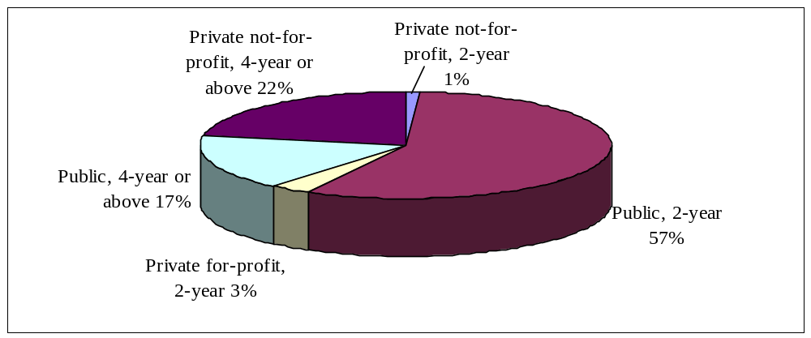
N = 95
Source: SIP data and Integrated Postsecondary Education and Data System, 2003 and 2004 data years.
ª Individual development continuation grant recipients are single institutions of higher education that have been awarded SIP grants and have completed the initial year of the award period, which may be set for as long as five years.

Over half of the two- and four-year schools are small, 57 and 63 percent, respectively. Both the two- and four-year schools are clustered in mid-size cities, urban fringes of large cities, and small towns.

Undergraduate Student Enrollment

Enrollment grew faster at the four-year schools receiving continuation grants in both FY 2003 and FY 2004 than at the two-year schools, on average. The 58 two-year institutions that received continuation funding in FY 2003 and FY 2004 increased their enrollment by one percent. The 37 four-year institutions receiving continuation funding in FY 2003 and FY 2004 increased their enrollment by 3 percent. These enrollment growths are equivalent to the national averages at two- and four-year Title IV institutions.

Figure 9 shows the percentage change in enrollment from FY 2004 to FY 2005 for two- and four-year schools based on the enrollment size of the school. On average, all enrollment size groups increased enrollment except the six very small and 12 medium, two-year schools.

Figure 9. Percentage change in enrollment, by enrollment sizeª and type of school funded in both FY 2004 and FY 2005

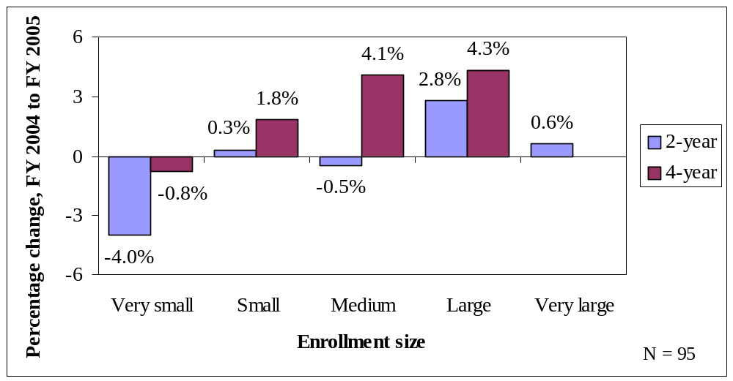
Source: SIP data and Integrated Postsecondary Education and Data System, 2003 and 2004 data years.
ª Enrollment size is an IPEDS classification indicating whether the institution is very large—more than 20,000 students, large—between 10,000 and 20,000, medium—between 5,000 and 10,000, small—between 1,000 and 5,000, or very small—less than 1,000.

Undergraduate Student Persistence Rate

FY 2004 was the initial year of collection of persistence data in IPEDS. Since collection was voluntary, less than half of SIP continuation grantees (69 of 149) provided data to the Department. Because the FY 2004 data are incomplete, the change in persistence from FY 2004 to FY 2005 will not be evaluated.

College Graduation Rate

For the 95 institutions that received individual development continuation grants in both FY 2003 and FY 2004, the graduation rate at two- and four-year institutions increased marginally from FY 2004 to FY 2005. However, the improvement was greater at four-year institutions. At two-year institutions, the graduation rate increased 0.3 percentage points from 26.1 to 26.4 percent; at four-year institutions, the rate increased 0.9 percentage points from 41.9 to 42.8 percent. The graduation rate increased despite increased enrollments because the number of students graduating increased more than the number of students enrolling. Although the graduation rate at the larger public four-year colleges increased 2.2 percentage points from 37.2 to 39.4 percent, the rate barely increased 0.3 percentage points from 25.7 to 26.0 percent at the public two-year schools. The graduation rate at the single, very small, private not-for-profit institution increased from 17 to 56 percent by more than doubling its numbers of graduates (fig. 10).
Figure 10. Graduation rate for institutions funded in both years, by institution type and control: FY 2004 and FY 2005

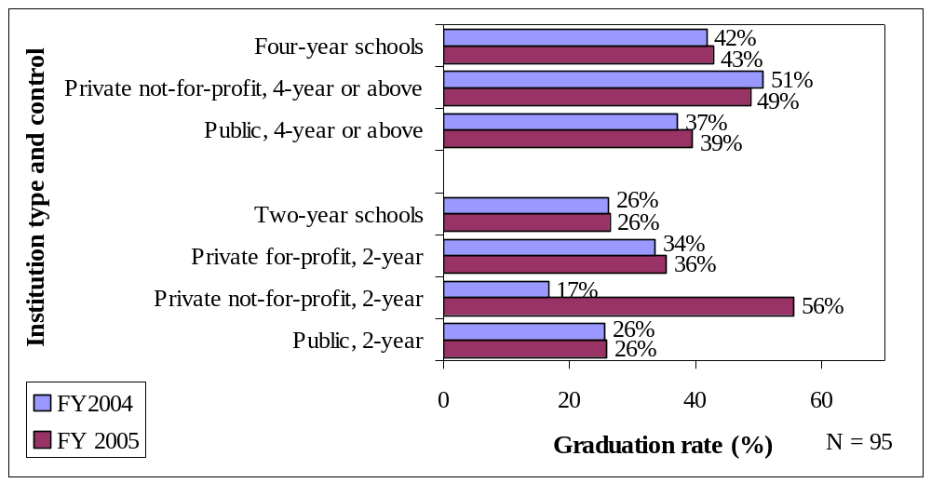
Source: SIP data and Integrated Postsecondary Education and Data System, 2003 and 2004 data years.

The graduation rate for small four-year institutions receiving continuation grants in both FY 2004 and FY 2005 declined slightly from FY 2003 to FY 2004, as did the graduation rate for large two-year institutions over the same time period (fig. 11).
Figure 11. Percentage-point change in graduation rate for institutions funded in both years, by enrollment sizeª and type of school: FY 2004 and FY 2005

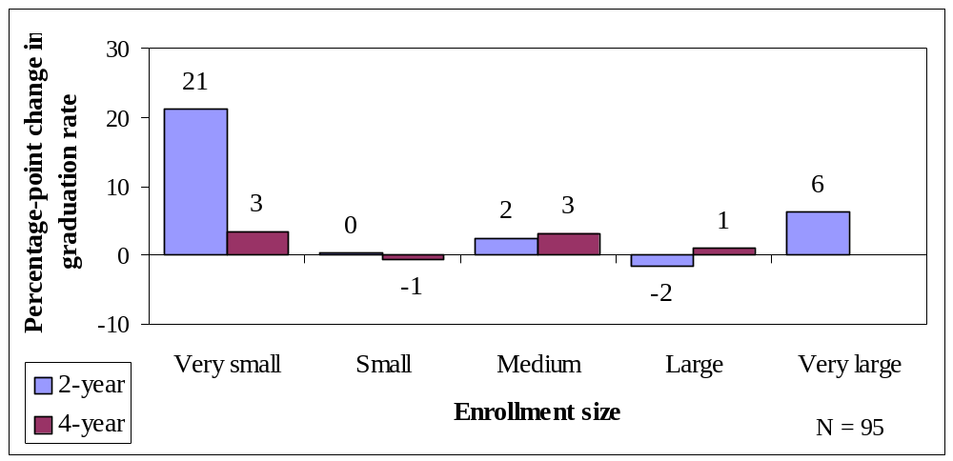
Source: SIP data and Integrated Postsecondary Education and Data System, 2003 and 2004 data years.
ª Enrollment size is an IPEDS classification indicating whether the institution is very large—more than 20,000 students, large—between 10,000 and 20,000, medium—between 5,000 and 10,000, small—between 1,000 and 5,000, or very small—less than 1,000.

Federal Cost per Degree Awarded

The federal cost per degree awarded (i.e., federal grant money expended per degree) decreased from $483 in FY 2004 to $460 in FY 2005 for the 95 institutions receiving individual development continuation awards in both FY 2003 and FY 2004. The two-year institutions reduced their federal cost by 7 percent from $648 in FY 2004 to $601 in FY 2005. Although four-year institutions only reduced their federal cost by 3 percent, their initial average cost of $347 in FY 2004 was almost half that of two-year institutions (fig. 12).

Figure 12. Federal cost per degree awarded for institutions funded in both FY 2004 and FY 2005, by institutional type and controlª

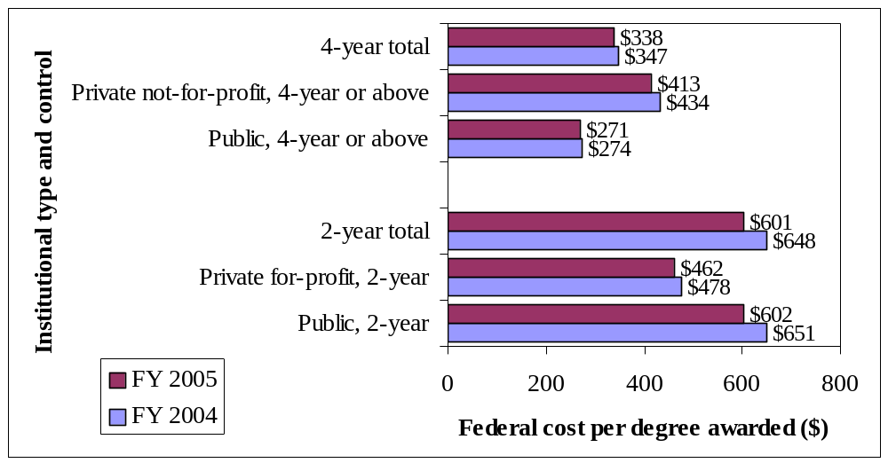
N = 95
Source: SIP data and Integrated Postsecondary Education and Data System, 2003 and 2004 data years.
ª Control is a classification indicating whether an institution is operated by publicly elected or appointed officials (public control) or by privately elected or appointed officials and derives its major source of funds from private sources (private control). This classification system is utilized in IPEDS.

Private not-for-profit, two-year grantees were the only institutional type and control category in which federal cost per degree awarded increased—from $3,805 to $4,840 (not shown in fig. 12). There was only one private not-for-profit, two-year institution that received a continuation grant in both years.

Conclusion

The SIP program supports postsecondary education institutions that serve students historically denied access to quality education by strengthening their fiscal, academic and management operations. The institutions that received continuation awards in both FY 2003 and FY 2004 show some positive results from FY 2004 to FY 2005. Enrollment increased 2 percent. The graduation rate at four-year schools increased from 41.9 to 42.8 percent; while at two-year schools, it increased from 26.1 to 26.4 percent. As a whole, the federal cost per degree awarded declined 5 percent.

For all grant recipients in FY 2003 and FY 2004, annual performance measure results were mixed. Enrollment increased from 382,890 to 426,485 in FY 2005. Persistence, however, decreased from 63 percent in FY 2004 to 61 percent in FY 2005. Similarly, the graduation rate at four-year institutions decreased from 44.4 to 43.4 percent. At two-year institutions, the graduation rate increased to 24.3 from 23.8 percent. The program, as a whole, achieved improved cost efficiencies by reducing the federal cost per degree awarded to $447 in FY 2005 from $470 in FY 2004.

In summary, although the program may not presently achieve its performance targets, the funded institutions are achieving performance improvements on three of the four measures (enrollment, graduation rate and federal cost per degree awarded). Progress has been made on all but one measure—persistence.

Our mission is to provide equal access to education and to promote
educational excellence throughout the nation.
www.ed.gov

The SIP regulations (Code of Federal Regulations, Title 34, Part 607) require that an eligible institution must have at least 50 percent of its degree-seeking students receiving need-based student financial assistance from the Department or have a higher percentage of students receiving Pell Grants than the median percentage at comparable institutions that offer similar instruction, and have education and general expenditures below the average of comparable institutions that offer similar instruction.
Individual development SIP continuation grantees are single institutions of higher education that have been awarded SIP grants and have completed the initial year of the award period, which may be as long as five years.
Continuation funds are the additional monies released after the initial year of the award period. Although an applicant may be awarded a multiyear grant, the Department evaluates the grantee’s performance every year and releases additional funds for each upcoming year for the grantee to expend in that year.
Title III, Part A, of the Higher Education Act of 1965, as amended, Sec. 301.
Title III, Part A, of the Higher Education Act of 1965, as amended, Sec. 311.
FY 2007 Performance Plan, Section 5 (Goal 5: Enhance the Quality of and Access to Postsecondary and Adult Education), subsection HEA: AID Strengthening Institutions – FY 2007, available at http://www.ed.gov/about/reports/annual/2007plan/edlite-g5heaaidinstitutions.html (accessed Oct. 17, 2006).
This initiative, “one of five governmentwide management initiatives, the Budget and Performance Integration Initiative builds on the Government Performance and Results Act of 1993 (GPRA) and earlier efforts to identify program goals and performance measures, and link them to the budget process. Since the FY 2003 budget was released, the Office of Management and Budget (OMB) has been refining and improving the program assessment process in preparation for the FY 2004 budget. Special attention has also been given to the development of common performance measures that can be used in the assessment of programs with similar goals.” (Accessed from http://www.whitehouse.gov/omb/budintegration/index.html on Oct. 17, 2006).
“The Program Assessment Rating Tool, or PART, for short, is a questionnaire designed to help assess the management and performance of programs. It is used to evaluate a program’s purpose, design, planning, management, results, and accountability to determine its overall effectiveness.” (Accessed from http://www.whitehouse.gov/omb/expectmore/part.html on Oct. 17, 2006). One of the questions asks whether program management practices have made the program more efficient in terms of dollars or time (excerpted from Guide to the Program Assessment Rating Tool (PART), Office of Management and Budget, March 2006).
Type, or level, is a classification indicating whether an institution’s programs are four-year or higher (four-year), two-but-less-than-four-year (two-year), or less than two-year. This classification system is utilized in IPEDS.
Control is a classification indicating whether an institution is operated by publicly elected or appointed officials (public control) or by privately elected or appointed officials and derives its major source of funds from private sources (private control). This classification system is utilized in IPEDS.
Size of institution data and classifications come from IPEDS. The five classes are as follows: very large—more than 20,000 students, large—between 10,000 and 20,000, medium—between 5,000 and 10,000, small—between 1,000 and 5,000, and very small—less than 1,000.
Geographic region is an IPEDS classification indicating the state/territory in which an institution is located. New England is CT, ME, MA, NH, RI and VT; the Mid East is DE, DC, MD, NJ, NY and PA; the Great Lakes are IL, IN, MI, OH and WI; the Plains are IA, KS, MN, MO, NE, ND and SD; the Southeast is AL, AR, FL, GA, KY, LA, MS, NC, SC, TN, VA and WV; the Southwest is AZ, NM, OK and TX; the Rocky Mountains are CO, ID, MT, UT and WY; the Far West is AK, CA, HI, NV, OR and WA; and the Outlying areas are AS, FM, GU, MH, MP, PR, PW and VI.
Degree of urbanization is an IPEDS classification indicating the institution's locale: large city—a central city of a consolidated metropolitan statistical area (CMSA) or metropolitan statistical area (MSA) with the city having a population greater than or equal to 250,000; mid-size city—a central city of a CMSA or MSA, with the city having a population less than 250,000; urban fringe of large city—any incorporated place, census-designated place (CDP), or non-place territory within a CMSA or MSA of a large city and defined as urban by the Census Bureau; urban fringe of mid-size city—any incorporated place, CDP, or non-place territory within a CMSA or MSA of a large city of a mid-size city and defined as urban by the Census Bureau; large town—an incorporated place or CDP with a population greater than or equal to 25,000 and located outside a CMSA or MSA; small town—an incorporated place or CDP with a population less than 25,000 and greater than or equal to 2,500 and located outside a CMSA or MSA; or rural—any incorporated place, CDP, or non-place territory designated as rural by the Census Bureau.
National Center for Education Statistics. (2006). The Condition of Education 2006 (NCES 2006-071). Washington, DC: U.S. Department of Education.
U.S. Department of Education, National Center for Education Statistics, Integrated Postsecondary Education Data System (IPEDS), spring 2005, table 26, Graduation rates at Title IV institutions, by race/ethnicity, level and control of institution, and gender: United States, cohort years 1998 and 2001, http://nces.ed.gov/das/library/tables_listings/Spring2005.asp.
Ibid.
Approximately $3 million in addition were appropriated to SIP continuation grantees in FY 2004 but are excluded from the efficiency measure calculation because (1) the appropriation funded cooperative grants where it would have been extremely difficult to accurately apportion the relative costs and benefits among the partnering grantees or (2) the appropriation funded a branch campus, which does not report results (such as degrees awarded) to the Department separately from its parent institution.
Three percent of the two-year schools are very small, 57 percent are small, 21 percent are medium, 17 percent are large, and two percent are very large. Five percent of four-year schools are very small, 62 percent are small, 16 percent are medium, and 16 percent are large (see p. 11, footnote 11, for size definitions).
Six two-year schools are in large cities, 13 are in mid-size cities, 11 are in urban fringes of large cities, three are in urban fringes of mid-size cities, three are in large towns, 15 are in small towns, and seven are in rural environments. Four four-year schools are in large cities, 12 are in mid-size cities, seven are in urban fringes of large cities, three are in urban fringes of mid-size cities, one is in a large town, seven are in small towns, two are in rural environments, and one is in an unassigned area (see p. 13, footnote 13, for definitions of degree of urbanization).
There were 126,854 students enrolled in two-year schools in FY 2004 and 128,219 in FY 2005.
There were 103,738 students enrolled in four-year schools in FY 2004 and 107,206 in FY 2005.
U.S. Department of Education, Integrated Postsecondary Education Data System (IPEDS), spring 2005, table 1, Enrollment at Title IV institutions, by control and level of institution, student level, attendance status, gender, and race/ethnicity: United States, fall 2004, http://nces.ed.gov/das/library/tables_listings/ Spring2005.asp and IPEDS, spring 2004, table 1, Enrollment in Title IV institutions, by degree-granting status, level and control of institution, student level, attendance status, gender, and race/ethnicity: United States, fall 2003, http://nces.ed.gov/das/library/tables_listings/Spring2004.asp.
Title III, Part A, of the Higher Education Act of 1965, as amended, Sec. 301.

