
Fiscal Year 2012 Competition Highlights for the Gaining Early Awareness & Readiness for Undergraduate Programs Program
Updated: 12/04/12

Table of Contents
Gaining Early Awareness & Readiness for Undergraduate Programs 3
Background and Focus 3
Funding History 3
Fiscal Year 2012 Funding Strategy 3
Fiscal Year 2011 Competition Competitive and Invitational Priorities 4
Competitive Preference Priorities Breakdown 5
Appendices 7
Grantee Breakdown 8
Grant Recipient by State FY 2011 13
Grant Recipient by State FY 2012 14

Gaining Early Awareness & Readiness for Undergraduate Programs
Fiscal Year 2012- Funding down the Fiscal Year 2011 Slate

Background and Focus

The Gaining Early Awareness & Readiness for Undergraduate Programs (GEAR UP) program is a discretionary grants program designed to significantly increase the number of low-income students who are prepared to enter and succeed in postsecondary education.
GEAR UP provides six-year grants to states and partnerships to provide services at high-poverty middle and high schools. GEAR UP grantees serve an entire cohort of students, beginning no later than the seventh grade, and follow the cohort through high school. State and partnership applicants may also apply for seven years of funding to enable them to provide services to a student through the student’s first year of attendance at an institution of higher education.
GEAR UP services include: (1) Providing information regarding financial aid for postsecondary education to participating students in the cohort; (2) Encouraging student enrollment in rigorous and challenging curricula and coursework; and (3) Improving the number of participating students who obtain a secondary school diploma and complete applications for, and enroll in, a program of postsecondary education. GEAR UP funds are also used to provide college scholarships to low-income students.
Funding History
The GEAR UP Program was initially funded in 1999 for $120,000,000 as a five-year program authorized under Title IV of the Higher Education Act of 1965, as amended in 1998.
The previous GEAR UP competition was held in fiscal year (FY) 2011. In FY 2011, the GEAR UP Program received 40 eligible state applications and 256 eligible partnership applications. The GEAR UP program awarded $77,307,346 to 19 states and $101,249,103 for 49 partnership projects. Forty seven percent of state applicants and nineteen percent of partnership applicants were successful in the 2011 competition.
The FY 2012 GEAR UP appropriation was $302,243,678. The Department did not hold a new competition with these funds. The Department funded down the FY 2011 grant slate in rank order to make new grant awards in FY 2012.

Fiscal Year 2012 Funding Strategy

The GEAR UP Program made non-competing continuation grants to 27 states at a cost of $109,624,217 and 94 partnership grants at a cost of $153,529,656, for a total non-competing continuation award cost of $263,153,873. In addition, $3,505,034 in FY 2012 funds were used for evaluation activities.

The remaining FY 2012 GEAR UP funds were used to fund down the FY 2011 slate. Specifically, the GEAR UP Program awarded $35,584,771 to seven new state and four new partnership projects to serve over 60,000 students.

- States receiving awards in FY 2012: Arizona, Connecticut, Nevada, New Mexico, North Carolina, Tennessee and Texas.

- Partnerships receiving awards in FY 2012: Hennepin Technical College (Minnesota), South Carolina State University (South Carolina), IDEA Public Schools (Texas) , and Utah State University (Utah).

Taking into account those grantees who received awards in either FY 2011 or FY 2012, a total of 65 percent of all eligible state applicants and 20 percent of all eligible partnership applicants from the 2011 competition were ultimately successful.

Fiscal Year 2011 Competition Competitive and Invitational Priorities

The FY 2011 GEAR UP Program state competition contained four competitive preference priorities. These were:
- Successful Completion of Prior GEAR UP Projects (two points)
- Turning Around Persistently Lowest-Achieving Schools (three points)
- Enabling More Data-Based Decision-Making (three points)
- Implementing Internationally Benchmarked, College and Career Ready Elementary and Secondary Academic Standards (four points)
The vast majority (85 percent) of successful state applicants chose to address all four priorities, as can be seen in the first bar chart on the following page.

Two of the priorities listed above, Turning Around Persistently Lowest-Achieving Schools and Enabling More Data-Based Decision-Making, were also contained in the partnership competition. The second chart on the following page shows that 92 percent of successful partnership applicants chose to address both of these competitive preference priorities.

Both the state and partnership programs contained one invitational priority, Financial Access and College Savings Accounts. As usual, no points were awarded for addressing the invitational priority.

Competitive Preference Priorities Breakdown

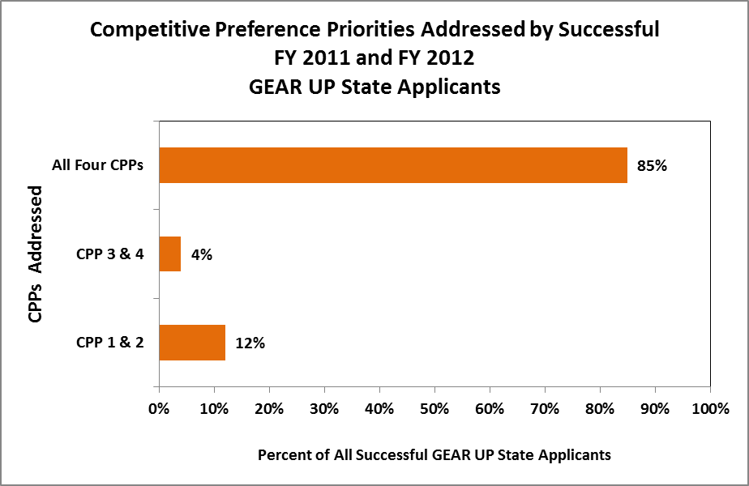

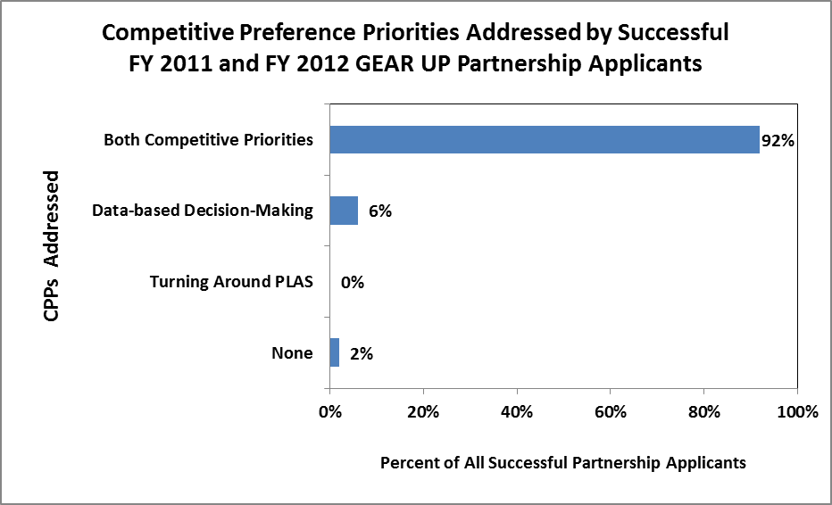

Appendices

Grantee Breakdown

Minority Serving Institutions Among Successful Applicants
for the FY 2011 and FY 2012 GEAR UP Program

Historically Black Colleges and Universities (HBCUs) | 2 institutions
Hispanic Serving Institutions (HSI) | 2 Institutions
Tribal Colleges and Universities | 0 Institutions
Asian American and Native American Pacific Islander Serving Institutions (AANAPISI) | 1 Institution
Total Minority Serving Institutions | 5 Institutions

Institutional Type and Control of Successful Applicants
for the FY 2011 and FY 2012 GEAR UP Program

Public Four-Year Institutions | 19 Institutions
Private Four-Year Institutions | 3 Institutions
State Agencies | 26 Institutions
Local Educational Agencies | 31 Institutions
Total | 79 Institutions

FY 2011 GEAR UP Awards
State | Number of Projects | Total Number of Students to be Served in the State
AK | 1 | 160
AR | 1 | 1,274
CA | 11 | 21,698
CO | 2 | 3,625
CT | 1 | 1,435
FL | 1 | 1,232
GA | 2 | 5,800
HI | 2 | 9,904
ID | 1 | 3,000
IL | 1 | 8,784
KS | 2 | 1,600
KY | 3 | 18,724
MA | 1 | 6,315
MI | 1 | 9,453
MN | 1 | 1,430
MT | 1 | 3,816
NJ | 1 | 2,319
NM | 1 | 1,726
NV | 3 | 13,217
NY | 1 | 650
OH | 1 | 500
OK | 4 | 28,883
OR | 1 | 1,700
PA | 1 | 1,500
RI | 1 | 3,500
SC | 2 | 5,594
SD | 1 | 6,591
TN | 1 | 891
TX | 7 | 33,288
UT | 2 | 5,352
VT | 1 | 1,760
WA | 5 | 17,728
WI | 2 | 5,865
WY | 1 | 2,000
Total | 68 | 231,314

FY 2012 GEAR UP Awards
State | Number of Projects | Total Number of Students to be Served in the State
AZ | 1 | 4,000
CT | 1 | 3,200
MN | 1 | 575
NC | 1 | 21,917
NM | 1 | 11,000
NV | 1 | 5,480
SC | 1 | 660
TN | 1 | 7,500
TX | 2 | 3,740
UT | 1 | 2,793
Total | 11 | 60,865

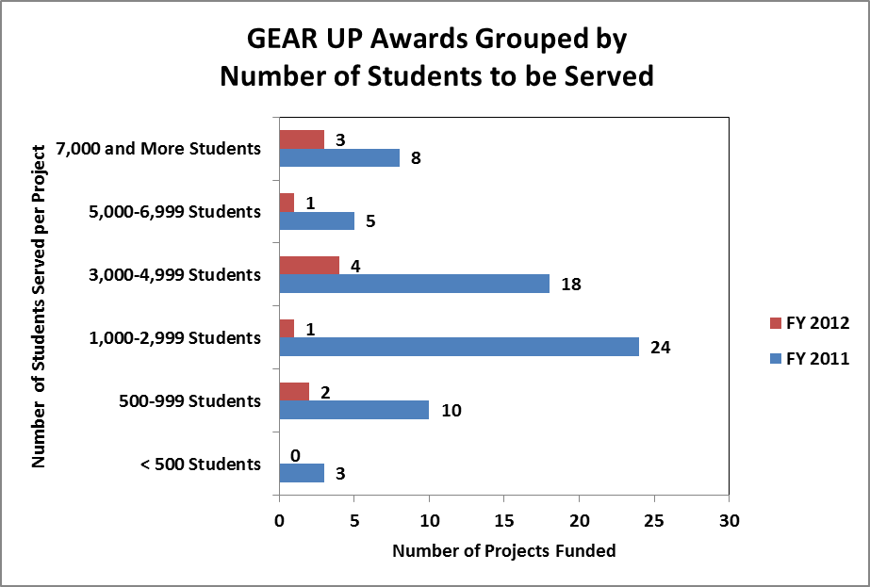

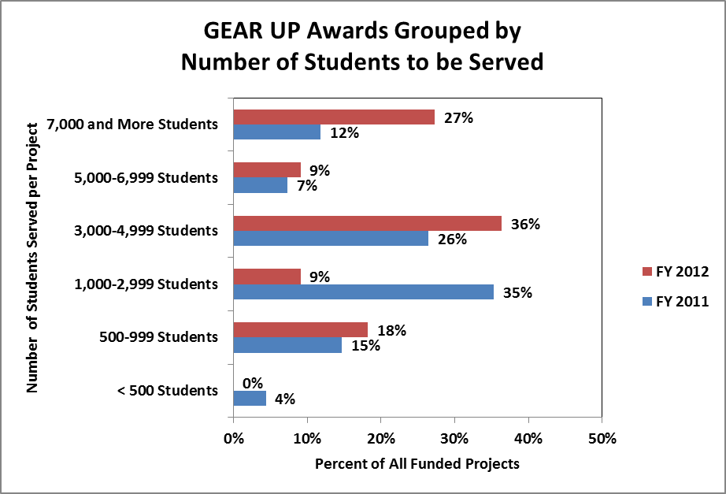
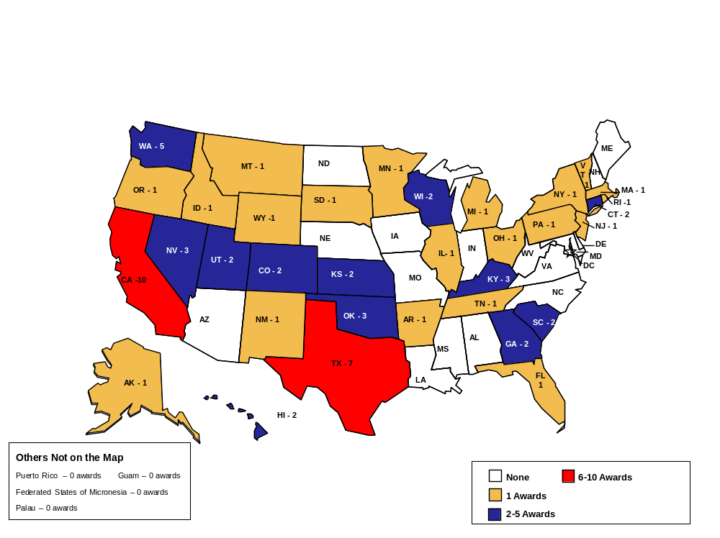

Grant Recipient by State FY 2011
GEAR UP FY 2011 Awards
Map Date: 11/2/2012
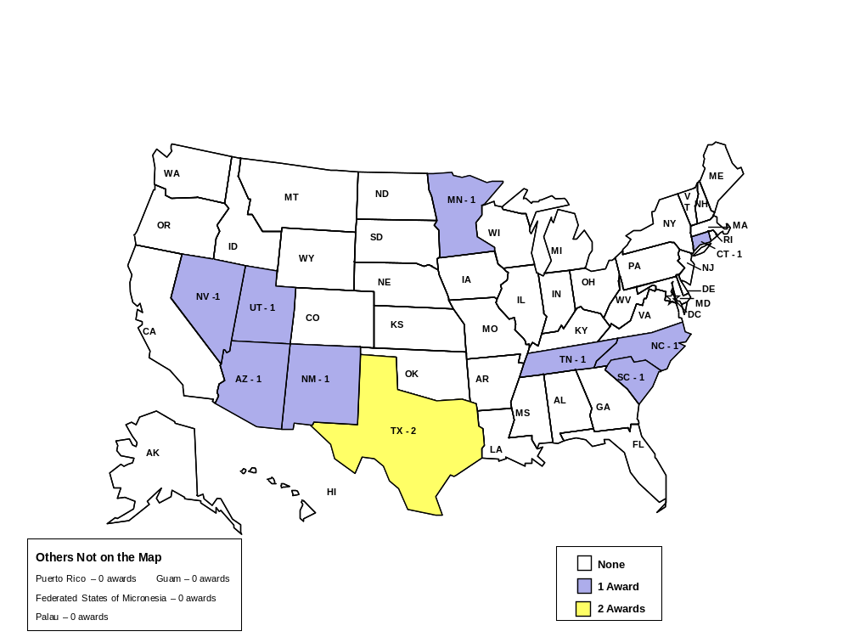

Grant Recipient by State FY 2012
GEAR UP FY 2012 Awards
Map Date: 11/2/2012

