For the new grants awarded in 2000 and 2001 and closed by December 2004, higher federal fellowship amounts and higher institutional match amounts per fellow appear related to higher success rates. Four percent of the variance in success rate can be associated with differences in the federal fellowship amount (chart 1). For instance:
- Grantees that provide larger federal fellowships, thus distributing the funds among fewer fellows, have a higher success rate, on average (chart 2),
- Grantees that distribute smaller federal fellowships to more students have a lower success rate, on average (chart 3), and
- The non-federal contribution or institutional match (a minimum of 25% of the federal funds) also is associated with success rate. Grantees that supplement larger fellowship amounts with a higher match have higher success rates, on average (chart 4).

However, there are several additional factors that have an effect on the relationship between the federal fellowship amount and success rate. These factors include the following:
- Graduate tuition and fees, which range from $1,300 to $30,000/year.
- Student living expenses, which range from $10,000 to $21,000/year depending on the school location.
- The financial need and overall financial aid packages (including student loans) of individual fellows, which affect the amount of the fellowship.
- Institutional matching contributions, which range between 23 percent and 100 percent; schools are required to provide at least 25 percent of the federal award.
- The point in their graduate school tenure that fellows receive GAANN fellowships, which may be at anytime from the first to final year.
- The length of time for which fellows receive the fellowship, which may be as short as one semester or as long as four years.
- Grant extensions, which extend the three-year grant into a fourth or fifth year giving fellows more time to progress in a doctoral program and likely resulting in a higher success rate.

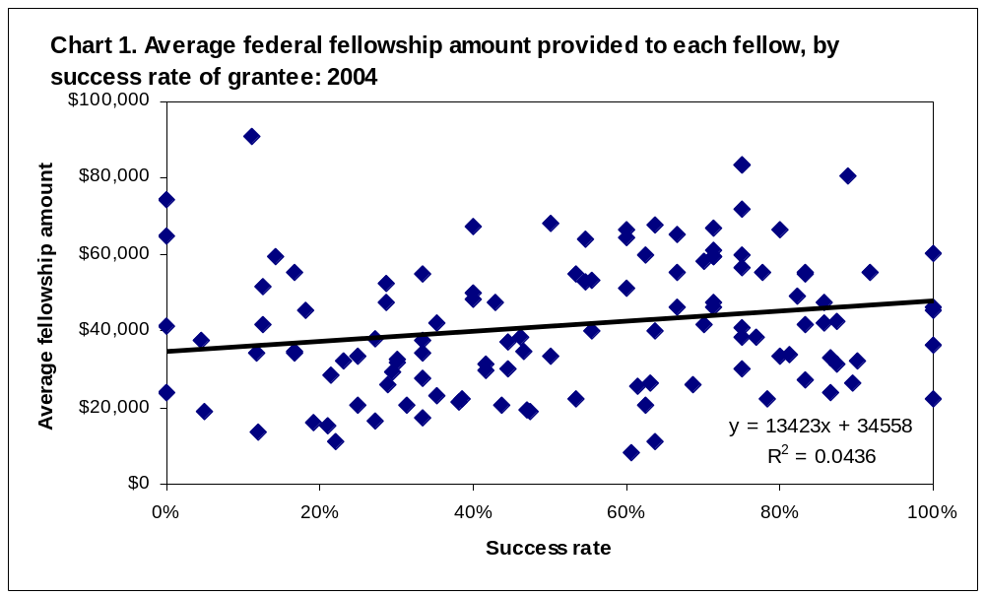

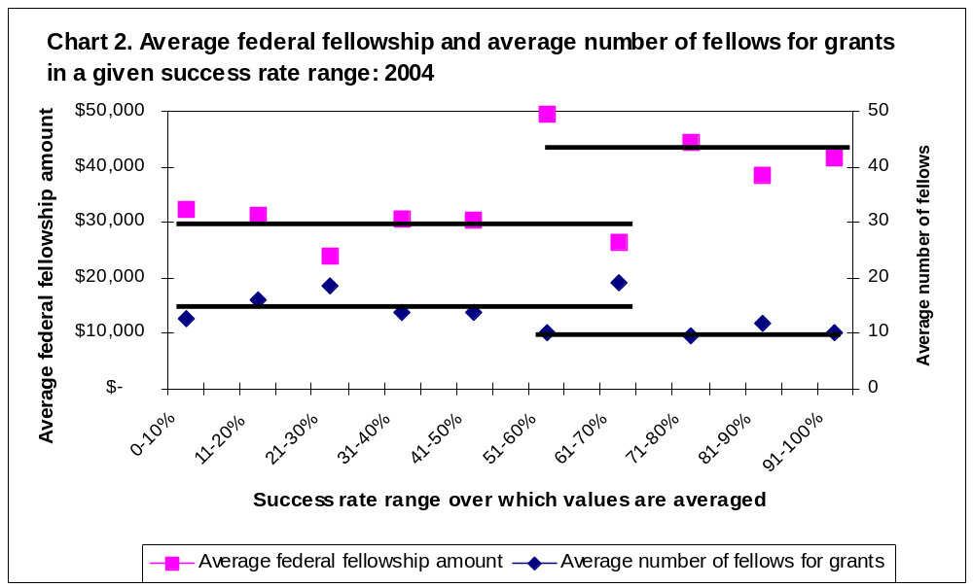

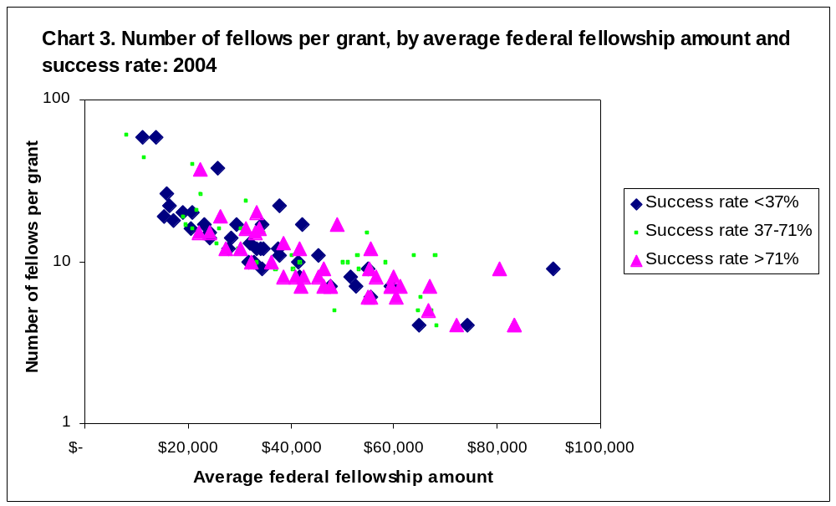

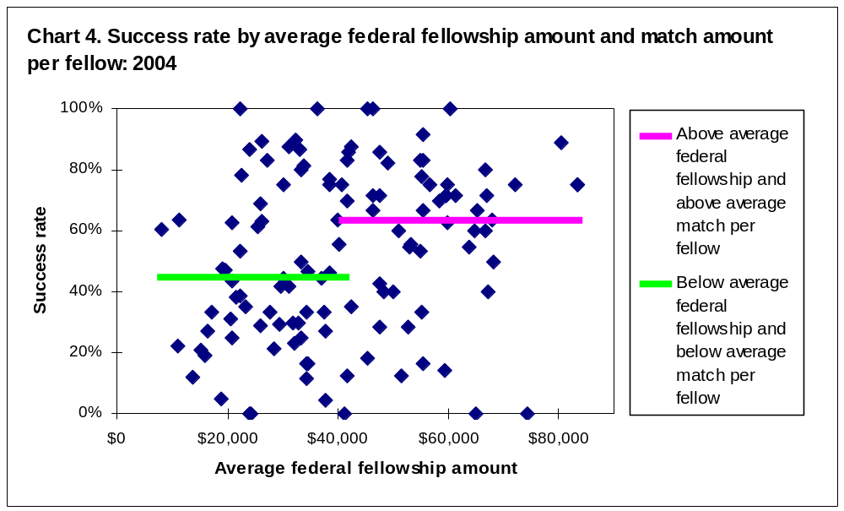

(IPEDS average of 2000-04 in-state average full-time graduate tuition and required full-time graduate fees (IC2000_AY, IC2001_AY, IC2002_AY, IC2003_AY, IC2004_AY).
www.collegeboard.com/highered/res/leb/leb.html accessed 6/19/2006.

