21st Century Community Learning Centers (21st CCLC) Analytic Support for Evaluation and Program Monitoring:
An Overview of the
21st CCLC Performance Data: 2008–09

July 26, 2010

U.S. Department of Education
Office of Elementary and Secondary Education

21st Century Community Learning Centers
Sylvia E. Lyles, Ph.D., Group Leader
Pilla Parker, Team Leader

Prepared by:
Neil Naftzger
Matthew Vinson
Learning Point Associates


1120 East Diehl Road, Suite 200
Naperville, IL 60563-1486
800-356-2735 • 630-649-6500
www.learningpt.org

This report was prepared for the U.S. Department of Education under contract number ED 1810-0668. The project officer is Stephen Balkcom of the Academic Improvement and Teacher Quality Programs.

This report is in the public domain. Authorization to reproduce it in whole or in part is granted. While permission to reprint this publication is not necessary, the suggested citation is as follows:

U.S. Department of Education (2010). 21st Century Community Learning Centers (21st CCLC) analytic support for evaluation and program monitoring: An overview of the 21st CCLC performance data: 2008–09 (Sixth Report). Washington, DC:

Contents

Executive Summary 1

Introduction 5

Section 1: Grantee and Center Characteristics 7
Grantee Type 7
Center Type 8
People Served 10
Activity Cluster 11
Staffing 16
Types of Employees 16
Staffing Clusters 17
Grade Level Served 22
Students and Grade Level 22
Centers and Grade Level 23
Estimated Per-Student Expenditures 24

Section 2: Performance on the GPRA Indicators 26
GPRA Indicator Results for 2007-08 28
Trends in GPRA Indicator Performance 30

Section 3: Indicator Performance by Key Subgroups 33
Indicator Performance by Activity Cluster 36
Indicator Performance by Center School-Based Status 40
Indicator Performance by Staffing Cluster 42
Indicator Performance by Per-Student Expenditure 45

Summary and Conclusions 47

References 49

Appendix A. Number of Centers Providing Grades and State Assessment Data 50

Appendix B. State Discretion in APR Reporting and Data Completeness 51

Executive Summary

For approximately ten years, the 21st Century Community Learning Centers (21st CCLC) program, as reauthorized by Title IV, Part B, of the No Child Left Behind (NCLB) Act of 2001, has provided students in high-poverty communities across the nation the opportunity to participate in academic enrichment and youth development programs designed to enhance their well-being. In crafting activities and programs to serve participating students and adult family members, centers funded by the 21st CCLC program have implemented a wide spectrum of program delivery, staffing, and operational models to help students improve academically as well as socially.

In this report, data collected through the 21st CCLC Profile and Performance Information Collection System (PPICS) have been synthesized to further inform an improved understanding of the intersection of program attributes and student achievement outcomes for children who participate in 21st CCLC programs. An Annual Performance Report (APR) is completed by grantees through PPICS once a year to summarize the operational elements of their program, the student population served, and the extent to which students improved in academic-related behaviors and achievement. One of the core purposes of the APR is to collect information on the Government Performance and Results Act (GPRA) performance indicators associated with the 21st CCLC program. These metrics, described in greater detail in Section 2, represent the primary mechanism by which the federal government determines the success and progress of the 21st CCLC program against clearly-defined, statutorily-based requirements.

Key findings of this report include:

- A total of 3,304 grantees representing 8,704 centers reported annual performance report data for 2008-09. These centers served a total of 1,506,852 students, with 754,338 of these attending 30 days or more.

- Approximately two thirds of centers in 2005–06, 2006-07, 2007–08, and 2008-09 served elementary students in some capacity, approximately 20 percent exclusively served middle school students, and 5 percent to ten percent exclusively served high school students. The percent of programs serving high school students has risen year-over-year since 2006, from five to six to eight to ten percent of programs, respectively.

- A total of 213,552 adult family members were provided with services in 2008-09. That is a decrease from the 223,165 adult family members served in 2007-08, but still higher than the 199,489 adult family members served in 2005-06 and 210,890 in 2006-07.

- School Districts (SD) were the largest grantee organization category, accounting for more than 65 percent of all grantees. Community Based Organizations (CBO) were the second largest grantee organization group accounting for more than 15 percent of grantees. Taken together, CBOs and Nationally Affiliated Nonprofit Agencies (NPAs) accounted for over 20 percent of all grantees.

- Approximately 89 percent of all centers are SDs; six percent are CBOs or NPAs.

- A total of 162,840 school year staff members were reported as serving in a role in afterschool programs. Of these, 38,999 were identified as volunteer staff.

- School-day teachers account for the largest percentage of paid staff at 45 percent. Non-teaching school staff account for the second largest at approximately 12 percent. For volunteer staff, college students account for the largest percentage at 24 percent with community members second at 20 percent. Similar trends are seen for other years.

- Of 4,032 centers reporting individual—as opposed to aggregated—activity data, nearly a fifth of centers were classified as falling within either the Mostly Homework Help (12 percent) or Mostly Tutoring clusters (7 percent); 22 percent were classified as Mostly Recreation; and 25 percent were classified as Mostly Enrichment. Thirty-four percent were classified as Variety.

- States have some flexibility in reporting GPRA-related data. For 2008-09, 53 percent of states provided grades data, 43 percent provided state assessment data, 81 percent provided teacher survey data, and 100 percent provided activity data.

- Nearly all of the performance targets for the 2008–09 reporting period were not reached. For the range of indicators related to regular attendee improvement in student achievement and behaviors, the only indicators where the performance target was reached were related to the percentage of regular program participants who were below proficient in mathematics or reading on 2007-08 state assessments who moved to proficient or above in 2008-09.

- Students who spend more time in programs (based on number of attendance days) tend to show greater improvement along several measures. For example, looking at State Assessment results across three years, students attending 60-89 days on average did better in mathematics than students attending 30-59 days. Students attending 90+ days, on average did better than students attending fewer than 90 days. Similar results hold true for other measures across all three years, with the exception of grades data for 2008-09, where improvement rates were relatively flat or slightly declined with increased attendance. Grades data for 2008-09 notwithstanding, suggest that there is a positive relationship between higher levels of participation in 21st CCLC programs and the likelihood that students will demonstrate improvement in student achievement and academic-related behaviors.
- Grade improvement rates for 2008-09 for both mathematics and reading fell compared with previous years’ improvement rates. It is not immediately clear why this is the case, as the trend is consistent across activity clusters, staffing clusters, grade levels, school-based status, cost-per-student quartile, and grant maturity. The trend is not consistent across states, but the decline is spread across enough states that no single state’s grades data seems to be causing the relative drop, whether through high 2007-08 rates or low 2008-09 rates. It should be noted that, across the same time frame, an increasingly higher proportion of students were reported as maintaining the highest grade possible across the span of the school year.

- Regular attendees in centers associated with the Mostly Teachers cluster were generally more apt to demonstrate an improvement in mathematics grades and state assessments in reading than regular attendees participating in programs with other staffing types. In particular, students in centers staffed by Mostly Teachers seemed to show consistently greater achievement along the attaining proficiency state assessment measures.

- In 2008-09, the average funding per student was $580. This is a slight drop from the previous two years where the funding per student was approximately $594. (Note that per-student funding does not take other sources of funding into account. See Estimated Per-Student Expenditures for an explanation of how these numbers are calculated.)

- There is a large jump in the average estimated per-student expenditure moving from the third to the fourth quartile. It appears that there is a fair degree of variation among centers classified within this fourth quartile, with the range of funding levels spanning $1,220 to $7,252 in 2005–06, $1,221 to $10,417 in 2006-07, $1,231 to $10,000 in 2007-08, and $1,213 to $5,037 in 2008-09.

- In relation to the mathematics-related measures, there is an overall positive, linear trend in the percentage of regular attendees witnessing an improvement in state assessment results as the level of funding increases. This linear trend especially is pronounced and consistent in relation to the state assessment measures related to the percentage of regular attendees attaining proficiency (Attained Prof), though there is a slight drop between the third and fourth quartiles. The results for reading/language arts grades and state assessment measures are very similar to these findings.

- Preliminary evidence outlined in this report suggests that programs providing Mostly Tutoring services appear to have a slight advantage in contributing to mathematics and reading achievement for grades, while centers staffed mostly by teachers and centers receiving higher levels of funding per student seem to demonstrate higher levels of achievement in both mathematics and reading. More rigorous investigation and focus should be centered on program effectiveness based on the staffing model employed by centers and of school-based and non-school-based afterschool programs, especially in the area of the allocation and distribution of funds.

Building on these key findings, there are four trends worthy of special note: First, it appears that there is a fairly strong relationship between student levels of participation (attendance) and student progress (performance indicators). Second, improvement rates for mathematics and reading grades dropped from prior years’ improvement rates, and did so consistently across all sub-categories. Third, students attending centers classified as falling within the Mostly Tutoring cluster appear more likely to demonstrate an improvement in both mathematics and reading grades. Finally, data on staffing suggest the possibility of a relationship between staffing type and student outcomes. In particular, students in centers associated with the Mostly Teachers staffing cluster were generally more apt to attain proficiency in both mathematics and reading.

Introduction

For approximately ten years, the 21st Century Community Learning Centers (21st CCLC) program, as reauthorized by Title IV, Part B, of the No Child Left Behind (NCLB) Act of 2001, has provided students in high-poverty communities across the nation the opportunity to participate in academic enrichment and youth development programs designed to enhance their well-being. In crafting activities and programs to serve participating students and adult family members, the 21st CCLCs have implemented a wide spectrum of program delivery, staffing, and operational models to help students improve academically as well as socially.

As suggested by research conducted on afterschool programming, the Department is interested in the types of program features that are likely to produce a positive impact on student achievement (Birmingham, Pechman, Russell, & Mielke, 2005; Black, Doolittle, Zhu, Unterman, & Grossman, 2008; Durlak & Weissberg, 2007; Granger, 2008; Lauer, Akiba, Wilkerson, Apthorp, Snow, & Martin-Glenn, 2006; Vandell et al., 2005). To date, research efforts suggest that a variety of paths can be taken in both the design and delivery of afterschool programs that may lead to improved student academic outcomes in both reading and mathematics. These strategies include (1) paying special attention to the social processes and environments in which services are being provided and how these services are delivered (in what Durlak and Weissberg [2007, p. 7] describe as “sequenced, active, focused and explicit”), (2) delivering tutoring-like services and activities (Lauer et al., 2006), (3) placing an emphasis on skill building and mastery (Birmingham et al., 2005), and (4) providing activities in accordance with explicit, research-based curricular models and teaching practices designed for the afterschool setting (Black et al., 2008).

In this report, data collected through the 21st CCLC Profile and Performance Information Collection System (PPICS) have been synthesized to further inform an improved understanding of the intersection of program attributes and student achievement outcomes for children who participate in 21st CCLC programs. Funded by the U.S. Department of Education, PPICS is a Web-based system designed to collect, from all active 21st CCLCs, comprehensive descriptive information on program characteristics and services as well as performance data across a range of outcomes. PPICS consists of various data collection modules, including the Annual Performance Report (APR) completed by grantees once a year to summarize the operational elements of their program, the student population served, and the extent to which students improved in academic-related behaviors and achievement. In addition, one of the core purposes of the APR is to collect information on the Government Performance and Results Act (GPRA) performance indicators associated with the 21st CCLC program. These metrics, described in greater detail in Section 2, represent the primary mechanism by which the federal government determines the success and progress of the 21st CCLC program against clearly defined statutorily based requirements.

The current GPRA indicators and PPICS data provide comprehensive information on the 21st CCLC program that can be exceptionally useful in identifying additional areas of inquiry related to program effectiveness and efficiency.

In Section 1 of this report, extensive descriptive information is provided on the domain of centers active during the 2008–09 reporting period, including analyses of the activity delivery and staffing approaches taken by 21st CCLCs, grade levels served, school-based status, and estimated per-student expenditure.

In Section 2, information on 21st CCLC program performance during the 2008–09 reporting period relative to the GPRA indicators, including information on the relationship between higher levels of student participation and the likelihood of student academic improvement, is outlined.

Finally, in Section 3, findings related to the intersection of program characteristics and student improvement in academic-related behaviors and achievement are described. In this final section, particular emphasis is given to a set of program characteristics that are worthy of further, more rigorous study in assessing how they impact the likelihood that 21st CCLC-funded programs will achieve desired student academic outcomes.

Section 1: Grantee and Center Characteristics

Grantee Type

One of the hallmarks of the 21st CCLC program is that all types of entities are eligible to apply for State-administered 21st CCLC grants, including, but not limited to, school districts, charter schools, private schools, community-based organizations, nationally affiliated nonprofit organizations (e.g., Boys and Girls Clubs, YMCAs, etc.), faith-based organizations, and for-profit entities. These applicants are referred to in this report as grantees.

As shown in Table 1, School Districts (SD) were the largest grantee organization category every year from 2005-06 to 2008-09, accounting for more than 64percent of all grantees each year. Community Based Organizations (CBO) were the second largest grantee organization group accounting for more than 15 percent of grantees each year. It should also be noted that Nationally-Affiliated Non-Profit Agencies (NPAs) like Boys and Girls Clubs and YMCAs/YWCAs accounted for more than 4 percent of grantees each year. Taken together, CBOs and NPAs accounted for over 19 percent of all grantees each year.

Table 1. Grantees by Organization Type
 | N |  |  |  | Percent
Grantee Type | 2005-06 | 2006-07 | 2007-08 | 2008-09 | 2005-06 | 2006-07 | 2007-08 | 2008-09
Unknown | 0 | 1 | 1 | 5 | 0.0% | 0.0% | 0.0% | 0.2%
CBO | 447 | 488 | 496 | 545 | 15.0% | 15.7% | 15.3% | 16.5%
COU | 44 | 49 | 50 | 55 | 1.5% | 1.6% | 1.5% | 1.7%
CS | 63 | 68 | 81 | 85 | 2.1% | 2.2% | 2.5% | 2.6%
FBO | 48 | 57 | 60 | 66 | 1.6% | 1.8% | 1.9% | 2.0%
FPC | 16 | 19 | 13 | 21 | 0.5% | 0.6% | 0.4% | 0.6%
NPA | 129 | 127 | 151 | 163 | 4.3% | 4.1% | 4.7% | 4.9%
Other | 206 | 205 | 234 | 242 | 6.9% | 6.6% | 7.2% | 7.3%
SD | 2,018 | 2,098 | 2,150 | 2,122 | 67.9% | 67.4% | 66.4% | 64.2%
Total | 2,971 | 3,112 | 3,236 | 3,304 | 100.0% | 100.0% | 100.0% | 100.0%

Center Type

While grantees are the organizations that apply for and receive funds, each grantee in turn may operate several centers, which are the physical places where student activities actually occur. Center types include school districts, charter schools, private schools, community-based organizations, nationally affiliated nonprofit organizations (e.g., Boys and Girls Clubs, YMCAs, etc.), faith-based organizations, and for-profit entities. As shown in Table 2, approximately 88 percent of centers were housed in school district buildings in 2008-09. Approximately 5 percent of centers were housed in community-based organization buildings in 2008-09, making this the second largest category. All other categories are at less than 3%. This general trend held true for the previous two years as well.

Table 2. Centers by Type
 | N |  |  |  | Percent
Center Type | 2005-06 | 2006-07 | 2007-08 | 2008-09 | 2005-06 | 2006-07 | 2007-08 | 2008-09
Unknown* | 5 | 6 | 5 | 14 | 0.1% | 0.1% | 0.1% | 0.2%
CBO | 332 | 347 | 381 | 389 | 3.5% | 3.9% | 4.2% | 4.5%
COU | 23 | 26 | 27 | 21 | 0.2% | 0.3% | 0.3% | 0.2%
CS | 89 | 92 | 105 | 118 | 1.0% | 1.0% | 1.2% | 1.4%
FBO | 120 | 129 | 125 | 128 | 1.3% | 1.4% | 1.4% | 1.5%
FPC | 9 | 9 | 8 | 6 | 0.1% | 0.1% | 0.1% | 0.1%
NPA | 183 | 176 | 200 | 170 | 2.0% | 2.0% | 2.2% | 2.0%
Other | 162 | 166 | 166 | 174 | 1.7% | 1.8% | 1.8% | 2.0%
SD | 8,430 | 8,036 | 8,036 | 7,684 | 90.1% | 89.4% | 88.8% | 88.3%
Total | 9,353 | 8,987 | 9,053 | 8,704 | 100.0% | 100.0% | 100.0% | 100.0%

In addition to the detailed categories shown above, centers can also be grouped based on two larger categories, school-based and non-school-based. There are some clear differences logistically for students and staff depending on whether centers are in school-based buildings or not. For example, at school-based centers, school-day materials would be more easily accessible, and students and staff would not have to deal with travel between the end of the school day and the start of 21st CCLC programs. It is possible that operating a center at a non-school-based site may hinder efforts to develop strong and meaningful connections between the afterschool program and school-day instruction and curriculum, potentially requiring the expenditure of a greater degree of effort to establish these linkages.

However, it also is possible that teachers hired to work in a non-school-based site with youth they teach during the school day may find the afterschool setting liberating in some respects, allowing them to design and deliver learning opportunities that would never be possible during the school day or even within the confines of the school building. Ultimately, it is possible that a number of factors associated with the school-based or non-school-based status of a site could have a bearing on the types of opportunities offered and outcomes expected.

As shown in Figure 1, approximately 90 percent of centers were housed in schools; the other centers were located at a variety of non-school-based sites. Differences in certain types of student outcomes were found between school-based and non-school-based centers. These differences are explored more thoroughly in Section 3 of this report.

Figure 1. Number of 21st CCLCs by School-Based Status
During the 2005–06, 2006-07, 2007–08, and 2008–09 Reporting Periods
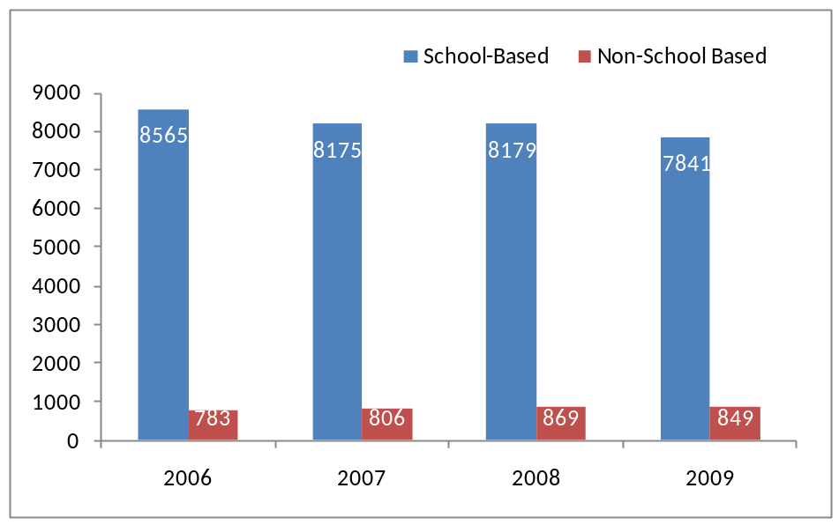

 | N |  |  |  | Percent
School-Based Status | 2006 | 2007 | 2008 | 2009 | 2006 | 2007 | 2008 | 2009
* MISSING | 5 | 6 | 5 | 14 | - | - | - | -
School-Based | 8565 | 8175 | 8179 | 7841 | 91.6% | 91.0% | 90.4% | 90.2%
Non-School-Based | 783 | 806 | 869 | 849 | 8.4% | 9.0% | 9.6% | 9.8%

People Served

As part of the APR submission process, centers are asked to report on the total number of students they served during the reporting period. In addition, students who attend 30 days or more are considered to be in a special category called regular attendees. As shown in Table 3, there were 1,506,852 students who attended 21st CCLC programming in 2008-09. Of those, 754,338 or 50 percent were regular attendees.

Table 3: Total and Regular Attendee Students per Year
APR Year | Total Students | Total Regular Attendee Students
2006 | 1,433,713 | 795,955
2007 | 1,388,776 | 753,307
2008 | 1,416,154 | 757,962
2009 | 1,506,920 | 754,338

Table 4 shows where students participated in 21st CCLC activities by center type. In 2008-09 for example, over 90 percent of students attended centers housed in school district (SD) buildings. Community Based Organization (CBO)-housed centers accounted for the second highest percentage of students at just over 3 percent. Ninety percent of all regular attendees in 2009 attended programming in centers housed in school district (SD) buildings. Community-Based Organization (CBO) centers accounted for the second highest percentage of regular attendees at over 3 percent. Similar trends are seen for 2005-06, 2006-07, and 2007-08.

Table 4: Total and Regular Attendees by Center Type
Center Type | 2006 |  | 2007 |  | 2008 |  | 2009
 | Total Students | Regular Attendees | Total Students | Regular Attendees | Total Students | Regular Attendees | Total Students | Regular Attendees
Unknown | 0.03% | 0.04% | 0.06% | 0.05% | 0.03% | 0.02% | 0.10% | 0.12%
CBO | 2.58% | 2.53% | 2.68% | 2.77% | 2.72% | 3.29% | 3.01% | 3.56%
COU | 0.13% | 0.13% | 0.35% | 0.29% | 0.33% | 0.26% | 0.24% | 0.17%
CS | 0.98% | 1.22% | 1.10% | 1.24% | 1.36% | 1.52% | 1.62% | 1.83%
FBO | 0.54% | 0.67% | 0.66% | 0.79% | 0.67% | 0.80% | 0.72% | 0.94%
FPC | 0.05% | 0.07% | 0.05% | 0.04% | 0.04% | 0.04% | 0.03% | 0.04%
NPA | 2.26% | 2.31% | 2.70% | 2.56% | 2.97% | 3.03% | 1.99% | 2.15%
Other | 1.41% | 1.38% | 1.62% | 1.61% | 1.74% | 1.57% | 1.59% | 1.38%
SD | 92.03% | 91.66% | 90.79% | 90.65% | 90.14% | 89.47% | 90.70% | 89.81%

Centers were also open to the adult family members of student attendees. Here again information about the number of adult family members served by a given center during the reporting period was obtained via the APR. As shown in Table 5, 213,552 adult family members were provided with services in 2008-09. That is a decrease from the 223,042 adult family members served in 2007-08.

Table 5: Family Members Served
 | 2006 | 2007 | 2008 | 2009
Family Members Served | 199,489 | 210,857 | 223,042 | 213,552

Activity Cluster

The mission of the 21st CCLC program is to provide academic and other enrichment programs that reinforce and complement the regular academic program of participating students. Generally, this broad mandate encompasses a host of different types of activities, including the following activity categories:
- Academic enrichment learning programs
- Tutoring
- Supplemental educational services
- Homework help
- Mentoring
- Recreational activities
- Career or job training for youth
- Drug and violence prevention, counseling, and character education programs
- Expanded library service hours
- Community service or service-learning programs
- Activities that promote youth leadership

Given the wide range of activities that an individual 21st CCLC could provide, a series of “activity clusters” were identified based on the relative emphasis given to providing the categories of activities listed previously during the 2005–06, 2006-07, 2007–08, and 2008-09 school years. To do this clustering, 21st CCLC activity data were used to calculate the percentage of total hours of center programming allocated to each of the activity categories. This was done by multiplying the number of weeks an activity was provided by the number of days per week it was provided by the number of hours provided per session. These products were then summed by activity category for a center. The center-level summations by category were then divided by the total number of hours of activity provided by a center to determine the percentage of hours a given category of activity was offered. Based on the results of these calculations, the following question can be answered: What percentage of a center’s total activity hours was dedicated to academic enrichment, tutoring, homework help, etc?

In order to further summarize the data related to the 21st CCLC activity provision, K-Means cluster analysis was employed using the center-level percentages for each category of activity. Cluster analysis is typically employed to combine cases into groups using a series of variables as criteria to determine the degree of similarity between individual cases, and it is particularly well-suited when there is a desire to classify a large number of cases into a smaller domain of discrete groupings. In this case, employing cluster analysis resulted in the identification of five primary program clusters defined by the relative emphasis centers placed on offering one or more programming areas during the course of the 2005–06, 2006-07, 2007–08, and 2008-09 school years. Following are the five clusters:
- Centers mostly providing tutoring activities
- Centers mostly providing homework help
- Centers mostly providing recreational activities
- Centers mostly providing academic enrichment
- Centers providing a wide variety of activities across multiple categories

It is important to note that the data used to assign centers to program clusters were available only from states that employed the individual activities reporting option in PPICS for the 2005–06, 2006-07, 2007–08, and/or 2008-09 reporting periods. For clarification, one of the foundational design elements of PPICS was to construct a system made up of two primary types of data: (1) data that would be supplied by all 21st CCLCs and (2) data that could vary based on a series of options afforded to SEAs to customize the APR to meet the unique data and reporting needs of the state. Activities data collected in PPICS is an example of the latter approach. In this case, states supply data using (1) an aggregated approach in which sites identify the typical number of hours per week a given category of activity was provided or (2) an individual activities approach in which each discrete activity provided by a center (e.g., a rocketry club that met from 4:00 p.m. to 5:00 p.m. each Tuesday and Thursday for eight weeks during the school year) is added to the system as a separate record. The cluster analysis described in this report relies on data supplied by states that required their grantees to report activities data through the individual activities reporting option (22 states in 2005–06, 27 states in 2006-07, 26 states in 2007–08, and 25 states in 2008-09).

As shown in Figure 2, the relative distribution of centers across each cluster type was found to be quite stable across the three reporting periods, with the majority of centers falling in either the Variety or Mostly Enrichment cluster. Nearly a fifth of centers were classified as falling within either the Mostly Homework Help or Mostly Tutoring clusters, while 20 percent of centers in each year were identified as providing Mostly Recreation programming.

Figure 2. Primary Program Clusters Based on Activity Data Provided
in Relation to the 2005–06, 2006-07, 2007–08, and 2008–09 School Years
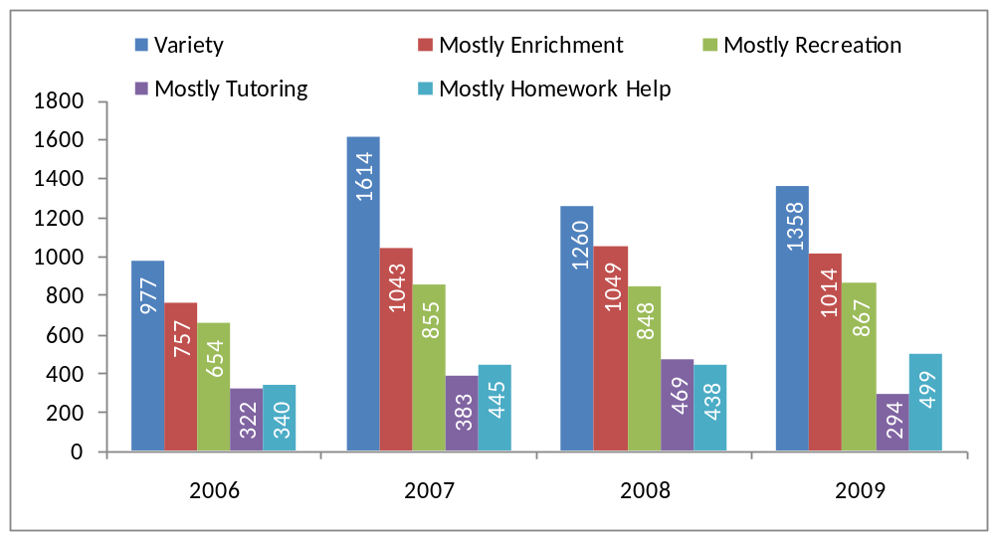

 | N |  |  |  | Percent
Activity Cluster | 2006 | 2007 | 2008 | 2009 | 2006 | 2007 | 2008 | 2009
Unknown* | 5,899 | 4,383 | 4,829 | 4,655 | - | - | - | -
Variety | 977 | 1,614 | 1,260 | 1,358 | 32% | 37% | 31% | 34%
Mostly Enrichment | 757 | 1043 | 1049 | 1014 | 25% | 24% | 26% | 25%
Mostly Recreation | 654 | 855 | 848 | 867 | 21% | 20% | 21% | 22%
Mostly Tutoring | 322 | 383 | 469 | 294 | 11% | 9% | 12% | 7%
Mostly Homework Help | 340 | 445 | 438 | 499 | 11% | 10% | 11% | 12%

*Primarily includes centers in states electing not to report individual activities data.

While the overall number of centers falling within a given cluster seems stable across years, a relatively high percentage of centers changed cluster membership from one year to the next (see Tables 6 through 8). In addition, the degree of change in terms of the relative emphasis given to certain categories often was fairly dramatic. Of the centers represented both in the 2007–08 and 2008–09 cluster analyses, nearly half were classified in a different cluster based on data supplied for 2008–09 than the cluster they were identified as falling within based on their 2007–08 submission. A similar trend can be seen when examining the change over two or three years.

As shown in Table through Table 8, centers initially classified as offering Mostly Enrichment or Mostly Recreation were the most likely to remain in the same cluster from 2005-06 to 2008–09 (48 and 46 percent remained in these clusters, respectively), from 2006-07 to 2008-09 (54 and 53 percent remained in these clusters, respectively), and from 2007-08 to 2008-09 (62 and 55 percent remained in these clusters, respectively). The cluster witnessing the greatest degree of turnover for the three year period from 2005-06 to 2008-09 was Mostly Homework Help where only 28% of centers remained in this cluster. The cluster witnessing the greatest degree of turnover for the two year period from the 2006-07 to the 2008–09 reporting period was the Mostly Tutoring cluster where only 41 percent of centers initially classified in this group remained in this cluster the next year. Roughly equivalent levels of turnover, 45 percent, were witnessed by the Mostly Tutoring and Mostly Homework Help clusters for the one year period from the 2007-08 to the 2008-09 reporting period.

Table 6. Comparison of Activities Cluster Membership Between 2005–06 and 2008–09—Percentage of Centers Remaining in the Same Cluster and Moving to Other Cluster Types
 | 2008-09 Cluster Membership
2005-06 Cluster Membership | Mostly Recreation | Mostly Tutoring | Variety | Mostly Enrichment | Mostly Homework Help
Mostly Recreation | 46% | 3% | 26% | 13% | 12%
Mostly Tutoring | 12% | 32% | 23% | 11% | 21%
Variety | 18% | 6% | 45% | 20% | 11%
Mostly Enrichment | 9% | 6% | 26% | 48% | 11%
Mostly Homework Help | 15% | 9% | 33% | 15% | 28%

Table 7. Comparison of Activities Cluster Membership Between 2006-07 and 2008-09—Percentage of Centers Remaining in the Same Cluster and Moving to Other Cluster Types
 | 2008-09 Cluster Membership
2006-07 Cluster Membership | Mostly Recreation | Mostly Tutoring | Variety | Mostly Enrichment | Mostly Homework Help
Mostly Recreation | 53% | 3% | 25% | 14% | 5%
Mostly Tutoring | 8% | 41% | 29% | 11% | 12%
Variety | 19% | 5% | 50% | 16% | 9%
Mostly Enrichment | 8% | 4% | 27% | 54% | 7%
Mostly Homework Help | 9% | 10% | 19% | 15% | 46%

Table 8. Comparison of Activities Cluster Membership Between 2007-08 and 2008-09—Percentage of Centers Remaining in the Same Cluster and Moving to Other Cluster Types
 | 2008-09 Cluster Membership
2007-08 Cluster Membership | Mostly Recreation | Mostly Tutoring | Variety | Mostly Enrichment | Mostly Homework Help
Mostly Recreation | 55% | 2% | 27% | 12% | 3%
Mostly Tutoring | 8% | 45% | 20% | 12% | 14%
Variety | 14% | 7% | 54% | 15% | 10%
Mostly Enrichment | 9% | 4% | 22% | 62% | 5%
Mostly Homework Help | 10% | 7% | 22% | 16% | 45%

It is also interesting to note that centers that changed clusters between the two years also were more likely to report substantial changes across years in the percentage of total hours offered in core activities. An example would be a center that dedicated 70 percent of the total programming hours to tutoring activities in 2005–06 but only 30 percent of their total activity hours to tutoring in 2007–08. As shown in Table 9, for the three year period from 2005-06 to 2008-09, 87 percent of centers that changed clusters had at least one activity category in which the percentage of total hours represented by that category changed by at least 20 percentage points (for example, from 70 percent to 50 percent of total activity hours offered); 40 percent of centers in this group witnessed at least one area where the change was more than 50 percentage points (for example, from 75 percent to 25 percent). As shown in Table10, during the 2006-07 to 2008-09 time period, 87 percent of centers that changed clusters had at least one activity category in which the percentage of total hours represented by that category changed by at least 20 percentage points; 35 percent of centers in this group witnessed at least one area where the change was more than 50 percentage points. For the 2007-08 to 2008-09 time period as shown in Table 11, 81 percent of centers that changed clusters had at least one activity category in which the percentage of total hours represented by that category changed by at least 20 percentage points; 33 percent of centers in this group witnessed at least one area where the change was more than 50 percentage points.

In some circumstances, such fluctuations would be expected, especially among first and second year programs as efforts are undertaken to ferret out what works and doesn’t work from a service provision standpoint. In addition, many states reduce grant levels in the fourth and/or fifth year of funding to encourage sustainability efforts. In some cases, centers will need to make significant modifications to both their activity and staffing models in light of reduced funding levels.

Table 9. Percentage of Centers Witnessing a Change in the Percentage of Total Hours Offered in One or More Categories
2006 to 2009 | Percentage of centers witnessing a change in the percentage of total hours offered in one or more categories of at least…
Cluster Change Status | 10 percent | 20 percent | 50 percent
Changed Clusters | 98% | 87% | 40%
Same Cluster | 84% | 56% | 5%

Table10. Percentage of Centers Witnessing a Change in the Percentage of Total Hours Offered in One or More Categories
2007 to 2009 | Percentage of centers witnessing a change in the percentage of total hours offered in one or more categories of at least…
Cluster Change Status | 10 percent | 20 percent | 50 percent
Changed Clusters | 98% | 87% | 35%
Same Cluster | 77% | 45% | 4%

Table 11. Percentage of Centers Witnessing a Change in the Percentage of Total Hours Offered in One or More Categories
2008 to 2009 | Percentage of centers witnessing a change in the percentage of total hours offered in one or more categories of at least…
Cluster Change Status | 10 percent | 20 percent | 50 percent
Changed Clusters | 96% | 81% | 33%
Same Cluster | 66% | 37% | 3%

Staffing

The quality of center staffing is a crucial factor in the success of afterschool programming (Vandell, Reisner, Brown, Pierce, Dadisman, & Pechman, 2004), and many of the program improvement approaches being used in the field emphasize the importance of staff for creating positive developmental settings for youth. In this regard, the success of afterschool programs is critically dependent on students forming personal connections with the staff, especially for programs serving older students where a much wider spectrum of afterschool options and activities are available to these youth (Eccles & Gootman, 2002; Rosenthal & Vandell, 1996).

Types of Employees
Staff members for 21st CCLC programs come from many sources including teachers, parents, and local college students. Some are paid, while others serve as volunteers. As shown in Table , for the 2008-09 school year, school-day teachers account for the largest percentage of paid staff at 45 percent. Non-teaching school staff account for the second largest at approximately 12 percent. As for volunteer staff, college students account for the largest percentage at 24 percent with community members second at 20 percent.

Table 12. 2008-09 Staffing Types
Staff Type | Paid Staff | Percent Paid Staff | Volunteer Staff | Percent Volunteer Staff
School-day teachers | 56,006 | 45% | 2,845 | 7%
College students | 10,635 | 9% | 9,269 | 24%
High school students | 4,827 | 4% | 7,055 | 18%
Parents | 1,232 | 1% | 6,581 | 17%
Youth development workers | 10,360 | 8% | 2,114 | 5%
Other community members | 3,288 | 3% | 7,817 | 20%
Other non-teaching school staff | 15,411 | 12% | 1,386 | 4%
Center administrators and coordinators | 10,219 | 8% | 488 | 1%
Other nonschool-day staff with some or no college | 8,924 | 7% | 850 | 2%
Other | 3,049 | 2% | 609 | 2%
Total | 123,951 | 100% | 39,014 | 100%
Staffing Clusters
Similar to the activities clusters, we classified centers into clusters based on the extent to which they relied on different categories of staff to deliver programming during the 2005–06, 2006-07, 2007–08, and 2008-09 school years. Each of these staff categories are a combination of the different staff types above. As shown in Figure 3, five primary staffing models were identified:
- Centers staffed mostly by school-day teachers
- Centers staffed mostly by a combination of youth development workers, school day teachers, and other staff with a college degree
- Centers staffed mostly by college students and school day teachers
- Centers staffed mostly by other staff with some or no college, and school day teachers
- Centers staffed by other staff, with school day teachers

Note that teachers, at least to some extent, were involved in each of the staffing clusters outlined in Figure 3, although the degree of involvement varied significantly from one cluster to the next. For example, on average, centers falling within the Mostly Teachers cluster had school-day teachers making up over 76 percent of their school year staff. By comparison, centers identified as falling within the Mostly Youth Development Workers, School Day Teachers, and Other Staff with College and Mostly Other Staff with School Day Teachers were found on average to have 25 percent and 21 percent of their school-year afterschool staff made up of school-day teachers, respectively. Centers staffed by Mostly Other Staff with Some or No College and School Day Teachers and Mostly College Students with Some or No College had the lowest average rate of teacher involvement, at 18 percent and 15 percent, respectively.

Figure 3. Primary Staffing Clusters Based on Staffing Data Provided
in Relation to the 2005–06, 2006-07, 2007–08, and 2008-09 School Years
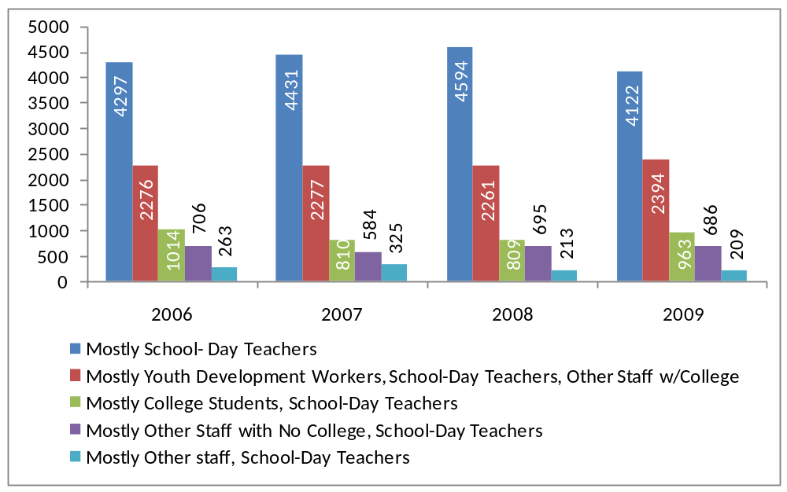

 | N |  |  |  | Percent
Activity Cluster | 2006 | 2007 | 2008 | 2009 | 2006 | 2007 | 2008 | 2009
Unknown | 281 | 281 | 293 | 304 | - | - | - | -
Mostly School- Day Teachers | 4297 | 4431 | 4594 | 4122 | 50.2% | 52.6% | 53.6% | 49.2%
Mostly Youth Development Workers, School-Day Teachers, Other Staff w/College | 2276 | 2277 | 2261 | 2394 | 26.6% | 27.0% | 26.4% | 28.6%
Mostly College Students, School-Day Teachers | 1014 | 810 | 809 | 963 | 11.9% | 9.6% | 9.4% | 11.5%
Mostly Other Staff with No College, School-Day Teachers | 706 | 584 | 695 | 686 | 8.3% | 6.9% | 8.1% | 8.2%
Mostly Other staff, School-Day Teachers | 263 | 325 | 213 | 209 | 3.1% | 3.9% | 2.5% | 2.5%

Similar to the analysis of activity patterns, note that the overall distribution of centers across each of the categories identified in Figure 3 was consistent across the 2005–06, 2006-07, 2007–08, and 2008-09 reporting periods. Here again, an effort also was made to explore how likely it was that a center would move from one cluster to another between the years. In this case, it was found that 42 percent of centers moved from one cluster to another between 2005–06 and 2008–09, 36 percent of centers moved from one cluster to another between 2006-07 and 2008-09, and 33 percent of centers moved from one cluster to another between 2007-08 and 2008-09. As shown in Table 13 through Table 15, centers falling within the Mostly Teachers cluster by far demonstrated the most consistency across years, with 75 percent of centers classified in this group in 2005–06 remaining in this cluster in 2008–09, 79 percent of centers classified in this group in 2006-07 remaining in this cluster in 2008-09, and 81 percent of centers classified in this group in 2007-08 remaining in this cluster in 2008-09. The Mostly Youth Development Workers, School Day Teachers, and Other Staff with College cluster demonstrated the highest average influx in terms of centers initially classified in a different cluster in 2005–06, 2006-07, and 2007-08 that moved into this cluster in 2008–09.

Table 13. Comparison of Staffing Cluster Membership between 2005–06 and 2008–09— Percentage of Centers Remaining in the Same Cluster and Moving to Other Cluster Types
 | 2008-09 Cluster Membership
2005-06 Cluster Membership | Mostly Youth Development, School-Day Teachers, Other Staff w/College | Mostly College Students, School-Day Teachers | Mostly Other No College, School-Day Teachers | Mostly Other staff, School-Day Teachers | Mostly School-Day Teachers
Mostly Youth Development, School-Day Teachers, Other Staff w/College | 47% | 10% | 11% | 3% | 28%
Mostly College Students, School-Day Teachers | 26% | 44% | 8% | 2% | 20%
Mostly Other No College, School-Day Teachers | 43% | 16% | 21% | 1% | 19%
Mostly Other staff, School-Day Teachers | 33% | 9% | 9% | 17% | 32%
Mostly School-Day Teachers | 17% | 3% | 4% | 1% | 75%

Table 14. Comparison of Staffing Cluster Membership between 2006-07 and 2008-09 — Percentage of Centers Remaining in the Same Cluster and Moving to Other Cluster Types
 | 2007-08 Cluster Membership
2006-07 Cluster Membership | Mostly Youth Development, School-Day Teachers, Other Staff w/College | Mostly College Students, School-Day Teachers | Mostly Other No College, School-Day Teachers | Mostly Other staff, School-Day Teachers | Mostly School-Day Teachers
Mostly Youth Development, School-Day Teachers, Other Staff w/College | 52% | 8% | 11% | 2% | 27%
Mostly College Students, School-Day Teachers | 25% | 53% | 9% | 1% | 12%
Mostly Other No College, School-Day Teachers | 35% | 16% | 26% | 1% | 21%
Mostly Other staff, School-Day Teachers | 28% | 9% | 7% | 33% | 22%
Mostly School-Day Teachers | 15% | 3% | 3% | 1% | 79%

Table 15. Comparison of Staffing Cluster Membership between 2007-08 and 2008-09 — Percentage of Centers Remaining in the Same Cluster and Moving to Other Cluster Types
 | 2007-08 Cluster Membership
2007-08 Cluster Membership | Mostly Youth Development, School-Day Teachers, Other Staff w/College | Mostly College Students, School-Day Teachers | Mostly Other No College, School-Day Teachers | Mostly Other staff, School-Day Teachers | Mostly School-Day Teachers
Mostly Youth Development, School-Day Teachers, Other Staff w/College | 56% | 9% | 9% | 1% | 24%
Mostly College Students, School-Day Teachers | 25% | 59% | 7% | 1% | 9%
Mostly Other No College, School-Day Teachers | 27% | 23% | 34% | 1% | 14%
Mostly Other staff, School-Day Teachers | 17% | 7% | 8% | 47% | 21%
Mostly School-Day Teachers | 13% | 3% | 3% | 1% | 81%

Centers that changed clusters between the two years were more likely to witness at least one large change across years in the percentage of staff in a given category that worked in the center. For example, a center may have reported that 70 percent of its staff members in 2005–06 were school-day teachers while in 2008–09 it reported that teachers made up only 30 percent of the total paid staff. As shown in Table16, for the three year period from 2005-06 to 2008-09, 92 percent of centers that changed clusters had at least one staffing category in which the percentage of total staff represented by that category changed by at least 20 percentage points (for example, from 70 percent to 50 percent of total staff); 44 percent of centers in this group witnessed at least one area where the change was more than 50 percentage points (for example, from 75 percent to 25 percent). As shown in Table17, for the period from 2006-07 to 2008-09, 89 percent of centers that changed clusters had at least one staffing category in which the percentage of total staff represented by that category changed by at least 20 percentage points; 41percent of centers in this group witnessed at least one area where the change was more than 50 percentage points. As shown in Table 18, for the period from 2007-08 to 2008-09, 84 percent of centers that changed clusters had at least one staffing category in which the percentage of total staff represented by that category changed by at least 20 percentage points; 39 percent of centers in this group witnessed at least one area where the change was more than 50 percentage points.

Table 16. Percentage of Centers Witnessing a Change in the Percentage of
Total Paid Staff in One or More Categories
2006 to 2009 | Percentage of centers witnessing a change in the percentage of total hours offered in one or more categories of at least…
Cluster Change Status | 10 percent | 20 percent | 50 percent
Changed Clusters | 100% | 92% | 44%
Same Cluster | 77% | 50% | 7%

Table 17. Percentage of Centers Witnessing a Change in the Percentage of
Total Paid Staff in One or More Categories
2007 to 2009 | Percentage of centers witnessing a change in the percentage of total hours offered in one or more categories of at least…
Cluster Change Status | 10 percent | 20 percent | 50 percent
Changed Clusters | 98% | 89% | 41%
Same Cluster | 74% | 45% | 5%

Table 18. Percentage of Centers Witnessing a Change in the Percentage of
Total Paid Staff in One or More Categories
2008 to 2009 | Percentage of centers witnessing a change in the percentage of total hours offered in one or more categories of at least…
Cluster Change Status | 10 percent | 20 percent | 50 percent
Changed Clusters | 97% | 84% | 39%
Same Cluster | 67% | 38% | 4%

Students and Grade Level

Table 19 shows the number of students served per grade level in 2008-09. The distribution is broad with grades 3 through 6 having the highest total number of students attending. Each of those grades account for approximately 10 percent of all student attendees. Students, who attend programming for 30 days or more, are considered to be in a special category called regular attendees. As shown in Table 19, grades 2 through 6 have the highest number of regular attendees with each grade level accounting for over 10 percent of all regular attendees.

Table 19. Students per Grade Level in 2008-09
 | Total Student Attendees |  | Total Regular Student Attendees
Grade Level | Number of Students | Percent of Students | Number of Students | Percent of Students
Pre-K | 7,366 | 1% | 3,793 | 1%
K | 58,703 | 4% | 36,342 | 5%
1st | 99,137 | 7% | 65,018 | 9%
2nd | 115,266 | 8% | 76,404 | 11%
3rd | 136,376 | 10% | 91,131 | 13%
4th | 135,452 | 10% | 88,899 | 12%
5th | 133,339 | 9% | 83,771 | 12%
6th | 145,125 | 10% | 77,407 | 11%
7th | 126,823 | 9% | 58,971 | 8%
8th | 112,295 | 8% | 48,940 | 7%
9th | 101,798 | 7% | 26,599 | 4%
10th | 93,121 | 7% | 25,791 | 4%
11th | 83,417 | 6% | 24,119 | 3%
12th | 68,673 | 5% | 19,684 | 3%
Total | 1,416,891 | 100% | 726,869 | 100%

Centers and Grade Level

Using data collected in PPICS related to the grade level of students attending a center, centers were classified as 1) Elementary Only, defined as centers serving students up to Grade 6; 2) Elementary/Middle, defined as centers serving students up to Grade 8; 3) Middle Only, defined as centers serving students in Grades 5–8; 4) Middle/High, defined as centers serving students in Grades 5–12; and 5) High Only, defined as centers serving students in Grades 9–12. A sixth Other category includes centers that did not fit one of the other five categories, including centers that served students in elementary, middle, and high school grades. Only the grade level of students considered regular attendees were used for the category assignments in this report.

As shown in Figure 4, approximately two thirds of centers in 2005–06, 2006-07, 2007–08, and 2008-09 served elementary students in some capacity, approximately 20 percent exclusively served middle school students, and 5 percent to 10 percent exclusively served high school students.

Figure 4. Number of 21st CCLCs by Grade Level Served
During the 2005–06, 2006-07, 2007–08, and 2008-09 Reporting Periods
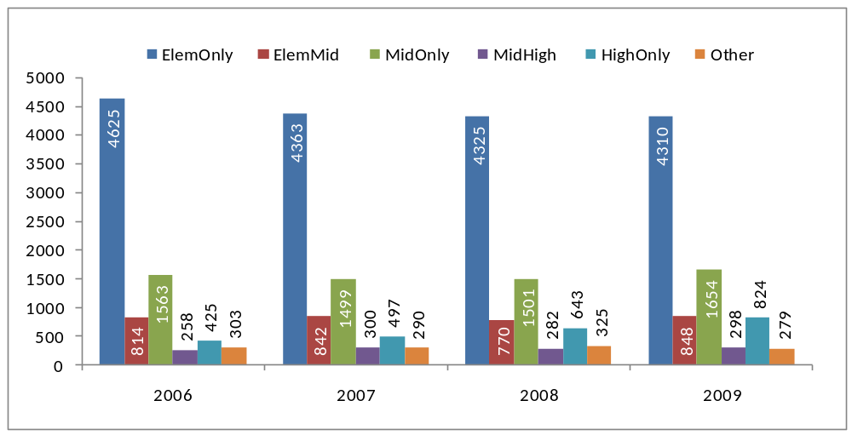

 | N |  |  |  | Percent
Grade Level Category | 2006 | 2007 | 2008 | 2009 | 2006 | 2007 | 2008 | 2009
* MISSING | 883 | 917 | 1022 | 467 | - | - | - | -
Elementary Only | 4,625 | 4,363 | 4,325 | 4,310 | 58% | 56% | 55% | 52%
Elementary / Middle | 814 | 842 | 770 | 848 | 10% | 11% | 10% | 10%
Middle Only | 1,563 | 1,499 | 1,501 | 1,654 | 20% | 19% | 19% | 20%
Middle / High | 258 | 300 | 282 | 298 | 3% | 4% | 4% | 4%
High Only | 425 | 497 | 643 | 824 | 5% | 6% | 8% | 10%
Other | 303 | 290 | 325 | 279 | 4% | 4% | 4% | 3%
Estimated Per-Student Expenditures

It is clear from the data provided so far on the characteristics of 21st CCLC programs that there was a large degree of diversity in program structure during the 2005–06, 2006-07, 2007–08, and 2008-09 reporting periods. Another area of substantial variation among 21st CCLC programs was in the amount of funding a center received to support the provision of afterschool services and activities, especially when considering the level of funding against the total number of students served in a given center. The following section explores the degree of variation in estimated per-student expenditures across centers during the 2005–06, 2006-07, 2007–08, and 2008-09 reporting periods.

Funding data in PPICS are collected at the grantee level. To derive a per-student funding amount for each grant, per-center 21st CCLC funding was estimated by dividing the total grant funding amount by the number of centers. The resulting center-level amount was then divided by the number of students served by that center during the reporting period.

To display these data efficiently, we grouped centers into quartiles (i.e., four groups containing roughly the same number of centers) based on the level of per-student expenditure, with centers in the first quartile having the lowest level of per-student expenditure and those in the fourth quartile demonstrating the highest level.

Note that these calculations result only in estimates of per-student expenditures because factors such as differential administrative costs, potential available carryover funding, and/or the existence of other sources of funding were not taken into consideration. With these caveats in mind, Figure 5 displays the average estimated per-student expenditure amount per quartile across the 2005–06, 2006-07, 2007–08, and 2008-09 reporting periods.

The most significant finding appears to be the large jump in the average estimated per-student expenditures as you move from the third to the fourth quartile. It appears that there is a fair degree of variation among centers classified within this fourth quartile, with the range of funding levels spanning $1,220 to $7,252 in 2005–06, $1,221 to $10,417 in 2006-07, $1,231 to $10,000 in 2007-08, and $1,213 to $5,037 in 2008-09. Note that these ranges reflect minimum and maximum quartile values taken after the exclusion of all per-student amounts that fell outside 3.28 standard deviations, with the standard deviation being calculated separately for each year. Amounts beyond this threshold were deemed to be outliers and were therefore excluded from the analyses displayed in Figure 5.

Figure 5. Average Estimated Per-Student Expenditures by Funding Quartile
for the 2005–06, 2006-07, 2007–08, and 2008–09 Reporting Periods
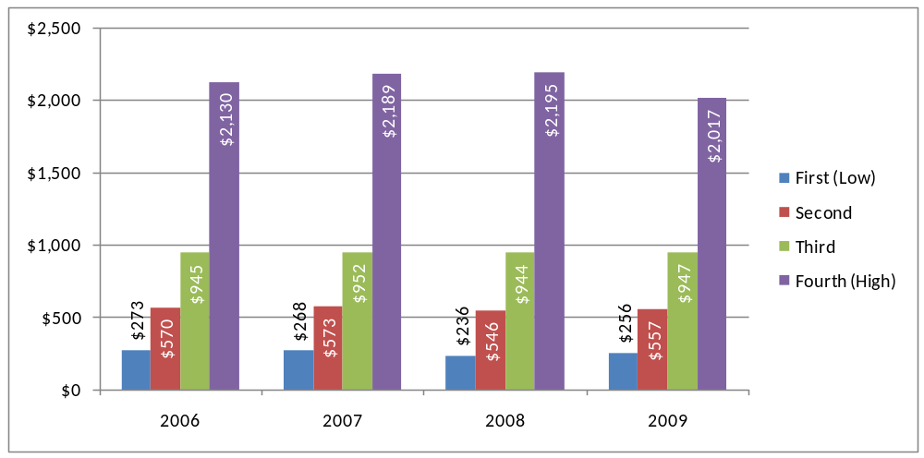

 | N |  |  |  | Percent
Per-Student Expenditure Quartile | 2006 | 2007 | 2008 | 2009 | 2006 | 2007 | 2008 | 2009
Centers Where Data Not Available | 709 | 781 | 735 | 328 | 7.6% | 8.7% | 8.1% | 3.8%
Mean Per-Student Funding Level |  |  |  |  | - | - | - | -
1st Quartile | $273 | $268 | $236 | $256 | - | - | - | -
2nd Quartile | $570 | $573 | $546 | $557 | - | - | - | -
3rd Quartile | $945 | $952 | $944 | $947 | - | - | - | -
4th Quartile | $2,130 | $2,189 | $2,195 | $2,017 | - | - | - | -

Table 20 shows an average funding-per-student estimate for all centers for 2005-06, 2006-07, 2007-08, and 2008-09 APR years. In 2008-09, the average funding per student was $580. This is a drop from the previous three years. Note that these estimates include grant award amounts and student totals from complete APR records—outlier values have not been excluded.

Table 20: Funding Per Student
 | Total Funding for Year | Total Students | Funding per Student
2006 | $898,873,960 | 1,433,713 | $626.96
2007 | $854,799,083 | 1,388,776 | $615.51
2008 | $841,255,936 | 1,416,154 | $594.04
2009 | $873,786,922 | 1,506,920 | $579.85

Section 2: Performance on the GPRA Indicators

In addition to collecting information on the operational characteristics of 21st CCLC programs, a primary purpose of PPICS is to collect data to inform performance in meeting the GPRA indicators established for the program. It should be noted that not all centers will be able to provide the requested GPRA data in relation to the reporting of state assessment results, where some centers exclusively serve students in grade levels outside of those participating in the state’s assessment and accountability system. In addition, states are allowed some discretion in the manner in which information about the activities supported by 21st CCLC funding are reported (see Appendix B). The GPRA indicators, outlined in Table21, are a primary tool by which ED evaluates the effectiveness and efficiency of 21st CCLCs operating nationwide relative to two primary objectives defined for the program, as follow:
- Participants in 21st Century Community Learning Center programs will demonstrate educational and social benefits and exhibit positive behavioral changes (indicators 1.1 to 1.14).
- 21st Century Community Learning Centers will develop afterschool activities and educational opportunities that consider the best practices identified through research findings and other data that lead to high-quality enrichment opportunities that positively affect student outcomes (i.e., used highly qualified staff; offer afterschool programs every day and on weekends; structure afterschool curriculum on school-based curriculum, etc.).

Also, in addition to the indicators identified in Table 21, it is important to note that ED has established a series of efficiency indicators for the program as well, which are assessed using information collected directly by ED outside the domain of PPICS. These efficiency indicators relate to the formal processes employed by ED program staff to monitor SEA implementation of the program:

- The average number of days it takes the Department to submit the final monitoring report to an SEA after the conclusion of a site visit.
- The average number of weeks a State takes to resolve compliance findings in a monitoring visit report.

Information related to ED and SEA performance relative to these measures is not provided in this report.

This section of the report provides a summary of the status of the performance indicators based on data collected as part of the 2008–09 APR and discusses how performance relative to these indicators has varied across the past four reporting periods.

Table 21. 21st CCLC GPRA Performance Indicators
GPRA Performance Indicators
Measure 1.1 of 14: The percentage of elementary 21st Century regular program participants whose mathematics grades improved from fall to spring.
Measure 1.2 of 14: The percentage of middle and high school 21st Century regular program participants whose mathematics grades improved from fall to spring.
Measure 1.3 of 14: The percentage of all 21st Century regular program participants whose mathematics grades improved from fall to spring.
Measure 1.4 of 14: The percentage of elementary 21st Century regular program participants whose English grades improved from fall to spring.
Measure 1.5 of 14: The percentage of middle and high school 21st Century regular program participants whose English grades improved from fall to spring.
Measure 1.6 of 14: The percentage of all 21st Century regular program participants whose English grades improved from fall to spring.
Measure 1.7 of 14: The percentage of elementary 21st Century regular program participants who improve from not proficient to proficient or above in reading on state assessments.
Measure 1.8 of 14: The percentage of middle and high school 21st Century regular program participants who improve from not proficient to proficient or above in mathematics on state assessments.
Measure 1.9 of 14: The percentage of elementary 21st Century regular program participants with teacher-reported improvement in homework completion and class participation.
Measure 1.10 of 14: The percentage of middle and high school 21st Century program participants with teacher-reported improvement in homework completion and class participation.
Measure 1.11 of 14: The percentage of all 21st Century regular program participants with teacher-reported improvement in homework completion and class participation.
Measure 1.12 of 14: The percentage of elementary 21st Century participants with teacher-reported improvement in student behavior
Measure 1.13 of 14: The percentage of middle and high school 21st Century participants with teacher-reported improvement in student behavior.
Measure 1.14 of 14: The percentage of all 21st Century participants with teacher-reported improvement in student behavior.
Measure 2.1 of 2: The percentage of 21st Century Centers reporting emphasis in at least one core academic area.
Measure 2.2 of 2: The percentage of 21st Century Centers offering enrichment and support activities in other areas.

GPRA Indicator Results for 2008–09

Table 22 provides an overall summary of the 21st CCLC program GPRA indicator data for the 2008−09 reporting period along with the performance targets for this period. Note that not all states collect each of the different types of indicator data. See Appendix B for more detail.

As Table 22 shows, nearly all of the performance targets for the 2008–09 reporting period were not reached, although, in most cases, the reported outcomes were relatively close to the established targets. For the range of indicators related to regular attendee improvement in student achievement and behaviors, the only indicators where the performance target was reached were related to the percentage of regular program participants improving from not proficient to proficient or above on mathematics or reading state assessments.

Table 22. GPRA Performance Indicators for the 2008–09 Reporting Period
GPRA Performance Indicator | Performance Target | 2008–09 Reporting Period
Measure 1.1 of 14: The percentage of elementary 21st Century regular program participants whose mathematics grades improved from fall to spring. | 48% | 37%
Measure 1.2 of 14: The percentage of middle and high school 21st Century regular program participants whose mathematics grades improved from fall to spring. | 48% | 34%
Measure 1.3 of 14: The percentage of all 21st Century regular program participants whose mathematics grades improved from fall to spring. | 48% | 37%
Measure 1.4 of 14: The percentage of elementary 21st Century regular program participants whose English grades improved from fall to spring. | 47% | 39%
Measure 1.5 of 14: The percentage of middle and high school 21st Century regular program participants whose English grades improved from fall to spring. | 48% | 35%
Measure 1.6 of 14: The percentage of all 21st Century regular program participants whose English grades improved from fall to spring. | 48% | 38%
Measure 1.7 of 14: The percentage of elementary 21st Century regular program participants who improve from not proficient to proficient or above in reading on state assessments. | 24% | 26%
Measure 1.8 of 14: The percentage of middle and high school 21st Century regular program participants who improve from not proficient to proficient or above in mathematics on state assessments. | 16% | 17%
Measure 1.9 of 14: The percentage of elementary 21st Century regular program participants with teacher-reported improvement in homework completion and class participation. | 75% | 74%
Measure 1.10 of 14: The percentage of middle and high school 21st Century program participants with teacher-reported improvement in homework completion and class participation. | 75% | 72%
Measure 1.11 of 14: The percentage of all 21st Century regular program participants with teacher-reported improvement in homework completion and class participation. | 75% | 73%
Measure 1.12 of 14: The percentage of elementary 21st Century participants with teacher-reported improvement in student behavior | 75% | 69%
Measure 1.13 of 14: The percentage of middle and high school 21st Century participants with teacher-reported improvement in student behavior. | 75% | 68%
Measure 1.14 of 14: The percentage of all 21st Century participants with teacher-reported improvement in student behavior. | 75% | 69%
Measure 2.1 of 2: The percentage of 21st Century Centers reporting emphasis in at least one core academic area. | 100% | 97%
Measure 2.2 of 2: The percentage of 21st Century Centers offering enrichment and support activities in other areas. | 100% | 97%

Trends in GPRA Indicator Performance

The 2008–09 reporting period represented the sixth wave of data collected in PPICS that allowed for an assessment of how well the program was functioning relative to the established GPRA measures for the program.

Table 23 describes the overall performance of programs (without breakdowns by grade level) by reporting period across each of the GPRA indicator categories. The performance levels, based on attendance gradation for the two reporting periods in which data were collected in this manner, are also included. Note that in Table 23, two different state assessment-based measures are presented: (1) Improving represents the percentage of regular attendees who scored below proficiency on the assessment taken in the prior year that moved to a higher proficiency category during the reporting period in question, and (2) Attaining represents the percentage of regular attendees who moved from below proficiency on the prior year’s assessment to proficiency or above on the assessment taken during the reporting period. The difference between the two measures is that the Improving metric counts regular attendees as having improved even if they did not achieve proficiency based on state standards; the latter measure does not count these students as having improved even though they demonstrated a higher level of performance on the state assessment in question. The GPRA indicator calculation is based on the latter approach.
As shown in Table 23, when the measures are examined without taking into consideration attendance gradation, no apparent trend toward higher levels of program performance is discernable across the reporting periods, and in the case of grades improvement rates the trend is a decline. Based on these results, one may surmise that programs are not making progress in helping students reach desired outcomes. This is mitigated, however, when cross-year progress is assessed employing the gradation reporting option, as both student behavior metrics and state assessment metrics in which the attaining criteria are employed demonstrate higher levels of achievement during the 2008–09 reporting period as compared with 2005–06 levels of performance. Gradation data were collected in only approximately half of the states in each reporting period, however, the positive cross-year comparisons are likely reflective of overall trends in this subset of states as opposed to the program as a whole. Also, grade improvement rates for 2008-09 were lower than they have been in any previous reporting period, even across the gradation bands.

Finally, Table 23 demonstrates the positive relationship that appears between higher levels of attendance and the percentage of regular attendees witnessing improvement on a given outcome measure type. For example, during the 2005–06 reporting period, approximately 34 percent of regular attendees participating in 21st CCLC programming from 30–59 days that scored below proficiency on the 2005 state assessment in mathematics improved to a higher proficiency level in 2006. For regular attendees participating 90 days or more, this percentage was 46 percent. This result is largely replicated in 2006-07, 2007–08, and 2008-09 where the gap between the 30–59 day group and the 90 days or more groups was found to be 6 to 12 percentage points. This general finding is consistent across many of the impact categories and reporting periods in which attendance gradation data were collected. The exception to this are again the grade improvement rates, which fell in 2008-09 compared with previous years. It should be noted, however, that the percentage of students reported as maintaining the highest grade possible increased in 2008-09 compared with previous reporting periods, as shown in Table 24.

Table 23. Grades, State Assessment Results, and Teacher Survey Results Across Years
 | % Increase  2008–09 | % Increase  2007–08 | % Increase  2006–07 | % Increase  2005–06 | % Increase  2004–05 | % Increase  2003–04
Grades
Mathematics Grades | 37 | 40 | 41 | 42 | 40 | 42
Reading Grades | 38 | 42 | 43 | 45 | 43 | 45
By Attendance Gradation
Mathematics Grades (30–59) | 35 | 37 | 39 | 36 | N/A | N/A
Mathematics Grades (60–89) | 35 | 39 | 39 | 39 | N/A | N/A
Mathematics Grades (90+) | 35 | 40 | 43 | 40 | N/A | N/A
Reading Grades (30–59) | 37 | 38 | 41 | 39 | N/A | N/A
Reading Grades (60–89) | 37 | 40 | 41 | 44 | N/A | N/A
Reading Grades (90+) | 36 | 41 | 45 | 43 | N/A | N/A
State Assessment Results (All Regular Attendees)
Mathematics Proficiency (Attaining) | 23 | 22 | 22 | 17 | 30 | N/A
Reading Proficiency (Attaining) | 23 | 23 | 23 | 17 | 29 | N/A
Mathematics Proficiency (Improving) | 36 | 36 | 36 | 32 | 41 | 31
Reading Proficiency (Improving) | 38 | 38 | 39 | 33 | 37 | 31
By Attendance Gradation
Mathematics Proficiency (Attaining, 30–59) | 29 | 29 | 27 | 24 | N/A | N/A
Mathematics Proficiency (Attaining, 60–89) | 34 | 31 | 31 | 24 | N/A | N/A
Mathematics Proficiency (Attaining, 90+) | 39 | 39 | 33 | 31 | N/A | N/A
Reading Proficiency (Attaining, 30–59) | 33 | 37 | 37 | 31 | N/A | N/A
Reading Proficiency (Attaining, 60–89) | 37 | 38 | 41 | 27 | N/A | N/A
Reading Proficiency (Attaining, 90+) | 39 | 41 | 41 | 33 | N/A | N/A
Mathematics Proficiency (Improving, 30–59) | 37 | 36 | 37 | 34 | N/A | N/A
Mathematics Proficiency (Improving, 60–89) | 42 | 39 | 41 | 37 | N/A | N/A
Mathematics Proficiency (Improving, 90+) | 47 | 47 | 43 | 46 | N/A | N/A
Reading Proficiency (Improving, 30–59) | 44 | 45 | 47 | 42 | N/A | N/A
Reading Proficiency (Improving, 60–89) | 48 | 45 | 51 | 40 | N/A | N/A
Reading Proficiency (Improving, 90+) | 49 | 48 | 51 | 48 | N/A | N/A
Teacher Survey Results
Improved HW Completion and Class Partic. | 73 | 76 | 75 | 73 | 72 | 68
Improved Student Behavior | 69 | 72 | 71 | 68 | 67 | 63
By Attendance Gradation
Improved HW Completion and Class Partic. (30–59) | 69 | 71 | 72 | 71 | N/A | N/A
Improved HW Completion and Class Partic. (60–89) | 71 | 72 | 73 | 74 | N/A | N/A
Improved HW Completion and Class Partic. (90+) | 72 | 73 | 73 | 76 | N/A | N/A
Improved Student Behavior (30–59) | 64 | 66 | 67 | 66 | N/A | N/A
Improved Student Behavior (60–89) | 65 | 66 | 67 | 69 | N/A | N/A
Improved Student Behavior (90+) | 67 | 68 | 69 | 72 | N/A | N/A

Table 24. Number and Percent of Students Maintaining Highest Grade, 2008-09
 | Highest Grade as % of All Grades Reported |  | Highest Grade N
 | Math | Reading | Math | Reading
2007 | 5.96% | 5.76% | 20,214 | 19,662
2008 | 6.06% | 6.13% | 19,962 | 20,088
2009 | 8.06% | 8.42% | 24,216 | 25,324

Section 3: Indicator Performance by Key Subgroups

Building from the analyses conducted in Sections 1 and 2, attention is given in this section to different program subgroups and how they varied in their level of performance relative to the federally defined performance indicators associated with the 21st CCLC program during the 2005–06 to 2008–09 reporting periods. Results are highlighted where there is some consistency across multiple impact categories, especially grades and state assessment results. In this regard, a meaningful correlation is more likely to exist between a given center characteristic and student achievement outcomes if the direction and strength of this relationship is consistent across multiple impact categories. Here again, the focus is primarily on the following center characteristics:
- The activity cluster associated with the center (e.g., mostly tutoring and homework help as opposed to an emphasis on offering arts enrichment)
- The staffing model employed by the center (e.g., mostly school-day teachers, mostly college students and school day teachers, etc.)
- The target population served by a program, especially in terms of the grade level served
- The type of organization where the 21st CCLC program is located, especially when comparing school-based with non-school-based centers
- The amount of funding a grant expended per student served during the reporting period

In Table 25, subgroups associated with each of these areas are considered in conjunction with the percentage of regular attendees nationwide demonstrating improvement in reading and mathematics grades and state assessment results during the 2008–09 reporting period. Again, note that in Table 25 that two different state assessment-based measures are presented: (1) Improving represents the percentage of regular attendees who scored below proficiency on the assessment taken in the prior year that moved to a higher proficiency category during the reporting period in question, and (2) Attaining represents the percentage of regular attendees who moved from below proficiency on the prior year’s assessment to proficiency or above on the assessment taken during the reporting period. The difference between the two measures is that Improving includes regular attendees even if they did not achieve proficiency based on state standards; the latter measure does not count these students even though they demonstrated a higher level of performance on the state assessment in question.

Table 25 presents a significant amount of data, although the most interesting findings may be related to the activity and staffing cluster, center type, and per-student expenditure analyses. The results are explored further in the following sections to determine how consistent these findings were across time and measurement approach.

Table 25. Grades and State Assessment Results for the 2008–09 Reporting Period
by Key Center Characteristics
 | Grades—Percentage Improved |  | State Assessment—Percentage Improving |  | State Assessment—Percentage Attaining
 | Mathematics | Reading | Mathematics | Reading | Mathematics | Reading
By Activity Cluster
Not Classified | 41 | 42 | 34 | 36 | 19 | 19
Mostly Recreation | 33 | 35 | 45 | 51 | 41 | 46
Mostly Tutoring | 40 | 41 | 47 | 48 | 33 | 33
Variety | 32 | 34 | 43 | 50 | 40 | 45
Mostly Enrichment | 35 | 36 | 44 | 49 | 38 | 42
Mostly Homework Help | 34 | 37 | 41 | 46 | 30 | 34
By Staffing Cluster
Not Classified | 41 | 41 | 41 | 47 | 33 | 36
YD, SD Teach, Other w/Coll | 35 | 37 | 33 | 37 | 19 | 21
Coll Stu, SD Teach | 35 | 38 | 35 | 37 | 21 | 21
Other wo/coll, SD Teach | 33 | 37 | 41 | 37 | 24 | 20
Other staff, SD Teach | 33 | 32 | 36 | 30 | 29 | 22
SD Teach | 38 | 39 | 36 | 40 | 26 | 28
By Grade Level
Not Classified | 45 | 44 | 50 | 42 | 27 | 25
Elem Only | 37 | 39 | 43 | 42 | 30 | 26
Elem Mid | 39 | 40 | 35 | 37 | 23 | 24
Mid Only | 33 | 34 | 35 | 39 | 23 | 25
Mid High | 36 | 37 | 35 | 40 | 24 | 29
High Only | 36 | 37 | 24 | 29 | 10 | 14
Other | 40 | 41 | 34 | 33 | 26 | 21
By Center Type
Not School Based | 38 | 39 | 36 | 38 | 26 | 28
School Based | 37 | 38 | 36 | 38 | 22 | 23
By Per-Student Expenditure (Quartiles)
First (Low) | 37 | 39 | 34 | 36 | 19 | 20
Second | 36 | 38 | 37 | 39 | 25 | 25
Third | 36 | 38 | 37 | 41 | 27 | 28
Fourth (High) | 37 | 39 | 38 | 41 | 26 | 26
Note. The appendix contains information on the number of centers associated with a given cell of data.
Indicator Performance by Activity Cluster

In Figure 6, program cluster is considered in conjunction with the percentage of regular attendees nationwide witnessing an improvement in mathematics grades and state assessment results during the 2006-07, 2007–08, and 2008-09 reporting periods. Regular attendees associated with centers in the Mostly Tutoring cluster in 2008–09 were more apt to demonstrate an improvement in mathematics grades in 2006-07, 2007–08, and 2008-09 (52 percent, 44 percent, and 40 percent, respectively) than regular attendees participating in other program types. However, similar results were found to be associated with state assessment measures in the 2006-07 school year only. In other years, centers in the Homework Help and Recreation clusters were at or near the top for state assessment measures.

Figure 6. Percent Increase in Mathematics Grade/Proficiency by Activity Cluster
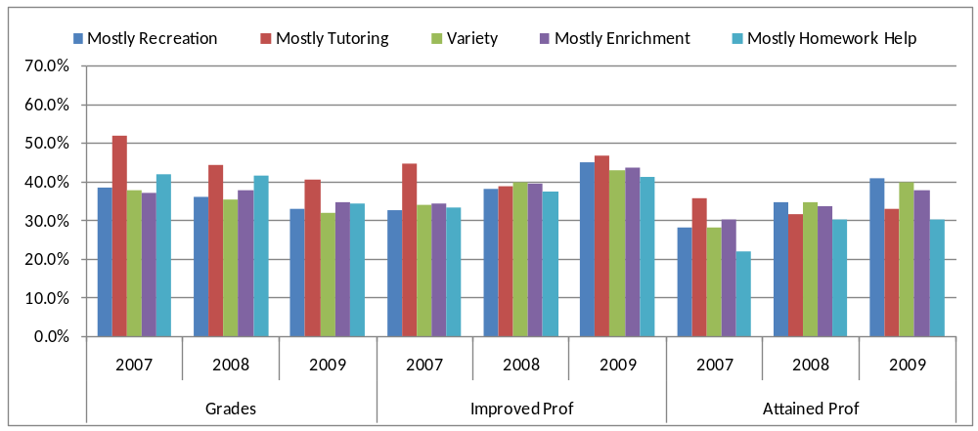
Note. “Improved Prof” and “Attained Prof” both refer to proficiency on State assessments.

In Figure 7, we see that centers associated with Mostly Homework Help and Mostly Tutoring clusters demonstrated the highest gains for reading grades across the three years. There are no clear trends that emerge for state assessment measures, except that centers associated with Mostly Tutoring and Mostly Homework Help clusters seem to trail centers in other clusters in the percent of students attaining proficiency in reading.

Figure 7. Percent Increase in Reading Grade/Proficiency by Activity Cluster
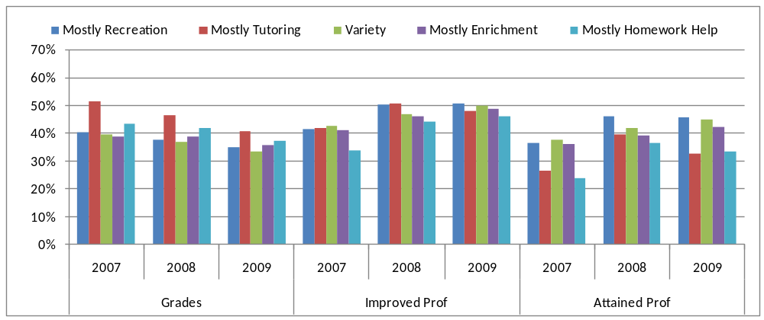
Note. “Improved Prof” and “Attained Prof” both refer to proficiency on State assessments.

In interpreting the analyses associated with Figure 6 and Figure 7, a relatively small number of Mostly Tutoring centers were having a meaningful impact on the overall performance numbers for this activity cluster by serving a fairly large number of regular attendees and reporting that a very high percentage of these regular attendees witnessed an improvement on the grades measures under consideration. In light of this finding, and in the interest of verifying the advantage of these programs demonstrated in Figure 6 and Figure 7, the median level of improvement across each of the activity clusters was examined. As a result, it was found that the influence of these large Mostly Tutoring centers that demonstrated very high levels of regular attendee improvement on the overall level of improvement demonstrated by centers in the cluster was reduced but still evident. These results are shown in Figure 8 and Figure 9 for mathematics and reading/language arts, respectively.

In terms of improvement in mathematics results, as shown in Figure 8, by exploring the median performance of centers, the Mostly Tutoring centers retain their advantage in terms of improving mathematics grades in 2006-07, 2007–08, and 2008-09, but the degree of this advantage is meaningfully attenuated.

Figure 8. Median Percent Increase in Mathematics Grade/Proficiency by Activity Cluster
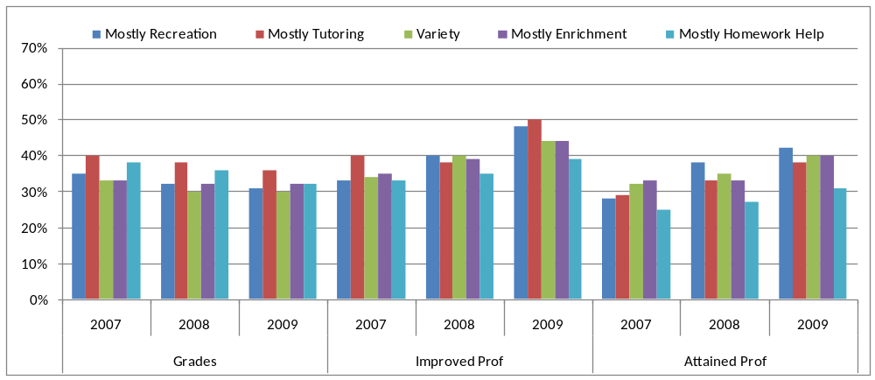Note. “Improved Prof” and “Attained Prof” both refer to proficiency on State assessments.

In Figure 9, median percent increase results are highlighted for reading/language arts by activity cluster. Similar to Figure 8, the advantage the Mostly Tutoring centers demonstrated in improving reading/language arts grades is meaningfully reduced.

Figure 9. Median Percent Increase in Reading Grade/Proficiency by Activity Cluster
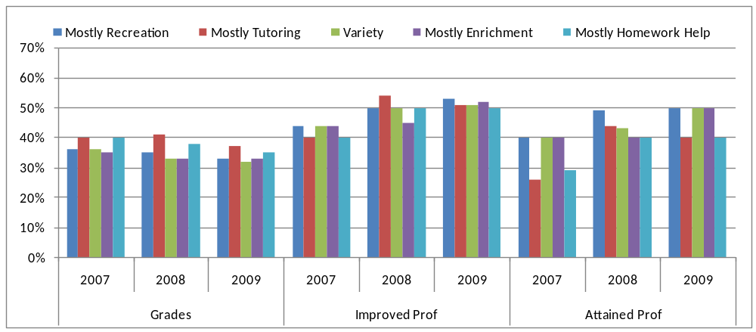
Note. “Improved Prof” and “Attained Prof” both refer to proficiency on State assessments.

One of the keys to further explain the potential impact of Mostly Tutoring programs on student grades outcomes relative to other program clusters would be to explore the service delivery approaches and student achievement data of this small number of large tutoring programs that reported fairly dramatic levels of improvement among their regular attendee population. Several interesting characteristics associated with centers falling within the Mostly Tutoring cluster were found and are worth noting.

Figure 10 shows ways that staffing may vary across each of the activity clusters. This was done by outlining what percentage of centers within a given activity cluster fell within each of the staffing clusters initially outlined in Section 1. As shown in Figure 10, a significantly larger percentage of centers (69 percent) associated with the Mostly Tutoring cluster was found to fall with the Mostly Teachers staffing cluster as compared with the other activity cluster types (which ranged from 44 percent to 56 percent). This result is especially interesting in light of the results highlighted in Figure 6 through Figure 9, which demonstrated that Mostly Tutoring centers were more apt to show greater improvement on grades in some instances than other types of programs.

Figure 10. Percentage of Centers Within an Activity Cluster
by Staffing Cluster Membership
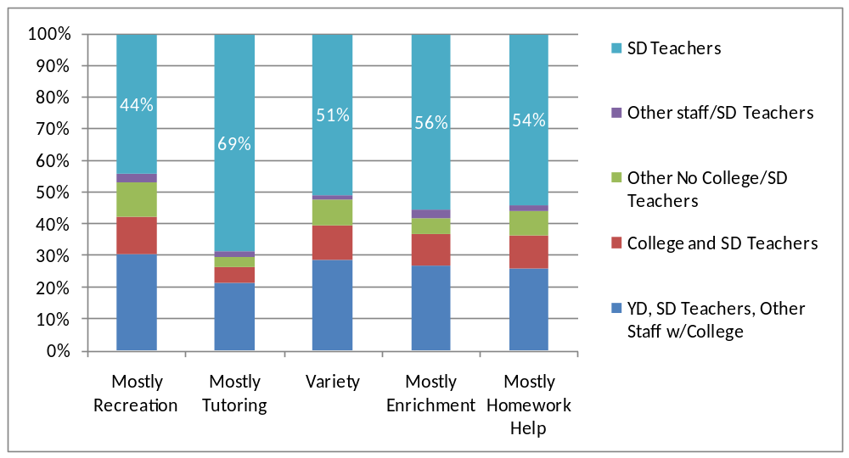

In keeping with the theme of exploring how other program characteristics intersect with activity cluster membership, in Figure 11 the school-based status of grantees is compared with the activity clusters. For 2008-09, centers in the Mostly Tutoring cluster were the most likely to be funded by school-based grantees.

Figure 11. Percentage of Centers Within an Activity Cluster
by School-Based Status of the Grantee
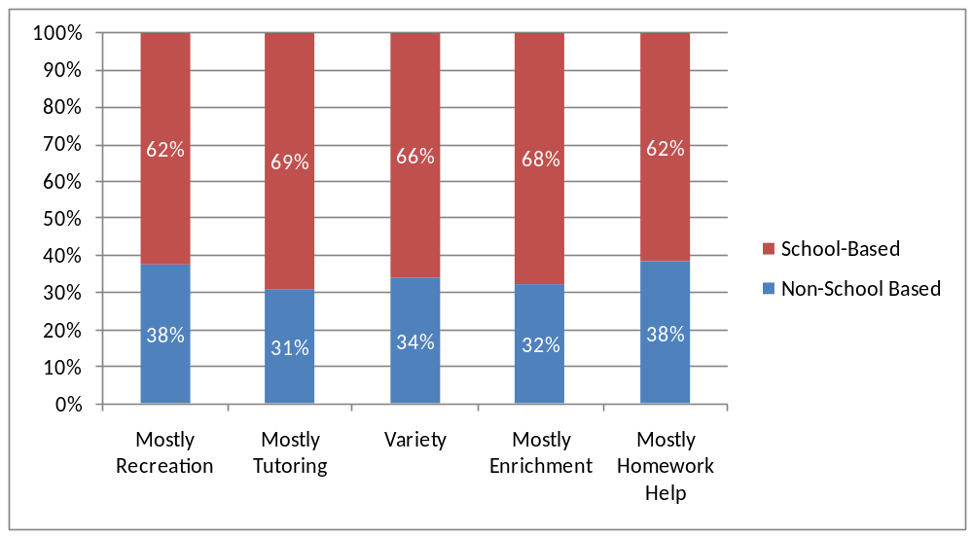

Indicator Performance by Center School-Based Status

Although Figure 11 noted several interesting differences across the clusters in terms of grantee school-based status, there is a more consistent difference in terms of center performance across grades and state assessment performance based on whether an actual center is located in a school-based or non-school-based facility (e.g., Boys and Girls Clubs, YMCA, community-based organization, etc.).

In Figure 12 the school-based status of centers is considered in conjunction with the percentage of regular attendees nationwide witnessing an improvement in mathematics grades and state assessment results during the 2005–06, 2006-07, and 2007–08 reporting periods. As shown in Figure 12, across all measures of mathematics achievement (except state improvement in 2008 and 2009), non-school-based centers demonstrated a higher percentage of regular attendees demonstrating improvement (ranging from 2–8 percentage points higher).

Figure 12. Percent Increase in Mathematics Grade/Proficiency by Center Type
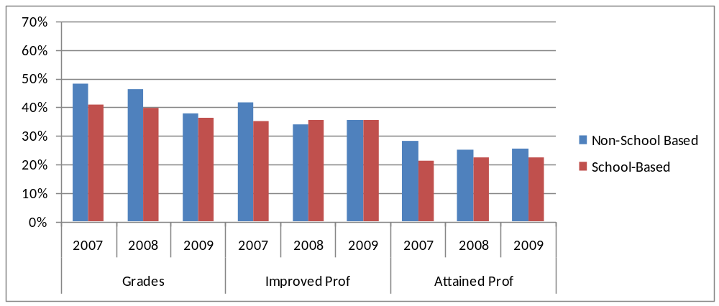
Note. “Improved Prof” and “Attained Prof” both refer to proficiency on State assessments.

In terms of reading/language arts achievement, the results largely mirror those associated with mathematics, as shown in Figure 13 (ranging from 1–15 percentage points higher in non-school-based centers). The lone exception to this trend relates to state improvement achievement measure in 2007–08, where school-based centers witnessed a slightly higher level of improvement as compared to non-school-based counterparts.

Figure 13. Percent Increase in Reading Grade/Proficiency by Center Type
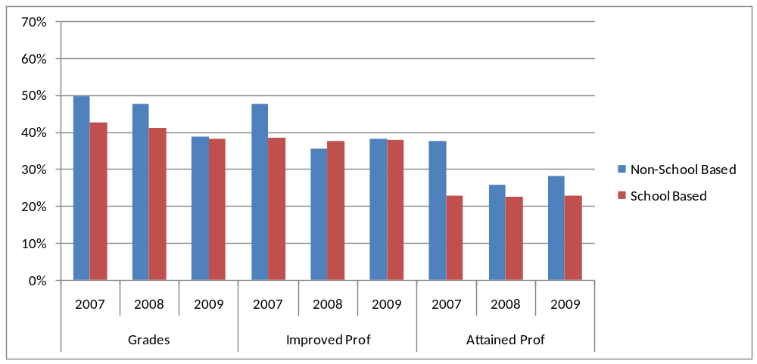
Note. “Improved Prof” and “Attained Prof” both refer to proficiency on State assessments.

To assess the consistency of these findings, an effort was made to calculate the median percentage of regular attendee improvement by school-based status; this would remove the influence of large centers that may have reported dramatically high percentages of improvement across the grades and state assessment measures of interest. When the median percentage was calculated, as shown in Figure 14 and Figure 15, the advantage of non-school-based programs was reduced across each measure and year and, in some cases, was lost altogether, notably for state assessment results in 2008 and 2009.

Figure 14. Median Percent Increase in Mathematics Grade/Proficiency by Center Type
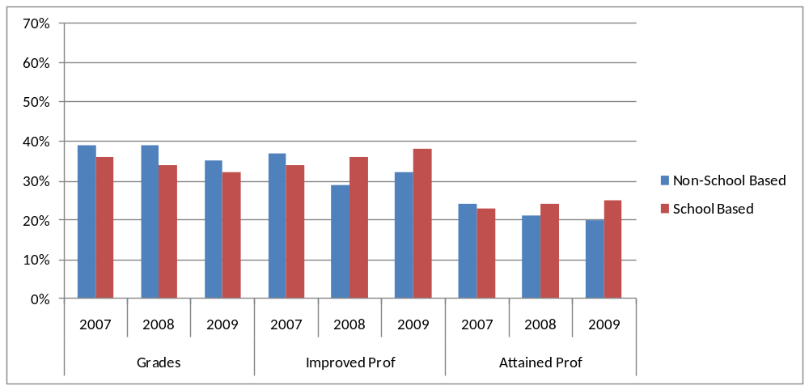
Note. “Improved Prof” and “Attained Prof” both refer to proficiency on State assessments.

Figure 15. Median Percent Increase in Reading Grade/Proficiency by Center Type
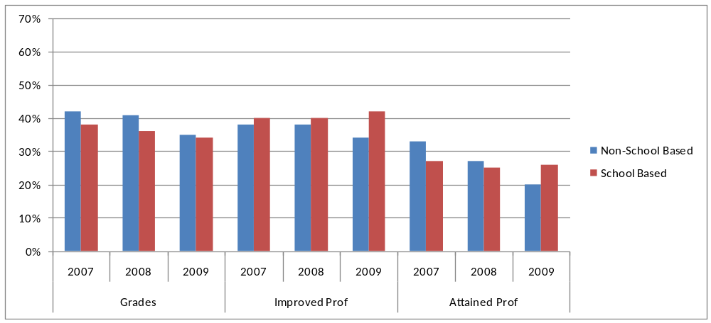
Note. “Improved Prof” and “Attained Prof” both refer to proficiency on State assessments.

Indicator Performance by Staffing Cluster

In Figure 16, staffing cluster is considered in conjunction with the percentage of regular attendees nationwide witnessing an improvement in mathematics grades and state assessment results during the 2006-07, 2007–08, and 2008-09 reporting periods. Regular attendees associated with centers in the Mostly Teachers cluster were generally more apt to demonstrate an improvement in mathematics grades and state assessments in 2006-07, 2007–08, and 2008-09 than regular attendees participating in programs with other staffing types. In particular, students in centers staffed by Mostly Teachers seemed to show consistently greater achievement along the attaining proficiency state measure.

Figure 16. Percent Increase in Mathematics Grade/Proficiency by Staffing Cluster
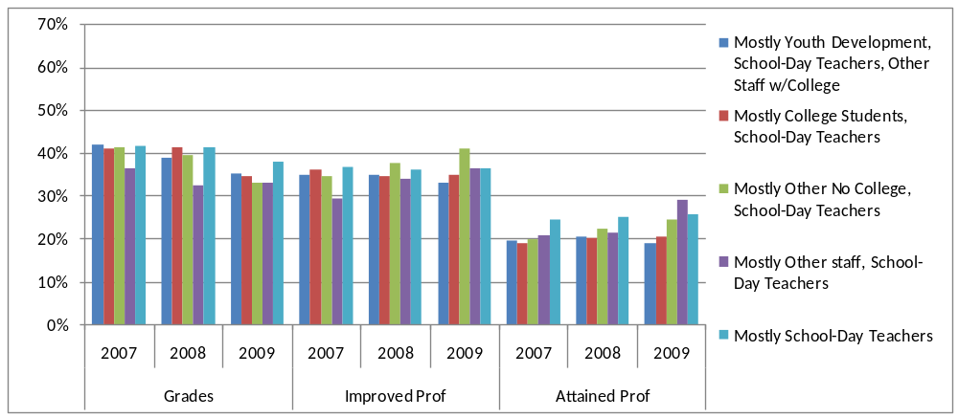
Note. “Improved Prof” and “Attained Prof” both refer to proficiency on State assessments.

In Figure 17, we see similar results with centers associated with Mostly Teachers clusters generally demonstrating the highest or second highest gains for reading grades across the three years along both grades and state achievement measures.

Figure 17. Percent Increase in Reading Grade/Proficiency by Staffing Cluster
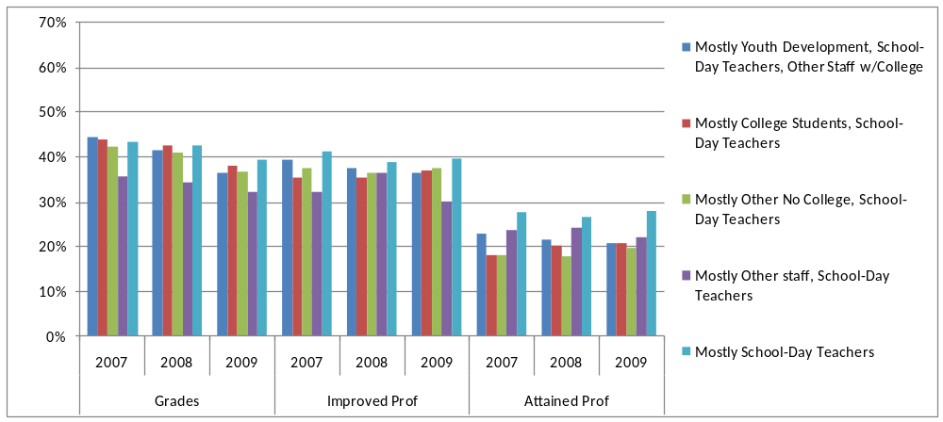
Note. “Improved Prof” and “Attained Prof” both refer to proficiency on State assessments.

To assess the consistency of these findings, the median percentage of regular attendee improvement by staffing cluster was calculated. These results are outlined in Figure 18 and Figure 19. The advantage of Mostly Teachers staffing clusters was clearly reduced, with the Mostly Other Staff, School Day Teachers cluster demonstrating high levels of improvement. Note that the n value of the Mostly Other Staff, School Day Teachers cluster for state assessment score reporting was the smallest of any of the clusters, however (see Appendix A for comparison of n values).

Figure 18. Median Percent Increase in Mathematics Grade/Proficiency
by Staffing Cluster
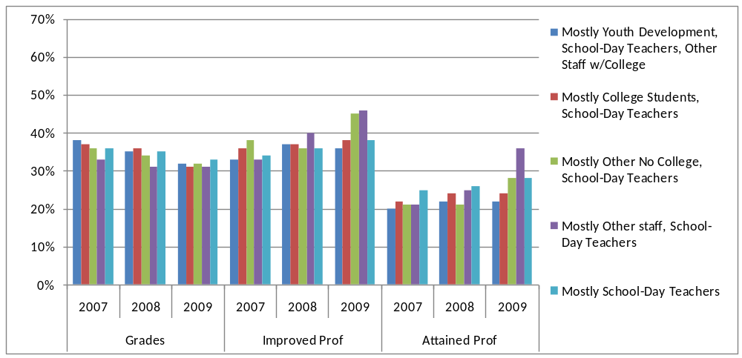
Note. “Improved Prof” and “Attained Prof” both refer to proficiency on State assessments.

Figure 19. Median Percent Increase in Reading Grade/Proficiency
by Staffing Cluster
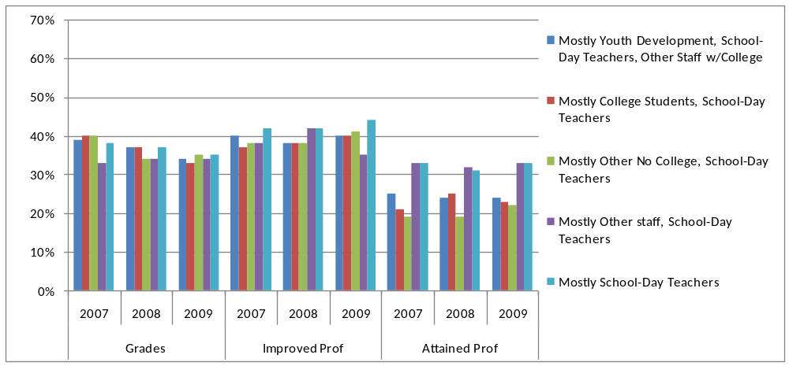
Note. “Improved Prof” and “Attained Prof” both refer to proficiency on State assessments.

Indicator Performance by Per-Student Expenditure

Considering ways in which center performance may vary by grantee and center characteristics, one question that emerged was - What is the relationship between the amount of grant funds spent per student served and the likelihood that regular attendees will witness an improvement in grades and self-assessment measures for the 2006-07, 2007–08, and 2008-09 reporting periods?
In order to derive a per-student funding amount, the amount of 21st CCLC grant funds received during the reporting period was divided by the number of centers associated with the program during the reporting period. Continually, the center-level amount was divided by the number of students served by the center during the reporting period to arrive at a per-student expenditure amount for the center in question. To facilitate the ability to display the data graphically, centers were grouped into quartiles based on the level of per-student expenditure during the reporting period in question, with centers in the first quartile having the lowest level of per-student expenditure and those in the fourth quartile demonstrating the highest level.

As shown in Figure 20, in relation to the mathematics-related measures, there is an overall positive, linear trend in the percentage of regular attendees witnessing an improvement in state assessment results as the level of funding increases, with a slight drop from the third to fourth quartile. This trend is especially pronounced and consistent in relation to the state assessment measures related to the percentage of regular attendees attaining proficiency (Attained Prof). The results for reading/language arts grades and state assessment measures are very similar to these findings, as shown in Figure 21.

Figure 20. Percent Increase in Mathematics Grade/Proficiency by Per-Student Expenditure
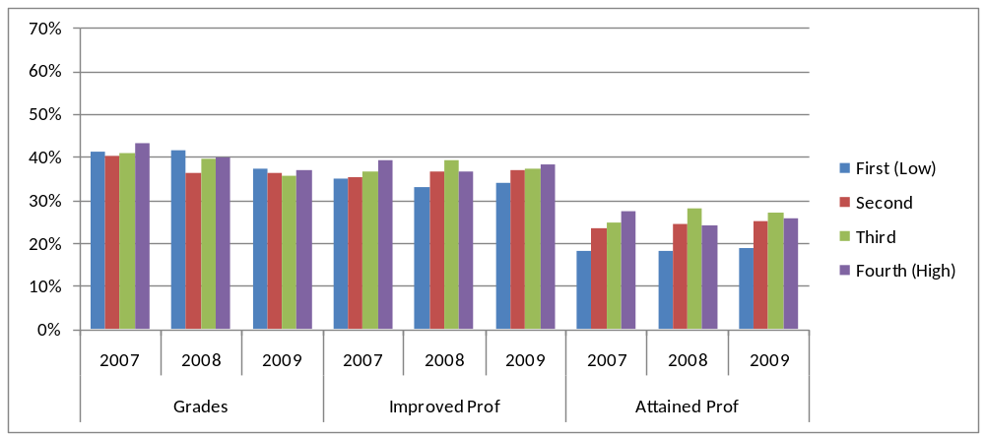
Note. “Improved Prof” and “Attained Prof” both refer to proficiency on State assessments.

Figure 21. Percent Increase in Reading Grade/Proficiency by Per-Student Expenditure
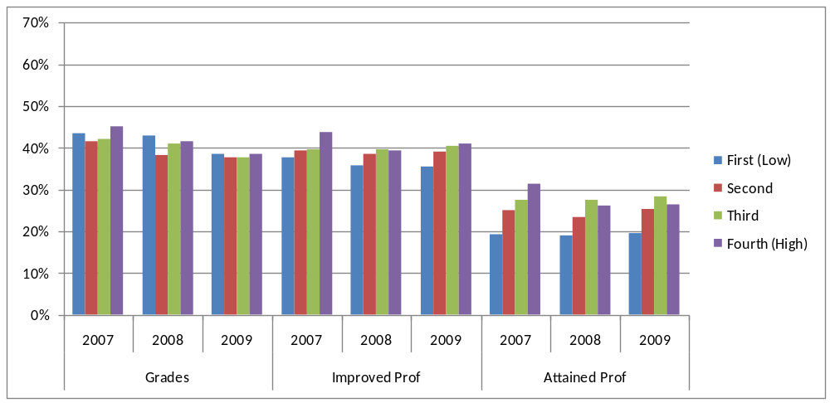
Note. “Improved Prof” and “Attained Prof” both refer to proficiency on State assessments.

To assess the consistency of these findings, the median percentage of regular attendee improvement by per-student expenditure was calculated. These results are outlined in Figure 22 and Figure 23. The reading/language arts results outlined in Figure 23 remain largely equivalent to those highlighted in Figure 21.

Figure 22. Median Percent Increase in Mathematics Grade/Proficiency
by Per-Student Expenditure
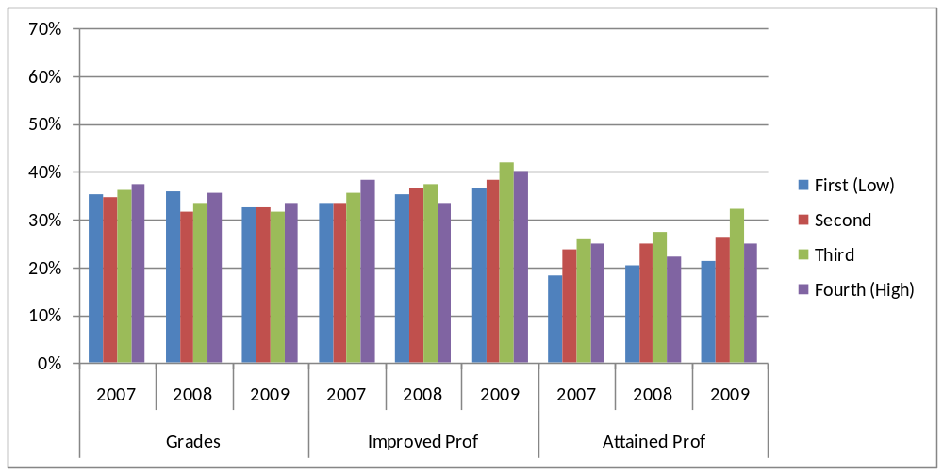
Note. “Improved Prof” and “Attained Prof” both refer to proficiency on State assessments.

Figure 23. Median Percent Increase in Reading Grade/Proficiency
by Per-Student Expenditure
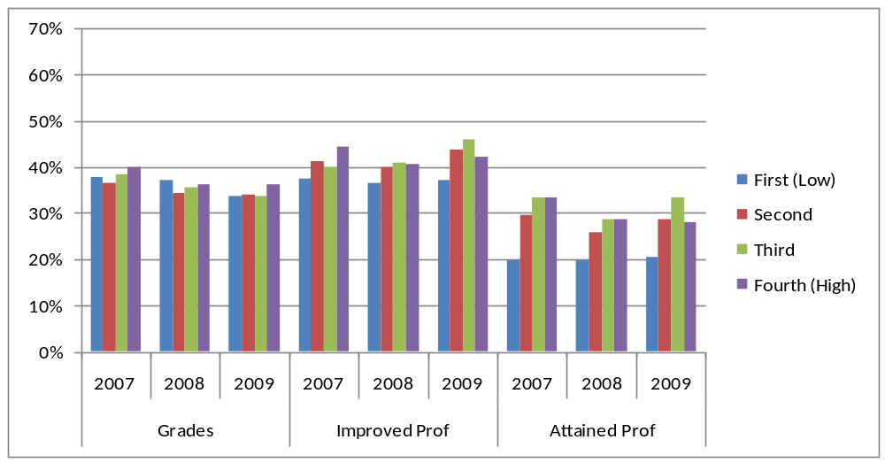
Note. “Improved Prof” and “Attained Prof” both refer to proficiency on State assessments.

Summary and Conclusions

The goal of this report is to provide results on the GPRA measures and to provide data on the overall efficacy of the program. PPICS data offer information on the operation of the projects funded by 21st CCLC, which has proven useful in identifying additional areas of future research and study related to program effectiveness and efficiency. The information and data highlighted in this report, which warrant further and more rigorous examination, include the following:
- Analyses predicated on examining the relationship between higher levels of program attendance and the achievement of GPRA-related outcomes suggest that students benefited more from 21st CCLC the more they attend the program. Additional research to align student State assessment data to participation in 21st CCLC programs is warranted.
- Information and data outlined in this report suggest that programs providing Mostly Tutoring services appear to have a slight advantage in contributing to mathematics achievement for mathematics grades, while non-school-based centers, centers staffed mostly by teachers, and centers receiving higher levels of funding per student seem to demonstrate higher levels of achievement in both mathematics and reading. More rigorous investigation and focus should be centered on the staffing model employed by centers and of school-based and non-school-based afterschool programs.
- Grade improvement rates for 2008-09 dropped relative to the 2007-08 reporting period, and 2007-08 demonstrated a drop from 2006-07. The reasons for this decline are not clear; the decline is evident across center characteristic categories (activity and staffing clusters, etc.). During the same period, however, a higher proportion of regular attendees maintained the highest grade possible. Further investigation into the 2008-09 grades data relative to previous reporting periods is warranted.
References

Birmingham, J., Pechman, E. M., Russell, C. A., & Mielke, M. (2005). Shared features of high- performing after-school programs: A follow-up to the TASC evaluation. Austin, TX: Southwest Educational Development Laboratory. Retrieved March 19, 2009, from http://www.sedl.org/pubs/fam107/fam107.pdf

Black, A. R., Doolittle, F., Zhu, P., Unterman, R., & Grossman, J. B. (2008). The
evaluation of enhanced academic instruction in after-school programs: Findings after the first year of implementation (NCEE 2008-4021). Washington, DC: National Center for Education Evaluation and Regional Assistance, Institute of Education Sciences, U.S. Department of Education. Retrieved March 19, 2009, from http://ies.ed.gov/ncee/pdf/20084021.pdf

Durlak, J. A., & Weissberg, R. P. (2007). The impact of after-school programs that promote personal and social skills. Chicago: Collaborative for Academic, Social, and Emotional Learning. Retrieved March 19, 2009, from
http://www.casel.org/downloads/ASP-Full.pdf

Eccles, J., & Gootman, J. A. (2002). Features of positive developmental settings. In J. Eccles & J. A. Gootman (Eds.), Community programs to promote youth development (pp. 86–118). Washington, DC: National Academy Press. Retrieved March 19, 2009, from http://www.nap.edu/openbook.php?record_id=10022&page=86

Granger, R. (2008). After-school programs and academics: Implications for policy, practice, and research. Social Policy Report, 22(2), 3–19. Ann Arbor, MI: Society for Research in Child Development. Retrieved March 19, 2009, from http://www.srcd.org/documents/publications/spr/spr22-2.pdf

Lauer, P. A., Akiba, M., Wilkerson, S. B., Apthorp, H. A., Snow, D., & Martin-Glenn, M. (2006). Out-of-school-time programs: A meta-analysis of effects for at-risk students. Review of Educational Research, 76(2), 275–313.

Rosenthal, R., & Vandell, D. L. (1996). Quality of school-aged child care programs: Regulatable features, observed experiences, child perspectives, and parent perspectives. Child Development, 67(5), 2434–2445.

Vandell, D. L., Reisner, E. R., Brown, B. B., Dadisman, K., Pierce, K. M., & Lee, D., et al. (2005). The study of promising after-school programs: Examination of intermediate outcomes in year 2. Madison, WI: Wisconsin Center for Education Research. Retrieved March 19, 2009, from http://childcare.wceruw.org/pdf/pp/year2_executive_summary_and_brief_report.pdf

Vandell, D. L., Reisner, E. R., Brown, B. B., Pierce, K. M., Dadisman, K., & Pechman, E. M. (2004). The study of promising after-school programs: Descriptive report of the promising programs. Madison, WI: Wisconsin Center for Education Research. Retrieved March 19, 2009, from http://childcare.wceruw.org/pdf/pp/study_of_after_school_activities_descriptive_report_year1.pdf

Appendix A.
Number of Centers Providing Grades and
State Assessment Data by Subgroup and APR Year

 | GRADES |  |  |  |  |  |  | STATE ASSESSMENT
 | Mathematics |  |  | Reading |  |  |  | Mathematics |  |  | Reading
 | 2007 | 2008 | 2009 | 2007 | 2008 | 2009 |  | 2007 | 2008 | 2009 | 2007 | 2008 | 2009
By Activity Cluster
Mostly Recreation | 628 | 613 | 629 | 632 | 613 | 627 |  | 277 | 314 | 279 | 276 | 314 | 274
Mostly Tutoring | 246 | 327 | 175 | 253 | 328 | 174 |  | 71 | 64 | 70 | 69 | 62 | 70
Variety | 1174 | 799 | 972 | 1176 | 802 | 971 |  | 487 | 487 | 473 | 491 | 483 | 471
Mostly Enrichment | 674 | 668 | 648 | 674 | 665 | 644 |  | 352 | 333 | 284 | 347 | 328 | 284
Mostly Homework Help | 259 | 283 | 318 | 258 | 283 | 314 |  | 94 | 91 | 136 | 97 | 93 | 137
By Staffing Cluster
Mostly Youth Development, School-Day Teachers, Other Staff w/College | 1140 | 1068 | 1132 | 1145 | 1065 | 1129 |  | 838 | 920 | 987 | 847 | 910 | 988
Mostly College Students, School-Day Teachers | 405 | 396 | 407 | 405 | 395 | 405 |  | 363 | 382 | 525 | 362 | 378 | 523
Mostly Other No College, School-Day Teachers | 285 | 265 | 318 | 285 | 261 | 315 |  | 246 | 384 | 343 | 246 | 369 | 346
Mostly Other staff, School-Day Teachers | 212 | 141 | 148 | 212 | 141 | 148 |  | 72 | 49 | 43 | 70 | 46 | 40
Mostly School-Day Teachers | 2761 | 2828 | 2434 | 2782 | 2795 | 2431 |  | 1396 | 1269 | 1281 | 1403 | 1192 | 1274
By Center Type
Non-School-Based | 388 | 497 | 474 | 392 | 494 | 473 |  | 176 | 160 | 176 | 179 | 141 | 177
School-Based | 4503 | 4275 | 4036 | 4529 | 4237 | 4027 |  | 2785 | 2904 | 3046 | 2793 | 2812 | 3039
By Grantee Type
Non-School-Based | 1306 | 1319 | 1546 | 1314 | 1315 | 1551 |  | 624 | 715 | 913 | 624 | 695 | 912
School-Based | 3587 | 3455 | 2972 | 3609 | 3418 | 2957 |  | 2338 | 2350 | 2310 | 2349 | 2259 | 2305
By Per-Student Expenditure (Quartiles)
First (low) | 1100 | 1134 | 909 | 1106 | 1138 | 903 |  | 665 | 644 | 929 | 665 | 647 | 931
Second | 1193 | 1104 | 1121 | 1199 | 1097 | 1114 |  | 782 | 855 | 909 | 790 | 820 | 913
Third | 1167 | 1163 | 1223 | 1175 | 1150 | 1229 |  | 796 | 784 | 807 | 801 | 745 | 798
Fourth (high) | 1123 | 1033 | 1151 | 1134 | 1022 | 1149 |  | 614 | 655 | 502 | 612 | 634 | 498

Appendix B
State Discretion in APR Reporting and Data Completeness

When reviewing GPRA indicator-related data, it should be noted that states have been afforded the option to collect and report different subsets of indicator data. States have discretion in PPICS to collect and report data on one or more of the following: changes in student grades, State assessment results, and teacher-reported behaviors. The following information is intended to provide clarification on the data underpinning of each indicator calculation:

- The number of states that selected a given APR reporting option (i.e., grades, state assessment, and teacher survey). States are required to supply data for at least one of these categories as part of the APR process but could also opt to report any combination of these three categories.
- The total number of centers active during the 2008-09 reporting period across all states selecting a given indicator option.
- The extent to which centers associated with a given reporting option were found to have (1) provided actual data for the APR section in question and (2) met all validation criteria associated with that section of the APR and, thereby, are included in associated indicator calculations.

The process of determining whether or not a given section of the APR is complete is predicated on a fairly complex set of validation criteria embedded in the PPICS application. It is important to note that for a given section of the APR related to performance reporting to be considered complete, not only does that section of the APR need to meet all validation criteria, but sections related to operations and attendance also need to pass a validation screen. These crosschecks help to ensure consistency across sections in terms of the data being provided, thereby enhancing the likelihood that the appropriate domain of activities and regular attendees are being reported in the appropriate sections of the APR.

In addition, it is anticipated that for some sections of the APR related to GPRA indicator calculations, not all centers will be able to provide the requested information. This is seen most often in relation to the reporting of state assessment results, where some centers exclusively serve students in grade levels outside of those participating in the state’s assessment and accountability system. To a lesser extent, this also is true with the reporting of grades data in which a center serves students who attend schools that do not provide grades in a common format that would allow for aggregation in the APR reporting process (i.e., pass or fail; satisfactory or unsatisfactory). In addition, 21st CCLC centers that operate only during the summer are not asked to provide grades or teacher survey information. In summary, grades, states assessment, or teacher survey data cannot be obtained from 100 percent of centers.

As shown in Table B.1, the percentage of centers that provided data relative to a given section of the APR and that met all validation criteria were very high, with rates all above 99 percent.

Table B.1. Centers Active During the 2008–09 Reporting Period by APR Section and
by Degree of Completion and Data Provision
Section of the APR Related to Indicator Reporting | Domain of States Reporting | Centers Active in These States During the Reporting Period | Number of Centers Meeting All Validation Criteria and That Reported Data | Percentage of Centers Meeting All Validation Criteria and That Reported Data
Grades  (Measures 1.1 to 1.6) | 28  (52.8%) | 5,299  (62.8%) | 5,262 | 99.3%
State Assessment (Measures 1.7 to 1.8) | 23  (43.4%) | 4,079  (44.0%) | 4,058 | 99.5%
Teacher Survey (Measures 1.9 to 1.14) | 43  (81.1%) | 6,150  (72.5%) | 6,100 | 99.2%
Activities  (Measures 2.1 to 2.2) | 53  (100.0%) | 8,704  (100.0%) | 8,654 | 99.4%

To make this report more readable, two of the displayed categories consist of data from multiple categories. Nationally Affiliated Non-Profit Agency (NPA) is the combination of the Big Brothers/Big Sisters, Boys & Girls Club, Boy Scouts/Girl Scouts, YMCA/YWCA, and other Nationally Affiliated Non-Profit Agencies categories. Other is the combination of the Other, Unit of City or County Government, Regional/Intermediate Education Agency, Health-Based Organization, Library, Park/Recreation District, Bureau of Indian Affairs, Museum, and Private School categories.
To make this report more readable, two of the displayed categories consist of data from multiple categories. Nationally Affiliated Non-Profit Agency (NPA) is the combination of the Big Brothers/Big Sisters, Boys & Girls Club, Boy Scouts/Girl Scouts, YMCA/YWCA, and other Nationally Affiliated Non-Profit Agencies categories. Other is the combination of the Other, Unit of City or County Government, Regional/Intermediate Education Agency, Health-Based Organization, Library, Park/Recreation District, Library, Bureau of Indian Affairs, Museum, and Private School categories.
Two of the displayed categories consist of data from multiple categories. Nationally Affiliated Non-Profit Agency (NPA) is the combination of the Big Brothers/Big Sisters, Boys & Girls Club, Boy Scouts/Girl Scouts, YMCA/YWCA, and other Nationally Affiliated Non-Profit Agencies categories. Other is the combination of the Other, Unit of City or County Government, Regional/Intermediate Education Agency, Health-Based Organization, Library, Park/Recreation District, Library, Bureau of Indian Affairs, Museum, and Private School categories.
The student totals here will not match the totals of Table 3, because students for whom the grade level is unknown are not included in this table.

