Borrower Defense Claims:
Data Analysis

Office of Postsecondary Education
U. S. Department of Education
November 2017

Introduction
Under Federal law, borrowers in the William D. Ford Federal Direct Loan (Direct Loan) Program may raise actions or omissions by their school as a defense to repayment of their loans. In particular, for the Direct Loan Program, under Section 455(h) of the Higher Education Act of 1965, as amended (HEA) and the Department of Education’s (the Department’s) regulations at 34 C.F.R. § 685.206(c), a borrower may assert as a defense against repayment of a loan (also known as “borrower defense”) any act or omission of the school attended by the student that would give rise to a cause of action against the school under applicable State law (the State law standard).
Though the regulation has existed since 1995, it was rarely used prior to 2015, when Corinthian Colleges, Inc. (Corinthian), a publicly traded company operating numerous postsecondary schools enrolling over 70,000 students at more than 100 campuses nationwide, filed for bankruptcy and closed. Corinthian was the subject of multiple Federal and State investigations, including one by the Department that found that Corinthian had widely misrepresented its job placement rates. Since Corinthian’s closure, the Department has received thousands of claims for student loan debt relief from former Corinthian students, as well as from students of other schools, pursuant to the borrower defense authority. In processing these claims, the Department determined that significant changes were needed to handle a large volume of claims, as well as to better protect students and taxpayers.
The Department is in the process of reviewing and considering possible changes to the regulations and their economic impact. On June 16, 2017, the Department published a notice of “Intent to establish negotiated rulemaking committees” (the negotiated rulemaking notice) in the Federal Register, at 82 Fed. Reg. 27640. One of the two committee’s task is to develop proposed regulations to revise the borrower defense regulations. The Department looks forward to working with the negotiated rulemaking committee on borrower defense and financial responsibility issues to determine how best to protect borrowers and taxpayers – and fulfill its responsibility to ensure that the student financial aid regulations provide protection for students, are fair for schools, and are fiscally responsible.
This report presents the current state of borrower defense claims received by the Department’s Federal Student Aid (FSA) office. These analyses are presented to support policy development and to inform data-driven decision making. Results presented here include frequency of claims over time, by state, and by claim status.

Methods
FSA maintains an IT database of Borrower Defense Claims (BD database). Data were extracted from the BD database on October 30, 2017 and used to produce this report. The results were produced using SAS Software 9.3 (TS1M2). Descriptive statistics were produced for the BD claims, borrowers, states, schools, and claim status. Results were reported over time and by school, and state. Charts, tables, graphs, and maps were included to illustrate interesting findings. Data were examined for inconsistencies and quality.
Some claims cover more than one school, claimant, or loan. Therefore, when counts of claims are grouped by school, claimant, or loan, the sum of these claims may be different than the count of distinct claims.
Small cell sizes were suppressed in order to prevent inadvertent disclosure of personally identifiable information.

Results

3.1 Demographics
The Department first published borrower defense regulations in 1995, and has been accepting claims since then. By October 30, 2017, the Department had received 135,470 borrower defense claims from 135,080 borrowers. The bulk of the claims were received starting in 2015; the database contains less than 10 claims prior to that. Borrower defense claims are currently decided based on an “act or omission of the school attended by the student that would give rise to a cause of action against the school under applicable State law” (the state standard). Therefore, determining the state of jurisdiction is important. This can be a complex issue when the school (or campus) the student attended was in one state, the student resided in another state, and the corporate ownership (if applicable) was in a third state. Because each state’s laws are distinct, the state of jurisdiction may impact whether the claim is accepted or denied.
Claims were submitted against schools in all 50 states, DC, and Puerto Rico (see Figure 1). The mean number of claims per state was 2,607 with a standard deviation of 5,896 and a median of 479. Logically, the states with the most claims had high proportions of claims from schools most commonly associated with a claim. However, because over half the states have more than 450 claims, the Department may process large quantities of claims under every state’s legal standard.
Figure 1: Number of Borrower Defense claims by state of school
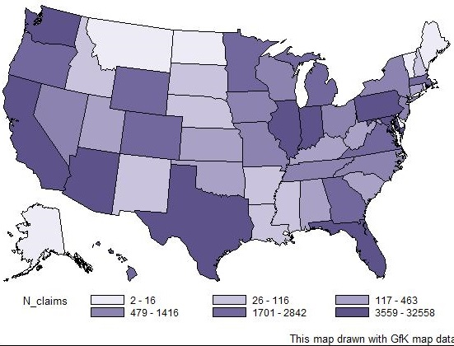

When listing at the publicly traded corporation or institutional level, there were over 1500 schools associated with claims. Of these, 95% of claims were from 15 schools (results not shown). The mean number of claims per school was 44 with standard deviation of 342 and median of 2.

3.2 Claim Status
The Department tracks the current status of borrower defense claims. The status generally falls into one of four categories: intake, adjudication, post-review, and completed. The breakdown of claims as of October 30, 2017, by status is shown in Table 1.
Table 1: Status of Borrower Defense Claims
Status | Number | Percent
Intake | 23,820 | 18
Adjudication | 78,910 | 58
Post-Review | 2,550 | 2
Completed | 29,780 | 22
TOTAL | 135,050 | 100
Cell counts greater than 10 were rounded to the tens place.

3.3 Changes over Time
Since 2015, the Department had received much larger claims volume than it previously experienced. For visualization purposes, the small number of cases received prior to 2015 was excluded from Figure 2. For claims submitted after January 1, 2015, the mean number of claims per month was 4,356 with a standard deviation of 4,460. Increases correlate temporally with school closures, lawsuits, other adverse actions against schools, Department outreach, and operational changes to claim submission.
Figure 2: Number of Borrower Defense Claims by date received
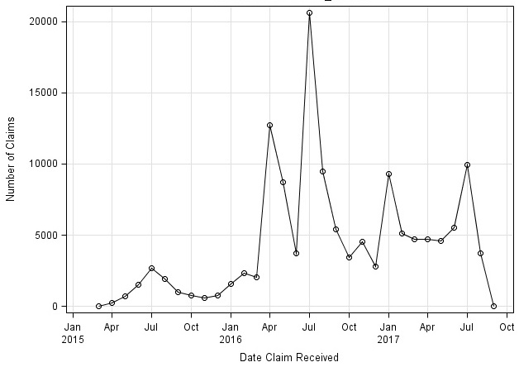
The breakdown of claims received by year and status is shown in Table 2. Most of the completed claims were received by the Department in 2016.
Table 2: Number of BD claims by current status category and year received
Year | Intake | Adjudication | Post-Review | Completed | Total
pre-2015 | * | * | * | * | *
2015 | 430 | 6,270 | 240 | 3,230 | 10,160
2016 | 10,640 | 40,810 | 1,950 | 23,940 | 77,340
2017 | 12,750 | 31,830 | 360 | 2,610 | 47,540
Total | 23,820 | 78,910 | 2,550 | 29,780 | 135,050
Counts with fewer than 10 observations were suppressed. Suppressed cells were represented by an asterisk. All remaining counts were rounded to the tens place.

The Department of Education tracked the date that an approved claim was sent to the servicer for disbursement or refund. This date only applies to those cases that were approved and for which loans existed. The comparison of number of claims received and number of claims resolved is shown in Figure 3. The mean number of days between date claim received and date approved claim sent to the servicer was 264 days with a standard deviation of 101 days.
Figure 3: Number of Claims by year Table 3: Number of claims by year
Year | Number Received | Number Resolved
pre-2015 | * | *
2015 | 10,160 | *
2016 | 77,340 | 14,980
2017 | 47,540 | 16,150
Total | 135,050 | 31,140
Counts with fewer than 10 observations were suppressed. Suppressed cells were represented by an asterisk. All remaining counts were rounded to the tens place.

