UTAH

ESEA Flexibility Request

TABLE OF CONTENTS

CONTENTS | PAGE
Cover Sheet for ESEA Flexibility Request | 4
Waivers | 5
Assurances | 7
Consultation | 8
Evaluation | 15
Overview of SEA’s ESEA Flexibility Request | 16
Principle 1: College- and Career-Ready Expectations for All Students | 20
1.A Adopt college-and career-ready standards | 20
1.B Transition to college- and career-ready standards | 21
1.C Develop and administer annual, statewide, aligned, high-quality assessments that measure student growth | 34
Principle 2: State-Developed Differentiated Recognition, Accountability, and Support | 35
2.A Develop and implement a State-based system of differentiated recognition, accountability, and support | 35
2.B Set ambitious but achievable annual measurable objectives | 45
2.C Reward schools | 48
2.D Priority schools | 49
2.E Focus schools | 52
2.F Provide incentives and supports for other Title I schools | 55
2.G Build SEA, LEA, and school capacity to improve student learning | 57
Principle 3: Supporting Effective Instruction and Leadership | 60
3.A Develop and adopt guidelines for local teacher and principal evaluation and support systems | 60
3.B Ensure LEAs implement teacher and principal evaluation and support systems | 68
Principle 3: Overall Review | 74
Principle 4: Reducing Duplication and Unnecessary Burden | 75

TABLE OF CONTENTS, CONTINUED

LABEL | LIST OF ATTACHMENTS | PAGE
1 | Notice to LEAs | 76
2 | Comments on request received from LEAs (if applicable) | 78
3 | Notice and information provided to the public regarding the request | 82
4 | Evidence that the State has formally adopted college- and career-ready content standards consistent with the State’s standards adoption process | 87
5 | Memorandum of understanding or letter from a State network of institutions of higher education (IHEs) certifying that meeting the State’s standards corresponds to being college- and career-ready without the need for remedial coursework at the postsecondary level (if applicable) | 93
6 | State’s Race to the Top Assessment Memorandum of Understanding (MOU) (if applicable) | 97
7 | Evidence that the SEA has submitted high-quality assessments and academic achievement standards to the Department for peer review, or a timeline of when the SEA will submit the assessments and academic achievement standards to the Department for peer review (if applicable) | 114
8 | A copy of the average statewide proficiency based on assessments administered in the 2010-2011 school year in reading/language arts and mathematics for the “all students” group and all subgroups (if applicable). | 116
9 | Table 2: Reward, Priority, and Focus Schools | 123
10 | A copy of any guidelines that the SEA has already developed and adopted for local teacher and principal evaluation and support systems (if applicable). | 127
11 | Evidence that the SEA has adopted one or more guidelines of local teacher and principal evaluation and support systems | 127
12 | Development and Implementation Timeline for Utah College and Career Readiness Student Standards | 133
13 | Timeline for Stakeholder Input on Educator Evaluation Development and Implementation Efforts | 135
14 | Utah Core to Common Core English Language Arts Alignment | 137
15 | Utah Public School Data Gateway Screenshots | 138
16 | Report Card Sample Screenshots | 145
17 | PEER | 150
18 | Stakeholder Committee Participants | 152
19 | Utah Comprehensive Accountability System | 157
20 | Promises to Keep | 167
21 | Superintendent Shumway’s Letter to Secretary Duncan | 168
22 | Secretary Duncan’s Letter to Governor Herbert cc Superintendent Shumway | 170
23 | Request to Change SBAC Participation from Governing to Advisory State | 171
24 | Utah School Report Card | 172
25 | Demonstration Data - Reward Schools | 173
26 | Demonstration Data - Focus Schools | 177
27 | Comprehensive Accountability System and Proficiency | 181
28 | Demonstration Data – Exit Criteria for Priority Schools | 183
29 | Three Tier Model of Title I Systems of Support | 187

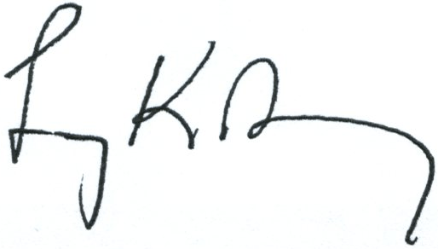
COVER SHEET FOR ESEA FLEXIBILITY REQUEST

Legal Name of Requester: Utah State Board of Education | Requester’s Mailing Address: 250 East 500 South  PO Box 144200  Salt Lake City, UT 84114-4200
State Contact for the ESEA Flexibility Request Name: Judy Park

Position and Office: Associate Superintendent, Student Services and Federal Programs

Contact’s Mailing Address: 250 East 500 South
PO Box 14420
Salt Lake City, UT 84114-4200

Telephone: 801-538-7550

Fax: 801-538-7768

Email address: judy.park@schools.utah.gov
Chief State School Officer (Printed Name): Larry K. Shumway | Telephone: 801-538-7510
Signature of the Chief State School Officer:  X | Date: 5/29/12
The State, through its authorized representative, agrees to meet all principles of the ESEA Flexibility.

WAIVERS

By submitting this flexibility request, the SEA requests flexibility through waivers of the ten ESEA requirements listed below and their associated regulatory, administrative, and reporting requirements by checking each of the boxes below. The provisions below represent the general areas of flexibility requested; a chart appended to the document titled ESEA Flexibility Frequently Asked Questions enumerates each specific provision of which the SEA requests a waiver, which the SEA incorporates into its request by reference.

- The requirements in ESEA section 1111(b)(2)(E)-(H) that prescribe how an SEA must establish annual measurable objectives (AMOs) for determining adequate yearly progress (AYP) to ensure that all students meet or exceed the State’s proficient level of academic achievement on the State’s assessments in reading/language arts and mathematics no later than the end of the 2013–2014 school year. The SEA requests this waiver to develop new ambitious but achievable AMOs in reading/language arts and mathematics in order to provide meaningful goals that are used to guide support and improvement efforts for the State, LEAs, schools, and student subgroups.
X

- The requirements in ESEA section 1116(b) for an LEA to identify for improvement, corrective action, or restructuring, as appropriate, a Title I school that fails, for two consecutive years or more, to make AYP, and for a school so identified and its LEA to take certain improvement actions. The SEA requests this waiver so that an LEA and its Title I schools need not comply with these requirements.
X

- The requirements in ESEA section 1116(c) for an SEA to identify for improvement or corrective action, as appropriate, an LEA that, for two consecutive years or more, fails to make AYP, and for an LEA so identified and its SEA to take certain improvement actions. The SEA requests this waiver so that it need not comply with these requirements with respect to its LEAs.
X

- The requirements in ESEA sections 6213(b) and 6224(e) that limit participation in, and use of funds under the Small, Rural School Achievement (SRSA) and Rural and Low-Income School (RLIS) programs based on whether an LEA has made AYP and is complying with the requirements in ESEA section 1116. The SEA requests this waiver so that an LEA that receives SRSA or RLIS funds may use those funds for any authorized purpose regardless of whether the LEA makes AYP.
X

- The requirement in ESEA section 1114(a)(1) that a school have a poverty percentage of 40 percent or more in order to operate a school-wide program. The SEA requests this waiver so that an LEA may implement interventions consistent with the turnaround principles or interventions that are based on the needs of the students in the school and designed to enhance the entire educational program in a school in any of its priority and focus schools, as appropriate, even if those schools do not have a poverty percentage of 40 percent or more.
X

- The requirement in ESEA section 1003(a) for an SEA to distribute funds reserved under that section only to LEAs with schools identified for improvement, corrective action, or restructuring. The SEA requests this waiver so that it may allocate section 1003(a) funds to its LEAs in order to serve any of the State’s priority and focus schools.
X

- The provision in ESEA section 1117(c)(2)(A) that authorizes an SEA to reserve Title I, Part A funds to reward a Title I school that (1) significantly closed the achievement gap between subgroups in the school; or (2) has exceeded AYP for two or more consecutive years. The SEA requests this
X
waiver so that it may use funds reserved under ESEA section 1117(c)(2)(A) for any of the State’s reward schools.

- The requirements in ESEA section 2141(a), (b), and (c) for an LEA and SEA to comply with certain requirements for improvement plans regarding highly qualified teachers. The SEA requests this waiver to allow the SEA and its LEAs to focus on developing and implementing more meaningful evaluation and support systems.
X

- The limitations in ESEA section 6123 that limit the amount of funds an SEA or LEA may transfer from certain ESEA programs to other ESEA programs. The SEA requests this waiver so that it and its LEAs may transfer up to 100 percent of the funds it receives under the authorized programs among those programs and into Title I, Part A.
X

- The requirements in ESEA section 1003(g)(4) and the definition of a Tier I school in Section
X
I.A.3 of the School Improvement Grants (SIG) final requirements. The SEA requests this waiver so that it may award SIG funds to an LEA to implement one of the four SIG models in any of the State’s priority schools.

Optional Flexibility:

An SEA should check the box below only if it chooses to request a waiver of the following requirements:

The requirements in ESEA sections 4201(b)(1)(A) and 4204(b)(2)(A) that restrict the activities provided by a community learning center under the Twenty-First Century Community Learning Centers (21st CCLC) program to activities provided only during non-school hours or periods when school is not in session (i.e., before and after school or during summer recess). The SEA requests this waiver so that 21st CCLC funds may be used to support expanded learning time during the school day in addition to activities during non-school hours or periods when school is not in session.
X

- The requirements in ESEA sections 1116(a)(1)(A)-(B) and 1116(c)(1)(A) that require LEAs and SEAs to make determinations of adequate yearly progress (AYP) for schools and LEAs, respectively. The SEA requests this waiver because continuing to determine whether an LEA and its schools make AYP is inconsistent with the SEA’s State-developed differentiated recognition, accountability, and support system included in its ESEA flexibility request. The SEA and its LEAs must report on their report cards performance against the AMOs for all subgroups identified in ESEA
X
section 1111(b)(2)(C)(v), and use performance against the AMOs to support continuous improvement in Title I schools that are not reward schools, priority schools, or focus schools.

- The requirements in ESEA section 1113(a)(3)-(4) and (c)(1) that require an LEA to serve eligible schools under Title I in rank order of poverty and to allocate Title I, Part A funds based on that rank ordering. The SEA requests this waiver in order to permit its LEAs to serve a Title I-eligible high school with a graduation rate below 60 percent that the SEA has identified as a priority school even if that school does not rank sufficiently high to be served.
X

ASSURANCES

By submitting this application, the SEA assures that:

  - It requests waivers of the above-referenced requirements based on its agreement to meet Principles 1 through 4 of the flexibility, as described throughout the remainder of this request.
X

  - It will adopt English language proficiency (ELP) standards that correspond to the State’s college- and career-ready standards, consistent with the requirement in ESEA section 3113(b)(2), and that reflect the academic language skills necessary to access and meet the new college- and career-ready standards, no later than the 2013–2014 school year. (Principle 1)
X

  - It will develop and administer no later than the 2014–2015 school year alternate assessments based on grade-level academic achievement standards or alternate assessments based on alternate academic achievement standards for students with the most significant cognitive disabilities that are consistent with 34 C.F.R. § 200.6(a)(2) and are aligned with the State’s college- and career-ready standards. (Principle 1)
X

  - It will develop and administer ELP assessments aligned with the State’s ELP standards, consistent with the requirements in ESEA sections 1111(b)(7), 3113(b)(2), and 3122(a)(3)(A)(ii). (Principle 1)
X

  - It will report annually to the public on college-going and college credit-accumulation rates for all students and subgroups of students in each LEA and each public high school in the State. (Principle 1)
X

  - If the SEA includes student achievement on assessments in addition to reading/language arts and mathematics in its differentiated recognition, accountability, and support system and uses achievement on those assessments to identify priority and focus schools, it has technical documentation, which can be made available to the Department upon request, demonstrating that the assessments are administered statewide; include all students, including by providing appropriate accommodations for English Learners and students with disabilities, as well as alternate assessments based on grade-level academic achievement standards or alternate assessments based on alternate academic achievement standards for students with the most significant cognitive disabilities, consistent with 34 C.F.R. § 200.6(a)(2); and are valid and reliable for use in the SEA’s differentiated recognition, accountability, and support system. (Principle 2)
X

  - It will report to the public its lists of reward schools, priority schools, and focus schools at the time the SEA is approved to implement the flexibility, and annually thereafter, it will publicly recognize its reward schools. (Principle 2)
X

  - Prior to submitting this request, it provided student growth data on their current students and the students they taught in the previous year to, at a minimum, teachers of reading/language arts and mathematics in grades in which the State administers assessments in those subjects in a manner that is timely and informs instructional programs, or it will do so no later the deadline required under the State Fiscal Stabilization Fund. (Principle 3)
X

  - It will evaluate and, based on that evaluation, revise its own administrative requirements to reduce duplication and unnecessary burden on LEAs and schools. (Principle 4)
X
  - It has consulted with its Committee of Practitioners regarding the information set forth in its request.
X

  - Prior to submitting this request, it provided all LEAs with notice and a reasonable opportunity to comment on the request and has attached a copy of that notice (Attachment 1) as well as copies of any comments it received from LEAs (Attachment 2).
X

  - Prior to submitting this request, it provided notice and information regarding the request to the public in the manner in which the State customarily provides such notice and information to the public (e.g., by publishing a notice in the newspaper; by posting information on its website) and has attached a copy of, or link to, that notice (Attachment 3).
X

  - It will provide to the Department, in a timely manner, all required reports, data, and evidence regarding its progress in implementing the plans contained throughout this request.
X

  - It will report annually on its State report card, and will ensure that its LEAs annually report on their local report cards, for the “all students” group and for each subgroup described in ESEA section 1111(b)(2)(C)(v)(II): information on student achievement at each proficiency level; data comparing actual achievement levels to the State’s annual measurable objectives; the percentage of students not tested; performance on the other academic indicator for elementary and middle schools; and graduation rates for high schools. It will also annually report, and will ensure that its LEAs annually report, all other information and data required by ESEA section 1111(h)(1)(C) and 1111(h)(2)(B), respectively.
X

If the SEA selects Option A in section 3.A of its request, indicating that it has not yet developed and adopted all guidelines for teacher and principal evaluation and support systems, it must also assure that:

X 15. It will submit to the Department for peer review and approval a copy of the guidelines that it will adopt by the end of the 2011–2012 school year. (Principle 3)

CONSULTATION

An SEA must meaningfully engage and solicit input from diverse stakeholders and communities in the development of its request. To demonstrate that an SEA has done so, the SEA must provide an assurance that it has consulted with the State’s Committee of Practitioners regarding the information set forth in the request and provide the following:
- A description of how the SEA meaningfully engaged and solicited input on its request from teachers and their representatives.

Teachers are well represented in all of the Utah Stakeholder groups as described throughout the proposal by the participation of the Utah Education Association (UEA). Utah prefers to use the UEA to represent teachers and provide teacher perspectives to reduce removing teachers from their classrooms to participate on state committees. The UEA well represents teachers and teacher perspectives. Their participation will continue to play an important role as Utah continues to refine, implement and evaluate their systems. As the waiver process moves forward, Utah will present training and seek feedback in locations across the state. Teachers will be invited to these meetings.

- A description of how the SEA meaningfully engaged and solicited input on its request from other diverse communities, such as students, parents, community-based organizations, civil rights
organizations, organizations representing students with disabilities and English Learners, business organizations, and Indian tribes.

The Utah State Board of Education (USBE) has sought input into the development of the ESEA Flexibility Waiver request from Utah’s stakeholders. The proposal incorporates key goals and priorities from Promises to Keep; the vision for the future of education in Utah. In order to ensure high quality instruction and rigorous standards that lead to college and career readiness for all students, the state of Utah is determined to have one accountability system that includes performance and growth that focuses valuable resources on student success.

The elements found in the Utah waiver application associated with Principles 1, 2 and 3 were in place before the application for waiver process began. The following details the variety of ways that diverse stakeholders, including teachers and communities, were informed and encouraged to provide input. The involvement of the various stakeholder groups at the beginning of the planning process, as well as throughout the process, ensure that those stakeholders had meaningful input in shaping the Utah State Office of Education’s (USOE’s) waiver request, thereby helping to ensure success during implementation.

Committee of Practitioners
The USOE presented to the Utah Title I Committee of Practitioners on November 16, 2011, information related to the ESEA Flexibility Waiver Request process that was announced by the U.S. Department of Education in October 2011. The information provided and the discussion centered on the flexibilities available to states and the requirements that states must meet to apply for the ESEA Flexibility Waiver. The Title I Committee of Practitioners expressed support for the USOE to meet with stakeholder groups to gather input in the development of the waiver request. One of the key concerns expressed by the Committee of Practitioners was that future education accountability and reporting needs continue to report school and student achievement by disaggregated groups to ensure emphasis on high quality instruction and achievement of historically underperforming student populations. The USOE agreed to reconvene the Committee of Practitioners in January 2012 to share key principles of Utah's ESEA Flexibility Waiver request based on stakeholder input.

The Utah Title I Committee of Practitioners convened on January 25, 2012, to consider Utah's ESEA Flexibility Waiver request, seek clarifications, and provide input. Based on the information provided by the USOE, the Committee of Practitioners discussed the potential consequences of those parts of Utah's proposal that was of greatest concern to them. The new Utah Comprehensive Accountability System was introduced and discussed. In understanding how the system includes both academic achievement and growth, the Committee of Practitioners expressed support of the new accountability system. The Utah Title I Committee of Practitioners provided the following specific comments:

  - “Having two accountability systems has been confusing to parents.”
- In reference to the need to continue to report disaggregated student achievement results, one member of the committee said, “Must do to assure equitable education for all students.”
- School district and community representatives declared, “Disaggregated group reporting allows LEAs to prioritize funds and resources where needed.”

The new accountability system provides achievement scores of disaggregated groups as part of the new report card system. This understanding removed the primary concerns regarding a new education accountability system. The Committee of Practitioners was encouraged to complete a survey regarding the ESEA Flexibility Waiver request.

Stakeholder Survey
The superintendency of the USOE sent formal notification of intent to apply for the ESEA Flexibility Waiver to local education agencies and community groups representing Utah students. The notification included an executive summary of Utah’s proposal and invitation to provide input through a comprehensive survey. The survey was designed to allow stakeholders to respond to key principles in the ESEA Flexibility Waiver request and to provide comments and/or recommendations. This information was sent to superintendents, charter leaders, local boards of education, principals, curriculum directors, Title I directors, special education directors, Title III directors, Title VII coordinators, teachers, parents, community advocates, higher education, and the public in general through a link on the USOE website.

The public input survey was available for fourteen days and there were 446 respondents to the ESEA Flexibility Waiver request survey (71% of respondents were teachers). A chart that summarizes input from Utah’s stakeholders and the complete summary of the survey and responses is available in Attachment 2.

Summary of Frequent Public Input Comments/Recommendations
In reviewing the comments /recommendations from the ESEA Flexibility Waiver Survey, the USOE provides the following table that summarizes some of the most frequent comments. See Attachment 2.

Utah Groups Representing Students with Disabilities
The USOE Director of Special Education met with groups (e.g., Protection and Advocacy, Utah Parent Center, and the Utah Coordinating Council for Persons with Disabilities) representing students with disabilities to provide information regarding Utah’s proposed ESEA Flexibility Waiver and gather input. Particular emphasis and discussion was directed to the concept of the non-proficient subgroup of students with disabilities. Additionally, the Utah ESEA Flexibility Survey described above, was emailed to a variety of Utah organizations, including those listed above representing students with disabilities for dissemination to their listservs to gather additional input from parents, advocates, students with disabilities, special educators, and related service providers (e.g., Vocational Rehabilitation, Work Ability, Division of Substance Abuse and Mental Health, the University of Utah Center for Public Policy and Administration, Easter Seals of Utah, Utah Council for Exceptional Children, Utah Personnel Development Center, Utah Association of School Psychologists, etc.). Input received from these groups was considered in the development and revision of this application.

The information and opportunity for stakeholders representing students with disabilities has been presented in multiple venues by the USOE Special Education staff including; interagency councils (i.e. Coordinating Council for People with Disabilities (CCPD) and the Initiative on Utah Children in Foster Care (IOU)); ongoing state special education meetings; meetings with Protection and Advocacy (P & A); and groups representing parents of children with disabilities.

These discussions started prior to Utah’s development and submission of the ESEA Flexibility Request and continue to provide current status and information and continue to solicit input and concerns both in person and in writing regarding the accountability process used for all students in Utah, including those with disabilities. In addition, during Utah’s regular IDEA monitoring process, individual discussions were held with special education teachers and related service providers regarding the CCSS and how to develop IEP goals that provide the student with meaningful access and involvement in that core curriculum, while addressing their individual learning needs.

Utah Groups Representing English Language Learners
May 7, 2012 – a joint meeting with Title I and Title III Alternative Language Services (ALS) Directors will be held specifically dealing with the ESEA Flexibility Request, specifically how the Request will affect College and Career Readiness/Utah Core Standards and Assessment and Accountability plans.
June 15, 2012 – a summer conference with Catherine Colliers, an expert in the field of bilingual/cross cultural special education. This conference is the initial launch of an ongoing focus on professional development and implementation of evidence-based instruction in relationship to achievement and growth of English Language Learners (ELLs) and Special Education students. School based teams will represent Utah schools that have high enrollment of ELLs, ELLs with disabilities and low CRT results in language arts and math. The teams will consist of the school principal, one special education teachers, one ELL teacher, and two other staff members which may include a counselor and/or instructional coach. The goal of this project is to create a catalyst in each school to build understanding of issues around achievement of ELLs and Special Education students.

Multicultural Commission
Brenda Hales, Associate Superintendent, has been appointed to the Utah Multicultural Commission. The Utah Multicultural Commission goals are to accomplish the following:

- Partner with State agencies to assure equity and access to culturally competent programs and services; to discuss policies, practices and procedures; and to make recommendations to ensure proper delivery of state services and resources to the ethnic community.
- Partner with State agencies to ensure proper outreach and response to the ethnic community about State government’s programs and resources.
- Develop a strategic plan to identify needs, goals, and deliverables that will directly impact the most significant needs of the ethnic community.
- Report to the Governor’s Office as needed about State government’s responsiveness to the ethnic community of Utah and other issues impacting these constituents.

Principle 1 College and Career-Ready Expectations for All Students Stakeholder Consultation
The Utah State Board of Education (USBE) adopted the College and Career Readiness Student Standards (CCSS) in June 2010. The USBE and Superintendent Larry K. Shumway began a system wide education reform process in 2009, looking for ways to improve student learning in the face of many challenges including: burgeoning class sizes, rapidly changing demographics, increasing rates of poverty, drastic cuts to education budgets, and rapid rates of growth in various student populations including increasing numbers of English language learners and minority populations. For example, 38 percent of Utah students in public education are considered economically disadvantaged and at least 20 percent of all students have limited English proficiency.

Students with disabilities have increased in numbers as well, particularly students labeled as having various forms of autism. In the last six years, the number of students with disabilities who receive the majority of their special education services in the general education classroom has increased from 42.10% to 54.98%, posing additional challenges for classroom teachers and education systems of support for all students.

Therefore, the USBE has been engaged in trying to determine policy and programs that will meet the needs of all students and the educators who serve them. They know from examining the research and from stories of success in the field that the quality of instruction is the driving factor in reform. They also agree that student performance standards need to be more clearly defined.

Utah has been fortunate to have statewide content standards for decades but student performance standards have not been clearly defined or aligned with college readiness standards for all students. As the college and career readiness standards developed by Council of Chief State School Officers (CCSSO) and National Governors Association (NGA) began to emerge, Utah not only showed interest, but also gave vital input to their creation. Highly effective classroom teachers were asked to give input to the
creation of the standards as well as to provide feedback during the development process. Teacher specialists at the USOE were instrumental in coalescing teams of teachers to provide input and give feedback to early drafts. The Utah Education Association (UEA) was consulted early in the process to ensure broad-based support for adoption and ongoing professional learning. Special Education teachers and leaders and leaders of Title III funded programs were consulted as well to determine if the standards would provide all students with higher expectations and opportunities for success. Based on input from these various stakeholders, a detailed timeline for the adoption of the Utah College and Career Readiness Student Standards (CCSS) and accompanying professional development was established. The events during the first year of implementation can be found in Attachment 12.

Principle 2: State-Developed Differentiated Recognition, Accountability, and Support Stakeholder Consultation
November 2010, a stakeholder committee was formed to begin discussing the possibility of developing a new state accountability system to replace the current system, Utah Performance Assessment System for Students (U-PASS) Accountability System. The meetings focused on the possibility of a new state law that would require grading schools. The committee began the process of developing a new system by reviewing some of the literature on accountability systems, such as “Key Elements for Educational Accountability Models” (Perie, Park & Klau, 2007). This committee met monthly. When state statute 53A-1-1101-1113 was passed in March 2011, the committee adjusted its focus to incorporate the new requirements in the law. In addition to this advisory committee, the process of developing an accountability system was discussed with multiple groups representing Utah public education, parents, and students, with each group’s input informing the work and final product. Below is a list of the many different committees and stakeholders that were an essential part of the process to develop a new accountability system. The process included input sessions with all stakeholder groups as is detailed below.

We would call specific attention to our work with the Coalition of Minorities Advisory Committee (CMAC). The USOE staff spent a half day reviewing federal requirements and potential Utah responses with CMAC. The exchange was lively, productive and significantly helped to shape the final application. The final draft was then presented and approved by CMAC. As the process moves forward, the USOE staff have committed to attend each CMAC meeting to provide continued updates and seek input on the waiver process. The USOE staff will continue to meet with the Utah Policy Advisory (PAC) Committee which has representatives from all stakeholder groups and meet with the individual groups represented on the PAC (PTA, Superintendents, CMAC, UEA, Special Education Teachers, Assessment Directors, Curriculum Directors, English Language Learners, and Charter Schools).

Coalition of Minorities Advisory Committee (CMAC)
The USOE presented an overview of both the state accountability proposal and ESEA waiver application to the Utah Coalition of Minorities Advisory Committee (CMAC) at their January 2012 meeting. CMAC provided feedback on the proposal.
See Attachment 18 for a list of the individuals that served on the committee.

Comprehensive Accountability System Advisory Committee
In 2011, state statute 53A-1-1101-1113 was passed in the Utah legislature which required the USOE to design a new state accountability system. In March 2011, the USOE assembled a committee of policy makers, education leaders, and stakeholders from across the state to begin the work. The committee, with technical assistance provided by the National Center for the Improvement of Educational Assessment, was charged to develop a new assessment system for Utah schools. The committee met monthly (April – November to design the accountability system. The committee met in February 2012 to review the final draft proposal and provide feedback.
See Attachment 18 for a list of the individuals that served on the committee.

Utah Association of Elementary School Principals
A presentation and discussion on the new accountability system occurred in February 2012. This group of 200 elementary principals reviewed the final accountability system and provided feedback for ongoing improvements and evaluations

Utah Association of Elementary School Principals Board
A presentation and discussion on the development of the new accountability system occurred in December 2012. This group of 30 elementary principals provided valuable feedback that was incorporated into the design of the accountability system.

Utah Association of Secondary School Principals
A presentation and discussion on the development of the new accountability system occurred in January 2012. This group of 200 secondary administrators provided valuable feedback that was incorporated into the design of the accountability system.

Utah Education Association Board
A representative from each local education association regularly attends meetings on issues that are important to teachers. A presentation and discussion on the development of the new accountability system was received by this board in November 2011 and again in January 2012. Their feedback was incorporated in the development of the accountability system.

Utah LEA Assessment Directors
A summary of both the state accountability proposal and ESEA waiver applications was presented to the Utah LEA Assessment Directors at their January 2012 meeting. The Assessment Director for each LEA in the state was invited to participate in the meeting. The Assessment Directors provided feedback on the proposal.

Utah LEA Indian Education Coordinators and Tribal Leaders
The USOE presented an overview of both the state accountability proposal and ESEA waiver application to the Utah LEA Indian Education Coordinators and Tribal Leaders at their January 2012 meeting.
Particular emphasis and discussion was directed to rigorous standards for all students, assessments and accountability that would allow schools to incorporate heritage language and culture, teacher and administrator evaluations and the need for quality counseling and support for students. Feedback from the participants was received on the accountability system and ESEA waiver application.
See Attachment 18 for a list of the individuals that attended the meeting.

Utah LEA Special Education Directors
A summary of both the state accountability proposal and the ESEA waiver applications was presented to the Utah LEA Special Education Directors at their January 2012 meeting. Particular emphasis and discussion was directed to the concept of the non-proficient subgroup of students with disabilities. Input received from this group was considered in the development and revision of this application; the majority of the discussion focused on the commitment of SEA and LEA staff to include students with disabilities in the implementation of the CCSS using the same timelines and criteria used for all students.

Utah Policy Advisory Committee
The Utah Policy Advisory Committee reviewed both the state accountability proposal and the ESEA waiver application in their January 2012 meeting. They provided thoughtful feedback for both.
See Attachment 18 for a list of the individuals that served on the committee.

Utah State Board of Education
The USBE reviewed and approved Utah’s ESEA flexibility request February 3, 2012. See Attachment 4 for the minutes of the Board meeting.

Utah Schools Superintendents Association
A presentation and discussion on the development of the new accountability system occurred several times in the monthly meetings of this important group. All of the district superintendents attend this meeting. The Superintendents provided valuable feedback that was incorporated into the design of the accountability system.

Utah Technical Advisory Committee
The Utah Technical Advisory Committee reviewed both the state accountability proposal and the ESEA waiver application in their January 2012 meeting and provided significant feedback.
See Attachment 18 for a list of the individuals that served on the committee.

Principle 3 Supporting Effective Instruction and Leadership Stakeholder Consultation
The elements found in the Utah waiver application associated with educator evaluation regulations were in place before the application for waiver process began. The USBE placed new Effective Teaching Standards and Education Leadership Standards in Board rule R277-530 during the August 2011 Board meeting. The Utah Educator Evaluation Framework for statewide educator evaluation was placed in Board rule R277-531 September 2011. All of this work was done in a robust manner with strategies for broad-based stakeholder input. Stakeholder groups involved in the development of these policies included teachers, parents, administrators, teacher associations, representatives from educators of students with disabilities and English language learner, district leaders, USOE staff, assessment directors, human resource directors, teacher preparation faculty from higher education, deans of education and board members.

The Utah Education Association (UEA) has been an integral partner in all of our reform efforts. Leadership from the state UEA association was involved in the initial design and continues to be involved in implementation strategies. They serve on our steering and workgroup committees and appear at every USBE meeting and legislative session in support of our presentations and proposals regarding educator effectiveness. The work of the USBE in these areas relies heavily on the input from teachers and school leaders. The USBE and staff are also reliant on input from parents, principals, central office staff, charter school leaders and staff, advocacy groups for early childhood, special education, English language learners, minority coalition leaders, and teacher preparation institutions (IHEs). Membership of all workgroups can be found at http://www.schools.utah.gov/cert/Educator-Effectiveness- Project/Committees.aspx . Another critical component is the voice of students. Protocols to get student input on teacher effectiveness are currently under development and will serve as one of the three components in our overall educator evaluation system. Social media is also being used to provide information and get input on design of these tools.

As a result of the waiver application, the USOE has been able to gather additional information to inform development and implementation efforts. For example, a survey for public input on the waiver uncovered perceptions about educator evaluation that will need to be addressed in professional development and provided us with specific concerns regarding student growth measures in educator evaluation. The survey results (Attachment 2) indicate that 96% of respondents believe that instructional effectiveness is important to extremely important in the overall effectiveness rating of an educator, with 31% responding that it is extremely important. A question about the measure of student growth in determining overall effectiveness of an educator had less favorable ratings with 72%, overall indicating it would be effective to extremely effective; and only 13% indicating this would be extremely useful. This feedback will
influence how we weight the measures of student growth and instructional effectiveness in our overall evaluation system.
A timeline outlining formal actions taken to involve stakeholder groups in development and implementation efforts for statewide educator evaluation can be found in Attachment 13.

EVALUATION

The Department encourages an SEA that receives approval to implement the flexibility to collaborate with the Department to evaluate at least one program, practice, or strategy the SEA or its LEAs implement under principle 1, 2, or 3. Upon receipt of approval of the flexibility, an interested SEA will need to nominate for evaluation a program, practice, or strategy the SEA or its LEAs will implement under principles 1, 2, or 3. The Department will work with the SEA to determine the feasibility and design of the evaluation and, if it is determined to be feasible and appropriate, will fund and conduct the evaluation in partnership with the SEA, ensuring that the implementation of the chosen program, practice, or strategy is consistent with the evaluation design.

Check here if you are interested in collaborating with the Department in this evaluation, if your request for the flexibility is approved.
X
Utah is interested in collaborating with the U.S. Department of Education to evaluate the effectiveness
of our efforts under Principle 2: State-developed differentiated recognition, accountability, and support. Utah stakeholders have invested considerable time and expertise in the articulation of a comprehensive system for school accountability. The proposed Utah Comprehensive Accountability System (UCAS) includes three components: achievement, growth, and readiness. This system will result in a performance/growth target assigned to each Utah school, and is designed to improve student achievement and school performance, close achievement gaps, and increase the quality of instruction for all students.

This accountability approach is significantly different from Utah’s current accountability system. As Utah implements the UCAS, an evaluation of the impact of the system on Utah schools and communities is critical for the process of continual improvement and refinement of the system. There are several key questions that Utah proposes to collaborate with the Department to address:
  - What impact does the UCAS have on the perception of community stakeholders regarding the effectiveness of the school?
  - What impact does the UCAS have on the perception of community stakeholders regarding the quality of Utah schools overall?
  - What impact does the UCAS have on student performance for all students? Is the intended outcome (improved student performance) being achieved?
  - What impact does the designation of a school as a Reward School, Priority School, or Focus School have on student achievement at those schools? Does student achievement improve as a result of these designations?
  - Does the designation of a school as a Priority School or a Focus School have a differentiated impact on the achievement of students in various subgroups?
  - What are the unforeseen or unintended consequences of the UCAS in the areas of student achievement, school achievement, closing the achievement gap, quality of instruction, quality of school personnel, and community perception?

Upon receipt of approval for ESEA flexibility, Utah will collaborate with the Department in the development of an evaluation program to address these key questions. In partnership with the Department, Utah will identify the specific tools and measurement strategies to use as part of this evaluation. With financial and technical support from the Department, the approved evaluation plan will
be implemented to measure the effectiveness of Utah’s approach to Principle 2, specifically the practices associated with the UCAS performance and accountability system.

Overview

Provide an overview (about 500 words) of the SEA’s request for the flexibility that:
1. explains the SEA’s comprehensive approach to implement the waivers and principles and describes the SEA’s strategy to ensure this approach is coherent within and across the principles; and

2. describes how the implementation of the waivers and principles will enhance the SEA’s and its LEAs’ ability to increase the quality of instruction for students and improve student achievement.

The ESEA Flexibility Waiver Application has given Utah the opportunity to clearly articulate how the vision, goals and programs of the USBE come together in a coherent process that is aligned with the requirements of the application. The USBE is committed to providing leadership and support to local education agencies and schools to achieve high levels of student success and to ensure that all students are college and career ready. The four principles in the application reflect the focus and ongoing work of the state of Utah in preparing all students to be college and career-ready through increased quality of instruction and improved student achievement. Utah’s students with disabilities and English language learners have been planned for and included throughout this application whenever the phrase “all students” is used.

Utah’s Flexibility Waiver Request application aligns all of the principles outlined by the Department into Utah's comprehensive plan for student achievement and school success.

In order to fulfill the constitutional responsibilities of public education in Utah and to achieve the high expectations of Utah’s citizens, the USBE on August 7, 2009, adopted Promises to Keep (see attachment
- as its vision for the future of education in Utah. These promises are Utah’s comprehensive plan for increased quality of instruction and improved student achievement. These promises clearly define the priorities of public education in Utah as:

  - Ensuring literacy and numeracy for all Utah children
  - Providing high quality instruction for all Utah children
  - Establishing curriculum with high standards and relevance for all Utah children
  - Requiring effective assessment to inform high quality instruction and accountability

Each of these promises are now well entrenched into state goals, policies and practices. They not only align with the principles of this application, but have served as the catalyst for preparing the state to be ready to replace current NCLB requirements with a more rigorous focus and requirement for students and educators.

Ensuring literacy and numeracy for all Utah children (Principle 1, 2 and 3)
In order to ensure that Utah's students are prepared for the future, the USBE adopted the English language arts and mathematics college and career-ready student standards.

Utah's new standards are more focused and are more rigorous than Utah's previous core curriculum standards. The benefit to Utah students is a set of focused student performance outcomes targeted at ensuring all students are college, career, and citizenship ready. To assist LEAs in building the instructional capacity of teachers including general educators, special educators (and related service providers), and English Language Acquisition educators to build literacy and numeracy skills for all
children, the USOE provides quality professional development. Priority attention has been given to and targeted at schools serving high needs populations. Reading specialists have also been highly trained to work with at-risk readers while reading coaches have been providing classroom teachers with additional tools to differentiate instruction and ensure all students are reading at a minimum, on grade-level. In addition, the Utah State Board of Education (USBE) also adopted the World Class Instructional Design and Assessment (WIDA) English language proficiency standards (May 7, 2010) to assist educators in differentiating instruction to ensure that English language learners develop English proficiency. In developing Utah’s ESEA Flexibility Waiver proposal, the USOE staffs have collaborated with the Office of English Language Acquisition (OELA) and the National Clearinghouse for English Language Acquisition (NCELA). By targeting classroom instruction in literacy and providing administrators with the tools needed to promote and monitor best practices, all Utah students will be better prepared with literacy skills needed to be successful in college and careers.

Providing high quality instruction for all Utah children (Principle 1 & 3)
A focus on improving the quality of instruction for all Utah children has included support for the Utah Educator Effectiveness Project. High quality instruction in all public schools in Utah requires:
- Measuring teaching and leadership with research-based performance standards.
- Aligning preparation programs to Utah Effective Teaching Standards and Utah Educational Leadership Standards.
- Evaluating the effectiveness of educators yearly using multiple measures.
- Recruiting, retaining, promoting, and rewarding the most effective educators.
- Providing appropriate professional development at all stages of the professional career continuum.

The five major components of the Educator Effectiveness Project are directly targeted at improving instruction and are all essential for improving educational outcomes for all students. The Utah State Board of Education (USBE) adopted the Utah Effective Teaching Standards and Utah Educational Leadership Standards, in Board rule R277-530 in August 2011 as the first and most crucial step of the overall project. See Attachment 10 and Attachment 11.

These standards will serve as the basis for LEA educator evaluation systems as well as the model system being developed by the Utah Educator Evaluation Advisory Committee and subsequent workgroups. The USBE then adopted Board rule R277-531 (Attachment 10 and Attachment 11) September 2011, outlining the educator evaluation components and processes required of all LEAs in Utah. The standards include indicators focused on differentiating instruction and understanding needs of English language learners and students with disabilities. The sole purpose of this project is to ensure teachers and leaders engage in instructional practices that will enable all students in Utah public schools to be successful. The details of this project are outlined in Principle 3.

Establishing curriculum with high standards and relevance for all Utah children (Principle 1) In January 1984, The USBE established policy requiring the identification of specific core curriculum standards to be completed by all K-12 students as requisite for graduation from Utah’s secondary schools. The Elementary and Secondary School Core Curriculum is defined in Board rule R277-700.

The new Utah college- and career-ready student standards for English language arts and mathematics provide a performance-based pathway to ensure all students in Utah public schools are prepared with knowledge and skills to succeed in college and careers for today’s economy. The Utah Core Curricula, which now incorporates these standards, is taught with respect to difference in student learning styles, rates, and individual capabilities without losing sight of established standards. Professional development has been provided to LEA staff regarding the use of standards-based (CCSS)
individualized educational programs (IEPs) and alternative language interventions to address the instructional needs of students with disabilities and English language learners transitioning to the CCSS.

Ongoing professional development also focuses on the need for implementation of research-based instructional methodology and accessibility strategies, including the use of tiered instruction and Universal Design for Learning (UDL) to allow access to grade level content for all students, regardless of whether it is provided by the USOE Teaching and Learning or USOE Special Education section.
Cross-training with general education staff, special education staff, and school and district administration occurs regularly, to ensure that all students in Utah receive high quality instruction from qualified and effective personnel.

Locally-selected textbooks and digital resources are used as tools in implementing the core curricula. Teachers and administrators utilize the core curricula to provide direction in determining professional development needs. The Utah Core Curricula process has been a part of Utah public education since the early 1980’s and provides guidance in organizing the Utah system for assessing students’ learning and instructional effectiveness and serves as a vehicle by which students, teachers, administrators, community leaders, and parents join as partners to build high quality instruction for all students.

The comprehensive system of counseling and guidance helps to ensure that counselors help students take courses that will assist in college and career readiness and graduation, scholarships, and opportunities for mentoring. Counselors help students more effectively transition from junior/middle schools to high schools and from high school to college and careers opportunities. Collaboration has occurred at the state and local level among special education staff and school counselors, as well as with the Utah Vocational Rehabilitation agency. Professional development has been provided to LEA special educators and school counselors, targeting the school to post school transition plan that is part of the IEP process for students of transition age. This professional development has been used to strengthen transition planning for students with disabilities and ensure that IEP teams consider the necessary specialized instruction needed to ensure these students leave school prepared for college and career.

Requiring effective assessment to inform high quality instruction and accountability (Principles 1 & 2)
In order to effectively assess student performance to inform instruction and ensure school accountability, the USBE has supported two important initiatives: 1) the focus on implementing high-quality assessments to measure student proficiency with the new standards and (2) a new Utah Comprehensive Assessment System (UCAS) that will evaluate school effectiveness based on achievement and growth.

With Utah’s commitment to a comprehensive adaptive testing system as evidenced by the pilot programs described in Principle 2, Utah is well prepared for transitioning to a more effective assessment process.

In addition, the focus of the USBE has been to prepare and plan for a transition to measuring student growth towards a goal of career and college readiness for all Utah children. This includes a goal to provide clear feedback to students, parents, teachers, principals and policy makers about individual student and group progress. The plan calls for eliminating the existing dual accountability systems and providing a single comprehensive accountability system which meets both state and federal needs. This vision has led to the implementation of two pilot assessment programs which are currently paving the way for the transition to the new assessment and accountability system.

Utah educational leaders recognize the need for schools to consistently use quality progress monitoring tools to assess student learning and inform instruction. If teachers collaborate in meaningful Professional Learning Communities at the school level, they will regularly review student performance data to design instructional activities to meet the individual needs of students and improve student learning.
Professional development on progress monitoring and the use of student data to guide instruction has been provided to LEA staff.

School Improvement Plans
Utah State Code 53A-1a-108.5 requires all Utah schools to complete a school improvement plan. The school improvement plan is to address the specific learning needs of the students. In developing this plan, schools are to review achievement data and elicit input from parents and teachers. The school improvement plan is to be reviewed annually and shared with the local school board and the school community. Specific school improvement plan requirements are outlined in 53A-1a-108.5.

Utah Strategic Planning Act for Educational Excellence
53A-1a-108.5 School improvement plan.
(1)(a) Each school community council shall annually evaluate the school’s U-PASS test results and use the evaluations in developing a school improvement plan.
(b) In evaluating U-PASS test results and developing a school improvement plan, a school community council may not have access to data that reveal the identity of students.
- Each school improvement plan shall:
  - identify the school’s most critical academic needs;
  - recommend a course of action to meet the identified needs;
  - list any programs, practices, materials, or equipment that he school will need to implement its action plan to have a direct impact on the instruction of students and result in measurable increased student performance; and
  - describe how the school intends to enhance or improve academic achievement, including how financial resources available to the school, such as School LAND Trust Program money received under Section 53A-16-101.5 and state federal grants, will be used to enhance or improve academic achievement.
- The school improvement plan shall focus on the school’s most critical academic needs but may include other actions to enhance or improve academic achievement and community environment for students.
- The school principal shall make available to the school community council the school budget and other data needed to develop the school improvement plan.
- The school improvement plan shall be subject to the approval of the local school board of the school district in which the school is located.
- A school community council may develop a multiyear school improvement plan, but the plan must be presented to and approved annually by the local school board.
- Each school shall:
  - implement the school improvement plan as developed by the school community council and approved by the local school board;
  - provide ongoing support for the council’s plan; and
  - meet local school board reporting requirements regarding performance and accountability.

The Title I school improvement process in Utah has demonstrated success in turning around schools identified in need of improvement. Title I schools identified in need of improvement have been required to revise their school improvement plans based on the results of a school appraisal conducted by an approved school support team. The USOE will continue to use this process to build school capacity in the lowest-performing schools to ensure high quality instruction and increased student achievement.

PRINCIPLE 1: COLLEGE- AND CAREER-READY EXPECTATIONS FOR ALL STUDENTS

1.A ADOPT COLLEGE- AND CAREER-READY STANDARDS

Select the option that pertains to the SEA and provide evidence corresponding to the option selected. *
X

Option A
The State has adopted college- and career- ready standards in at least reading/language arts and mathematics that are common to a significant number of States, consistent with part (1) of the definition of college- and career- ready standards.

i. Attach evidence that the State has adopted the standards, consistent with the State’s standards adoption process. (Attachment 4)
Option B
The State has adopted college- and career- ready standards in at least reading/language arts and mathematics that have been approved and certified by a State network of institutions of higher education (IHEs), consistent with part (2) of the definition of college- and career-ready standards.

Attach evidence that the State has adopted the standards, consistent with the State’s standards adoption process. (Attachment 4)

Attach a copy of the memorandum of understanding or letter from a State network of IHEs certifying that students who meet these standards will not need remedial coursework at the postsecondary level. (Attachment 5)
*On August 6th, 2010, Utah adopted college and career ready standards in English language arts and mathematics which were approved and certified by the Utah State Board of Education pursuant to Article X of the Utah State Constitution, which delegates general control and supervision of public education to the State Board. The introductory summary (as well as narrative in principle 1.B) outlines how stakeholders gave input to this decision, including representatives from the Utah IHE system.

Adoption of the college and career ready standards included numerous opportunities and strategies for public input before full consideration by the USBE. The process began in 2006 with the implementation of the K-16 Alliance http://science.uvu.edu/k16alliance/. This committee, jointly hosted by the USBE and the Utah Board of Regents, is committed to preparing all students to be college and career ready. The Superintendent of Schools and the Commissioner of Higher Education co-chair this committee.
Membership is made up of a variety of education stakeholders and community activists who have a vested interest in ensuring that Utah public schools prepare ALL students for success. This alliance frames the conversation and action around ensuring that all students are prepared and supported in achieving success in post-secondary education.

A primary topic of conversation during the past few years has been the amount of remediation occurring in mathematics and English language arts courses during the freshman year of college. A 2010 study by Utah Valley University indicated that almost half of the entering freshmen needed to enroll in remedial mathematics or English language arts courses. While most of these struggling students profiled in the data did not attend college right out of high school, the percentage of all students needing remediation was worth noting. A major strategy to combat this issue included adopting student performance standards based on 21st century skills and providing all students with high quality instruction every day in every classroom by all educators. The collaborative work of the USBE and the Utah Board of Regents resulted in the documented commitment to encourage all students to prepare for college and careers through a rigorous course of study and through a focus that includes:
    - Build an Academic Foundation
    - Develop Intellectual and Career Capacity
    - Evaluate Progress for College
    - Explore Postsecondary Options.

Graduation standards and student performance measures have also been a recent target of the USBE reform initiatives. In 2007, the USBE increased graduation requirements from two years of mathematics and science to three, (including Algebra 2), for the graduating class of 2011 while acknowledging that this was merely a starting point for standards reform. Subsequently, states were coming together, under the leadership of the NGA and the CCSSO, to produce standards for student performance that will help all students be better prepared for success in college and careers. Governor Gary Herbert and Superintendent Larry K. Shumway agreed that participation in the development of these standards would serve Utah students well. Staff members of both the Governor’s office and the USOE were involved in the development, providing input, direction and feedback. Members of our Institutions of Higher Education (IHE) partners also served on design committees. These standards then informed the work of Utah’s development and implementation of the Utah Core Standards for mathematics and English language arts.

In a letter to Secretary Duncan dated March 5, 2012 (Attachment 21), Utah Superintendent Larry Shumway stated, “On behalf of the Board, I assert its right to complete control of Utah’s learning standards in all areas of our public education curriculum.”

A letter from Secretary Duncan dated March 16, 2012 (Attachment 22), agrees that Utah is in control of Utah’s standards.

1.B TRANSITION TO COLLEGE- AND CAREER-READY STANDARDS

Provide the SEA’s plan to transition to and implement no later than the 2013–2014 school year college- and career-ready standards statewide in at least reading/language arts and mathematics for all students and schools and include an explanation of how this transition plan is likely to lead to all students, including English Learners, students with disabilities, and low-achieving students, gaining access to and learning content aligned with such standards. The Department encourages an SEA to include in its plan activities related to each of the italicized questions in the corresponding section of the document titled ESEA Flexibility Review Guidance, or to explain why one or more of those activities is not necessary to its plan.

Implementation Timeline:
The USBE adopted the CCSS in June 2010 along with a statewide implementation timeline. Letters were sent to school district superintendents and charter directors regarding the adoption and timeline; making it clear that all LEAs would be expected to adopt the standards within the given timeline. The timeline represents the USBE’s ability to support statewide implementation efforts while being based on a backwards design aligned with the timeline for accompanying assessment development. Full implementation of both English language arts and mathematics standards for all students will occur in the 2013-14 school year with accompanying assessments used for accountability measures in 2014-15. Many LEAs have chosen to implement at a faster rate and several LEAs elected to wait until 2012-13 to begin implementation. However, all LEAs have been involved in early professional development, curriculum alignment, and in the use of instructional strategies more aligned with new standards. Non-scored pilot assessment questions will be included in the existing end of level tests and results will be disaggregated for further analysis. The timeline has not been adjusted for various groups of students. Rather, the USBE believes that the standards are for all students including students with disabilities and English language learners and that the quality of instruction
accompanying the standards is key to ensuring all students are prepared for post-secondary education in order to be successful in today’s economy.

Readiness Efforts in 2010-2011
Implementation efforts after the USBE adoption in 2010 were focused on communication and gathering stakeholder input. A website (http://www.schools.utah.gov/core/) was assembled providing information for parents and educators to assist in understanding the new Utah college and career ready standards. The following activities were the focus of our first year efforts.

- Communicate reasons for adopting new standards to stakeholders
- Gather stakeholder input about college and career ready standards adoption and implementation plans
- Provide professional development for Utah Core Academy facilitators, teacher leaders, district leaders
- Distribute resources for parent, educators, and policymakers to aide in understanding of changes
- Align curriculum with standards and crosswalk with current Utah CORE
- Begin course development for new integrated secondary mathematics courses
- Develop performance expectations for students and teachers
- Engage in articulation with IHEs
- Develop interventions and expand opportunities for Students with Disabilities, English language learners, and accelerated learners
- Work with publishers to develop e-books and other integrated resources

The following timelines illustrate the USOE rollout of professional and resource development by grade level. For example, in the summer of 2011, the USOE provided Academies for K-12 English language arts with the exception of 6th grade, which was focused on mathematics. Mathematics sessions were provided for 6th and 9th grade mathematics teachers. The USOE will focus efforts on mathematics K-5, 7th, 8th, and 10th grades during the 2012-2013 year in order to develop resources, provide technical assistance and ongoing professional learning opportunities for successful implementation.

USOE Implementation Timeline for English Language Arts Grades K-12
School Year | K | 1 | 2 | 3 | 4 | 5 |  | 6 | 7 | 8 | 9 | 10 | 11 | 12
2011-2012 | Summer Utah Core Academy, follow-up PD |  |  |  |  |  | 6th grade  mathematics |  | Summer Utah Core Academy, follow-up PD
2012-2013 | - Statewide implementation K-12  - Ongoing professional learning shifted to LEAs  - SEA providing resources, technical assistance, and professional dev.  - New aligned test items added to existing assessment system
2013-2014 | - Statewide implementation K-12  - Ongoing professional learning  - SEA providing resources, technical assistance, and professional development  - Pilot new assessments
2014-2015 | Full implementation of ELA standards and new assessments

USOE Implementation Timeline for Mathematics Grades K-12
School Year | K | 1 | 2 | 3 | 4 | 5 | 6 | 7 | 8 |  | 9 | 10 |  | 11
2011-2012 | - Summer Core Academy,  - Follow-up professional dev.  - Resource and course development |  |  |  |  |  | 6 |  |  |  | 9
2012-2013 | - Statewide implementation K-5 |  |  |  |  |  |  | 7 |  | 8 |  | 10

Ongoing professional learning shifted to LEAs
- SEA providing resources, technical assistance, and ongoing professional development.
- New aligned test items added to existing assessment system
2013-2014 | - Statewide implementation K-11  - Ongoing professional learning SEA providing resources, technical assistance, and professional dev.  - Pilot new assessments | 11
2014-2015 | Full implementation of mathematics standards and new aligned assessments

Alignment with Existing Utah Standards:
One of the challenges educators face with new standards or materials adoption is the ability to integrate with existing practices. The USOE staff has been very clear and strategic in addressing this concern. The CCSS standards were cross-walked with three other key sets of standards; existing Utah Core Curriculum standards in mathematics and English language arts, World Class Instructional Design and Assessment (WIDA) English Language Proficiency (ELP) standards adopted by the USBE on May 7, 2010, and the new Utah Effective Teaching Standards (addressed in Principle 3). These crosswalks and alignment documents can be found at www.schools.utah.gov/core and samples are located in Attachment 14.

Since Utah adopted an integrated model for mathematics, crosswalks for secondary courses were found to be ineffective. The English language arts crosswalks follow the pattern of showing where the new standard is found in the current core and then reverses this process; showing the current standard in the new core. The alignment is rated at four levels: complete match, strong-partial, weak-partial, and no match. The committees engaged in this work included educators serving a variety of populations (i.e., students with disabilities, ELL, gifted) and were deemed to be experts in their grade level band and content area. Independent audits conducted by content experts, university professors, and organizations such as the Fordham Institute found the current Utah mathematics and English language arts standards to be very closely matched to the CCSS. However, it was very clear that Utah English language arts standards needed vast improvement in argumentative and expository writing and the use of informational text. The Utah college and career ready standards will provide our students and teachers with opportunities to improve cognitive, analytical, real-world application, literacy and writing skills necessary to be successful in today’s economy.

Inclusion of English Language Learners
To ensure that ELL students have access to the new standards, the USBE adopted the WIDA English Language Proficiency standards. These standards encompass the vocabulary and academic language of all content areas and clearly delineate language development across all proficiency levels in each academic content area. An alignment of the English language arts linguistic demands and the standards for English language proficiency was conducted early in the adoption of the new standards. It was clear that there were many similarities as well as concerns expressed by some educators that the Utah college and career ready standards could be too challenging for English language learners. The crosswalk enabled the USOE staff members from Title III and Teaching and Learning to create systemic strategies for improved instruction for all students. It was discovered during the crosswalk that WIDA ELP standards ensured that ELL students would receive appropriate and aligned instruction and support in all of their classes. As part of the professional development strategy, staff members co-presented this information to various stakeholders and used sample lessons to show educators how all students can meet the linguistic demands found in the English language arts standards
when appropriate instructional strategies are used, such as Sheltered Instruction Observation Protocol (SIOP) and classroom assessments with appropriate accommodations. By having multiple voices, including the Coalition for Minority Advisory Council (CMAC), advocate for using the Utah college and career ready standards to ensure all students are college and career ready, educators are more likely to understand that the CCSS are really for all students. Utah’s ELL students have been planned for and included throughout this application whenever the phrase “all students” is used to promote equity and assist in the effort to reduce the achievement gap.

The Master Plan for English Language Learners (2007) is being updated this year. The Plan included research-based interventions tied to the specific needs of English Learners. The Master Plan for ELL’s provided guidance to schools and districts to implement both recommendations and state requirements to improve student academic achievement and school success. The Master Plan addresses the unique needs of ELL families, which include cultural, educational and language barriers. The Plan provided systemic guidance tools for schools to communicate educational requirements (e.g. progress toward college and career readiness).

Inclusion of Students with Disabilities
State leaders, LEA Special Education Directors, and stakeholder groups representing students with disabilities have unanimously voiced support in ensuring that all students with disabilities are provided meaningful access and high quality instruction in the Utah college and career ready standards, which will aid in closing achievement gaps by working towards the same targeted goals (with the same implementation timeline as for all students). Utah’s students with disabilities have been planned for and included throughout this application whenever the phrase “all students” is used to promote equity and assist in the effort to reduce the achievement gap.

The USOE Special Education leadership meets regularly with LEA Special Education Directors and IHE representatives from teacher preparation programs to discuss and address concerns about assessments, materials, and teacher support for transitioning educators and students with disabilities to the higher standards. State Special Education Administration meetings have focused on LEA-level planning for the implementation of the Utah college and career ready standards for the last two years, addressing educator professional development needs, service delivery options, and upcoming assessment changes to ensure that students with disabilities are appropriately supported by special education staff in preparation for college and career.

Coordinated efforts between departments at the USOE are resulting in collaborative work between the USOE and LEAs to build capacity in aligning all educator instruction with the new standards, determining the accommodations and interventions needed for students with disabilities to engage and progress in the standards, and providing targeted specialized instruction to reduce achievement gaps and support improved student performance. Professional development has been provided to LEA special education staff, general education staff, and administrators on implementing the Utah college and career ready standards for students with disabilities, planning for the transition to the standards (e.g., providing additional, supplemental instruction in missing concepts), and the use of standards-based IEPs to address student specific needs while maintaining a focus college and career readiness. The strength of these ongoing professional development activities is increased by the inclusion of school and teacher teams of both general education and special education teachers, providing them an opportunity to review and evaluate instruction to meet the needs of all students.

Tiered Instruction for all students
Utah’s 3-Tier Model of Mathematics Instruction and Utah’s 3-Tier Model of Reading Instruction provide a framework for K-12 educators to implement tiered instruction for all students, including students with disabilities, ELL students, and high ability students, in the content areas of English language arts and mathematics. These documents support all educators in facilitating success in and ensuring access for all students to the Utah college and career readiness standards. These documents do not describe students, but rather the instruction including differentiated instruction and instructional strategies needed to support and assist all students’ to equitably access and understand the core content areas of English language arts and mathematics. All tiers of instruction are intended to enable all students to meet the rigorous and relevant demands of college and career readiness without changing the performance targets.

Alignment with Textbooks and Materials
Teams of educators with expertise in both content and grade-level curriculum created crosswalks for existing curriculum, using the K-12 English language arts CCSS standards as well as K-5 mathematics standards. These crosswalks can be found at http://www.schools.utah.gov/core . In addition, the USOE has a process for evaluating all textbooks and materials to ensure they are aligned with Utah specifications. This legislated process utilizes a Board-appointed Commission along with committees of content experts to approve aligned materials. It has been common practice this past year for textbook publishers to rearrange current materials and label them “College and Career Ready Materials.” It does not take a close reading to determine that these claims are often not the case. Therefore, the USOE has encouraged LEAs to use the same alignment template used by the Commission and content committees to align current texts and materials where possible, including those instructional materials used for students with disabilities.

Utah is a leader in developing and utilizing digital resources. For example, the USOE has entered into a partnership with Dr. David Wiley, an associate professor at Brigham Young University and a Senior Fellow for Open Education with Digital Promise, to research, develop and implement technologies that transform reaching and learning. The USOE staff, LEA and Higher Ed experts, and Dr. Wiley are working to develop online digital e-books that will be based on open-source materials. They will be available in a hybrid format for all Utah students. Teachers can use the digital or inexpensive print format (five dollars per book or less) to deliver instructional material to learners. Dr. Wiley is leading a successful pilot of open-sources science textbooks in Utah classrooms. By next fall, e-books based on Utah Core Standards will be available for secondary language arts and mathematics. The mathematics e- books will facilitate our transition to an integrated high school math model while the language arts e- books will contain heavier emphasis on content literacy and oral argumentative writing. Digital resources are a key to designing and using highly relevant and responsive curriculum to Utah’s students. We also have a working relationship with Apple, use ITunes U and work with the Utah Education Network to provide resources aligned with the Standards. All of this can be found on the various content websites and linked to our CCSS website http://www.schools.utah.gov/core/.

Accelerated Opportunities for Students
The standards define what students should know and be able to do at each grade level. They are aligned with college and career expectations and include rigorous content and application of knowledge through high-order skills. The English language arts standards require more rigor in using informational text and argumentative writing. Utah’s English language arts standards were previously lacking in these two areas. Since English language arts coursework is required K-12, all students will experience more rigor in the content as well as the application of the English language arts standards to other content areas.

Students will continue to have opportunities for advanced coursework in Honors, Advanced Placement (AP), and Concurrent Enrollment (CE). Utah has a history of high participation and pass rates in AP courses. Students in rural settings have access to these courses delivered digitally and through collaboration with institutions in the Utah System of Higher Education (USHE). CE provides an opportunity for prepared high school students to take selected college courses while still in high school. Students earn both high school credit for graduation and college credit corresponding to the first year at a USHE institution. CE begins a student's college experience: the grades earned create a permanent college transcript.

The structure of the new math standards are in line with that of countries with high mathematics achievement. Thus, this is a transition to “world-class” mathematics instruction for Utah. The Utah college and career ready standards provide both the challenge and the depth necessary for all students to engage meaningfully in mathematics.

The rigor and complexity of the new standards begins in Kindergarten and continues to accelerate through high school using an integrated approach. For example, students in ninth grade will be studying topics formerly common in Algebra, Geometry and Algebra 2. By the end of eleventh grade, students will have the quantitative skills needed for post-secondary work and study. Each grade features the study of topics in depth and examines the interrelationships among mathematics concepts. The new core’s structure allows more flexibility to accelerate learning for students as they progress through their secondary education.

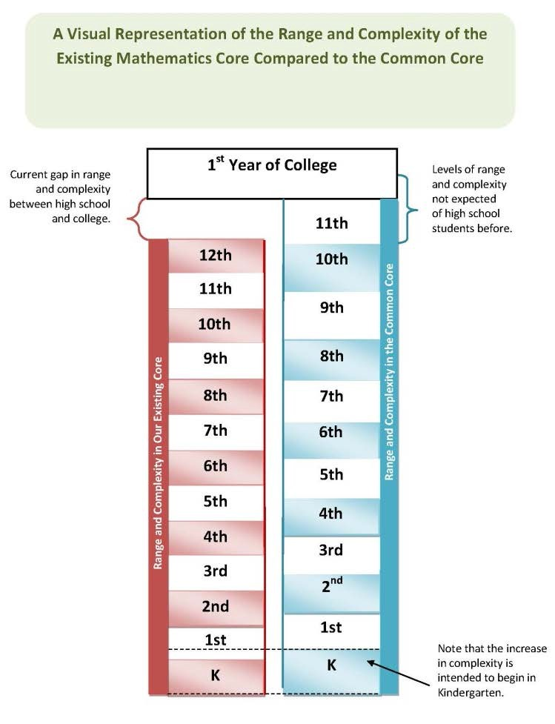
Some students will be ready to move through the mathematics core more quickly, and others will require additional scaffolding and instruction to challenge their abilities. “Students who are capable of moving more quickly deserve thoughtful attention, both to ensure that they are challenged and that they are mastering the full range of mathematical content and skills—without omitting critical concepts and topics” (CCSS, Attachment A, 80). The new core includes Honors courses beginning in seventh grade and provides higher level math courses such as Calculus or AP Statistics for students who are ready to accelerate.

In seventh and eighth grade, Honors courses contain extra topics not included in the former core. These topics include elements from discrete mathematics, non- traditional geometries, different counting systems, and other mathematics that would be interesting to advanced middle school students. In addition, students in the Honors courses will have increased opportunities to model contextual situations with the mathematics at their grade level. These courses have increased rigor and advanced content that will challenge the minds of high- ability students.

Courses for all students are much more advanced than in previous class work. Students on the regular pathway will be prepared for Pre-Calculus, AP Statistics, or CE in their senior year. In the accelerated pathway to high school (AP), calculus is a compacted version of Secondary I, II, III and Pre-Calculus and will begin in ninth grade. This pathway allows students successfully completing the three high school Honors courses to be ready for AP Calculus as seniors. The Mathematics Task Force, consisting of mathematics educators from public and higher education, as well as policy makers and other stakeholders, has supported this coursework for high ability students.

Additional choices and flexibility have been built into the new secondary mathematics core. If high ability students have difficulty, they may exit the Honors program at any time and take the regular Secondary I, II, or III courses, without being forced to repeat coursework.

In rare circumstances, an LEA may compact mathematics courses to allow an especially advanced student to take Calculus before the senior year. Extreme care must be taken to properly identify and verify that these students are eligible and ready for such acceleration. With thoughtful and informed placement and curricular decisions, students can be guided and placed in appropriate classes.

Compacted courses must not skip any content or reduce rigor. Instead, they should move at a faster pace and include multiple assessments to ensure content has been mastered. The CCSS Attachment A includes guidelines for setting up compacted courses, including delayed selection of students. Since the new Honors core is much more rigorous than previous class-work, districts and charters should proceed with caution in the implementation of compacted courses and collect data to validate the efficacy of such programs.

Outreach to Stakeholders
During the development phases of the Utah college and career ready standards, the USOE began meeting with key stakeholder groups to lay the groundwork for adoption and implementation of the standards. The USBE was committed to strengthening student performance standards to ensure all students are college and career ready. They had been studying the data on college remediation courses, examining course-taking patterns in the senior year, and evaluating dropout data. The USBE is focused on the use of data in decision making and saw the early efforts by CCSSO and NGA as a foundation for their vision of reform efforts for Utah public education.

With the USBE’s public support for the new standards, the USOE staff began meeting with key policymakers before the 2010 legislative session. Policymakers, including school board members, engaged the USOE staff in public dialogue to ensure understanding of the need to adopt a new set of student performance standards. Assurances were given that Utah had local control over adoption of college and career ready standards and accompanying resources used to implement the standards. The USOE used social media sites like Facebook, http://www.facebook.com/UtahPublicEducation?v=wall, Twitter http://twitter.com/UTPublicEd, a weekly blog, (http://utahpubliceducation.org/), and employed a former reporter from National Public Radio (NPR) to provide ongoing media support. Social media was also used to give the public opportunity for input into the standards themselves.

Parents and guardians were provided with pamphlets describing the Utah college and career ready standards and the potential impact on Utah schools. The brochure describes the purpose of Utah adopting the standards and what it will mean for their children. The information provided also addressed questions specific to the needs of students with disabilities and English language learners. In addition, parents have access to the social media updates and various newspaper articles. The USOE staff appeared at local boards of education, political rallies, and community events to provide information and answer questions. Ongoing information and solicitation of public input continues to occur; the USOE recently conducted a public input opportunity and information session to provide additional forums for input. After two years of engaging the public in the process and providing a year of professional development, there is great buy in and support for the new standards. Challenges still exist with our integrated approach to mathematics instruction as many parents were not taught using the same methods or student expectations of understanding. Strategies continue to be developed to support parents in their understanding of the mathematical concepts as well.

The Board of Regents, who governs our IHEs, has been supportive at the onset of the USBE’s adoption efforts. The K-16 Alliance has been strategic in promoting K-16 collaboration around the standards at each IHE in the state. In addition, deans of education from the ten teacher preparation institutions meet monthly to discuss common issues. This group, known as Utah Council of Education Deans (UCED), includes the USOE as part of the agenda each month. The new standards have been a monthly topic since January 2010. These ten IHEs have also been provided with on-site professional development regarding their role in preparing teachers (general education and special education) to use the standards. A series of meetings was held to provide an overview of the standards and to facilitate conversation among their preparation personnel to determine how specific preparation programs will need to change to meet the rigor of the new standards. Preparation programs began implementing the use of the standards during the fall semester 2011. Additional meetings have been held with USOE special education staff and IHE personnel from special education personnel preparation programs to discuss additional needs in the areas subject-matter content knowledge, and possible changes in the provision of special education services and the USOE continues to create opportunities for LEAs and IHEs to dialogue and reconsider the needs of teacher preparation programs for general education and special education teachers.

The Utah Chamber of Commerce has been a strategic partner in engaging the business community in an urgent manner to view education as an economic issue. They developed a plan called Prosperity 2020 (http://www.prosperity2020.com/), which views rigorous student performance standards and effective instruction as levers to improve educational outcomes for all students. Key business leaders have publicly stood in solidarity to promote increased funding for education and to include professional development for teachers in using new college and career ready standards as one of their funding priorities. Their endorsement has provided enormous leverage in receiving policymakers’ support for increased rigor and for highly effective instruction and accountability. The business leaders of this movement meet often with State Superintendent Shumway, USBE members, and other USOE leaders to ensure alignment of efforts.

Preparing All Teachers and Leaders to Transition to the CCSS
The purpose of the USBE’s adoption of the Utah college and career ready standards is to ensure all students are prepared for college and post-secondary training when they leave Utah’s K-12 system. A secondary and ancillary purpose is to propel high quality instruction in order to impact student learning. These new core standards, therefore, demand new expectations and behaviors for students of all abilities and all teachers. Teachers will need to place greater emphasis on and be skilled at embedding analysis, critical thinking, and problem solving in all content areas. All teachers will need to engage students in strategies to use informational text and teach in an interdisciplinary manner. Elementary teachers and secondary mathematics teachers will need to increase their content knowledge of mathematical properties and understanding of mathematical processes. Most importantly, their instructional focus must be laser-like on student performance rather than merely knowing and demonstrating content knowledge. For highly effective teachers, these expectations will mirror their current practice. For all others, however, this entails revised methodologies. High quality professional learning experiences are the key to changing instructional behaviors and skills to meet the needs of today’s students.

The professional development plan for new standards implementation is multi-faceted and ongoing. The plan includes professional learning focused on building capacity in both teachers and leaders in all LEAs in order to shift ownership and implementation to the local level. This entails a layered approach with professional learning efforts: program implementation, school and team improvement, and individual educator improvement. This three-pronged approach is crucial to improving classroom instruction utilizing the more rigorous standards in order to improve student achievement. SEA activities are outlined in the following approaches to professional learning:

Program Implementation
The USOE is generally involved in professional learning that is focused on program implementation. The purpose of this approach is to promote the successful implementation of a program typically characterized as a new curriculum or it could be something like integrating new technologies across the school system or across a particular group of teachers. Another example could be implementing a program that improves knowledge and skills of designated groups like coaches or potential administrators. LEAs may or may not choose to use outside expertise to implement and support these programs. The USOE continues to provide leadership to LEAs in modeling best practices, engaging teachers and leaders in authentic learning tasks, providing tools to use at the district or school site and following up with technical assistance. The following professional learning activities are targeted at advancing the Utah College and Career Readiness Student Standards in Utah classrooms.

Conferences
The USOE staff worked strategically with various education organizations, LEAs, and local boards of education to be placed on the agenda of every conference being held June 2010 through June 2011. This strategy was to ensure system-wide awareness and to ensure that all educators and stakeholders had the same information. Conferences included winter and summer conferences for elementary and secondary principals, the Utah School Boards Association, the Utah Special Education Law Conference, School Improvement Network Education Innovation Summit, Utah Association for School Curriculum Development, Northern Utah Curriculum Consortium, Utah School Superintendents Association, and many others. Of note was the awarding of a Gates Foundation grant through the National Association for School Curriculum Development to present a fall conference on CCSS implementation. Keynote speakers from CCSSO and Association for School and Curriculum Development (ASCD) provided great impetus for LEAs to own and make progress with implementation efforts. Breakout facilitators listened to successes and concerns from participants grouped by role. This December 2011 conference helped create a systemic shift to local ownership for instructional improvement in using the Utah college and career ready standards.

Utah Core Academies
In order to provide the LEAs with awareness about the new standards in both mathematics and ELA, the USOE determined that it would be helpful to put the bulk of our time and resources into summer Core Academies. Fourteen locations around the state were secured and planning began. Governor Gary Herbert heeded the USOE’s call for funding and provided $2 million in his budget to help in these efforts. Based on these resources, approximately 5,000 educators (general education, special education and language acquisition educators), including administrators, could be served.

In order to build capacity, a layered approach was used. A committee of professional development and content experts created a design that included investing a six-month period in developing high quality Core Academy Facilitators. These educators would be called upon to begin implementing Utah college and career ready standards in their respective content in their personal classrooms and used adult learning theory in facilitating five-day summer sessions with their peers. A call went out for highly effective general education and special education teachers who had successful experience working with adult learners. While almost 300 applications were received, 120 educators were selected from a K-16 pool. Work began immediately building their capacity in the new standards.

The participants in the Academies came from teachers determined by their LEA to be ready and committed to immediate implementation and willing to share their personal learning with colleagues. This strategy was used to build confidence in the first wave of attendees and generate enthusiasm among peers. Sessions were aligned with the state implementation timeline. This meant that sessions were provided at each site for K-12 teachers teaching English language arts and 6th and 9th grade mathematics. Teacher participants included regular classroom teachers, teachers of students with disabilities, instructional coaches, specialists, teachers of English language learners and LEA administrators. Due to limited space, resources, and facilitators, registration was structured with participant allotments per LEA. Equitable practice was used by providing more slots for rural districts that did not have district capacity.

Throughout the professional development section, we talk about various strategies that all teachers are involved in. By all, we mean general education – multiple content areas, special education, and teachers of ELL students. Our professional development facilitators are classroom teachers; including teachers who teach students with disabilities full time and teachers who specialize in working with students who are learning English. All professional development incorporates, and specifically addresses, strategies that work for various learners. Our new ELA flexbooks, for example, are being created with various level of text complexity to get at the same student outcomes so that teachers can make adjustments depending on the needs of the students they serve. The Special Education staff at the USOE is offering professional development this summer, in addition to the academies, for specialized instruction. The professional
development opportunities offered by both the USOE Teaching and Learning and Special Education provide opportunities for both regular and special education teachers to receive high quality professional learning together, which provides an opportunity for collaboration around an identical goal. Topics include lesson design and delivery to differentiate instruction. We know this is key to special education teachers being prepared to ensure students with disabilities can access the new Utah Core Standards. The technical assistance suggestions by peer reviewers seem to suggest that a mere workshop will ensure that change in the classroom occurs. This would merely be awareness. Our professional development model for college and career ready expectations for all students meets the criteria of high quality professional development found in the Learning Forward professional learning standards. We believe in follow-up and ongoing support, which is found in abundance in our system. We have online journals, Saturday Seminars, online book studies, webinars, coaching, etc. occurring that includes teachers from general and special education. The new WIDA ELL standards are embedded and discussed in many of these settings.

The USOE has partnered with the Personnel Development Center (UPDC) to provide integrated professional development targeted at improving outcomes for students with disabilities to Utah public school staff (special educators, related service providers, and administrators). This professional development is determined based upon a data review of Annual Performance Report (APR) and data submitted by LEAs to determine areas requiring additional training. That training is implemented through the use of several models, and considers the research of systems-change, including the need for fidelity and scaling up.

An important development is the onslaught of requests from various states, including Race to the Top states, to help them craft professional development in their states to better implement the Common Core Standards.

Principals from all schools and district level administrators were invited to the last day of the Academy, where they spent the morning learning about the new standards and hearing from teachers in the afternoon about what they needed for successful implementation. Debriefing at the end with principals and district leaders was strategically designed to help them clarify what this would require of leadership. Feedback from teachers was overwhelmingly positive. Administrators gave mixed reviews, which seemed to be closely aligned with their own prior knowledge about the new standards. This feedback is being used to redesign the work for administrators’ professional development for the 2012 Academy sessions.

Surveys were conducted shortly after the school year began to determine what participants needed as follow-up to the Academy to help them implement the Standards with fidelity. Since the focus was on English language arts for the first year, the respondents wanted additional help with:

  - Argumentative Writing
  - Assessment as Student Performance
  - Lesson Re-design
  - Text Complexity

Planning for the second year of Core Academy is also based on participant feedback. Sixty percent of the participants responded to a follow-up survey. Participants were overwhelmingly positive about their experience and indicated a high level of interest and confidence in working with the new standards.
Principals did express a desire to have more hands on experience with the type of learning tasks that teachers were involved with so they would be better prepared to recognize appropriate instruction in classrooms.

School and Team Learning
Data from student performance and teacher performance is used to design and adjust professional learning. This type of professional learning promotes shared goals for the entire school, grade level or subject areas and leads to collective responsibility. The role of the SEA includes helping schools and team follow a cycle of continuous improvement (consistent with practices of high performing companies) and may require or not external assistance and expertise. The impact on student achievement is measured at team and school wide levels. The USOE has promoted and led efforts in collaborative team learning, lesson study, online learning communities, examining student work, book studies, and improving instructional leadership. The USOE led activities targeted and school and team learning are described below:

Book Study and Online Collaboration
In August 2011, secondary English language arts teachers began to join an English language arts online forum: sharing lesson ideas, insights, and studying research on argumentative writing and text complexity. Currently, over 200 participants are active in this online community. Participants include teachers of students with disabilities, college professors, ELL instructors and secondary classroom teachers. Two books have been read and discussed thus far. This online forum using the networking system called Collaborize, is both synchronous and a-synchronous providing 24 hour access to high quality professional learning; regardless of district capacity or geographic location.

Curriculum Planning and Lesson Design
The USOE is engaging LEAs to work together on developing curriculum for English language arts and mathematics as well as designing model lessons. At the USOE led quarterly statewide curriculum directors meetings and monthly regional meetings, LEAs are sharing this work and posting it on their websites (http://www.jordandistrict.org/schools/commoncore/). Samples of this work are linked to the USOE website and will eventually be organized into a subsection of the website, making it easier to find specific lessons tied directly to each standard. Evaluating quality instructional material is still a challenge as well as helping teachers to see the difference in a lesson based on student outcomes vs. a lesson driven by the learning activity. The USOE special education personnel participate and provide this information to LEA Special Education Directors during State Special Education Administration meetings and a monthly newsletter.

Reading Apprenticeship Improving Secondary Education (RAISE) Initiative
The USOE entered into a partnership with WestEd to provide professional development focused on content literacy strategies aligned to the student performance outcomes in the ELA standards. The first cohort involves 66 teachers representing 14 high schools and various content areas. Cohort two will begin this summer engaging an additional 70 teachers in the work of using the literacy standards called for in order to ensure all students are college and career ready. The purpose of the initiative is to ensure all teachers are equipped with the knowledge and skills necessary to utilize content literacy strategies in their content. Therefore, special education and general education teachers are working together to ensure content literacy strategies are embedded in daily instruction in all classrooms.

Professional Learning Communities
Utah teachers are commonly engaged in Professional Learning Communities (PLCs). Local districts have invested a great deal of time and resources setting up structures and engaging in professional development to implement PLCs effectively. The USOE specialists and LEA leaders have been modeling strategies of studying student work, using tuning protocols, and designing lessons as ways to make the work of PLCs more productive in implementing new standards. District superintendents have charged their schools with using PLC time for this purpose and the USOE specialists are modeling the use of data and discussion protocols to aide in this process. The USOE Special Education section has also participated in PLCs with other State agency staff around the subjects of Utah college and career ready standards, Data, and Instructional Assistive Technology; work from
these PLCs is guiding the USOE and the Utah Personnel Development Center actions for providing technical assistance materials, professional development, and policy development for students with disabilities. Title III (Alternative Language Services) staff have been actively involved in establishing PLC’s with regards to WIDA trainer of Trainers training. Twenty –one trainers attended concentrated professional development to assist in training teachers state-wide in WIDA Standards. Further, Title III staff traveled state-wide to train teacher in Sheltered Instruction (SIOP). Trainings for Alternative Language Services (ALS) Directors and school administrators were conducted to better equip them to provide support for Title III PLC’s. A survey will be conducted in districts during April 2012 to see how the structure and process of PLCs have aided in educators’ implementation efforts.

Trainer of Trainers for Alternative Language Services
USOE Title III (Alternative Language Services) staff has been actively involved in developing and implementing a trainer of trainers model for WIDA training. Twenty-one trainers attended concentrated professional development to assist in supporting teachers state-wide on the effective use of WIDA standards. Further, Title III staff members traveled statewide to support LEAs in their use of Sheltered Instruction (SIOP) strategies. These SIOP strategies have also been cross-walked with the new Utah Effective Teaching Standards to look for high leverage instructional strategies that can be a focus for all teachers to ensure that English language learners are getting the kind of instruction that leads to higher levels of student achievement.

Instructional Leadership
One of the charges and challenges put forward to local school principals is using their faculty meetings as a time to lead instructional improvement. Too many teachers still report that faculty meetings do not touch on instructional expectations but are focused on business. While improvements are being made, the USOE will continue to work with school leaders to use faculty meetings more effectively. Most schools have early release or late start times to enable teachers to meet together in professional development.
Principals have committed that much of this time will be focused on the student performance standards called for in Utah college and career ready standards.

Walk-throughs have been used during the past decade by many principals in Utah to help them gather data on classroom practices. For example, Granite School District has approximately 225 K-12 school administrators involved in cadres where the focus is using walk-throughs as tools for instructional change. The school administrator works with a personal coach to help him or her develop a knowledge base of best instructional practices as well as knowing how to have the critical conversations with teachers when they aren’t effective. Most administrators are showing greater instructional leadership by clearly stating instructional expectations, following through with support, and remediating when necessary. Minimally, principals involved in the cadres report having a much greater knowledge base of what to look for in the classroom. Many districts are starting to replicate the work of Granite School District and are using the protocols and digital tools provided by the administrator in charge of this program. The Utah Personnel Development Center has been providing similar ongoing professional development to LEA special education administrators and staff in the areas of administrative support for special educators and students with disabilities.

Individual Educator Improvement
The USOE efforts to work with individual educators to improve their practice are aligned with the Utah Effective Teaching Standards, Utah College and Career Readiness Student Standards and Utah Educational Leadership Standards. The purpose of individually focused professional development is to improve individual performance and effectiveness. Designs are based on data from both student and teacher evaluation systems and the impact is targeted at the individual classroom level. The role of an SEA at the individual level is a bit more challenging but the USOE is leading efforts that individual teachers can engage in as follow-up from participation in Core Academies or self-paced professional
learning. Professional development activities for individual teachers currently being led by the USOE are as follows:

Saturday Studio Seminars
Secondary English language arts, science, and social studies teachers have been coming together with facilitators from the Core Academy on Saturdays to learn more about assessment as student performance. Many of these teachers have also been involved in the online book study. Participants do not receive compensation for coming. Seminars are open to all secondary teachers and generally involve bringing in guest speakers on topics related to the new Utah ELA standards and focusing on the kind of instruction needed for improved achievement for all learners. Participation ranges from 25 to 100 teachers per seminar.

Literacy in Technical Subjects
The USOE and Stanford University have developed a Partnership to support Career and Technical Education (CTE) Technology Teams (grades 6-9 with English teachers & Administrators) in literacy standards to be used in CTE subjects. Several all day sessions have been or will be held throughout the 2011-2012 school year, continuing through the summer. Approximately 200 teachers are expected to participate in each session.

Teacher and Principal Preparation
Utah is uniquely positioned for high levels of collaboration among preparation programs, K-12 systems, and the USOE. The Deans of Education in all ten preparation IHEs meet together each month as part of an organization called the Utah Council of Education Deans (UCED). The inclusion of the USOE, with designated time on the monthly agenda, provides the USBE with leverage for helping shape preparation practices. Efforts to prepare teachers and leaders to use the CCSS as a lever for improving student learning began in the fall of 2011 with all educator preparation institutions committed to ongoing professional development and support for preparation staff. USOE has been an integral part of the professional learning design and implementation and continues to provide updates at monthly Deans meetings as well as ongoing professional development for their staff.

IHEs came together in August and September 2011 to hear from the USOE leaders about the content and teaching practices needed to ensure teachers and principals are prepared to teach and lead in ways that ensure all students will be college and career ready. These regional institutes included explicit instruction on the new Utah college and career ready standards, state expectations and timelines for implementation, and facilitated conversations among licensure program faculty for both general educators and special educators at each IHE to determine gaps between expectations and current practices. All IHEs have begun implementation of the new Utah standards; particularly in the secondary English language arts and mathematics faculties. Several university ELA and mathematics professors served as facilitators for the Core Academies and continue to serve on state content committees. Elementary education faculty members are working together to design curriculum and lesson plans to model best practices. Special education teacher preparation programs are continuing the discussions with the USOE staff in the areas of content knowledge requirements for special educators to determine if changes are needed to adequately prepare special education teachers for the new standards and designing special education services to bridge the achievement gap.

An ongoing challenge is ensuring that all preparation faculty members embed the CCSS in an integrated and explicit fashion so that all teacher candidates have the capacity to enter the classroom prepared to help all students become college and career ready. An additional challenge is helping reshape principal preparation programs into a focus on instructional leadership. This entails letting go of outdated and ineffective courses while adding coursework specifically targeted at using data to make instructional improvements and incorporating strategies for ensuring school systems prepare all students for today’s challenges.

Assessment Transition
Promises to Keep includes the 4th Promise: Requiring effective assessment to inform high quality
instruction and accountability. With that promise in mind, Utah’s current assessment system is being adjusted to support Utah teachers as they begin the instructional transition to the Utah college and career ready standards prior to the administration of a fully aligned assessment system. Pilot items will be included on the summative assessment aligned to the common core and the results made available to schools but not counted in scoring. All current items on the summative mathematics tests have been reviewed for alignment to the common core so that some reporting of common core achievement can be provided to schools using existing items.

In addition, Utah’s online formative assessment system’s item bank has been aligned to the common core and new common core items are being written. Teachers will have available pre- and post-tests in language arts and mathematics in the fall 2012. These formative tests will allow teachers to both expose gaps in student knowledge at the beginning of the year and to check for student understanding throughout the year.

1.C. DEVELOP AND ADMINISTER ANNUAL, STATEWIDE, ALIGNED, HIGH-QUALITY ASSESSMENTS THAT MEASURE STUDENT GROWTH

Select the option that pertains to the SEA and provide evidence corresponding to the option selected.

Option A  The SEA is participating in one of the two State consortia that received a grant under the Race to the Top Assessment competition.  - Attach the State’s Memorandum of Understanding (MOU) under that competition. (Attachment 6) | Option B  The SEA is not participating in either one of the two State consortia that received a grant under the Race to the Top Assessment competition, and has not yet developed or administered statewide aligned, high-quality assessments that measure student growth in reading/language arts and in mathematics in at least grades  3-8 and at least once in high school in all LEAs.  i. Provide the SEA’s plan to develop and administer annually, beginning no later than the 2014-2015 school year, statewide aligned,  high-quality assessments that measure student growth in reading/language arts and in mathematics in at least grades 3-8 and atn least once in high school in all LEAs, as well as set academic achievement standards for those assessments. | Option C  x  The SEA has developed and begun annually administering statewide aligned, high-quality assessments that measure student growth in reading/language arts and in mathematics in at least grades 3-8 and at least once in high school in all LEAs.  i Utah has and continues to follow the high-quality plan that DOE approved on June 23,2014 for having developed these assessments: The State Board developed and implemented during 2014 its Student Assessment of Growth and Excellence (SAGE)Computer adaptive testing in English/language arts, mathematics, and science (Board rule R277-404).

Transition Activities
Utah is currently preparing for the transition to a new comprehensive assessment system which will measure the full breadth and depth of the Utah college and career ready standards using computer based adaptive testing by implementing two pilots.

The first pilot began in 2008 in an effort to move towards an adaptive test system which would enable a more accurate measure of the full achievement spectrum and the calculation of reliable growth scores. The pilot was the recommendation of a blue ribbon committee assembled by the governor to study and make recommendations on how to improve the state’s assessment system.

The second began in 2010 and allowed pilot schools to administer the ACT in 11th grade and/or an adaptive test of basic skills in an effort to improve student career and college readiness.

These pilots will allow Utah to continue to work towards a planned implementation of an adaptive assessment system which will meet the following board goals:

- Include a K–12 scaled test based on the college and career-ready student standards. Accurately measure individual student growth through a pre and post-test.
- Identify student capabilities in the first weeks of school to immediately adjust instruction based on skill level in order to provide support services to all students with careful attention to historically underrepresented subgroups.
- Give immediate feedback to students, parents, and teachers.
- Fulfill the requirements for the U-PASS testing system.
- Fulfill state requirements as ESEA is reauthorized through work with the federal government.

Assessment transition plans include students with disabilities. Using a variety of formats, the USOE is providing professional development opportunities and technical assistance to LEA administrators and staff in guiding IEP teams to preplan to address the core instruction needs of the student with disabilities in participation of statewide assessments. These plans include strategies for ensuring students with disabilities access the core curriculum, receive appropriate and high quality content-area and individualized instruction, accommodations, and/or modifications, and are prepared for meaningful participation in statewide assessments.

PRINCIPLE 2: STATE-DEVELOPED DIFFERENTIATED RECOGNITION, ACCOUNTABILITY, AND SUPPORT

2.A DEVELOP AND IMPLEMENT A STATE-BASED SYSTEM OF DIFFERENTIATED RECOGNITION, ACCOUNTABILITY, AND SUPPORT

    - Provide a description of the SEA’s differentiated recognition, accountability, and support system that includes all the components listed in Principle 2, the SEA’s plan for implementation
of the differentiated recognition, accountability, and support system no later than the 2012–2013 school year, and an explanation of how the SEA’s differentiated recognition, accountability, and support system is designed to improve student achievement and school performance, close achievement gaps, and increase the quality of instruction for students.

Overview of Utah’s Current Accountability Systems
The chart below details the characteristics of Utah’s current accountability systems, both federal and state and Utah’s proposed UCAS. The UCAS includes key elements from both existing systems and builds on those to create a more fair and accurate measurement of school performance.

Existing Utah Accountability Systems
 | Indicators | Subgroup | Measures | Decision Rules
State Accountability System  Utah Performance Assessment System for Students (UPASS) | Language Arts, Mathematics, Writing, Science, Attendance | Super subgroup including all students in NCLB  subgroups*, students count only once. | Proficiency Growth | Compensatory
Federal Accountability System  Adequate Yearly Progress (AYP) | Language Arts, Mathematics, Graduation Rate, Attendance | NCLB*  Federally designated subgroups | Proficiency | Conjunctive

Utah’s Proposed Comprehensive Assessment System
 | Indicators | Subgroup | Measures | Decision Rules
Comprehensive Assessment System | Language Arts, Mathematics, Writing, Science, Graduation Rate | Non-proficient subgroup.  Includes all non- proficient students independent of NCLB subgroup classification. | Proficiency  Growth (Student Growth Percentile) | Compensatory

* Asian, African American, American Indian, Caucasian, Hispanic, Pacific Islander, Economically Disadvantaged, Limited English Proficient, Students with Disabilities.

The central component of both the current state and federal accountability systems is the state’s high quality standards-based Criterion-Referenced assessments (CRTs). Utah has a long history of standards- based assessments aligned to the Utah Core Standards and the Utah Core Curriculum, which is a comprehensive curriculum for each subject at each grade-level/course as mandated by state law. Utah’s CRTs were first administered in the 1989-1990 school year. See Attachment 7.

Performance standards have been established for all CRTs. Performance standards are also approved for the Utah Alternate Assessment (UAA) intended for qualifying students with significant cognitive disabilities. Establishing appropriately challenging performance standards for each assessment allows the state to hold all students accountable for academic performance, including students with significant cognitive disabilities that do not take the Core CRTs in standard or accommodated conditions.

Other non-testing indicators (graduation rate and attendance) are uniformly defined and implemented in schools and LEAs across the state. This uniformity of measures assures that the same criteria are applied
in determining LEA and school status. By state statute 53A-1-603, all Utah students participate in the Utah state assessment program.

Current Federal Accountability
Utah’s current federal accountability system uses three criteria for AYP determination: participation rate, academic achievement, and graduation rate and attendance as the additional indicators. These three criteria are applied to both mathematics and in English language arts separately.

Utah incorporated the NCLB expectation that by 2013-14 all student subgroups, schools, and LEAs would demonstrate proficiency in the areas of in English language arts and mathematics. Utah’s plan includes all public and charter schools. See Attachment 8.

To determine if yearly progress is made, starting points were set for mathematics and in English language arts at each of two levels: elementary/middle school and high school. The starting point was set using 2001-2002 school year data and a uniform trajectory established with the ultimate goal of 100% of students proficient by 2013-2014 school year. Intermediate goals were set based on the statewide annual measurable objectives. Schools must meet the annual measurable objectives or make acceptable improvement (safe harbor provision) for academic achievement as part of the requirements for making AYP.

The other two criteria – participation rate and additional indicators are also used to make AYP determinations for student subgroups, schools, and LEAs.

Current State Accountability
The U-PASS, as required by state law 53A-1-603, identifies schools not achieving state established acceptable levels of student performance in order to assist those schools in raising their student performance levels. The U-PASS system has paved the way for the proposed UCAS.

  - ASS also uses a single super sub-group model. The subgroup is defined as each student who qualifies for a subgroup other than white only. Individual student proficiencies and progress are added together and divided by the number of students to determine the subgroup proficiency and progress level.

Unlike Utah’s Adequate Yearly Progress (AYP) system, U-PASS includes science and writing scores in addition to language arts and mathematics.

These differences in the two systems results in inconsistent classifications. Schools can pass AYP while not meeting U-PASS standards or the reverse may occur with a school not making AYP but meeting U- PASS standards. This inconsistency between the two systems produces confusion, frustration and prevents the clarity and transparency necessary for a powerful accountability system which unites resources and efforts to drive school improvement. The UCAS meets both federal and state accountability requirements while providing clarity and transparency for Utah stakeholders regarding the performance of all students, including those with disabilities.

Adaptive Pilot
In 2008, Utah began a pilot in an effort to move towards an adaptive test system which would enable a more accurate measure of the full achievement spectrum and the calculation of reliable growth scores. The pilot was the recommendation of a blue ribbon committee assembled by the governor to study and make recommendations on how to improve the state’s assessment system. The pilot was then placed in state statute 53A-1-603 and R277-405 and began with two participating districts. By 2012 the pilot has expanded to include 86 schools representing 10 districts and 9 charter schools
The pilot includes the following components:

NWEA adaptive tests in all AYP tested subjects/grades
The purpose of the adaptive tests is to provide both summative information that addresses federal NCLB requirements and instructionally informative results that can be productively used in classrooms.
Northwest Evaluation Association (NWEA) has been approved for the 2011/12 school through a federal peer review process and determined to be a valid and reliable local assessment option in lieu of the CRTs.

EPAS (Explore, Plan and ACT) in grades 9,10 and 11
The EPAS tests are designed to provide a longitudinal, systematic approach to educational and career planning, assessment, instructional support, and evaluation. The system focuses on the integrated, higher- order thinking skills students develop in grades K-12 that are important for success both during and after high school:

Explore: The assessment is designed to help 8th or 9th grade students explore a broad range of options for their future academic and career success. EXPLORE prepares students for their high school coursework and post–high school choice.
PLAN: The assessment provides a high school midpoint evaluation of a 10th grade student’s college and career readiness. It is a comprehensive guidance resource that helps
students measure their current academic development, explore career/training options, and make plans for the remaining years of high school and post-graduation years. PLAN also assists in the identification of academic areas that may require some level of intervention or remediation.
ACT: The test assesses 11th grade high school students' general educational development,
their readiness to begin college-level work, and is highly regarded and accepted as an admissions assessment at virtually all universities and colleges in the United States.

Pre and Post online writing test in grades 5 & 8
The writing tests are delivered online and scored using artificial intelligence. They provide an opportunity to monitor student’s growth in writing within the school year and across years. The test is scored using the six traits of writing: Ideas and Content, Organization, Voice, Word Choice, Sentence Fluency, and Conventions. In addition to the summative feedback, students and teachers can also use the program as a formative assessment tool to improve writing instruction throughout the school year.

High School Pilot
In 2010-11, through a new state law, 53A-1-603 and R277-405, Utah eliminated its high school competency exam, the Utah Basic Skills Competency Test (UBSCT), and directed the money to a high school pilot program which provided an opportunity for self-selected districts and charter schools to administer alternative assessments. The pilot schools choose to administer the ACT in 11th grade and/or an adaptive test of basic skills in an effort to improve student career and college readiness.
Participants include 158 schools representing a diverse range of 22 districts and 10 charter schools. The pilot schools administered 26,000 ACT tests, and 12,000 adaptive tests using 5 different assessments (NWEA, Accuplacer, SRI, ALEKS and NovaNet). In addition, the High School Pilot has funded over 25,000 administrations of the PLAN and EXPLORE in grades 8, 9 and 10 in conjunction with the ACT in 11th grade. This allowed high schools to collaborate with their feeder schools and begin tracking and impacting student career and college readiness earlier. Current legislation is proposed to extend the pilot to all secondary students. This legislation may become effective beginning with the 2012/13 school year.

Overview of Utah’s Proposed Comprehensive Accountability System
With the passage of state statute 53A-1-1101-1113 in March 2011, efforts began to develop a new comprehensive system, which built upon the work of the two existing systems and the pilots described above. The USOE assembled a committee of policy makers, education leaders, and stakeholders from across the state. The committee, with technical assistance provided by the National Center for the
Improvement of Educational Assessment, was charged to develop a single comprehensive accountability system for Utah’s schools which incorporated the following design principles:
    - Promote progress toward and achievement of college and career readiness
    - Value both meeting standards (proficiency) and improving academic achievement (growth)
    - All schools, including those that serve traditionally low performing students, should have an opportunity to demonstrate success
    - Strong incentives for schools to improve achievement for the lowest performing students
    - Growth expectations for non-proficient students should be linked to attaining proficiency
    - Growth expectations for all students, including students above proficiency, should be appropriately challenging and meaningful
    - Clear and understandable to stakeholders
The resulting accountability system provides a straightforward determination of school performance and supports the design principles by valuing performance on state tests, prioritizing individual student growth toward meaningful achievement targets, promoting equity for low performing students, and incentivizing attainment of graduation and college/career readiness.

Process
Beginning in the fall of 2010, an advisory committee was formed by the USOE to guide the development of a new state accountability system. This committee was comprised of senior policy makers, education leaders from across the state, and key stakeholders. The committee convened monthly through December 2011 to guide design decisions and review impact analyses. When state statute 53A-1-1101-1113 was passed in March 2011, the committee adjusted its focus to incorporate the new requirements in the law.
The accountability model was also reviewed on two separate occasions by Utah’s National Technical Advisory Committee and the state Policy Advisory Committee, who provided substantial feedback to improve the model. In November 2011, the USBE reviewed and accepted the recommendations of the committee. See Attachment 19.

Components
Utah’s proposed UCAS is centered on two components: achievement and growth, with readiness accounting for half of the achievement scores in high schools. The structure of the proposed system and points allocated to each component are depicted in figure 1 for elementary and middle schools and figure 2 for high schools.

Figure 1: Structure of Elementary and Middle School Accountability Model. (See Attachment 2 for calculation rules and specific examples.)

Overall School
Score
600 Total Points
Growth
300 total points
Achievement
300 total points
All Students
200 total points
Below
Proficient Students
100 total points
Percent at or
above proficient 300 points
Figure 2: Structure of High School Accountability Model

Overall School
Score
600 total points
Growth
300 total points
Achievement
300total points
All students
200 total points
Below Proficient
Students
100 total points
Percent at or
above proficient
150 points
Readiness
Graduation rate
150 points (HS only)

Participation
A school must meet the 95% participation rate for subgroups of 40 students or more. Schools not meeting the participation requirement will receive a score of 0 (See Attachment 24).

Achievement
Achievement is measured as the percent of students scoring at or above proficient for all English language arts, mathematics, and science Criterion-Referenced Tests (CRTs) and the direct writing assessment (DWA) in applicable grades. In grades with no DWA, each content area is weighted equally (one third). When the DWA is included, it counts for one half of the weight of one CRT content area. The weighted percent proficient is scaled such that a maximum of 300 points is attainable.

Readiness
Readiness accounts for 150 of the 300 points for high schools in the achievement component. The readiness component is the federal graduation rate calculation as approved by USED. All graduation reporting includes this rate. For purposes of calculating CAS, the graduation rate is calculated by multiplying the graduation rate by 150 (e.g. .70 x 150 = 105).

Growth
The Student Growth Percentile (SGP) method provides the basis for measuring academic growth in the model. Student growth is determined by comparing each student’s progress with that of other students in the state with the same prior achievement pattern. SGPs provide a familiar basis to interpret performance, the percentile, which indicates the probability of an outcome given the student’s starting point and can be used to gauge whether the student’s growth was atypically high or low.

To evaluate growth for a school, the median of all individual SGPs is calculated and evaluated against a rubric. See Attachment 19 for specifics and examples. This rubric provides higher points for a rate of growth that is associated with attaining or maintaining proficiency. This process is completed twice – once for all students at the school and once for only those students who are non-proficient. By so doing, the schools have an extra incentive to promote achievement of the lowest performing students. An SGP is calculated for all students with a minimum of two CRT scores in a given content area and the mean of the content area growth scores is evaluated against the rubric.

The overall outcome for growth is a whole-school score with a maximum value of 200 and a non- proficient student score with a maximum value of 100, for a total of 300 growth points available.

Outcomes
Performance in achievement and growth are summed to produce an overall composite score and a percentile ranking. The target score established for schools will be 480 points for elementary and middle schools and 470 for high schools. Data analyses reveal this is a very ambitious target, yet achievable for the highest performing schools in Utah. Elementary and middle schools achieving the benchmark of 480 are at approximately the 75th percentile statewide. The target is even more rigorous for high schools where a composite score of 470 is at the 85th percentile statewide. Although these targets are clearly ambitious, the fact that 25% of elementary and middle schools and 15% of high schools have achieved this superior level of performance indicates that they are attainable. The advisory committee carefully studied and discussed the impact data generated by the proposed 480 and 470 cuts (see Attachment 19). The committee was guided by the principal that expectations informed by observed performance provide a basis for ‘ambitious but achievable’ goals (see e.g. Linn, R. L. (2003). "Accountability: Responsibility and Responsible Expectations." Educational Research.) The target established by the committee was considered by them to be challenging to schools but reasonable and attainable. The USOE is continuing to review draft impact data as to assure the target is both ambitious and achievable for all schools.

Differentiated Recognition
Reward schools will be identified using the composite score and the target of 480 points for elementary and middle schools and 470 for high schools. This structure incentivizes and rewards both achievement and growth simultaneously as they are both components of the composite score. This also provides an opportunity for all schools, independent of demographics or previous performance, the opportunity to achieve and be recognized. This establishes an achievable goal and standard for all Utah schools. These schools will be recognized annually through a press release, certificate of achievement, letters to the LEA superintendent or charter leader, and to the building principal to be shared with the school community.

Priority Schools will be identified each year using the total composite score. The lowest performing five percent of the schools will be identified. Initially, to ensure continuity and build on existing identification and improvement efforts, those schools that have already been identified as Title I School Improvement Grant (SIG) schools will be identified as Priority Schools.

Focus Schools will be the next lowest-performing ten percent of schools (excluding those Title I schools already identified as Priority Schools) based on the composite score.

AMOs
Annual Measureable Objectives (AMOs) will be based on the percent of students achieving proficiency on the states Criterion-Referenced Tests (CRTs) separately in English language arts and mathematics. AMO targets are set for each school and subgroup in annual equal increments toward a goal of reducing by half the percentage of students in the all-students group and in each subgroup who are not proficient within six years. The trajectory starts with the proficiency rates for 2010-11 academic year and will be reported in the school report card.

Subgroup Accountability
Subgroup accountability is a challenging task in Utah due to the large number of schools with subgroups of fewer than 30 students. An accountability framework which identifies typical subgroups, such as Utah’s current federal system, with a minimum n size of 30 would exclude significant numbers of both students and schools. This typical approach does not work in an atypical state and fails to hold all Utah schools to a sufficiently high standard for students with the highest needs. Utah previously addressed this
challenge with subgroup classifications in the state accountability system. The current state system (U- PASS) determines accountability based on a super subgroup, whose membership includes any student who belongs to one of the NCLB* required subgroups. This aggregation has proven to be an effective method of working with the small subgroup n sizes in Utah to ensure the maximum numbers of students are included in accountability calculations. Importantly, however, the reporting provides achievement data for each individual subgroup. This method of calculation and reporting was approved by Utah policy makers including those representing each of the subgroups.

- Asian, African American, American Indian, Caucasian, Hispanic, Pacific Islander, Economically Disadvantaged, Limited English Proficient, Students with Disabilities.

The framework for the UCAS builds upon the success of the current state system to meet the challenge of Utah’s unique demographics. UCAS identifies those students who are not proficient as a single subgroup. This ensures that all students who are below standard, regardless of group membership, are the focus for improvement. In fact, non-proficient students will be counted twice for the growth calculation, once in the total group and once as part of the non-proficient subgroup. This double weighting of non-proficient students will allow maximum accountability for subgroups and increase focus on those most at risk as identified by existing achievement data.

All ‘traditional NCLB’ subgroup scores will be included and prominently displayed in reporting and are used as the basis of the AMOs. The reports detail subgroup achievement gap information and both groups which are making significant progress in closing the gap and those that are not making appropriate progress are highlighted. All schools are encouraged to address any concerns with subgroup performance or gap achievement in their school improvement plans.

The chart below shows that there is a substantial increase in the number of schools accountable for the most at risk students using this framework. Using NCLB subgroup classifications, with a minimum N count of 10, fewer subgroups across all Utah schools would be included. In contrast, the non-proficient subgroup classification would include 90% of all student subgroups in Utah.

Total percent of subgroups included in Accountability Calculation N>10
 | Current NCLB Subgroups | Proposed Non- Proficient Subgroup
Student Subgroups | 62% | 90%

Establishing a new subgroup comprised of non-proficient students and heavily weighting this in the state accountability model as Utah proposes, will provide an increased focus on serving the high needs students in the state. This approach does not retreat from a commitment to students with disabilities, racial/ethnic groups, English language learners, and students in poverty. In fact, our data analysis shows that these subgroups are overwhelmingly represented in the new proposed subgroup definition and more schools will be accountable for their performance. Even so, Utah is committed to continuing to generate and review additional impact data to monitor and report the progress of these subgroups and refine the model if necessary.

Equity
The UCAS is built upon the premise that only schools that are able to move historically non-proficient groups to proficiency would achieve high grades. Utah has identified this as the critical issue of equity, focusing on non-proficient students independent of AYP subgroup classification. Utah believes the non- proficient subgroup classification is the key to encouraging schools to intensify their focus on
underperforming students and focus resources on reducing the achievement gap and enhance a school’s ability to demonstrate success in this critical area.

With Utah’s small subgroups, high performance by a few students in a subgroup can mask low performance by others when using the traditional AYP classifications. The non-proficient subgroup will focus attention, and hold schools accountable for all low performing students in subgroups by double weighting. The non-proficient subgroup makeup is revealing as 72% of the students are from the NCLB subgroup classifications. Potentially a large number of these 72% would not be included in Utah accountability using the traditional NCLB classifications. NCLB subgroup performance in both achievement and growth will be calculated and displayed prominently in the public reports highlighting any equity concerns and allowing all constituencies full access to performance data for all subgroups.

Reporting
Utah’s current dynamic public data system, the Utah Public School Data Gateway, (Attachment 15) and Utah’s educator data site, the USOE Data Display (Attachment 15), will be used to display the Comprehensive Accountability System school report card. This electronic report card allows for dynamic reporting that includes pop up definitions and drill down disaggregation. The drillable reports will include the composite score, achievement score, progress score, percentile ranking, AMO classification and target trajectory, Reward, Priority, and Focus school identifications, and complete detailed achievement data and all required Title 1 reporting elements. Additional data not used in the classification calculation will also be displayed. Detailed subgroup data will be prominently displayed.
A sample report card is provided in Attachment 16 which displays the front page of the report and three additional drillable pages. Many features of the dynamic report cannot be captured in a static PDF including but not limited to:

  - Hoover activated explanation bubbles provided for all assessment and accountability terms
  - Dynamic Google Mapping
  - Comparison charts

The USOE Data Display is password protected to allow educators to appropriately use student level data. The Utah Public School Data Gateway provides a live example of the strategic approach which will be used (http://www.schools.utah.gov/main/).

PSD Gateway Purpose
- Purpose is to identify and compare school performance
- Audience is intended for parents and media
- Compares school to school
- Data are blended into whole picture perspectives
- Data is at school aggregation

Accountability Data
- Designed for inclusion for student report card
- Drill down to teacher level, possibly show student growth percentile (SGP)
- Compare report cards of like schools
- Easy navigation between reports
- Historical data
- Compare against state average
USOE Data Display Purpose
  - Purpose is to facilitate instructional improvement
  - Audience is intended for educators and administrators
  - Comparison to State, District, School, Subject, Classroom and teacher
  - Data are categorized for focused analysis
  - Drills allow aggregation at teacher and student levels

Accountability Data
- Detailed disaggregation of report values
- Longitudinal comparisons
- Teacher aggregation of student growth percentile (SGP) by subject and class/section
- Comparison against District and State performance
- Drill down to student level

    - Select the option that pertains to the SEA and provide the corresponding information, if any.

X
Option A
The SEA only includes student achievement on reading/language arts and mathematics assessments in its differentiated recognition, accountability, and support system and to identify reward, priority, and focus schools.
Option B
If the SEA includes student achievement on assessments in addition to reading/language arts and mathematics in its differentiated recognition, accountability, and support system and to identify reward, priority, and focus schools, it must:

provide the percentage of students in the “all students” group that performed at the proficient level on the State’s most recent administration of each assessment for all grades assessed; and

include an explanation of how the included assessments will be weighted in a manner that will result in holding schools accountable for ensuring all students achieve college- and career-ready standards.

In addition to reading/language arts and mathematics Utah will be including the following: science, the Direct Writing Assessment (DWA,) and graduation rate. See Attachment 8 for performance data.

Science will be used in both the growth and achievement calculations. The DWA will be used in the achievement calculation. Science is weighted equally with reading/language arts and math; when the DWA is included, it counts for one-half of the weight of one CRT content area. Graduation rate is the sole determinate of readiness and accounts for half the achievement score in high schools.

Participation
A school must meet the 95% participation rate for subgroups of 40 students or more. Schools not meeting the participation requirement will receive a score of 0 (see Attachment 24).

Achievement
Achievement is measured as the percent of students scoring at or above proficient for all English language arts, mathematics, science and CRTs and the DWA in applicable grades. In grades with no DWA, each content area is weighted equally (one third). When the DWA is included, it counts for one-half of the weight of one CRT content area. The weighted percent proficient is scaled such that a maximum of 300 points is attainable.

Growth
The SGP method provides the basis for measuring academic growth in the model. Student growth is determined by comparing each student’s progress with that of other students in the state with the same prior achievement pattern. SGPs provide a familiar basis to interpret performance, the percentile, which indicates the probability of an outcome given the student’s starting point and can be used to gauge whether the student’s growth was atypically high or low.

To evaluate growth for a school, the median of all individual SGPs is calculated and evaluated against a rubric. This rubric provides higher points for a rate of growth that is associated with attaining or maintaining proficiency. This process is completed twice – once for all students at the school and once for only those students who are non-proficient. By so doing, the schools have an extra incentive to promote achievement of the lowest performing students. An SGP is calculated for all students with a minimum of two CRT scores in a given content area and the mean of the content area growth scores is evaluated against the rubric.

The overall outcome for growth is a whole-school score with a maximum value of 200 and a non- proficient student score with a maximum value of 100, for a total of 300 growth points available.

Readiness
Readiness accounts for 150 of the 300 points for high schools in the achievement component. The readiness component is the federal graduation rate calculation as approved by USED. All graduation reporting includes this rate. For purposes of calculating CAS, the graduation rate is calculated by multiplying the graduation rate by 150 (e.g. .70 x 150 = 105).

2.B SET AMBITIOUS BUT ACHIEVABLE ANNUAL MEASURABLE OBJECTIVES

Select the method the SEA will use to set new ambitious but achievable annual measurable objectives (AMOs) in at least reading/language arts and mathematics for the State and all LEAs, schools, and subgroups that provide meaningful goals and are used to guide support and improvement efforts. If the SEA sets AMOs that differ by LEA, school, or subgroup, the AMOs for LEAs, schools, or subgroups that are further behind must require greater rates of annual progress.

Option A  X Set AMOs in annual equal increments toward a goal of reducing by half the percentage of students in the “all students” group and in each subgroup who are not proficient within six years. The SEA must use current proficiency rates based on assessments administered in | Option B  Set AMOs that increase in annual equal increments and result in 100 percent of students achieving proficiency no later than the end of the 2019–2020 school year. The SEA must use the average statewide proficiency based on assessments administered in the 2010– 2011 school year as the | Option C  Use another method that is educationally sound and results in ambitious but achievable AMOs for all LEAs, schools, and subgroups.  i. Provide the new AMOs and an explanation of the method used to set these AMOs.

the 2010–2011 school year as the starting point for setting its AMOs.  i. Provide the new AMOs and an explanation of the method used to set these AMOs. | starting point for setting its AMOs.  i. Provide the new AMOs and an explanation of the method used to set these AMOs. | - Provide an educationally sound rationale for the pattern of academic progress reflected in the new AMOs in the text box below.  - Provide a link to the State’s report card or attach a copy of the average statewide proficiency based on assessments administered in the 2010-2011 school year in reading/language arts and mathematics for the “all students” group and all subgroups. (Attachment 8)

Procedures for Establishing AMOs
Annual Measureable Objectives (AMOs) will be based on the percent of students achieving proficiency on the states Criterion-Referenced Tests (CRTs) separately in English language arts and mathematics.

- ELA: CRT results in grades 3-8 and 10 are used to determine the percent of students proficient.
- Mathematics: results are based on CRTs in grades 3-6 and in the course appropriate CRT thereafter which includes math 7, algebra, or geometry for grades 7 and 8. High schools will be determined by calculating the percent of 10th grade students who scored proficient on the Algebra I CRT in 10th grade year or a prior year.
- Results from the Utah Alternative Assessment (UAA) are included for students with significant cognitive disabilities approved to participate in this assessment.

Proficient is defined as scores in Level 3 or Level 4. The CRTs have been peer reviewed and fully approved for use in Utah’s ESEA accountability system.

AMO targets are set based on percent proficient in each of language arts and mathematics for each school and subgroup in annual equal increments toward a goal of reducing by half the percentage of students in the all-students group and in each subgroup who are not proficient within six years. The trajectory starts with the proficiency rates for 2010-11 academic year.

This is shown for language arts and mathematics using the state proficiency rates in 2011. The process described will be implemented for each school and subgroup using their 2011 proficiency rate as a starting point. By doing so, greater rates of progress will be required for schools that start further behind.

Table 1: Language Arts Grades 3-8: State Goal and Annual Targets
 | All Students | Asian | African American | American Indian | Caucasian | Hispanic | Pacific Islander | ED | LEP | SWD
2011 | 81 | 82 | 64 | 60 | 85 | 63 | 73 | 70 | 51 | 54
2012 | 83 | 84 | 67 | 63 | 86 | 66 | 75 | 73 | 55 | 58
2013 | 84 | 85 | 70 | 67 | 88 | 69 | 78 | 75 | 59 | 62

2014 | 86 | 87 | 73 | 70 | 89 | 72 | 80 | 78 | 63 | 66
2015 | 87 | 88 | 76 | 73 | 90 | 75 | 82 | 80 | 67 | 69
2016 | 89 | 90 | 79 | 77 | 91 | 78 | 84 | 83 | 71 | 73
2016 | 89 | 90 | 79 | 77 | 91 | 78 | 84 | 83 | 71 | 73
2017 | 91 | 91 | 82 | 80 | 93 | 82 | 87 | 85 | 76 | 77
Goal: | 91 | 91 | 82 | 80 | 93 | 82 | 87 | 85 | 76 | 77

Table 2: Mathemtics Grades 3-8 State Goal and Annual Targets
 | All Students | Asian | African American | American Indian | Caucasian | Hispanic | Pacific Islander | ED | LEP | SWD
2011 | 76 | 79 | 52 | 52 | 81 | 55 | 66 | 65 | 45 | 49
2012 | 78 | 81 | 56 | 56 | 83 | 59 | 69 | 68 | 50 | 53
2013 | 80 | 83 | 60 | 60 | 84 | 63 | 72 | 71 | 54 | 58
2014 | 82 | 84 | 64 | 64 | 86 | 66 | 75 | 74 | 59 | 62
2015 | 84 | 86 | 68 | 68 | 87 | 70 | 77 | 77 | 63 | 66
2016 | 86 | 88 | 72 | 72 | 89 | 74 | 80 | 80 | 68 | 70
2016 | 86 | 88 | 72 | 72 | 89 | 74 | 80 | 80 | 68 | 70
2017 | 88 | 90 | 76 | 76 | 91 | 78 | 83 | 83 | 73 | 75
2017 | 88 | 90 | 76 | 76 | 91 | 78 | 83 | 83 | 73 | 75
Goal: | 88 | 90 | 76 | 76 | 91 | 78 | 83 | 83 | 73 | 75

Table 3: Language Arts High School: State Goal and Annual Targets
 | All Students | Asian | African American | American Indian | Caucasian | Hispanic | Pacific Islander | ED | LEP | SWD
2011 | 87 | 83 | 67 | 71 | 91 | 71 | 75 | 78 | 44 | 55
2012 | 88 | 84 | 70 | 73 | 92 | 73 | 77 | 80 | 49 | 59
2013 | 89 | 86 | 73 | 76 | 93 | 76 | 79 | 82 | 53 | 63
2014 | 90 | 87 | 75 | 78 | 93 | 78 | 81 | 84 | 58 | 66
2015 | 91 | 89 | 78 | 81 | 94 | 81 | 83 | 85 | 63 | 70
2016 | 92 | 90 | 81 | 83 | 95 | 83 | 85 | 87 | 67 | 74
2017 | 94 | 92 | 84 | 86 | 96 | 86 | 88 | 89 | 72 | 78
Goal: | 94 | 92 | 84 | 86 | 96 | 86 | 88 | 89 | 72 | 78

Table 4: Mathematics High School: State Goal and Annual Targets
 | All Students | Asian | African American | American Indian | Caucasian | Hispanic | Pacific Islander | ED | LEP | SWD
2011 | 63 | 65 | 42 | 40 | 68 | 37 | 48 | 48 | 21 | 30
2012 | 66 | 68 | 47 | 45 | 71 | 42 | 52 | 52 | 28 | 36
2013 | 69 | 71 | 52 | 50 | 73 | 48 | 57 | 57 | 34 | 42
2014 | 72 | 7 | 457 | 55 | 76 | 53 | 61 | 61 | 41 | 48
2015 | 75 | 77 | 61 | 60 | 79 | 58 | 65 | 65 | 47 | 53
2016 | 78 | 80 | 66 | 65 | 81 | 63 | 70 | 70 | 54 | 59
2017 | 82 | 83 | 71 | 70 | 84 | 69 | 74 | 74 | 61 | 65
Goal: | 82 | 83 | 71 | 70 | 84 | 69 | 74 | 74 | 61 | 65

2.C REWARD SCHOOLS

    - Describe the SEA’s methodology for identifying highest-performing and high-progress schools as reward schools. If the SEA’s methodology is not based on the definition of reward schools in ESEA Flexibility (but instead, e.g. based on school grades or ratings that take into account a number of factors), the SEA should also demonstrate that the list provided in Table 2 is consistent with the definition, per the Department’s “Demonstrating that an SEA’s Lists of Schools meet ESEA Flexibility Definitions” guidance.

In order to reinforce schools that are achieving success in implementing Promises to Keep by providing high quality instruction that leads to literacy and numeracy for all students, the USOE will annually review the Utah Comprehensive Accountability System (UCAS) results to identify Reward Schools. The USOE has revised the list and verified that all proposed Title I High Performing schools met AYP for all students and sub-groups on the 2011 state assessment.

A maximum of 15% of Title I schools be identified as High Performing Reward Schools (40 schools) and 5% of Title I schools be identified as High Progress Reward Schools (14 schools). The USOE has verified that all Title I High Progress schools (14 schools) have succeeded in reducing achievement gaps when compared with the all students group over a number of years.

Highest-performing Schools: Schools will be identified based on highest levels of achievement (a minimum score of 255) and above average performance on growth (a minimum growth score of 150).

High-progress Schools: Schools will be identified based on highest levels of growth (a minimum score of 225) and above average performance on achievement (a minimum achievement score of 230).

The USOE in evaluating the numeric scores within the new UCAS determined that an achievement score of 255 establishes a rigorous standard that reflects the highest levels of performance. The growth score of 225 establishes a rigorous standard that reflects the highest levels of growth.

This structure incentivizes and rewards both achievement and growth simultaneously and provides an opportunity for all schools, independent of demographics or previous performance, the opportunity to achieve and be recognized. This establishes an achievable goal and standard for all Utah schools.

    - Provide the SEA’s list of reward schools in Attachment 9.
The demonstration data for Reward Schools is in Attachment 25.

    - Describe how the SEA will publicly recognize and, if possible, reward highest-performing and high-progress schools.

The USOE will annually recognize Reward Schools through the following strategies:
- Disseminate a press release of the Reward Schools, including a description of the eligibility criteria along with the list of Utah’s high-performing schools and high-progress schools;
- Send a letter of congratulations to the local superintendent and school board recognizing each high-performing and high-progress school;
- Send a certificate of achievement signed by the Superintendent of Public Instruction for the state of Utah for each high-performing and high-progress school; and
- Send a letter of congratulations to the building principal of each high-performing and high- progress school with encouragement to make copies of the letter available to patrons of the school.
Additionally, the USOE will continue to identify the state’s highest-performing Title I school and the highest-progress Title I school for recognition at the annual National Title I Conference. As part of the national recognition, the USOE will provide a Title I grant award to the two national recognition schools to support a team from each school to attend the National Title I Conference to receive the recognition in person. These two schools will be recognized by the USBE in one of its monthly board meetings.

ESEA Section 1117(c)(2)(A) which authorizes SEAs to reserve funds to provide rewards to high- achieving Title I schools, limits the SEA to reserving up to 5% of the increase in Title I funds when comparing new Title I funds with those received from the previous fiscal year. Because of the uncertainty of annual increases to Title I funds, Utah has chosen to not set a precedent of implementing a system that provides financial incentives to high-performing Title I schools that may not have meaningful resources available from year to year. LEA representatives agreed that public recognition of high Title I school performance was an appropriate way for Utah to address this requirement.

The following additional tangible reward for Utah’s Title I Reward Schools: Reward Schools, based on proven academic success for all students and subgroups, will have a different requirement in terms of annual school improvement planning. Although Utah state statute requires all schools to annually update their school improvement plans, once a Title I school achieves Reward School status, based on proven academic success for all students and subgroups, the school will have the option to revise only the budget section of its school improvement plan as long as it maintains Reward School status.

2.D PRIORITY SCHOOLS

    - Describe the SEA’s methodology for identifying a number of lowest-performing schools equal to at least five percent of the State’s Title I schools as priority schools. If the SEA’s methodology is not based on the definition of priority schools in ESEA Flexibility (but instead, e.g. based on school grades or ratings that take into account a number of factors), the SEA should also demonstrate that the list provided in Table 2 is consistent with the definition, per the Department’s “Demonstrating that an SEA’s Lists of Schools meet ESEA Flexibility Definitions” guidance.

In accordance with ESEA Flexibility Waiver requirements, the USOE will identify a minimum of 14 Priority Schools. The USOE will annually review the UCAS results to identify Priority Schools. The state of Utah has 276 Title I schools for the 2011-2012 school year. Five percent equates to 14 (13.85) Title I schools.

In accordance with guidance from the Department, the USOE will implement the following criteria in identifying its lowest-performing Title I schools as Priority Schools.

Priority Schools Identification: In order to maintain the focus and continuity to the LEAs and schools already participating in the Title I SIG process, the USOE will select as the state’s lowest-performing schools those schools that have already been identified as Title I School Improvement Grant (SIG) schools. The USOE developed the procedure to identify Utah’s lowest-performing Title I and Title I eligible schools through the Title I School Improvement Grant application that was approved by the Department. That process included reviewing four years of achievement data in reading/language arts and mathematics to determine the state’s lowest-performing schools. The formulas also considered graduation rate and progress. Currently, the USOE has approved seven schools in Cohort 1 and eight schools in Cohort 2 of the Title I SIG process. All fifteen schools will be identified as Priority Schools for Utah.
    - Provide the SEA’s list of priority schools in Attachment 9.

    - Describe the meaningful interventions aligned with the turnaround principles that an LEA with priority schools will implement.

The state of Utah will implement the same requirements and supports for Priority Schools as have already been developed and approved by the Department for Title I SIG schools. Among the interventions are the following:

      - Implementation of one of the four federally-defined school intervention models, including replacement of the building principal (in accordance with SIG requirements)
      - The LEA contract with an approved third-party School Support Team (SST) to assist in improvement efforts. An SST is made up of at least three distinguished educators external to the school (one of whom must be a representative of the LEA). The LEA and school select SST members based on needs of the school and expertise available. The SST must have the proven success, knowledge and skills, and the ability to facilitate quality improvement that will lead to student achievement. The composition of the SST may change based on the strengths and challenges of the school as determined through the school appraisal process.
      - Priority Schools work with the SST to conduct a school appraisal using Utah Title I School Improvement tools
      - Develop a comprehensive plan for school improvement that includes improvement goals, strategies, resources, evaluations, professional development, and timelines
      - Utilize the web-based Utah Title I Plan Tracker System to submit school improvement plans and progress reports on a regular basis
      - As defined in the school improvement plan, the local education agency (LEA) provides needed technical assistance to the school(s)
      - The LEA regularly monitors and reports to the USOE implementation of the comprehensive school improvement plan
      - The USOE provides a significant 3-year grant (grants range from $750,000 to $2,000,000 based on school size and needs) to participating LEAs to support the SIG schools in implementation of meaningful school improvement efforts
      - The USOE provides technical assistance to participating LEAs and Priority Schools
      - The USOE provides intensive professional development to administrators and coaches of Priority Schools
      - The USOE regularly monitors participating LEAs and Priority Schools
      - The USOE determines whether the LEAs and Priority Schools are meeting improvement targets to determine continuation of funding

The USOE will require the following actions for those Priority schools that do not make progress after full implementation of interventions:

      - Provide parent notification that the school is continuing as a lowest-performing school in Utah
      - LEA contracts with a third party provider to analyze school data, School Improvement Plan implementation data, and complete an Instructional Audit to determine reasons for lack of significant progress
      - School revises the School Improvement Plan with third party input as needed
      - Local School Board presents revised School Improvement Plan to the USOE
      - School implements the revised School Improvement Plan
      - LEA will evaluate the principal for leadership effectiveness and determine whether a replacement of the building principal is needed (for schools that have implemented the Turnaround or Transformation Model)
      - School will continue to provide supports for teachers, reward teachers who demonstrate student success, and take steps to replace teaching staff, as appropriate (for schools implementing the Turnaround or Transformation Model)
      - School provides quarterly reports of implementation progress to district leadership and the USOE
      - LEA meets with SEA representatives to evaluate end-of-year achievement data to determine if the school has made significant progress
      - State Superintendent of Public Instruction imposes appropriate sanctions and determine whether further state control of the low-performing school is warranted if significant progress is not achieved

    - Provide the timeline the SEA will use to ensure that its LEAs that have one or more priority schools implement meaningful interventions aligned with the turnaround principles in each priority school no later than the 2014–2015 school year and provide a justification for the SEA’s choice of timeline.

Utah’s Priority Schools are the fifteen Title I SIG schools already identified and being served. Every one of Utah’s Title I SIG schools in both Cohort 1 and Cohort 2 has begun implementation of its approved Title I SIG plan. The LEAs for all fifteen of Utah’s Priority Schools selected the Transformational Model as defined by Title I SIG.

    - Provide the criteria the SEA will use to determine when a school that is making significant progress in improving student achievement exits priority status and a justification for the criteria selected.

Exiting Priority Status
To exit priority status, schools must earn a two year composite CAS score of at least 320 or a two year composite CAS score that is at the 15th percentile or higher, whichever is greater. The score of 320 is selected because it represents the 15th percentile threshold based on 2010-11 data. However, if the distribution of scores should shift in future years such that a lower value represents the 15th percentile, Utah will maintain the original and more rigorous exit standard of 320. Conversely, if the distribution of scores shifts such that higher CAS composite represents the 15th percentile, Utah will adopt this new and higher exit standard. To be clear, the exit standard will never be lower than the original 15th percentile and will increase if schools improve over time as expected. This prevents any school from exiting priority status because the performance of other schools decreased. Utah’s rigorous exit criterion ensures that only those schools demonstrating real improvement over time can exit priority status. Attachment 27 demonstrates the positive correlation between the CAS and Proficiency. No school shall exit Priority Status if they do not make their AMO for the whole school for the year in which they exit Priority Status or have at least 50% of the students proficient for the combined language arts and math averaged score.
This demonstrates the exit criterion for Priority Schools is rigorous.

Justification
Utah believes when a Title I school previously identified as a Priority School no longer is among the state’s lowest-performing 15% of Title I schools, it has demonstrated that it is no longer among the state’s five percent lowest-performing Title I schools. The two-year achievement requirement encourages both the state and local education agency to support sustainable improvement results and to not overemphasize short-term achievement gains.

2.E FOCUS SCHOOLS

    - Describe the SEA’s methodology for identifying a number of low-performing schools equal to at least 10 percent of the State’s Title I schools as “focus schools.” If the SEA’s methodology is not based on the definition of priority schools in ESEA Flexibility (but instead, e.g. based on school grades or ratings that take into account a number of factors), the SEA should also demonstrate that the list provided in Table 2 is consistent with the definition, per the Department’s “Demonstrating that an SEA’s Lists of Schools meet ESEA Flexibility Definitions” guidance.

In accordance with ESEA Flexibility Waiver requirements, the USOE will identify a minimum of 28 Focus Schools. The USOE will annually review the UCAS results to identify Focus Schools. For the school year 2011-12, Utah has 276 Title I schools. Ten percent of that number is 28 schools to be identified as Focus Schools.

In order to ensure that the state of Utah identifies and supports the Title I schools most in need of improvement, the SEA will identify those schools with lowest achievement, do not meet AMOs for two consecutive years and have the largest achievement gaps, and Title I high schools with graduation rates less than 60% as Focus Schools and require them to implement all Focus School procedures. The SEA will rank order Title I schools every two years to determine the Title I schools with the lowest performance, the largest achievement gaps based on two years data for reading/language arts and mathematics, and graduation rates under 60%. The process for measuring achievement gap will compare subgroup achievement with all student performance. The resulting list will be used to identify the 10% of Utah’s Title I schools designated as Focus Schools for the next two-year period. For those Title I schools identified as Focus Schools for the previous two-year period that have not achieved the exit criteria, the LEA will be required to set aside sufficient Title I funding to continue implementation of the Title I Systems of Support until the school achieves the Focus School exit criteria.

    - Provide the SEA’s list of focus schools in Table 2.
The list of Title I Focus Schools is found in Table 2 in Attachment 9. The demonstration data for Focus Schools is found in Attachment 26.

The following chart reflects the number of schools identified under each category.

Category of Focus Schools | Number of Schools
Total number of Title I schools | 275
Total number of schools required to be identified as focus schools | 28
Total number of schools on list generated based on overall rating that are Title I-participating high schools that have a graduation rate less than 60% over a number of years | 0
Total number of additional Title I-participating high schools that have a graduation rate less than 60% over a number of years and are not identified as priority schools | 6
Total number of schools on the list generated on overall rating that have the greatest within school gaps | 9
Total number of schools on the list generated on overall rating that have a subgroup or subgroups with low achievement or, at the high school level, low graduation rates | 4
Total number of schools on the list generated on overall rating that have a subgroup or subgroups with low achievement and greatest within school gaps | 9

    - Describe the process and timeline the SEA will use to ensure that its LEAs that have one or more focus schools will identify the specific needs of the SEA’s focus schools and their students and provide examples of and justifications for the interventions focus schools will be required to implement to improve the performance of students who are the furthest behind.

Process
Utah will implement the same Title I school improvement process that is currently in place. This process has been successful in turning around every Title I school identified in need of improvement within four years as demonstrated by participating schools achieving adequate yearly progress for at least two consecutive years and exiting Title I school improvement status. One evidence of the successful nature of Utah’s Title I school improvement process is that no school in improvement have moved to Corrective Action in the last three years.

The Utah Title I Systems of Support are more intense and focused on the lowest-performing schools. At the heart of the Utah Title I school improvement process is the research-based school appraisal process conducted by a trained School Support Team (SST), the improvement process is truly unique to each school based on the strengths and challenges of the school. The SST is made up of external providers and at least one LEA representative. The school and LEA determine if the SST needs to be reconstituted to include additional experts in the fields shown by the appraisal to be of greatest need (with particular emphasis on underperforming subgroups, including English language learners and students with disabilities, and lower graduation rates). The SST works with the school leadership team to revise the school improvement plan to address specific needs. The USOE describes the Title I Systems of Support that are differentiated based on school performance in Attachment 29.

The following chart reflects the status and number of Title I schools in improvement.

History of Title I School Improvement in Utah
School year | Number of Title I schools in School Improvement | Number of Title I Schools in Corrective Action | Number of Title I schools successfully exited School Improvement
2007-08 | 13 | 3 | 6
2008-09 | 15 | 2 | 5
2009-10 | 12 | 0 | 8
2010-11 | 8 | 0 | 1
2011-12 | 17 | 0 | Data not yet available

Key Components of Utah’s Title I School Improvement process include:

      - Schools are required to form a school leadership team
      - Schools provide parent notification that the school has been identified as a Title I Focus School with information on how parents can support their student’s achievement and how to provide input into the school improvement process
      - Schools/LEAs are required to contract with an external school support team (SST) made up of distinguished educators that include current and former superintendents, principals, teachers, specialists in curriculum and instruction, ELL, and SWD, community representatives, and representatives from higher education; each SST is to include at least one LEA member
      - Schools are required to participate in a comprehensive school appraisal conducted by the SST; this appraisal tool is research-based to focus on those components that have the greatest potential impact on student achievement
      - The SST works with the school leadership team to develop/revise the school improvement plan
      - The LEA peer review team will examine for content and approve or request revisions of the school improvement plan before submitting to the USOE
      - The LEA will present to the local school board the approved school improvement plan
      - Focus Schools will be required to utilize Utah’s web-based Tracker system that facilitates quality planning and progress monitoring of the school improvement plan implementation
      - The LEA and the SST team leader work with the school to implement the school improvement plan and provide Quarterly Progress Reports to the SEA
      - The USOE will provide a two year Title I school improvement grant of $100,000 to support school improvement efforts
      - The USOE provides a follow-up review of all school improvement plans to ensure compliance and potential for success
      - The USOE provides intensive professional development to school teams that include LEA staff, principals, coaches, and teachers
      - The USOE provides ongoing technical assistance to LEAs and Focus Schools
      - The USOE monitors implementation of school improvement plans and annual achievement results of each Title I Focus School

Timeline
Identification of Focus Schools
Based on end of year test results for 2011-12, the USOE will identify the Focus Schools for the 2012-13 school year by August 8, 2012.

Notification to Parents of Focus Schools
Fourteen days prior to the first day of school the school will notify parents that the school has been identified as a Title I Focus School.

Improvement Plan Development
Within the first 90 days of the school year, the school will establish its school leadership team, contract with the SST, conduct the appraisal, revise the school improvement plan, present the school improvement plan to the school board, and submit its LEA approved school improvement plan to the USOE.

Implementation of Focus School Improvement Plans
Focus schools will be required to begin implementation of the Focus School Improvement Plan no later than the start of the second term of the 2012-2013 school year (90 days).

Quarterly Progress Reports
Utilizing the Utah web-based Tracker system, schools work with the SST team leader and LEA to complete Quarterly Progress Reports on the implementation of the school improvement plan.

SEA Monitoring of Focus Schools
At least annually the USOE Title I team will conduct an on-site monitoring and technical assistance visit to each Focus School. Each visit will include an in-depth interview of the principal, focus group interviews of teachers, parents, and students (at the high school level), and classroom observations tied to the appraisal rubrics and best practices of instructional delivery.

Annual Review of School Progress
The USOE will annually review the achievement and growth of each Focus School as measured by the UCAS to determine the school’s progress toward exiting Focus School status.
    - Provide the criteria the SEA will use to determine when a school that is making significant progress in improving student achievement and narrowing achievement gaps exits focus status and a justification for the criteria selected

Exiting Focus Status

The rigorous exit criteria for Focus Schools are tied to the reason the school was originally identified as a Focus school. The Title I Focus school exit criteria require significant progress in student achievement.

Focus school identification reason | Exit criteria
Composite score within the new Utah Comprehensive Accountability System in lowest 10% of Title I schools | Composite score at or above the 25th percentile of performance for all Title I schools
Graduation less than 60% | Graduation rate exceeds 60%
Greatest within-school achievement gaps | Significant progress in closing within-school achievement gaps (at least 50% decrease in gaps)
Sub-group(s) low achievement | Significant progress in achievement for all subgroup(s) for which the school was originally identified as a Focus School for low achievement (exceeding AMOs for two consecutive years)

The SEA will rank order Title I schools every two years to determine the Title I schools with the lowest performance, the largest achievement gaps based on two years data for reading/language arts and mathematics, and graduation rates under 60%. The process for measuring achievement gap will compare subgroup achievement with all student performance. The resulting list will be used to identify the 10% of Utah’s Title I schools designated as Focus Schools for the next two year period. For those Title I schools identified as Focus Schools for the previous two-year period that have not achieved the exit criteria, the LEA will be required to set aside sufficient Title I funding to continue implementation of the Title I Systems of Support until the school achieves the Focus School exit criteria.

Justification
Utah believes that a Focus School that has successfully exited Focus School status, has demonstrated that it is no longer among the state’s 25% lowest-performing Title I schools. The two-year achievement requirement encourages both the state and local education agency to support sustainable improvement results and to not overemphasize short-term achievement gains.

The lowest-performing Focus Schools that do not make progress after full implementation of interventions will be required collaborate with the SEA in selecting a new school support team, complete an instructional audit of the school, revise the school improvement plan, and present it to the local school board for approval prior to submission to the SEA.

2.F PROVIDE INCENTIVES AND SUPPORTS FOR OTHER TITLE 1 SCHOOLS

  - Describe how the SEA’s differentiated recognition, accountability, and support system will provide incentives and supports to ensure continuous improvement in other Title I schools that, based on the SEA’s new AMOs and other measures, are not making progress in improving student achievement and narrowing achievement gaps, and an explanation of how these incentives and supports are likely to improve student achievement and school performance, close achievement gaps, and increase the quality of instruction for students.
Utah State Code 53A-1a-108.5 requires all Utah schools to complete a school improvement plan. The USOE will require Title I schools that have not achieved AMOs two consecutive years to revise and present to their local school board their school improvement plan to specifically address the reason(s) for which the school did not achieve AMOs.

As Utah moves to the new UCAS of education accountability, the USOE will ensure that individual school performance will be made public. The public posting of this information will not only reflect overall student achievement and growth, but will also provide clear data on the school’s effectiveness in subgroup achievement and growth.

The development of the UCAS was built upon the premise that only schools that are able to move historically non-proficient groups to proficiency would achieve high grades. In order to achieve this priority, the UCAS places a double value on the scores of non-proficient students. This ensures that schools intensify their focus on underperforming students. The growth component of the UCAS enhances a school’s ability to demonstrate significant student achievement improvement when students enter the school’s system below their age-level peers.

Any Title I school that does not achieve its AMOs for two consecutive years will be required to revise its school improvement plan to address the reason(s) the school did not achieve its AMOs. The LEA for each of the Title I schools required to revise its school improvement plan will conduct a peer review of the proposed plan revisions and will present the revised school improvement plan to the local board of education.

Additionally, LEAs with schools that have not achieved AMOs for two consecutive years that have the largest in-school achievement gaps, as identified by the state, will be required to set aside sufficient Title I funds to work with those schools to implement the Title I School System of Support.

Key Components of Utah’s Title I School Improvement process that other Title I schools not meeting AMOs but not identified as Focus or Priority schools will be required to implement:

    - Schools are required to form a school leadership team
    - Schools/LEAs are required to establish a school support team (SST) made up of distinguished educators that include current and former superintendents, principals, teachers, specialists in curriculum and instruction, ELL, and SWD, community representatives, and representatives from higher education; each SST is to include at least one LEA member
    - Schools are required to participate in a comprehensive school appraisal conducted by the SST; this appraisal tool is research-based to focus on those components that have the greatest potential impact on student achievement
    - The SST works with the school leadership team to develop/revise the school improvement plan
    - The LEA peer review team will examine for content and approve or request revisions of the school improvement plan before submitting to the local school board the approved school improvement plan
    - The LEA and the SST team leader work with the school to implement the school improvement plan
    - The USOE invites participation in professional development to school teams that include LEA staff, principals, coaches, and teachers

In order to ensure that the state of Utah identifies and supports the Title I schools most in need of improvement, the SEA will rank order Title I schools every two years and identify as Focus Schools (based on the two most recent years of data for reading/language arts and mathematics):
      - Title I schools with the lowest achievement;
      - Title I schools that do not meet AMOs for two consecutive years that have the largest achievement gaps (achievement gap will be measured by comparing subgroup achievement with all student performance); and
      - Title I high schools with graduation rates less than 60%

The resulting list will be used to identify the 10% of Utah’s Title I schools designated as Focus Schools for the next two-year period. All Focus Schools will be required to implement all Focus School procedures.

2.G BUILD SEA, LEA, AND SCHOOL CAPACITY TO IMPROVE STUDENT LEARNING

  - Describe the SEA’s process for building SEA, LEA, and school capacity to improve student learning in all schools and, in particular, in low-performing schools and schools with the largest achievement gaps, including through:
- timely and comprehensive monitoring of, and technical assistance for, LEA implementation of interventions in priority and focus schools;
- ensuring sufficient support for implementation of interventions in priority schools, focus schools, and other Title I schools identified under the SEA’s differentiated recognition, accountability, and support system (including through leveraging funds the LEA was previously required to reserve under ESEA section 1116(b)(10), SIG funds, and other Federal funds, as permitted, along with State and local resources).
- holding LEAs accountable for improving school and student performance, particularly for turning around their priority schools.

Explain how this process is likely to succeed in improving SEA, LEA, and school capacity.

The following information comes from the overview of the Utah 3 Tier Model of Title I Systems of Support found in Attachment 29.

Tier 1 – General Support to All Title I Schools
The USOE provides on-going training and support to LEAs in research-based instructional strategies that lead to improved student achievement. The general support to all Title I schools includes collaborative professional development opportunities. The list below outlines some of those training opportunities.
    - Utah Core Academies
    - Principals’ Literacy Institute
    - STAR training (literacy volunteer training)
    - Positive Behavior Intervention Supports (PBIS)
    - Utah Futures (individualized student planning)
    - Sheltered Instruction Observation Protocol (SIOP)
    - World-class Instructional Design Assessment (WIDA)
    - Best Practices
    - Differentiated Instruction
    - 3 Tier Models of Instruction
    - Title I Principals’ Leadership Institute
    - Title I Coaching Institute

Public Reporting of School Achievement
Utah, in an effort to ensure meaningful accountability and public access to information, will annually publish school report cards based on the new UCAS. These reports will reflect overall school achievement and growth and provide specific information related to achievement and growth of disaggregated groups for all schools.

Support to all Utah Schools
The USOE will provide leadership, professional development, technical assistance, and monitoring in order to ensure successful implementation of the new, rigorous CCSS for all Utah students. Much of the detail is provided under Principle 1 of this proposal.

The following descriptions focus primarily on Utah’s LEAs that have Title I schools.

Comprehensive monitoring and technical assistance
The USOE provides the following annual activities to ensure comprehensive monitoring of and technical assistance for LEA implementation of interventions in priority and focus schools:
- September: mandatory training to LEAs and school teams regarding the requirements and timeline related to the school improvement process and implementation of interventions
- Late fall: the USOE reviews the LEA approved school improvement plans following the presentation to the local school board to ensure compliance and potential for success
- Priority Schools: the USOE conducts at least two on-site monitoring and technical assistance visits to each Priority School. These visits include: a comprehensive interview with the principal; focus groups with teachers, parents, and students; and classroom observations
- Focus Schools: the USOE conducts at least one on-site monitoring and technical assistance visits to each Focus School. These visits include: an interview with the principal; focus groups with teachers and parents; and classroom observations
- Review the electronic school improvement plans and progress reports that are part of the web- based Utah Tracker System

Holding LEAs Accountable
The USOE will take the following steps to ensure that LEAs are accountable for improving school and student performance, particularly for turning around Priority and Focus Schools:
- The USOE requires LEA participation in the school improvement appraisal and planning process
- The USOE requires LEA participation in the mandatory training meetings for all Priority and Focus Schools
- The USOE requires the LEA to present the revised school improvement plan to the local board of education; LEAs provide evidence to the USOE indicating that this step has been completed
- The USOE will monitor, at least once annually, each LEA that has Priority or Focus Schools to ensure implementation of required interventions and LEA technical assistance to the schools
- The USOE will review the Quarterly Progress Reports submitted for each Priority and Focus School to ensure that the school improvement activities outlined in each school improvement plan is being implemented

Ensuring Sufficient Support
The USOE, for a number of years, has implemented a rigorous process for recruiting, approving, and training School Support Team (SST) and District Support Team (DST) providers to assist Title I schools and LEAs in the improvement process. The USOE utilizes a web-based tool which assists LEAs and schools to select SST/DST providers who have the expertise needed to address the specific concerns, including the unique instructional challenges of subgroups such as English learners and students with
disabilities. The Utah web-based SST Application is available to review at: https://usoe.edgateway.net/sst/.

Currently, the state of Utah has a bank of more than 200 distinguished educators that have been approved as SST providers. When an LEA creates an SST, that LEA is responsible to establish contractual arrangements and make payments to SST providers. The LEA may use Title I school improvement or LEA Title I funds to fully implement the Title I Systems of Support. The USOE has worked closely with LEAs to build the capacity of LEA leaders in the school improvement process. Many of these leaders now work to support underperforming schools in the improvement process. To qualify as state of Utah approved School Support Team (SST) members, individuals must demonstrate knowledge/expertise in the following:
- Classroom experience
- Knowledge of Utah State Core Curriculum content and research-based pedagogy (Section 1117(a)(5)(A) of the ESEA)
- Knowledge of and experience in research-based school reform
- Knowledge of implementation of successful school-side projects, school reform, and improving educational opportunities for low-achieving students
- Master’s degree or specialized endorsement from an accredited institution
- Knowledge of continuous quality improvement
- Knowledge of and experience in research-based school reform
• Leadership experience
• Demonstration of successfully improving academic achievement
• Experience as a community liaison or community representative of special populations
• Special skills such as instruction for English Learners and/or Students with Disabilities, budgeting, continuous quality improvement, conflict resolution skills
• Human relations skills, including team building and problem solving

The Title I section at the USOE utilizes funds from the state set aside for school improvement (1003(a) and 1003(g) to support cross-agency targeted, collaborative professional development efforts that ensure that LEAs and schools have sufficient support for implementation of interventions in priority schools, focus schools, and other Title I schools identified under the SEA’s differentiated recognition, accountability, and support system.

- School Support Team Training: The USOE provides annual training in the school support team (SST) process. Applicants, including distinguished educators, participate in this training in order to receive state approval to serve as an SST member or team leader. Because LEAs have recognized the quality and value of this training, approximately one-third of Utah's school districts have sent LEA leaders to participate in the training in order to better support struggling Title I schools.

- Title I Leadership Institute: The USOE provides a Title I Leadership Institute for Title I principals that addresses key leadership skills. This Institute strengthens the principals' abilities and skills to lead school improvement and to ensure strong instructional delivery. The first priority for participation in the Title I Leadership Institutes is principals of Priority and Focus Schools. If there is space available, the next priority is to involve principals from Title I schools that are not identified as Priority or Focus, have not achieved AMOs or have significant achievement gaps.
  - Title I Coaching Institute: The USOE provides a Title I Coaching Institute for instructional coaches in Title I schools that strengthen the coaches' abilities and skills to enhance the quality of instructional delivery in the school. The first priority for participation in the Title I Coaching Institute is instructional coaches from Priority and Focus Schools. If there is space available, the next priority is to involve instructional coaches from Title I schools that are not identified as Priority or Focus, but have not achieved AMOs or have significant achievement gaps.

  - USOE Collaboration in Quality Professional Development: The Title I section of the USOE has historically partnered with colleagues in Special Education and Title III to ensure that quality professional development opportunities are available that address the instructional needs of teachers who serve students with disabilities, English language learners, and economically disadvantaged students. Participating schools are required to send a school team with representation from administration, special education, English language learners, and general education teachers.

The state of Utah is not including the ESEA Flexibility Waiver request specific requirements of LEAs to set-aside funding for transportation associated with Public School Choice or Supplemental Educational Services previously required. Those LEAs with Priority, Focus Schools, and/or Title I schools not achieving AMOs for two consecutive years will be required to set aside sufficient Title I funding to implement the Utah Title I Systems of Support for those schools until the school achieves the defined exit criteria.

PRINCIPLE 3: SUPPORTING EFFECTIVE INSTRUCTION AND LEADERSHIP

3.A DEVELOP AND ADOPT GUIDELINES FOR LOCAL TEACHER AND PRINCIPAL SUPPORT SYSTEMS

Select the option that pertains to the SEA and provide the corresponding description and evidence, as appropriate, for the option selected.

 | Option A |  | Option B
 | If the SEA has not already developed and adopted all of the guidelines consistent with Principle 3, provide:  - The SEA’s plan to develop and adopt guidelines for local teacher and principal evaluation and support systems by the end of the 2011-2012 school year;  - A description of the process the SEA will use to involve teachers and principals in the development of these guidelines; and  - An assurance that they SEA will submit to the Department a copy of the guidelines that it will adopt by the end of the 2011-2012 school year (see Assurance 14). |  | If the SEA has developed and adopted all of the guidelines consistent with Principle 3, provide:  X  - A copy of the guidelines the SEA has adopted (Attachment 10) and an explanation of how these guidelines are likely to lead to the development of evaluation and support systems that improve students achievement and the quality of instruction for students;  - Evidence of the adoption of the guidelines (Attachment 11); and  - a description of the process the SEA used to involve teachers and principals in the development of these guidelines.

    - Student growth measures are still under development. However, we have made progress since our initial waiver request. We are continuing to work with The Center for Assessment and the Utah Education Policy Center to ensure that our student growth measures can adequately describe appropriate teacher and leader attributions that contribute to growth. For tested subjects we will be using end of level tests that are under development to align with the Utah Core Standards. The test will look at each student and the point between beginning and end of year to measure progress. We have chosen the value-added model of student growth percentiles (SGPs).

We have been working with Colorado to learn from their implementation and will phase in growth starting in 2013-14. For non-tested subjects, teacher attribution will come from student learning objectives (SLOs). Parameters for developing the SLOs will come from the USOE. Exemplars will be established and samples will be submitted from districts to a committee for vetting and placed in a bank of exemplars for LEAs to use as they see fit. However, early work around the country on SLOs indicates that teacher involvement in writing the SLOs is critical. If a teacher teaches both tested and non-tested subjects, they will be required to write SLOs and be linked to growth in both areas. Administrator evaluation will include student growth measures in aggregate form for tested subjects and additional data from non-tested subjects.

The student growth workshop will be working with national consultants and early SGP implementing states during the 2012-13 year to ensure a valid and reliable measure of student growth can be attributed to teachers and administrators. The weighting of this measure will be a significant factor in the overall performance rating and will be established in 2013-14 as piloting occurs.

Overview of the Utah Educator Effectiveness Project

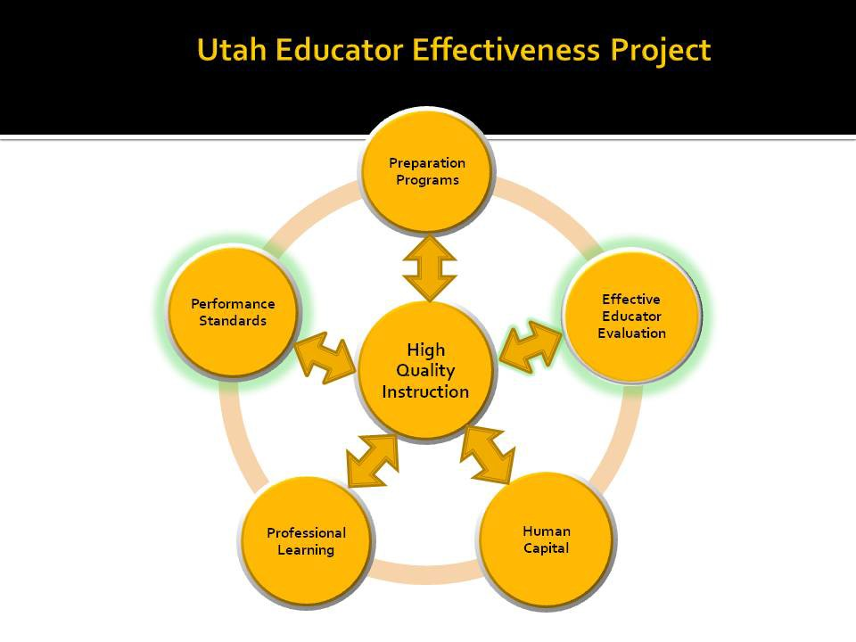
Improving instruction is a key pillar of reform found in Promises to Keep. In order to impact instruction, USOE is taking a comprehensive approach to improving educator effectiveness. The foundational assumptions of the Utah Educator Effectiveness Project, illustrated in the diagram above, recognize that high quality instruction in all public schools in Utah requires:
- Measuring teaching and leadership with research-based performance standards.
- Aligning preparation programs to Utah Effective Teaching Standards and Utah Educational Leadership Standards.
- Evaluating the effectiveness of educators yearly using multiple measures.
- Recruiting, retaining, promoting, and rewarding the most effective educators.
- Providing appropriate professional development at all stages of the professional career continuum.

The five major components of the Educator Effectiveness Project are directly targeted at improving instruction and are all essential for improving educational outcomes for all students. While all five components are critical to the overall mission of ensuring all students are college and career ready; the USOE has chosen to first work on establishing effective teaching and leadership standards and then subsequently, developing and implementing a statewide educator evaluation system to measure effectiveness in accordance with these standards.

Performance Standards for Instructional Improvement
The USBE adopted the Utah Effective Teaching Standards and Utah Educational Leadership Standards (R277-530), in August 2011 as the first and most crucial step of the overall project. The Utah Effective Teaching Standards are aligned with the new CCSSO Interstate Teacher Assessment and Support Consortium ( InTASC) Model Core Teaching Standards. The USOE Director of Teaching and Learning was a member of the CCSSO InTASC revision team and provided staff with a preview of the new standards. Therefore, Utah was able to lead out in this work and develop Utah standards, with accompanying tools and professional development. The Effective Teaching Standards Workgroup made up of teachers, association leaders, school and district administrators, parents, university professors, board members, technology partners, and state leaders came together to develop standards, indicators, and a continuum of practice; outlining expectations for educator practices in Utah classrooms.

The Utah Effective Teaching Standards articulate what effective instruction and learning must look like in the Utah public education system in order to ensure that all students are college and career ready with careful attention to historically underrepresented subgroups. These standards take into account the needs of teachers, administrators and, most importantly, students. The standards focus on the knowledge, skills, and attitudes necessary to successfully implement the Utah Core State Standards. The standards will also serve as the basis for district educator evaluation systems as well as the model system being developed by the Utah Educator Evaluation Advisory Committee and subsequent workgroups discussed later in the narrative.

Utah Educational Leadership Standards, like the Effective Teaching Standards, specifically detail the knowledge, skills, and attitudes leaders must develop and display in order to ensure all students are prepared for today’s economy. While Utah university educational leadership preparation programs have been using the ISSLC standards to prepare school leaders, the USOE had not subscribed to a set of standards statewide prior to 2011 for evaluation of leadership practice. The Utah Education Leadership Standards will now serve as the basis for preparation, evaluation, professional development and ongoing professional practice in order to ensure all students are college and career ready.

Effective Educator Evaluation
The purpose of the Educator Evaluation Project is threefold: systematically provide data and feedback to improve instructional practice, identify highly effective educators, and assist less effective educators (including removing ineffective educators). In addition, the USOE must respond to federal reports, legislative requests and state Board initiatives with accurate and comprehensive data on teacher effectiveness. The work behind the project actually began in 2008 when the USOE convened a group of
education stakeholders, including parents and association leaders, to analyze the effectiveness of educator evaluation practices in Utah schools and study what current research tells us about effective evaluation practices. In order to determine the state of current practices, the committee gathered available district evaluation policies and checked district websites to see if evaluation policy and practices are transparent to teachers, students, and parents. This committee, known as the Educator Evaluation Committee (EEC) determined that very few districts had comprehensive, valid teacher evaluation programs and those that did were very hard to find. This was particularly true in the small and rural districts. At issue was also an absence of consistency in evaluating principals. Many were only evaluated when complaints were made. Most districts also had not updated their evaluation practices in many years and were not conducting annual evaluations for veteran teachers. These discoveries led the committee to discuss policy that could promote a more systemic approach to educator evaluation.

The EEC worked with several key state legislators in 2009 to update 53A-10-106 in Utah code to include updated language, require multiple measures including student achievement, and bring attention to the need for districts to update evaluation policy and practices. In order to remedy the inconsistent practices in districts, however, it was determined that the State Board of Education must develop and implement educator evaluation policy, creating a statewide educator evaluation system focused on improving instruction.

Statewide Educator Evaluation Model Evaluation Model Development
In order to develop a comprehensive statewide model, it was necessary to reconvene a broad-based group of education stakeholders. The Educator Evaluation Advisory Committee (EEAC) was developed to study the research and best models around the country, develop a framework for implementation and advise the Board on policy. The first step was to determine the level of the USOE involvement in providing leadership for educator evaluation. In studying national models, the committee found three trends: one state-wide model for all districts; district systems with state required parameters; or an elective state-level system that districts could choose to follow. The USBE chose to create and implement a model based on a combination of required parameters and an elective model system. (State statute releases charter schools from complying with evaluation requirements as charter employees are all at will. However, most charters schools include requirements for teacher evaluation as part of their charter).

Public Educator Evaluation Requirements (PEER)- State Board Rule R277-531
Board rule R277-531 was adopted September 2011, outlining the parameters that every district must incorporate into new or existing evaluation systems in order to be in compliance. The purpose of placing PEER in Board rule is “to provide a statewide educator evaluation system framework that includes required Board directed expectations and components and additional district determined components and procedures to ensure the availability of data about educator effectiveness” (R277- 531-2.B). The rule describes the evaluation components and elements as recommended by the Educator Effectiveness Workgroup necessary for quality educator evaluation systems statewide. The rule describes the parameters for the district evaluation system, leaving some flexibility for local autonomy. It also describes what the state will do to assist and support districts. A chart depicting the roles and responsibilities of the USOE and the LEAs can be found in Attachment 17.

Multiple Valid Performance Measures
Board rule R277-531-3 calls for every LEA evaluation system to “include valid and reliable measurement tools including, at a minimum:
      - observations of instructional quality;
      - evidence of student growth;
      - parent and student input; and
      - other indicators as determined by the LEA.

These performance measures are being developed in collaboration with national and local experts in the field of educator evaluation. The weighting of these elements is likewise under development and will be determined by the USBE at the May 2012 Board meeting. This timeframe allows the various workgroups to receive adequate input and feedback before making recommendations. Utah has had the privilege of working closely with WestEd and the Southwest Comprehensive Center who have brought together state leaders from Colorado, Arizona, and Nevada to inform USOE’s work. Laura Goe and Stanley Rabinowitz have served as consultants for WestEd’s coalition of western states and have been particularly influential on the development of Utah measurement tools. In addition, the USOE leadership has consulted with the Utah Policy Center, Forlini, Brinkman, and Williams, the Center for Assessment, CCSSO, and Regional Education Lab (REL), to ensure development of performance measures will result in valid and reliable tools and implementation efforts. Psychometricians from several of these organizations will continue to work with USOE through 2015 to ensure the measurements and weights of those measurements are valid and reliable.

Workgroups comprised of members of the Educator Evaluation Advisory Committee and various stakeholder groups (including parents, association members, principals, district leaders, teachers and USOE staff) are working through 2011-2012 to develop tools aligned with the intended outcomes of the Framework. Of particular importance is the inclusion of the Utah Education Association, the predominant teacher association in Utah schools. Utah is a right to work state and not bound by collective bargaining but UEA is instrumental in coalescing educators around programs and policies.
Committees and Workgroups are currently comprised as follows:

        - Educator Effectiveness Advisory Committee
        - Educational Leadership Standards Workgroup
        - Effective Teaching Standards Workgroup
        - Educator Effectiveness Evaluation Workgroup
        - Student Growth Workgroup
        - Higher Education Workgroup
        - Educational Leadership Measurement Tools Workgroup
        - Teacher Measurement Tools Workgroup

Membership of the workgroups, meeting minutes, progress, and resources, can be found at http://www.schools.utah.gov/cert/Educator-Effectiveness-Project/Committees.aspx . The performance measures are the focal points of the model system and are the most complex to develop. An important factor is that the work of developing these measures is ahead of the research. Recent research like the Measures of Effective Teaching Project (MET, 2011) and the Tripod Project, 2011 is informing the work, but most states are all in early stages of adoption, and longitudinal data is still in process of being collected and analyzed.

Student growth measures are aligned with the UCAS project. Both achievement and growth will be considered for both tested and non-tested subjects. Student growth for tested subjects will be measured using the Student Growth Percentile (SGP). The SGP quantifies the academic progress of individual students or groups of students (median SGP). More formally, it is a regression-based measure of growth that works by conditioning current achievement on prior achievement and describing performance relative to other students with identical prior achievement histories. Utah currently has assessments for 3rd through 11th grade in English language arts, mathematics and science. Our current CRTs will be used until 2014-15 when the new assessments are fully implemented, with a pilot in 2013-14. In addition,
formative, interim and summative assessments are being developed and all can provide valuable data regarding student achievement. Until new assessments are developed, we will be using comparative data from year to year aligned with peer groups. So the Spring CRT scores will be compared for a year’s growth against the prior spring score. For students who do not have a prior year’s score, we would still be able to compare against peer groups for the current year.

Non-tested subjects will be aligned with Student Learning Objectives (SLOs) under development. Our current CRTs will be used until 2014-15 when the new assessments are fully implemented, with a pilot in 2013-14. In addition, formative, interim and summative assessments are being developed and all can provide valuable data regarding student achievement. Due to this transition, advisors to the Student Growth Workgroup are suggesting that this performance measurement be used as a graduated measure. The workgroup has been discussing and making recommendations about:

        - Which indicators (data) are collected;
        - How they are weighted and combined (if they are combined);
        - What counts as “good enough” on each indicator (perhaps) and/or on some overall composite;
        - How the results are used and reported; and
        - If there are any consequences and/rewards and how they are applied.

Student growth measures are still under development as there is currently no substantive research to support the correct weighting for this measure to impact teacher and student performance. However, we have made progress since our initial waiver request. We are continuing to work with the Center for Assessment, Regional Education Laboratory, and the Utah Education Policy Center to ensure that our student growth measures can adequately describe appropriate teacher and leader attributions that contribute to growth. Starting in 2014-2015, for tested subjects, we will be using end of level tests that are under development to align with the Utah Core Standards. The test will look at each student and the point between beginning and end of year to measure progress.

We have been working with Colorado and learning from the early adopters (Delaware, Georgia, Rhode Island) to learn from their implementation and will phase in growth starting in 2013-14. For non-tested subjects, teacher attribution will come from student learning objectives (SLOs). Parameters for developing the SLOs will come from the USOE. Exemplars will be established and samples will be submitted from districts to a committee for vetting and placed in a bank of exemplars for LEAs to use as they see fit. However, early work around the country on SLOs indicates that teacher involvement in writing the SLOs is critical. If a teacher teaches both tested and non-tested subjects, they will be required to write SLOs and be linked to growth in both areas. Administrator evaluations will include student growth measures in aggregate form for tested subjects and additional data from non-tested subjects.

Incorporating student growth into an overall educator evaluation system takes the right analytic approach. Importantly, identifying an analytic approach to growth is a small part of a much larger initiative. As we continue to follow the research from early adopters as well as learning from our pilots, we must consider the following items:
- Addressing attribution
- Linking outcomes to classes
- Determining data system requirements
- Defining ‘teacher of record’ (e.g. multiple educators contributing to instruction)
- Dealing with student mobility
- Limited grades/ subject areas covered by state tests
- Setting performance expectations
  - How will growth be used to inform decisions about educators?
  - What is ‘good enough’ growth?
  - What level of precision/ consistency will be required to support decisions?
  - What additional evidence will be necessary to support/ confirm outcomes?
- Incorporating student growth in the full system; a comprehensive and defensible system incorporates multiple measures that go beyond student performance on state tests:
- Determining what evidence will be used?
  - Observations
  - Stakeholder input
  - Student Learning Objectives (SLO)
  - How will each component be valued (e.g. weighted)?
  - How will multiple (sometimes different) sources of evidence be combined to support an overall summative rating?
- Evaluating outcomes
- Establishing criteria to determine if results are reasonable
- Safeguarding against unintended consequences
- Developing methods and standards to assess the precision and stability of results
- Collecting data frequently and systematically and reviewing it for continuous improvement

The student growth workgroup will be consulting with national consultants and early SGP implementing states during the 2012-13 year to ensure a valid and reliable measure of student growth can be attributed to teachers and administrators. During the 2012-13 school years, we will also look at historical data going back five years to see if we can correlate existing attributions between teacher and student data.
We have a Student Information System (SIS) that houses student/teacher assignments as well as our end of level assessment data. This will enable us to be better prepared to engage in the work of determining attributions in SGPs with new assessments as they are implemented in 2014-15. The weighting of this measure will be a signification factor in the overall performance rating and will be established in 2013-14 as piloting occurs. However, we will utilize the floor of 40% of our overall weighting for student growth as our target while we work to validate this measure. Data obtained through historical correlation and SGP/SLO pilots with the new system will create fluctuation until we find the appropriate, research-based weights for all three of our components (student growth, instructional/leadership effectiveness, stakeholder input). Since student growth is the most complex of our three effectiveness measures and doesn’t yet have a strong research base, we will phase this in through 2014-15.

Instructional Effectiveness is the performance measure our USBE and State Superintendent view as the key to impacting student growth and achievement. Both formative and summative data regarding instruction will be collected using observational tools. A summative tool, focused on particular instructional standards, will be used statewide to enable the Board to gather and analyze data on instructional effectiveness. The measure of instructional effectiveness will account for at least 40 percent of the overall score at minimum. However, the USBE will determine the percentage of the overall score of this measure June 2012 when the model is developed and ready for pilot.

It has been critical to first clarify the type of instruction necessary to ensure all students are college and career ready, and then determine how to measure instruction through observation of classroom practice. Reliability will come from ensuring that evaluators are trained to use the tools and can calibrate their responses with consistency. Validity will come from the piloting phase to ensure that what is purported to be measured can actually be measured via the observational tools.

Observational tools are being constructed in consultation with national and state experts. The tools will focus on standards that can be observed and will be accompanied by electronic formats to be used with handheld devices. One comprehensive tool that can be used as a summative observation tool, along with
observation tools targeted at high leverage instructional strategies, are anticipated to be completed in June 2012 for piloting in the 2012-2013 school year. The Educator Effectiveness Committee will make a recommendation to the Board about the indicators (attached to standards) that must be observed and reported. This will enable the USOE to gather statewide data on the improvement of instructional practices as related to student achievement goals. LEAs may want to gather data on additional elements as well. These tools will be made available on the USOE website to aide in transparency for students, educators, and parents.

The Utah Effective Teaching Standards are the basis for observations, conversations, and professional development. The Utah Education Leadership Standards are equally important and are the basis for measuring the effectiveness of instructional leadership in Utah schools. Rubrics have been developed for both sets of standards to be used in a formative manner. The rubric helps educators self-assess to set professional goals, identify areas of needed support through professional development, and aides in making summative judges about overall performance. A comprehensive document that includes the standards, rubric, glossary of terms, research base, and overview can be found for both the teacher and leader standards at http://www.schools.utah.gov/cert/Educator-Effectiveness-Project/Teaching-and- Leadership-Standards.aspx .

Stakeholder Input
Utah will also include stakeholder input as part of the overall effectiveness score. Research seems to indicate that parent input cannot provide actual data about instructional effectiveness or student growth (Rorrer, 2011, Utah Policy Center), but can speak to important elements like effective communication, support of students, clarity of expectations, etc. Student input, according to recent research from the Tripod Project (2011), can provide insight on elements more closely aligned to the Utah Effective Teaching Standards. The USBE feels it is critical to improvement to gather both parent and student input. However, this measure will not carry the weight of the other indicators. It will likely account for no more than 20 percent of the overall score but will be determined through pilot. Tools for stakeholder input will be provided on the Educator Effectiveness website for use by districts. This will be an area with local flexibility to focus on school improvement goals and other elements that may be contextually unique.

Differentiated Levels of Performance
Board rule R277-531 calls for at least three levels of differentiated performance. The formative rubric accompanying the standards outlines four levels of performance: practicing, effective, highly effective, and distinguished. However, these levels are not intended to be summative in nature and were strategically determined to ensure that all educators had improvement targets as well as an approach to improvement that could follow the continuum of an educator’s career.

Summative judgments will be based on a combination of the three elements described above; student growth, instructional effectiveness, and stakeholder input. Labels of performance will include ineffective, effective and highly effective. However, the input from the field indicates there may be another level between ineffective and effective yet to be determined. These decisions will be made in the April 2012 USBE meeting, ready to roll out to LEAs at the April 2012, Educator Evaluation Summit. The Summit is the second in a series of meetings that brings educator evaluation teams (including the district superintendent, teacher’s union representative, and human resource director), together to study research, learn from evaluation experts, and explore ideas and concerns about the components of the statewide educator evaluation components. LEA levels of effectiveness are currently reported in the aggregate in the Utah Consolidated Application, and subsequently become part of the of the Title IIA report.
However, individual data is also necessary to analyze effectiveness by grade level, subject, school and district. Utah has a robust educator credential system called CACTUS that can house the effectiveness data and generate disaggregated and aggregated reports. At issue is the ability to ensure privacy and protection of individual educator data from public access. Aggregate data will be used in public
reporting.

Evaluation Outcomes
The purpose of Utah’s Educator Effectiveness Project, including Educator Evaluation, is to ensure all students are college and career ready by impacting the effectiveness of the educators who serve them. With a clearly defined set of instructional and leadership standards, educators are better equipped to engage in practices aligned with intended outcomes. Professional learning opportunities will be developed and implemented based on data obtained from evaluation tools. A focus of the USOE is to determine how instruction in Utah classrooms is changing as a result of more clearly defined instructional standards and ensuing professional learning for educators. The implementation of a yearly professional growth plan for every licensed educator will include evidence of improvement efforts based on student growth, observations, professional learning implementation and stakeholder input. This process is based on the continuous improvement cycle common to school improvement efforts; using data to determine goals, providing professional learning to improve practices, implementing new learning, measuring results, analyzing data and back to goal setting.

All certified school personnel will be evaluated yearly, with provisional educators being evaluated twice yearly. Feedback from both the formative process of creating yearly professional growth plans and summative performance level based on student growth, instructional observation, (instructional leadership for administrators), and stakeholder input will be used to provide timely feedback, professional learning opportunities, and impact personnel decisions. These provisions are detailed in Board rule and will be spelled out specifically in the model system developed by April 2012.

3.B ENSURE LEAS IMPLEMENT TEACHER AND PRINCIPAL EVALUATION AND SUPPORT SYSTEMS

  - Provide the SEA’s process for ensuring that each LEA develops, adopts, pilots, and implements, with the involvement of teachers and principals, including mechanisms to review, revise, and improve, high-quality teacher and principal evaluation and support systems consistent with the SEA’s adopted guidelines.

Accountability Measures
Described below are both the responsibilities of the Utah State Board of Education and the Educator Effectiveness Advisory Committee (EEAC) that will serve under the direction of the Board. The EEAC Committee will monitor LEA implementation and alignment with Board rule. Reporting of LEA alignment and implementation efforts will be reported to the Board on a yearly basis. Board rule R277- 114 also allows the Board to withhold funds and resources from LEAs who are not in compliance.

Utah State Board of Education Responsibilities as Described in R277-531 (PEER) and SB 64 (2012 Legislative Session):
Board Rule R277-531 clearly defines the role of the Board of Education in assuring stakeholders that district evaluation systems are aligned with state requirements and will result in improving instruction in Utah public school classrooms. The following responsibilities of the Board and staff are outlined in R277-531:

    - Establish a state evaluation advisory committee to support and review LEA evaluation systems
    - Review evaluation components and elements in order to evaluate their usefulness in providing a consistent statewide framework for evaluation
    - Review LEA evaluation systems for alignment with PEER ; including recommending Board approval or needed changes for alignment
- Create model evaluation systems for both teaching and leadership with performance expectations consistent with Utah Effective Teaching Standards and Utah Educational Leadership Standards R277-530
- Develop and provide statewide model for measuring student growth as indicated by individual teacher and leader performance.
- Develop and provide sample instructional observation tools for use by LEAs
- Develop and provide sample parent and student satisfaction surveys
- Provide professional development and technical support to LEAs as they make valid and reliable evaluation decisions
- Develop and support cadre of district facilitators to provide expertise to LEAs on state evaluation model
- Yearly evaluation of all educators
- Yearly performance ratings
  - Student growth
  - Observations of instruction/leadership
  - Stakeholder input
- Contain both formative and summative components
- Use data to inform employment, professional learning and compensation decisions
- Evaluation tools must be valid and reliable

The State Evaluation Advisory Committee serves at the request of the USBE, is made up of a variety of stakeholders, and will perform the following functions:
- Oversee and monitor the development and implementation of the model system via specified workgroups
- Review district plans for alignment with framework: Each LEA will be required to submit a complete overview of their evaluation system spring of 2013; outlining the required elements in rule as well as additional requirements, implementation timeline, and support system for educators. The Educator Evaluation Advisory Committee will review each plan and make recommendations for Board approval or identify needed changes.
- Monitor pilot of measurement tools and make recommendations for adjustments
- Analyze common data from measurement tools
- Contribute to required reporting for the USOE, legislative, and federal reporting
- Evaluate effectiveness of framework elements and model system
- Gather and house yearly effectiveness data
- Provide technical assistance and professional development

Timeline for Development and Implementation Strategies are listed below by quarter and include activities for both USOE and the LEAs. LEA implementation does not include charters as they are exempt from educator evaluation code. However, as part of the charter, each school has to outline a plan for including educator evaluation. All employees in public charter schools are currently at will. The Utah State Board of Education will continue to work with the Charter board to mitigate this inequity in statute.

All systems include teachers of students with disabilities and students learning English as a second language. Factors of student growth, instructional effectiveness and stakeholder input apply to all teachers. Representatives from these populations of teachers serve on workgroups, steering committees, tool development, etc. Our value-added model of SGP will utilize data from IEPs and other sources to ensure that adequate measure of growth are accounted for.

Validity and reliability are technical terms that can seem daunting and yet in simple terms they mean
“does the tool or system measure what it purports to measure – validity, and can it be used to measure the same thing consistently over time – reliability”. This process occurs through piloting of observation tools, professional development that focuses on calibration of raters, accurate data collection and monitoring from the outside for calibration.

The PEER Educator Evaluation Advisory committee will be receiving all district plans in Spring of 2013 to assess that the three components of student growth, instructional (and leadership) effectiveness, and stakeholder input are in compliance with Board rule. The committee is made up of K-16 educators who have developed expertise in educator evaluation and will be able to determine whether each district has a valid and reliable system in place. The committee will ensure that the performance ratings of highly effective, effective, minimally/emerging, and non-effective are consistent across the state. Each district will designate a liaison to this committee to serve as a cadre of evaluation experts (based on ongoing professional learning) and internal auditors of evaluation system effectiveness.

Dates | Educator Evaluation Development and Implementation Strategies
Dates | USOE LEAs
Nov. 2011  through Feb. 2012 | - Engage stakeholder groups (parents, teachers, principals, associations, superintendents, higher education, business community, students, ethnic minority community, advocates for students with disabilities, the USOE staff)  - Begin on-going Communication Plan with stakeholders  - Determine guiding factors for selecting observation instruments  - Refine work of targeted measurement tools  - Determine high leverage instructional strategies for summative tool  - Determine processes for teaching and leadership evaluations  - Determine levels of performance that match Board requirements  - Determine weights for the measures  - Ensure validity and usefulness of the measures and determine how reliability will be determined through pilots  - Establish data infrastructure  - Establish data validation process  - Determine criteria for confidentiality  - Develop online resources for self- assessment, professional growth plans, and PD360 resources aligned with standards | - LEAs select representation for LEA Joint Educator Evaluation Committee  - LEAs send JEEC members' names to the USOE  - Convene LEA JEEC committee to analyze current LEA practices  - Determine roles and responsibilities of stakeholders on LEA JEEC

Mar., 2012  Through  June, 2012 | - Decide where and when to pilot the system  - Hold 2nd USOE Educator Evaluation Summit  - Roll out measurement elements to system for feedback  - Determine factors to consider when evaluating the system  - Determine what resources are available to evaluate the system  - Report to stakeholders  - Prepare districts for 2012-13 pilot  - Develop and provide professional development for model tools and resources  - Train stakeholders on data base for inputting performance levels for educators | - Give input to the USOE model  - Determine to adopt the USOE model or develop LEA model  - Discuss policy that will list consequences for failure to meet performance levels  - Determine training needs and criteria for selecting evaluators  - Plan how evaluation results will be used  Establish a plan for assessing the LEA selected evaluation system
2012-2013 | - Support pilots with technical assistance  - Monitor evaluators reliability  - Gather and analyze data from pilot districts  - Expand development of SLOs for non-tested subjects
2013-2014 | - Statewide implementation of model system or LEA developed systems  - Gather data from all LEA evaluation systems  - Analyze data and make adjustments to the USOE and LEA systems where needed
2014-2015 | - Full implementation of statewide educator evaluation using student growth measures from new assessment system aligned to CCSS

Support for LEA Implementation Efforts Technical Assistance Team
The USOE staff leading the Educator Effectiveness Project, bring years of experience in developing and supporting effective instruction and educator evaluation. In addition, the lead staff and stakeholders leading workgroups have been privileged to build their own capacity by working with organizations such as CCSSO, SCEE, InTASC, West Ed, the Southwest Comprehensive Center, the TQ Center, the Center for Assessment, the Utah Policy Center, Stanford University, and state education leaders from neighboring states. The USOE lead team, along with workgroup leaders, will provide technical assistance to LEAs and work to build capacity in key LEA leaders (i.e., HR Directors, superintendents, mentor leaders). By shifting responsibility and expertise to LEAs, the USOE can focus on product and process development.

Technical assistance will be present in multiple forms. On April 25, 2012, the USOE sponsored the second Educator Evaluation Summit where teams came from each district to hear updates about the updated process, new code from Senate Bill 64 Public Education Employment Reform, and see samples of pilot observation tools. The USOE officials received overwhelmingly positive feedback about their experience and understanding. District teams were made up of superintendents or their designee, personnel directors, curriculum directors, local and state teacher association leaders, principal association leaders, state and local board members and key legislators. Participants indicated that they feel better equipped to analyze, adjust, adapt, or adopt a new system.

Professional development on model tools will begin this fall with pilot districts. Pilots will include approximately ten districts for instructional observation tools and up to ten districts for leadership effectiveness tools. Student growth pilots will begin in the fall of 2013. Digital platforms will be used for observation tools and our education partners – True North Logic and School Improvement Network – have co-created an electronic system that will house our professional growth plan that includes the following:

- Utah Effective Teaching and Educational Leadership Standards with accompanying video of the new standard in practice
- A self-assessment based on the standards that links to the video examples
- A professional growth plan based on the standards and self-assessment – this includes goals setting, evidence of goal attainment, professional learning to support goals, and other support needed
- Digital system for classroom and leadership observation tools with ability to record and view data for multiple observations
- Yearly performance rating
- Sign off system for accountability

The yearly performance ratings will be protected for individuals but reported in aggregate form for Title IIA purposes, as well as allowing the USOE to disaggregate data by school and district to look for patterns in evaluation practices.

Additional support will include a bank of parent, student, and teacher surveys that LEAs can use to gather stakeholder input. The Utah Education Policy Center is developing a set of questions that can be triangulated among all surveys to provide stateside data on perceptions and satisfaction.

LEA Facilitators
Facilitators will be chosen from each LEA to serve as liaisons between the USOE and the LEA. Facilitators will have access to expertise, resources, training, and ongoing support to ensure fidelity in implementation of evaluation tools and processes. Charter schools may participate in this facilitator cadre as they conform to the tenets of the state framework. The USOE will facilitate bringing facilitators together both face-to-face and through a digital platform in order to provide a space for sharing successes and challenges. The mantra, “no one is as smart as all of us” applies to the work of the LEAs.

Local Joint Educator Evaluation Committee
The Joint Educator Evaluation Committee in each district must be comprised of teachers, parents, association members, and district personnel responsible for educator evaluation. This is required both in State statute 53A-10 and Board rule R277-531. The committees will receive technical support from the USOE to ensure they are equipped to implement and monitor the required elements of the Educator Evaluation Framework. An Educator Evaluation Summit was held fall 2012 involving all LEA superintendents and members of their JEEC. The Summit provided an overview of current research and trends as well as more information about the elements of the framework.

Exemplars of Effective Practice
Utah is working with two longtime educational partners; School Improvement Network (SINET) and True North Logic (TNL) to implement an updated system that does the following:

- Take a self-assessment based on the rubric to identify areas of growth
- View digital exemplars of the teaching standards in practice
- Create a professional growth plan with lines of evidence and ability to send it to supervisor and/or mentor
- Register for formal and informal professional learning opportunities
- Join online professional learning communities that can be established at school, LEA, state or national level
- Access one portal that houses information about professional learning activities completed, licensure renewal data, effectiveness data and progress on professional growth plan

This digital resource, called OnTrack, is already in place but not up to date with new Effective Teaching Standards or updated Learning Forward professional learning standards. Completion date is slated for April 2012. This system will provide a resource of comprehensive support to improve on those areas determined through observation tools to be deficient or areas of potential growth.

Educator Effectiveness Project Website
http://www.schools.utah.gov/cert/Educator-Effectiveness-Project.aspx will continue to house resources, research, and tools to support LEA and USOE educator evaluation efforts. A link will remain on the home page of the USOE website in order to provide greater transparency to stakeholders and ease of access to tools, resources and research. While aggregate data may be published, individual educator data will be kept private and protected by both LEA and SEA.

Expert Assistance from Partnerships
The USOE will continue to partner with West Ed, SWCC, CCSSO, Learning Forward, ASCD, Utah Policy Center and other education partners to gain expertise, develop resources and tools, and guide efforts in ensuring high quality instruction and effective leadership in all Utah public schools. The Center for Assessment and the Utah Policy Center will conduct evaluations on pilots and ongoing process to ensure validity and reliability of tools and evaluation process.

Pilots
Pilot Site Selection
Pilots will include approximately ten districts for instructional observation tools and up to ten districts for the leadership effectiveness tool. Student growth pilots will begin in the fall of 2013. Districts will be chosen by application (due to USOE June 15, 2012) and be selected by members of PEER Educator Evaluation Advisory Committee by July 1, 2012. They will be selected based on criteria that include their ability to demonstrate teacher and administrator buy-in, as well as the commitment of the local school board, district leadership, and teacher association. They will also need to assist in the collection and analysis of data from the USOE developed tools.

Pilot Outcomes
The components for the pilot will be the observation tools for teachers and leaders to ensure validity and reliability. After the pilot process and subsequent adjustments to tools, LEAs will be able to adopt, adapt, or add to the tools to meet their local needs (as long as they can validate the adjustments). The ability to determine appropriate weighting in the overall system for instructional/leadership effectiveness will be based on data from the pilot and will occur when there is more information. A floor of 40% will be set for both student growth and instructional/leadership effectiveness as we pilot and work towards our weighted targets according to the timeline. Data will inform the necessary adjustments to these weightings to ensure that we have a research base behind our weighting decisions.

Technical Assistance
Technical assistance will be heavily concentrated on pilots during the 2012-13 school year while providing assistance to all LEAs in the form of exemplars and ideas as they determine the direction of their local evaluation committee. It will be expected that they continue to make employment and recruitment decisions based on current systems if they are a non-pilot district. A website will be maintained on the Educator Effectiveness Project http://www.schools.utah.gov/cert/Educator- Effectiveness-Project.aspx to keep the process transparent and the public informed about our progress with pilots and tools.

Educator Evaluation Pilot Timeline
Project Element | School Year
District committee meet to review current evaluation system and compare with rule | September 2011
Pilot for observation/interview tools | 2012-2013
Parent/Student/Teacher surveys (piloted 2012-13) | 2013-14
Pilot for student growth model | 2013-14
All districts implement updated/aligned evaluation system including student growth | 2014-15

PRINCIPLE 3 OVERALL REVIEW

Summary
The foundation of education excellence and equity is based on educator effectiveness. For too many years Utah educator evaluation systems have focused on inputs (e.g., degrees, coursework); have not adequately addressed outputs (e.g., instructional performance, effectiveness); and have not taken place in a consistent manner statewide. Utah, like other states, supports the current state and federal policy of ensuring all educators are qualified to teach the subjects they are assigned; but more importantly are effective in doing so. Our Board mission, Promises to Keep, is very focused on the improvement of instruction and effective educator evaluation is viewed as a key lever to improving instruction for all students.

Highly effective educators in Utah classrooms understand and use high leverage instructional practices in order to ensure all students are experiencing success. They are crystal clear about their role in impacting student learning; particularly for students who do not speak English proficiently or have a disability. In addition, they are not fearful of the evaluation process. They welcome professional feedback and use it to become better educators. They understand that being an educator is a rewarding career; that there are advantages to progressing along a career continuum and growing professionally in both practice and skills to become more effective. The goal of the Board is to enact evaluation policy that will lead more teachers to become highly effective while remediating or removing ineffective educators.

A new expectation for Utah’s educators is that determining yearly performance ratings of educator effectiveness will incorporate measures of student achievement. Including student achievement and growth as indicators of educator effectiveness requires a better understanding of how to assess student learning and measure student growth accurately and consistently. With this understanding, the stage is set for the argument supporting a robust educator evaluation system that incorporates multiple measures, including observation tools, student learning data, and stakeholder input. Utah’s new educator evaluation
system will be performance-based and growth centered, provide immediate and timely feedback, and be based on standards of high quality instructional practices. Utah educators and students will benefit from an educator evaluation system that incorporates these elements in order to ensure all students are college and career ready for today’s economy. We have Promises to Keep to all students in Utah public schools.

PRINCIPLE 4: REDUCING DUPLICATION AND UNNECESSARY BURDEN

- In order to provide an environment in which schools and LEAs have the flexibility to focus on what’s best for students, an SEA should remove duplicative and burdensome reporting requirements that have little or no impact on student outcomes. To receive the flexibility, an SEA must assure that it will evaluate and, based on that evaluation, revise its own administrative requirements to reduce duplication and unnecessary burden on LEAs and schools.

In the 2010 legislative general session, the Utah legislature passed HB 166 which stipulates the following:

“On or before December 31, 2010, the State Board of Education shall review mandates or requirements provided for in board rule to determine whether certain mandates or requirements could be waived to remove funding pressures on public schools on a temporary basis.”

In the 2011 legislative session, the Utah legislature passed HB02 with the following requirements: “The Legislature intends that the State Board of Education review reports required of local education agencies in statute or board rule, and that the State Board of Education submit any recommended report eliminations to the education Interim Committee by the October meeting of the Education Interim Committee in 2011.”

The USOE has complied with the intent of the legislation through a continuous review of the requirements it makes of local school agencies. This has been a sincere effort to reduce the USOE imposed burdens wherever possible and practical. The following is a list of specific examples of program or procedures which have been impacted by this on-going process.

  - Single comprehensive accountability system
  - Web-based grant management tool
  - Statewide unique student identifier
  - Online summative assessment
  - Computer based writing assessment
  - Utah Transcript Record Exchange (UTREX)
  - Electronic upload and editing procedure for student test data

ATTACHMENT 1
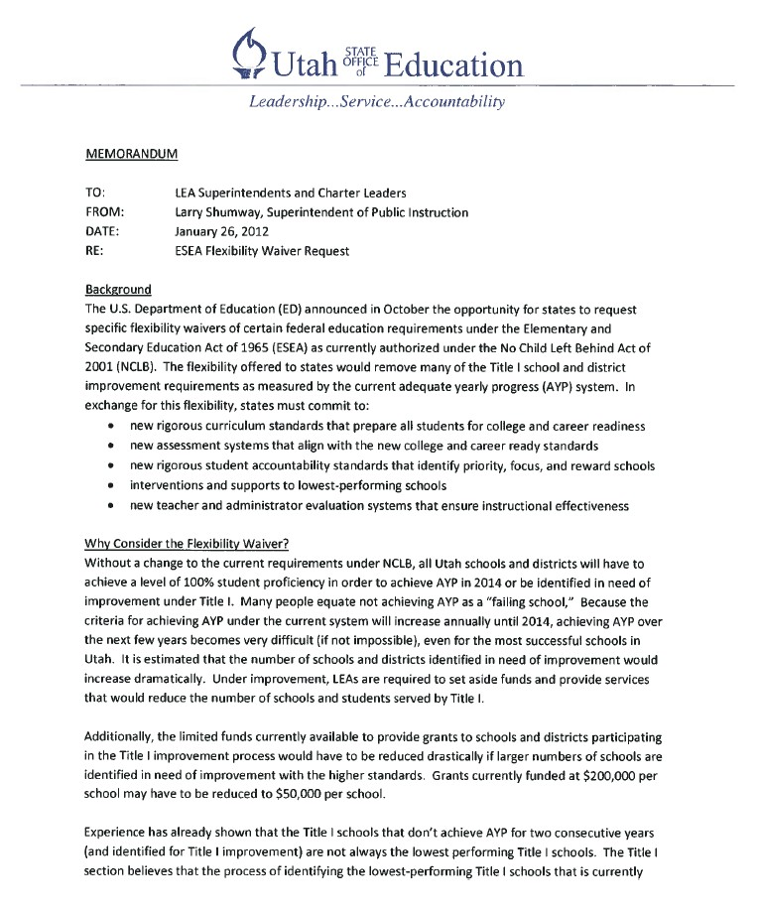

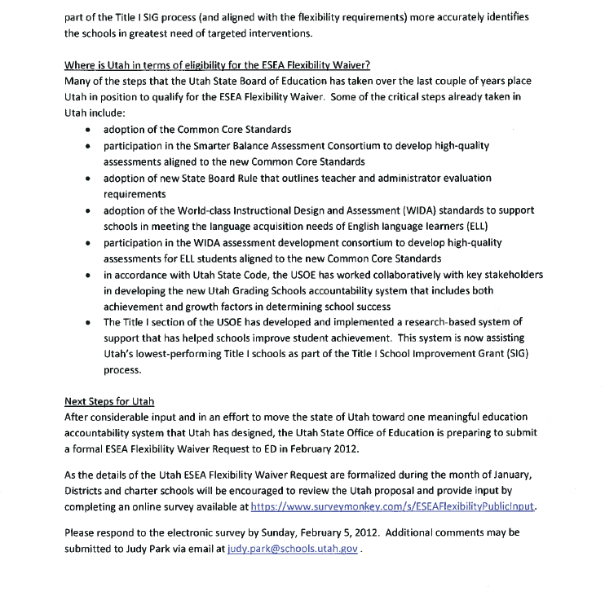
ATTACHMENT 2

Summary of Input
ESEA Flexibility Public Input Survey Results

Survey Question | Percent Perceived as Important | Percent Perceived as Not Important
Utah should have one education accountability system. | 87.5% | 12.5%
Utah should include a growth factor in education accountability. | 94.6% | 5.4%
The new Utah Comprehensive Accountability System should be proposed in the ESEA Flexibility Waiver request. | 79.2% | 20.8%
The USOE should identify Utah’s current Title I SIG schools as Priority Schools (Utah’s lowest-performing 5% of Title I schools). | 87.9% | 12.1%
The USOE should use the composite score from the Utah Comprehensive Accountability System to identify Focus Schools (Utah’s next lowest-performing 10% of Title I schools). | 86.3% | 13.7%
The Utah Educator Evaluation System will lead to improved instruction in Utah K-12 classrooms. | 65% | 35.0%

Summary of Responses
Most frequent comments/recommendations | How addressed by the USOE
1. The education accountability system for Utah should reflect both achievement and growth | The new Utah Comprehensive Accountability System is designed to include both achievement and growth.
2. Student achievement needs include multiple measures | The calculations for school accountability will include CRT results in reading/language arts, mathematics, and science; graduation rate; and Direct Writing Assessment.
3. Utah should have one accountability system | The Utah ESEA Flexibility Waiver proposal includes one education accountability system for Utah. Based on stakeholder input and priorities of the Utah State Board of Education, Utah proposes eliminating dual education accountability systems (federal AYP and state UPASS) and replacing them with the new Utah Comprehensive Accountability System to meet both federal and state requirements.
4. There is too much testing | The Utah ESEA Flexibility Waiver proposal does not add to or diminish current testing requirements. Many of the testing concerns listed in the public input survey identified assessment procedures that have been established by the LEA or school.
5. Schools need to focus on all students; low achieving, average, and high performing students | Unlike the old AYP accountability system that simply identified the number of students achieving proficiency, the new Utah Comprehensive Accountability System looks at student growth for all students regardless of current performance level. Although not part of the ESEA Flexibility Waiver

 | proposal, parents will continue to receive individual student performance reports.
6. Parents need to be held accountable | Although research shows that parental involvement is important in student achievement, the Utah ESEA Flexibility Waiver proposal does not specifically address this concern.
7. The state needs to continue to report student achievement by disaggregated groups | The new Utah Comprehensive Accountability System will continue to report student achievement and growth by disaggregated student groups to the public.
8. In order for the Data Gateway System to be effective, parents need training and access | The USOE is in the process of developing assistance to more effectively communicate with and train parents on the use and value of the Utah Data Gateway System.
9. Low-performing schools need support, not just negative press | Under Utah’s ESEA Flexibility Waiver proposal, the USOE will provide support including grants to Utah’s lowest-performing Title I schools to assist in quality school improvement efforts.
10. The state needs to commit more financial resources to all schools | Although the Utah State Board of Education continually advocates for adequate funding for all Utah schools, the Utah ESEA Flexibility Waiver proposal does not specifically address this concern.
11. Any new teacher evaluation system must recognize the challenges of teachers working with historically underperforming students | A key component of the new Utah Educator Evaluation System as described by Board rule R277-531 is that student growth is to be considered in teacher evaluations. The growth component of Utah’s Comprehensive Accountability System gives credit to teachers and schools for helping all students make progress.
12. Administrators need to be trained in order to fairly implement new teacher evaluations | In the implementation of new educator evaluation systems, training and support to teachers and administrators is addressed.
13. The USOE needs to communicate internally to eliminate unnecessary, burdensome reporting requirements | Under the leadership of the USOE superintendency, staff at the USOE will continue to assess which reporting requirements may be revised or eliminated to minimize redundancy and burden.

Complete Survey Responses
Respondents’ Role in Education | Percent | Count
LEA Superintendent | 1.3 | 6
LEA Charter Leader | 4.7 | 21
School Board Member | 1.3 | 6
District/Charter School Program Director or Coordinator | 11 | 49
School Principal | 2.5 | 11
Teacher | 71.1 | 317
Parent/Guardian | 4.5 | 20
Student | .9 | 4
Community Leader/Advocate | 2 | 9
Representative form Higher Education | .7 | 3

Total Respondents | 100 | 446

How important is it to have one education accountability system versus multiple distinct education accountability systems?
Responses | Percent | Count
Extremely Important | 40.3 | 143
Very Important | 25.4 | 90
Important | 22.5 | 80
Not Important | 11.8 | 42
Total Respondents | 100 | 355

How effective do you think the Utah Grading Schools System will be in ensuring that schools focus instructional efforts on all non-proficient students?
Responses | Percent | Count
Extremely Effective | 11.5 | 41
Very Effective | 33.2 | 118
Effective | 34.4 | 122
Not Effective | 20.8 | 74
Total Responses | 100 | 355

How important is it to the state of Utah to include a “growth” factor in its education accountability system?
Responses | Percent | Count
Extremely Important | 58 | 206
Very Important | 21.1 | 75
Important | 15.5 | 55
Not Important | 5.4 | 19
Total Respondents | 100 | 355

Are you familiar with and/or have you used the Public School Data Gateway system located on the USOE homepage at www.schools.utah.gov?
Responses | Percent | Count
Yes | 43.1 | 153
No | 56.9 | 202

Helpful will the Utah Public School Data Gateway tool be in providing timely information to the public regarding the Utah Grading Schools System results?
Responses | Percent | Count
Extremely Helpful | 10.4 | 37
Very Helpful | 30.1 | 107
Helpful | 45.9 | 163
Not Helpful | 13.5 | 48
Total Respondents | 100 | 355

How effective do you think Utah’s identification of the Title I SIG schools as Priority Schools will be in focusing the needed resources around Utah’s lowest-performing Title I schools?
Responses | Percent | Count
Extremely Effective | 13.7 | 44
Very Effective | 34.5 | 111

Effective | 39.8 | 128
Not Effective | 12.1 | 39
Total Responses | 100 | 322

How effective do you think Utah’s identification of the Focus Schools will be in focusing the needed resources to turn around Utah’s next lowest-performing Title I schools?
Responses | Percent | Count
Extremely Effective | 9.3 | 30
Very Effective | 31.7 | 102
Effective | 45.6 | 146
Not Effective | 13.7 | 44
Total Responses | 100 | 322

How effective do you think Utah’s identification of the Reward Schools will be in recognizing the achievements of Utah’s high-performing and high-progress Title I schools?
Responses | Percent | Count
Extremely Effective | 8.7 | 28
Very Effective | 21.7 | 70
Effective | 42.9 | 138
Not Effective | 26.7 | 86
Total Responses | 100 | 322

How effective will a statewide educator evaluation system be in improving instruction in Utah K-12 classrooms?
Responses | Percent | Count
Extremely Effective | 10.1 | 32
Very Effective | 17.4 | 55
Effective | 37.5 | 119
Not Effective | 35 | 112
Total Responses | 100 | 317

How effective is the measure of student growth in determining overall effectiveness of an educator?
Responses | Percent | Count
Extremely Effective | 12.9 | 41
Very Effective | 23 | 73
Effective | 36.3 | 115
Not Effective | 27.8 | 88
Total Responses | 100 | 317

How important is instructional effectiveness in the overall rating of an educator?
Responses | Percent | Count
Extremely Important | 30.6 | 97
Very Important | 39.4 | 125
Important | 25.9 | 82
Not Important | 4.1 | 13
Total Responses | 100 | 317

ATTACHMENT 3

Public Notice of Utah Proposal to Apply for the ESEA Flexibility Waiver

The Utah State Office of Education invited the public to learn about the ESEA Waiver Request and share their comments in a survey. A link was placed under “Popular Links” on the home page of the USOE Web site, http://schools.utah.gov. This forwarded the public to a web page that included links for ESEA Flexibility Waiver – Intent to Apply Overview Letter; ESEA Flexibility Waiver – Executive Summary; and an online survey conducted via SurveyMonkey.

The USOE Public Relations Director also sent a news release to stakeholders and the media for distribution by individuals and via mass media channels (http://www.schools.utah.gov/main/INFORMATION/Online-Newsroom/DOCS/ESEAWaiver.aspx). In total, this email reached 69 individuals. Specifically, it was sent to the voting and non-voting members of the Utah State Board of Education, the Utah State Office of Education leadership and their assistants, the Governor’s Office, the Office of the Commissioner of Higher Education, the Utah Education Association and the American Federation of Teachers, CCSSO and our contacts at Utah media outlets. These media outlets included: Provo Daily Herald, Associated Press, KTVX, KUER, Ogden Standard-Examiner, KNRS, St. George Spectrum, Valley Journals, KCSG, KSL TV, KURV, Salt Lake Tribune, KSL Radio, Deseret News, Logan Herald Journal, Telemundo and KSTU.

This news release and the above-mentioned links were also posted on http://UtahPublicEducation.org, the official blog from the Utah State Board of Education and Office of Education (http://utahpubliceducation.org/2012/01/26/utah-seeks-comments-on-federal-education-law-waiver- request/).

Posts on Facebook and Twitter were also employed. In total, 202 people were reached via the http://www.facebook.com/UtahPublicEducation Facebook Page, from two updates posted on January 26, 2012, and February 2, 2012. These Facebook posts were followed by Twitter posts on Jan. 26 and Feb. 2. We had approximately 1,350 Twitter followers at the time these messages were posted. Images of the Facebook and Twitter posts are below.
Links to tweets: Jan. 26:
- https://twitter.com/#!/UTPublicEd/status/162709276144582657 Feb. 2:
- https://twitter.com/#!/UTPublicEd/status/165188176451870720
- https://twitter.com/#!/UTPublicEd/status/165186539830259712
- https://twitter.com/#!/UTPublicEd/status/165185294948241408
- https://twitter.com/#!/UTPublicEd/status/165184476538863617
Images of Facebook and Twitter Posts:






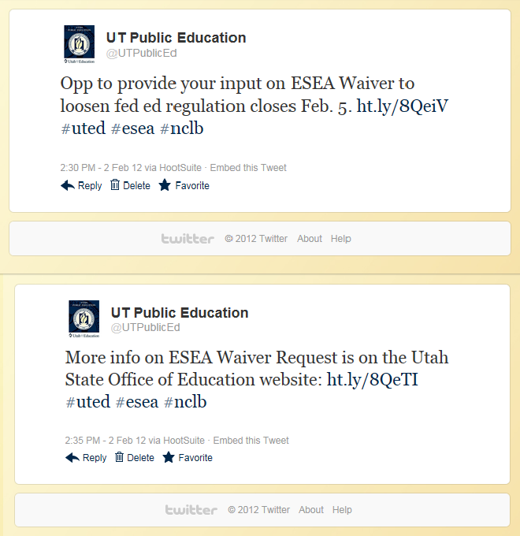



ATTACHMENT 4
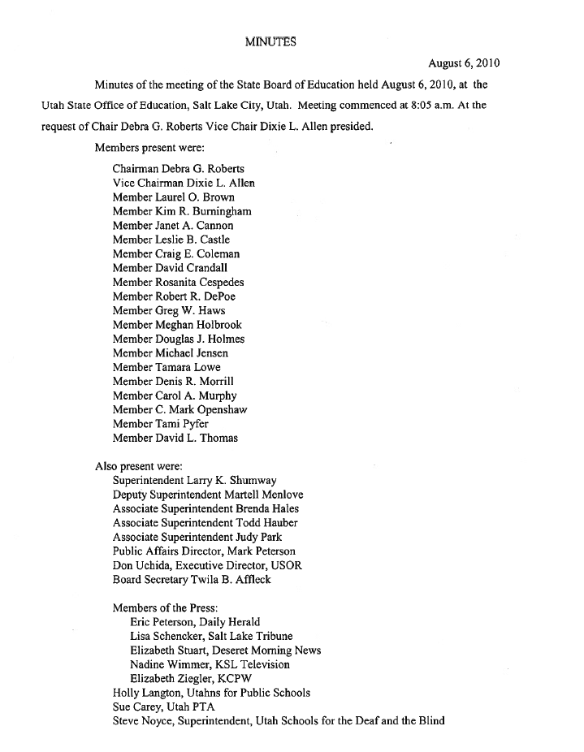

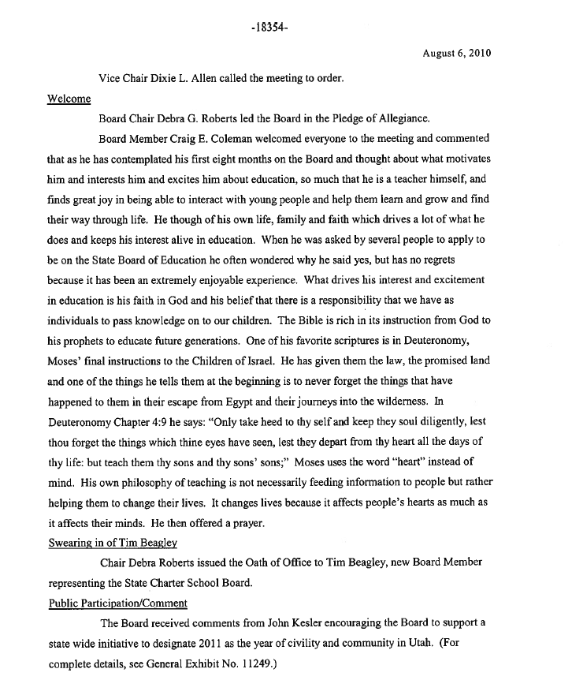

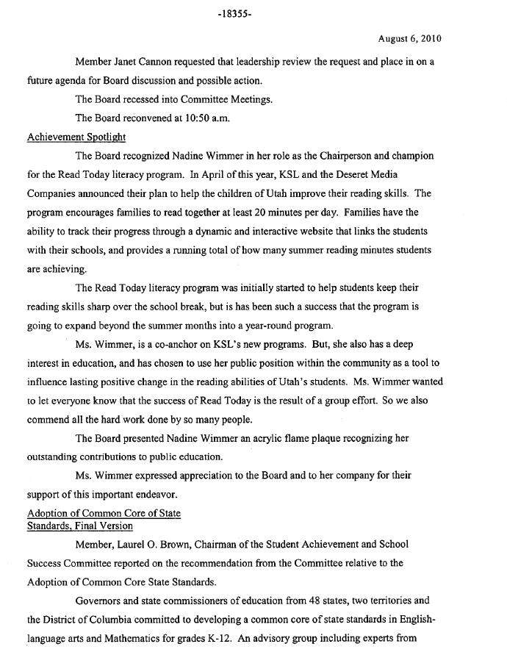

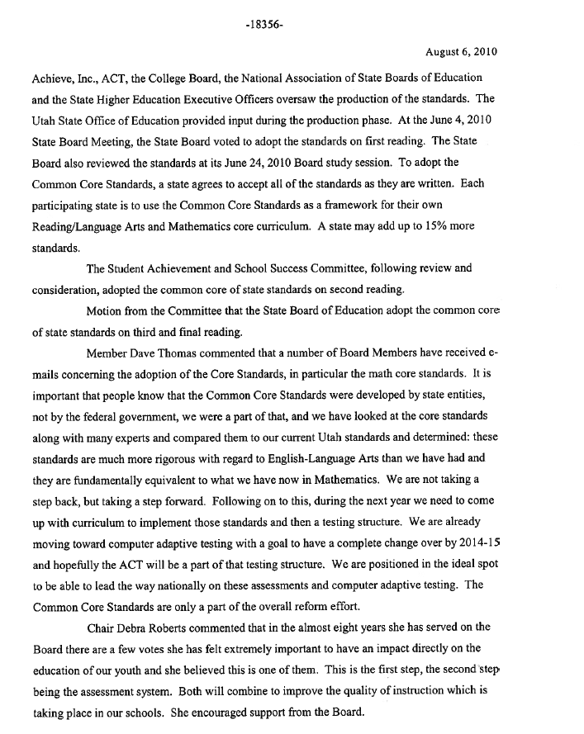

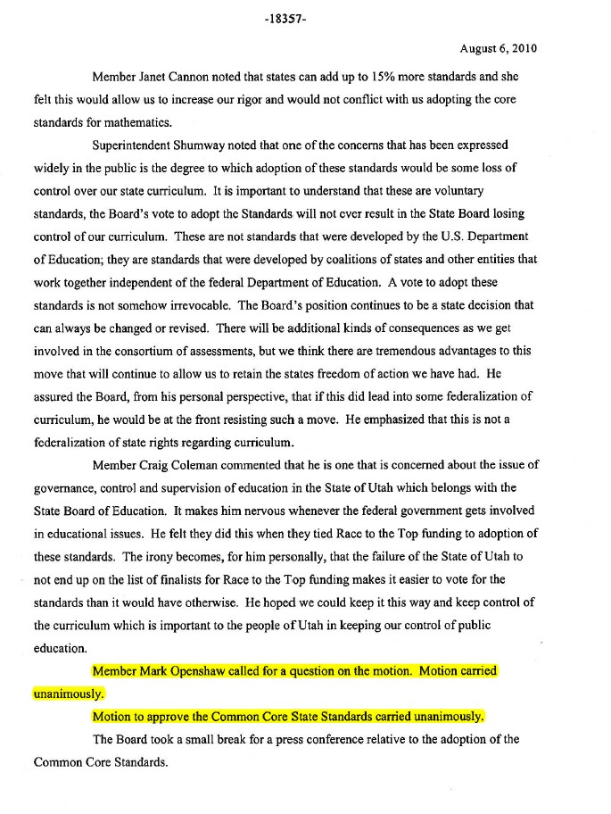

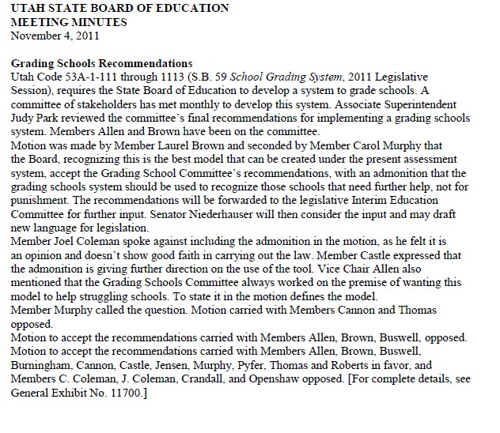
ATTACHMENT 5

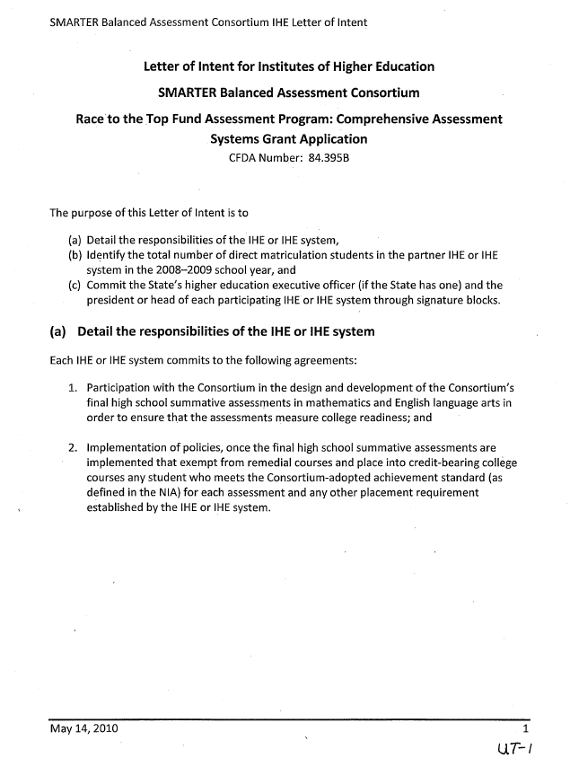

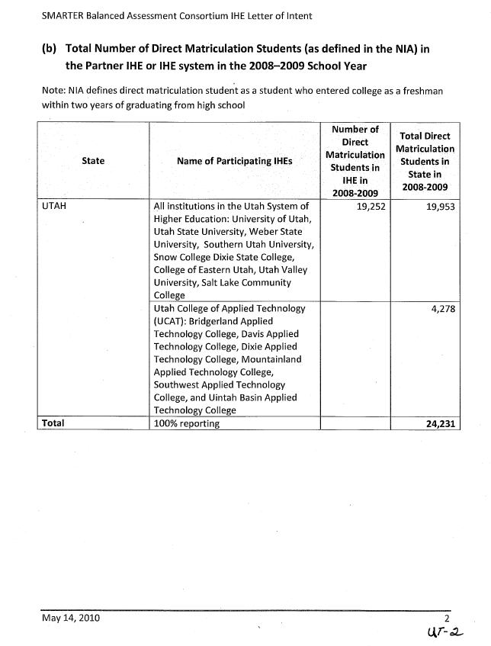

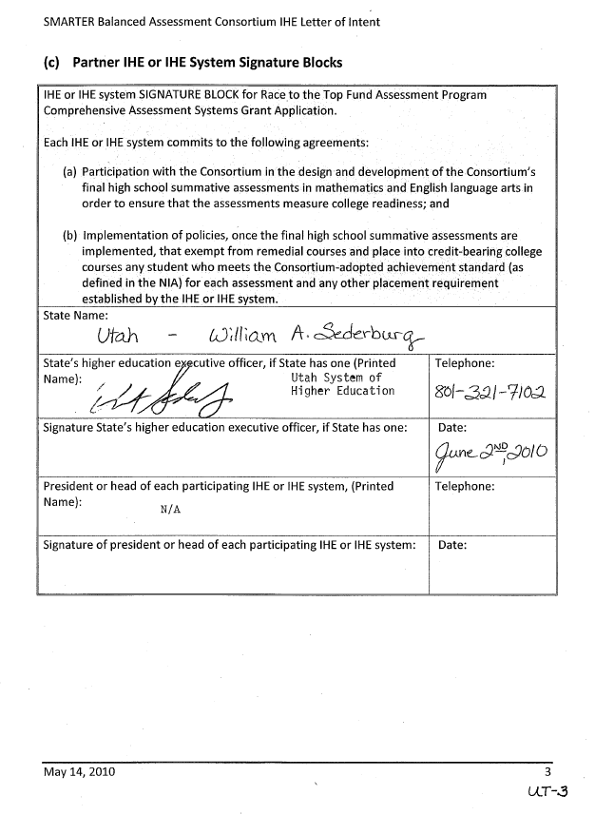

ATTACHMENT 7
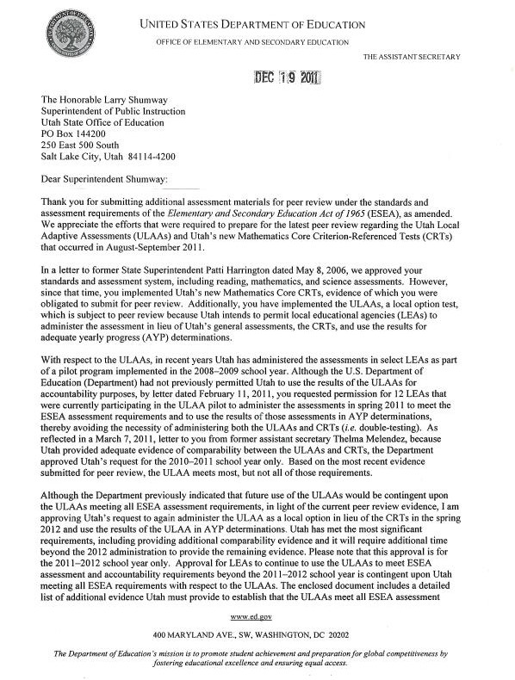

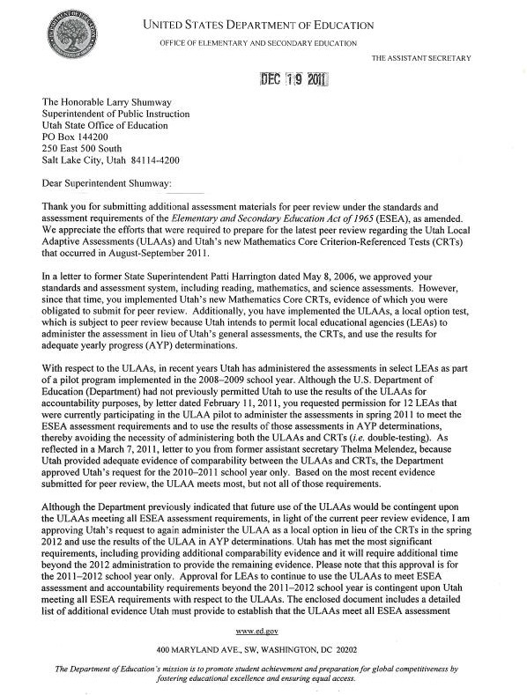

ATTACHMENT 8

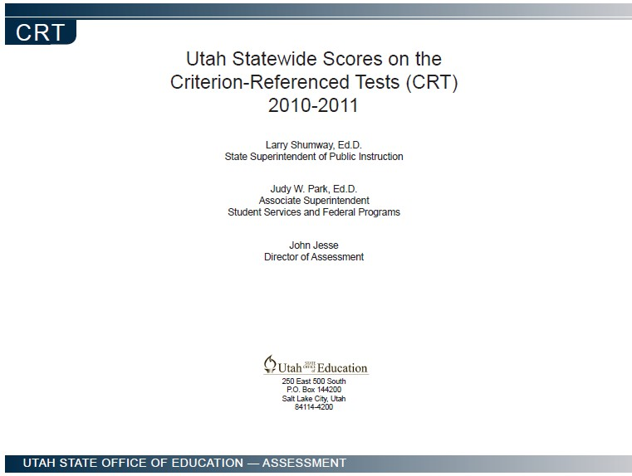

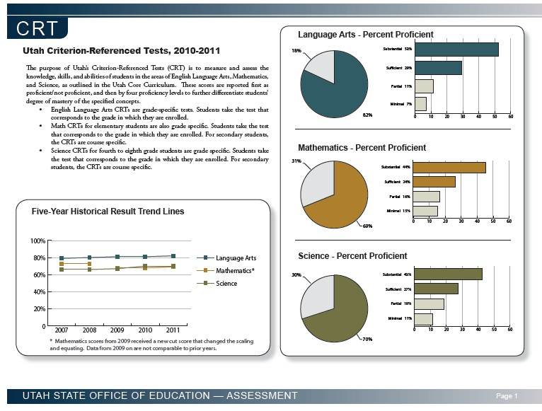

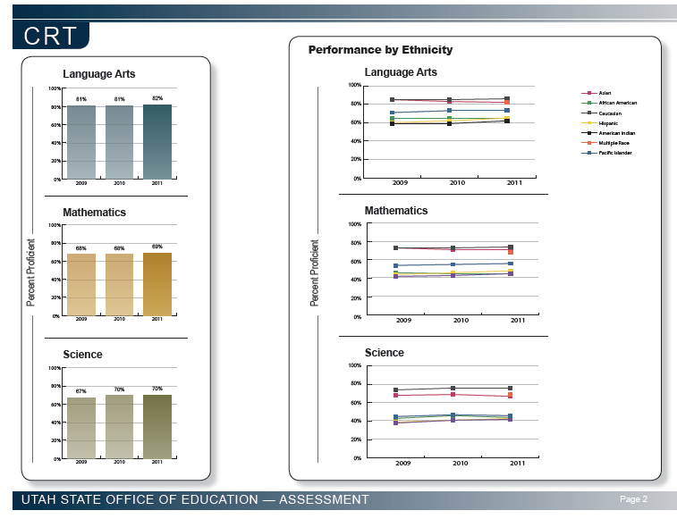

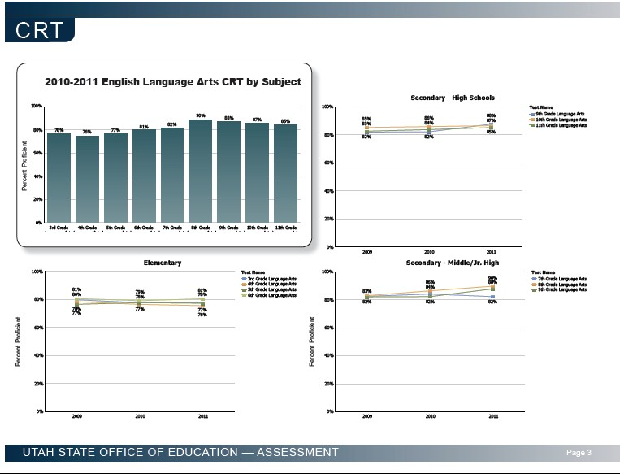

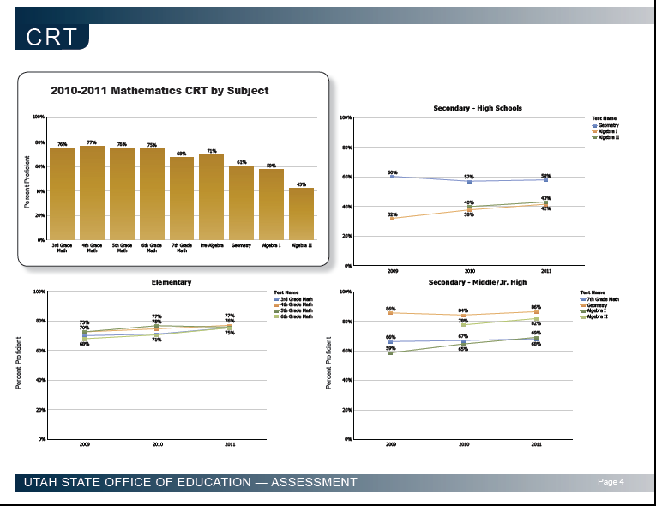

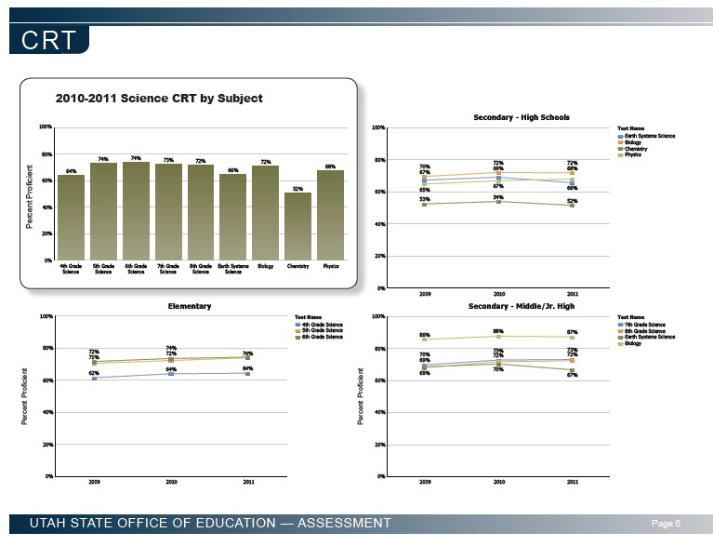

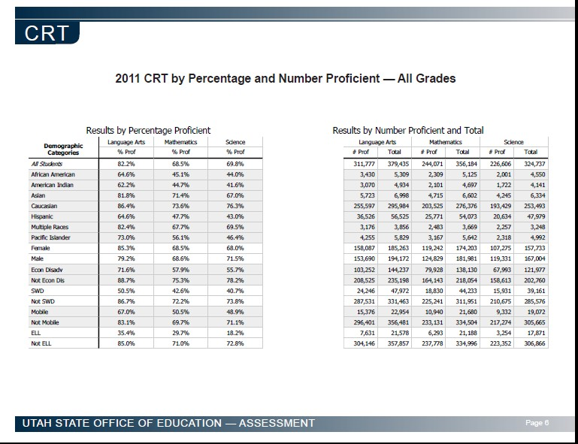

ATTACHMENT 9

Table 2: Reward, Priority, and Focus Schools

Provide the SEA’s list of reward, priority, and focus schools using the Table 2 template. Use the key to indicate the criteria used to identify a school as a reward, priority, or focus school.

LEA Name | School Name | School NCES ID # | REWARD SCHOOL | PRIORITY SCHOOL | FOCUS SCHOOL
Cache District | Park School | 490012000080 | A
Salt Lake Arts Academy | Salt Lake Arts Academy | 490001800905 | A
Nebo District | Goshen School | 490063000383 | A
Cache District | Lincoln School | 490012000077 | A
Soldier Hollow Charter | Soldier Hollow Charter School | 490001100587 | A
Logan City District | Bridger School | 490051001063 | A and B
Iron District | Three Peaks School | 490039001121 | A
Cache District | Nibley School | 490012000598 | A
Iron District | Enoch School | 490039000682 | A
Cache District | Summit School | 490012000085 | A
Garfield District | Escalante School | 490030000187 | A
Provo District | Provost School | 490081000461 | A
Beaver District | Milford School | 490006000039 | A
Providence Hall | Providence Hall | 490012401202 | A
Iron District | Cedar East School | 490039000279 | A
Alpine District | Central School | 490003000008 | A
Beaver District | Belknap School | 490006000037 | A
Wasatch District | J.R. Smith School | 490111000788 | A
San Juan District | Monticello High | 490090000535 | A
Emery District | Ferron School | 490027000181 | A
Beaver District | Minersville School | 490006000040 | A
Logan City District | Ellis School | 490051000348 | A
Morgan District | Morgan School | 490057000365 | A
San Juan District | Monticello School | 490090000536 | A

Cache District | Lewiston School | 490012000076 | A
Box Elder District | Garland School | 490009000053 | A and B
Cache District | Canyon School | 490012001064 | A
Garfield District | Panguitch School | 490030000189 | A
Channing Hall | Channing Hall | 490004001130 | A
Iron District | Escalante Valley School | 490039000283 | A
Piute District | Circleville School | 490078000448 | A
Carbon District | Bruin Point School | 490015001209 | A
Freedom Academy | Freedom Academy | 490006200992 | A
Carbon District | Sally Mauro School | 490015000097 | A
Iron District | Cedar North School | 490039000281 | A
Kane District | Kanab School | 490048000340 | A
Murray District | Liberty School | 490060000370 | B
Rich District | South Rich School | 490084000472 | B
South Summit District | South Summit School | 490099000558 | A and B
Washington District | Heritage School | 490114000606 | B
Davis District | Fremont School | 490021000121 | E
Granite District | Granger High School | 490036000218 | E
Ogden District | Dee School | 490072001283 | E
Ogden District | George Washington High | 490004601147 | E
Ogden District | James Madison School | 490072001287 | E
Ogden District | Odyssey School | 490072001273 | E
Ogden District | Ogden High School | 490072001271 | E
Salt Lake District | Edison School | 490087000487 | E
Salt Lake District | Glendale Middle | 490072001273 | E
Salt Lake District | Horizonte Learning Center | 490087000732 | E
Salt Lake District | Northwest Middle | 490087000512 | E
San Juan District | Bluff School | 490090000528 | E
San Juan District | Tse’bii’nidzisgai Elementary | 490090000533 | E
Tooele District | Wendover High School | 490105000577 | E
Uintah District | Eagle View Elementary | 490108001270 | E
Uintah River High School | Uintah River High School | 490001300671 | G-Grad

Utah Virtual Academy | Utah Virtual Academy | 490013001196 |  |  | G-Grad
Merit College Preparatory Academy | Merit College Preparatory Academy | 490013101220 |  |  | G-Grad
Rockwell Charter High School | Rockwell Charter High School | 490012501199 |  |  | G-Grad
City Academy | City Academy | 490000900742 |  |  | G-Grad
DaVinci Academy | DaVinci Academy | 490006500995 |  |  | G-Grad
Davis District | Vae View School | 490021000149 |  |  | G
Dual Immersion Academy | Dual Immersion Academy | 490007301187 |  |  | G
Gateway Preparatory Academy | Gateway Preparatory Academy | 490012201214 |  |  | G
Granite District | Granite Park Jr High | 490036000223 |  |  | G
Granite District | Lincoln School | 490036000238 |  |  | G
Granite District | Redwood School | 490036000255 |  |  | G
Granite District | Roosevelt School | 490036000259 |  |  | G
Granite District | Western Hills School | 490036000273 |  |  | G
Ogden City District | Gramercy School | 490072001286 |  |  | G
Ogden City District | Lincoln School | 490072001297 |  |  | G
Ogden City District | Mound Fort Jr High | 490072001297 |  |  | G
Ogden City District | Thomas O Smith School | 490072001274 |  |  | G
Ogden City District | Bonneville School | 490072001266 |  |  | G
Salt Lake District | Backman School | 490087000474 |  |  | G
Salt Lake District | Franklin School | 490087000490 |  |  | G
Salt Lake District | Lincoln School | 490087000666 |  |  | G
Salt Lake District | Meadowlark School | 490087000509 |  |  | G
Salt Lake District | Parkview School | 490087000514 |  |  | G
Salt Lake District | Rose Park School | 490087000516 |  |  | G
San Juan District | Montezuma Creek School | 490090000534 |  |  | G
San Juan District | Monument Valley High | 490090000802 |  |  | G
San Juan District | Whitehorse High | 490090000667 |  |  | G
Spectrum Academy | Spectrum Academy | 490004201137 |  |  | G

Total # of Reward Schools: 40

High Performing (only): 34 (12.4% of Title I schools) High Progress (only): 3 (1.1% of Title I schools)
High Performing & High Progress: 3 (1.1% of Title I schools) Total # of Priority Schools: 15 (5.5% of Title I schools)
Total # of Focus Schools: 28 (10.2% of Title I schools)
- Grad Rate=6
- Low Achievement=4
- Gap=9
- Low Achievement & Gap=9 Total # of Title I schools in the State: 275
Total # of Title I-participating high schools in the State with graduation rates less than 60%: 7

High School | Graduation Rate (2-yr Ave.) | Proposed Status
George Washington Alternative HS | 27.5% | Priority
Uintah River HS - Charter | 31.0% | Focus
Utah Virtual Academy - Charter | 32.0% | Focus
Merit College Preparatory Academy - Charter | 40.0% | Focus
Rockwell Charter HS - Charter | 49.0% | Focus
City Academy - Charter | 46.5% | Focus
DaVinci Academy - Charter | 59.0% | Focus

ATTACHMENT 10 & 11

R277. Education, Administration.
R277-530. Utah Effective Teaching and Educational Leadership Standards. R277-530-1. Definitions.
- "Board" means the Utah State Board of Education.
- "Local education agency (LEA)" means a Utah school district or charter school.
- "Promises to Keep" is the Board's statement of vision and mission for Utah's system of public education. Utah's public education system keeps its constitutional promise by ensuring literacy and numeracy for all Utah children, providing high quality instruction for all Utah children, establishing curriculum with high standards and relevance for all Utah children, and requiring effective assessment to inform high quality instruction and accountability.
- "School administrator" means an educator serving in a position that requires a Utah Educator License with an Administrative area of concentration and who supervises Level 2 educators.
- "Teacher" for purposes of this rule means an individual licensed under Section 53A-6-104 and who meets the requirements of R277-501.
- "USOE" means the Utah State Office of Education.

R277-530-2. Authority and Purpose.
- This rule is authorized under Utah Constitution Article X, Section 3 which vests general control and supervision over public education in the Board, by Sections 53A-1-402(1)(a)(i) and (ii) which require the Board to establish rules and minimum standards for the qualification and certification of educators and for required school administrative and supervisory services, and Section 53A-1-401(3) which allows the Board to make rules in accordance with its responsibilities.
- The purpose of this rule is to establish statewide effective teaching standards for Utah public education teachers and to establish statewide educational leadership standards for Utah public education administrators consistent with the Board's supervision of the public education system under Utah Constitution Article X, Section 3 and supports one pillar of the Board's Promises to Keep - high quality instruction for all Utah children.

R277-530-3. USOE Responsibilities for Effective Teaching and Educational Leadership Standards.
- The Board shall use the Effective Teaching Standards and Educational Leadership Standards as the foundation of educator development that includes alignment of teacher and school administrator preparation programs, expectations for licensure, and the screening, hiring, induction, and mentoring of beginning teachers and school administrators.
- The Board shall use the Effective Teaching Standards and Educational Leadership Standards to direct and ensure the implementation of the Utah Common Core Standards.
- The Board shall rely on the Effective Teaching Standards and Educational Leadership Standards as the basis for an evaluation system and tiered-licensing system.
- The Board shall develop a model educator assessment system for use by LEAs based on the Effective Teaching Standards and Educational Leadership Standards.
- The Board shall provide resources, including professional development, that assist LEAs in integrating the Effective Teaching Standards and Educational Leadership Standards into educator practices.

R277-530-4. LEA Responsibilities for Effective Teaching Standards and Educational Leadership Standards.
- LEAs shall develop policies to support teachers and school administrators in implementation of the Effective Teaching and Educational Leadership Standards.
- LEAs shall develop professional learning experiences and professional learning plans for relicensure using the Effective Teaching and Educational Leadership Standards to assess educator progress toward implementation of the standards.
- LEAs shall adopt formative and summative educator assessment systems based on the Effective Teaching and Educational Leadership Standards to facilitate educator growth toward expert practice.
- LEAs shall use the Effective Teaching and Educational Leadership Standards as a basis for the development of a collaborative professional culture to facilitate student learning.
- LEAs shall implement induction and mentoring activities for beginning teachers and school administrators that support implementation of the Effective Teaching Standards and Educational Leadership Standards.

R277-530-5. Effective Teaching Standards.
- The Board document, Promises to Keep, identifies the development and retention of teachers who have the skills and knowledge to provide effective, high quality instruction to all of Utah's students as one of four essential promises between the Board and the public education community. The Utah Effective Teaching Standards describe what effective teachers must know and be able to do to fulfill the Board's constitutional promise. The Effective Teaching Standards focus on the high-leverage concepts of personalized learning for diverse learners, a stronger focus on application of knowledge and skills, improved assessment literacy, a collaborative professional culture, and new leadership roles for teachers.
- Effective Teaching Standards - Utah teachers shall demonstrate the following skills and work functions designated in the following ten standards:
- Learner Development - A teacher understands cognitive, linguistic, social, emotional, and physical areas of student development.
- Learning Differences - A teacher understands individual learner differences and cultural and linguistic diversity.
- Learning Environments - A teacher works with learners to create environments that support individual and collaborative learning, encouraging positive social interaction, active engagement in learning, and self motivation.
- Content Knowledge - A teacher understands the central concepts, tools of inquiry, and structures of the discipline.
- Assessment - A teacher uses multiple methods of assessment to engage learners in their own growth, monitor learner progress, guide planning and instruction, and determine whether the outcomes described in content standards have been met.
- Instructional Planning - A teacher plans instruction to support students in meeting rigorous learning goals by drawing upon knowledge of content areas, core curriculum standards, instructional best practices, and the community context.
- Instructional Strategies - A teacher uses various instructional strategies to ensure that all learners develop a deep understanding of content areas and their connections, and build skills to apply and extend knowledge in meaningful ways.
- Reflection and Continuous Growth - A teacher is a reflective practitioner who uses evidence to continually evaluate and adapt practice to meet the needs of each learner.
- Leadership and Collaboration - A teacher is a leader who engages collaboratively with learners, families, colleagues, and community members to build a shared vision and supportive professional culture focused on student growth and success.
- Professional and Ethical Behavior - A teacher demonstrates the highest standards of legal, moral, and ethical conduct as specified in R277-515.

R277-530-6. Educational Leadership Standards.
- The Board document, Promises to Keep, expects that school administrators shall meet the standards of effective teaching and have the knowledge and skills to guide and supervise the work of teachers, lead the school learning community, and manage the school's learning environment in order to provide effective, high quality instruction to all of Utah's students. The Educational Leadership Standards focus on visionary leadership, advocacy for high levels of student learning, leading professional learning communities, and the facilitation of school and community collaboration.
- In addition to meeting the standards of an effective teacher, school administrators shall demonstrate the following traits, skills, and work functions designated in the following six standards:
- Visionary Leadership - A school administrator promotes the success of every student by facilitating the development, articulation, implementation, and stewardship of a vision of learning that is shared and supported by all stakeholders.
- Teaching and Learning - A school administrator promotes the success of every student by advocating, nurturing and sustaining a school focused on teaching and learning conducive to student, faculty, and staff growth.
- Management for Learning - A school administrator promotes the success of every student by ensuring management of the organization, operation, and resources for a safe, efficient, and effective learning environment.
- Community Collaboration - A school administrator promotes the success of every student by collaborating with faculty, staff, parents, and community members, responding to diverse community interests and needs and mobilizing community resources.
- Ethical Leadership - A school administrator promotes the success of every student by acting with, and ensuring a system of, integrity, fairness, equity, and ethical behavior.
- Systems Leadership - A school administrator promotes the success of every student by understanding, responding to, and influencing the interrelated systems of political, social, economic, legal, policy, and cultural contexts affecting education.

KEY: educators, effectiveness, leadership, standards
Date of Enactment or Last Substantive Amendment: October 11, 2011
Authorizing, and Implemented or Interpreted Law: Art X Sec 3; 53A-1-402(1)(a)(i); 53A-1-401(3)

R277. Education, Administration.
R277-531. Public Educator Evaluation Requirements (PEER). R277-531-1. Definitions.
- "Board" means the Utah State Board of Education.
- "Educator" means an individual licensed under Section 53A-6-104 and who meets the requirements of R277-501.
- "Formative evaluation" means evaluations that provide educators with feedback on how to improve their performance.
- "Instructional quality data" means data acquired through observation of educator's instructional practices.
- "Joint educator evaluation committee" means the local committee described under Section 53A- 10-103 that develops and assesses an LEA evaluation program.
- "LEA" means a local education agency directly responsible for the public education of Utah students, including traditional local school boards and school districts.
- "LEA Educator Evaluation Program" means an LEA's process, policies and procedures for evaluating educators' performance according to their various assignments; those policies and procedures shall align with R277-531.
- "School administrator" means an educator serving in a position that requires a Utah Educator License with an Administrative area of concentration and who supervises Level 2 educators.
- "Student growth score" means a measurement of a student's achievement towards educational goals in the course of a school year.
- "Summative evaluation" means evaluations that are used to make annual decisions or ratings of educator performance and may inform decisions on salary, confirmed employment, personnel assignments, transfers, or dismissals.
- "USOE" means the Utah State Office of Education.
- "Utah Consolidated Application (UCA)" means the web-based grants management tool employed by the Utah State Office of Education by which local education agencies submit plans and budgets for approval of the Utah State Office of Education.
- "Utah Effective Teaching Standards" means the teaching standards identified and adopted in R277-530.
- "Utah Educational Leadership Standards" means the standards for educational leadership identified and adopted in R277-530.
- "Valid and reliable measurement tool(s)" means an instrument that has proved consistent over time and uses non-subjective criteria that require minimal interpretation.

R277-531-2. Authority and Purpose.
- This rule is authorized under Utah Constitution Article X, Section 3 which vests general control and supervision over public education in the Board, by Sections 53A-1-402(1)(a)(i) and (ii) which require the Board to establish rules and minimum standards for the qualification and certification of educators and for required school administrative and supervisory services, and Section 53A-1-401(3) which allows the Board to make rules in accordance with its responsibilities.
- The purpose of this rule is to provide a statewide educator evaluation system framework that includes required Board directed expectations and components and additional LEA determined components and procedures to ensure the availability of data about educator effectiveness are available. The process shall focus on the improvement of high quality instruction and improved student achievement. Additionally, the process shall include common data that can be aggregated and disaggregated to inform Board and LEA decisions about retention, preparation, recruitment, improved professional development practices and ensure LEAs engage in a consistent process statewide of educator evaluation.

R277-531-3. Public Educator Evaluation Framework.
- The Board shall provide a framework that includes five general evaluation system areas and additional discretionary components of an LEA's educator evaluation system.
- Alignment with Board expectations and standards and required consistency of LEA policies with evaluation process:
- An LEA educator evaluation system shall be based on rigorous performance expectations aligned with R277-530.
- An LEA evaluation system shall establish and articulate performance expectations individually for all licensed LEA educators.
- An LEA evaluation system shall include valid and reliable measurement tools including, at a minimum:
- observations of instructional quality;
- evidence of student growth;
- parent and student input; and
- other indicators as determined by the LEA.
- An LEA evaluation system shall provide a summative yearly rating of educator performance using uniform statewide terminology and definitions. An LEA evaluation system shall include summative and formative components.
- An LEA evaluation system shall direct the revision or alignment of all related LEA policies, as necessary, to be consistent with the LEA Educator Evaluation System.
- Valid and reliable tools:
- An LEA evaluation system shall use valid, reliable and research-based measurement tool(s) for all educator evaluations. Such measurements:
  - employ a variety of measurement tools;
  - adopt differentiated methodologies for measuring student growth for educators in subject areas for which standardized tests are available and in subject areas for which standardized tests are not available;
  - provide evaluation for non-instructional licensed educators and administrators;
- shall provide for both formative and summative evaluation data;
- data gathered from tools may be considered by an LEA to inform decisions about employment and professional development.
- Discussion, collaboration and protection of confidentiality with educators regarding evaluation

process:

- An LEA evaluation system shall provide for clear and timely notice to educators of the

components, timelines and consequences of the evaluation process.
- An LEA evaluation system shall provide for timely discussion with evaluated educators to include professional growth plans as required in R277-501 and evaluation conferences.
- An LEA evaluation system shall protect personal data gathered in the evaluation process.
- Support for instructional improvement:
- An LEA evaluation system shall assess professional development needs of educators.
- An LEA evaluation system shall identify educators who do not meet expectations for instructional quality and provide support as appropriate at the LEA level which may include providing educators with mentors, coaches, specialists in effective instruction and setting timelines and benchmarks to assist educators toward greater improved instructional effectiveness and student achievement.
- Records and documentation of required educator evaluation information:
- An LEA evaluation system shall include the evaluation of all licensed educators at least once a

year.

- An LEA evaluation system shall provide at least an annual rating for each licensed educator,

including teachers, school administrators and other non-teaching licensed positions, using Board-directed statewide evaluation terminology and definitions.
- An LEA evaluation system shall provide for the evaluation of all provisional educators, as defined by the LEA under Section 53A-6-106, at least twice yearly.
- An LEA evaluation system shall include the following specific educator performance criteria:
  - instructional quality measures to be determined by the LEA;
  - student growth score to be completely phased in by July 1, 2015; and
  - other measures as determined by the LEA including data gathered from student/parent input.
- the Board shall determine weightings for specific educator performance criteria to be used in the LEA's evaluation system.
- An LEA evaluation system shall include a plan for recognizing educators who demonstrate exemplary professional effectiveness, at least in part, by student achievement.
- An LEA evaluation system shall identify potential employment consequences, including discipline and termination, if an educator fails to meet performance expectations.
- An LEA evaluation system shall include a review or appeals process for an educator to challenge the conclusions of a summative evaluation that provides for adequate and timely due process for the educator consistent with Section 53A-10-106.5.
- An LEA may include additional components in an evaluation system.
- A local board of education shall review and approve an LEA's proposed evaluation system in an open meeting prior to the local board's submission to the Board for review and approval.

R277-531-4. Board Support and Monitoring of LEA Evaluation Systems.
- The Board shall establish a state evaluation advisory committee to provide ongoing review and support for LEAs as they develop and implement evaluation systems consistent with the law and this Rule. The Committee shall:
- analyze LEA evaluation data for purposes of:
  - reporting;
  - assessing instructional improvement; and
  - assessing student achievement.

- review required Board evaluation components regularly and evaluate their usefulness in providing a consistent statewide framework for educator evaluation, instructional improvement and commensurate student achievement;
- review LEA educator evaluation plans for alignment with Board requirements.
- The USOE, under supervision of the Board, shall develop a model educator evaluation system that includes performance expectations consistent with this rule.
- The USOE shall evaluate and recommend tools and measures for use by LEAs as they develop and initiate their local educator evaluation systems.
- The USOE shall provide professional development and technical support to LEAs to assist in evaluation procedures and to improve educators' ability to make valid and reliable evaluation judgments.

R277-531-5. Implementation.
- Each LEA shall have an educator evaluation committee in place by October 2011.
- Each LEA shall design the required evaluation program, including pilot programs as desired.
- Each LEA shall continue to report educator effectiveness data to the USOE in the UCA.
- Implementation shall be in place for the 2013-2014 school year.
- Board directed student growth measures shall be implemented as part of the LEA evaluation system by the 2014-2015 school year.

KEY: educator, evaluation, requirements
Date of Enactment or Last Substantive Amendment: November 8, 2011
Authorizing, and Implemented or Interpreted Law: Art X Sec 3; 53A-1-402(1)(a)(i); 53A-1-401(3)
ATTACHMENT 12

Development and Implementation Timeline for Utah College and Career Readiness Student Standards

- June 2009 – The Utah Board of Education adopted the mission and vision statement of Promises to Keep as a driving document for education reform. Included in this document are the four pillars of success which include a laser focus on literacy, mathematics, high quality instruction, curriculum and accompanying assessments based on rigor and relevance.
- June 2009 – State Board committees engaged staff to look at the CCSS as a driver for the pillars found in Promises to Keep.
- June 2009 - Race to the Top application process included examining the CCSS as a lever for change. Utah State Office of Education employees provided awareness training and held focus groups throughout the state to discuss the Board’s intent to adopt the standards. Parents, business leaders, local boards of education, Utah Education Association leadership, teachers, administrators, district and charter leadership, legislative leaders, civic groups, and community members at large were engaged in the discussion. Feedback was supportive and positive about the standards with the only angst coming from political factions who were concerned about the national perspective. This political rhetoric died down over time as the business community stood behind the standards as a matter of economic improvement.
- June 2010 – Joint document developed by Utah State Board of Education and Utah Board of Regents supporting college and career readiness standards. The document outlines high school coursework critical for college readiness as well as the types of skills needed to be successful in college and careers. The following principles of college and career readiness are addressed in detail: build an academic foundation, develop intellectual and career capacity, evaluate progress for college, and explore postsecondary options.
- January 2011 – Professional development for implementation of CCSS began. Over 120 highly effective mathematics and English language arts educators were identified by LEA school leaders. These educators began the process of learning about the CCSS in their respective areas in depth and engaged in adult learning theory. This approach was used to develop a core of CCSS facilitators in preparation for summer Utah Core Academy.
- Summer 2011 – Round one of Utah Core Academy was implemented, serving over 5,000 educators, (including administrators) in fourteen locations around the state. The weeklong academies provided participants with hands on experience in using the college and career student performance standards. Participants received information and sample lessons illustrating how students can meet the linguistic demands found in the English language Acquisition Standards (WIDA). Attendees included both general and special education teachers. They were identified by their school system leaders as teachers who would go back in implement the CCSS with fidelity in their classrooms. LEA Special Education Directors were involved in the educator selection process to ensure that key special education personnel received the same professional development as general education teachers, which allows for ongoing collaboration and dialogue between school personnel to address the individual needs of students, while still maintaining the expectation that all students receive CCSS instruction.
- Fall 2011 to Present – Professional learning support continued to be provided for Utah Core Facilitators and Academy participants to deepen their learning together in online- and face-to-face formats.
- October 2011 – Utah was chosen as one of five Learning Forward Critical Friends to support Kentucky in their implementation efforts of the CCSS. Utah’s role is to provide input and insight into implementation efforts.
- Membership in ICCSS – Utah elected to participate in a consortium of states implementing new college and career ready standards. Our six member team includes representation from Title I,
Special Education, Educator Quality, Teaching and Learning and Assessment. Team attends summits, online forums, and has access to research and state implementation ideas.
- December 2011 – Utah partnered with ASCD to provide a CCSS Implementation Summit to ensure school systems are prepared to support and guide implementation efforts. The intended outcome was to create gradual release from state ownership of implementation to successful LEA implementation.

ATTACHMENT 13

Timeline for Stakeholder Input on Educator Evaluation Development and Implementation Efforts

The following timeline outlines formal actions involving teacher associations and various educator stakeholders to develop and implement teacher and leader improvement efforts:

- March 2009 – revision to Utah state statute [53A-10-106] on teacher evaluation included working with UEA to update language and add student achievement as one of the multiple measures required in teacher evaluation.
- July 2010 – Utah joined with Arkansas, Kansas, Missouri, South Dakota, and West Virginia to develop strategies to recruit, prepare and support educators throughout the continuum of their careers. Representatives from all state teacher associations and teacher preparation programs attended meetings to provide input and give feedback on products and projects. Educational Testing Services (ETS) and Learning Forward served as education partners in the process.
- September 2010 (ongoing) – The Education Excellence Committee sponsored by UEA (representatives from United Way, PTA, Children First, USOE, IHEs) included the USOE to provide a united front at the legislature regarding educator quality issues. The Committee was able to combat ineffective policy proposals that would have been barriers to improving educator effectiveness. The Committee supported legislation on performance pay pilots and adoption of the CCSS in Board rule as well as presentations to Education Interim Committee on 2011 Educator Effectiveness Project.
- 2010 Preparation efforts for the Race to the Top Competition included teacher association representatives on development committees. The targets focused on educator effectiveness described in the R2T application included projects targeted at instructional improvement, performance pay, effective teacher evaluation, and improving working conditions for teachers.
- Spring 2011 – Educator Effectiveness Advisory Committee was established in response to the Board initiative of improving instruction in Utah public schools. The committee developed the framework for the Educator Effectiveness Project that includes revamping educator evaluation, teacher and leader preparation, teacher and leader standards, recruitment and retention policies, and professional development standards. Committee members also gave input to policy development and are currently serving on various educator effectiveness work groups. These workgroups are Utah Effective Teaching Standards, Utah Leadership Standards, Measuring Student Growth, Instructional Observation Tools, High Quality Professional Learning, and Stakeholder Input.
- January 2011 to Present – Formal presentation and conversations with focus groups around the state (school boards, teacher associations, superintendents, parents, business community stakeholders, legislative committees, special education directors, principal associations, Utah Legislative Education Interim Committee, Utah Chamber of Commerce, and Board of Regents) continue to be held to refine the processes of educator evaluation and contextualize the needs and concerns of educators.
- June 2011 – Membership in the State Coalition for Educator Effectiveness (SCEE) includes representation from various departments at USOE. UEA leadership is often invited to participate in SCEE conferences, webinars and meetings involving educator evaluation.
- August 2011 – New Teacher and Leader standards adopted in Board rule R277-530. These standards are focused on meeting needs of diverse learners and ensuring ALL students are college and career ready. These standards will be used as the basis for all educator evaluation systems as outlined in the Framework. Utah’s ten teacher preparation institutions are using these new standards to prepare and support teacher candidates. LEAs are using the standards to support new teachers and develop professional growth plans for all educators in their systems.
- September 2011 – Adoption of Educator Evaluation Framework by the Utah State Board of Education (R277-531), with opportunities for public comment and input. The UEA made public comment in support of the Framework and expressed appreciation to the Board for their inclusion in
the development and policy adoption process. Based on an earlier request from the UEA, the Board changed wording in Board rule R277-531 mandating how records will be kept by the USOE due to concerns about potential posting of individual teacher rankings in media
- September 2011 – Partnered with West Ed/Southwest Comprehensive Center to hold Educator Effectiveness Summit providing information and direction for district teams to align local educator evaluation programs with Board required framework components. Teams from all 41 districts and several charters attended. Each team consisted of a local teacher association leader, superintendent (or designee) and educator evaluation chair. Participants learned about latest educator evaluation research and trends related to Utah’s framework requirement from Laura Goe (ETS), Andrea Rorrer (Utah Policy Center), and other local experts. Feedback from the event was extremely positive. A follow-up summit is planned for April.
- October 2011 – Deadline for ensuring all districts have Educator Evaluation Committee in place to review current LEA practices and begin the process of aligning their practices with requirements in R277-531.

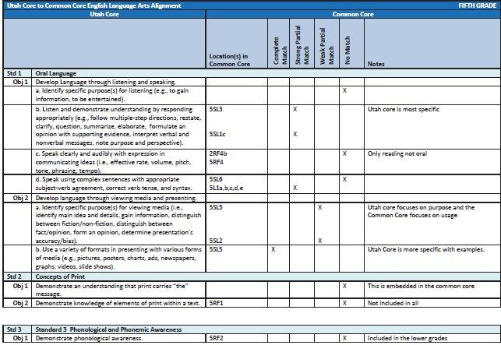
ATTACHMENT 14

137

ATTACHMENT 15
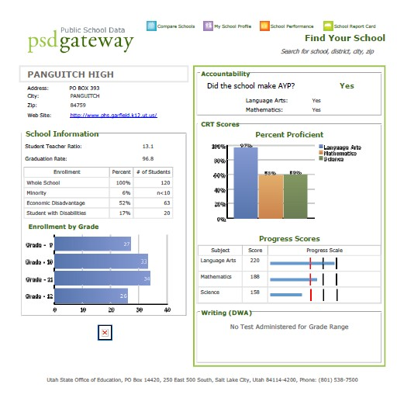

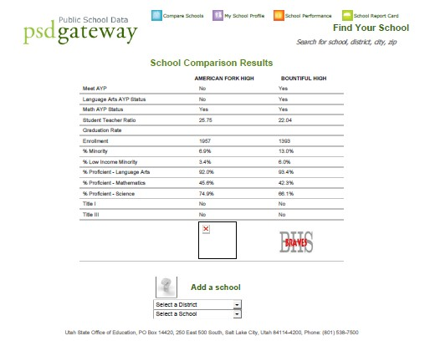

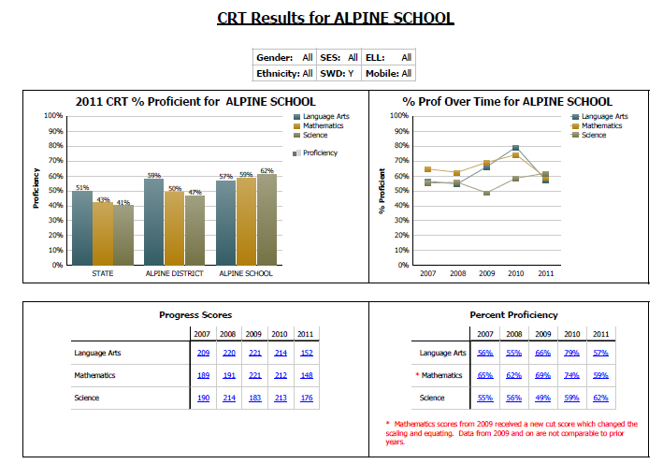

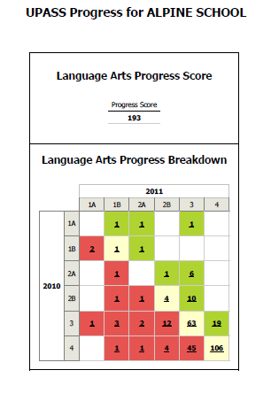

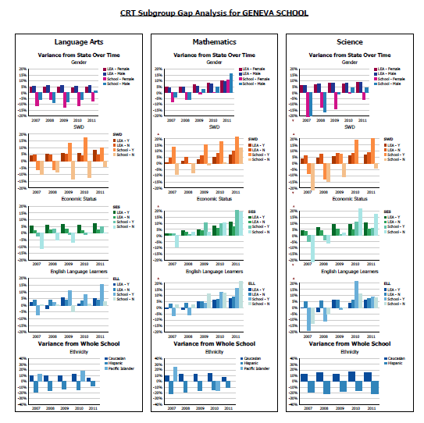

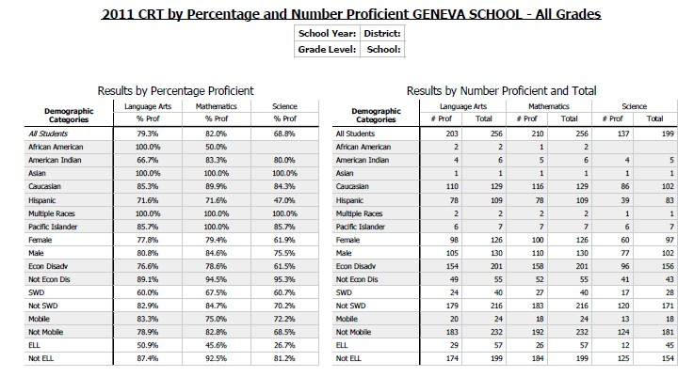

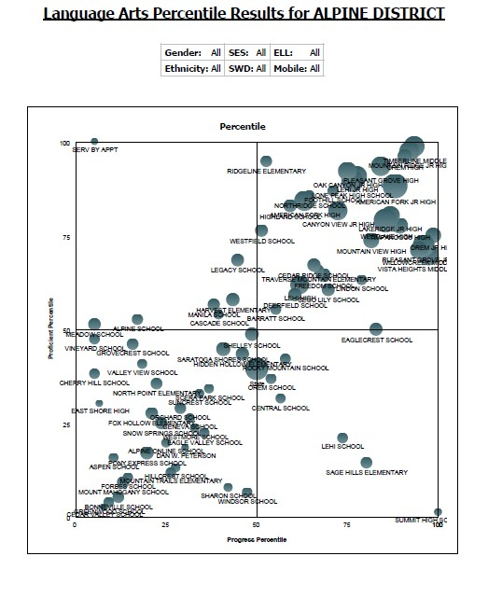

ATTACHMENT 16

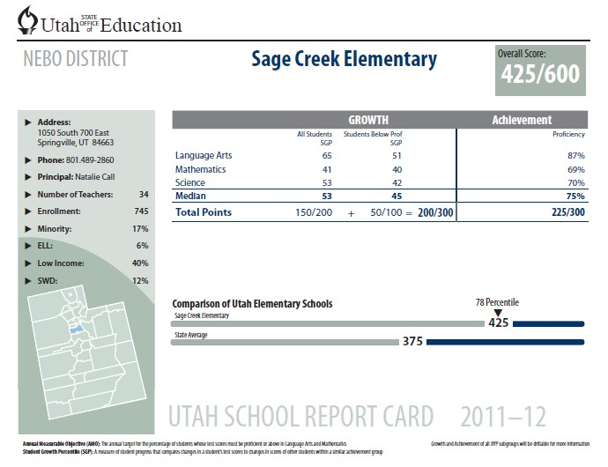

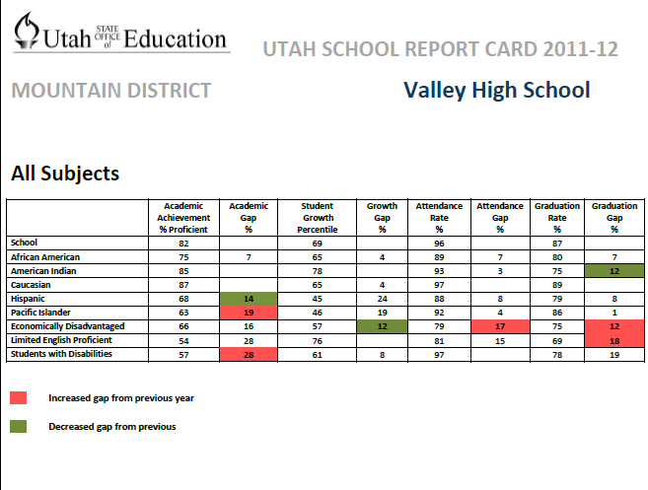

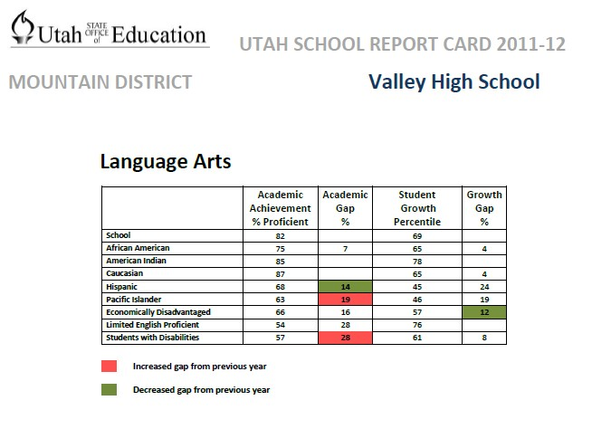

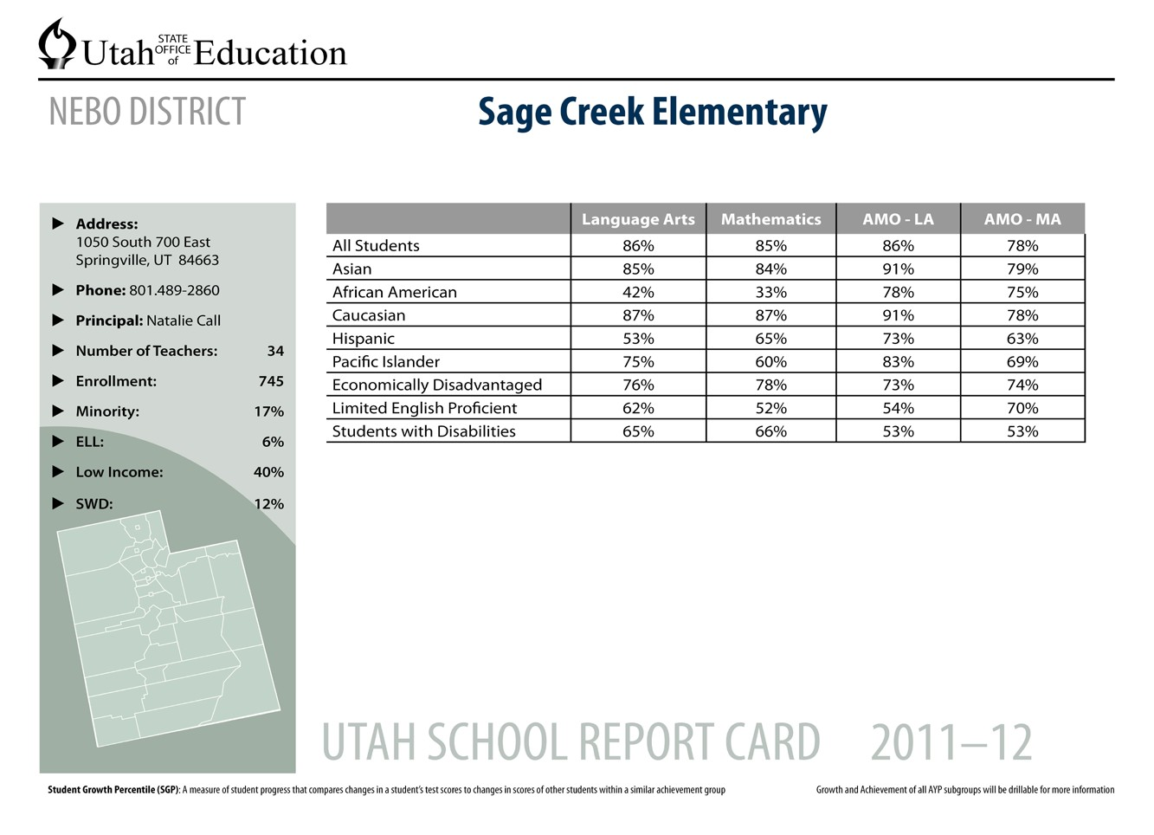

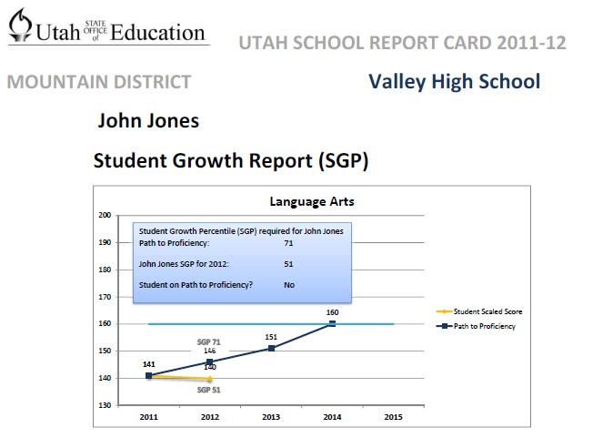
ATTACHMENT 17

The following chart is a summary of the major components included in Board Rule R277-531- PEER and corresponding elements required of USOE and LEAs to comply with evaluation components:

Role of USOE | LEA Requirements and Expectations
Standards and Expectations – Apply the Utah Educational Leadership Standards and Utah Effective Teaching Standards to educator evaluations and other Educator Effectiveness policies | - Align local educator evaluation processes with R277-530 Utah Effective Teaching Standards and the Utah Educational Leadership Standards  - Develop educator evaluation system aligned with PEER, or adopt USOE developed model, Align all related LEA policies and procedures as necessary to be consistent with LEA evaluation system and R277-531
Quality Assurance – Provide quality assurance to all educators by establishing valid and fair purposes and processes for evaluation systems | - Ensure that evaluation measurement tools are valid and reliable  - Ensure that educator evaluation data produced as part of the educator evaluation process are used for both formative and summative purposes  - Adopt differentiated methodology for measuring student growth for educators in tested and non-tested subject areas  - Evaluate non-instructional licensed educators and administrators  - Protect personal data gathered in the educator evaluation process and ensure confidentiality  - Identify all educators who do not meet expectations for educator quality and provide them with intensive support designed to improve educator performance When needed, jointly develop an educator improvement plan to clearly define objectives, benchmarks, and timelines to continually improve performance to acceptable levels and to reach professional learning goals  - Identify potential employment consequences if an educator fails to meet performance expectations  - Provide an appeal process for summative evaluations
Evaluation Process – Establish an evaluation process that assures fair, accurate, and consistent measurement of educator | - Ensure alignment of adopted performance expectations and instruments with R277- 530 Utah Effective Teaching Standards and

performance | Utah Educational Leadership Standards  - Evaluate career educators at least once per year, and provisional educators twice per year  - Initiate an ongoing Joint Educator Evaluation Committee in each LEA to develop and assess the LEA evaluation system  - Provide appropriate support, training, and communication in writing about the purpose, criteria, instruments, procedures, and expectations for acceptable levels of performance  - Ensure that the evaluation process is transparent to all stakeholders  - Ensure the validity of educator evaluation decisions  - Adhere to timeframes for reporting educator evaluation data
Professional Growth and Learning - Emphasize the professional growth and continuous improvement of educators’ professional practice to enhance student performance | - Use a variety of tools for formative measurements of educators’ performance in order to assist with professional growth goals  - Ensure that detailed feedback on performance and recommendations for professional growth is both timely and included in evaluation conferences  - Provide recognition of educators who demonstrate exemplary professional effectiveness and enhanced student achievement
Multiple Rating Levels and Measures – Establish multiple ratings on a summative evaluation rating instrument, and use multiple measures to formulate an educator’s performance level, (i.e. ineffective, effective, highly effective) | - Adopt recommended summative rating terminology to contribute to statewide alignment and equity  - Incorporate appropriate evaluation measurement tools, including at a minimum, observations of educator’s practice, evidence of student growth measures, parent and student input, and demonstration of professional practices and responsibilities

ATTACHMENT 18

Stakeholder Committee Participants Coalition of Minorities Advisory Committee
Group Representing: | Name: | Current Position:
AFRICAN-AMERICAN REPS: | Cooper, Freddie  * Chair-Elect  *Executive Committee | Retired Educator
 | Howell Ross, Sharon Darlene | Office Manager
 | Spencer, Isaiah “Ike”  * Current Chair  *Executive Committee | Principal, West Lake Jr. High School Granite School District
AMERICAN INDIAN REPS: | Groves, Eugenia | Student Support, Alpine School District
 | Vacant
 | Windchief, Sweeney | Graduate Student, University of Utah
ASIAN REPS: | Irwin, Jean Tokuda | Arts Education, Utah Division of Arts and Museums (UDAM)
 | Misaka, Jeanette  *Executive Committee | Retired Educator
 | Santos-Mattingley, Aida | Retired Librarian
HISPANIC/LATINO REPS: | Corsino-Moore, Debbie | Director of Multicultural Initiatives, Salt Lake Community College
 | Mendiola, Hector | Program Leader for Latino Communities, Utah State University, Logan
 | Vacant
PACIFIC-ISLANDER REPS: | Lui, Charlene  *Past CMAC Chair  *Executive Committee | Director of Educational Equity, Granite School District
 | Palu, ‘Afa | PhD Candidate  Advanced Research, Scientist/ Molecular Biologist  Noni Research Center, Morinda, Inc.
 | Stroud, Soulee L.K.O. | Owner of Stroud Jewelry, Salt Lake City, Utah

Committee of Practitioners
Name | Role
Robert Averett | Granite District Title I Schools Director
Brenda Bates | Salt Lake District Secondary Teacher
Rita Brock | Utah State Office of Education Title III
Kim Dohrer | Academica West Charter School Representative
Rebecca Donaldson | Utah State Office of Education Title Improvement Specialist
Janet Gibbs | Utah State Office of Education Special Education
Sandra Grant | Utah State Office of Education Title I Monitoring
Louise Herman | Our Lady of Lourdes Catholic School Private School Representative
John Jesse | Utah State Office of Education Assessment and Accountability Director
Mary Kay Kirkland | Box Elder District Curriculum Director
Max Lang | Utah State Office of Education Migrant Education
Lorna Larsen | Weber District Special Education Director
Charlene Lui | Coalition of Minorities Advisory Committee (CMAC)
Murray Meszaros | Utah State Office of Education Neglected or Delinquent
Aleida Ramirez | Granite District Parent
Barbara Smith | State Parent Information and Resource Centers (PIRC) Parent Representative
Ann White | Utah State Office of Education Title I Improvement Coordinator
Karl Wilson | Utah State Office of Education Title I Director

Comprehensive Accountability System Advisory Committee
Name | Representing
Julie Adamic | John Hancock Charter Schools
Rob Averett | Title I Director, Granite District
Marlies Burns | State Charter Schools Director
Dave Crandall | State School Board
Robert Cox | Special Education Director, Carbon District
Dawn Davies | Legislative Vice President, Utah Parent Teacher Association
Anthony Done | Assessment Director, San Juan District
Jeremiah Fierro | Special Education Teacher, South Summit District
Glenna Gallo | State Special Education/IDEA Director
Marshal Garrett | Superintendent, Logan District
Donald Hill | Superintendent, South Sanpete District
John Jesse | State Assessment and Accountability Director
Robert Johnson | Superintendent, Kane District
Sara Jones | Utah Education Association
Chris Kearl | Governor’s Deputy to Education
Mary Kay Kirkland | Curriculum Director, Box Elder District
Randy Merrill | Superintendent, Provo District
Ann Miller | Special Education Director, Weber District
Rick Nielsen | Superintendent, Nebo District
Bruce Northcott | Superintendent, Daggett District
Steve Norton | Superintendent, Cache District
Linda Oda | State Title III Coordinator
Judy Park | State Associate Superintendent
Randy Richardson | Education Equity Coordinator, Washington District
Lisa Robinson | Educational Support Coordinator, Jordan District
Susie Scherer | The Ranches Charter School

David H Smith | Assessment Director, Alpine District
Connie Steffen | Legislative Analyst
Logan Toone | Assessment Director, Davis District
Deon Turley | Education Commissioner, Utah Parent Teacher Association
Karl Wilson | State ESEA Director
Jerry Winkler | State Information Technology Director
McKell Withers | Superintendent, Salt Lake District
Doug Wright | Superintendent, San Juan District

Title VII Coordinators and Tribal Leaders 2011-2012
Name | Title
Clayton Long | Title VII Coordinator for San Juan School District
Eugenia Groves | Title VII Coordinator for Alpine School District
Eileen Quintana | Title VII Coordinator for Nebo School District
Jennifer Leo | Title VII Coordinator for Murray School District
Karma Grayman | Title VII Coordinator for Washington School District
Linda Ocana | Title VII Coordinator for Davis School District
Lucille Montano | Title VII Coordinator for Ogden School District
Nizhone Meza | Title VII Coordinator for South Summit School District
Patrick McGee | Title VII Coordinator for Jordan School District
Sophie Adison | Title VII Coordinator for Sevier School District
Rae Garcia | Title VII Coordinator for Tooele School District
Julie Smith | Title VII Coordinator for Iron School District/Director of Piute Education
Kris Hart | Title VII Coordinator for Cache School District
Sheila Lukenbill | Title VII Coordinator for Cache School District
Ed Napia | Indian Walk in Center Administrator
Janet Canyon | Title VII Coordinator for Salt Lake City School District
Analis Ruiz | Title VII Coordinator for Canyons School District
Bernice Tsinnijinnie | Title VII Coordinator for Iron School District
Lorriane Beaumont | Title VII Coordinator for Provo School District
Edie Park | Title VII Coordinator for Canyons School District
Monica Thacker | Title VII Coordinator for Jordan School District
Gwen Cantsee | Ute Mountain Tribe Education Director
Hayne Atcitly | Ute Mountain Tribe Assistant Education Director
Eldon McMurray | Utah Valley University Multicultural Department
Kevin Bell | University of Utah American Indian Programs
Tim Peters | Title VII Coordinator for Ogden School District
Antonio Arce | Ute Education Director
Cathy Bledsoe | Title VII Coordinator Provo School district
Cara Shonie | Title VII Coordinator Grand School district
Curleen Pfeiffer | Title VII Coordinator Granite School District
Gloria Thompson | Title VII Coordinator for Duchesne School District
Joyce Guenon | Title VII Coordinator for Canyons School District
Lori Anne Williams | Indian Walk in Center Administrator
Paula Toledo | Title VII Coordinator for Cache School District
Penelope Pincesoose | Indian Walk in Center Administrator
Robert Stearmer | Title VII Coordinator Uintah School District
Veveca Starks | Title VII Coordinator for Granite School District
Keakaoklani Hanamaikai | Utah Valley University, Multicultural Center

Tony Flores | Utah State University, Diversity Programs
Denise Bochard | Tribal Chair for Piute Indian Tribe
Ed Navarjo | Education Director for Goshute Tribe
Dr. Chuck Foster | USOE American Indian Education Specialist

Utah Policy Advisory Committee
Name | Title
Bruce Northcott | Superintendent, Daggett School District
Chris Domaleski | Senior Associate, NCIEA
Connie Steffen | Legislative Analyst, Utah State Government
Dale Lamborn | Superintendent, Rich School District
Deon Turley | Education Commissioner, Utah Parent Teacher Association
Don Hill | Superintendent, South Sanpete School District
Doug Wright | Superintendent, San Juan School District
Duke Mossman | Executive Director, Northeaster UT Educational Services
Gaye Gibbs | Dir. Of Instructional Improvement/Title 1, Provo City School District
Jerry Winkler | State Information Technology Manager
John Brandt | State Information Technology Director
John Jesse | State Assessment & Accountability Director
Judy Park | State Associate Superintendent
Julie Quinn | State Assessment Coordinator
Karl Wilson | State ESEA Director
Kevin King | State Assessment Coordinator
Kodey Hughes | Superintendent, Tintic School District
Logan Toone | Assessment Director, Davis School District
Marshal Garrett | Superintendent, Logan School District
McKell Withers | Superintendent, Salt Lake School District
Myron Mickelsen | Superintendent, Sevier School District
Randy Merrill | Superintendent, Provo City School District
Ray Terry | Superintendent, Beaver County School District
Ray Timothy | Superintendent, Park City School District
Rick Nielsen | Superintendent, Nebo School District
Robert Johnson | Professor, University of Utah Department of Educational Leadership & Policy
Sara Jones | Director of Educational Excellence, Utah Education Association
Scott Marion | Associate Director, NCIEA
Scott Zellmer | Principal, Weber School District
Steve Norton | Superintendent, Cache School District
Terry Shoemaker | Superintendent, Wasatch School District
Wendy Carver | State Special Education Assessment Specialist Office of Education

Utah Technology Advisory Committee
Name | Title
Chris Domaleski | Senior Associate, NCIEA
Derek Briggs | Research & Evaluation Methodology Program, University of Colorado, Boulder
Dona Carling | Director of Client Services, Measured Progress
Jerry Winkler | State Information Technology Manager
Jim Olsen | Psychometric Accreditation Certification, Alpine Testing Solutions
John Brandt | State Information Technology Director
John Jesse | State Director of Assessment & Accountability
Judy Park | State Associate Superintendent
Kevin King | State Assessment Coordinator
Kristin Campbell | State Data & Statistics Analyst
Randy Raphael | Senior Research Associate, Univeristy of Utah Education Policy Center
Richard Hill | Board of Trustees, Chair, NCIEA
Richard Sudweeks | Program Director, BYU, Education Inquiry, Measurement & Evaluation
Scott Marion | Associate Director, NCIEA
Stanley Rabinowitz | Director, Assessment & Standards Development, WestEd
Wendy Carver | State Special Education Assessment Specialist

ATTACHMENT 19

DETAILED EXPLANATION OF UTAH’ S COMPREHENSIVE ACCOUNTABILITY SYSTEM
In this section, we present the work done to date to define the specific computational procedures. While the procedures are not expected to change significantly, the state continues to evaluate the model and various business rules to refine the process in preparation for implementation in the spring 2012. It is possible that some of the procedures described below will be changed in that process.

Points are computed for each indicator and these points are used to determine a final score for each school. Points will be rounded to the next whole number. For example, an Achievement score of 124.5 points will be rounded to 125 points.

Achievement/Status
The calculation rules for all metrics under Achievement are presented below.

CRT Status | Inclusion | - A CRT score for a specific test may ONLY count the first time the student participates in that specific assessment EXCEPT for students participating in UAA.  - A student participating in more than one CRT in a given content area may have multiple scores counted as long as rule #1 above is not violated.
CRT Status | Math CRT | The number of students scoring at Level 3 or 4 on any math CRT (and UAA) DIVIDED by the number of validated warehouse students enrolled for a full academic year (160 days) with math CRT scores
CRT Status | ELA CRT | Number of students in grades scoring at Level 3 & 4 on the ELA CRTs (and UAA) DIVIDED by the number of validated warehouse students enrolled for a full academic year (160 days) with ELA CRT scores.
CRT Status | Science CRT | Number of students scoring at Level 3 & 4 on any science CRT (and UAA) DIVIDED by the number of validated warehouse students enrolled for a full academic year with science CRT scores.
DWA Status (for elementary and middle schools only) | DWA in grades 5 and  8 only | Number of students scoring at proficient level (no UAA available) DIVIDED by the number of validated warehouse students enrolled for a full academic year with DWA scores.
Graduation Rate (High Schools only) | Graduation Rate | Same cohort based calculation used for AYP

Calculating Achievement Points in Elementary and Middle Schools
For elementary and middle schools, CRT proficiency on ELA, Math, Science, and the DWA are the only sub-indicators evaluated under Achievement. A total of 300 points is attributed to CRT proficiency in elementary and middle schools. All achievement is calculated or aggregated across grades. That is, information is reported at the school level and not disaggregated by grade level for accountability purposes.

Additional Considerations for Calculating Proficiency
For schools administering the DWA in grades 4 and 8, an additional step is taken to calculate the achievement score:
  - The DWA is given the weight of half of one CRT.
  - Calculating the weight of the DWA relative to the CRT tests entails multiplying the points for each CRT by 28.6% and the points of each DWA by 14.3%.
  - This calculation ensures that each of the CRT subjects is weighted equally and the total weight given to the DWA test is the equivalent of half the weight of one CRT test.
  - The sum of the weights across all content areas is calculated to establish the lower thresholds for each grade on Achievement

The following outlines the steps for re-distributing the weights for schools with one or more missing sub- indicators.

- The school has data available for 1 CRT and the DWA.
If a school has only 1 CRT available, the points of that CRT is multiplied by the weight of 3 CRTs.

Example 1: A school does not meet the minimum n for reporting math and science scores and only has ELA and DWA available for evaluating achievement.
  - The school has a proficiency score of 75% on the ELA test and a proficiency score of 90% on the DWA.
  - For this school:
- ELA = 300 x .75 or 225
- DWA = 300 x .9 or 270
  - The weighted achievement score for ELA = 225 x .857 (.857 reflects the total weight dedicated to all CRTs.)
  - The weighted score for the DWA = 270 x .143 (the weight of one half of one CRT.) The achievement score earned by this school is equal to 231.

- A school has data for 2 CRT content areas and the DWA.
If a school has only 2 CRTs available, the points of each CRT is multiplied by .4286. The same process for calculating the points for schools with only 1 CRT applies, but in this case, the points for each CRT is multiplied by .4286. This value represents half of the entire weight attributed to all 3 CRTs (.8571).

Example 2: A school has ELA, Math, and DWA scores, but does not have science scores.
  - The school has proficiency score of 60% on Math, 70% on ELA and 55% on the DWA.
- Math = 300 x .6 or 180
- ELA = 300 x .7 or 210
- DWA = 300 x .55 or 165
  - Translating the above points to weighted points is as follows:
    - Math = 180 x .4286 or 77.1 points
    - ELA = 210 x .4286 or 90 points
- DWA = 165 x .1429 or 23.6 points

In this example, the school would earn a total of 190.7 points.

- The elementary or middle school does not have any DWA data.
If a school does not have any DWA data, calculate the mean across points earned in each CRT content area. Since all CRT content areas are equally weighted, the mean is simply taken across points earned by content area to determine the achievement score of an elementary and middle school.
Example 3: A school has 80% proficiency on ELA, 90% on Math and 95% on science.
  - Points by content areas are computed as follows:
    - ELA = 300 x .8 or 240 points
    - Math = 300 x .9 or 270 points
    - Science = 300 x .95 or 285 points
  - The school’s achievement score = 265 (mean of all points earned across content areas).

Calculating Achievement Points in High Schools
For high schools, achievement is divided into two parts: CCR and proficiency. The total of 300 points attributed to achievement is equally divided between these two indicators.

Calculations for Proficiency
Since the CRTs are weighted equally, the proficiency points for high schools are calculated by taking the mean across points earned in each content area (same approach used for elementary/middle schools with no DWA scores).

Example 4: A school has 60% proficiency on ELA, and 90% on Math.
  - Points by content areas are computed as follows:
    - ELA = 150 x .6 or 90 points
    - Math = 150 x .9 or 135 points
  - The school’s achievement score = 113 (mean of all points earned across content areas).

Calculations for College and Career Readiness
Graduation rate factored into the rate represents the only CCR sub-indicator under Achievement. The graduation rate represents a lagged indicator since the rate is reflective of achievement in the prior year.

Example 5: A school’s graduation rate factored in is equal to 65%.
  - Total points awarded for this school for CCR = 150 x .65 or 98 points.

- Not all high schools have an adequate number of students to report points for graduation.
If a high school does not have a graduation rate reported, then the total points earned for proficiency must be doubled to compensate for the lack of a CCR score. Doubling the proficiency points will ensure that Achievement is always equally weighted with Growth.

Example 6: A high school earns 100 points on proficiency but does not have any points for CCR.
  - The school’s Achievement = 100 x 2 or 200 points.

- The school does not have any CRT proficiency data or does not meet the minimum n size required to report proficiency and only has a graduation rate reported.
In the rare case where a high school has a CCR score but no status score, then the high school’s Achievement score is only based on points earned on the graduation rate sub-indicator.

Example 7: A high school has a 100% graduation rate and no proficiency score.
  - The total points earned for the graduation rate = 150 x 1 = 150 points
  - Since there are no other indicators available to evaluate this school’s performance.

Growth Calculating Growth
A student growth percentile (SGP) is calculated for all students with a minimum of two CRT scores in a given content area1. Growth is evaluated in the same way for all schools (elementary, middle and high schools). The growth performance for two groups in all schools are first assessed separately and then evaluated together. Group 1 consists of all students in the school and group 2 consists of all below proficient students in the school. A total of 200 points is awarded for whole school performance and an additional 100 points is awarded for below proficient performance. For each group, the median of all growth percentiles are taken and evaluated using the rubric presented in Table 7.

Table 7: Rubric for Evaluating Median Growth Percentiles by Group
Median SGP Achieved | All Students (Maximum 200 points) | Below Proficient Students (Maximum 100 points)
0-34 | 50 | 25
35-49 | 100 | 50
50-59 | 150 | 75
60 and above | 200 | 100

As indicated by the rubric:
- Minimum points are awarded to a school if the median SGP achieved by a given group is located below 35.
- Maximum points are awarded if the median SGP is located at 60 or above.

This rubric is used for each of the three CRT content areas (ELA, Math, and Science) evaluated.

Example 8: The median SGP growth performance of an elementary school for all students and below proficient students is as follows:
Group | ELA MGP | Math MGP
All Students | 56 | 45
Below Proficient Students | 35 | 55

Using the rubric in Table 7, the median SGPs would translate into the following points earned by each group:
Group | ELA  Points | Math Points | Mean
All Students | 150 | 100 | 125
Below Proficient Students | 50 | 75 | 62.5

1 The specifics of calculating a student growth percentile (SGP) using the SGP Package in R is not discussed in this document but can be provided upon request.

The total growth points earned for this school is computed by summing the points earned by all students and below proficient students:
• Total points = 125 + 62.5 or 187.5.

Evaluating UAA Growth Performance
To evaluate growth for students with significant cognitive disabilities who take the Utah Alternate Assessment (UAA), the scores for these students are evaluated using a value table approach, and then the points earned from the value table are transformed for inclusion to the growth scores:
- Growth for UAA students is first calculated separately from growth for all other students using a value table (see Figure 3).
- A direct transformation can then be made to convert the progress scores into the scale of the SGP rubric.
- The mean is then taken across transformed scores and combined with the SGP generated growth scores at the non-proficient and whole school level.

Figure 3: Value Table from U-PASS

Year
Year 2 Level

1  Level | 1a | 1b | 2a | 2b | 3 | 4
1a | 0 | 200 | 350 | 350 | 400 | 400
1b | 0 | 125 | 225 | 350 | 375 | 400
2a | 0 | 50 | 150 | 225 | 350 | 350
2b | 0 | 0 | 75 | 175 | 275 | 325
3 | 0 | 0 | 0 | 100 | 200 | 275
4 | 0 | 0 | 0 | 0 | 125 | 225

Example 12 specifies the steps for incorporating the UAA progress scores with the growth scores generated from the SGP approach. In Example 12, the first step considers all UAA progress scores with the growth score of all students. The second step entails incorporating the UAA progress scores of below proficient students with the growth score of all below proficient students at the school. The final step entails adding up the growth points earned by both groups of students to compute the final growth points for the school and to assign a grade to growth.

Example 12:
Step 1: Incorporating UAA scores in the whole school growth score
Three students in a school of 100 have UAA scores. One student advances from 1b to 3 (375 pts), the second declines from 3 to 2b (100 pts), and the third stays at 2b between Year 1 and 2 (175 points).
- Take the average points across all UAA scores. The average of the three scores = 216.7
- Transform this average into the SGP rubric scale for all students (200 points) as follows:
- 216.7 points out of 400 = .542 or 54.2%.
- 54.2% out of 200 points = 108
- The 108.4 points from the UAA scores can then be combined with the schools growth score by attributing the proper weight to the score relative to the proportion of students taking all tests as follows:
  - Growth score based on 97 students taking CRT = 175 points
  - Growth score for 2 students taking UAA = 108 points
  - Total growth points earned = 175 x (.97) + 108 x (.03) = 173 points

Step 2: Incorporating UAA scores in the below proficient growth score

Continuing with the same example, out of the three students with UAA scores, two of those students would be included with the below proficient group: the student who advanced from 1b to 3 and the student who stayed at 2b in both years. The same process described to incorporate these UAA scores into the whole school growth score apply but the progress scores in this case are rescaled to the 100 point scale attributed to below proficient growth. The following outlines the specific steps taken to incorporate the below proficient UAA scores with the below proficient group score.
- Take the average points across the two UAA scores. The average of the two scores = 237.5.
- Transform this average into the SGP rubric scale for all students (100 points) as follows:
- 237.5 points out of 400 = .592 or 59.3%.
  - 59.3% out of 100 points = 59.3 points
- The rescaled UAA points of 59.3 points can then be combined with the below proficient growth score by attributing the proper weight to the score relative to the proportion of below proficient students taking the regular CRT tests as follows:
  - Growth score based on 48 students taking CRT = 75 points
  - Growth score for 2 students taking UAA = 59.3 points
  - Total growth points earned = 75 x (.96) + 59.3 x (.04) = 74.4 points

Step 3: Calculating the school’s growth score
The final step of calculating the school’s growth score requires summing the points computed for the below proficient students and the points computed for all students.
- In this example, the school’s overall growth points earned = 74.4 + 173 or 247.4.

Example 13: In the event that there are no below proficient scores available for either UAA or all other students, the UAA scores would be re-scaled to 300 points. The exact same steps described for transforming and incorporating the UAA scores in Example 12 apply. In this example, an elementary school has 30 students with either UAA growth or SGPs.
- Out of the 30 students, 6 have UAA growth scores. Those scores were: 100, 150, 200, 200, 400, and 325.
- The mean across those 6 scores =229.2
- Transform this average into the 300 point rubric scale as follows:
- 229.2 out of 400 points = .573 or 57.3%
  - 57.3% out of 300 points = 171.9 points
- The rescaled UAA points of 171.9 points can then be combined with the growth score earned by all other students by attributing the proper weight to the UAA score relative to the proportion of all other students taking the regular CRT tests as follows:
  - Growth score based on 24 students taking CRT = 225 points
  - Growth score for 6 students with UAA scores = 171.9 points
  - Total growth score earned = 225 (.8) + 171.9 (.2) = 214.38 points

PILOT ANALYSES TO EVALUATE THE MODEL
Model Outcomes
In this section, we show pilot data based on 2011 performance to evaluate the Utah Comprehensive Accountability System.

Relationship of Proficiency and Growth
A desired featured of the Utah Comprehensive Accountability System is to incorporate a measure of academic growth that is not duplicative of status, or proficiency. This is in keeping with the design principle that higher levels of growth should be attainable by schools of all type, including those that serve traditionally low performing students. The following figures which describe the relationship between growth (x axis: 2011 median SGP) and prior achievement (y axis: 2010 percent proficient) reveal
that there is a moderate to weak relationship between growth and status for each content area across all Utah schools. This is a promising finding in that it shows that favorable growth outcomes are accessible by schools across the full distribution of status and for schools of varying size.

Figure 7: Growth and Prior Achievement - ELA
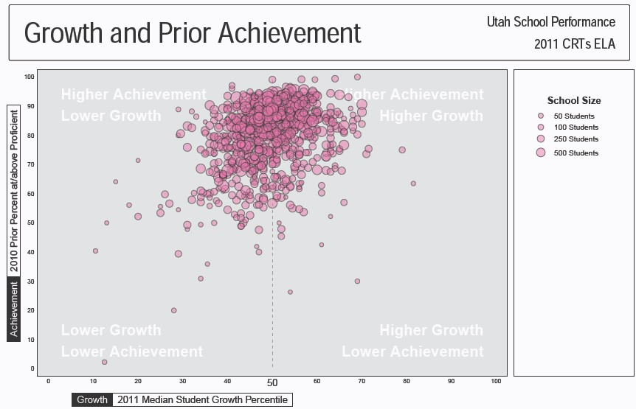

Figure 8: Growth and Prior Achievement- Math
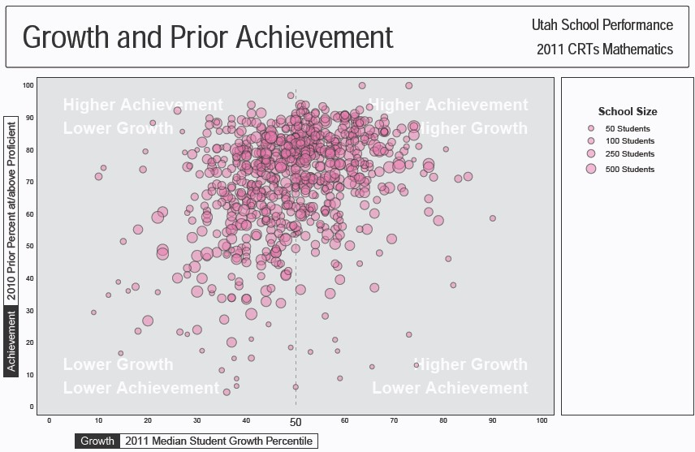
Figure 9: Growth and Prior Achievement – Science
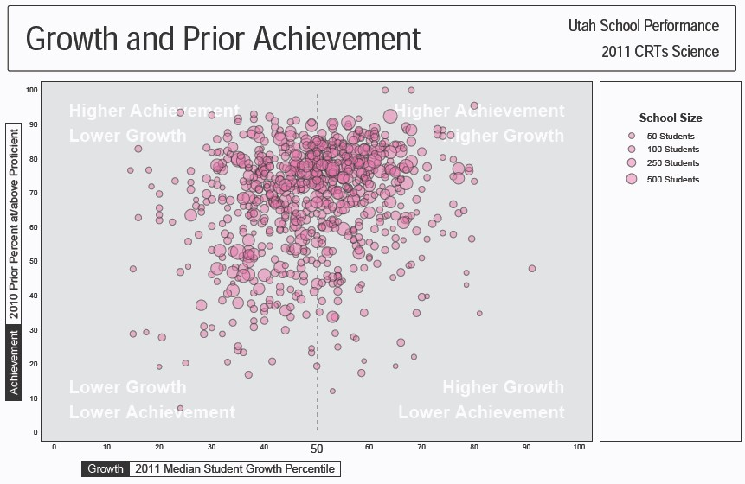

Evaluation of Growth Expectations
Another critical design feature of the model is that growth expectations should be tied to proficiency. That is, students who grow at higher levels must be on track to attain proficiency. To evaluate this claim, the USOE analyzed data for non-proficient students at each level of the ‘growth rubric’ (see Table 7.) Of particular interest were the outcomes for students growing at the higher levels of the rubric - those attaining an SGP of 50-59 and those attaining an SGP of 60 and above. Because schools receive more favorable overall growth scores at these levels, it is important to demonstrate that these schools are succeeding in moving students who are not proficient to proficiency.

Tables 14-16 below show the proficiency outcomes in 2011 for below-proficient students in 2010. The cells highlighted in yellow show the percent of students in 2011 growing at the two highest rubric levels who attain proficiency in just one year. Naturally, it is expected that students growing at this level over multiple years will have an even greater likelihood of achieving proficiency.

Table 14: Percent of Below Proficient Students in 2010 who Attain Proficiency in 2011 by Growth Level
- ELA
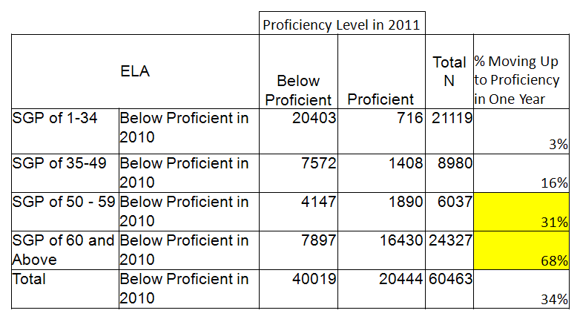
Table 15: Percent of Below Proficient Students in 2010 who Attain Proficiency in 2011 by Growth Level
- Math
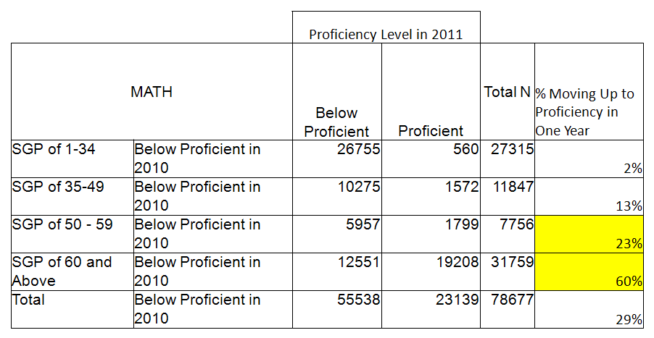

Table 16: Percent of Below Proficient Students in 2010 who Attain Proficiency in 2011 by Growth Level
- Science
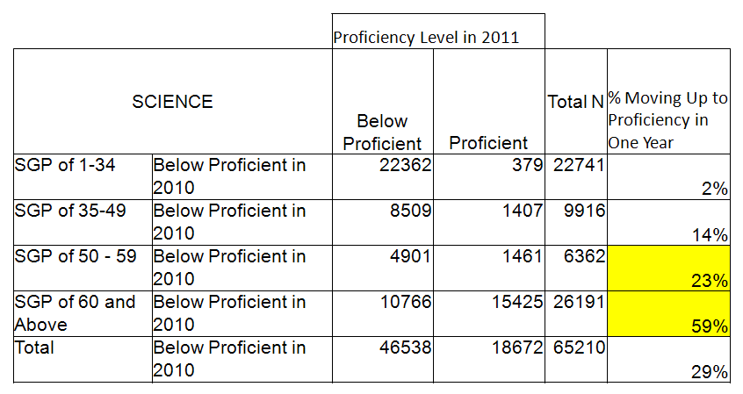

Model Consistency
Another area the USOE reviewed in preparing and refining model specifications was the consistency of outcomes. A relatively high degree of year to year stability was regarded as desirable to bolster claims of model reliability.

The set of tables (Tables 21 and 22) present the correlations of median SGPs across years by content area and by level. Although these correlations are not as strong as the associations typically found for the status measures, the moderate strength of these correlations are similar to, if not stronger than those that have been found in other studies that have correlated growth measures in school accountability systems by content area (e.g., see Kane & Staiger, 2002.) However again, it is important to note here that these correlations only capture a two-year relationship and may potentially increase when additional years are considered.
Table 21: Correlations by content area for elementary and middle schools
Content Area | r
ELA | 0.64
Math | 0.47
Science | 0.51

Table 22: Correlations by content area for high schools
Content Area | r
ELA | 0.64
Math | 0.47
Science | 0.51

ATTACHMENT 20

Promises to Keep The Vision and Mission of Utah Public Education
Promises to Keep is a statement of vision and mission for Utah’s system of public education. The statement relies on the language of the Utah Constitution for its central premise. It
is intended to provide focus to the work of the State Board of Education, the Utah State Office of Education, and all school districts, local boards of education, and charter schools within the general control and supervision of the Board.

The Vision of Public Education

Utah’s public education system is created in the state Constitution to “secure and perpetuate” freedom.
Freedom, as envisioned in the Utah Constitution, is a promise to future generations that requires:
  - Citizen participation in civic and political affairs.
  - Economic prosperity for the community.
  - Strong moral and social values.
  - Loyalty and commitment to constitutional government.

The premise of Promises to Keep is that there are essential, core “promises” that leaders in the public education system should be clear about with citizens of Utah; that these “promises” are made as part of the civic compact at work
as the citizens of Utah give into our hands resources for the public education system; that citizens should have high expectations regarding our success in the essential “promised” work of public education.

The Mission of Public Education

Utah’s public education system keeps its constitutional promise by:
  - Ensuring literacy and numeracy for all Utah children.
  - Providing high quality instruction for all Utah children.
  - Establishing curriculum with high standards and relevance for all Utah children.
  - Requiring effective assessment to inform high quality instruction and accountability.
Adopted by the Utah State Board of Education August 7, 2009

ATTACHMENT 21
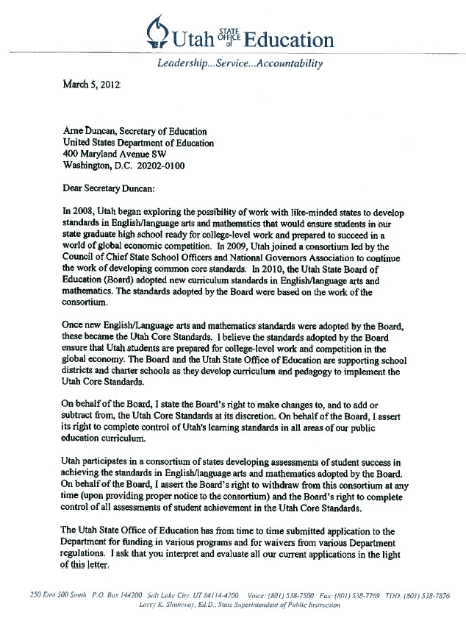

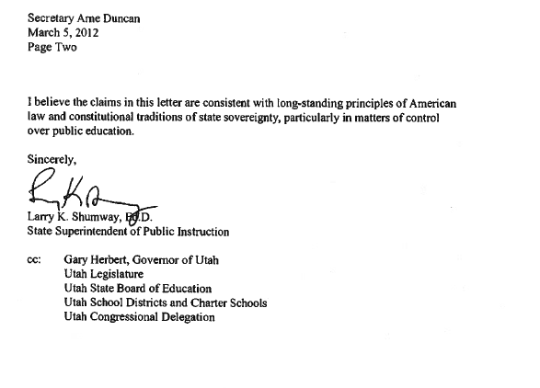
ATTACHMENT 22

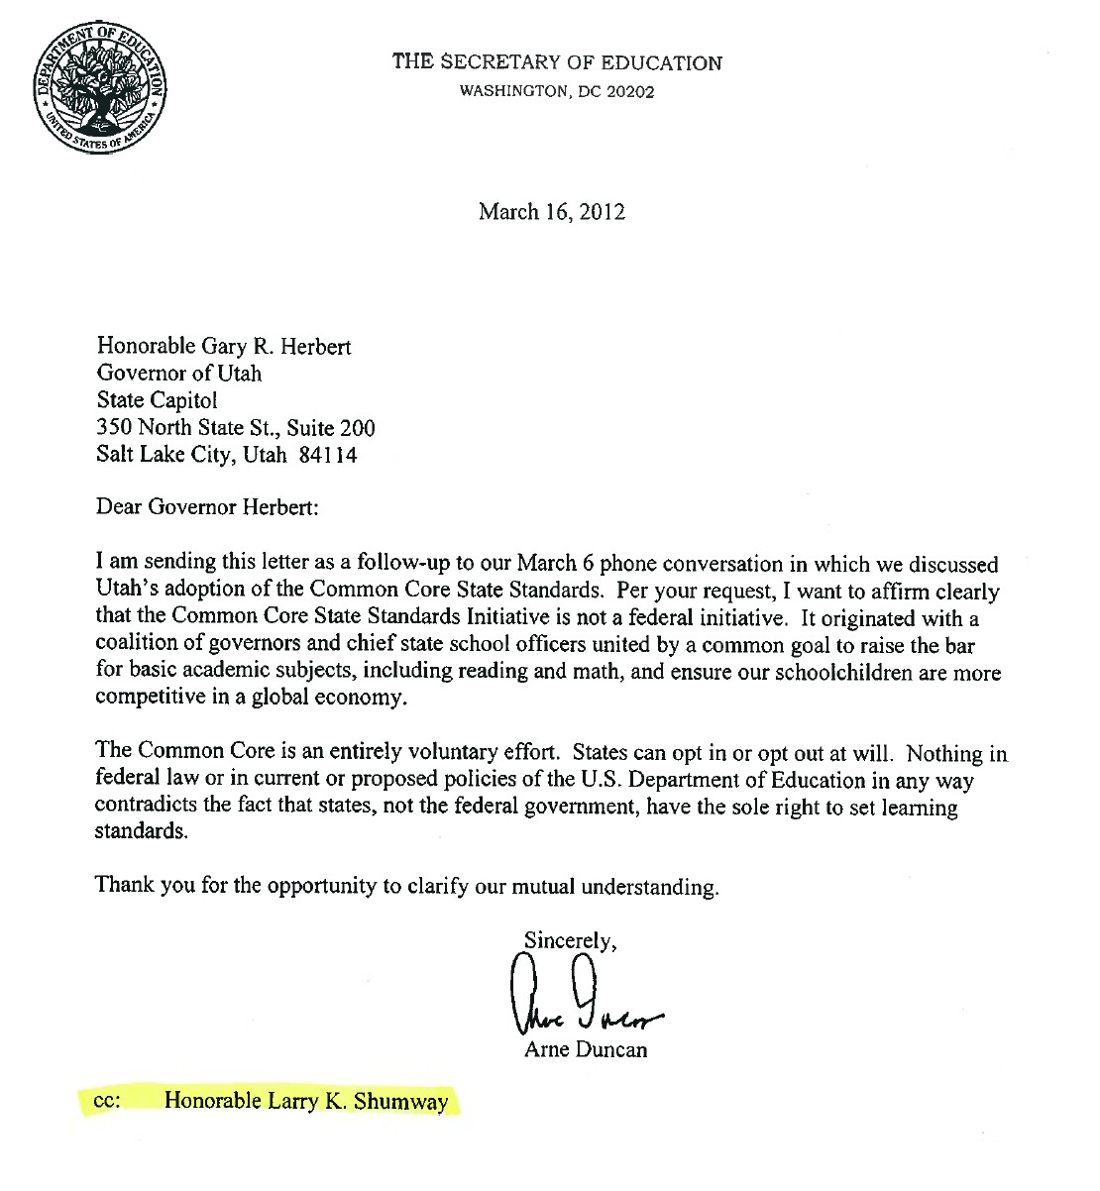
ATTACHMENT 23

May 3, 2012
Dr. Stanley Rabinowitz, Project Management Partner WestEd
730 Harrison Street
San Francisco, California 94107 Dear Dr. Rabinowitz:
Utah has been a “governing state” member of the Smarter Balanced Assessment Consortium (SBAC) since the consortium’s inception. We have valued our work with member states and believe that our participation has contributed to the progress of the consortium.

At this time, it is in our state’s best interest to change our state’s status within SBAC. This letter serves as our notice of that change. Utah will no longer participate as a “governing state” but intends to remain as an “advisory state.” As an “advisory state,” our intention is to remain informed as to the work of SBAC. Additionally, it is our intent that Utah State Office of Education staff attend certain SBAC meetings, but not accept work assignments or participate beyond observing and listening at SBAC meetings.

As we make this notification, we are relying on the membership policies established in the Smarter Balanced Assessment Consortium Governance Structure Document. This document provides that “Any state may leave the Consortium without cause . . .” (p. 12). Though we do not believe that we can be required to justify our decision to change status, we inform you that we make this change as we undertake a procurement process as authorized by the Utah Legislature (HB15, 2012 General Session) to select an assessment system to measure Utah students’ achievement of the Utah Core Standards.

Sincerely,
Larry K. Shumway, Ed.D. Debra G. Roberts
State Superintendent of Public Instruction Chair, State Board of Education
Gary R. Herbert Governor of Utah

ATTACHMENT 24

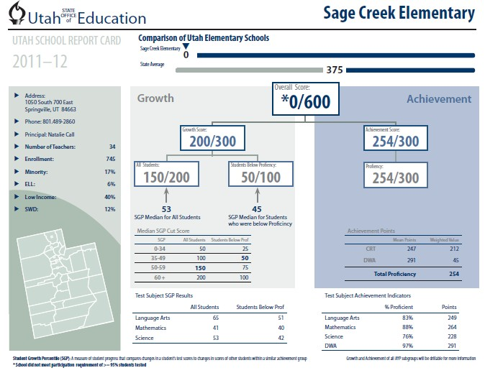

ATTACHMENT 25

Utah Title I ESEA Flexibility Waiver Demonstration Data for Reward Schools
Title I High-performing and High-progress Schools – Comparison of Proficiency with CAS
Process for determining Utah Reward Schools for Demonstration Document
Highest-performing Schools (not exceed 15% of Utah’s Title I schools)

Utah generated a list that rank-orders Title I schools in Utah based on the average of 3 years of proficiency achievement data for Reading/Language Arts and Mathematics for the all student group.
- Utah also set a cut point on the new Utah Comprehensive Accountability System (CAS) based on highest levels of achievement (minimum score of 255) and above average performance on growth (a minimum growth score of 150) that separates high-performing schools from other schools. The attached chart shows a comparison between proficiency only and the new Utah CAS. Those schools that would be recognized using both methodologies are highlighted in yellow.
- Utah reviewed the graduation rate for the one Title I high school on the list (Monticello High School: 2-year average = 91.5%).
- Utah reviewed the AYP determinations for each school and did not count as eligible for highest-performing schools recognition any school that did not achieve AYP for the all students group and all subgroups in the past two years.
- Utah identified and eliminated any Title I schools that had a significant achievement gap (greater than 20%) between the all students group achievement and any of its subgroups from the list of Utah’s highest-performing schools.
High-progress Schools (not exceed 5% of Utah’s Title I schools)

Utah generated a list that rank-orders Title I schools that are making the greatest progress in Utah based on the average of 3 years of proficiency achievement data for Reading/Language Arts and Mathematics for the all student group. Those Title I schools that reduced the achievement gap between the all students group and subgroups by at least 50% over the three years were identified as eligible for the Title I high-progress recognition.
- For purposes of comparison using the CAS system to identify high-progress schools, Utah set a cut point on the (CAS) based on highest levels of growth (minimum score of 225) and above average performance on achievement (a minimum achievement score of 230) to separates high-progress schools from other schools.
- Utah eliminated any Title I schools that had a significant achievement gap (greater than 20%) between the achievement of the all students group and any of its subgroups from the list of Utah’s high-progress schools.

LEA Name | School Name | Proficiency Rank order | Proficiency (Combined ELA &  Math) | CAS  Ranking (1=highest) | CAS Score (Proficiency  & Growth) | Reward School | AYP All Students | AYP  Subgroups
Cache District | Summit School | 1 | 93.67% | 11 | 519 | A | Yes | Yes
Salt Lake Arts Academy | Salt Lake Arts Academy | 2 | 91.49% | 2 | 555 | A | Yes | Yes
Beaver District | Minersville School | 3 | 91.29% | 26 | 491 | A | Yes | Yes
Beaver District | Belknap School | 4 | 91.02% | 20 | 500 | A | Yes | Yes
Iron District | Enoch School | 5 | 90.27% | 10 | 520 | A | Yes | Yes
Cache District | Park School | 6 | 90.00% | 1 | 568 | A | Yes | Yes
Emery District | Ferron School | 7 | 89.70% | 25 | 491 | A | Yes | Yes
Morgan District | Morgan School | 8 | 89.41% | 28 | 490 | A | Yes | Yes
Garfield District | Panguitch School | 9 | 89.22% | 38 | 481 | A | Yes | Yes
Cache District | Nibley School | 10 | 88.98% | 8 | 522 | A | Yes | Yes
Cache District | Lewiston School | 11 | 88.71% | 30 | 489 | A | Yes | Yes
Beaver District | Milford School | 12 | 88.15% | 15 | 511 | A | Yes | Yes
Cache District | Lincoln School | 13 | 87.19% | 4 | 532 | A | Yes | Yes
Piute District | Circleville School | 14 | 85.89% | 44 | 478 | A | Yes | Yes
Garfield District | Escalante School | 15 | 85.77% | 13 | 514 | A | Yes | Yes
Kane District | Kanab School | 16 | 85.71% | 51 | 466 | A | Yes | Yes
Iron District | Three Peaks School | 17 | 85.54% | 9 | 522 | A | Yes | Yes
North Sanpete District | Spring City School | 18 | 85.39% | 61 | 454 | No | No | No
Cache District | Canyon School | 19 | 85.01% | 37 | 482 | A | Yes | Yes
Provo District | Provost School | 20 | 84.96% | 16 | 511 | A | Yes | Yes

LEA Name | School Name | Proficiency Rank order | Proficiency (Combined ELA &  Math) | CAS  Ranking (1=highest) | CAS Score (Proficiency  & Growth) | Reward School | AYP All Students | AYP  Subgroups
Tintic District | Eureka School | 21 | 84.78% | 63 | 451 | No | Yes | Yes
Cache District | Millville School | 22 | 84.75% | 32 | 487 | No | No | No
Freedom Academy | Freedom Academy | 23 | 84.62% | 46 | 475 | A | Yes | Yes
Logan City District | Ellis School | 24 | 84.53% | 27 | 491 | A | Yes | Yes
Logan City District | Woodruff School | 25 | 84.29% | 82 | 434 | No | No | No
Iron District | Parowan | 26 | 83.66% | 86 | 427 | No | Yes | Yes
Wasatch District | J.R. Smith School | 27 | 83.53% | 22 | 500 | A | Yes | Yes
North Sanpete District | Fountain Green School | 28 | 83.46% | 76 | 439 | No | Yes | Yes
Channing Hall | Channing Hall | 29 | 83.28% | 39 | 481 | A | Yes | Yes
Canyon Rim Academy | Canyon Rim Academy | 30 | 83.09% | 24 | 492 | No | No | No
Park City District | Parley’s Park | 31 | 83.06% | 14 | 514 | No | No | No
South Sanpete District | Manti School | 32 | 83.02% | 36 | 482 | No | No | No
Providence Hall | Providence Hall | 33 | 82.94% | 17 | 508 | A | Yes | Yes
Park City District | McPolin School | 34 | 82.19% | 47 | 473 | No | No | No
Iron District | Cedar East School | 35 | 82.15% | 18 | 505 | A | Yes | Yes
Carbon District | Castle Heights School | 36 | 81.89% | 67 | 449 | No | No | No
Iron District | Cedar North School | 37 | 81.61% | 49 | 468 | A | Yes | Yes
Soldier Hollow Charter | Soldier Hollow Charter School | 38 | 81.39% | 5 | 530 | A | Yes | Yes
North Sanpete | Mt Pleasant School | 39 | 80.90% | 33 | 484 | No | No | No
San Juan District | Monticello School | 40 | 80.77% | 29 | 489 | A | Yes | Yes
South Sanpete | Gunnison Valley School | 41 | 80.26% | 12 | 517 | No | No | No
Iron District | Escalante Valley School | 42 | 79.92% | 40 | 480 | A | Yes | Yes

LEA Name | School Name | Proficiency Rank order | Proficiency (Combined ELA &  Math) | CAS  Ranking (1=highest) | CAS Score (Proficiency  & Growth) | Reward School | AYP All Students | AYP  Subgroups
San Juan District | Monticello High | 43 | 79.45% | 23 | 494 | A | Yes | Yes
Logan City District | Bridger School | 44 | 79.43% | 6 | 525 | A and B | Yes | Yes
South Summit District | South Summit School | 45 | 79.41% | 43 | 479 | A and B | Yes | Yes
Murray District | Liberty School | 46 | 78.84% | 65 | 451 | B | Yes | Yes
Alpine District | Hillcrest School | 47 | 78.04% | 21 | 500 | Not Reward | No | No
Alpine District | Central School | 48 | 76.48% | 19 | 501 | A | Yes | Yes
Carbon District | Sally Mauro School | 49 | 76.39% | 50 | 468 | A | Yes | Yes
Washington District | Heritage School | 50 | 76.19% | 56 | 456 | B | Yes | Yes
Carbon District | Bruin Point School | 51 | 75.28% | 45 | 475 | A | Yes | Yes
Garfield District | Bryce Valley HS | 52 | 75.25% | 48 | 468 | Not Reward | No | No
Nebo District | Goshen School | 53 | 75.18% | 3 | 536 | A | Yes | Yes
Rich District | South Rich School | 54 | 74.75% | Below 90 | 406 | B | Yes | Yes
Box Elder District | Garland School | 55 | 74.43% | 35 | 482 | A and B | Yes | Yes

Total # of Reward Schools: 40 (14.5% of Title I schools)
High Performing (A) only: 34 (12.4% of Title I schools) High Progress (B) only: 3 (1.1% of Title I schools)
High Performing (A) and High Progress (B): 3 (1.1% of Title I schools)

ATTACHMENT 26

Utah Title I ESEA Flexibility Waiver Demonstration Data (Priority & Focus Schools) Title I Schools Subgroup Achievement Gap – Economically Disadvantaged
Process for determining Utah Focus Schools for Demonstration Document
- Utah determined the number of Utah Title I schools that must be identified as Focus Schools: 10% of 275 = 28 schools
- Utah identified the Utah Title I high schools with the lowest ratings on the new Utah Comprehensive Accountability System (CAS) that had graduation rates less than 60% over a 2-year period (and not identified as Priority Schools): 0 schools
- Utah identified additional Title I-participating high schools that had graduation rates less than 60% over a 2-year period (and not identified as Priority Schools): 6 schools
- Utah determined the remaining number of Title I schools that needed to be identified as Focus Schools(28-6): 22 schools
- Utah identified Utah’s low-achieving-subgroup schools using the following methodology:
  - Utah compiled a rank-order list of all Title I schools that shows the Title I schools with the largest achievement gap compared to the state using the economically disadvantaged subgroup (state average = 71.3%). For Utah, the economically disadvantaged subgroup provided the most inclusive data among Title I schools (n-size for other subgroups excluded more schools)
  - Utah averaged the Reading/Language Arts and Mathematics proficiency scores using 3 years of achievement data
  - Utah identified the lowest-ranking 22 Title I schools with the largest subgroup achievement gap (excluding Title I schools already identified as Priority Schools)
- Utah verified that the schools identified through the new Utah Comprehensive Accountability System, through the low- graduation methodology, and largest subgroup achievement gap were identified as Focus Schools as shown on the demonstration list below.

Name of LEA | Name of Title I School | Achievement Proficiency Gap Ranking | Subgroup Achievement Proficiency Percentage | Gap between School and State Average | CAS Ranking (lowest  score = 1) | Priority or Focus Designation
Ogden District | Washington High (Alternative High School) | 1 | 8.1% | -63.2% | 1 | Priority
Uintah River High | Uintah River High* (Charter School) | 2 | 15.3% | -56.0% | Insufficient data | Focus
San Juan District | Monument Valley High | 3 | 31.8% | -39.5% | 6 | Focus
San Juan District | Whitehorse High | 4 | 35.1% | -36.2% | 12 | Focus
Tooele District | Wendover High | 5 | 36.6% | -34.7% | Insufficient data | Priority
Ogden District | James Madison Elementary | 6 | 36.8% | -34.5% | 4 | Priority
Ogden District | Dee School | 7 | 39.8% | -31.5% | 3 | Priority
San Juan District | Tse' Bii'nidzisgai School | 8 | 42.0% | -29.3% | Insufficient data | Priority
Ogden District | Thomas O Smith School | 9 | 43.2% | -28.1% | 18 | Focus
Granite District | Granite Park Jr. High | 10 | 43.5% | -27.8% | 11 | Focus
San Juan District | Bluff School | 11 | 44.2% | -27.1% | 37 | Priority
Uintah District | Eagle View Elementary | 12 | 44.5% | -26.8% | Insufficient data | Priority
Dual Immersion Academy | Dual Immersion Academy (Charter School) | 13 | 44.5% | -26.8% | 16 | Focus
Ogden District | Odyssey Elementary | 14 | 45.7% | -25.6% | 7 | Priority
Granite District | Lincoln School | 15 | 45.7% | -25.6% | 13 | Focus
Ogden District | Gramercy School | 16 | 45.8% | -25.5% | 10 | Focus
Spectrum Academy | Spectrum Academy (Charter School) | 17 | 46.6% | -24.7% | 15 | Focus
Salt Lake District | Glendale Middle | 18 | 47.1% | -24.2% | 40 | Priority

Name of LEA | Name of Title I School | Achievement Proficiency Gap Ranking | Subgroup Achievement Proficiency Percentage | Gap between School and State Average | CAS Ranking (lowest  score = 1) | Priority or Focus Designation
Granite District | Western Hills School | 19 | 48.2% | -23.1% | 30 | Focus
Salt Lake District | Lincoln School | 20 | 48.4% | -22.9% | 8 | Focus
Davis District | Vae View School | 21 | 48.6% | -22.7% | 14 | Focus
Gateway Preparatory Academy | Gateway Preparatory Academy (Charter School) | 22 | 48.9% | -22.4% | 23 | Focus
Ogden District | Lincoln School | 23 | 49.4% | -21.9% | 25 | Focus
Salt Lake District | Edison School | 24 | 49.6% | -21.7% | 55 | Priority
San Juan District | Montezuma Creek School | 25 | 49.8% | -21.5% | 2 | Focus
Granite District | Redwood School | 26 | 50.5% | -20.8% | 21 | Focus
Salt Lake District | Parkview School | 27 | 51.0% | -20.3% | 17 | Focus
Salt Lake District | Rose Park School | 28 | 51.2% | -20.1% | 38 | Focus
Salt Lake District | Meadowlark School | 29 | 51.2% | -20.1% | 5 | Focus
Ogden District | Mound Fort Junior High | 30 | 51.7% | -19.6% | 31 | Focus
Salt Lake District | Backman School | 31 | 51.9% | -19.4% | 20 | Focus
Ogden District | Bonneville School | 32 | 52.4% | -18.9% | 43 | Focus
Salt Lake District | Franklin School | 33 | 52.9% | -18.4% | 44 | Focus
Granite District | West Lake Junior High | 34 | 53.5% | -17.8%
Granite District | Woodrow Wilson School | 35 | 53.5% | -17.8%
Canyons District | Copperview School | 36 | 53.8% | -17.5%
Charter District | Rockwell Charter High School | 37 | 53.8% | -17.5%
Granite District | Roosevelt School | 38 | 53.9% | -17.4%

Name of LEA | Name of Title I School | Achievement Proficiency Gap Ranking | Subgroup Achievement Proficiency Percentage | Gap between School and State Average | CAS Ranking (lowest  score = 1) | Priority or Focus Designation
Salt Lake District | Mountain View Schools | 39 | 54.0% | -17.3%
Granite District | Pioneer School | 40 | 54.3% | -17.0%

Title I Schools with Graduation Rates less than 60% - Identified as Priority or Focus Schools
Name of LEA | Name of Title I School | Graduation Rate | Priority or Focus Designation
Ogden District | George Washington High School (Alternative HS) | 27.5% | Priority
Uintah River High School | Uintah River High School* (Charter) | 31.0% | Focus
Utah Virtual Academy | Utah Virtual Academy (Charter) | 32.0% | Focus
Merit College Preparatory Academy | Merit College Preparatory Academy (Charter) | 40.0% | Focus
City Academy | City Academy (Charter) | 46.5% | Focus
Rockwell Charter High School | Rockwell Charter High School (Charter) | 49.0% | Focus
DaVinci Academy | DaVinci Academy (Charter) | 59.0% | Focus

ATTACHMENT 27

Comprehensive Accountability System (CAS) and Proficiency

The following analyses are presented to help demonstrate that school performance on Utah’s proposed CAS is strongly tied to the percent of students scoring proficient on state tests. While schools with relatively similar proficiency rates will appropriately receive different CAS scores due to the influence of growth, it is rare for schools with dramatically lower proficiency rates to receive high CAS scores. By design, proficiency has a substantial influence on CAS scores.
First, we show that the 2 year composite CAS score for title I schools, which is the basis for determining focus and priority classification, is strongly related to proficiency rates. The correlation between percent proficient and the CAS composite is above .80 in each content area as shown in table 1. Figures 1-3 also demonstrate that schools with low proficiency rates do not receive high CAS scores.
Table 1. School Level Correlation Between CAS Score and Percent Proficient

Content Area | CAS Score
ELA | .844
Math | .822
Science | .827

Figure 1. Scatter Plot of Percent Proficient in Language Arts (Y) by CAS Score (X) for Title I Schools

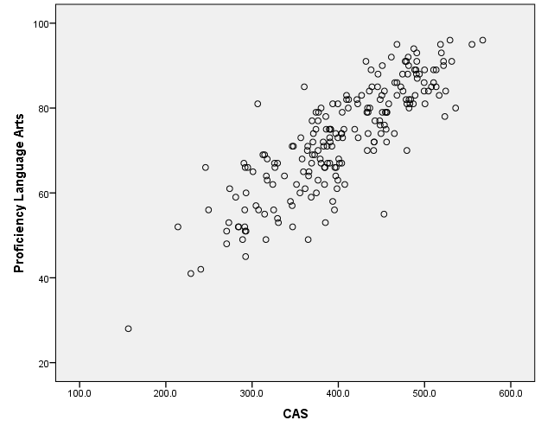

Figure 2. Scatter Plot of Percent Proficient in Mathematics (Y) by CAS Score (X) for Title I Schools
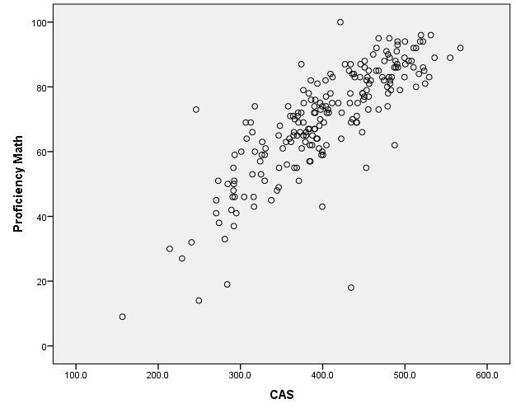

Figure 3. Scatter Plot of Percent Proficient in Science (Y) by CAS Score (X) for Title I Schools

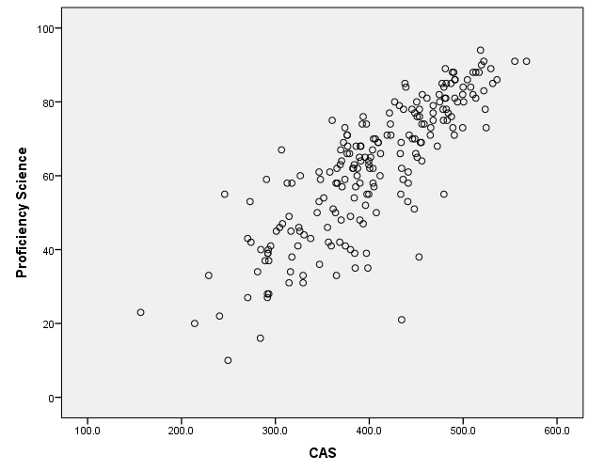

ATTACHMENT 28

Utah Title I ESEA Flexibility Waiver Demonstration Data - Exit Criteria for Priority Schools
Utah Exiting Priority School Status Demonstration Document
To demonstrate that the criteria for exiting Priority School status are rigorous, the state of Utah compiled the following data:
- Utah identified the 4-year average combined Reading/Language Arts and Mathematics proficiency for the Utah Title I and Title I eligible schools that were identified as eligible for the Title I School Improvement Grant (SIG).
- Utah identified the percent proficient for the Utah’s lowest-performing Title I schools for the period of 2007-2010:
  - Utah compiled a rank-order list of all Title I schools that shows the Title I schools with the lowest 4-year average of proficiency for the combined Reading/Language Arts and Mathematics;
  - Utah identified the 4-year average percent proficiency for the Title I school at the 15th percentile of Title I schools
(53%);
- Utah identified the average percent proficient for the most recent year of achievement data available (2010-2011) for the lowest-performing schools as shown on the demonstration list below.
- The 15th percentile proficiency score for the combined Reading/Language Arts and Mathematics for Utah Title I schools for
2010-2011 is 55.44%.
- Utah identified the Title I and Title I eligible-but not served schools that received Title I SIG funding in Cohort 1 and Cohort 2. Under the ESEA Flexibility Waiver Request, Utah has selected the Title I SIG schools as Priority Schools

The average percentile rank for all current SIG schools is the 7.7th percentile rank. Four schools are still scoring below the 5th percentile, six schools are scoring between the 5th and 15th percentile of all Title I schools, and five schools are currently scoring above the 15th percentile. Based on the exit criteria proposed as part of this waiver, these five schools would be eligible to exit Priority status. In terms of a change in the percentage of students scoring proficient or advanced on the State CRTs in ELA and math, schools scoring at the 5th percentile have an average of 43% proficient/advanced, while schools at the 15th percentile have an average of 55% of its students scoring proficient or advanced. This difference represents more than a 25% increase in the percentage of students meeting standards compared to when schools entered the SIG program.

Exiting Priority Status
To exit priority status (page 51) schools must earn a two year composite CAS score of at least 320 or a two year composite CAS score that is at the 15th percentile or higher, whichever is greater.

Utah’s Lowest-Performing Title I Served Schools – Eligible for Title I School Improvement Grant (SIG)
Name of LEA | Name of Title I School | Title I SIG Criterion | Achievement Proficiency Ranking (1=lowest) | Combined ELA/Math Achievement Proficiency  % (2007-  2010) | Combined ELA/Math Achievement Proficiency  % (2010-  2011) | Title I SIG Designation
Ogden District | Washington High (Alternative High School) | Tier 2 Newly Eligible | 1 | 20% | 15% | SIG Cohort 2
San Juan District | Navajo Mountain High | Tier 2 Newly Eligible | 2 | 25% |  | Applied, not awarded
San Juan District | Whitehorse High | Tier 2 Newly Eligible | 3 | 28% |  | No LEA  application
San Juan District | Monument Valley High | Tier 2 Newly Eligible | 4 | 31% |  | No LEA  application
Carbon District | Lighthouse Learning Center (Alternative High School) | Tier 2 Newly Eligible | 5 | 32% |  | Applied, not awarded
Tooele District | Wendover High | Tier 2 Newly Eligible | 6 | 34% | 44% | SIG Cohort 2
Uintah District | Eagle View Elementary | Tier 1 Newly Eligible | 7 | 36% | 55% | SIG Cohort 2
Rockwell | Rockwell High (Charter School) | Tier 2 Newly Eligible | 8 | 36% |  | No LEA  application
Ogden District | James Madison Elementary | Tier 1 Newly Eligible | 9 | 37% | 36% | SIG Cohort 1
San Juan District | Tse' Bii'nidzisgai Elementary | Tier 1 Newly Eligible | 10 | 38% | 46% | SIG Cohort 2
Dual Immersion | Dual Immersion (Charter School) | Tier 1 Newly Eligible | 11 | 40% |  | Applied, not awarded
Fast Forward | Fast Forward High (Charter School) | Tier 2 Newly Eligible | 12 | 40% |  | No LEA  application
Salt Lake District | Edison Elementary | Tier 1 Newly Eligible | 13 | 42% | 55% | SIG Cohort 2

Name of LEA | Name of Title I School | Title I SIG Criterion | Achievement Proficiency Ranking (1=lowest) | Combined ELA/Math Achievement Proficiency  % (2007-  2010) | Combined ELA/Math Achievement Proficiency  % (2010-  2011) | Title I SIG Designation
Salt Lake District | Glendale Middle | Tier 2 Newly Eligible | 14 | 42% | 45% | SIG Cohort 1
Ogden District | Gramercy Elementary | Tier 1 Newly Eligible | 15 | 43% |  | No LEA  application
Ogden District | Odyssey Elementary | Tier 1 Newly Eligible | 16 | 45% | 44% | SIG Cohort 1
San Juan District | Bluff Elementary | Tier 1 Newly Eligible | 17 | 45% | 59% | SIG Cohort 1
Ogden District | Dee Elementary | Tier 1 Newly Eligible | 18 | 46% | 34% | SIG Cohort 1
Granite District | Granite Park Jr. High | Tier 2 Newly Eligible | 19 | 46% |  | No LEA  application
Ogden District | Thomas O Smith Elementary | Tier 1 Newly Eligible | 20 | 47% |  | No LEA  application
Salt Lake District | Lincoln Elementary | Tier 1 Newly Eligible | 21 | 47% |  | No LEA  application
Canyons District | Midvale Elementary | Tier 1 | 22 | 47% |  | No LEA  application
Salt Lake District | Northwest Middle | Tier 1 | * | 49% | 71% | SIG Cohort 1
Davis District | Fremont Elementary | Tier 1 | * | 62% | 65% | SIG Cohort 2

Utah’s Lowest-Performing Title I Eligible, but Not Served Schools - Eligible for Title I School Improvement Grant (SIG)
Name of LEA | Name of Title I School | Title I SIG Criterion | Achievement Proficiency Ranking (1=lowest) | Combined ELA/Math Achievement Proficiency  % (2007-  2010) | Combined ELA/Math Achievement Proficiency  % (2010-  2011) | Title I SIG Designation
Logan District | Logan South Campus (Alternative High School) | Tier 2 | 1 | 17% |  | No LEA  application
Salt Lake District | Horizonte Instructional Center (Alternative High School) | Tier 2 | 2 | 18% | 20% | SIG Cohort 2
Granite District | Granite Peaks High | Tier 2 | 5 | 26% |  | No LEA  application
Granite District | Young Parent Program (Alternative High School) | Tier 2 | 8 | 31% |  | No LEA  application
Granite District | Granger High | Tier 2 | 9 | 32% | 43% | SIG Cohort 1
Provo District | Independence High (Alternative High School) | Tier 2 | 13 | 36% |  | No LEA  application
Granite District | Kearns High | Tier 2 | 17 | 39% |  | Applied, not awarded
Ogden District | Ogden High | Tier 2 | 14 | 41% | 45% | SIG Cohort 2

ATTACHMENT 29

Description of 3 Tier Model of Title I Systems of Support


Tier 3
Tier 2
Tier 1
Tier 3 System of Support - Priority Schools
Tier 2 System of Support - Focus Schools
Tier 1 – General Support to All Title I Schools

Tier 1 – General Support to All Title I Schools

The USOE provides on-going training and support to LEAs in research-based instructional strategies that lead to improved student achievement. The general support to all Title I schools includes collaborative professional development opportunities. The list below outlines some of those training opportunities.

- Utah Core Academies
- Principals’ Literacy Institute
- STAR training (literacy volunteer training)
- Positive Behavior Intervention Supports (PBIS)
- Utah Futures (individualized student planning)
- Sheltered Instruction Observation Protocol (SIOP)
- World-class Instructional Design Assessment (WIDA)
- Best Practices
- Differentiated Instruction
- 3 Tier Models of Instruction
- Title I Principals’ Leadership Institute
- Title I Coaching Institute

Tier 2 Systems of Support – Focus Schools

In addition to the general support to all Title I schools, the USOE requires Focus Schools to participate in the Title I school improvement process. Key components of Utah’s Title I School Improvement process include:

- Schools are required to form a school leadership team
- Schools provide parent notification that the school has been identified as a Title I Focus School with information on how parents can support their student’s achievement and how to provide input into the school improvement process
- Schools/LEAs are required to contract with an external school support team (SST) made up of distinguished educators that include current and former superintendents; principals; teachers; specialists in curriculum and instruction, ELL, and SWD; community representatives; and representatives from higher education – each SST is to include at least one LEA member.
- Schools are required to participate in a comprehensive school appraisal conducted by the SST; this appraisal tool is research-based to focus on those components that have the greatest potential impact on student achievement
- Following the school appraisal, the SST may reconstitute to ensure that expertise is included to address specific challenges related to instruction and/or subgroup achievement
- The SST works with the school leadership team to develop/revise the school improvement plan
- The LEA peer review team will examine for content and approve or request revisions of the school improvement plan before submitting to the USOE
- The LEA will present to the local school board the approved school improvement plan
- Focus Schools will be required to utilize Utah’s web-based Tracker system that facilitates quality planning and progress monitoring of the school improvement plan implementation
- The LEA and the SST team leader work with the school to implement the school improvement plan and provide Quarterly Progress Reports to the SEA
- The USOE will provide a two year Title I school improvement grant of $100,000 to support school improvement efforts
- The USOE provides a follow-up review of all school improvement plans to ensure compliance and potential for success
- The USOE provides intensive professional development to school teams that includes LEA staff, principals, coaches, and teachers
- The USOE provides ongoing technical assistance to LEAs and Focus Schools
- The USOE monitors implementation of school improvement plans and annual achievement results of each Title I Focus School

Tier 3 Systems of Support – Priority Schools

In addition to the general support to all Title I schools and the school improvement process required of Focus Schools, the USOE requires Priority Schools to implement one of the four rigorous reform strategies outlined in the Title I School Improvement Grant (SIG) process. Key Components of Utah’s Title I SIG process include:

- Implementation of one of the four federally-defined turnaround principles, including replacement of the building principal (in accordance with SIG requirements)
- The LEA Contract with an approved third party School Support Team (SST) to assist in improvement efforts. An SST is made up of at least three distinguished educators external to the school (one of whom must be a representative of the LEA). The LEA and school select SST members based on needs of the school and expertise available. The SST must have the proven success, knowledge and skills, and the ability to facilitate quality improvement that will lead to student achievement. The composition of the SST may change based on the strengths and challenges of the school as determined through the school appraisal process.
- Priority Schools work with the SST to conduct a school appraisal using Utah Title I School Improvement tools
- Develop a comprehensive plan for school improvement that includes improvement goals, strategies, resources, evaluations, professional development, and timelines
- Utilize the web-based Utah Title I Plan Tracker System to submit school improvement plans and progress reports on a regular basis
- As defined in the school improvement plan, the LEA provides needed technical assistance to the school(s)
- The LEA regularly monitors and reports to the USOE implementation of the comprehensive school improvement plan
- Historically, the USOE has provided a significant 3-year grant (grants range from $750,000 to
$2,000,000 based on school size and needs) to participating LEAs to support the SIG schools in implementation of meaningful school improvement efforts
- The USOE provides technical assistance to participating LEAs and Priority Schools
- The USOE provides intensive professional development to administrators and coaches of Priority Schools
- The USOE regularly monitors participating LEAs and Priority Schools
- The USOE determines whether the LEAs and Priority Schools are meeting improvement targets to determine continuation of funding

Attachment 30


