DETAILED GUIDE for LOGIN.GOV and
TRIO APR WEB PORTAL

As the project director for your TRIO grant, the Federal Government now requires you have an account with Login.gov to access the TRIO APR Web Portal. This requirement follows new federal rules pertaining to federal IT system security. Below are instructions on how to access the TRIO APR Web Portal including registering with Login.gov.

What is Login.gov?
Login.gov securely verifies, stores, and manages user’s digital identity using verified credentials and multi-factor authentication. This means multiple layers to your identity are verified when you access the system to ensure the person logging into your account is indeed you! Several levels of security are needed to qualify as an official identity provider (IdP) for a government agency, and Login.gov meets these requirements.

How Does This Work?
Think of Login.gov as a directory where external users’ identities can all be housed and managed. The Department of Education allows transferring that identity (after being verified) from Login.gov to the Department’s network. There are two steps to the transfer:
1. External users set up and use their Login.gov account
2. Login.gov verifies a user’s identity through a vetted process

How do I access the TRIO APR Web Portal?
- If you have setup an account in Login.gov and used the email address as listed in G5 of your Grant Award Notification (GAN), please click here for further instructions.

- If you have not setup a Login.gov account, please click here for further instructions.

- If you have an account but the email address you used to create that account is different from the email address in G5 of your Grant Award Notification (GAN), please click here for further instructions.

What if I need additional assistance?
If you need assistance with Login.gov, please go to the Login.gov Help Center at https://login.gov/help/. If you need assistance with the TRIO APR Web Portal, please contact TRIO Help Desk at TRIO@helpdesk.thetactilegroup.com.

If you have setup an account in Login.gov and used the email address as listed in G5 of your Grant Award Notification (GAN), please follow the steps below.

- Go to https://trio.ed.gov/ and click the button “Click Here To Accept”.
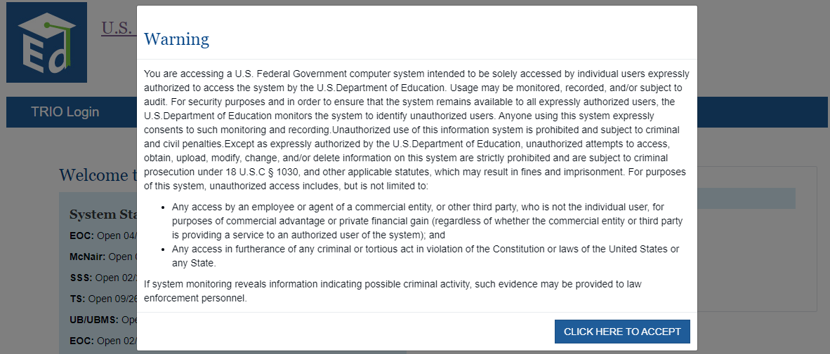

- Click ”Login.”
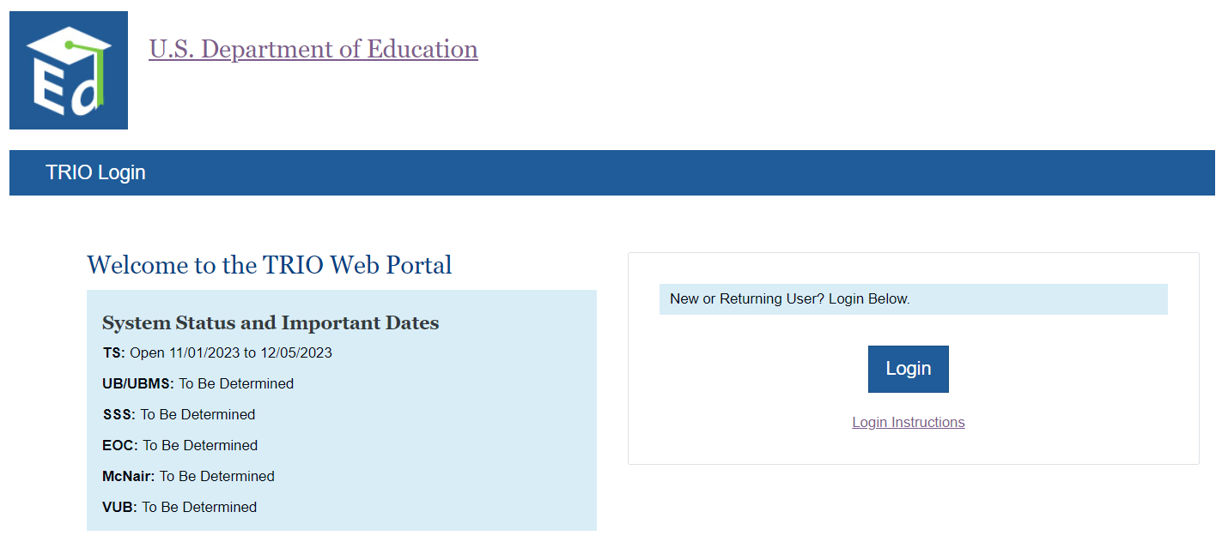

- Click “Sign in with Login.gov.”
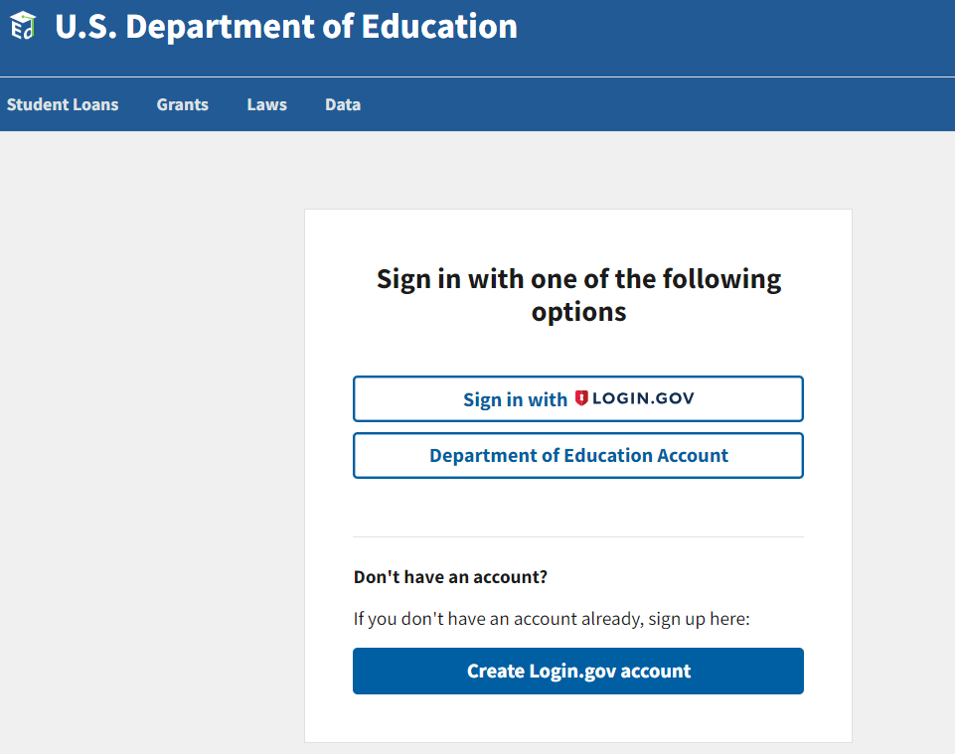

- Enter your email address and password and click “Sign In.”
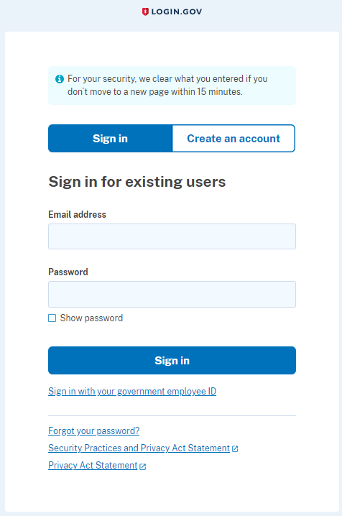

- Enter the one-time password code that is generated by the method you used to create Login.gov and click on Submit. Examples of methods you may have used are authenticator app, text message, email, etc.
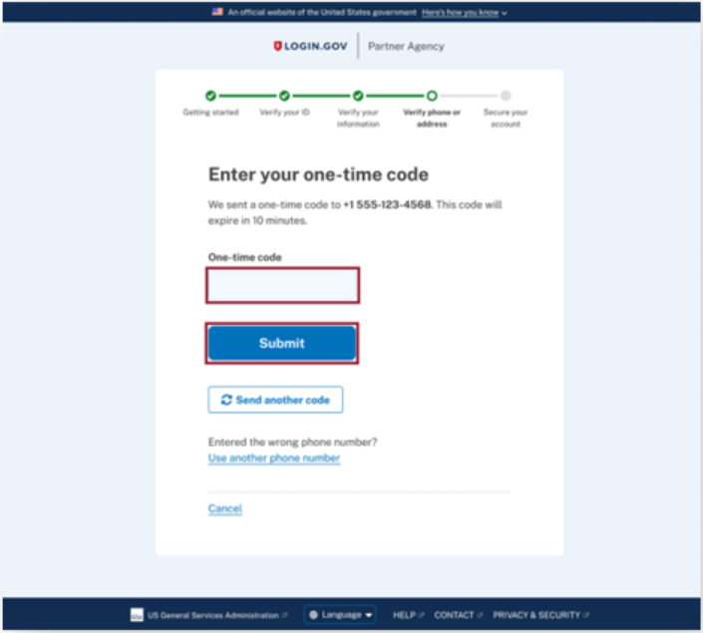

- You will be taken to the TRIO Web Portal page where you can begin your APR submission.
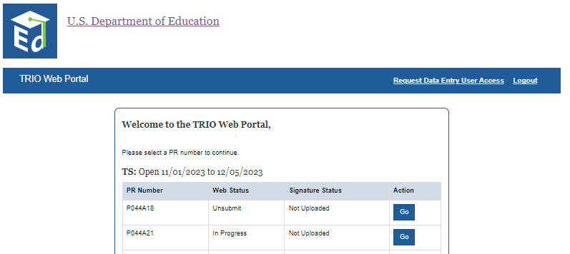

If you have not setup a Login.gov account, please follow the steps below.

- Go to https://trio.ed.gov/ and click the button “Click Here to Accept.”

- Click on “Login.”

- Click on “Create Login.gov account.”

- Enter your email address as it appears in G5 of your Grant Award Notification (GAN), check the box “I read and accept the Login.gov” Rules of Use and click “Submit.”
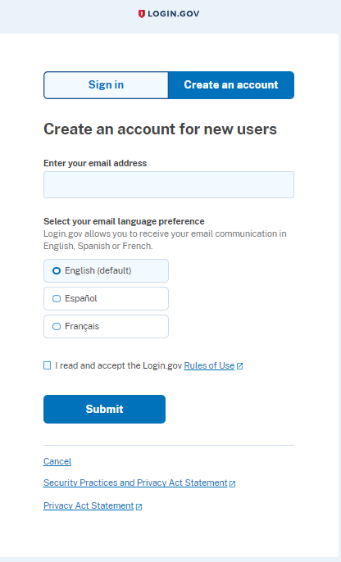

- Open the email that was sent to your email address, then click on the button “Confirm your email” or click on the link below the button. If you did not receive the email, please check your SPAM or Junk folders.
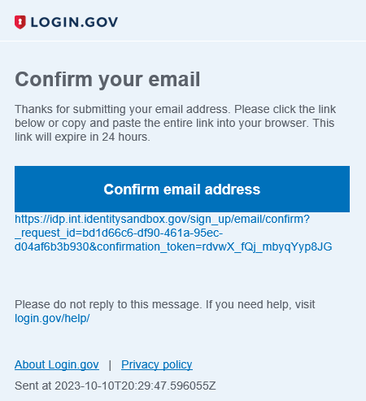

- Create a password.
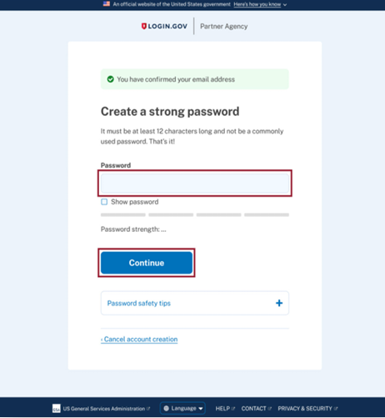

- Setup your multi-factor authentication method(s) by selecting at least one of the methods (e.g., authenticator application, text or voice message, etc.), then click “Continue.”
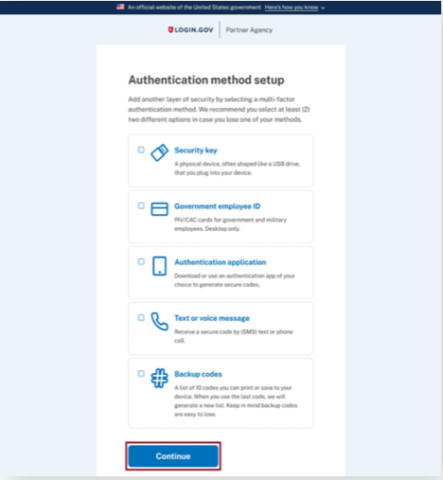

- You will be taken to the TRIO APR Web Portal page where you can begin your APR submission.

If you have an account but the email address you used to create that account is different from the email address in G5 of your Grant Award Notification (GAN), please follow the steps below.

- Go to https://trio.ed.gov/ and click the button “Click Here to Accept.”

- Click on “Login.”

- Click on “Sign in with Login.gov.”

- Enter your email address and password and click “Sign In.”
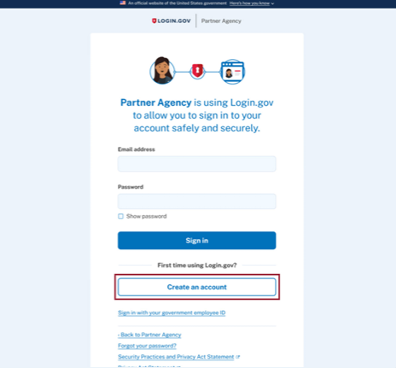

- Enter the one time password code that is generated by the method you used to create Login.gov, then click “Submit.” Examples of methods you may have used are authenticator app, text or voice message, backup codes, etc.

- The web page “Welcome to the TRIO APR Web Portal” will be displayed. Click on “Change Project Director Request.”

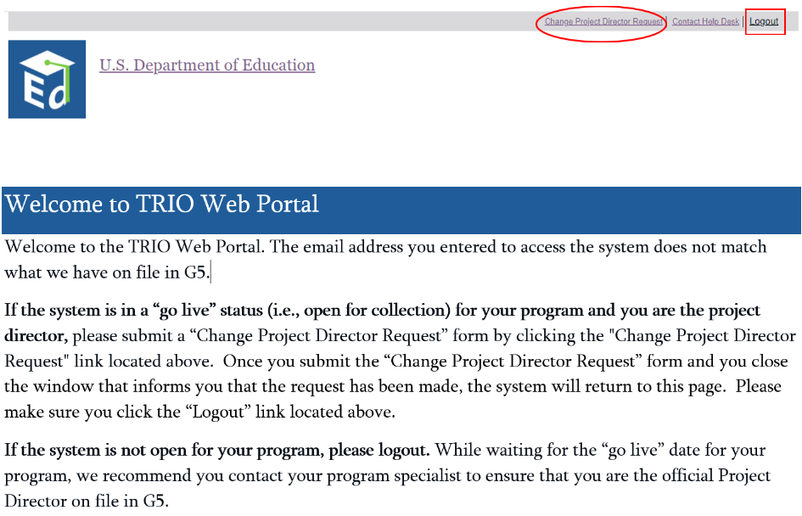

- Complete the information requested, then click “Submit.” If you need to cancel the request, click the “Close” button.
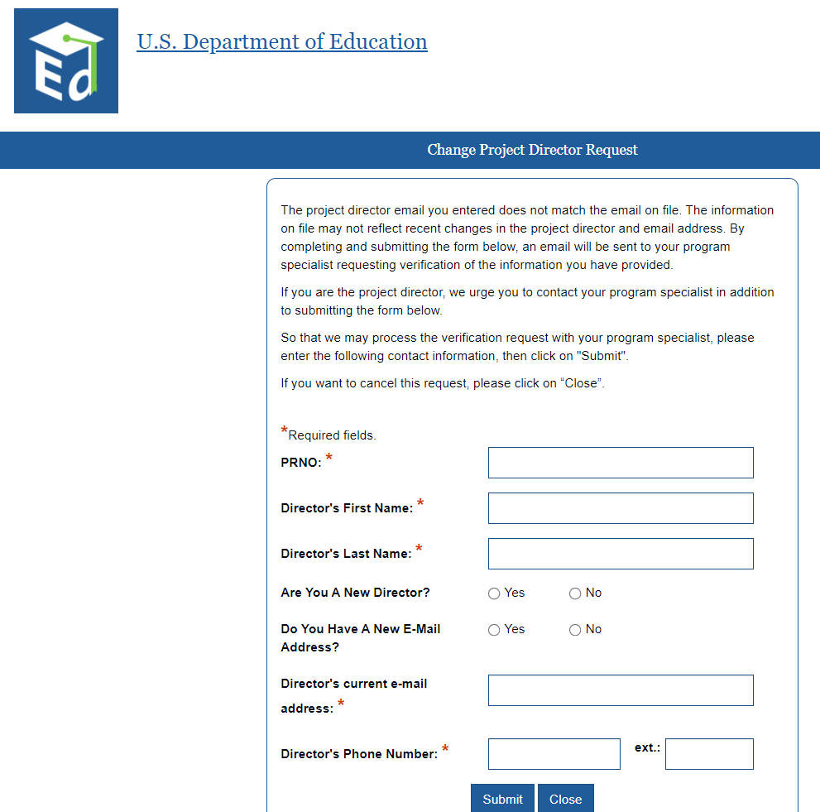

- The message below will display after you have submitted a “Change Project Director Request.” Close the window by clicking on the button “Close”. You will then see the previous window “Welcome to TRIO Web Portal”. Be sure to click the “Logout” link located at the top of the window.

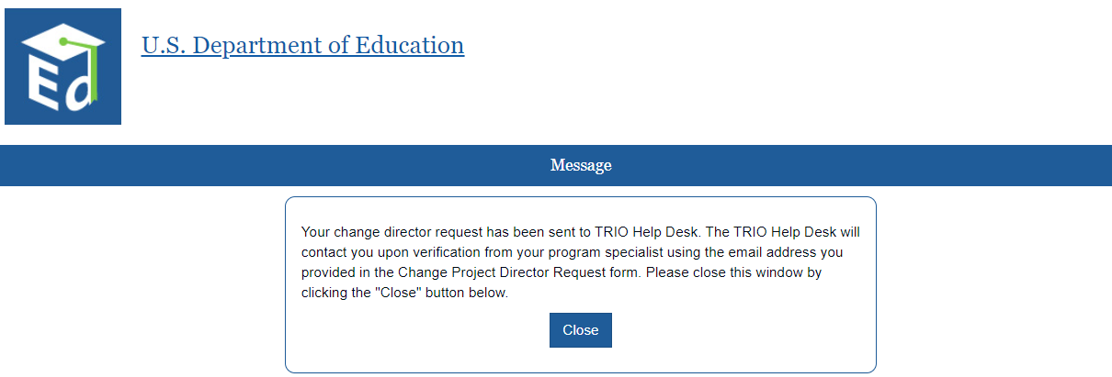

- Once you have been verified as the Project Director for your grant, please follow the instructions beginning on page 2—"A. If you have setup an account in Login.gov and used the email address as listed in G5 of your Grant Award Notification (GAN), please follow the steps below.”

