Archived Information

Spotlight on FIPSE
International Programs

Fund for the Improvement of Postsecondary Education
U.S. Department of Education
November 2005

Innovation with Impact in Postsecondary Education

Spotlight on FIPSE

International Programs

November 2005

Fund for the Improvement of Postsecondary Education
Office of Postsecondary Education
U.S. Department of Education
1990 K Street, N.W.
Washington, DC 20006-8544
Telephone: (202) 502-7500
Fax: (202) 502-7877
E-mail FIPSE@ed.gov
Web Site: www.ed.gov/FIPSE
Spotlight on FIPSE

INTRODUCTION TO SPOTLIGHT ON FIPSE— INTERNATIONAL PROGRAMS
The Fund for the Improvement of Postsecondary Education (FIPSE), a program office within the Office of Postsecondary Education (OPE), U.S. Department of Education, was established by the Higher Education Amendments of 1972. FIPSE focuses on problems that are unsolved, as well as on new agenda. FIPSE’s prim-ary legislative mandate, essentially unchanged since the agency’s inception, is “encouraging the reform, innovation, and improvement of postsecondary education, and providing equal educational opportunity for all.” This mandate focuses FIPSE’s work on two areas: improving the quality of postsecondary education, and improving access to postsecondary education for all Americans.
FIPSE’s applicants include a wide variety of nonprofit agencies and institutions offering education at the postsecondary level, such as colleges and universities, testing agencies, professional associations, libraries, museums, state and local educational agencies, student organizations, cultural institutions, and community groups. New and established organizations are eligible for FIPSE support. FIPSE grantees have been represen-tative of every state and several U.S. territories.
A distinctive feature of FIPSE is its broad mandate, determined by statute, which gives it a unique capacity to respond to needs and problems of postsecondary education. FIPSE’s portfolio of projects represents an agenda for improvement that could not be derived from more categorical approaches. Postsecondary priorities are identified through wide consultation, beginning with the Department of Education’s Strategic Plan and FIPSE’s advisory board (appointed by the Secretary of Education), including many groups in the field. From time to time, FIPSE sponsors special competitions that target a specific priority. However, even in such special-focus competitions, problems are not narrowly defined, applicant eligibility is not limited, and FIPSE depends on the field for creative solutions.
For more than 30 years, FIPSE has accomplished its purposes primarily through modest seed grants that serve as incentives for improvement. FIPSE’s grant programs share these characteristics:
- They focus on widely felt issues and problems in postsecondary education, rather than on prescribed solutions or special interest groups.
- They are responsive to local initiative, leaving to applicants the tasks of identifying specific local problems and proposing solutions. Responses to local problems must, however, have clear potential for wider influence.
- They are comprehensive with respect to the variety of problems addressed and the range of institutions and learners served.
- They are action oriented, usually involving direct implementation of new ideas or approaches rather than basic research.
- They are risk taking in their willingness to support new and unproven ideas.
Compared to other programs in OPE, FIPSE’s budget is relatively modest (table 1). FIPSE has been very effective in establishing a record of promoting meaningful and lasting solutions to various, often newly emerging, problems and concerns. The evaluation and dissemination of funded projects is central to FIPSE’s operation. FIPSE seeks to support the implementation of innovative educational reform ideas and to evaluate how well they work, share the lessons learned with the larger education community, and encourage the adaptation of proven reforms. A considerable number of reforms supported by FIPSE have received recognition in national publications or have earned major awards, including the Presidential Award for Excellence in Science, Mathematics, and Engineering Mentoring, the Charles A. Dana Award, the MacArthur Foundation Fellowship, the Theodore J. Hesburgh Award, the National Humanities Medal, and the Bellwether Award in Workforce Development.
The Comprehensive Program is FIPSE’s major grant competition. It serves as the primary vehicle through which FIPSE fulfills its statutory mandate to improve quality and access at the postsecondary level. Over the years Comprehensive Program grants have provided seed capital for innovation in such areas as student access, retention, and completion; improving the quality of K-12 teaching; curricular and pedagogical reform; controlling the cost of postsecondary education; improving campus climate; workforce development;
distance learning and use of instructional technologies; faculty development; international education and
foreign languages; and dissemination of successful postsecondary innovations.
The Comprehensive Program’s priorities have sometimes addressed areas of national need of such importance that FIPSE has initiated separate special-focus competitions in those areas. In the 1980s and 1990s, for example, the Comprehensive Program competition called for proposals on “international and cross-cultural perspectives,” “global education,” and international education.” Invited were proposals for projects to identify new approaches for encouraging international and cross-cultural education and to increase study and proficiency in foreign languages. Then, as now, language study was declining and there were concerns about meeting challenges posed by population shifts, global communication, and inter-national business. Since 1995, these national concerns have been addressed not only by the Comprehensive Program but also by FIPSE competitions designed specifically with an international focus. There are currently three international consortia programs that address one of the areas of national need identified in FIPSE’s statute: “international cooperation and student exchange among postsecondary educational institutions.”

FIPSE’s international consortia programs represent a unique collaboration among the U.S. Department of Education and foreign government agencies to fund and coordinate federal education grant programs. Since 1995, FIPSE has conducted three separate international special focus competitions: 1) the Program for North American Mobility in Higher Education (North American Program), which is run cooperatively by the United States, Canada, and Mexico; 2) the European Union-United States Cooperation Program in Higher Education and Vocational Education and Training (EU-U.S. Program), which is run cooperatively by the United States and the European Union; and 3) the U.S.-Brazil Higher Education Consortia Program (U.S.-Brazil Program), which is run cooperatively by the United States and Brazil.
Table 1. FIPSE Appropriations for Competitive Grant Awards*

Fiscal year | Appropriation | New and continuing grant awards
1996 | 15,000,000 | 225
1997 | 16,000,000 | 244
1998 | 21,200,000 | 283
1999 | 21,700,000 | 210
2000 | 31,200,000 | 253
2001 | 31,200,000 | 223
2002 | 31,200,000 | 283
2003 | 31,929,103 | 267
2004 | 32,011,025 | 266
2005 | 17,414,560 | 165**

*Excludes congressionally-directed grants (earmarks)
**No new grant awards made

PURPOSE OF PROGRAMS
The primary purpose of the FIPSE international programs is to support collaboration between colleges and universities in the United States with higher education institutions in Europe, North America, and Brazil. Grants are made to consortia of institutions to support the following:
- Curriculum development.
- Student and faculty exchange.
- Foreign language learning in the disciplines.
- International credit recognition and transfer.

SCOPE OF ALL PROGRAMS
Since 1995, the FIPSE international programs have funded 226 consortia (table 2). These programs collectively involve 615 departments at 417 institutions in 48 U.S. states and territories and 824 departments at 479 institutions in 20 countries, including the United States.
In all, FIPSE international programs have involved 1,439 departments at 896 institutions in 20 countries since 1995 (table 3). The figures provided are both duplicated (institutions participated in two or more projects) and unduplicated counts (institutions are counted only once).
Table 4 shows the number of institutions involved, both duplicated and unduplicated, by region and program.
Figure 1 shows the distribution of non-U.S. institutions by country. The majority of foreign institutional partners are in Europe, with 385 separate projects in 16 different countries of the European Union.

CURRICULAR FOCUS OF FIPSE INTERNATIONAL PROGRAMS
Because FIPSE’s international programs engage students and faculty in collaborative international projects, the majority of projects address such wide-ranging issues as petroleum engineering, teacher education, veterinary medicine, biotechnology, and urban planning. Table 5 and figure 2 show a breakdown of projects funded since 1995, with the largest curricular activity in environmental science and in engineering and technology, both representing curricular focus areas of about 15 percent of all projects funded.
Figures 3 and 4 and table 6 show a slight difference in focus area by program and region (Brazil, North America, and Europe). The EU-U.S. Program, for example, tends to fund a larger proportion of projects focused on vocational education. The U.S.-Brazil Program, on the other hand, has a higher proportion of projects in agriculture and veterinary sciences, while the North American Program has a slightly higher number of projects in the area of business and economics.

STUDENT MOBILITY

One of the primary activities of the FIPSE international programs is to promote mobility of students and faculty to participating countries. Table 7 shows the numbers of students who have traveled to and from the United States from 2001 through 2005. Table 8 shows the amount of time these students spent abroad in 2004–05.
Table 2. Projects Co-Funded with the European Union, Canada, Mexico, and Brazil, 1995-2004
226 | Consortia
615 | U.S. Institutions
824 | Non-U.S. Institutions
20 | Different Countries
48 | Different U.S. States/Territories

NOTE: Some institutions receive more than one grant.
Table 3. FIPSE International Programs: Partner Institutions, 1995-2004 | Duplicated | Unduplicated
U.S. | 615 | 417
Non-U.S. | 824 | 479
Total | 1,439 | 896

Table 4. FIPSE International Programs: Partner Institutions by Region and Programs by Region and Program, 1995–2004
Program
 | EU-U.S. Program |  | North American Program |  | U.S.-Brazil Program |  | Total
Region | Duplicated | Unduplicated | Duplicated | Unduplicated | Duplicated | Unduplicated | Duplicated | Unduplicated
U.S. | 341 | 230 | 176 | 123 | 98 | 81 | 615 | 417
Mexico |  |  | 170 | 56 |  |  | 170 | 56
EU | 385 | 304 |  |  |  |  | 385 | 304
Canada |  |  | 173 | 68 |  |  | 173 | 68
Brazil |  |  |  |  | 96 | 49 | 96 | 49
Total | 726 | 534 | 519 | 247 | 194 | 130 | 1,439 | 894
NOTE: Some institutions receive more than one grant.

Figure 1. Participating Non-U.S. Institutions by Program and Country, 1995-2004

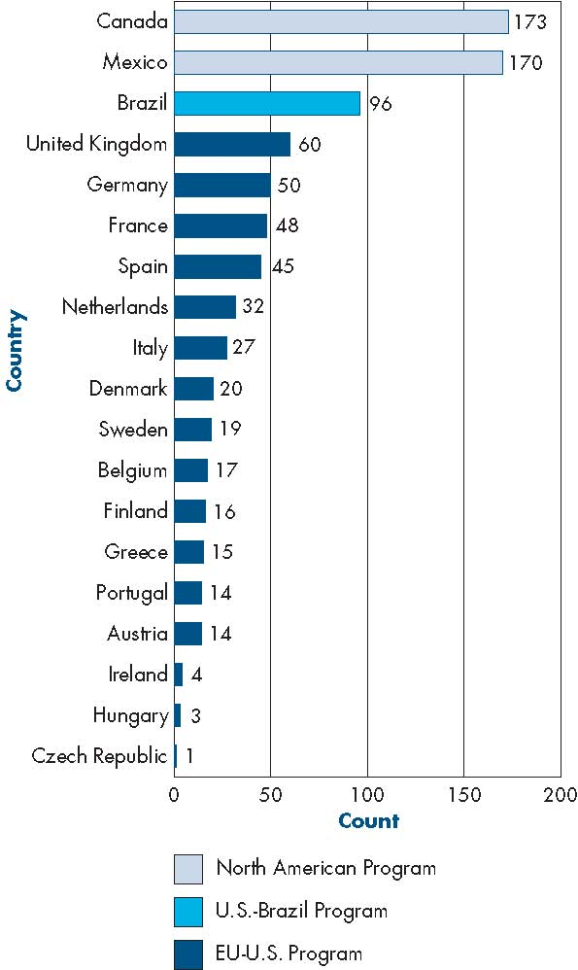

Figure 1 is a stacked bar chart providing the following information:

Figure 1. Participating Non-U.S. Institutions by Program and Country, 1995-2004
Country |  | Program |  |  | Total
 |  | EC-US Cooperation Program | North American Program | US-Brazil Program | Total
 | United Kingdom | 60 | 0 | 0 | 60
 | Sweden | 19 | 0 | 0 | 19
 | Spain | 45 | 0 | 0 | 45
 | Portugal | 14 | 0 | 0 | 14
 | Netherlands | 32 | 0 | 0 | 32
 | Mexico | 0 | 170 | 0 | 170
 | Italy | 27 | 0 | 0 | 27
 | Ireland | 4 | 0 | 0 | 4
 | Hungary | 3 | 0 | 0 | 3
 | Greece | 15 | 0 | 0 | 15
 | Germany | 50 | 0 | 0 | 50
 | France | 48 | 0 | 0 | 48
 | Finland | 16 | 0 | 0 | 16
 | Denmark | 20 | 0 | 0 | 20
 | Czech Republic | 1 | 0 | 0 | 1
 | Canada | 0 | 173 | 0 | 173
 | Brazil | 0 | 0 | 96 | 96
 | Belgium | 17 | 0 | 0 | 17
 | Austria | 14 | 0 | 0 | 14
Total |  | 385 | 343 | 96 | 824

TABLE 5. FIPSE International Programs: Projects by Main Subject Area, 1995–2004
Subject Area | Number | Percent
Environmental Science | 35 | 15.5
Engineering & Technology | 34 | 15.0
Social Science & Public Policy | 33 | 14.6
Business & Economics | 28 | 12.4
Agriculture & Veterinary Science | 23 | 10.2
Vocational Education | 22 | 9.7
Health Sciences & Medicine | 18 | 8.0
Education | 13 | 5.8
Legal & Professional Studies | 11 | 4.9
Arts & Humanities | 6 | 2.7
Natural Sciences | 3 | 1.3
Total | 226 | 100.0
NOTE: Percents may not add to 100 due to rounding.

FIGURE 2. FIPSE International Programs: Percentage of Projects by Main Subject Area, 1995–2004

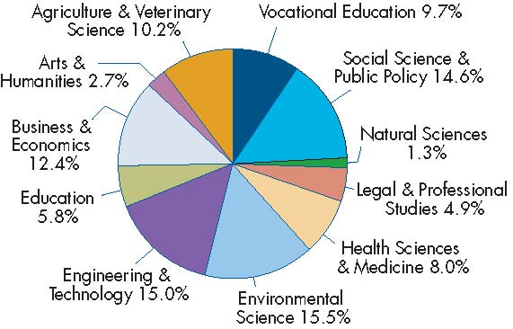
NOTE: Percents may not add to 100 due to rounding.

Figure 2 is a pie chart providing the following information:
Figure 2. FIPSE International Programs: Percentage of Projects by Main Subject Area, 1995-2004
Main Subject Area |  | Number | Percent
 | Environmental Science | 35 | 15.5
 | Engineering & Technology | 34 | 15.0
 | Social Science & Public Policy | 33 | 14.6
 | Business & Economics | 28 | 12.4
 | Agriculture & Veterinary Science | 23 | 10.2
 | Vocational Education | 22 | 9.7
 | Health Sciences & Medicine | 18 | 8.0
 | Education | 13 | 5.8
 | Legal & Professional Studies | 11 | 4.9
 | Arts & Humanities | 6 | 2.7
 | Natural Sciences | 3 | 1.3
 | Total | 226 | 100.0
 | Percentages may not add up to 100 due to rounding.
FIGURE 3. FIPSE International Programs: Projects in Each Program by Main Subject Area, 1995–2004

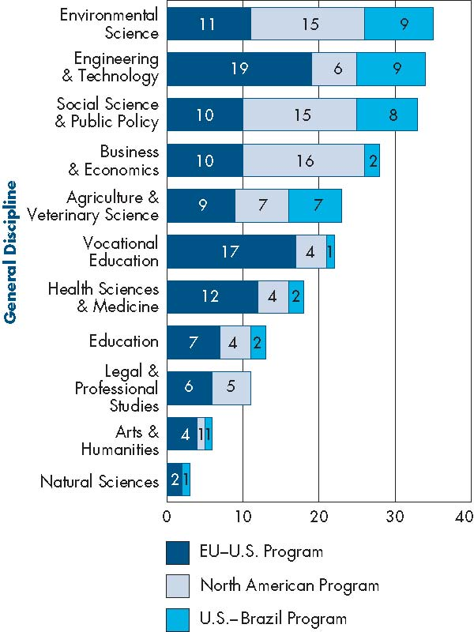
NOTE: Percents may not add to 100 due to rounding.

Figure 3 is a stacked bar chart providing the following information:

Figure 3. FIPSE International Programs: Projects in Each Program by Main Subject Area, 1995-2004
Main Subject Area |  | Program |  |  | Total
 |  | EC-US Cooperation Program | North American Program | US-Brazil Program | Total
 | Vocational Education | 17 | 4 | 1 | 22
 | Social Science & Public Policy | 10 | 15 | 8 | 33
 | Natural Sciences | 2 | 0 | 1 | 3
 | Legal & Professional Studies | 6 | 5 | 0 | 11
 | Health Sciences & Medicine | 12 | 4 | 2 | 18
 | Environmental Science | 11 | 15 | 9 | 35
 | Engineering & Technology | 19 | 6 | 9 | 34
 | Education | 7 | 4 | 2 | 13
 | Business & Economics | 10 | 16 | 2 | 28
 | Arts & Humanities | 4 | 1 | 1 | 6
 | Agriculture & Veterinary Science | 9 | 7 | 7 | 23
Total |  | 107 | 77 | 42 | 226

FIGURE 4. FIPSE International Programs: Percentage of Projects by Main Subject Area and Program, 1995-2004

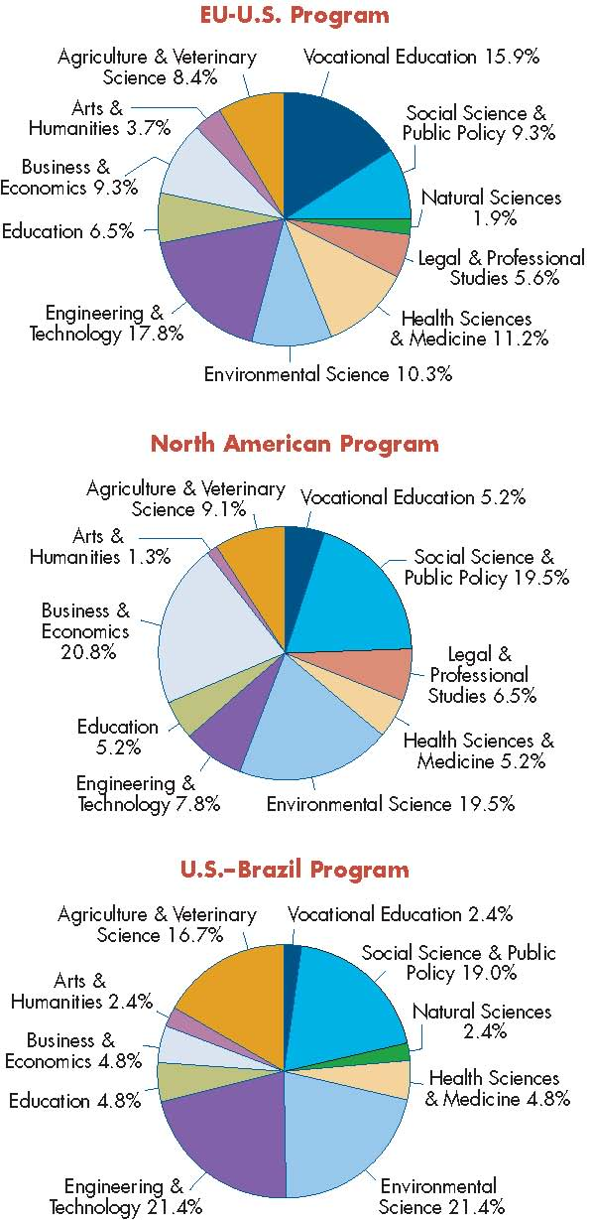

Figure 4 is a series of three pie charts providing the following information:

Figure 4. FIPSE International Programs: Percentage of Projects by Main Subject Area and Program, 1995-2004
Main Subject Area |  | Program |  |  | Total
 |  | EC-US Cooperation Program | North American Program | US-Brazil Program | Total
 | Vocational Education | 15.9% | 5.2% | 2.4% | 9.7%
 | Social Science & Public Policy | 9.3% | 19.5% | 19.0% | 14.6%
 | Natural Sciences | 1.9% | 0.0% | 2.4% | 1.3%
 | Legal & Professional Studies | 5.6% | 6.5% | 0.0% | 4.9%
 | Health Sciences & Medicine | 11.2% | 5.2% | 4.8% | 8.0%
 | Environmental Science | 10.3% | 19.5% | 21.4% | 15.5%
 | Engineering & Technology | 17.8% | 7.8% | 21.4% | 15.0%
 | Education | 6.5% | 5.2% | 4.8% | 5.8%
 | Business & Economics | 9.3% | 20.8% | 4.8% | 12.4%
 | Arts & Humanities | 3.7% | 1.3% | 2.4% | 2.7%
 | Agriculture & Veterinary Science | 8.4% | 9.1% | 16.7% | 10.2%
Total |  | 100.0% | 100.0% | 100.0% | 100.0%
 | Percentages may not add up to 100 due to rounding.

TABLE 6. FIPSE International Programs: Projects by Main Subject Area and Program, 1995–2004
 | Program
 | EU-U.S. Program |  | North American Program |  | U.S.-Brazil Program
Main Subject Area | Number | Percent | Number | Percent | Number | Percent
Environmental Science | 11 | 10.3% | 15 | 19.5% | 9 | 21.4%
Engineering & Technology | 19 | 17.8% | 6 | 7.8% | 9 | 21.4%
Social Science & Public Policy | 10 | 9.3% | 15 | 19.5% | 8 | 19.0%
Business & Economics | 10 | 9.3% | 16 | 20.8% | 2 | 4.8%
Agriculture & Veterinary Science | 9 | 8.4% | 7 | 9.1% | 7 | 16.7%
Vocational Education | 17 | 15.9% | 4 | 5.2% | 1 | 2.4%
Health Sciences & Medicine | 12 | 11.2% | 4 | 5.2% | 2 | 4.8%
Education | 7 | 6.5% | 4 | 5.2% | 2 | 4.8%
Legal & Professional Studies | 6 | 5.6% | 5 | 6.5% | 0 | 0.0%
Arts & Humanities | 4 | 3.7% | 1 | 1.3% | 1 | 2.4%
Natural Sciences | 2 | 1.9% | 0 | 0.0% | 1 | 2.4%
Total | 107 | 100.0% | 77 | 100.0% | 42 | 100.0%
NOTE: Percents may not add to 100 due to rounding.

TABLE 7. FIPSE International Programs: Student Mobility and Involvement, 2004–05 and 2001–05
 | Mobile Students 2004–05 | Mobile Students 2001–05 | Non-Mobile Students 2001–05
U.S. Students | 897 | 1,695 | 5,823
Foreign Students | 939 | 1,863 | 3,367
Total Students | 1,836 | 3,558 | 9,190

TABLE 8. FIPSE International Programs: Student Time Abroad in Weeks, 2004–05
 | Mean | Median | Minimum | Maximum
Brazil to U.S. | 19 | 20 | 12 | 28
Canada to U.S. | 13 | 15 | 1 | 20
EU to U.S. | 13 | 12 | 1 | 54
Mexico to U.S. | 12 | 15 | 2 | 18
U.S. to Brazil | 19 | 20 | 2 | 39
U.S. to Canada | 13 | 15 | 1 | 20
U.S. to EU | 10 | 10 | 1 | 26
U.S. to Mexico | 11 | 14 | 1 | 20

U.S.-BRAZIL PROGRAM
The U.S.-Brazil Higher Education Consortia Program is a grant competition run cooperatively by FIPSE in the United States and the Fundação Coordenação de Aperfeiçoamento de Pessoal de Nível Superior (CAPES) in Brazil. This program funds collaborative consortia of at least two academic institutions from each country for up to four years. The program issues grants in the form of four-year consortia grants and two-year complementary research activities. Total grant amounts for U.S. institutions in each consortium averages about $200,000 for the four-year grants and $75,000 for the two-year grants. Each country supports participating institutions within its borders.
Between 2001 and 2004, the program funded 42 grants involving 194 institutional participants (tables 9 and 10). This includes 98 U.S. institutional and organizational partners in 35 separate U.S. states and territories and over 96 Brazilian institutional and organizational partners in 15 Brazilian states (figures 5 and 6).
Figure 5. U.S.-Brazil Program: Number of Partner Institutions by U.S. State or Territory, 2001-04

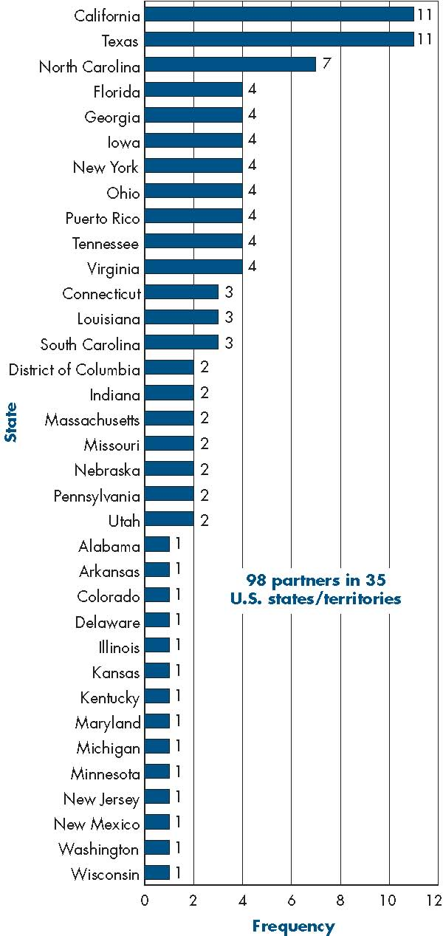

Figure 5 is a stacked bar chart providing the following information:

Figure 5. U.S.-Brazil Number of Partner Institutions by U.S. State or Territory, 2001-04
U.S. State |  | Frequency | Percent | Valid Percent | Cumulative Percent
 | California | 11 | 11.2 | 11.2 | 11.2
 | Texas | 11 | 11.2 | 11.2 | 22.4
 | North Carolina | 7 | 7.1 | 7.1 | 29.6
 | Florida | 4 | 4.1 | 4.1 | 33.7
 | Georgia | 4 | 4.1 | 4.1 | 37.8
 | Iowa | 4 | 4.1 | 4.1 | 41.8
 | New York | 4 | 4.1 | 4.1 | 45.9
 | Ohio | 4 | 4.1 | 4.1 | 50.0
 | Puerto Rico | 4 | 4.1 | 4.1 | 54.1
 | Tennessee | 4 | 4.1 | 4.1 | 58.2
 | Virginia | 4 | 4.1 | 4.1 | 62.2
 | Connecticut | 3 | 3.1 | 3.1 | 65.3
 | Louisiana | 3 | 3.1 | 3.1 | 68.4
 | South Carolina | 3 | 3.1 | 3.1 | 71.4
 | District of Columbia | 2 | 2.0 | 2.0 | 73.5
 | Indiana | 2 | 2.0 | 2.0 | 75.5
 | Massachusetts | 2 | 2.0 | 2.0 | 77.6
 | Missouri | 2 | 2.0 | 2.0 | 79.6
 | Nebraska | 2 | 2.0 | 2.0 | 81.6
 | Pennsylvania | 2 | 2.0 | 2.0 | 83.7
 | Utah | 2 | 2.0 | 2.0 | 85.7
 | Alabama | 1 | 1.0 | 1.0 | 86.7
 | Arkansas | 1 | 1.0 | 1.0 | 87.8
 | Colorado | 1 | 1.0 | 1.0 | 88.8
 | Delaware | 1 | 1.0 | 1.0 | 89.8
 | Illinois | 1 | 1.0 | 1.0 | 90.8
 | Kansas | 1 | 1.0 | 1.0 | 91.8
 | Kentucky | 1 | 1.0 | 1.0 | 92.9
 | Maryland | 1 | 1.0 | 1.0 | 93.9
 | Michigan | 1 | 1.0 | 1.0 | 94.9
 | Minnesota | 1 | 1.0 | 1.0 | 95.9
 | New Jersey | 1 | 1.0 | 1.0 | 96.9
 | New Mexico | 1 | 1.0 | 1.0 | 98.0
 | Washington | 1 | 1.0 | 1.0 | 99.0
 | Wisconsin | 1 | 1.0 | 1.0 | 100.0
 | Total | 98 | 100.0 | 100.0
 | 98 partners in 35 U.S. states/territories
Figure 6. U.S.-Brazil Program: Number of Partner Institutions by Brazilian State, 2001-2004

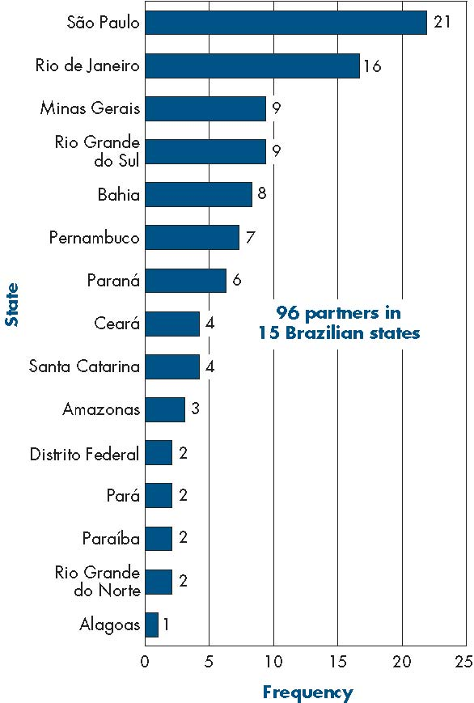

Figure 6 is a stacked bar chart providing the following information:

Figure 6. U.S.-Brazil Program: Number of Partner Institutions by Brazilian State, 2001-04
Brazilian State |  | Frequency | Percent | Valid Percent | Cumulative Percent
 | São Paulo | 21 | 21.9 | 21.9 | 21.9
 | Rio de Janeiro | 16 | 16.7 | 16.7 | 38.5
 | Minas Gerais | 9 | 9.4 | 9.4 | 47.9
 | Rio Grande do Sul | 9 | 9.4 | 9.4 | 57.3
 | Bahia | 8 | 8.3 | 8.3 | 65.6
 | Pernambuco | 7 | 7.3 | 7.3 | 72.9
 | Paraná | 6 | 6.3 | 6.3 | 79.2
 | Ceará | 4 | 4.2 | 4.2 | 83.3
 | Santa Catarina | 4 | 4.2 | 4.2 | 87.5
 | Amazonas | 3 | 3.1 | 3.1 | 90.6
 | Distrito Federal (BR) | 2 | 2.1 | 2.1 | 92.7
 | Pará | 2 | 2.1 | 2.1 | 94.8
 | Paraíba | 2 | 2.1 | 2.1 | 96.9
 | Rio Grande do Norte | 2 | 2.1 | 2.1 | 99.0
 | Alagoas | 1 | 1.0 | 1.0 | 100.0
 | Total | 96 | 100.0 | 100.0
 | 96 partners in 15 Brazilian states

TABLE 9. U.S.-Brazil Program: Projects Co-Funded with CAPES, 2001–04
42 Consortia
98 U.S. Institutions/Departments
96 Brazilian Institutions/Departments
35 U.S. States/Territories
15 Brazilian States/Territories

TABLE 10. U.S.-Brazil Program: Partner Institutions, 2001–04
 | Duplicated | Unduplicated
U.S. | 98 | 81
Brazil | 96 | 49
Total | 194 | 130

FOCUS AREAS
As part of the activities of the U.S.-Brazil Program, participating institutions set up agreements to create curricula that incorporate a U.S.-Brazil approach. Students, therefore, benefit by taking coursework at their home institution that has incorporated an international dimension. A wide array of topics is represented under these larger subject areas, including, but not limited to, projects on the African Diaspora to agroecology, coastal and ocean management, petroleum engineering, and
biotechnology (table 11). As demonstrated in figure 7, the greatest numbers of projects are in environmental science and in engineering and technology, each representing approximately 21 percent of all projects funded from 2001 to 2004. Social science and public policy represents approximately 19 percent of the total projects.

STUDENT MOBILITY: U.S.-BRAZIL PROGRAM

Since the first students began traveling in August 2002, 815 U.S. and Brazilian students have spent an average of a semester-long stay (19 weeks) abroad. The balance of mobility between students in the United States and those in Brazil is close, with the Brazil sending 407 students to the United States and the United States sending 408 students to Brazil.
TABLE 11. U.S.-Brazil Program: Sample Topic Area
African Diaspora Studies
Agribusiness
Biosystems and Agricultural Engineering
Biotechnology
Coastal and Ocean Management
Community Development
Comparative Public Policy
Control and Dynamical Systems
Disability Studies
Environmental Engineering
Film Studies
Forestry and Wetlands Management
Geological Sciences
Globalization
Health Policy
Industrial Engineering
Infectious Diseases
International Entrepreneurship
International Trade
Manufacturing and Global Security
Manufacturing Engineering
Marine and Coastal Management
Petroleum Engineering
Race and Ethnicity Studies
Ruminant Livestock
Sustainable Development
Teacher Education
Veterinary Medicine
NOTE: Percents may not add to 100 due to rounding.

FIGURE 7. U.S.-Brazil Program: Percentage of Projects by Main Subject Area, 2001–04

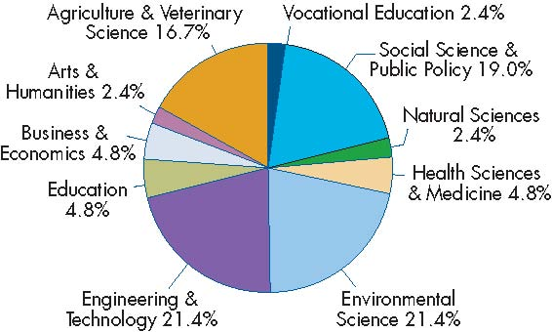

Figure 7 is a pie chart providing the following information:
Figure 7. U.S.-Brazil Program: Percentage of Projects by Main Subject Area, 2001-04
Subject Area |  | Percent
 | Environmental Science | 21.4
 | Social Science & Public Policy | 19.0
 | Engineering & Technology | 21.4
 | Agriculture & Veterinary Science | 16.7
 | Education | 4.8
 | Vocational Education | 2.4
 | Health Sciences & Medicine | 4.8
 | Business & Economics | 4.8
 | Arts & Humanities | 2.4
 | Natural Sciences | 2.4
 | Total | 100.0
 | Percentages may not add up to 100 due to rounding.

FIGURE 8. U.S.-Brazil Program: Student Mobility,
2004–05 and 2002–05
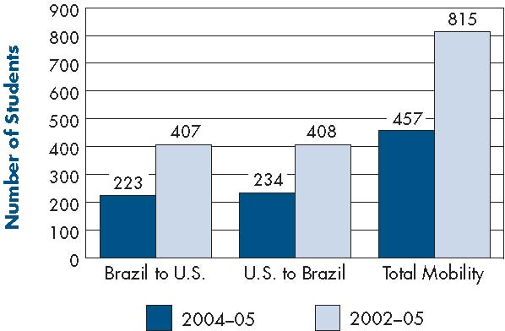

Figure 8 is a clustered column chart providing the following information:
 | Figure 8. U.S.-Brazil Program: Student Mobility, 2004-05 and 2002-05
Exchange Countries |  | Students 2004-2005 |  | Students 2002-2005 |  | Students Non Mobile 2002-2005
 |  | Sum | Mean | Sum | Mean | Sum | Mean
 | Brazil to US | 223 | 7 | 407 | 14 | 433 | 14
 | US to Brazil | 234 | 7 | 408 | 14 | 369 | 12
 | Total | 457 | 7 | 815 | 14 | 802 | 13

FIGURE 9. U.S.-Brazil Program: Duration of Student Time Abroad, 2002–05
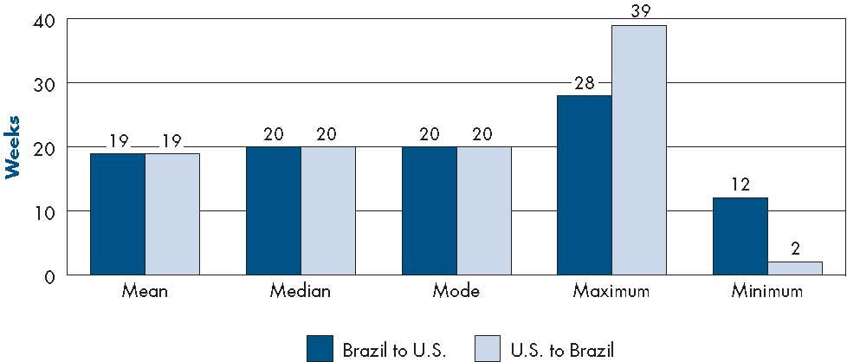

Figure 9 is a clustered column chart providing the following information:

Figure 9. U.S.-Brazil Program: Duration of Student Time Abroad, 2002-05
Exchange Countries | Mean | Median | Mode | Maximum | Minimum
Brazil to US | 19 | 19 | 20 | 28 | 12
US to Brazil | 18 | 20 | 20 | 39 | 2

EU-U.S. PROGRAM

The EU-U.S. Program is a grant competition conducted cooperatively by FIPSE in the United States and the European Commission’s Directorate General for Education and Culture (DG EAC). Consortia generally consist of six postsecondary institutions from three member states in the European Union (funded by DG EAC) and three from the United States (funded by FIPSE). The program awards grants in the form of three-year implementation grants, two-year complementary activities grants, and one-year preparatory grants. Total grant amounts for each U.S. consortium average about $210,000 for three-year grants, $80,000 for two-year grants, and $25,000 for one-year grants.
Between 1996 and 2004, the program funded 107 consortia involving 726 institutional participants (table 12). These include 341 U.S. institutional and organizational partners in 46 U.S. states and territories and 385 European institutions and organizations in 16 EU member states (table 13 and figures 10 and 11).

Figure 10. EU-U.S. Program: Number of Partner Institutions by U.S. State or Territory, 1996-2004

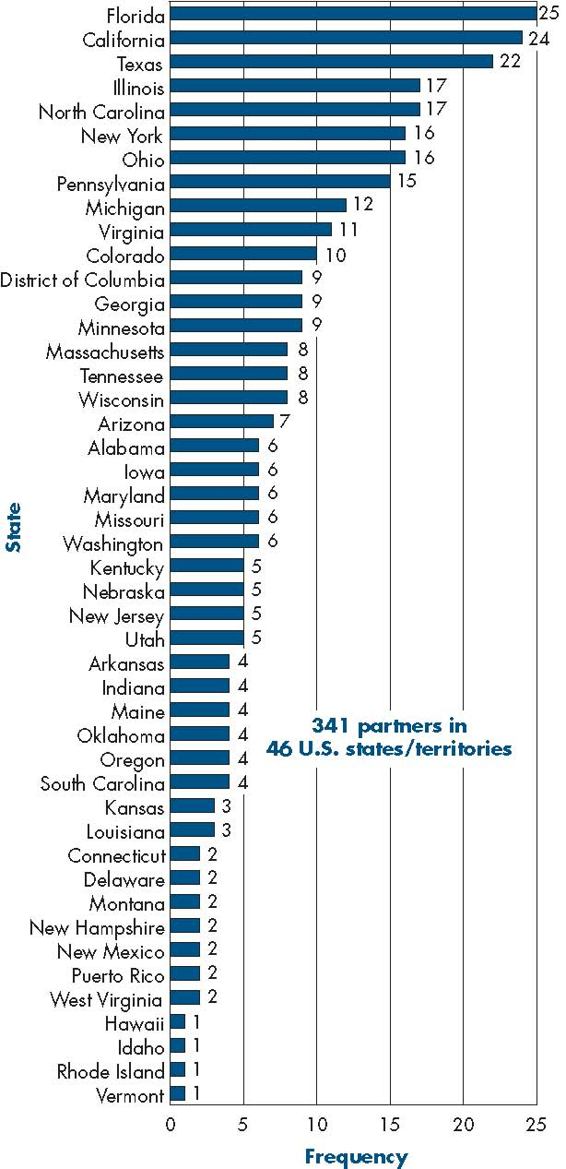

Figure 10 is a stacked bar chart providing the following information:
Figure 10. EU-U.S. Program: Number of Partner Institutions by U.S. State and Territory, 1996-2004
State |  | Frequency
 | Florida | 25
 | California | 24
 | Texas | 22
 | Illinois | 17
 | North Carolina | 17
 | New York | 16
 | Ohio | 16
 | Pennsylvania | 15
 | Michigan | 12
 | Virginia | 11
 | Colorado | 10
 | District of Columbia | 9
 | Georgia | 9
 | Minnesota | 9
 | Massachusetts | 8
 | Tennessee | 8
 | Wisconsin | 8
 | Arizona | 7
 | Alabama | 6
 | Iowa | 6
 | Maryland | 6
 | Missouri | 6
 | Washington | 6
 | Kentucky | 5
 | Nebraska | 5
 | New Jersey | 5
 | Utah | 5
 | Arkansas | 4
 | Indiana | 4
 | Maine | 4
 | Oklahoma | 4
 | Oregon | 4
 | South Carolina | 4
 | Kansas | 3
 | Louisiana | 3
 | Connecticut | 2
 | Delaware | 2
 | Montana | 2
 | New Hampshire | 2
 | New Mexico | 2
 | Puerto Rico | 2
 | West Virginia | 2
 | Hawaii | 1
 | Idaho | 1
 | Rhode Island | 1
 | Vermont | 1
 | Total | 341
341 partners in 46 U.S. states/territories
Figure 11. EU-U.S. Program: Number of Partner Institutions by EU Member State, 1996-2004

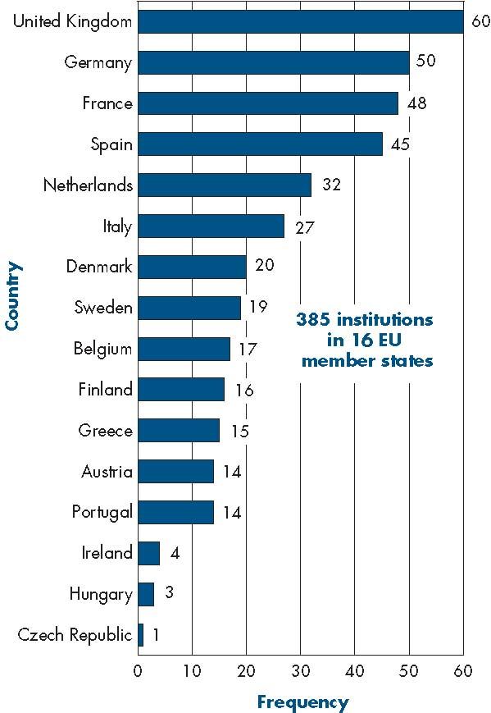

Figure 11 is a stacked bar chart providing the following information:

Figure 11. EU-U.S. Program: Number of Partner Institutions by EU Member State, 1996-2004
EU Member State |  | Frequency | Percent | Valid Percent | Cumulative Percent
 | United Kingdom | 60 | 15.6 | 15.6 | 15.6
 | Germany | 50 | 13.0 | 13.0 | 28.6
 | France | 48 | 12.5 | 12.5 | 41.0
 | Spain | 45 | 11.7 | 11.7 | 52.7
 | Netherlands | 32 | 8.3 | 8.3 | 61.0
 | Italy | 27 | 7.0 | 7.0 | 68.1
 | Denmark | 20 | 5.2 | 5.2 | 73.2
 | Sweden | 19 | 4.9 | 4.9 | 78.2
 | Belgium | 17 | 4.4 | 4.4 | 82.6
 | Finland | 16 | 4.2 | 4.2 | 86.8
 | Greece | 15 | 3.9 | 3.9 | 90.6
 | Austria | 14 | 3.6 | 3.6 | 94.3
 | Portugal | 14 | 3.6 | 3.6 | 97.9
 | Ireland | 4 | 1.0 | 1.0 | 99.0
 | Hungary | 3 | 0.8 | 0.8 | 99.7
 | Czech Republic | 1 | 0.3 | 0.3 | 100.0
 | Total | 385 | 100.0 | 100.0
 | 385 institutions in 16 EU member states

Table 12. Projects Co-Funded with the European Commission, 1996-2004
107 Consortia
341 U.S. Institutions/Departments
385 EU Institutions/Departments
46 U.S. States/Territories
16 EU Member States

TABLE 13. EU-U.S. Number of Participating Institutions,
1996–2004
 | Duplicated | Unduplicated
U.S. | 341 | 230
EU | 385 | 304
Total | 726 | 534

FOCUS AREAS
As part of the activities of the EU-U.S. Program, participating institutions set up agreements to create curric-ula that integrate transatlantic topics and viewpoints. Students derive the greatest benefits from a program of study that includes both continuity and new approaches as they transition from home to foreign institution and back again. A wide array of topics is represented under these larger subject areas, including, but not limited to, aerospace engineering, agribusiness, biotechnology, and international law (table 14). As demonstrated in figure 12, the greatest number of projects is in engineering and technology, representing approximately 18 percent of all projects funded from 1996 through 2004. Vocational education, at about 16 percent, represents the second largest category.

STUDENT MOBILITY: EU-U.S. PROGRAM
Since 2000, 1,904 U.S. and European students together have spent an average of between 10–13 weeks abroad (figures 13 and 14). The balance of mobility between students in the United States and those in Europe is roughly equivalent, with Europe sending 1,037 students to the United States and the United States sending 959 students to Europe.

TABLE 14. EU-U.S. Program: Sample Topic Areas
Aerospace Engineering
Agribusiness
Air Quality Studies
Automotive Engineering
Biotechnology
Comparative Politics
Computer Science/Information Technology
Construction Training
Disability Studies
Earth Imaging
Educational Technology
Entrepreneurship
Geography
Health Care Policy
Horticulture
Hospitality & Tourism
Information Technology
International Law
Journalism
Marine Sciences
Mechanical Engineering
Migration and Ethnic Studies
Music Education
Pharmacology
Regional Development and Planning
Robotics
Teacher Education
Transportation Technology
Urban Planning and Environment
Veterinary Medicine
FIGURE 12. EU-U.S. Program: Main Subject Area of Projects, 1996–2004

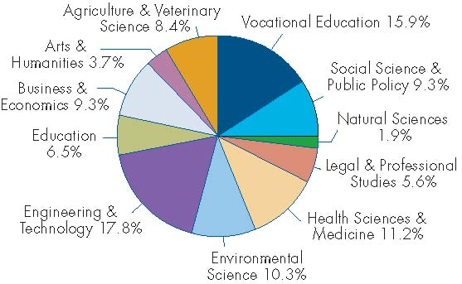
NOTE: Percents may not add to 100 due to rounding.

Figure 12 is a pie chart providing the following information:
Figure 12. EU-U.S. Program: Main Subject Area of Projects 1996-2004
Subject Area |  | Percent
 | Engineering & Technology | 17.8
 | Vocational Education | 5.9
 | Health Sciences & Medicine | 11.2
 | Environmental Science | 10.3
 | Social Science & Public Policy | 9.3
 | Business & Economics | 9.3
 | Agriculture & Veterinary Science | 8.4
 | Education | 6.5
 | Legal & Professional Studies | 5.6
 | Arts & Humanities | 3.7
 | Natural Sciences | 1.9
 | Total | 100.0
Percents may not add to 100 due to rounding.
FIGURE 13. EU-U.S. Student Mobility: Most Recent Year
(2004–05) and 2000–05

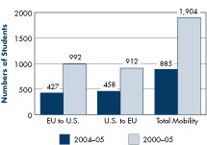

Figure 13 is a clustered column chart providing the following information:

Figure 13. EU-U.S. Student Mobility: Most recent year (2004-05) and 2000-05
 | Exchange Countries | 2004-2005 | 2000-2005
 | EU to U.S. | 427 | 992
 | U.S. to EU | 458 | 912
 | Total Mobility | 885 | 1,904

FIGURE 14. EU-U.S. Program: Duration of Student Time Abroad, 2004–05

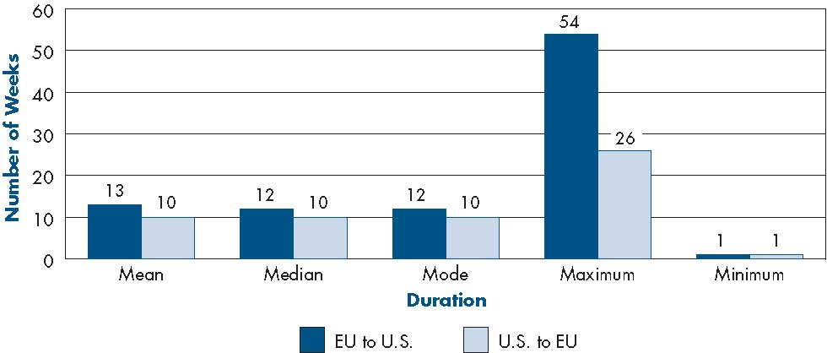

Figure 14 is a clustered column chart providing the following information:

Figure 14. EU-U.S. Duration of Student Time Abroad, 2004-05
 |  | Exchange Countries | Mean | Median | Mode | Maximum | Minimum
 |  | EU to U.S. | 13 | 12 | 12 | 54 | 1
 |  | U.S. to EU | 10 | 10 | 10 | 26 | 1

PROGRAM FOR NORTH AMERICAN MOBILITY
The Program for North American Mobility in Higher Education is a grant competition run cooperatively by the U.S. Department of Education’s Fund for the Improvement of Postsecondary Education (FIPSE), Secretaría de Educación Pública (SEP) in Mexico, and Human Resources and Skills Development (HRSD) in Canada. This program funds collaborative consortia of at least two academic institutions from each country for up to four years. The program issues grants in the format of four-year consortia grants. Total grant amounts for each U.S. consortium averages about $210,000 for four-year grants.
Between 1995 and 2004, the program funded 77 consortia involving 519 institutional and departmental participants. This includes 176 U.S. institutions/departments in 41 U.S. states, 170 institutions in 28 Mexican states, and 173 Canadian institutions/departments in 10 Canadian provinces (tables 15 and 16 and figures 15, 16, and 17).
FIGURE 15. North American Program: Number of Partner Institutions by U.S. State and Territory, 1995–2004

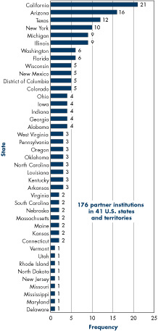

Figure 15 is a stacked bar chart providing the following information:
Figure 15. North American Program: Number of Partner Institutions by U.S. State and Territory, 1995-2004
 | State | Number
 | California | 21
 | Arizona | 16
 | Texas | 12
 | New York | 10
 | Michigan | 9
 | Illinois | 9
 | Washington | 6
 | Florida | 6
 | Wisconsin | 5
 | New Mexico | 5
 | District of Columbia | 5
 | Colorado | 5
 | Ohio | 4
 | Iowa | 4
 | Indiana | 4
 | Georgia | 4
 | Alabama | 4
 | West Virginia | 3
 | Pennsylvania | 3
 | Oregon | 3
 | Oklahoma | 3
 | North Carolina | 3
 | Louisiana | 3
 | Kentucky | 3
 | Arkansas | 3
 | Virginia | 2
 | South Carolina | 2
 | Nebraska | 2
 | Massachusetts | 2
 | Maine | 2
 | Kansas | 2
 | Connecticut | 2
 | Vermont | 1
 | Utah | 1
 | Rhode Island | 1
 | North Dakota | 1
 | New Jersey | 1
 | Missouri | 1
 | Mississippi | 1
 | Maryland | 1
 | Delaware | 1
 | Total | 176
 | 176 partner institutions in 41 U.S. states and territories

FIGURE 16. North American Program: Number of Partner Institutions by Mexican State, 1995–2004
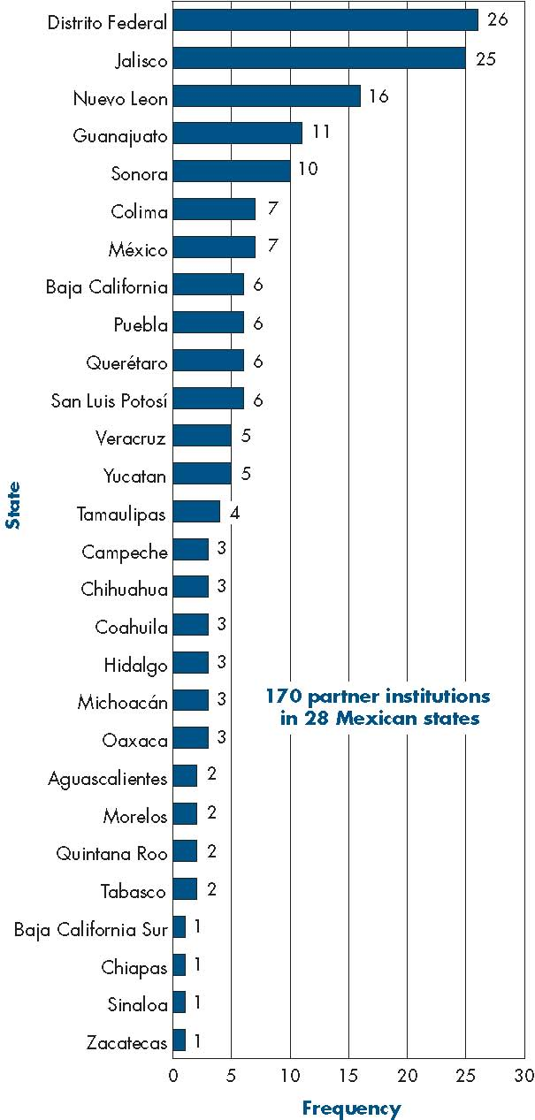

Figure 16 is a stacked bar chart providing the following information:
Figure 16. North American Program: Number of Partner Institutions
by Mexican State, 1995-2004
State |  | Frequency | Percent | Valid Percent | Cumulative Percent
 | Baja California Sur | 1 | 0.6 | 0.6 | 0.6
 | Chiapas | 1 | 0.6 | 0.6 | 1.2
 | Sinaloa | 1 | 0.6 | 0.6 | 1.8
 | Zacatecas | 1 | 0.6 | 0.6 | 2.4
 | Aguascalientes | 2 | 1.2 | 1.2 | 3.5
 | Morelos | 2 | 1.2 | 1.2 | 4.7
 | Quintana Roo | 2 | 1.2 | 1.2 | 5.9
 | Tabasco | 2 | 1.2 | 1.2 | 7.1
 | Campeche | 3 | 1.8 | 1.8 | 8.8
 | Chihuahua | 3 | 1.8 | 1.8 | 10.6
 | Coahuila | 3 | 1.8 | 1.8 | 12.4
 | Hidalgo | 3 | 1.8 | 1.8 | 14.1
 | Michoacan | 3 | 1.8 | 1.8 | 15.9
 | Oaxaca | 3 | 1.8 | 1.8 | 17.6
 | Tamaulipas | 4 | 2.4 | 2.4 | 20.0
 | Veracruz | 5 | 2.9 | 2.9 | 22.9
 | Yucatan | 5 | 2.9 | 2.9 | 25.9
 | Baja California | 6 | 3.5 | 3.5 | 29.4
 | Puebla | 6 | 3.5 | 3.5 | 32.9
 | Querétaro | 6 | 3.5 | 3.5 | 36.5
 | San Luis Potosí | 6 | 3.5 | 3.5 | 40.0
 | Colima | 7 | 4.1 | 4.1 | 44.1
 | Mexico | 7 | 4.1 | 4.1 | 48.2
 | Sonora | 10 | 5.9 | 5.9 | 54.1
 | Guanajuato | 11 | 6.5 | 6.5 | 60.6
 | Nuevo Leon | 16 | 9.4 | 9.4 | 70.0
 | Jalisco | 25 | 14.7 | 14.7 | 84.7
 | Distrito Federal | 26 | 15.3 | 15.3 | 100.0
 | Total | 170 | 100.0 | 100.0
170 partner institutions in 28 Mexican states

TABLE 15. Projects Co-Funded with HRSD-Canada and SEP, Mexico, 1995–2004
78 Consortia
176 U.S. Institutions/Departments
173 Canadian Institutions/Departments
170 Mexican Institutions/Departments
41 U.S. States/Territories
28 Mexican States
10 Canadian Provinces

TABLE 16. North American Program: Number of Participating Institutions, 1995–2004
 | Duplicated | Unduplicated
U.S. | 176 | 123
Mexico | 170 | 56
Canada | 173 | 68
Total | 519 | 247

FOCUS AREAS

As part of the activities of the North American Program, participating institutions set up agreements to create curricula that incorporate a North American approach. Students benefit by taking a program of study at their home and host institutions incorporating a North American dimension. A wide array of topics is represented under these larger subject areas, including, but not limited to, community nursing, water resource management, food safety, and North American legal studies (table 17). The greatest number of projects is in business and economics, representing approximately 21 percent of all projects funded from 1995 through 2004 (figure 18). Social science and public policy, and environmental science, each at about 20 percent, represent the second largest categories.

STUDENT MOBILITY: NORTH AMERICA PROGRAM
Since 2001, 1,176 students from the United States, Canada, and Mexico have spent an average of about
13 weeks abroad. Mobility between the United States and Mexico is
the most active, with 292 Mexican students traveling to the United States and 267 U.S. students traveling to Mexico since 2001.
The second most active area of mobility is between Canada and Mexico (figures 19 and 20).

TABLE 17. North American Program: Sample Topic Areas
Accounting
Agribusiness
Architecture & Cultural Studies
Civic Education
Community Nursing
Computer Systems Technology
Disability Studies
Ecotourism
Entrepreneurship
Environmental Engineering
Ethics
Food Safety
Hospitality & Tourism
Information Technology
Interior Design
International Trade
Journalism
North American Legal Studies
Management
Marine Science
Mining Engineering
Rural Development
Small & Medium Sized Business
Teacher Education
Urban Studies
Veterinary Medicine
Water Resource Management

FIGURE 17. North American Program: Number of Partner Institutions by Canadian Province, 1995–2004

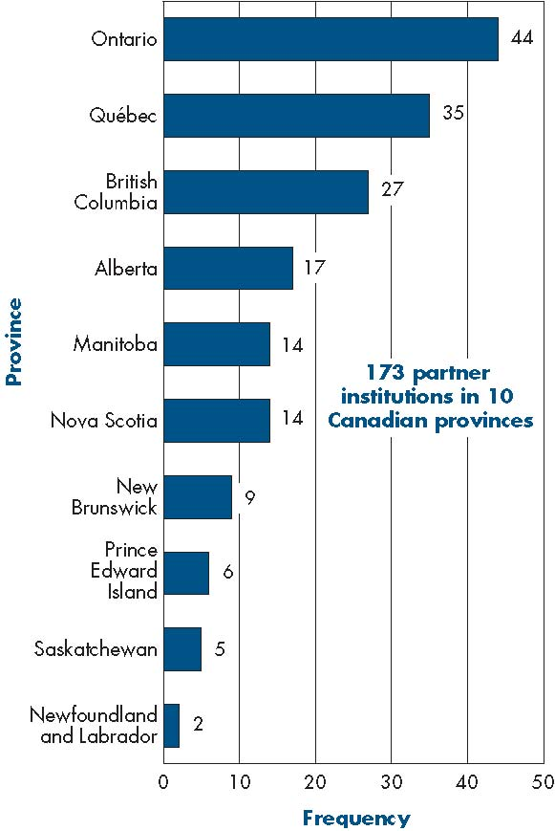

Figure 17 is a stacked bar chart that provides the following information:
Figure 17. North American Program: Number of Partner Institutions by Canadian Province, 1995-2004
State |  | Frequency | Percent | Valid Percent | Cumulative Percent
 | Newfoundland and Labrador | 2 | 1.2 | 1.2 | 1.2
 | Saskatchewan | 5 | 2.9 | 2.9 | 4.0
 | Prince Edward Island | 6 | 3.5 | 3.5 | 7.5
 | New Brunswick | 9 | 5.2 | 5.2 | 12.7
 | Manitoba | 14 | 8.1 | 8.1 | 20.8
 | Nova Scotia | 14 | 8.1 | 8.1 | 28.9
 | Alberta | 17 | 9.8 | 9.8 | 38.7
 | British Columbia | 27 | 15.6 | 15.6 | 54.3
 | Québec | 35 | 20.2 | 20.2 | 74.6
 | Ontario | 44 | 25.4 | 25.4 | 100.0
 | Total | 173 | 100.0 | 100.0
173 partner institutions in 10 Canadian provinces

FIGURE 18. North American Program: Main Subject Area of Projects, 1995–2004

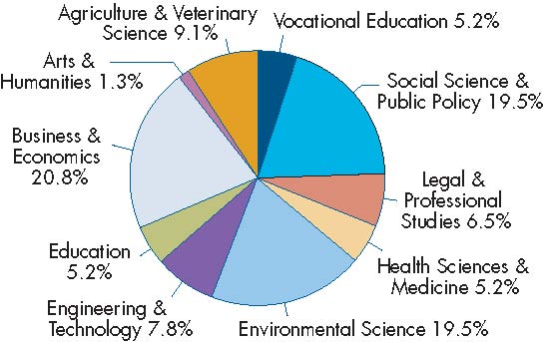
NOTE: Percents may not add to 100 due to rounding.

Figure 18 is a pie chart that provides the following information:

Figure 18. North American Program: Main Subject Area of Projects, 1995-2004
Subject Area |  | Frequency | Percent | Valid Percent | Cumulative Percent
 | Business & Economics | 16 | 20.8 | 20.8 | 20.8
 | Social Science & Public Policy | 15 | 19.5 | 19.5 | 40.3
 | Environmental Science | 15 | 19.5 | 19.5 | 59.7
 | Agriculture & Veterinary Science | 7 | 9.1 | 9.1 | 68.8
 | Engineering & Technology | 6 | 7.8 | 7.8 | 76.6
 | Legal & Professional Studies | 5 | 6.5 | 6.5 | 83.1
 | Vocational Education | 4 | 5.2 | 5.2 | 88.3
 | Education | 4 | 5.2 | 5.2 | 93.5
 | Health Sciences & Medicine | 4 | 5.2 | 5.2 | 98.7
 | Arts & Humanities | 1 | 1.3 | 1.3 | 100.0
 | Total | 77 | 100.0 | 100.0
Percents may not add to 100 due to rounding

FIGURE 19. North American Student Mobility: Most Recent Year (2004–05) and 2001–05

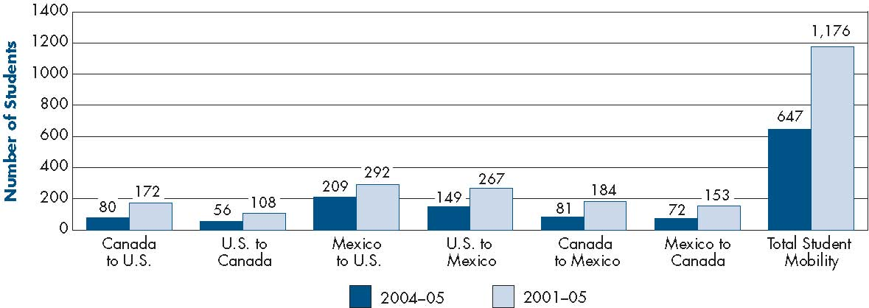

Figure 19 is a clustered column chart that provides the following information:

Figure 19. North American Student Mobility: Most Recent Year (2004-05) and 2001-05
 |  | Exchange Countries | 2004-2005 | 2001-2005
 |  | Canada to U.S. | 80 | 172
 |  | U.S. to Canada | 56 | 108
 |  | Mexico to U.S. | 209 | 292
 |  | U.S. to Mexico | 149 | 267
 |  | Canada to Mexico | 81 | 184
 |  | Mexico to Canada | 72 | 153
 |  | Total Student Mobility | 647 | 1176

FIGURE 20. North American Program: Duration of Student Time Abroad, 2004–05
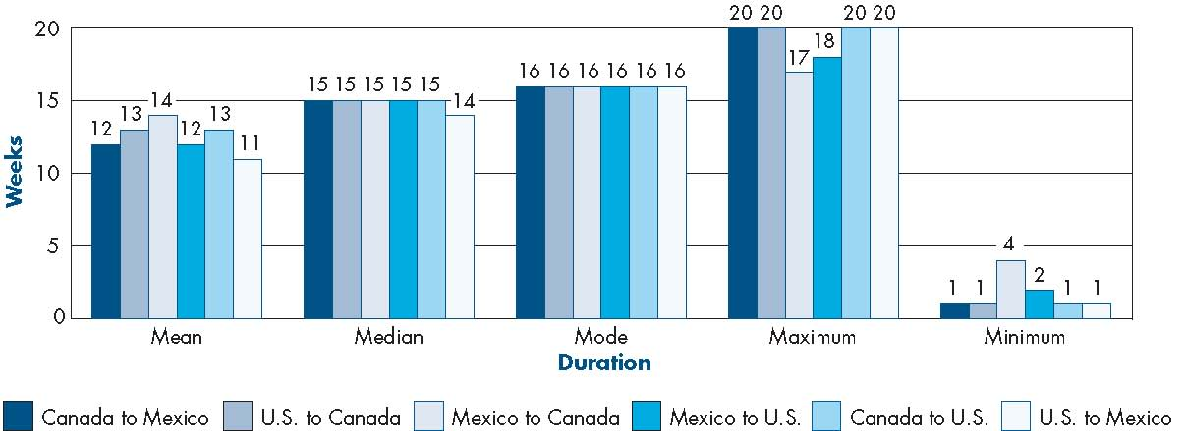

Figure 20 is a clustered bar column chart that provides the following information:

Figure 20. North American Program: Duration of Student Time Abroad, 2004-05
Exchange Countries
 |  | Mean | Median | Mode | Maximum | Minimum
 | Canada to Mexico | 12 | 15 | 16 | 20 | 1
 | Canada to US | 13 | 15 | 16 | 20 | 1
 | Mexico to Canada | 14 | 15 | 16 | 17 | 4
 | Mexico to US | 12 | 15 | 16 | 18 | 2
 | US to Canada | 13 | 15 | 16 | 20 | 1
 | US to Mexico | 11 | 14 | 16 | 20 | 1
End of document.

