U.S. Department of Education



EDStart Corporate Onboarding
Roles and Responsibilities Toolkit

1.0 Introduction

The Department of Education’s (ED) Corporate Onboarding Process is designed to provide guidelines and useful tools for the Human Capital and Client Services (HCCS) Office (FSA – Human Resource (HR) Office) and the Principal Offices (POs) to use as they support new employees from the day they accept their job offer through their first year with the Department. This corporate process will be implemented across the entire Department to consistently meet the needs of the New Hires (NHs) while allowing each PO to create, expand and execute its own special brand of onboarding.

Two new roles have emerged in support of the Corporate Onboarding Process:

- The Concierge, an HCCS Specialist (FSA – HR Specialist) assigned to guide a NH in areas related to HCCS (FSA – HR) processes
- The Ambassador, an employee selected by the NH’s Principal Office who will provide guidance in areas specific to ED, the PO and the NH’s position
This document provides tools and guidance for both the Concierge and the Ambassador. In addition, a checklist for the NH’s Supervisor has been included to ensure clarity relative to responsibilities for ED’s Corporate Onboarding process. Finally, checklists are provided for the NH. These checklists are designed to communicate the practical steps required for successful onboarding and to empower the NH to proactively seek support and assistance as needed.

The toolkit document is organized as follows:

Section | Title | Page
1.0 | Introduction | 2
2.0 | Concierge | 3
3.0 | Ambassador | 9
4.0 | Supervisor | 14
5.0 | New Hire | 19
Appendices | A – Concierge Assignment Tracking Table | 28
Appendices | B – Welcome Letter Template Draft | 29

2.0 Concierge

Introduction

Concierge Definition:
The Concierge is a Human Resources professional who is assigned to guide the New Hire (NH) in areas related to Human Capital and Client Services (HCCS) (FSA – HR) processes. The Concierge is available to assist the NH from the day he/she accepts the offer through the first twelve months of employment.

Concierge Responsibilities:
- Serves as the NH’s primary point of contact for HCCS (FSA – HR Office), providing contact information for questions and concerns that are not specific to POs
- Provides assistance to the NH on the completion of their checklist and ensures the NH is receiving the support needed to complete the activities on the checklist until it has been completed
- Proactively connects with the NH from the date of offer acceptance until thirty days after Entry on Duty (EOD)
  - Answers questions
  - Provides contact information to obtain additional/specific information
  - Offers resources
- After 30 days post-EOD, serves as a responsive resource to the NH, and proactively contacts the NH quarterly throughout the employee’s first 12 months

Characteristics of a Concierge
- Detail-oriented
- Proactive
- Strong communication skills
- Strong understanding of HR processes
- Responsible (follows through on requests)
- Tenacious (willingness to locate contacts and “find” answers for questions that can not be answered easily)
- Champion of the Department of Education
- Dedicated to successfully welcoming and onboarding new employees

EDStart Concierge Checklist

New Hire Name______________________________________________________

New Hire Personal Email Address_______________________________________

New Hire Contact Phone #_____________________________________________

New Hire EOD Date___________________________________________________

New Hire Principal Office (PO) _________________________________________

Talent Recruitment and Hiring (TRH) Specialist____________________________
(FSA – HR Specialist)

New Hire’s Ambassador Name_________________________________________

Ambassador PO_____________________________________________________

New Hire’s Supervisor Name ___________________________________________

Concierge Checklist
Step # | Step Description | Status | Notes
Preparing to Onboard
1 | Attend Concierge Training
2 | Review EDStart Roles and Responsibilities
3 | Review Concierge checklist / Understand Concierge role
(A) Pre-Arrival Steps – Day of Offer Acceptance
4 | Email PO’s Executive Officer (EXO): “Please assign an Ambassador”, cc: Supervisor |  | Include NH Information:  - Name  - Contact phone, email  - Appt type  - Position Title  - Offer Date  - Acceptance Date
(B) Post-Offer Steps – One Week After Offer Acceptance
5 | - Contact New Hire (NH) and ask if Offer Packet was received  - Inform NH that he/she will be receiving a Welcome Packet |  | Offer Packet for STEP < 1 year, Summer Hires and information for Student Volunteers does not include Benefits Forms.
6 | - If Offer Packet was not received, follow up with TRH Specialist (FSA – HR Specialist) to resend Offer Packet  - Confirm address
7 | Retrieve PO-specific Welcome Packet material from Concierge shared drive
8 | Retrieve location-specific and generic onboarding info from Concierge shared drive
(C-1) Pre-EOD Steps – 2-3 Weeks Before EOD
9 | Send Welcome Packet to NH |  | - Welcome Letter  - EDStart Roadmap  - New Hire Checklist  - EDStart Logistics Document (one document per location with information on transportation, parking, address, location of EDStart room, and any other logistical information)  - Local Information (area restaurants, sites, attractions, relevant area information)  - PO-specific information (from Concierge shared drive)
10 | Contact NH to follow up on Welcome Packet |  | - Ensure that the NH has received the benefits and security forms and understands when they should be returned  - Point out the Welcome Packet’s “checklist” of forms to complete and submit to HCCS (FSA – HR Office) and Security  - Ensure that NH has visited EDStart Online and other ed.gov sites to learn more about the Department of Education (ED)
11 | - Serve as the NH’s primary point of contact to answer questions for non-PO questions (one-stop shopping)  - Continue from date NH accepts offer through first 12 months of employment |  | - Contact appropriate HCCS (FSA – HR Office) or Security office to find answers for NH  - Provide NH responses and/or contact information within 1 business day  - If you need more time, respond to the NH and tell them when they can expect an answer/follow-up from you
(C-2) Pre-EOD Steps – One Week Before EOD
12 | Contact NH
12 | Ensure that NH has transportation information – getting to work |  | - Public Transportation  - Metro Map  - Car Pools  - Parking  - Transit Subsidy (direct to benefit information on EDStart Online)
12 | Review NH Checklist with NH to ensure that all HCCS (FSA – HR) and Security items have been completed before EOD; remove obstacles to completion (i.e., if NH is missing a form, provide it) |  | This step is repeated at week 1, week 2 and week 4, until all forms have been completed and submitted
12 | Refer the NH to the person in Work/Life Benefits who can provide answers to benefits questions |  | STEP, Summer Hires and Student Volunteers are not eligible for benefits.
(E-1) One Week after the New Hire’s First Day
13 | Contact NH
13 | Review New Hire Checklists with NH to ensure that all HCCS (FSA – HR) and Security items have been completed; remove obstacles to completion (i.e., if NH is missing a form, provide it) |  | This step is repeated at week 2 and week 4, until all forms have been completed and submitted
13 | Explain SF50, Notification of Personnel Action, will be received hardcopy; thereafter, it will be available electronically
(E-2) Two Weeks after the New Hire’s First Day
14 | Review NH Checklist with NH to ensure that all HCCS (FSA – HR) and Security items have been completed; remove obstacles to completion (i.e., if NH is missing a form, provide it) |  | This step is repeated at week 4 and beyond if necessary, until all forms have been completed and submitted
(E-3) Three Weeks after the New Hire’s First Day
15 | Ensure that the NH has access to his/her Electronic Official Personnel File (eOPF)
(E-4) Four Weeks after the New Hire’s First Day
16 | Review NH Checklist with NH to ensure that all HCCS (FSA – HR) and Security items have been completed; remove obstacles to completion (i.e., if NH is missing a form, provide it)
17 | - Check with the NH on the 4th Tuesday from EOD date to ensure that paycheck has been deposited  - Ensure NH has received Employee Express password to access their Leave & Earning Statement  - Offer to answer any questions about the employee’s first paycheck or other pay issues  - Ensure that the NH is familiar with the pay calendar |  | Not for Student Volunteers
18 | If pay was not deposited or there is a problem with it, contact the HCCS Payroll Coordinator to research issue to see if special check needs to be issued; work with the PO Executive Office |  | Not for Student Volunteers

3.0 Ambassador

Introduction

Ambassador Definition:
The Ambassador is a Department of Education (ED) employee who is familiar with the Department, the Principal Office (PO) and the type of work that the New Hire (NH) may be performing. The Ambassador is a strong representative of ED and the PO and is knowledgeable of ED overall, its mission, values and strategic initiatives. This individual will guide the NH from before the Entry on Duty (EOD) day with ED through the first 12 months of employment (primarily in the areas that are specific to the PO to which the NH is assigned).

Ambassador Responsibilities:
- Serves as the NH’s primary point of contact for job-related, PO and ED related questions and concerns
- Supports the NH as needed in completing the NH Checklists
- Proactively connects with the NH from the date of being assigned as an Ambassador until 12 months from the EOD date:
  - Reaches out at least once prior to the NH’s EOD date, preferably within one week after offer acceptance (see Ambassador Checklist)
  - Answers questions
  - Provides contact information to obtain additional/specific information
  - Offers resources
- Delivers messages consistent with PO Leadership relative to:
  - ED mission
  - ED culture
  - ED organizational structure
  - Mission, work, values and strategic initiatives of the PO
  - How the PO fits into the overall mission of ED
While the Welcome Packet will contain material in support of these messages, it is also important for this information to be reinforced through personal connection. This information can be relayed by phone, email, postal service mail or a combination thereof. Prior to EOD, a balance is necessary in order not to inundate the NH who may be completing education or work obligations.
- Supports the acculturation of the NH to the PO and is supportive of the Supervisor in this process
- Although not the NH’s direct supervisor, ensures that this individual receives the proper “care and feeding” from all sources as he or she develops throughout the first year

The POs have some flexibility as they select Ambassadors for their NHs. Often, an Ambassador will come from the NH’s PO; selecting an Ambassador from a team, branch or division different from that of the NH will ensure a broader exposure to the PO overall. However, the PO may determine that an Ambassador from a different PO who holds a similar position or works in a parallel service mission will be able to guide the NH most effectively. This decision can be made at the discretion of the PO.

Characteristics of an Ambassador
- Confident and personable
- Proactive
- Strong communication and interpersonal skills
- Has positive informal relationships in the Department (knows how things are done)
- Responsible (follows through on requests)
- Tenacious (willingness to locate contacts and “find” answers for questions that can not be answered easily)
- Champion of ED and the PO
- Dedicated to successfully welcoming and onboarding New Hires
- At least 3 years of experience with ED
- Further selection criteria may be developed during the Pilot Period (i.e., GS Level, Supervisory status, etc.)

EDStart Ambassador Checklist
This checklist includes items that should be handled consistently across the Department of Education (ED). POs may choose to provide additional checklists for items specific to the PO.

There may be times when it is impractical or impossible for the Ambassador to personally execute a listed step. In this case, it is the Ambassador’s responsibility to engage a designee and to ensure that the step is completed.

New Hire Name_______________________________________________________

New Hire Personal Email Address_______________________________________

New Hire Contact Phone #______________________________________________

New Hire EOD Date____________________________________________________

New Hire PO _________________________________________________________

New Hire’s Concierge Name____________________________________________

New Hire’s TRH Specialist _____________________________________________
(FSA – HR Specialist)

New Hire’s Supervisor Name ___________________________________________

Ambassador Checklist
Step # | Step Description | Status |  | Notes
Preparing to Onboard
1 | Attend an Ambassador training / briefing
2 | Review Ambassador and Supervisor EDStart checklists / Understand Ambassador role
(C-1) Pre-EOD Steps – 2-3 Weeks Before EOD
3 | Contact New Hire (NH) to: |  |  | Share with Supervisor (Both should do this step)
3 | Officially welcome the NH to ED and (your) PO after confirmation of offer acceptance |  |  | Share with Supervisor (Both should do this step)
3 | Provide the NH with your contact information |  |  | Share with Supervisor (Both should do this step)
3 | Ensure that the NH has received the Welcome Packet from the Concierge |  |  | Share with Supervisor (Both should do this step)
(C-2) Pre-EOD Steps – One Week Before EOD
4 | Contact NH to answer any questions |  |  | Frequency depends on NH needs / interest in contact
(D) New Hire’s First Day
5 | Meet the NH at the conclusion of EDStart Live or ensure that a designee does so |  |  | If EDStart Live ends mid-day, accompany the NH to lunch and then to work space
6 | Accompany NH to work space after EDStart Live or ensure that a designee does so |  |  | Provide information on getting to work space, if needed
7 | Provide a tour of the facility:  - Restrooms  - Conference Rooms  - Printers  - Recycling  - Vending Machines  - Mail Pick-up  - Copy Center  - Mailing Center  - Other |  |  | - Share information on office amenities (day care, gym membership, etc)  - Provide information on:  - Building Hours  - Inclement Weather Policy  - Make introductions
(E-1) One Week after the New Hire’s First Day
8 | Connect with the NH one week after EOD for a check-in:  Review EDStart Calendar checklist; ensure plans to attend online sessions have been made |  |  | In person is best  Ask:  - How are things going?  - Do you need anything?  - Can I answer any questions?
9 | Review PO Norms:  - Documents templates  - Communication channels  - Office protocol  - Other |  |  | Share with Supervisor, if the Ambassador is from the same PO
10 | Introduce NH to ConnectEd
11 | Provide PO Mission |  |  | Share with Supervisor, if the Ambassador is from the same PO
12 | Make introductions to Management and Leadership |  |  | Share with Supervisor, if the Ambassador is from the same PO
(E-3) Three Weeks after the New Hire’s First Day
13 | Ensure NH is aware of mandatory training requirements:  - NO FEAR  - Ethics  - Internal Control (only session required for temporary employees)  - Privacy Act  - Flexiplace |  |  | - Share with Supervisor  - Complete / current mandatory training requirements listing:  http://connected/index.cfm?navid=480
14 | If position requires travel, provide information on Government Travel policies and procedures |  |  | Share with Supervisor

4.0 Supervisor

EDStart Supervisor Checklist
This checklist includes Corporate Onboarding items that should be handled consistently across the Department of Education (ED). POs may choose to provide additional checklists for items specific to PO.

There may be times when it is impractical or impossible for the Supervisor to personally execute a listed step. In this case, it is the Supervisor’s responsibility to engage a designee and to ensure that the step is completed.

New Hire Name_______________________________________________________

New Hire Personal Email Address_______________________________________

New Hire Contact Phone #______________________________________________

New Hire EOD Date____________________________________________________

New Hire’s Ambassador Name__________________________________________

New Hire’s Concierge Name_____________________________________________

New Hire’s TRH Specialist _____________________________________________
(FSA – HR Specialist)
Supervisor Checklist
Step # | Step Description | Status |  | Notes
Preparing to Onboard
1 | Create training plan for Federal Career Intern Program (FCIP) positions; submit with SF52 package before recruitment
2 | Attend a Supervisor EDStart training / briefing
3 | Review Ambassador and Supervisor EDStart checklists / Understand Supervisor role
(C-1) Pre-EOD Steps – 2-3 Weeks Before EOD
4 | Contact New Hire (NH) to: |  |  | Share with Ambassador (Both should do this step)
4 | Officially welcome the NH to ED and (your) PO after confirmation of offer acceptance |  |  | Share with Ambassador (Both should do this step)
4 | Provide the NH with your contact information |  |  | Share with Ambassador (Both should do this step)
4 | Ensure that the NH has received the Welcome Packet from the Concierge |  |  | Share with Ambassador (Both should do this step)
(C-2) Pre-EOD Steps – One Week Before EOD
5 | Ensure set-up of cubicle or office:
5 | - Computer
5 | - Telephone
5 | - Office supplies
5 | - Name plate
5 | - Submit OCIO Account Request Form
6 | Announce the NH’s arrival to co-workers and leaders within the week before EOD
7 | Arrange for any welcome activities
(D) New Hire’s First Day
8 | Send out Email Announcement / Welcome NH to the PO
9 | Greet NH on day of arrival to PO
(E-1) One Week after the New Hire’s First Day
10 | Discuss NH’s initial work schedule
11 | Ensure that NH has received Communications and IT information:  - Shared Drives  - Printers  - Help Desk  - Property Passes  - Telephone Instructions (setup, voice mail)  - Fax
12 | Discuss basic office policies as applicable:  - Lunch timeframe  - Office coverage  - Other
13 | Share information on office amenities (day care, gym membership, etc.) |  |  | Share with Ambassador if Ambassador works in the same office as the NH
14 | Ensure that NH has had a tour of the office |  |  | Providing a tour of the office is on the Ambassador’s checklist
15 | Ensure NH has proper access to the building with ED and other applicable ID badges
16 | Distribute Office/Cubicle, Files, and other keys
17 | Inform NH about telephone, email and network systems and policies
18 | Review Time and Attendance procedure with NH
19 | Provide Safety and Security information  - Security Guards  - Fire Evacuation  - Suspicious Packages and Bomb Threats  - Link to OSHA required training  - Shelter in Place Location  - Fly-Away Kit  - ConnectED “Emergency Preparedness”
20 | Ensure Fly-Away Kit has been provided
21 | Inform the NH of Work Schedules  - Duty Hours  - Alternative Schedules  - Review Bi-weekly T & A Reporting  - Lunch Timeframe  - Holidays  - Inclement Weather / Emergency Days Policy  - Leave policies
22 | Provide an overview of the NH’s position and duties and responsibilities
23 | Help the NH gain an understanding of current projects in the division/branch/team
24 | Ensure that the NH has been given and completes appropriate clearance forms for each computer system needed for performing duties of the position. (e.g., G5 financial system)
25 | Assign meaningful work related to the employee’s new position
26 | Provide contact information for Network Administrators and HELP DESK
(E-2) Two Weeks after the New Hire’s First Day
27 | Ensure NH completes Department’s mandatory Computer Security Awareness Training (CSAT)
28 | Work with NH to develop Performance Agreement |  |  | Not a requirement for Summer Hires; Student Volunteers
29 | Verify that all OM forms have been completed and submitted to HCCS (FSA – HR Office)
30 | Provide PO mission, work, and internal policies and procedures |  |  | Share with Ambassador, if the Ambassador is from the same PO
31 | Make introductions to Co-Workers, Management and Leadership |  |  | Share with Ambassador, if the Ambassador is from the same PO
32 | Review Leave and Earnings Statement with NH (Introduction to Employee Express)
33 | Ensure NH has access to all applicable software
(E-3) Three Weeks after the New Hire’s First Day
34 | Review PO Norms:  - Regularly scheduled meetings  - Documents templates  - Communication channels  - Office protocol |  |  | Share with Ambassador, if the Ambassador is from the same PO
35 | Provide information on Government Travel policies and procedures |  |  | - Share with Ambassador
(E-4) Four Weeks after the New Hire’s First Day
36 | Verify employee receives and completes all required training
37 | Provide and review performance standards and how they are measured |  |  | Not a requirement for Summer Hires; Student Volunteers
38 | Sign Performance Agreement |  |  | Not a requirement for Summer Hires; Student Volunteers

5.0 New Hire

New Hire Checklist
Step # | Step Description |  | Status | Notes
(A) Offer Acceptance
1 | Accept Offer
(B) Post-Offer – One Week after Offer Acceptance
2 | Review Offer Letter
3 | Begin process of completing required forms received in the Offer Packet
(C-1) Pre-EOD Steps – 2-3 Weeks before Your First Day
4 | Receive and review Welcome Packet
5 | Complete Table A, Important Contact and First Day Information |  |  | This is an optional worksheet for you to use to keep track of your important contact and transportation information for your first day
6 | Complete Table B, New Hire Forms |  |  | STEP, Summer, and Student Volunteers not required to complete benefits forms
7 | Complete the online eQIP process (if applicable) |  |  | Information on how to complete this may be found in your Offer Letter
8 | Review Table C, Useful Online Information
9 | Contact your Concierge or your Ambassador with questions |  |  | These are your Points of Contact throughout the process. Contact them with any questions or issues. You may find their contact information in the Welcome Packet Letter
(C-2) Pre-EOD Steps – One Week before Your First Day
10 | Complete Table D, What to Bring on Your First Day
(D) On Your First Day
11 | Arrive at EDStart Live location |  |  | See the EDStart Logistics Document for this information (included in your Welcome Packet)
12 | Complete EDStart Live
13 | Submit all necessary paperwork (from Table B) |  |  | Bring printed copies of any forms marked “Required” if you have not been directed to submit them electronically.  In addition, you may bring benefits forms on this day if you have completed them (except STEP, Summer and Student Volunteers)
14 | Meet your Ambassador after EDStart Live
15 | Travel to your Principal Office (PO) work location after EDStart Live
16 | Tour the office (restrooms, break rooms, vending areas, mail center, emergency exits) and meet colleagues |  |  | Your Ambassador will provide you with this tour  Introduce yourself to co-workers on a ongoing basis
(E-1) One Week after your First Day
17 | Ensure you understand telephone, email and network systems |  |  | Your Supervisor will provide you with this overview
18 | Discuss basic office policies with your Supervisor (lunch breaks, work hours, down time)
19 | Ask about office amenities (day care, gym, etc.)
20 | Become familiar with the ConnectED intranet website (www.ConnectED.gov) |  |  | If you have questions, contact your Ambassador or Concierge
21 | Familiarize yourself with the Employee Express online self-service program |  |  | If you have questions, contact your Concierge
22 | Review procedures for completing bi-weekly time and attendance |  |  | If you have questions, contact your Supervisor
23 | Complete the Department of Education (ED)’s Information Technology (IT) Online Computer Security Awareness Training (CSAT) |  |  | Mandatory
24 | Establish your work schedule with your Supervisor |  |  | Meet with your Supervisor to learn about:  - Duty Hours  - Alternative schedules  - Bi-weekly time and attendance reporting  - Lunch time frame  - Holidays  - Inclement weather / emergency days policy  - Leave Policies and Procedures
25 | Check with your Supervisor to see whether you need to complete form SF278, public or confidential financial disclosure report
26 | Ask your Supervisor to introduce you to leadership (as applicable)
27 | Understand the Department’s Employee Assistance Program (EAP) |  |  | If you have questions, contact your Concierge  Available to employees eligible for benefits (i.e., not Student Temporary Employment Program (STEP) < 1 year, Summer Hires, Student Volunteers)
(E-2) Two Weeks after your First Day
28 | Receive and review your electronic Notification of Personnel Action (SF-50) form |  |  | If you have questions, contact your Concierge
29 | Prepare Performance Agreement with input from your Supervisor |  |  | Not a requirement for Summer Hires; Student Volunteers  STEP requirements - TBD
30 | Meet with your Supervisor to discuss the mission of your PO and how your job responsibilities and performance will contribute to accomplishing strategic goals
30 | Understand how your PO’s strategic objectives support ED’s mission
30 | Learn about your PO’s internal policies and procedures
31 | Input contact information for Employee Locator System (optional) |  |  | If you have questions, contact your Concierge
32 | Discuss any Leave and Earnings Statement questions with your Supervisor (as needed)
33 | Confirm that you have access to all applicable software on your computer |  |  | If you have questions, contact your Supervisor
(E-3) Three Weeks after your First Day
34 | Complete the mandatory “No Fear Act” computer-based training, available on the Talent Management System (TMS) at https://tms.nbc.gov |  |  | Complete / current list of required training:  http://connected/index.cfm?navid=480  If you have questions, contact your Concierge
34 | Complete Internal Controls training within first 30 days computer-based training, available on the Talent Management System (TMS) at https://tms.nbc.gov
34 | Complete Privacy act training within first 30 days computer-based training, available on the Talent Management System (TMS) at  https://tms.nbc.gov
35 | Complete E2 Government Travel Cardholder Training if your position will involve travel  http://connected.ed.gov/doc_img/e2userguide.pdf |  |  | If you have questions, contact your Concierge
(E-4) Within Four Weeks after your First Day
36 | Complete any PO or job-specific training, as required by your Supervisor |  |  | Every position may not require additional training, but ask your Supervisor if there is any training you need to complete specific to your job function or PO
37 | Sign Performance Agreement |  |  | Meet with Supervisor  Not a requirement for Summer Hires; Student Volunteers
If You are a Federal Government Transfer:
38 | Check with your TRH Specialist (FSA – HR Specialist) to ensure pickup Notification of Personnel Action (SF50) has been sent to previous government agency
39 | Provide your SF1150, Record of Leave Data, and last performance appraisal to HCCS (FSA – HR Office) to update leave balance and ensure last performance rating is on file in FPPS
If you are new to Government:
40 |  | Complete Health Benefits Forms and submit to:  Human Capital Client Services, Room 2E233, LBJ |  | STEP < 1 year, Summer Hires, and Student Volunteers not eligible for benefits; therefore, not required  This step should be completed within 60 days after your EOD date (start date)  If you have questions, contact your Concierge

Table  A | Optional: Before your first day, complete this information for your own reference: |  | Information Source
TRH Specialist  (FSA – HR Specialist) | Name |  | Offer Letter
TRH Specialist  (FSA – HR Specialist) | Email Address |  | Offer Letter
TRH Specialist  (FSA – HR Specialist) | Phone Number |  | Offer Letter
Concierge | Name |  | Welcome Letter
Concierge | Email Address |  | Welcome Letter
Concierge | Phone Number |  | Welcome Letter
Ambassador | Name |  | Welcome Letter
Ambassador | Email Address |  | Welcome Letter
Ambassador | Phone Number |  | Welcome Letter
Supervisor | Name |  | Offer letter
Supervisor | Email Address |  | Offer letter
Supervisor | Phone Number |  | Offer letter
Supervisor | Office / Cubicle |  | Offer letter
First Day | Date |  | Welcome Letter
First Day | Time |  | Welcome Letter
First Day | EDStart Address |  | Welcome Letter
First Day | Public Transit or Parking Information for EDStart |  | Welcome Letter
First Day | Address of Principal Office (work location after EDStart) |  | Welcome Packet
First Day | Public Transit or Parking Information for work location after EDStart |  | Welcome Packet
Other Notes

Table  B | Offer Packet Items to Complete Prior to First Day (EDStart Day)  Bring your completed copy of each item to EDStart Day.
Item # | Form | Notes | Completed?
1 | Your State Income Tax Withholding Form | Fill out the appropriate form based on your state of residence.
2 | W4 Income Tax Withholding Form | Required
3 | SF 1199 Direct Deposit Forms  (Include voided check to show bank and account info if applicable.) | Required
4 | CD525 Address Form | Required
5 | SF181 - Race and Ethnicity Identification | Optional
6 | SF 256 - Self Identification of Handicap | Required
7 | SF 144 - Prior Federal Service | Required – if transferring from another federal agency
8 | I9 - Employment Eligibility Verification to be completed on your first day during your in-processing | Required
9 | Fair Credit Release Form | Required
10 | SF 1152 Designation of Beneficiary (Civilian Employment) | Complete if applicable
11 | SF 2823 Designation of Beneficiary (FEGLI) | Complete if applicable
12 | SF 2817 - Life Insurance Election Form (optional) | Complete if applicable
13 | SF 3102 Designation of Beneficiary (FERS) | Complete if applicable
14 | Transit Benefit Application | Complete if applicable
15 | TSP 1 TSP Enrollment Form | Complete if applicable
16 | TSP 3 Change of Beneficiary Form | Complete if applicable
17 | Certification pages from e-QIP Online Process | Leave yourself 4-8 hours to complete e-QIP online process (you may save and come back in later). This is required unless you have been granted reciprocity.

Table C | Useful Online Information
Item # | Type of Information | URL | Reviewed?
1 | Review EDStart Online | http://www.ed.gov/edstartonline

Table D | What to Bring On Your First Day  Complete Prior to Arriving
Item # | Item | Source | Contact w/Questions | Ready?
1 | Print out of all of your HR Required Forms (include e-QIP certification forms) | Offer Packet | TRH Specialist (FSA - HR Specialist)
2 | Two forms of acceptable government issued ID | Offer Packet (guidance);  I9 form | TRH Specialist (FSA - HR Specialist)
3 | A copy of your Offer Letter | Offer Packet | TRH Specialist (FSA - HR Specialist)
4 | Contact Information for your TRH Specialist (FSA – HR Specialist), your Concierge, and your Ambassador | Offer and Welcome Packets | TRH Specialist (FSA - HR Specialist)
5 | Name and Phone Number of your Supervisor | Offer Packet | TRH Specialist (FSA - HR Specialist) / Concierge
6 | Bank account information for direct deposit | Offer Packet | TRH Specialist (FSA - HR Specialist)

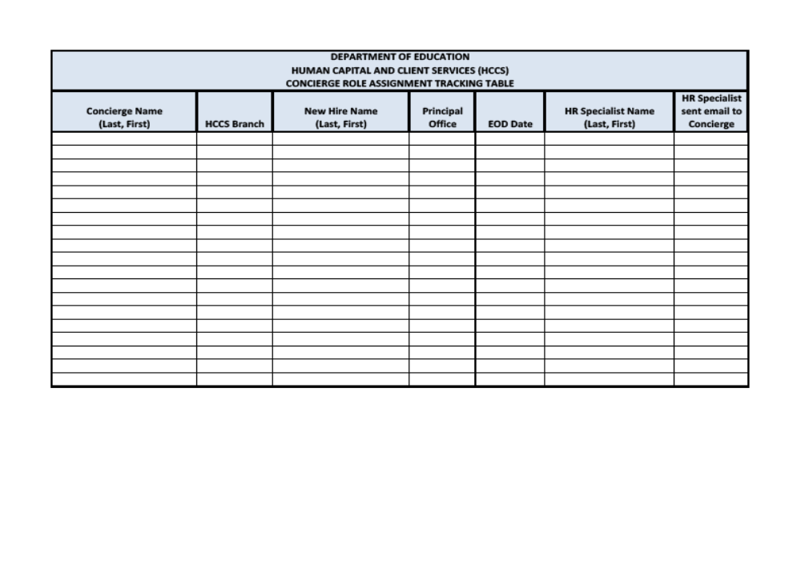
<Letterhead>

<Date>
Dear <insert name>,
Welcome to the US Department of Education (ED)! We are so pleased that you will be joining the team. We are excited that you have accepted our job offer and agreed upon your start date. I trust that this letter finds you as excited about your new employment with ED as we are about your decision.
This Welcome Packet includes documents and links to information you may find useful leading up to your first day with ED. While the forms you received with your Offer Letter from Human Capital and Client Services (HCCS) (FSA – HR Office) are necessary for you to complete prior to your first day, the information in this packet is provided as a reference for you. The Welcome Packet will help you learn more about ED, available work/life resources, information relevant to your work environment and local area services. You may find this information as well as additional detailed information on the ED Onboarding website at: www.ed.gov/ONBOARDING

You have been assigned a Concierge and an Ambassador to support you as you prepare to come onboard with us and through your first year of employment at ED. I am your Concierge and my role is to help you find any Human Resources information you need (benefits, insurance, pay, etc). You have also been assigned an Ambassador, who will support you as you learn about ED, your Principal Office (PO), and your new role. We are both here to help you navigate during your first year at the Department.

Your Ambassador is: _______________________________________________

Ambassador Phone Number: _________________________________________

Ambassador Email Address: _________________________________________

Enclosed in this Welcome Packet is a set of New Hire Checklists with all the mandatory and optional steps to take to prepare for your entry to ED. We have provided a checklist to help you keep track of the steps to take prior to your first day (pre-Entry on Duty (EOD)), on your first day (EOD) and soon after your first day (post-EOD).
As a reminder, you are scheduled for EDStart on <insert date>. Please plan to arrive at <insert address> no later than <insert time>. Once you arrive, tell the guard you are there for EDStart (New Hire Orientation). They will have your name on a list. If there are any problems the morning of EDStart, please contact <insert name and phone>.

If you have any questions, please do not hesitate to contact me or your Ambassador. We are dedicated to making your transition to the Department as seamless as possible.

We are thrilled you are joining the Department of Education community and look forward to working with you.

Sincerely,

<Name of Concierge>
<Title>
<Phone #>
<Email>

cc: Ambassador/<name>
Supervisor/<name>

List of inserts to be included in the Welcome Packet:
- Onboarding Roadmap
- New Hire Checklist
- EDStart Logistics Document (one document per location with information on transportation, parking, address, location of EDStart room, and any other logistical information)
- Local Information (area restaurants, sites, attractions, relevant area information)
- PO-specific information (as determined by the PO)

The diagram below is a visual roadmap that depicts the main steps in your Onboarding process. Please note that each New Hire will not necessarily complete each step, but these are the steps that are common to most New Hires joining the Department of Education. If you have questions about any of these, please feel free to reach out to your Concierge and/or Ambassador.

Welcome to the Department of Education!

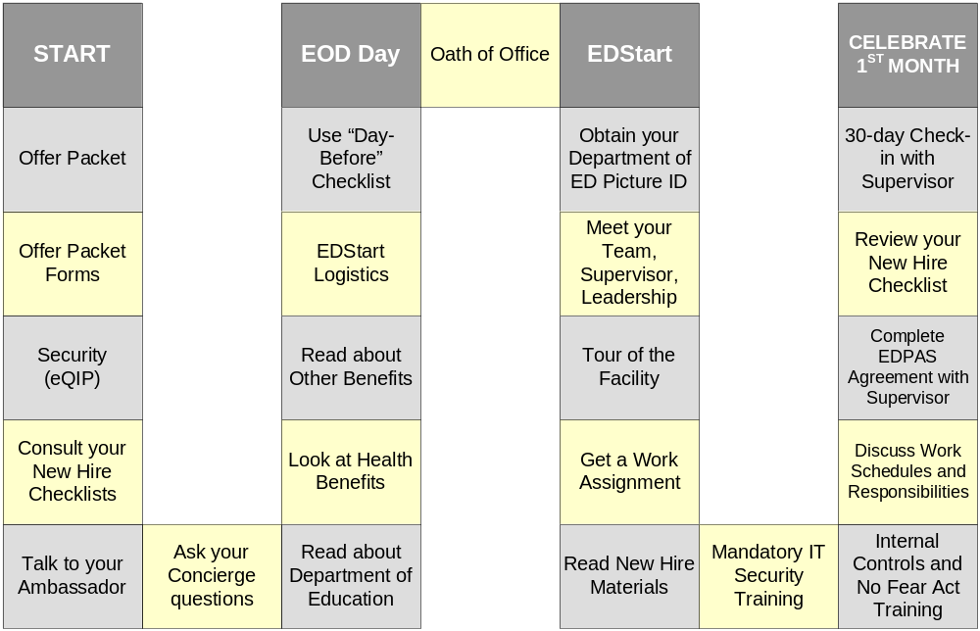

As online submission is enabled, this checklist to be updated to reflect which forms must be printed and which can be submitted electronically.
Note to Reviewer: The website is currently under development. Once it is completed, the appropriate link will be inserted here.

