Topic areas:
Account Access/DMS Support
Error Reports in DMS
Viewing Entity Data in DMS
DMS Navigation Tips
Common Questions about Specific Data Issues
Account Access/DMS Support
- How do I get a DMS account?
- The Partner Support Center (PSC) establishes the initial account in each state, which is assigned to the state EDFacts Coordinator.
- New users should contact their state’s EDFacts Coordinator to be added as a user.
- Users will receive a series of 3 emails that contain detailed instructions to establish a DMS account, including a temporary password. Note: the temporary password expires in 48 hours if no action is taken to set up the account. In case of password timeout, contact PSC (see question #4 below).
- Follow the e-mail instructions outlined in the DMS State User Guide to set up your account.

- How do I reset my password?
Click Forgot Password? link on the login screen and follow the instructions on the page.

- Can a state have multiple DMS users?
Yes, each state can have a maximum of 10 DMS users. The EDFacts Coordinator in each state administers this account and can add users as needed. If a state needs more than 10 users, contact PSC.

- What DMS support is available?
Resources are available through the EDFacts Initiative site, including:
- DMS State User Guide, and
- DMS Business Rules.

Additionally, feel free to contact PSC:
Toll Free: 877-457-3336
Fax: 888-329-3336
Federal Relay Service: 800-877-0996 (Voice/TTY)/ federalrelay@sprint.com
E-mail: EDEN_SS@ed.gov

PSC is available to answer questions from 8:00 a.m. to 6:00 p.m. ET, Monday through Friday, excluding federal holidays.

- Can more than one person from a state access DMS and make data comments at the same time?
Yes, multiple users can access the DMS using their individual user accounts and add data comments simultaneously for a state.

- The login screen doesn’t respond after I click “Login” while using Internet Explorer. What can I do?
This issue may be due to compatibility settings a state may have in place to access the CSPR using Internet Explorer v11 (IE11). Here are two solutions states have found helpful in the past:
- Check the compatibility settings in IE11 - Go to Tools > Compatibility View Settings > Highlight ed.gov > click Remove
- If an ed.gov URL is included, remove it from the list.
- Switch to a different browser, such as Chrome or Firefox. If you continue to have DMS login issues, contact PSC for additional support.

- I receive the message, “Your account has not been assigned to any state” after logging in. What can I do?
This is a known issue in DMS that occurs occasionally that the DMS technical team is currently researching to put a permanent solution in place. In the meantime, if you receive this message we recommend you do the following:
- Work with the EDFacts Coordinator in your state reassign your state to users by selecting “Assign User to State(s)” in the Admin dropdown menu.
- Contact PSC to report this issue in your state.
- Contact PSC if your EDFacts Coordinator is unable to assign your account to your state.

Error Reports in DMS
- What is the best way to view error reports in DMS?
There are two ways to view error reports
- Click the Errors icon on top of the homepage to get a dropdown menu of error reports; and
- Click the Error Reports link on the left side of the landing page for a specific data group.

- I’ve researched the errors in DMS; how do I resolve them?
- Resubmit data. If DMS flagged a data issue and you have determined there was an error, resubmit the file to correct the error, if possible.
- Add comments. Often the data issue is not erroneous data but rather correct data that are anomalous. To add comments to individual errors:
- Click on the dialogue bubble next to the error to which you want to provide an explanation; the comment box will appear.
- Add your comment in the comment box.
- Click Post.
The DMS Data Analysts will review comments and determine if the comments explain the data anomaly, or if additional follow-up is needed.

- A lot of my schools have the same issue and same explanation. How can I add the same comment to these errors at the same time?
Users can add the same comment to multiple errors by checking the box of Add multiple comments and resolution at the bottom of error reports. If no filters are applied, the same comment will be applied to all errors in that group. If the comment is relevant to a subset of errors, users can either filter the list of errors or click specific errors once the Add multiple comments box is selected.

- I want to view the errors in Excel; can I do that?
All error reports can be exported from DMS to Excel. Click the Create Excel Report icon once. This action will create a single Excel file with a separate tab for each of the separate errors for that group.

- How soon after I submit data through ESS can I review the errors in DMS?
The error reports now run automatically following data submissions (and resubmissions). In most cases, the error reports related to a file submission are viewable by users the following day.

- Can I delete or edit a comment in DMS?
Comments cannot be edited or deleted; however, new comments can be added to a comment thread.

- Is there a character limit for comments?
Yes; the character limit for comments is 1,000 characters.

- How can I view additional questions asked by DMS Data Analysts?
There are two ways to view additional questions asked by DMS Data Analysts outside of the regular DMS checks.
- From the Home page, click on the Data icon on the menu bar at the top of the screen and select Add A Question.
- From any error report, click on Additional Questions at the top right of the screen.

Viewing Entity Data in DMS
- I want to look at data for a specific school or district. How do I do that?
The view data function lets users view SEA-level data, as well as the data for any LEA or school. To use this function in DMS:
- Click on the Data dropdown in the menu bar and select View Data.
- Select the level (SEA, LEA, or School) from the dropdown menu.
- Enter the name of the entity in the field labeled “Search Name” directly below Name.
  - DMS will automatically filter the list to just show the entities that satisfy that criteria.
Note: If “Montgomery” is typed into the search field, the search function will return a list that includes all entities at that level with the text string Montgomery in the name.
- Navigate to different EDFacts data files (e.g., Directory, Membership, Staff) by clicking the dropdown box next to the entity name
Note: the DMS automatically shows data for current and prior years on the data screen.

- How do I view the parent LEA data for a school?
To view the data for an LEA associated with a particular school:
- In the school page in view data, locate the parent organization line.
- Hold the control key; click on the name of the LEA listed as the parent organization.
  - A new window will open in your browser with the view data screen for LEA parent organization for the school.
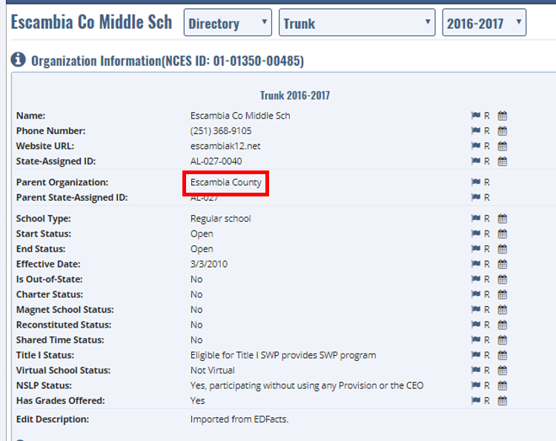

- How can I view all the schools associated with an LEA?
- In the view data page for a specific LEA, scroll down to the children section. The names listed in this section are all of the schools tied to this LEA.
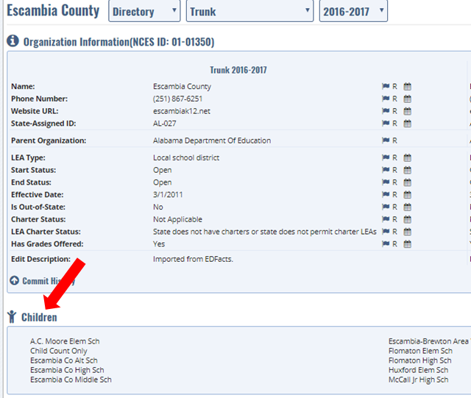
- Hold the control key; click on the name of any school to open the view data screen for that school in a new tab.

DMS Navigation Tips
- Can you provide tips to make it easier to use the DMS?
Yes; the DMS Data Analysts use several of the following when working within the DMS. Note: these tools work in both view data mode and within the specific error reports.
  - Sort: Click on the caret next to the headers to sort data in ascending or descending order.
  - Show entries: The default view is 50 entries per page for error reports and 10 entries per page for view data. Change the default using the dropdown box next to “Show” at the top of the screen. The bottom right corner indicates if additional pages are available.
  - Open new windows: DMS allows users to open multiple browser tabs in the same session. To do this, hold the control key; click on a link to open a new page. This approach is particularly helpful to users who want to look at data for a number of entities but maintain the same source screen.
  - Filter by error level: Clicking this option allows the user to filter the errors by level, focusing on the highest priority errors first

Common Questions about Specific Data Issues
- The operational status for a school is listed as “Null” in the DMS. What does this mean?
An operational status of “Null” showing in the Directory Match Error Report means that institution was not included in the directory file for that year.

- CCD only: How do I read and interpret a 5‐year Edits Report?
The 5‐year edits are displayed in a format slightly different than other error reports. There is a Base Value 1 column, a Calculated Value column, and a Base Value 2 column for each 5‐year edit business rule. For each of these columns, five years of data are displayed, starting with the current year data (CY) and subsequent data for the four previous collection years delineated by H1, H2, H3, and H4.
In the example below, the current year is 2015‐16, H1 is 2014‐15, H2 is 2013‐14, H3 is 2012‐ 13, and H4 is 2011‐12. A description of what data is displayed is included in each individual row of the 5‐year Edits report.
The total number of teachers (CY: 1.18) under Base Value 1 was flagged for review and possible suppression because the value reported appears to be in error. The reported number of teachers and students in membership remained steady for H1-H4. In CY, however, the number of students continued in line with the prior year figures but the number of staff dropped precipitously. State explanations are considered when making final decisions to retain or suppress data.
